MarkeTrak Users Guide
Section 6: NON LSE DEV
Table of Contents

MarkeTrak Users Guide 1
6.1.1.2 Subsection Definitions of NON LSE Data Extract Variance Issues – Issues and Sub Types………………. 5
6.1.1.3 NON LSE Data Extract Variance Issues – Fields Defined 15
6.1.1.4 NON LSE Data Extract Variance Issues – Required Fields 17
Issue type: DEV Characteristics 17
6.1.2 General………… 19
6.1.3 Timing….. ……………………………………………………………………………...………………...19
6.1.4 NON LSE Relationship DEV Existence Issues 20
6.1.4.1 ESI ID Existence DEV Issues - Existence – In TDSP system not ERCOT 20
6.1.4.2 DEV Issues – Existence – In ERCOT system not TDSP 24
6.1.4.3 DEV Issues – Existence – In ERCOT with start date issues 26
6.1.4.4 DEV Issues – Existence – Inactive record has date issues 27
6.1.4.5 DEV Issues – Existence – Status Assignment 30
6.1.4.6 DEV Issues – Existence – Un Retire ESI ID 31
6.1.5 ESI ID Characteristic DEV Issues 32
6.1.5.1 DEV Issues – Characteristics – Region Code Assignment 32
6.1.5.2 DEV Issues – Characteristics – Loss Code Assignment 39
6.1.5.3 DEV Issues – Characteristics – Profile Code Assignment 41
6.1.5.4 DEV Issues – Characteristics – Station Code Assignment 41
6.1.5.5 DEV Issues – Characteristics – Zip Assignment 41
6.1.6 Usage DEV Issues 45
6.1.6.1 DEV Issues – IDR – In MP system not ERCOT 46
6.1.6.2 DEV Issues – IDR – In ERCOT system not MP 53
6.1.6.3 DEV Issues – IDR – In both systems with date issues 55
6.1.6.4 DEV Issues – IDR – In both systems with kWh issues 57
6.1.6.5 DEV Issues – Non-IDR – In MP system not ERCOT 58
6.1.6.6 DEV Issues – Non-IDR – In ERCOT system not MP 68
6.1.6.7 DEV Issues – Non-IDR – In both systems with date issues 69
6.1.6.8 DEV Issues – Non-IDR – In both systems with kWh or kW issues 71

Invalid submission of Data Extract Variance Types:

Variances not requiring resolution (do not file Data Extract Variance)
Description of Variance | Reason No Resolution Required
CR relationship records associated to the TDSP as LSE prior to 01-01-2002 | Per Market Decisions related to 2002-2003 Market Sync Project
CR relationship record date mismatches of +/- 2 calendar days on either the Start or Stop Time | Per Market Decisions related to 2002-2003 Market Sync Project
CR relationship records missing or date mismatches due to batch timing consideration (always consider a four-day data latency) | Siebel to Lodestar batch processing timing considerations
CR relationship records missing for consecutive Move In/Move Outs for same CR. For example, ERCOT has CR1 from 01/15/2002 to current. TDSP/CR has CR1 from 01/15/2002 – 05/01/2002 and 05/01/2002 – current | Prior to recent ERCOT system changes, CR relationships that did not contain any ESI ID characteristic changes were compressed to a minimum Start date and maximum End date for the ESIIDSERVICEHIST row. In addition, due to the Safety Net process, ERCOT often does not receive transactions for each MVI/MVO. As long as there are no de-energized periods or changes in CR, date issues for consecutive periods should be considered valid
Continuous Service Agreements (CSAs) are NOT reflected in the data extract | The ESI ID Service History extract only includes CR relationships as the energy provider. If there is an issue with a CSA relationship, a day to day MarkeTrak issue may be filed
Pending (In Review or Scheduled) energy relationship transactions are NOT reflected in the data extract | Only transactions completed by 867 transactions that have been updated to the Data Archive are provided in the data extract.  If there is an issue with a pending service order, a day to day MarkeTrak issue may be filed
ERCOT system IDR data that matches for each interval but Start and Stop Time do not match | There are instances where ERCOT has manually cut IDR data at midnight to support TDSP submission of 814_20 maintain transactions

Valid submission Data Extract Variance Types:

Variances for submission (you may file a Data Extract Variance)
Variance Description | Details
ESI ID present in TDSP system but not in ERCOT system | ESI ID does not exist in ERCOT systems
ESI ID present in ERCOT system but not in MP system | ESI ID needs to be retired
ESI ID present in ERCOT system but has start date issues | ESI ID Start Date needs to be adjusted to an earlier date
Inactive record has date issues | ESI ID is Inactive but has incorrect date
Status Assignment | Status needs to be Inactive
Un-Retire ESI ID | ESI ID retired in error, reinstate to De-energized
Region Code Assignment | Incorrect Region Code
Loss Code Assignment | Incorrect Loss Code
Profile Code Assignment | Incorrect Profile Code
Station Code Assignment | Incorrect Station Code
ZIP Assignment | Incorrect ZIP
IDR Usage present in MP system but not in ERCOT system | IDR Usage needs to be loaded at ERCOT
IDR Usage present in ERCOT system but not in MP system | Data needs to be cancelled from ERCOT system or TDSP to submit IDR Usage to CR
IDR Usage present in both systems but has date issues | Delete and reload LSE file or TDSP to verify IDR Usage values
IDR Usage present in both systems but has kWh issues | Load corrected LSE file or TDSP to verify IDR Usage values
Non-IDR Usage present in MP system but not in ERCOT system | NIDR Usage needs to be loaded at ERCOT
Non-IDR Usage present in ERCOT system but not in MP system | Data needs to be cancelled from ERCOT system or TDSP to submit NIDR Usage to CR
Non-IDR Usage present in both systems but has date issues | Dates of Usage date are incorrect. Update to new STOPTIME
Non-IDR Usage present in both systems but has kWh or kW total issues | Need to update loaded usage data or  TDSP to verify NIDR Usage values

6.1.1.2 Subsection Definitions of NON LSE Data Extract Variance Issues – Issues and Sub Types

How to Identify Existence Data Extract Variances:
In TDSP system not ERCOT
Submitted: TDSP to ERCOT – ERCOT DEV
- ESIID Existence Issue
- TDSPs should file this variance when:
  - ESIID does not exist in ERCOT systems
  - 814_20 ADD will not process into ERCOT systems
ERCOT Resolution: Add the ESIID to ERCOT systems in a De-Energized status in ERCOT systems

In ERCOT system not TDSP
Submitted: TDSP to ERCOT – ERCOT DEV
- ESIID Existence Issue
- TDSPs should file this variance when:
  - It is determined that the ESIID should not exist at ERCOT
- ESIID must have a De-Energized status to file this variance
  - If the status is Active then an LSE Variance Issue to remove the relationship must be submitted prior to filing the Existence Issue
ERCOT Resolution: Add a STOPTIME to the ESIID and change the status from De-Energized to Inactive in ERCOT systems

In ERCOT with start date issues
Submitted: TDSP to ERCOT – ERCOT DEV
- ESIID Existence Issue
- TDSPs should file this variance when:
  - It is determined that the ESIID has an incorrect STARTTIME
    - There are no transactions that can update the STARTTIME of the ESIID
ERCOT Resolution: Update the STARTTIME of the ESIID in ERCOT systems

Inactive record has date issues
Submitted: TDSP to ERCOT – ERCOT DEV
- ESIID Existence Issue
- TDSPs should file this variance when:
  - It is determined that the ESIID has an incorrect STOPTIME
    - There are no transactions that can update the STOPTIME of the ESIID
- ESIID must have an Inactive status to file this variance
ERCOT Resolution: Update the STOPTIME of the ESIID in ERCOT systems and the status will remain Inactive

Status assignment
Submitted: TDSP to ERCOT – ERCOT DEV
- ESIID Existence Issue
- TDSPs should file this variance when:
  - The ESIID cannot be retired and the status updated to INACTIVE with an 814_20 RETIRE transaction from the TDSP to ERCOT
- ESIID must have a De-Energized status to file this variance
  - If the status is Active then an LSE Variance Issue to remove the relationship must be submitted prior to filing the Existence Issue
ERCOT Resolution: Add a STOPTIME to the ESIID and change the status from De-Energized to Inactive in ERCOT systems

Un-Retire ESIID
Submitted: TDSP to ERCOT – ERCOT DEV
- ESIID must have a Inactive status to file this variance
  - This DEV process is NOT used often, but was added to DEVs ~ 2 years ago for special circumstances when an ESIID needs to be Un-Retired.
ERCOT Resolution: ESIID status will be changed from Inactive to De-Energized in ERCOT systems

How to Identify ESIID Characteristic Data Extract Variances:

Submitted: TDSP to ERCOT – ERCOT DEV or CR to TDSP – NON-ERCOT DEV
- ESIID Characteristic Issue
  - Includes the Region Code, Loss Code, Profile Code, Station Code and Zip Assignments
- TDSPs should file this variance when:
  - The characteristic cannot be updated with an 814_20 UPDATE transaction from the TDSP to ERCOT
- CRs should file this variance when:
  - There is a discrepancy with the characteristic in the extract compared to CR systems
ERCOT Resolution: Update the characteristic of the ESIID in ERCOT systems from the given effective date to current

Recommended Extract Data Integrity Checks for Characteristics and Existence
- ESIID table
  - ESIID Existence Check (TDSPs)
    - Does the ESIID exist in ERCOT system and MP system?
    - Are the STARTTIME and the STOPTIME of the ESIID the same in both systems?
- ESIIDSERVICEHIST table
  - ESIID Characteristic Assignment Checks (All MPs)
    - Are the ESIID characteristics the same in ERCOT system and MP system?
    - Are the STARTTIME and the STOPTIME of the ESIID characteristics the same in both systems?
    - Does the Loss Code assignment correspond to the Profile Code assignment?
      - If Loss Code of ‘T’ does the Profile Code have an ‘IDR’ meter type?
    - Is the Station Code assigned during a time when the Station is not active?

How to Identify IDR Usage Data Extract Variances:
**INVALID Data Extract Variance Submissions:
What would make an IDR Usage Data Extract Variance Invalid:
  - IDR Usage rows with an ORIGIN of ‘G’ (EPS Read) or ‘C’ (Calculated by ERCOT)
  - IDR Usage loaded in ERCOT systems where data matches for each interval for a defined period of time but the Start and Stop Time do not match

**VALID Data Extract Variance Submissions:
In MP system not ERCOT
Submitted: CR to TDSP – NON-ERCOT DEV
- ESIID Usage Issue
- CRs should file this variance when:
  - IDR usage is present in the CR system but not in ERCOT system
    - Profile Code should have an ‘IDR’ metertype in ERCOT system
    - Determined by not having an IDR usage data cut with ORIGIN = ‘G’ or ‘M’
Submitted: TDSP to ERCOT – ERCOT DEV
- ESIID Usage Issue
- TDSPs should file this variance when:
  - IDR usage is present in the TDSP system but not in ERCOT system
    - Profile Code should have an ‘IDR’ metertype in ERCOT system
    - Determined by not having an IDR usage data cut with ORIGIN = ‘G’ or ‘M’
  - Unable to load IDR usage via 867_03
ERCOT Resolution: Load the IDR usage data into ERCOT systems manually via an LSE file or via transactions sent to ERCOT.

In ERCOT system not MP
Submitted: TDSP to ERCOT – ERCOT DEV or CR to TDSP – NON-ERCOT DEV
- ESIID Usage Issue
- TDSPs should file this variance when:
  - Unable to cancel IDR usage via 867_03 Cancel
- CRs should file this variance when:
  - IDR usage needs to be cancelled from ERCOT system
  - IDR usage needs to be provided to the CR
ERCOT Resolution: Cancel the IDR usage data into ERCOT systems manually

In both systems with date issues
Submitted: TDSP to ERCOT – ERCOT DEV or CR to TDSP – NON-ERCOT DEV
- ESIID Usage Issue
- TDSPs should file this variance when:
  - Unable to cancel IDR usage via 867_03 Cancel
- CRs should file this variance when:
  - IDR usage has date issues
    - File variance with the minimum STARTTIME usage record because of the cascading affects on consecutive usage records
      - Allows TDSP to resolve consecutive issues as well, if necessary
ERCOT Resolution: Cancel the IDR usage data in ERCOT systems manually
TDSP send in 867_03 transaction once IDR data is cancelled

In both systems with KWh issues
Submitted: TDSP to ERCOT – ERCOT DEV or CR to TDSP – NON-ERCOT DEV
- ESIID Usage Issue
- TDSPs should file this variance when:
  - Unable to cancel IDR usage via 867_03 Cancel
- CRs should file this variance when:
  - It is determined that the IDR usage has kWh issues
ERCOT Resolution: Cancel the IDR usage data in ERCOT systems manually
TDSP send in 867_03 transaction once IDR data is cancelled

How to Identify Non-IDR Usage Data Extract Variances:
In MP system not ERCOT
Submitted: CR to TDSP – NON-ERCOT DEV
- ESIID Usage Issue
- CRs should file this variance when:
  - NIDR usage is present in the CR system but not in ERCOT system
  - Profile Code should have a ‘NIDR’ meter type in ERCOT system
Submitted: TDSP to ERCOT – ERCOT DEV
- ESIID Usage Issue
- TDSPs should file this variance when:
  - NIDR usage is present in the TDSP system but not in ERCOT system
  - Unable to load NIDR usage via 867_03
    - Profile Code should have a ‘NIDR’ meter type in ERCOT system
ERCOT Resolution: Load the NIDR usage data into ERCOT systems manually per the data provided in the DEV MarkeTrak issue

In ERCOT system not MP
Submitted: TDSP to ERCOT – ERCOT DEV or CR to TDSP – NON-ERCOT DEV
- ESIID Usage Issue
- TDSPs should file this variance when:
  - Unable to cancel NIDR usage via 867_03 Cancel
- CRs should file this variance when:
  - NIDR usage needs to be cancelled from ERCOT system
  - NIDR usage needs to be provided to the CR
ERCOT Resolution: Cancel the NIDR usage data into ERCOT systems manually

In both systems with date issues
Submitted: TDSP to ERCOT – ERCOT DEV or CR to TDSP – NON-ERCOT DEV
- ESIID Usage Issue
- TDSPs should file this variance when:
  - Unable to cancel NIDR usage via 867_03 Cancel
- CRs should file this variance when:
  - NIDR usage has date issues in the extract compared to CR systems
    - File variance with the minimum STARTTIME usage record because of the cascading affects on consecutive usage records
      - Allows TDSP to resolve consecutive issues as well, if necessary
ERCOT Resolution: Cancel the NIDR usage data in ERCOT systems manually
TDSP send in 867_03 transaction once NIDR data is cancelled

In both with KWh or KW issues
Submitted: TDSP to ERCOT – ERCOT DEV or CR to TDSP – NON-ERCOT DEV
- ESIID Usage Issue
- TDSPs should file this variance when:
  - Unable to cancel NIDR usage via 867_03 Cancel
- CRs should file this variance when:
  - NIDR usage has kWh or kW issues in the extract compared to CR systems
ERCOT Resolution: Cancel the NIDR usage data in ERCOT systems manually
TDSP send in 867_03 transaction once NIDR data is cancelled

Recommended Extract Data Integrity Checks for IDR and NIDR
- ESIIDUSAGE and LSCHANNELCUT tables
  - Negative usage
    - ERCOT implemented an 867_03 data validation where negative usage will no longer load as of 06/11/2003
  - Non-IDR Extreme Average Daily Usage (ADU)
    - ERCOT implemented an 867_03 data loading validation where usage data will no longer load if the ADU exceeds 49,998 kWh on 08/06/2003
  - Non-IDR Demand (K1) loaded without kWh (KH)
  - Gaps in data between usage records
  - Usage loaded during De-Energized periods
- ESIIDUSAGE and LSCHANNELCUT tables (continued)
  - Does the usage data loaded for the ESIID coincide with the meter type of the Profile Code assigned to the ESIID?
  - Are demand values (kW) loaded at ERCOT and the Profile Code is a non-demand Profile Code assignment?

Lodestar Data Archive Database
- Daily Lodestar archiving process
  - Data records are processed from the Lodestar database to the Archive database
  - Captures records with an Add Time between previous day at 04:00:00 AM and current day at 03:59:59 AM
  - Data Certification is completed to ensure integrity of data between the source and archive databases

Extract Creation and Posting
- Daily SCR 727 Extract process
  - Market Participant ESIID Extract files are created
  - Extract files are created with the records that processed into the archive from Lodestar that day
  - Extract data records are provided to the Market Participant(s) based on the ownership assigned to each ESIIDSERVICEHIST record OR Market Participants have the option to do ad-hoc reports via the SCR 740 web database. This will provide Market Participants the ability to research ESIID level data through self-service. There are fifteen different data requests present in SCR 740 will allow Market Participants to do anything from validating the ownership of a single ESIID to generating a full historical data dump from all public and private tables.
  - After the extract files are produced, they are posted to the ERCOT Portal

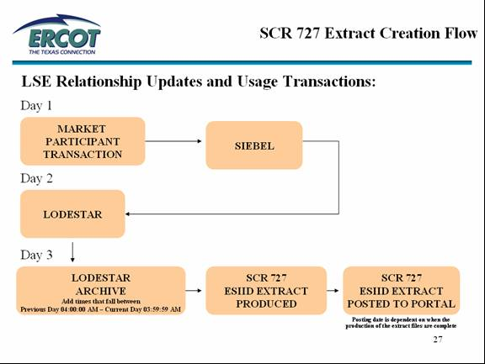
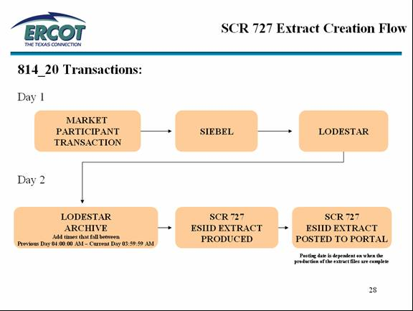

Understanding the SCR 727 Extract Data

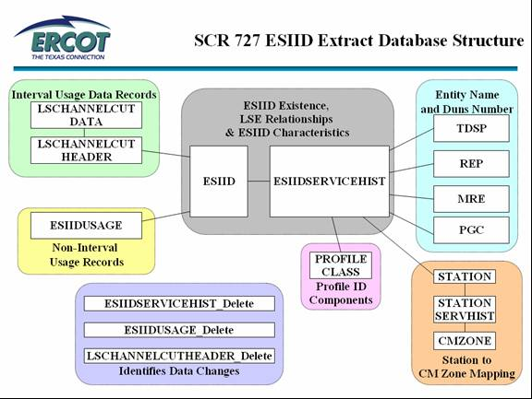

ESIID TABLE
- Lodestar table that stores the parent record for the ESIID
  - UIDESIID – unique identifier for ESIID

  - ESIID – ESIID as provided by the TDSP
  - STARTTIME – ESIID existence start time
  - STOPTIME – ESIID existence stop time
    - Field is only populated when the ESIID has an INACTIVE status
  - ADDTIME – timestamp representing the add time or last modified time of the record
- Each MP can receive a record for the ESIID they ‘own’ based on the ESIIDSERVICEHIST record(s) OR opt to use the 740 web database.
  - TDSPs & MREs can receive the ESIID record when:
    - ESIIDs are added and updated to ERCOT systems
    - ESIIDSERVICEHIST records are sent in the daily extracts
  - LSEs can receive the ESIID record when:
    - ESIIDs are updated to ERCOT systems
    - ESIIDSERVICEHIST records are sent in the daily extracts

ESIIDSERVICEHIST TABLE
- Allows ERCOT to manage ESIID service history
  - LSE relationships
  - Characteristic data of an ESIID from its creation to its retirement
- Child table of ESIID table
- The STARTTIME and STOPTIME of the ESIIDSERVICEHIST record defines the period of time for which the characteristics and relationships apply
- Trade Day specific ESIID settlement characteristics are defined by the data elements in the corresponding ESIIDSERVICEHIST data record
- Data record with a null STOPTIME is the current record and therefore the current status of the ESIID
- STATUS field options:
  - A – ESIID is active (energy is flowing) and an LSE relationship exists for that time period
  - D – ESIID is de-energized (no energy should be flowing) and no LSE relationship is established for that time
  - I – ESIID is inactive/retired
- Each MP can receive the records for each ESIID they ‘own’ OR opt to use the 740 web database.
  - TDSPs & MREs can receive the entire ESIIDSERVICEHIST for each ESIID
    - ESIID parent data record included in extract for all ESIIDSERVICEHIST records sent to MP
    - May receive ESIIDSERVICEHIST records for each STATUS (A, D, I)
  - LSEs can receive the data records where they are assigned as the REP
    - ESIID parent data record included in extract for all ESIIDSERVICEHIST records sent to MP
    - Only receives ESIIDSERVICEHIST records for where the STATUS is ‘A’
- Allows user to identify the status of the ESIID for a given trade date
- Allows user to identify current MP relationships for ESIID
- Allows user to identify maintenance of ESIID characteristics as assigned by TDSP

ESIIDUSAGE TABLE
- Non-IDR usage is stored in the following fields:
  - TOTAL
  - ONPEAK
  - OFFPEAK
  - MDPK
  - SPK
- Key to table is combination of UIDESIID, STARTTIME, STOPTIME and METERTYPE
- METERTYPE field
  - KH - kWh record
  - K1 - kW record
  - K3 - kVArh record
  - K4 - kVA record
- Table is populated via conversion and/or 867_03/867_03F transactions
- Non-IDR usage data is used during the aggregation process if the meter type of the Profile Code is ‘NIDR’
- NIDR usage data cuts are not calculated on an ESIID level during the aggregation process
- Each MP can receive the usage record for the ESIID they ‘own’ based on the ESIIDSERVICEHIST record(s) OR opt to use the 740 web database.
  - TDSPs & MREs can receive all ESIIDUSAGE records
  - CRs can receive the usage data records that are contained within their associated REP relationship in the ESIIDSERVICEHIST records

LSCHANNELCUT TABLE
- Lodestar tables that store the IDR data and header information
- IDR usage data is used during the settlement process based on the meter type of the Profile Code being ‘IDR’
- LSCHANNELCUTHEADER is parent table to the LSCHANNELCUTDATA table
- LSCHANNELCUTDATA table stores the 15 minute interval usage data

LSCHANNELCUTHEADER TABLE
- RECORDER
  - Equivalent to the ESIID
- STARTTIME
  - All read dates after 01/01/2003 are submitted to ERCOT in whole days
    - Must have a timestamp of 00:00:00
- STOPTIME
  - All read dates after 01/01/2003 are submitted to ERCOT in whole days
    - Must have a timestamp of 23:59:59
- CHANNEL
  - Channel 1 stores generation data
  - Channel 4 stores load data
- ORIGIN
  - Stores Data Source
    - C – Calculated Data
      - ERCOT calculated IDR data cut when data is not present for the Trade Date being settled
      - Does not validate relationship or characteristic changes
      - Should not be used when filing a Data Extract Variance
        - Indicates ‘actual’ IDR usage data is not loaded in ERCOT systems
    - M – Metered Data (from TDSP)
    - G – EPS Data (ERCOT Polled)
      - One day cuts polled and loaded by ERCOT
      - Should not be used when filing a Data Extract Variance
- 814_20 Update verifications against usage are performed against the records with an ORIGIN of ‘M’ or ‘G’
- Each MP can receive a record for the ESIID they ‘own’ based on the ESIIDSERVICEHIST record(s) OR opt to use the 740 web database.
  - TDSPs & MREs can receive all LSCHANNELCUTHEADER records
  - CRs can receive the usage data records that are contained within their associated REP relationship in the ESIIDSERVICEHIST records

***This section will explain HOW DEV issues are filed***

6.1.1.3 NON LSE Data Extract Variance Issues – Fields Defined

FIELD NAME | DESCRIPTION | Populated By
Issue ID | Incremented number per issue submitted | System
Submitting MP | Submitting MP DUNS # + MP name + MP type | Digital Certificate of the User
Submitting MP Type | Entity type of the Submitting MP | Company list
Submitting MP Company Name | The name of the entity Submitting the issue | Company list
Submitting MP DUNS | DUNS number of the entity Submitting the issue | Company list
Issue Subtype | Sub Type of issue selected | User-submit tree
Assignee | Assignee MP DUNS # + MP name + MP Type | Defined per workflow-user or workflow populated
Assignee MP Type | Entity type of the Assigned Market Participant | Company list
Assignee Company name | Name of the MP in the Assignee field | Company list
Assignee DUNS | DUNS number of the entity in the Assignee field | Company list
Assign To Pending: | Check box. Activating sends the issue to a pending state when submit process completes | User-submit process
ESIID: | It is the Electric Service Identifier that is stored in ERCOT system | User-submit process
Original Tran ID: | It is the BGN02 of the initiating transaction | User-submit process
GLOBPROCID: | Formula involving the ESIID and Original Tran Id. This is stored in ERCOT system and will be auto populated when the ESIID and Original Tran Id or given | System generated from user populated info
Tran Type: | The transaction that pertains to the issue | User-submit process
Date of Transaction: | Date the transactions was submitted to ERCOT | User-submit process
GS Number: | Group Number | User-submit process
Comments: | Free form field | User-log throughout issue lifecycle
Responsible MP: | MP with current transition responsibility | Defined per workflow-user or workflow populated
MPs involved: | List of market participants involved in the issue; the submitter, the assignee(s) and ERCOT | Defined per workflow-user or workflow populated

DEV Existence, Characteristic and Usage
FIELD NAME | DESCRIPTION | Populated By
Requested Resolution | Defaulted, longer description of sub type selected | System per subtype selected from submit tree
New STARTTIME | The requested new start time. Format mm/dd/yyyy hh:mm:ss | User-submit process
New STOPTIME | The requested new stop time. Format mm/dd/yyyy hh:mm:ss | User-submit process
ESIID: | It is the Electric Service Identifier that is stored in ERCOT system | User-submit process
UIDESIID | A unique number generated in Lodestar to ID an ESIID | User-submit process
UIDCHANNELCUT | An id associated with a specific IDR Usage record in the LSCHANNELCUTDATA table of Lodestar | User-submit process
CHANNEL | CHANNEL 1 = Generation, CHANNEL 4 = Load | User-submit process
STARTTIME | The start time of the current data record found in the Market Participant's data extract. | User-submit process
STOPTIME | The stop time of the current data record found in the Market Participant's data extract. | User-submit process
PROFILECODE | The Profile Code of the current data record found in the Market Participant's data extract. | User-submit process
New PROFILECODE | The requested New Profile Code | User-submit process
STATIONCODE | The Station Code of the current data record found in the Market Participant's data extract. | User-submit process
New STATIONCODE | The requested New Station Code | User-submit process
LOSSCODE | The Loss Code of the current data record found in the Market Participant's data extract | User-submit process
New LOSSCODE | The requested New Loss Code | User-submit process
REGION CODE | The Region Code of the current data record found in the Market Participant's data extract | User-submit process
New REGION CODE | The requested New Region Code | User-submit process
ZIP | The ZIP Code of the current data record found in the Market Participant's data extract | User-submit process
New ZIP Code | The requested New Zip Code | User-submit process
ADDTIME | CHAR/Existence/IDR Usage Issues - date the record was added/updated in Lodestar. May default to current date for various issues.  Format mm/dd/yyyy hh:mm:ss | User-submit process
Meter Type | Type of Meter data for NIDR Usage issues.  KH = Monthly kWh, K1 = Monthly kW, K4 = kVA | User-submit process
Total | Total consumption | User-submit process
New ONPK, OFFPK, MDPK,SPK | New Peak values requested | User-submit process
New Total | New Total value requested | User-submit process
Timestamp | NIDR Usage – date NIDR Usage loaded into Lodestar | User-submit process
Service Address | Service Address | User-submit process
Premise Type | Large Non-Residential, Residential or Small Non-Residential | User-submit process
Service City | Service City | User-submit process
Service State | Service State | User-submit process
Title | Variance Issue Title | Defined per workflow-user or workflow populated
Assignee | Assignee MP DUNS # + MP name + MP Type | Defined per workflow-user or workflow populated

6.1.1.4 NON LSE Data Extract Variance Issues – Required Fields

Issue type: DEV Characteristics
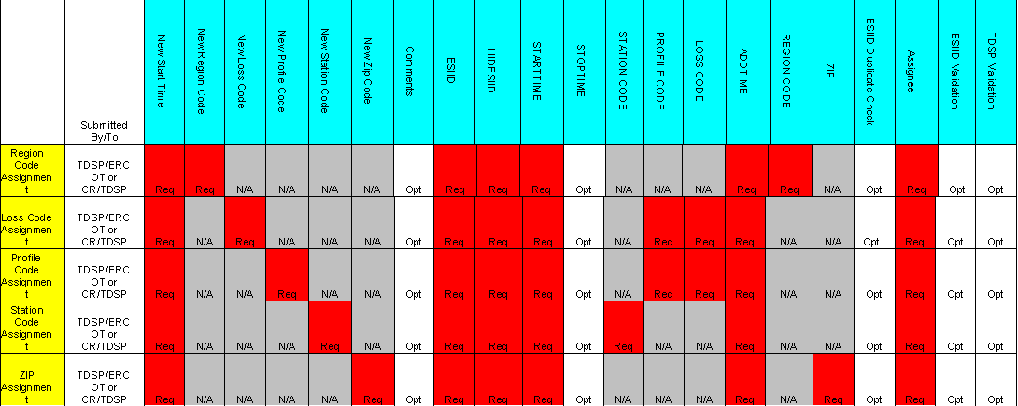

Issue type: DEV Existence
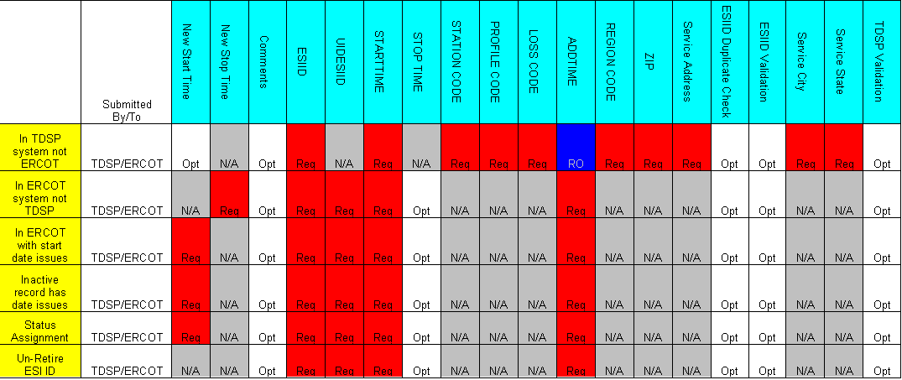

Issue type: DEV IDR Usage

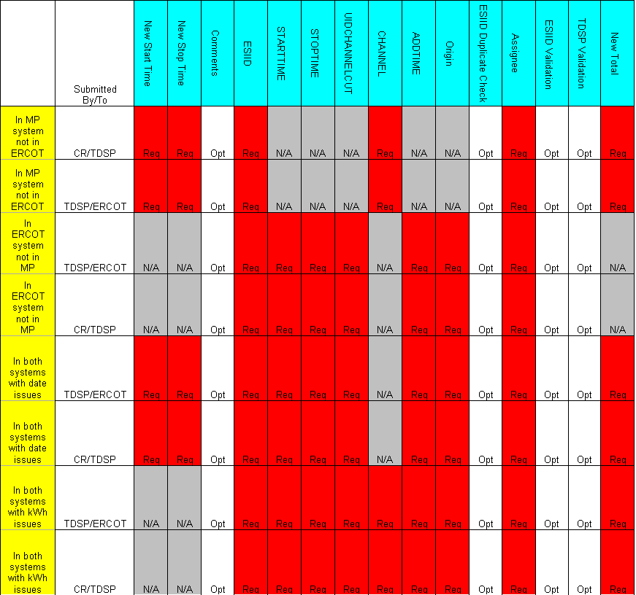

Issue type: DEV Non-IDR Usage

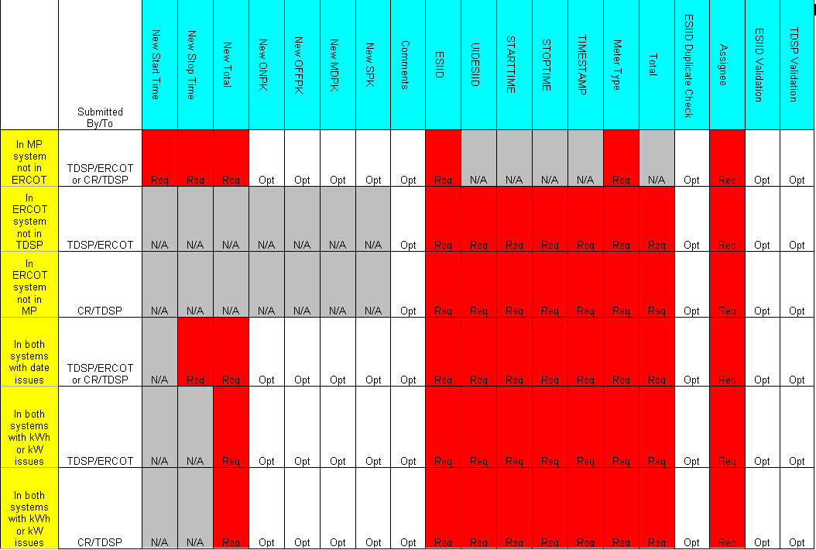

General
DEV issues should only be submitted after transactions have been attempted and as a result of comparing the ERCOT SCR727 Data Extract and the Market Participants system. Manual intervention will only be accepted once all other standard resolution paths have been exhausted.

The required fields within MarkeTrak for each issue must be populated before an issue can be submitted.

The correct MP owning the data in question must be the submitter of the issue. All LSE DEV issues must have an MP assigned. Issues can only contain information pertaining to one MP.

ESI IDs that should never have been registered at ERCOT will not be deleted from ERCOT systems. Upon request by the TDSP, the ESI ID may be retired utilizing a date prior to market open (07-30-01).

Changes made to ESI ID characteristics in the ESIIDSERVICEHIST table will be effective from the New Start Time provided by the TDSP and all subsequent records through the current date.

Timing
Issues received by noon will be acknowledged by 5:00 p.m. the same business day. Issues received after noon will be acknowledged the next business day by 5:00 p.m.

Per the 10-16-2003 RMS directive, a 75 calendar day deadline for completion of each issue will be implemented. Each MP (including ERCOT) will complete the DEV process in accordance with the timelines and other requirements of the DEV manual. Variance must be submitted at least 75 calendar days prior to the scheduled True-Up settlement/resettlement to allow the full 75 calendar day resolution period for the various parties Variances submitted in less than 75 calendar days from the scheduled resettlement of the True-Up settlement/resettlement may not be fully resolved prior to the True-Up settlement/resettlement. The following details the expected turn-around deadlines for variances to ensure the 75 calendar day timeline is met:

NIDR and IDR Usage DEV Issues:
45 calendar days for TDSP validation and analysis to be completed
30 calendar days for TDSP to send transactions (if necessary) or for CR to manually update their system (if needed)

ESI ID Characteristics DEV Issues:
45 calendar days for TDSP validation and analysis to be completed
30 calendar days for TDSP to send transactions (if necessary) or for CR to manually update their system (if needed)

ESI ID Existence DEV Issues:
10 calendar days for initial validation and analysis by ERCOT
65 calendar days for TDSP to send transactions (if necessary)

Issues requiring additional analysis or follow-up data from other MPs will be updated in MarkeTrak to indicate such a need. MPs are required to respond with the necessary information within seven (7) business days.

6.1.4 NON LSE Relationship DEV Existence Issues

6.1.4.1 ESI ID Existence DEV Issues - Existence – In TDSP system not ERCOT
ESI ID Existence DEV issues are issues filed by the TDSP to ERCOT regarding the establishment or retirement of an ESI ID in ERCOT systems. These issues are filed to ERCOT when an 814_20 ADD or 814_20 RETIRE cannot be submitted.

TDSP to ERCOT
The DEV issue of In TDSP system not ERCOT should be submitted when the ESI ID is in the TDSP’s system, but not in the data extract from ERCOT.

Action: ERCOT needs to Add ESI ID

The ESIID needs to be added to ERCOT systems and cannot be added via an 814_20 ADD transaction.

TDSP cannot add and activate an ESI ID at the same time. After the ESI ID Existence issue is resolved, the MPs should resume using normal transactions to activate the ESI ID (i.e. 814_16 Move In)

CRs cannot file a Data Extract Variance for ESI ID existence. If a CR believes that an ESI ID should be active, then the CR should file a Variance Issue regarding the Start Time or existence of an LSE relationship.

Required fields for Existence – In TDSP system not ERCOT
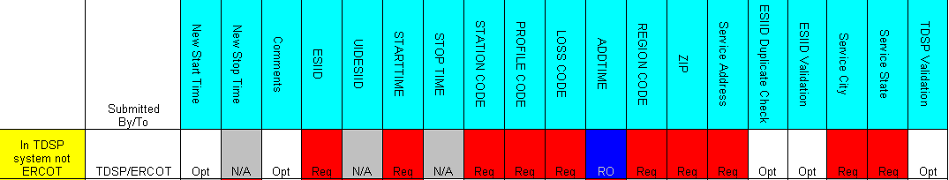

***NOTE: Validate TDSP is Associated with Issue will be applied to ALL DEV submissions

***NOTE: The Submitter will be allowed to ‘CLOSE’ a DEV issue IF the Submitter is the Responsible Party.

***Note: (Add notification) User may subscribe to new notification that will send email when an issue transitions to “Closed” by Submitter. Refer to Section 1- General

6.1.4.1.2 Example of Existence: In TDSP system not ERCOT

- Select the Submit tab (Fig 11.5a)
- From the submit Tree, select In TDSP system not ERCOT
Fig 11.5a
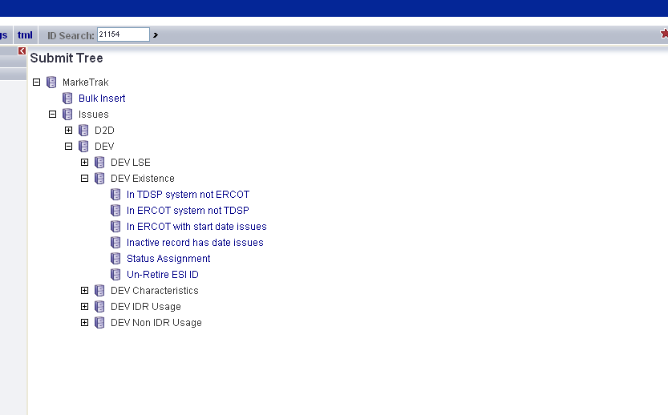

- The following fields must be populated for successful submission:
ESIID
STARTTIME
STATIONCODE
PROFILECODE
LOSSCODE
ADDTIME (default to current day)
REGIONCODE
ZIP
SERVICE ADDRESS
SERVICE CITY
SERVICE STATE
PREMISE TYPE

- Select OK (Fig 11.5b)

Fig 11.5b
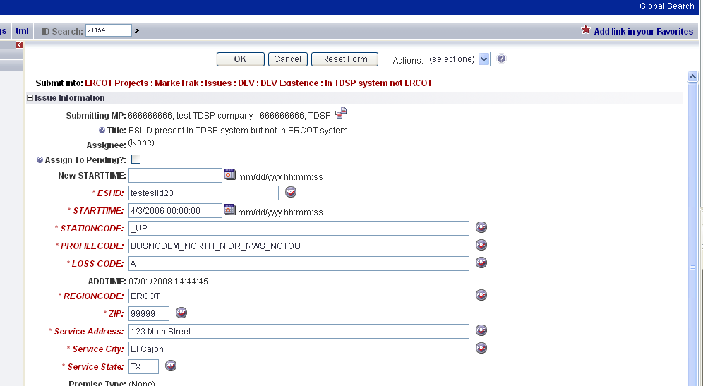

- The issue enters ERCOT’s queue in the state of New
- The TDSP only may Withdraw the issue prior to acknowledgement by ERCOT (Fig 11.5c)
Fig 11.5c
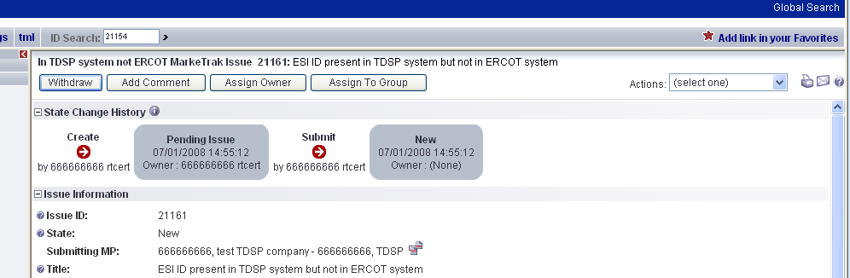

- ERCOT selects Begin Working and the TDSP can no longer Withdraw the issue. (Fig 11.5d)
Fig 11.5d
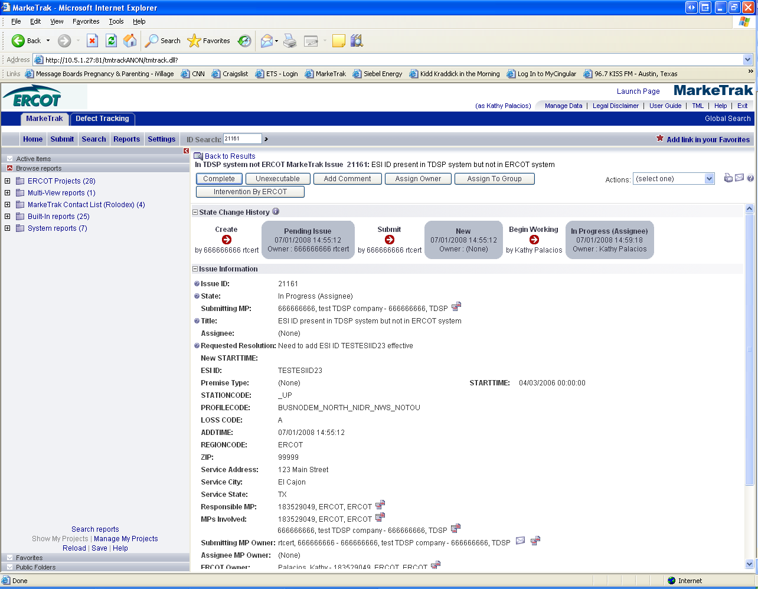

- ERCOT has the options of Complete, Unexecutable and Intervention by ERCOT. Intervention by ERCOT is used only by ERCOT to close the issue regardless of who is the Responsible MP. (Fig 11.5e)

Fig 11.5e

- If in agreement ERCOT will take appropriate action and select Complete which transitions the issue to Pending Complete with the TDSP. (Fig 11.5f)

Fig 11.5f
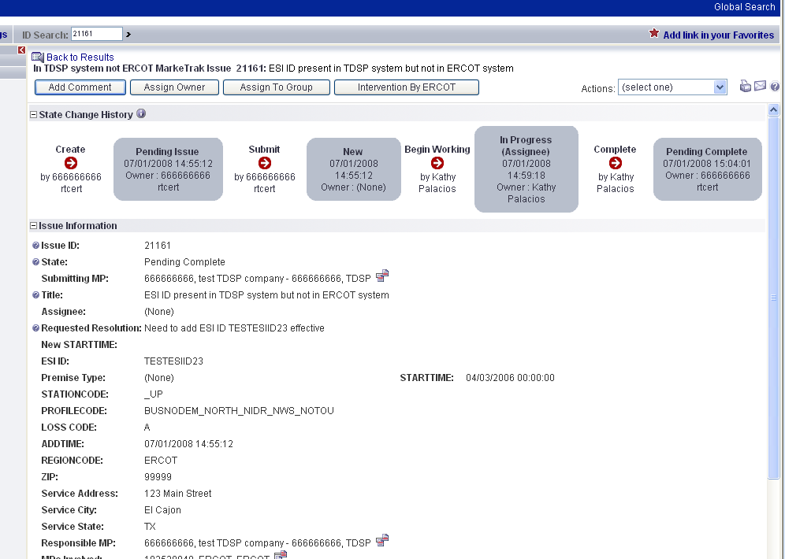

- The TDSP selects Complete and the issue is closed
- If not in agreement, ERCOT may select Unexecutable which will require a comment and return the issue back to TDSP’s queue as Unexecutable (Pending Complete).
- TDSP will add comment and select Pending Complete.
- ERCOT will select Accept and issue will be closed.
- Once in the Pending Complete state, if the issue is not transitioned for 14 calendar days the issue will then automatically go to Auto Complete. The issue will then be closed.

DEV Issues – Existence – In ERCOT system not TDSP
TDSP to ERCOT
The DEV issue of In ERCOT system not TDSP should be submitted when the ESI ID is in the data extract from ERCOT, but not in the TDSP’s system.

Action: ERCOT needs to inactivate ESI ID

The ESIID needs to be inactivated in ERCOT systems and TDSP is unable to submit an 814_20 RETIRE transaction.

TDSP cannot de-energize and retire/inactivate an ESI ID at the same time. If the ESI ID needs to be de-energized, the TDSP/CR should file a Variance Issue regarding the Stop Time of the last relationship record. Once that Variance Issue has been completed, then the MPs should resume using normal transactions to retire the ESI ID (i.e. 814_20 Retire).
CRs cannot file a Data Extract Variance for ESI ID existence. If a CR believes that an ESI ID should be inactive, then the CR should file a Variance Issue regarding the Stop Time of an LSE relationship.

Retired ESI IDs will not be deleted from ERCOT - just inactivated as of the end date as provided by the TDSP.

ESI IDs that should never have been registered at ERCOT will not be deleted from ERCOT systems. Upon request by the TDSP, the ESI ID may be retired back prior to market open (07-30-01).

The STOPTIME in the ESIID table is the end date provided in the 814_20 Retire plus 23:59:59. The STARTTIME of the ESIIDSERVICEHIST row with the Status of ‘I’ is 1 second greater than the ESI ID Stoptime (equivalent to one day greater than the DTM~197 End Date in 814_20Retire).

Required fields for Existence – In ERCOT system not TDSP

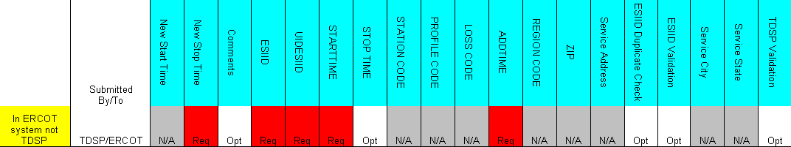

6.1.4.2.2 Example of Existence – In ERCOT system not TDSP

- Select the Submit tab
- From the Submit Tree, select In ERCOT system not TDSP
- The following fields must be populated for successful submission:
New STOPTIME
ESIID
UIDESIID
STARTTIME (STARTTIME - SCR727 Extract)
ADDTIME (ADDTIME - SCR727 Extract)
- Select OK
- The issue enters ERCOT’s queue in the state of New
- The TDSP only may Withdraw the issue prior to acknowledgement by ERCOT
- ERCOT selects Begin Working and the TDSP can no longer Withdraw the issue
- ERCOT has the options of Complete, Unexecutable and Intervention by ERCOT.
Intervention by ERCOT is used only by ERCOT to close the issue regardless of who is the Responsible MP.
- If in agreement, ERCOT will take appropriate action and select Complete which transitions the issue to Pending Complete with the TDSP
- The TDSP selects Complete and the issue is closed
- If not in agreement, ERCOT may select Unexecutable which will require a comment and return the issue back to TDSP’s queue as Unexecutable (Pending Complete).
- TDSP will add comment and select Pending Complete
- ERCOT will select Accept and issue will be closed.
- Once in the Pending Complete state, if the issue is not transitioned for 14 calendar days the issue will automatically go to Auto Complete. The issue will then be closed.

DEV Issues – Existence – In ERCOT with start date issues
TDSP to ERCOT
The DEV issue In ERCOT with start date issues should be submitted when the ESI ID is in the data extract from ERCOT and in the TDSP’s system, but there is an issue with the STARTTIME of the ESI ID.

Action: ERCOT needs to update ESI ID start date

The ESIID needs to have the start date updated in ERCOT systems, which cannot be performed via the 814_20.

CRs cannot file a Data Extract Variance for ESI ID Existence. If a CR believes that an ESI ID should exist at ERCOT with a different start date, then the CR should file a Variance Issue regarding the Start Time of an LSE relationship.

No activity should occur prior to the start date of the ESI ID as provided by the TDSP. Meaning, LSE relationships cannot begin prior to the Start Time of an ESI ID.

The STARTTIME in the ESI ID table is the begin date provided in the 814_20 Add. The STARTTIME of the first ESIIDSERVICEHIST row with the Status of ‘D’ is the date the ESI ID is ready to be energized (equivalent to the DTM~196 Start Date in 814_20 Add).

6.1.4.3.1 Required fields for Existence – In ERCOT with start date issues

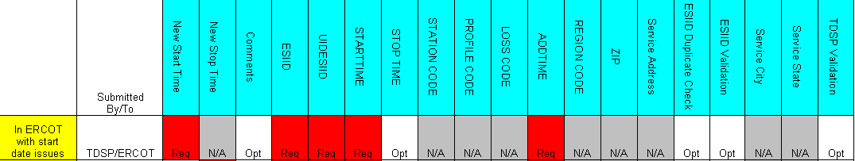

6.1.4.3.2 Example of Existence – In ERCOT with start date issues

- TDSP selects Submit tab
- From the Submit Tree, select In ERCOT with start date issues
- The following fields must be populated for successful submission:
New STARTTIME
ESIID
UIDESIID
STARTTIME (STARTTIME - SCR727 Extract)
ADDTIME (ADDTIME - SCR727 Extract)

- Select OK
- The issue enters ERCOT’s queue in the state of New
- The TDSP only may Withdraw the issue prior to acknowledgement by ERCOT
- ERCOT selects Begin Working and the TDSP can no longer Withdraw the issue
- ERCOT has the options of Complete, Unexecutable and Intervention by ERCOT. Intervention by ERCOT is used only by ERCOT to close the issue regardless of who is the Responsible MP
- If in agreement, ERCOT will take appropriate action and select Complete which transitions the issue to Pending Complete with the TDSP
- The TDSP selects Complete and the issue is closed
- If not in agreement, ERCOT may select Unexecutable which will require a comment and return the issue back to TDSP’s queue as Unexecutable (Pending Complete).
- TDSP will add comment and select Pending Complete.
- ERCOT will select Accept and issue will be closed.
- Once in the Pending Complete state, if the issue is not transitioned for 14 calendar days the issue will automatically go to Auto Complete. The issue will then be closed.

DEV Issues – Existence – Inactive record has date issues
TDSP to ERCOT
The DEV issue Inactive record has date issues should be submitted when the ESI ID is in the data extract from ERCOT and in the MP’s system, but there is an issue with the STARTTIME of the ESI ID Inactive ESIIDSERVICEHIST record. This date is equivalent to one day greater than the End Date in the 814_20 Retire.

Action: ERCOT needs to update ESI ID inactive status effective date
The ESIID inactive status effective date needs to be updated in ERCOT systems, which cannot be performed via 814_20 transactions.
CRs cannot file a Data Extract Variance for ESI ID existence or status. If a CR believes that an ESI ID should no longer exist at ERCOT, then the CR should file a Variance Issue regarding the Stop Time of an LSE relationship.
The STOPTIME in the ESIID table is the end date provided in the 814_20 Retire plus 23:59:59. The STARTTIME of the ESIIDSERVICEHIST row with the Status of ‘I’ is 1 second greater than the ESI ID Stoptime (equivalent to one day greater than the DTM~197 End Date in 814_20Retire.

Required fields for Existence – Inactive record has date issues
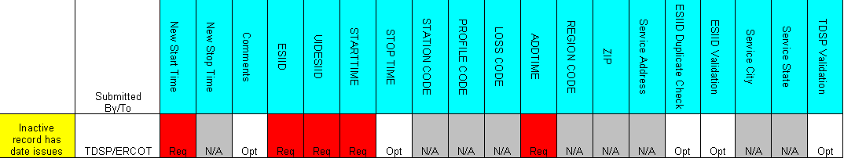

6.1.4.4.2 Example of Existence – Inactive record has date issues

- Select the Submit tab
- From the Submit Tree, select Inactive record has date issues
- The following fields must be populated for successful submission:
New STARTTIME
ESIID
UIDESIID
STARTTIME (STARTTIME - SCR727 Extract)
ADDTIME (ADDTIME - SCR727 Extract)
- Select OK
- The issue enters ERCOT’s queue in the state of New
- The TDSP only may Withdraw the issue prior to acknowledgement by ERCOT
- ERCOT selects Begin Working and the TDSP can no longer Withdraw the issue
- ERCOT has the options of Complete, Unexecutable and Intervention by ERCOT. Intervention by ERCOT is used only by ERCOT to close the issue regardless of who is the Responsible MP.
- If in agreement ERCOT will take appropriate action and select Complete which transitions the issue to Pending Complete with the TDSP
- The TDSP selects Complete and the issue is closed
- If not in agreement ERCOT may select Unexecutable which will require a comment and return the issue back to TDSP’s queue as Unexecutable (Pending Complete).
- TDSP will add comment and select Pending Complete.
- ERCOT will select Accept and issue will be closed.

- Once in the Pending Complete state, if the issue is not transitioned for 14 calendar days the issue will automatically go to Auto Complete. The issue will then be closed.

DEV Issues – Existence – Status Assignment
TDSP to ERCOT
The DEV issue Status Assignment should be submitted when the TDSP needs to change the status of the ESIID to Inactive.

Action: ERCOT needs to change status of ESI ID to Inactive as of new start time

CRs cannot file a Data Extract Variance for ESI ID existence. If a CR believes that an ESI ID should be inactive, then the CR should file a Variance Issue regarding the Stop Time of an LSE relationship.

TDSP cannot de-energize and retire/inactivate an ESI ID at the same time. If the ESI ID needs to be de-energized, the TDSP/CR should file a Variance Issue regarding the Stop Time of the last relationship record. Once that Variance Issue has been completed, then the MPs should resume using normal transactions to retire the ESI ID (i.e. 814_20 Retire).

6.1.4.5.1 Required fields for Existence – Status Assignment

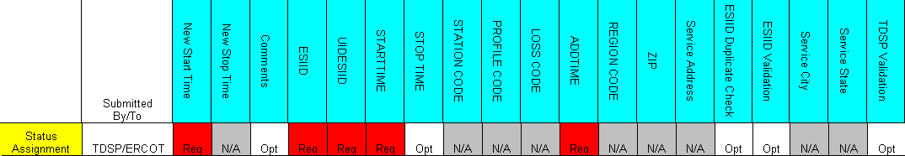

6.1.4.5.2 Example of Existence – Status Assignment

- Select Submit tab
- From the Submit Tree, select Status Assignment
- The following fields must be populated for successful submission:
New STARTTIME
ESIID
UIDESIID
STARTTIME (STARTTIME - SCR727 Extract)
ADDTIME (ADDTIME - SCR727 Extract)
- Select OK
- The issue enters ERCOT’s queue in the state of New
- The TDSP only may Withdraw the issue prior to acknowledgement by ERCOT
- ERCOT selects Begin Working and the TDSP can no longer Withdraw the issue
- ERCOT has the options of Complete, Unexecutable and Intervention by ERCOT. Intervention by ERCOT is used only by ERCOT to close the issue regardless of who is the Responsible MP.
- If in agreement ERCOT will take appropriate action and select Complete which transitions the issue to Pending Complete with the TDSP
- The TDSP selects Complete and the issue is closed
- If not in agreement, ERCOT may select Unexecutable which will require a comment and return the issue back to TDSP’s queue as Unexecutable (Pending Complete).
- TDSP will select Accept and issue will be closed.
- Once in the Pending Complete state, if the issue is not transitioned for 14 calendar days the issue will go to automatically Auto Complete. The issue will then be closed.

DEV Issues – Existence – Un Retire ESI ID
TDSP to ERCOT
The DEV issue Un-Retire ESI ID should be submitted when the TDSP needs to update Inactive ESIID from status Inactive to De-energize.

Action: ERCOT needs to update inactive ESI ID to De-energized

CRs cannot file a Data Extract Variance for ESI ID existence. If a CR believes that the status of an ESI ID should be active, then the CR should file the appropriate LSE DEV to ERCOT.
ERCOT will remove stop time of ESI ID and update all ESIIDServicehistory status ‘I’ rows to ‘D’.

TDSP must use the minimum start time row in a status of ‘I’ when reporting the extract variance to ERCOT.

TDSP must send appropriate characteristic changes and usage transactions to ERCOT to bring the ESI ID information to current.

6.1.4.6.1 Required fields for Existence – Un-Retire ESI ID

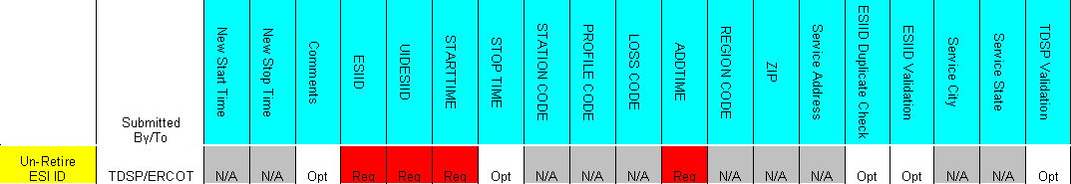

6.1.4.6.2 Example of Existence – Un-Retire ESIID

- Select Submit tab
- From the Submit Tree, select Un-Retire ESIID
- The following fields must be populated for successful submission:
ESIID
UIDESIID
STARTTIME (STARTTIME - SCR727 Extract)
ADDTIME (ADDTIME - SCR727 Extract)
- Select OK
- The issue enters ERCOT’s queue in the state of New
- The TDSP only may Withdraw the issue prior to acknowledgement by ERCOT
- ERCOT selects Begin Working and the TDSP can no longer Withdraw the issue
- ERCOT has the options of Complete, Unexecutable and Intervention by ERCOT. Intervention by ERCOT is used only by ERCOT to close the issue regardless of who is the Responsible MP.
- If in agreement, ERCOT will take appropriate action and select Complete which transitions the issue to Pending Complete with the TDSP
- The TDSP selects Complete and the issue is closed
- If not in agreement, ERCOT may select Unexecutable which will require a comment and return the issue back to TDSP’s queue as Unexecutable (Pending Complete).
- TDSP will add comment and select Pending Complete.
- ERCOT will select Accept and issue will be closed.
- Once in the Pending Complete state, if the issue is not transitioned for 14 calendar days the issue will automatically go to Auto Complete. The issue will then be closed.

ESI ID Characteristic DEV Issues
*** This applies to all Characteristic, IDR and Non-IDR DEVs. Corrected ‘Assignee’ on the grid. Striked through OPT and added ‘Req.’ This field is NOT Optional via Bulk Insert nor the GUI. If the TDSP is the Submitter (ERCOT) is auto populated but still required. Therefore, I believe ‘Req’ should be in the grid under ‘Assignee’. ***

ESI ID Characteristic DEV issues are issues filed by MPs regarding the characteristics assigned (i.e. Profile Code, Zip Code, etc.) to an ESI ID in ERCOT systems. For CR to TDSP issues, the CR is requesting the TDSP to submit an 814_20 MAINTAIN to ERCOT to reconcile the characteristic discrepancy between ERCOT systems and CR systems. For TDSP to ERCOT issues, the TDSP is requesting ERCOT to manually update the characteristics in ERCOT systems due to an 814_20 processing exception in ERCOT systems.

DEV Issues – Characteristics – Region Code Assignment
TDSP to ERCOT or CR to TDSP
The DEV Issue of Region Code Assignment should be submitted when the ESI ID is in the data extract from ERCOT and in the MP’s system, but there is an issue with the REGIONCODE of the ESI ID.

Action: Need to update REGIONCODE with new effective date

CR should contact TDSP if they believe an ESI ID has been assigned an incorrect Region Code.

The STARTTIME of an update in the ESIIDSERVICEHIST row is equivalent to the DTM~152 Effective Date of Change in 814_20 Maintain.

Assignee field:
For TDSP to ERCOT – Assignee will auto populate with ERCOT
For CR to TDSP - Assignee will be required for submission
The Assignee can be located by using the search feature through the ‘Find’ button by typing in all or part of the MPs name or DUNS number. The Comments field is optional.

6.1.5.1.1 Required fields for Characteristics – Region Code Assignment

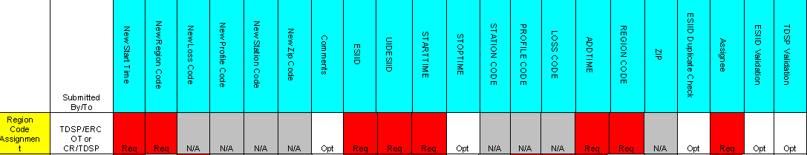

6.1.5.1.2 Example of Characteristics – Region Code Assingment

Example: TDSP submits Region Code Assignment to ERCOT

- Select the Submit tab (Fig 11.6a)
- From the Submit Tree, select Region Code Assignment
Fig 11.6a
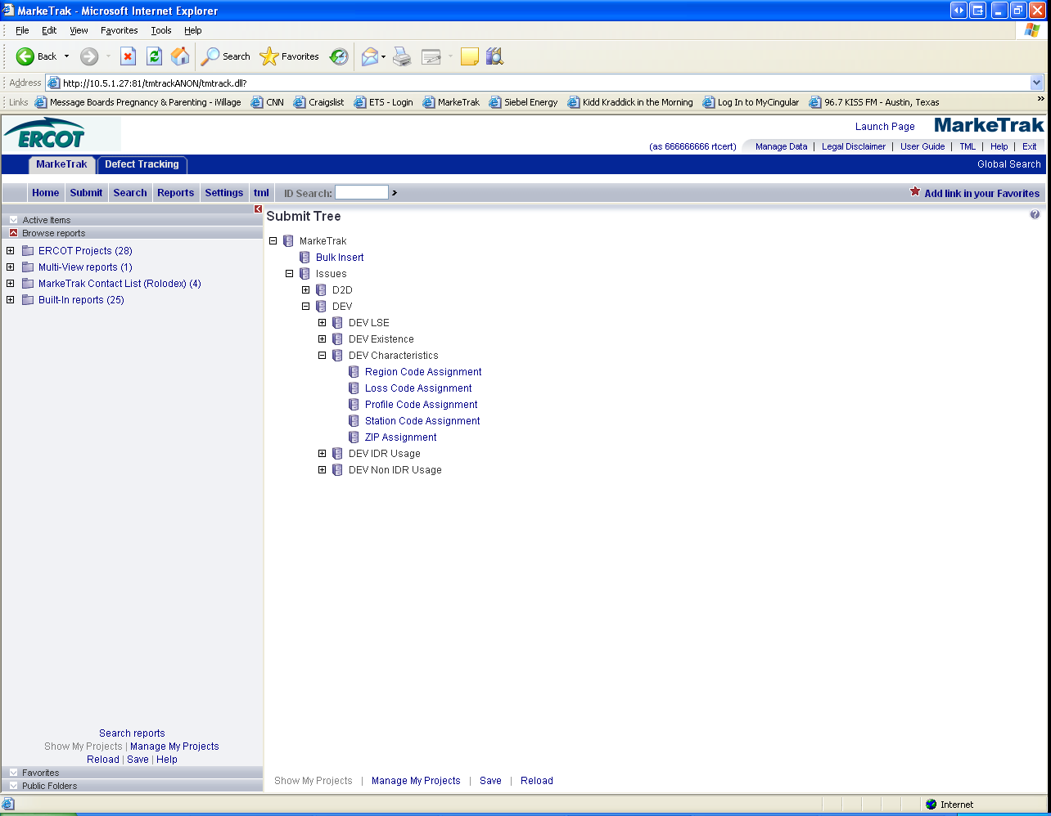
The following fields must be populated for successful submission:
New STARTTIME
New REGIONCODE
ESIID
UIDESIID
STARTTIME (STARTTIME - SCR727 Extract)
ADDTIME (ADDTIME – SCR727 Extract)
REGIONCODE
- Select OK (Fig 11.6b)
Fig 11.6b
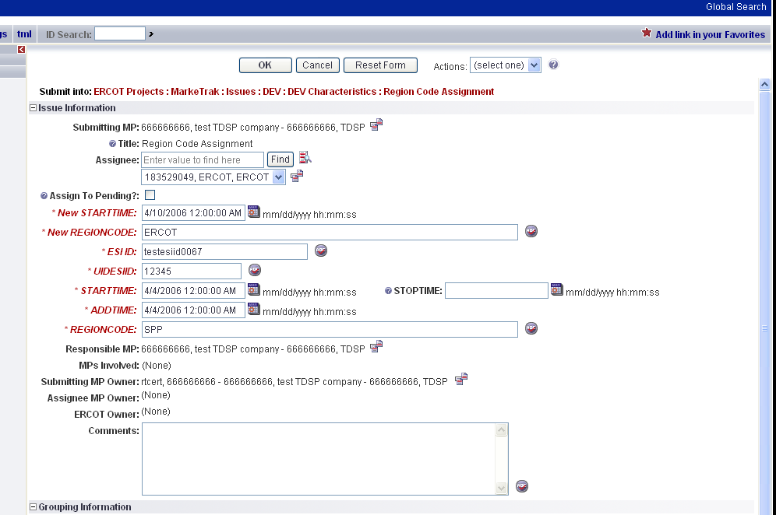

- The issue enters ERCOT’s queue in the state of New.
5. The TDSP only may Withdraw the issue prior to acknowledgement by ERCOT. (Fig 11.6c) Fig 11.6c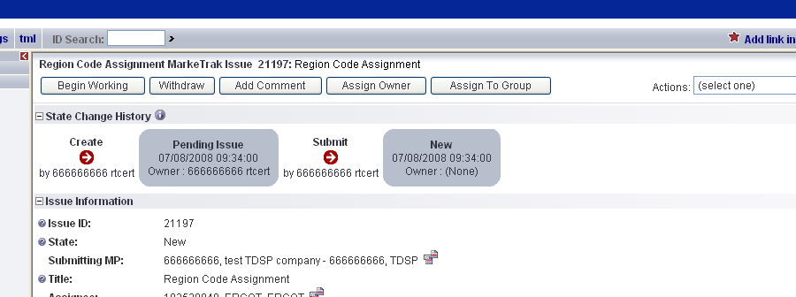
- ERCOT selects Begin Working and the TDSP can no longer Withdraw the issue. (Fig 11.6d)
Fig 11.6d
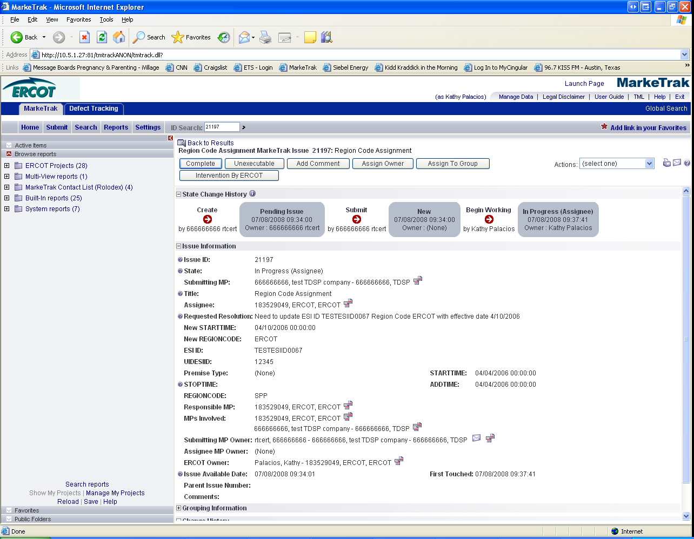

- 6. ERCOT has the options of Complete, Unexecutable and Intervention by ERCOT. Intervention by ERCOT is used only by ERCOT to close the issue regardless of who is the Responsible MP. (Fig 11.6e)
Fig 11.6e

- If in agreement, ERCOT will take appropriate action and select Complete which transitions the issue to Pending Complete with the TDSP. (Fig 11.6f)
Fig 11.6f
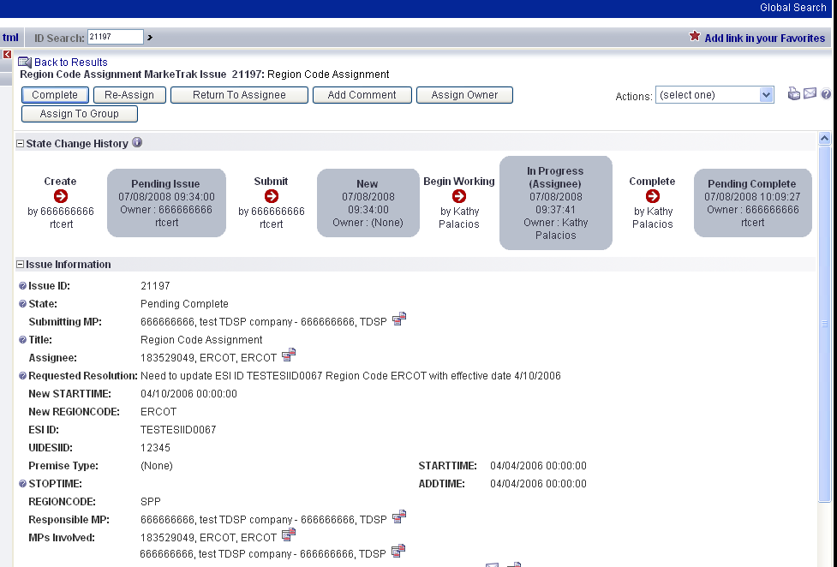

- The TDSP selects Complete and the issue is closed
- If not in agreement ERCOT may:
  - Select Unexecutable which will require a comment and return the issue back to TDSP’s queue as Unexecutable (Pending Complete).
- The TDSP selects Accept and the issue is closed
- Once in the Pending Complete state, if the issue is not transitioned for 14 calendar days the issue will automatically go to Auto Complete. The issue will then be closed.

DEV Issues – Characteristics – Loss Code Assignment
TDSP to ERCOT or CR to TDSP
The DEV issue of Loss Code Assignment should be submitted when the ESI ID is in the data extract from ERCOT and in the MP’s system, but there is an issue with the LOSSCODE of the ESI ID.

Action: Need to update Loss Code with new effective date

.

The STARTTIME of an update in the ESIIDSERVICEHIST row is equivalent to the DTM~152 Effective Date of Change in 814_20 Maintain.

Assignee field:
For TDSP to ERCOT – Assignee will auto populate with ERCOT
For CR to TDSP - Assignee will be required for submission
The Assignee can be located by using the search feature through the ‘Find’ button by typing in all or part of the MPs name or DUNS number. The Comments field is optional.

6.1.5.2.1 Required fields for Characteristics – Loss Code Assignment

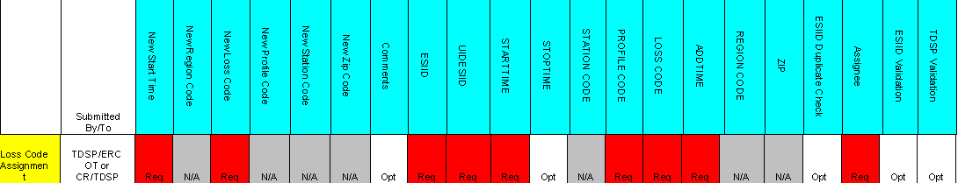

6.1.5.2.2 Example of Characteristics – Loss Code Assignment

Example: TDSP submits Loss Code Assignment to ERCOT

- Select the Submit tab (Fig 11.7a)
- From the Submit Tree, select Loss Code Assignment
Fig11.7a
- The following fields must be populated for successful submission:
New STARTTIME
New LOSSCODE
ESIID
UIDESIID
STARTTIME (STARTTIME - SCR727 Extract)
PROFILECODE (PROFILECODE – SCR727 Extract)
LOSS CODE (LOSSCODE – SCR727 Extract)
ADDTIME (ADDTIME – SCR727 Extract)
- Select OK (Fig11.7b)

Fig11.7b
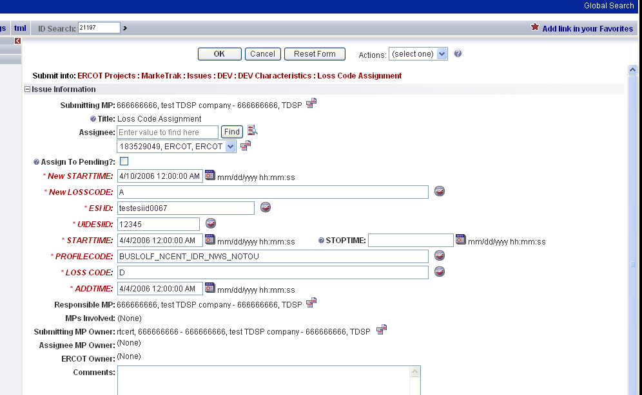

Note: Refer to screen shots Fig 11.6c-11.6f for the remaining steps

- The issue enters ERCOT’s queue in the state of New
- The TDSP only may Withdraw the issue prior to acknowledgement by ERCOT
- ERCOT selects Begin Working and the TDSP can no longer Withdraw the issue
- ERCOT has the options of Complete, Unexecutable and Intervention by ERCOT. Intervention by ERCOT is used only by ERCOT to close the issue regardless of who is the Responsible MP.
- If in agreement, ERCOT will take appropriate action and select Complete which transitions the issue to Pending Complete with the TDSP
- The TDSP selects Complete and the issue is closed
- If not in agreement, ERCOT may:

  - Select Unexecutable which will require a comment and return the issue back to TDSP’s queue as Unexecutable (Pending Complete).
- The TDSP will select Accept and issue will be closed.
- Once in the Pending Complete state, if the issue is not transitioned for 14 calendar days the issue will automatically go to Auto Complete. The issue will then be closed.

Example: CR submits Loss Code Assignment to TDSP

- Select the Submit tab
- From the Submit Tree, select Loss Code Assignment.
- The following fields must be populated for successful submission:

New STARTTIME
New LOSSCODE
Assignee
ESIID
UIDESIID
STARTTIME (STARTTIME - SCR727 Extract)
PROFILECODE (PROFILECODE – SCR727 Extract)
LOSS CODE (LOSSCODE – SCR727 Extract)
ADDTIME (ADDTIME – SCR727 Extract)

- Select OK
- The issue enters TDPS’s queue in the state of New
- The CR only may Withdraw the issue prior to acknowledgement by TDSP
- TDSP selects Begin Working and the CR can no longer Withdraw the issue
- TDSP has the options of Complete and Unexecutable.
- If in agreement the TDSP will take appropriate action and select Complete which transitions the issue to Pending Complete with the CR
- The CR selects Complete and the issue is closed
- If not in agreement the TDSP may:
  - Select Unexecutable which will require a comment and return the issue back to the CR’s queue as Unexecutable (Pending Complete).
- CR will select Accept and issue will be closed.
- Once in the Pending Complete state, if the issue is not transitioned for 14 calendar days the issue will automatically go to Auto Complete. The issue will then be closed.

DEV Issues – Characteristics – Profile Code Assignment
TDSP to ERCOT or CR to TDSP
The DEV issue of Profile Code Assignment should be submitted when the ESI ID is in the data extract from ERCOT and in the MP’s system, but there is an issue with the PROFILECODE of the ESI ID.

Action: Need to update Profile Code with new effective date

The STARTTIME of an update in the ESIIDSERVICEHIST row is equivalent to the DTM~152 Effective Date of Change in 814_20 Maintain.

Assignee field:
For TDSP to ERCOT – Assignee will auto populate with ERCOT
For CR to TDSP - Assignee will be required for submission
The Assignee can be located by using the search feature through the ‘Find’ button by typing in all or part of the MPs name or DUNS number. The Comments field is optional.

6.1.5.3.1 Required fields for Characteristics – Profile Code Assignment

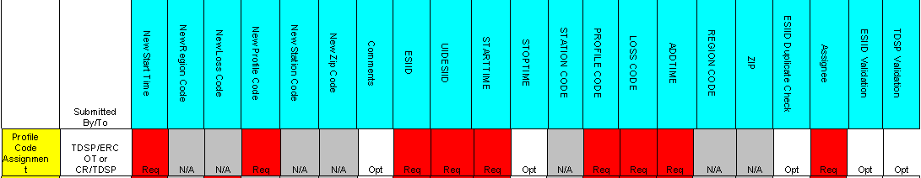

6.1.5.3.2 Example of Characteristics – Profile Code Assignment
Example: CR submits Profile Code Assignment to TDSP

- Select the Submit tab (Fig 11.8a)
- From the Submit Tree, select Profile Code Assignment
Fig 11.8a

- The following fields must be populated for successful submission:
New STARTTIME
New PROFILECODE
ESIID
ASSIGNEE
UIDESIID
STARTTIME (STARTTIME - SCR727 Extract)
PROFILECODE (PROFILECODE - SCR727 Extract)
LOSS CODE (LOSSCODE - SCR727 Extract)
ADDTIME (ADDTIME - SCR727 Extract)
Fig 11.8b
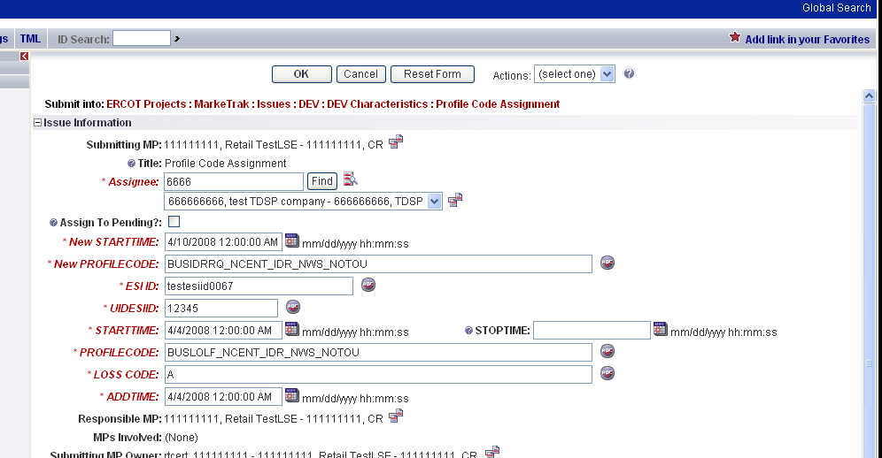

Note: Reference screen shots Fig 11.6c-11.6f for the remaining steps

- Select OK (Fig 11.8b)
- The issue enters the TDSP’s queue in the state of New
- The CR only may Withdraw the issue prior to acknowledgement by the TDSP
- TDSP selects Begin Working and the CR can no longer Withdraw the issue
- TDSP has the options of Complete and Unexecutable.
- If in agreement the TDSP will take appropriate action and select Complete which transitions the issue to Pending Complete with the CR
- The CR selects Complete and the issue is closed
- If not in agreement the TDSP may:
  - Select Unexecutable which will require a comment and return the issue back to the CR’s queue as Unexecutable (Pending Complete).
- CR will select Accept and issue will be closed.
- Once in the Pending Complete state, if the issue is not transitioned for 14 calendar days the issue will automatically Auto Complete. The issue will then be closed.

DEV Issues – Characteristics – Station Code Assignment
TDSP to ERCOT or CR to TDSP
The DEV issue of Station Code Assignment should be submitted when the ESI ID is in the data extract from ERCOT and in the MP’s system, but there is an issue with the STATIONCODE of the ESI ID.

Action: Need to update Station Code with new effective date

The STARTTIME of an update in the ESIIDSERVICEHIST row is equivalent to the DTM~152 Effective Date of Change in 814_20 Maintain.

Assignee field:
For TDSP to ERCOT – Assignee will auto populate with ERCOT
For CR to TDSP - Assignee will be required for submission
The Assignee can be located by using the search feature through the ‘Find’ button by typing in all or part of the MPs name or DUNS number. The Comments field is optional.

Required fields for Characteristics – Station Code Assignment

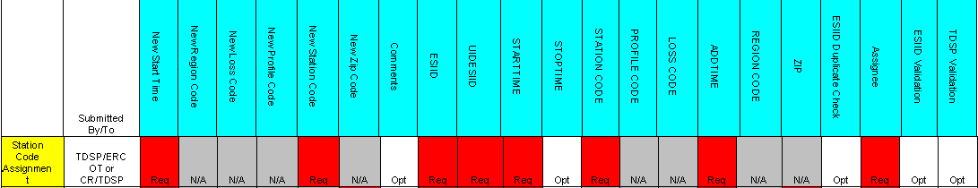

Example of Characteristics – Station Code Assignment
Example: CR submits Station Code Assignment to TDSP

- Select the Submit tab (Fig 11.9a)
- From the Submit Tree, select Station Code Assignment

Fig11.9a
- The following fields must be populated for successful submission:
New STARTTIME
New STATIONCODE
ESIID
ASSIGNEE
UIDESIID
STARTTIME (STARTTIME - SCR727 Extract)
STATIONCODE (STATIONCODE - SCR727 Extract)
ADDTIME (ADDTIME - SCR727 Extract)
Fig 11.9b
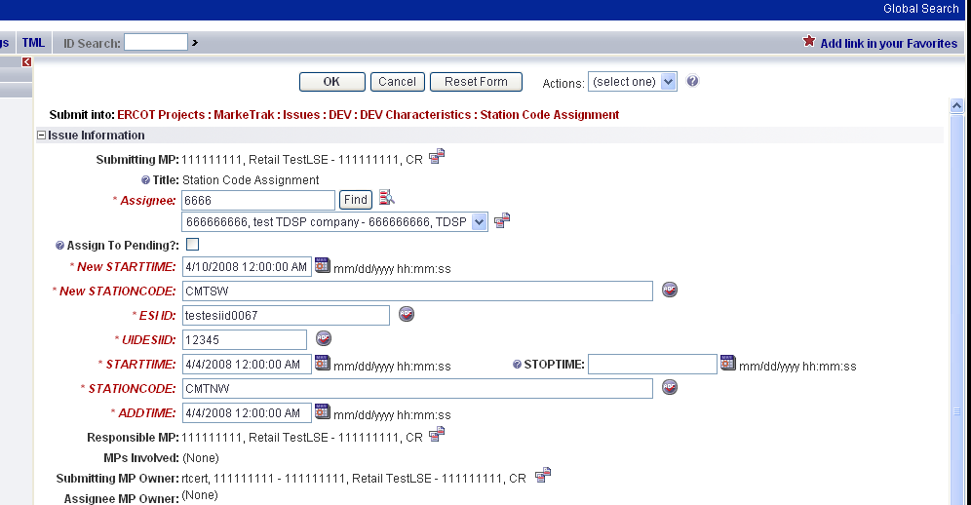
Note: Reference screen shots Fig 11.6c-11.6f for the remaining steps

- Select OK (Fig 11.9b)
- The issue enters the TDSP’s queue in the state of New
- The CR only may Withdraw the issue prior to acknowledgement by the TDSP
- TDSP selects Begin Working and the CR can no longer Withdraw the issue
- TDSP has the options of Complete and Unexecutable.
- If in agreement the TDSP will take appropriate action and select Complete which transitions the issue to Pending Complete with the CR
- The CR selects Complete and the issue is closed
- If not in agreement the TDSP may:
  - Select Unexecutable which will require a comment and return the issue back to CR’s queue as Unexecutable (Pending Complete)
12. CR will select Accept and issue will be closed.
13. Once in the Pending Complete state, if the issue is not transitioned for 14 calendar days the issue will automatically go to Auto Complete. The issue will then be closed.

DEV Issues – Characteristics – Zip Assignment

TDSP to ERCOT or CR to TDSP
The DEV issue of ZIP Assignment should be submitted when the ESI ID is in the data extract from ERCOT and in the MP’s system, but there is an issue with the ZIP of the ESI ID.

Action: Need to update Zip Code with new effective date

The STARTTIME of an update in the ESIIDSERVICEHIST row is equivalent to the DTM~152 Effective Date of Change in 814_20 Maintain.

Assignee field:
For TDSP to ERCOT – Assignee will auto populate with ERCOT
For CR to TDSP - Assignee will be required for submission
The Assignee can be located by using the search feature through the ‘Find’ button by typing in all or part of the MPs name or DUNS number. The Comments field is optional.

6.1.5.5.1 Required fields for Characteristics – Zip Assignment

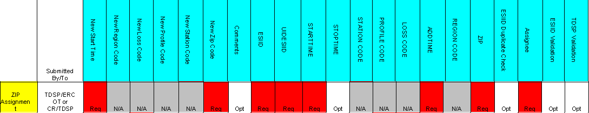

6.1.5.5.2 Example of Characteristics – ZIP Assignment
Example: CR submits ZIP Assignment to TDSP

- Select the Submit tab (Fig 11.10a)
- From the Submit Tree, select ZIP Assignment
Fig 11.10a
- The following fields must be populated for successful submission:
New STARTTIME
New ZIPCODE
ESIID
ASSIGNEE
UIDESIID
STARTTIME (STARTTIME - SCR727 Extract)
ADDTIME (ADDTIME - SCR727 Extract)
ZIP (ZIPCODE - SCR727 Extract)

Fig 11.10b
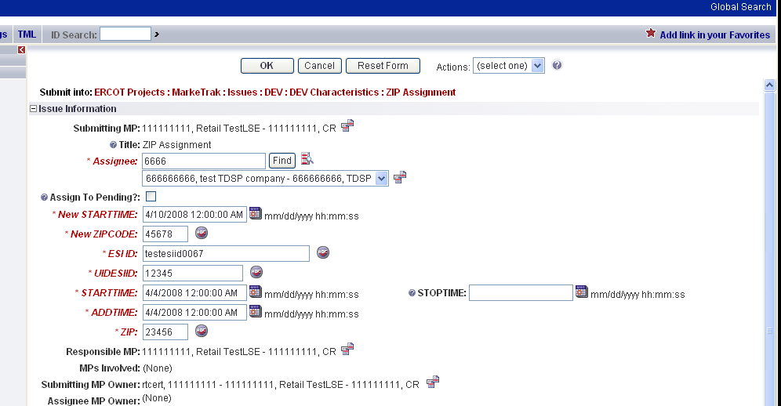

Note: Reference screen shots Fig 11.6c-11.6f for the remaining steps

- Select OK (Fig 11.10b)
- The issue enters the TDSP’s queue in the state of New
- The CR only may Withdraw the issue prior to acknowledgement by the TDSP
- TDSP selects Begin Working and the CR can no longer Withdraw the issue
- TDSP has the options of: Complete and Unexecutable.
- If in agreement TDSP will take appropriate action and select Complete which transitions the issue to Pending Complete with the CR
- The CR selects Complete and the issue is closed
- If not in agreement the TDSP may:
  - Select Unexecutable which will require a comment and return the issue back to the CR’s queue as Unexecutable (Pending Complete).
- CR will select Accept and issue will be closed.
- Once in the Pending Complete state, if the issue is not transitioned for 14 calendar days the issue will automatically go to Auto Complete. The issue will then be closed.

Usage DEV Issues

Usage DEV issues must be submitted by meter type (IDR/Non-IDR) and Issue Type. ERCOT Data Extract Usage Variances may only be submitted to ERCOT by TDSPs. The TDSPs will not be able to assign a party for the variance. Usage Variances that are CR to TDSP should include only the ESI IDs for the resolving TDSP and must be filed as Data Extract Variance – Usage Issues (IDR/Non-IDR).

*** IDR usage rows with an ORIGIN of ‘C’ or ‘G’ are calculated by ERCOT. These usage rows should NOT be filed as DEV IDR Usage ‘In ERCOT system not MP’ Variance Issues. ***

Requests to load negative usage will be rejected.

For all Usage DEV issues that require changes to usage data or loading of missing data at ERCOT into Lodestar per the resolution, the TDSP should send the usage to ERCOT in accordance with the 867_03 usage loading validations. These validations are performed whether the data is submitted via transaction or file for manual loading. The issue shall not be marked as Complete until the corrected usage has properly loaded into ERCOT systems.

For all Usage DEV issues that require changes to usage data or loading of missing data into the CR’s system per the resolution, the TDSP shall confirm that a TX SET compliant 867_03 transaction was sent with the variance issue submitter as the forwarding DUNS number for the usage in question. If it is determined that the CR needs the 867_03 for customer billing purposes, the TDSP shall send the requested usage.

For Usage DEV issue type DEV IDR/Non IDR Usage ‘In MP system not in ERCOT’ the following processes shall be followed:

Situation 1: If the TDSP confirms via the ESI ID Extract that usage is loaded at ERCOT and matches the usage in the TDSP system, the TDSP shall transition the issue back to the CR as Unexecutable with comments and/or transactions submitted for explanation.

Situation 2: The TDSP will transition the issue back to the CR for assignment to ERCOT for assignment (Assign Owner) SIR (10908) if ALL the following conditions are met:

- The TDSP determines via the ESI ID Extract that usage data is not loaded at ERCOT.
- The TDSP confirms ERCOT acknowledged acceptance of the transaction(s) in all levels of the 997 response.
- The TDSP determine the usage was reported as loaded successfully via the 867_03 activity report as of August 6, 2003.

Situation 3: The TDSP shall submit usage data to ERCOT via transaction in cases where either condition (b) or (c) above is not met. The issue shall not be marked as Complete until such usage data has been properly loaded into ERCOT systems.

For Usage DEV issues filed by the TDSP to ERCOT that result in manual loading or correction of usage by ERCOT, it is the TDSP’s responsibility to communicate any changes to the appropriate CR(s). Neither ERCOT nor the TDSP shall mark the issue as Resolved until the necessary changes have been completed.

Changes made to Usage records where usage is currently loaded at ERCOT in either the LSCHANNELCUTHEADER or ESIIDUSAGE must cover the entire time period in error to prevent the creation of usage gaps.

***NOTE: Validate TDSP is Associated with Issue will be applied to ALL DEV submissions

***NOTE: The Submitter will be allowed to ‘CLOSE’ a DEV issue IF the Submitter is the Responsible Party.

DEV Issues – IDR – In MP system not ERCOT
CR to TDSP
The DEV issue of In MP system not ERCOT should be submitted when the ESI ID IDR meter data is in the MP’s system, but not in the data extract from ERCOT.

Action: IDR Usage needs to be loaded at ERCOT.

Situation 1: If the TDSP confirms via the ESI ID Extract that usage is loaded at ERCOT and matches the usage in the TDSP system, the TDSP shall transition the issue back to the CR as Unexecutable with comments and/or transactions submitted for explanation.

Situation 2: The TDSP will transition the issue back to the CR for assignment to ERCOT for assignment (Assign Owner) SIR (10908) if ALL the following conditions are met:
- The TDSP determines via the ESI ID Extract that usage data is not loaded at ERCOT,
- The TDSP confirms ERCOT acknowledged acceptance of the transaction(s) in all levels of the 997 response, and
- The TDSP determine the usage was reported as loaded successfully via the 867_03 activity report as of August 6, 2003.

Situation 3: The TDSP shall submit usage data to ERCOT via transaction in cases where either condition (b) or (c) above is not met. The issue shall not be marked as Complete until such usage data has been properly loaded into ERCOT systems.
If the TDSP determines that the usage data is not loaded at ERCOT, then the TDSP is responsible for submitting the usage data to ERCOT via transaction.

TDSP to ERCOT
The TDSP will submit In MP system not ERCOT to ERCOT if ALL the above conditions in Situation 2 are met.

For all Usage Variance Issues that require changes to usage data or loading of missing data at ERCOT into Lodestar per the resolution, the TDSP should send the usage to ERCOT in accordance with the 867_03 usage loading validations. These validations are performed whether the data is submitted via transaction or file for manual loading.

It is the TDSP’s responsibility to communicate all ESI ID Service History and Usage (IDR and Non-IDR) data changes to the appropriate CR(s).

Requests to load negative usage will be rejected.

Assignee field:
For TDSP to ERCOT – Assignee will auto populate with ERCOT
For CR to TDSP - Assignee will be required for submission
The Assignee can be located by using the search feature through the ‘Find’ button by typing in all or part of the MPs name or DUNS number. The Comments field is optional.

DEV Issues – IDR – In MP system not ERCOT
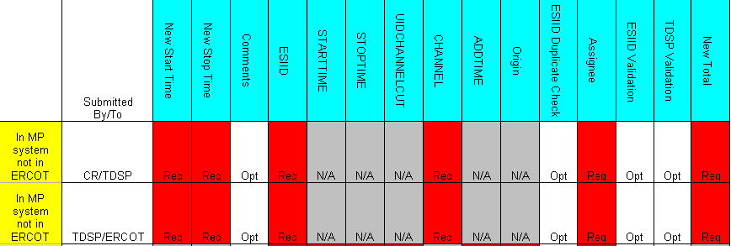

Example of IDR – In MP system not ERCOT

Example: CR submits In MP system not ERCOT to TDSP

      - Select the Submit tab. (Fig 11.7.1a)
      - From the Submit Tree, select In MP system not ERCOT
Fig 11.7.1a
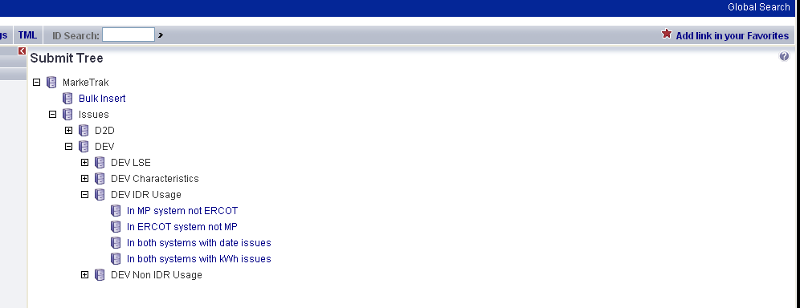
      - The following fields must be populated for successful submission:
Assignee
New STARTTIME
New STOPTIME
ESIID
CHANNEL – CR to TDSP CHANNEL should = ‘4’
New Total

      - Select OK (Fig 11.7.1b)
Fig 11.7.1b
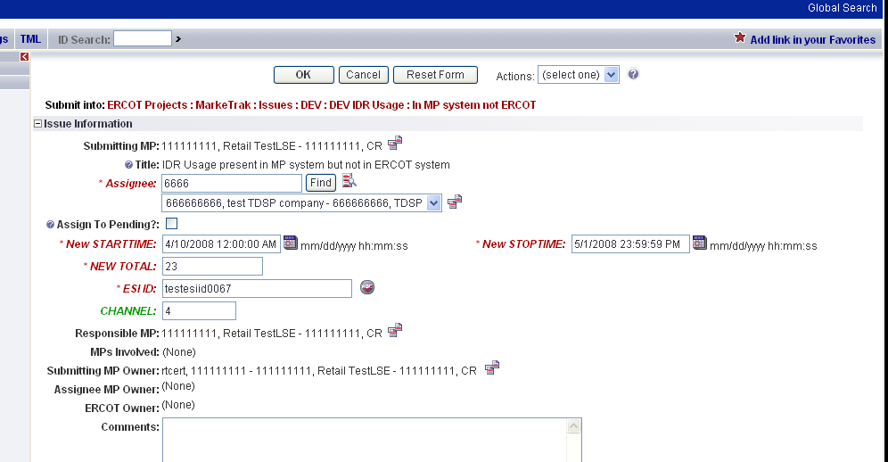

      - The issue enters TDSP’s queue in the state of New. (Fig 11.7.1c)
      - The CR only may Withdraw the issue prior to acknowledgement by the TDSP
Fig 11.7.1c
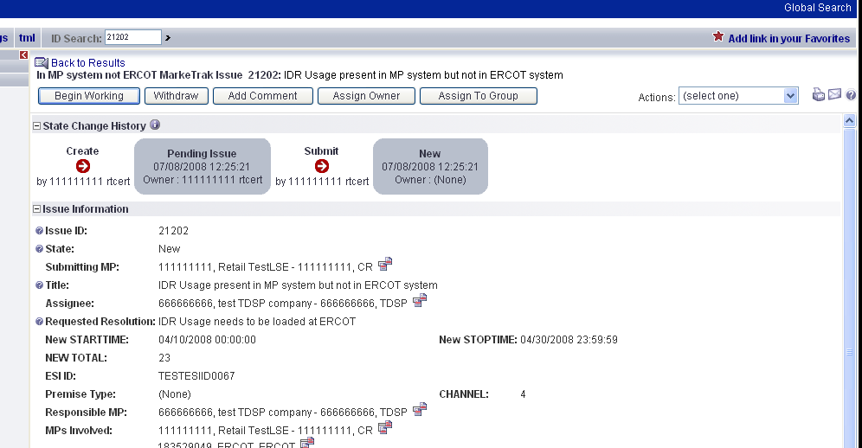

      - TDSP selects Begin Working and the CR can no longer Withdraw the issue. (Fig 11.7.1d)
Fig 11.7.1d
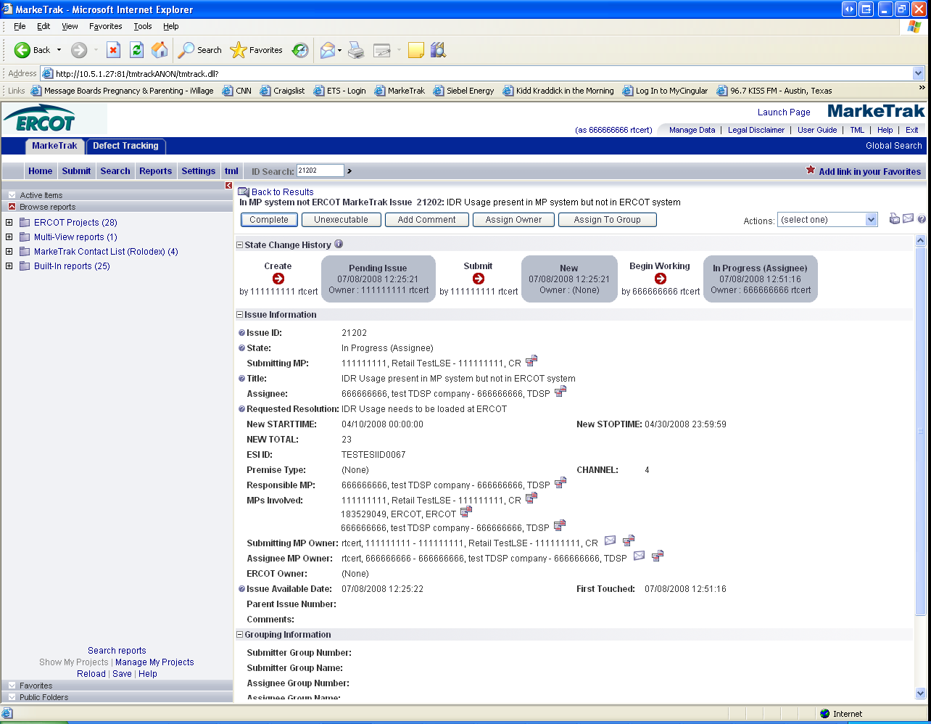

      - TDSP has the options of Complete and Unexecutable. (Fig 11.7.1e)
Fig 11.7.1e
      - If in agreement TDSP will take appropriate action then select Complete which transitions the issue to Pending Complete with the CR. (Fig 11.7.1f)
Fig 11.7.1f
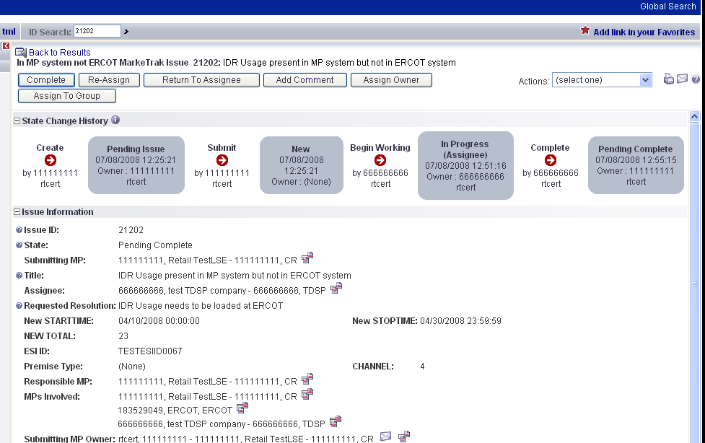

      - The CR selects Complete and the issue is closed
      - If not in agreement the TDSP may:
  - Select Unexecutable which will require a comment and return the issue back to the CR’s queue as Unexecutable (Pending Complete).
      - CR will select Accept and issue will be closed.
      - Once in the Pending Complete state, if the issue is not transitioned for 14 calendar days the issue will automatically go to Auto Complete. The issue will then be closed.

NOTE: CR to TDSP submissions, the channel will auto populate with ‘4’. For TDSP to ERCOT submissions, TDSP must enter value ‘1’ or ‘4’.

DEV Issues – IDR – In ERCOT system not MP
The DEV issue of In ERCOT system not MP should be submitted when the ESI ID IDR meter data is in the data extract from ERCOT, but not in the MP’s system.

TDSP to ERCOT
Action: Data needs to be cancelled from ERCOT system.

CR to TDSP
Prior to correcting or resending usage, the TDSP will verify that the requesting CR is the LSE of record for requested timeframe.

Action: TDSP to submit IDR Usage to CR

It is the TDSP’s responsibility to communicate all ESI ID Service History and Usage (IDR and Non-IDR) data changes to the appropriate CR(s).

Assignee field:
For TDSP to ERCOT – Assignee will auto populate with ERCOT
For CR to TDSP - Assignee will be required for submission
The Assignee can be located by using the search feature through the ‘Find’ button by typing in all or part of the MPs name or DUNS number. The Comments field is optional.

Required fields for IDR – In ERCOT system not MP
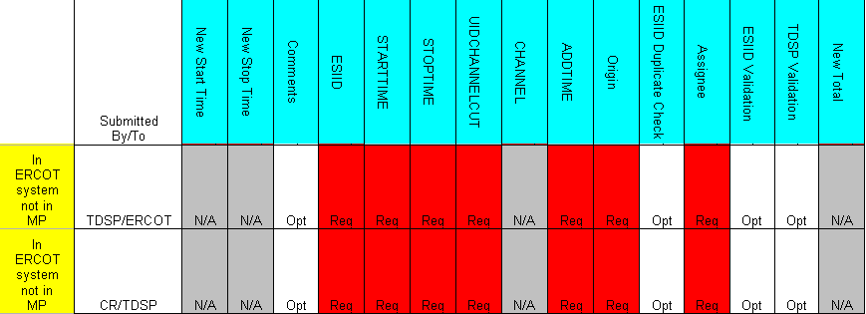

6.1.6.2.2 Example of IDR – In ERCOT system not MP

Example: CR submits In ERCOT system not MP to TDSP

- Select the Submit tab
- From the Submit Tree, select In ERCOT system not MP
- The following fields must be populated for successful submission:
Assignee
ESIID
STARTTIME (STARTTIME - SCR727 Extract)
STOPTIME (STOPTIME - SCR727 Extract)
UIDCHANNELCUT
ADDTIME (ADDTIME - SCR727 Extract)
Origin – Must be ‘M’

- Select OK
- The issue enters TDSP’s queue in the state of New
- The CR only may Withdraw the issue prior to acknowledgement by the TDSP
- TDSP selects Begin Working and the CR can no longer Withdraw the issue
- TDSP has the options of Complete and Unexecutable
- If in agreement TDSP will take appropriate action then select Complete which transitions the issue to Pending Complete with the CR
- The CR selects Complete and the issue is closed
- If not in agreement the TDSP may:
a. Select Unexecutable which will require a comment and return the issue back to CR’s queue as Unexecutable (Pending Complete)
- CR will select Accept and issue will be closed.
- Once in the Pending Complete state, if the issue is not transitioned for 14 calendar days the issue will automatically go to Auto Complete. The issue will then be closed.

DEV Issues – IDR – In both systems with date issues
The DEV issue of In both systems with date issues should be submitted when the ESI ID IDR meter data is in the data extract from ERCOT and in the MP’s system, but has STARTTIME and/or STOPTIME issues.

TDSP to ERCOT
Action: Dates of IDR data are incorrect. Delete and reload LSE file.

CR to TDSP
Action: TDSP to verify IDR Usage values

For all Usage Variance Issues that require changes to usage data or loading of missing data at ERCOT into Lodestar per the resolution, the TDSP should send the usage to ERCOT in accordance with the 867_03 usage loading validations. These validations are performed whether the data is submitted via transaction or file for manual loading.

Requests to load negative usage will be rejected.

It is the TDSP’s responsibility to communicate all ESI ID Service History and Usage (IDR and Non-IDR) data changes to the appropriate CR(s).

Assignee field:
For TDSP to ERCOT – Assignee will auto populate with ERCOT
For CR to TDSP - Assignee will be required for submission
The Assignee can be located by using the search feature through the ‘Find’ button by typing in all or part of the MPs name or DUNS number. The Comments field is optional.

Required fields for IDR – In both systems with date issues
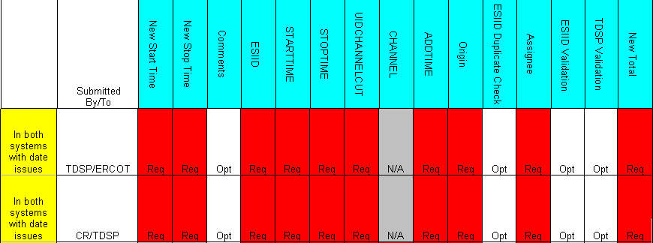

Example of IDR – In both systems with date issues

Example: CR submits In both systems with date issues to TDSP

- Select the Submit tab
- From the Submit Tree, select In MP system not ERCOT
- The following fields must be populated for successful submission:
Assignee
New STARTTIME
New STOPTIME
ESIID
STARTTIME (STARTTIME - SCR727 Extract)
STOPTIME (STOPTIME - SCR727 Extract)
UIDCHANNELCUT
ADDTIME (ADDTIME - SCR727 Extract)
Origin – Must be ‘M’
New Total

- Select OK
- The issue enters TDSP’s queue in the state of New
- The CR only may Withdraw the issue prior to acknowledgement by the TDSP
- TDSP selects Begin Working and the CR can no longer Withdraw the issue
- TDSP has the options of Complete and Unexecutable
- If in agreement TDSP will take appropriate action then select Complete which transitions the issue to Pending Complete with the CR
- The CR selects Complete and the issue is closed
- If not in agreement the TDSP may:
  - Select Unexecutable which will require a comment and return the issue back to CR’s queue as Unexecutable (Pending Complete)
- CR will select Accept and issue will be closed.
- Once in the Pending Complete state, if the issue is not transitioned for 14 calendar days the issue will automatically go to Auto Complete. The issue will then be closed.

DEV Issues – IDR – In both systems with kWh issues
The DEV issue of In both systems with kWh issues should be submitted when the ESI ID IDR meter data is in the data extract from ERCOT and in the MP’s system, but has kWh issues.

TDSP to ERCOT
Action: Load the corrected LSE file

CR to TDSP
Action: TDSP to verify IDR Usage values

For all Usage Variance Issues that require changes to usage data or loading of missing data at ERCOT into Lodestar per the resolution, the TDSP should send the usage to ERCOT in accordance with the 867_03 usage loading validations. These validations are performed whether the data is submitted via transaction or file for manual loading.

Requests to load negative usage will be rejected.

It is the TDSP’s responsibility to communicate all ESI ID Service History and Usage (IDR and Non-IDR) data changes to the appropriate CR(s).

This Variance Issue cannot be used to request changes to usage dates.

Assignee field:
For TDSP to ERCOT – Assignee will auto populate with ERCOT
For CR to TDSP - Assignee will be required for submission
The Assignee can be located by using the search feature through the ‘Find’ button by typing in all or part of the MPs name or DUNS number. The Comments field is optional.

Required fields for IDR – In both systems with kWh issues

Example of IDR – In both systems with kWh issues

Example: CR submits In both systems with kWh issues to TDSP

- Select the Submit tab
- From the Submit Tree, select In both systems with kWh issues

- The following fields must be populated for successful submission:
Assignee
ESIID
STARTTIME (STARTTIME - SCR727 Extract)
STOPTIME (STOPTIME - SCR727 Extract)
UIDCHANNELCUT
CHANNEL– CR to TDSP CHANNEL should = ‘4’
ADDTIME (ADDTIME - SCR727 Extract)
Origin – Must be ‘M’
New Total

- Select OK
- The issue enters TDSP’s queue in the state of New
- The CR only may Withdraw the issue prior to acknowledgement by the TDSP
- TDSP selects Begin Working and the CR can no longer Withdraw the issue
- TDSP has the options of Complete and Unexecutable
- If in agreement TDSP will take appropriate action then select Complete which transitions the issue to Pending Complete with the CR
- The CR selects Complete and the issue is closed
- If not in agreement TDSP may:
- Select Unexecutable which will require a comment and return the issue back to CR’s queue as Unexecutable (Pending Complete)
- CR will select Accept and issue will be closed.
- Once in the Pending Complete state, if the issue is not transitioned for 14 calendar days the issue will automatically go to Auto Complete. The issue will then be closed.

NOTE: CR to TDSP submissions, the channel will auto populate with ‘4’. For TDSP to ERCOT submissions, TDSP must enter value ‘1’ or ‘4’.

DEV Issues – Non-IDR – In MP system not ERCOT
CR to TDSP
The DEV issue of In MP system not ERCOT should be submitted when the ESI ID Non-IDR meter data is in the MP’s system, but not in the data extract from ERCOT.

Action: NIDR Usage needs to be loaded at ERCOT

Situation 1: If the TDSP confirms via the ESI ID Extract that usage is loaded at ERCOT and matches the usage in the TDSP system, the TDSP shall transition the issue back to the CR as Unexecutable with comments and/or transactions submitted for explanation.

Situation 2: The TDSP will transition the issue to ERCOT for assignment (Assign Owner) SIR (10908) if ALL the following conditions are met:
a) The TDSP determines via the ESI ID Extract that usage data is not loaded at ERCOT,
b) The TDSP confirms ERCOT acknowledged acceptance of the transaction(s) in all levels of the 997 response, and
c) The TDSP determine the usage was reported as loaded successfully via the 867_03 activity report as of August 6, 2003.

Situation 3: The TDSP shall submit usage data to ERCOT via transaction in cases where either condition (b) or (c) above is not met. The issue shall not be marked as Complete until such usage data has been properly loaded into ERCOT systems.

If the TDSP determines that the usage data is not loaded at ERCOT, then the TDSP is responsible for submitting the usage data to ERCOT via transaction.

TDSP to ERCOT
The TDSP will submit In MP system not ERCOT to ERCOT if ALL the above conditions in Situation 2 (above) are met.

Action: NIDR Usage needs to be loaded at ERCOT

Requests to load negative usage will be rejected.

For all Usage Variance Issues that require changes to usage data or loading of missing data at ERCOT into Lodestar per the resolution, the TDSP should send the usage to ERCOT in accordance with the 867_03 usage loading validations. These validations are performed whether the data is submitted via transaction or file for manual loading.

Assignee field:
For TDSP to ERCOT – Assignee will auto populate with ERCOT
For CR to TDSP - Assignee will be required for submission
The Assignee can be located by using the search feature through the ‘Find’ button by typing in all or part of the MPs name or DUNS number. The Comments field is optional.

Required fields for Non-IDR – In MP system not ERCOT

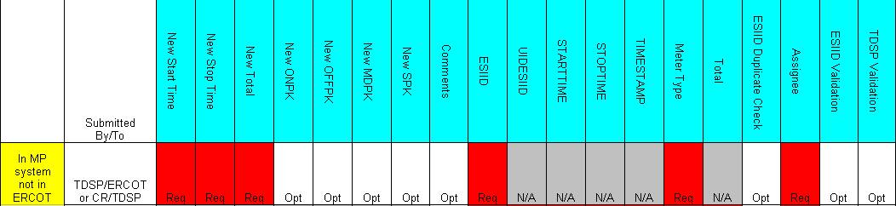

Example of Non-IDR – In MP system not ERCOT

***NOTE: Validate TDSP is Associated with Issue will be applied to ALL DEV submissions

***NOTE: The Submitter will be allowed to ‘CLOSE’ an DEV issue IF the Submitter is the Responsible Party.

***Note: (Add notification) User may subscribe to new notification that will send email when an issue transitions to “Closed” by Sumbittor. Refer to Section 1- General

Example: CR submits In MP system not ERCOT to TDSP

- Select the Submit tab (Fig 11.7.5a)
- From the Submit Tree, select In MP system not ERCOT

Fig 11.7.5a
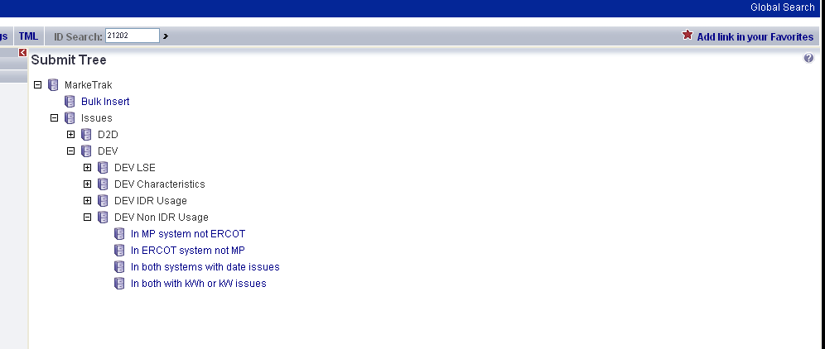
- The following fields must be populated for successful submission:
Assignee
New STARTTIME
New STOPTIME
New Total
ESIID
Meter Type
- Select OK (Fig 11.7.5b)
Fig 11.7.5b
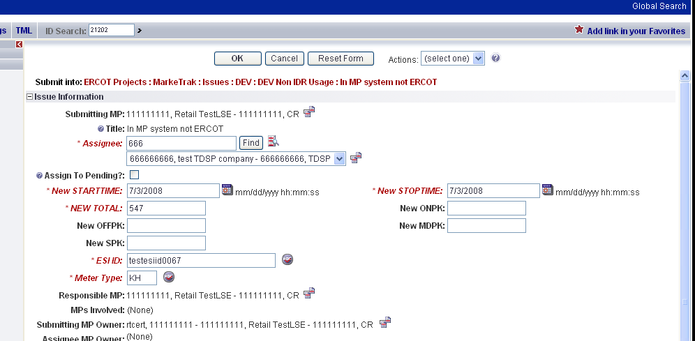

- The issue enters TDSP’s queue in the state of New.
- The CR only may Withdraw the issue prior to acknowledgement by the TDSP. (Fig 11.7.5c)
Fig 11.7.5c
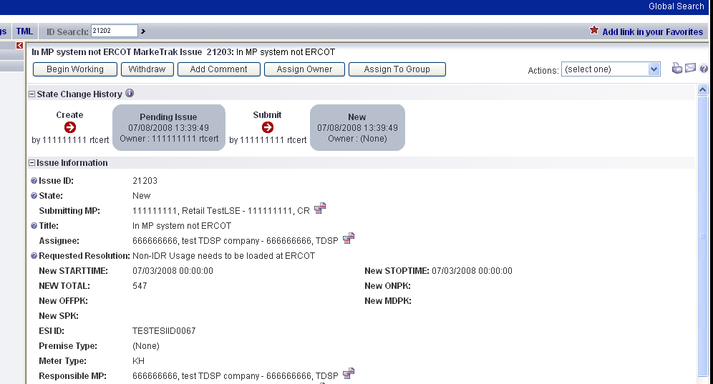
- TDSP selects Begin Working and the CR can no longer Withdraw the issue. (Fig 11.7.5d)
Fig 11.7.5d
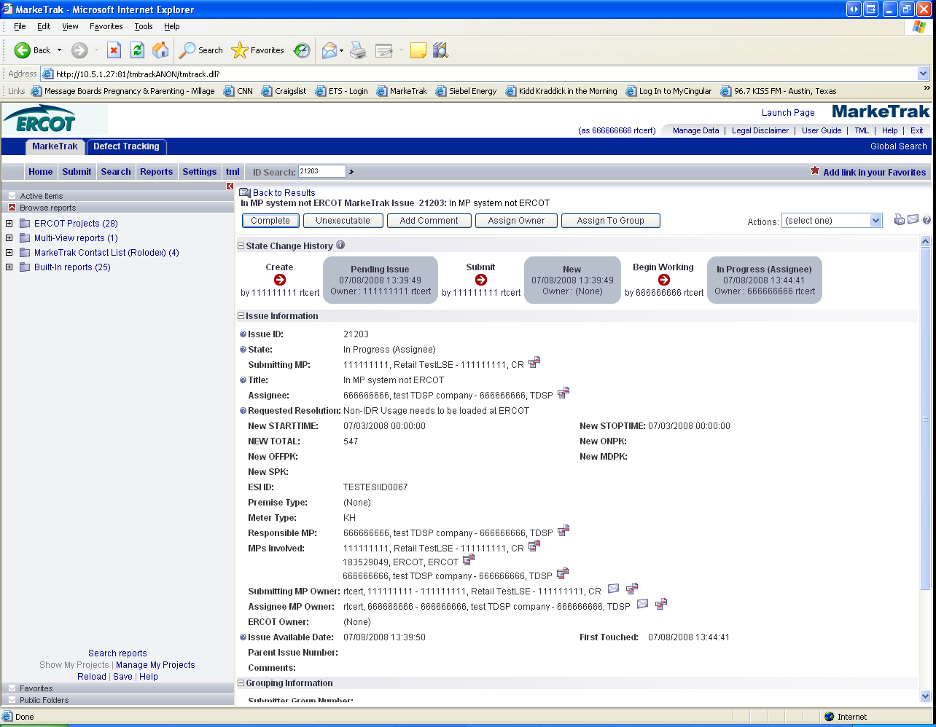
- TDSP has the options of Complete and Unexecutable. (Fig 11.7.5e)
Fig 11.7.5e
- If in agreement TDSP will take appropriate action then select Complete which transitions the issue to Pending Complete with the CR
- The CR selects Complete and the issue is closed
- If not in agreement the TDSP may:
  - Select Unexecutable which will require a comment and return the issue back to the CR’s queue as Unexecutable (Pending Complete)(Fig 11.7.5f)
Fig 11.7.5f
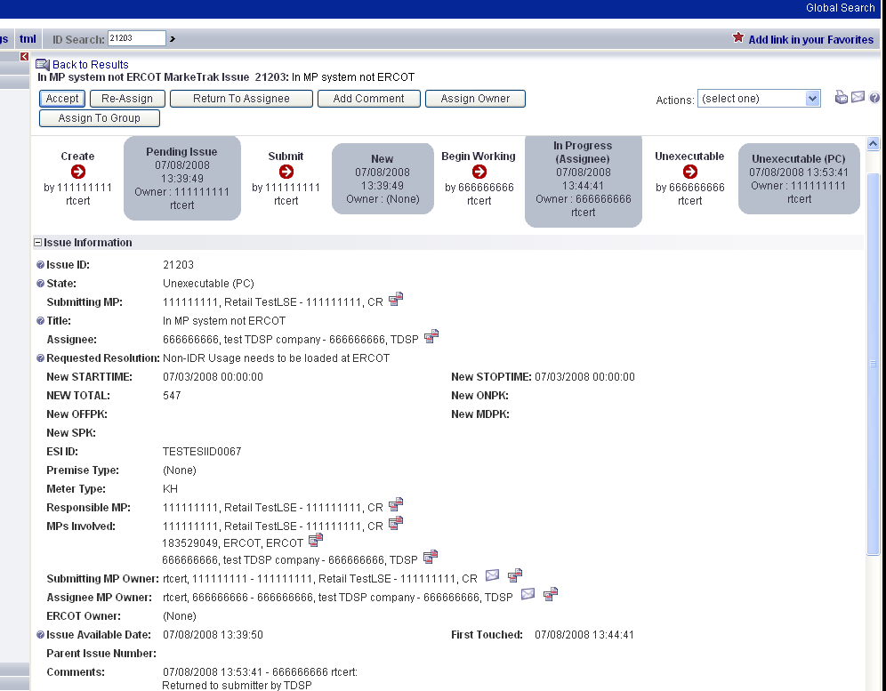

- CR will select Accept and issue will be closed.
- Once in the Pending Complete state, if the issue is not Accepted it will transition in 14 calendar days and the issue will automatically Auto Complete. The issue will then be closed.

DEV Issues – Non-IDR – In ERCOT system not MP
The DEV Issue of In ERCOT system not MP should be submitted when the ESI ID Non-IDR meter data is in the data extract from ERCOT, but not in the MP’s system.

TDSP to ERCOT
Action: Data needs to be cancelled from ERCOT system.

CR to TDSP
Prior to correcting or resending usage, the TDSP will verify that the requesting CR is the LSE of record for requested timeframe.

Action: TDSP to submit Non-IDR Usage to CR

It is the TDSP’s responsibility to communicate all ESI ID Service History and Usage (IDR and Non-IDR) data changes to the appropriate CR(s).

Assignee field:
For TDSP to ERCOT – Assignee will auto populate with ERCOT
For CR to TDSP - Assignee will be required for submission
The Assignee can be located by using the search feature through the ‘Find’ button by typing in all or part of the MPs name or DUNS number. The Comments field is optional.

Required fields for Non-IDR – In ERCOT system not MP
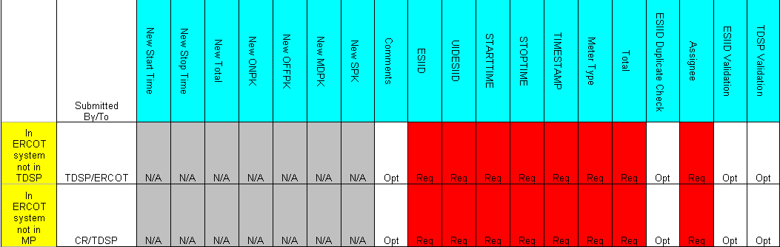

Example of Non-IDR – In ERCOT system not MP
Example: CR submits In ERCOT system not MP to TDSP

- Select the Submit tab
- From the Submit Tree, select In ERCOT system not MP Screen shot
- The following fields must be populated for successful submission:
Assignee
ESIID
UIDESIID
STARTTIME (STARTTIME - SCR727 Extract)
STOPTIME (STOPTIME - SCR727 Extract)
TIMESTAMP (TIMESTAMP - SCR727 Extract)
METERTYPE
TOTAL (TOTAL - SCR727 Extract)

- Select OK
- The issue enters TDSP’s queue in the state of New
- The CR only may Withdraw the issue prior to acknowledgement by the TDSP
- TDSP selects Begin Working and the CR can no longer Withdraw the issue
- TDSP has the options of Complete, and
Unexecutable
- If in agreement TDSP will take appropriate action then select Complete which transitions the issue to Pending Complete with the CR
- The CR selects Complete and the issue is closed
- If not in agreement TDSP may:
  - Select Unexecutable which will require a comment and return the issue back to the CR’s queue as Unexecutable (Pending Complete)
- CR will select Accept and issue will be closed.
- Once in the Pending Complete state, if the issue is not transitioned for 14 calendar days the issue will automatically go to Auto Complete. The issue will then be closed.

DEV Issues – Non-IDR – In both systems with date issues
TDSP to ERCOT or CR to TDSP
The DEV Issue of In both system with date issues should be submitted when the ESI ID Non-IDR meter data is in the data extract from ERCOT and in the MP’s system, but has a STOPTIME issue. The TDSP must select the earliest affected record to file this Variance Issue. STARTTIME issues by themselves cannot be filed. STARTTIME issues become STOPTIME issues of the prior record.

Action: Dates of Usage data are incorrect. Update to new STOPTIME.

For all Usage Variance Issues that require changes to usage data or loading of missing data at ERCOT into Lodestar per the resolution, the TDSP should send the usage to ERCOT in accordance with the 867_03 usage loading validations. These validations are performed whether the data is submitted via transaction or file for manual loading.
Requests to load negative usage will be rejected.

It is the TDSP’s responsibility to communicate all ESI ID Service History and Usage (IDR and Non-IDR) data changes to the appropriate CR(s).

TDSPs need to consider that the TDSP may have submitted usage for a date range which has more than one LSE of record (i.e. CR may not be the “owner” of all days).

Prior to correcting or resending usage, the TDSP will verify that the requesting CR is the LSE of record for requested timeframe.

Required fields for Non-IDR – In both systems with date issues
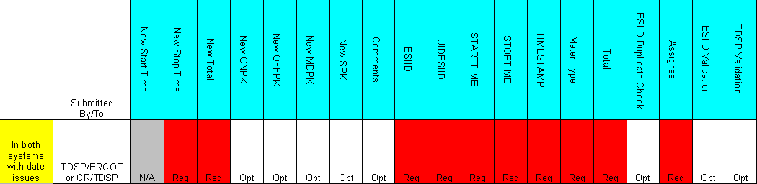

Example of Non-IDR – In both systems with date issues

Example: CR submits In both systems with date issues to TDSP

- Select the Submit tab
- From the Submit Tree, select both systems with date issues
- The following fields must be populated for successful submission:
Assignee
New STOPTIME
New Total
ESIID
UIDESIID
STARTTIME (STARTTIME - SCR727 Extract)
STOPTIME (STOPTIME - SCR727 Extract)
TIMESTAMP (TIMESTAMP - SCR727 Extract)
METERTYPE
TOTAL (TOTAL - SCR727 Extract)
NOTE: The Assignee can be located by using the search feature through the ‘Find’ button by typing in all or part of the MPs name or DUNS number. The Comments field is optional.

- Select OK
- The issue enters TDSP’s queue in the state of New.
- The CR only may Withdraw the issue prior to acknowledgement by the TDSP
- TDSP selects Begin Working and the CR can no longer Withdraw the issue
- TDSP has the options of Complete and Unexecutable
- If in agreement TDSP will take appropriate action then select Complete which transitions the issue to Pending Complete with the CR
- The CR selects Complete and the issue is closed
- If not in agreement TDSP may:
  - Select Unexecutable which will require a comment and return the issue back to CR’s queue as Unexecutable-Pending Complete.
- CR will select Accept and issue will be closed
- Once in the Pending Complete state, if the issue is not transitioned for 14 calendar days the issue will automatically go to Auto Complete. The issue will then be closed.

DEV Issues – Non-IDR – In both systems with kWh or kW issues
The DEV issue of In both system with kWh or kW issues should be submitted when the ESI ID Non-IDR meter data is in the data extract from ERCOT and in the MP’s system, but has kWh and/or kW issue.

TDSP to ERCOT
Action: Need to update loaded usage data

For all Usage Variance Issues that require changes to usage data or loading of missing data at ERCOT into Lodestar per the resolution, the TDSP should send the usage to ERCOT in accordance with the 867_03 usage loading validations. These validations are performed whether the data is submitted via transaction or file for manual loading.
It is the TDSP’s responsibility to communicate all ESI ID Service History and Usage (IDR and Non-IDR) data changes to the appropriate CR(s).

Requests to load negative usage will be rejected.

This DEV issue cannot be used to request changes to usage dates.

CR to TDSP

Action: TDSP to verify Non-IDR usage values

Requests to load negative usage will be rejected.

This DEV issue cannot be used to request changes to usage dates.

CRs must populate the kWh or kW total they have in their system in the <Field New Total> to assist the TDSP in analyzing the Issue. CR must also populate the <Field STARTTIME> and <Field STOPTIME> with the STARTIME and STOPTIME of the usage loaded in their system.

Required fields for Non-IDR – In both systems with kWh or kW issues
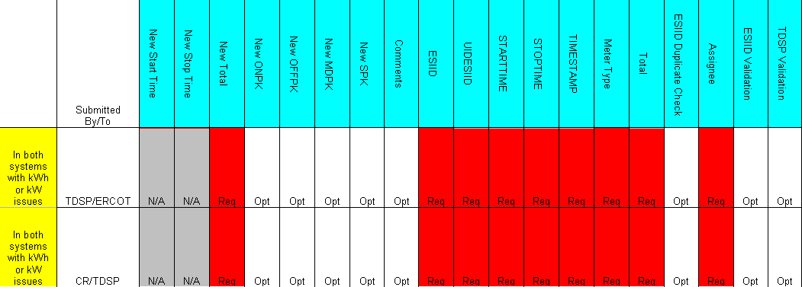

Example of Non-IDR – In both systems with kWh or kW issues

Example: CR submits In both systems with kWh or KW issues

- Select the Submit tab
- From the Submit Tree, select In both systems with kWh or kW issues
- The following fields must be populated for successful submission:
Assignee
New Total
ESIID
UIDESIID
STARTTIME (STARTTIME - SCR727 Extract)
STOPTIME (STOPTIME - SCR727 Extract)
TIMESTAMP (TIMESTAMP - SCR727 Extract)
METERTYPE
TOTAL (TOTAL - SCR727 Extract)
- Select OK
- The issue enters TDSP’s queue in the state of New
- The CR only may Withdraw the issue prior to acknowledgement by the TDSP
- TDSP selects Begin Working and the CR can no longer Withdraw the issue
- TDSP has the options of Complete, and Unexecutable
- If in agreement TDSP will take appropriate action then select Complete which transitions the issue to Pending Complete with the CR
- The CR selects Complete and the issue is closed
- If not in agreement TDSP may:
- Select Unexecutable which will require a comment and return the issue back to CR’s queue as Unexecutable (Pending Complete).
- CR will select Accept and issue will be closed
- Once in the Pending Complete state, if the issue is not transitioned for 14 calendar days the issue will automatically go to Auto Complete. The issue will then be closed.

NOTE: Submittor may “CLOSE” when they are Responsible MP on the issue and WITHDRAW is not available or the issue is not in a “Complete” state. Comments will be required for the “CLOSE” transition. All work will stop on this issue at this point.

