MarkeTrak Users Guide
Section 2: Inadvertent Gain

Table of Contents
MarkeTrak Users Guide 1
2.1 Day to Day Issues – Inadvertent Gain 3
2.1.1 Required Fields for Inadvertent Gain 3
2.1.2 Definition of Inadvertent Gain 3
2.1.3 Submitting an Inadvertent Gain
3
2.1 Day to Day Issues – Inadvertent Gain

2.1.1 Required Fields for Inadvertent Gain
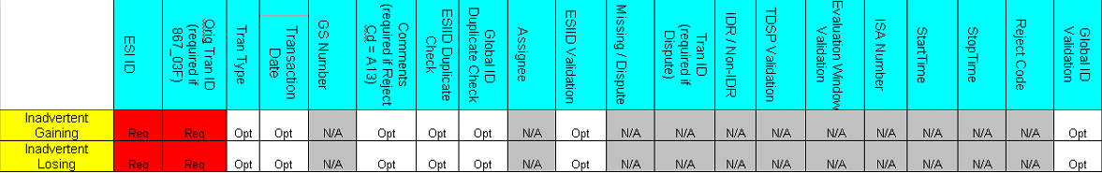

2.1.2 Definition of Inadvertent Gain
Note:

For purposes of this section of the MarkeTrak Users Guide, CR2 is defined as the non-submitting CR. For example, if the submitting rep indicates they are the Gaining CR then CR2 is the Losing CR and vice versa.

An inadvertent issue begins upon the discovery of an Inadvertent Gain or Move-In transaction submission. Upon identification of an Inadvertent Gain or Move-in, the CR will check the transaction status via the ERCOT TML.

1. If transaction Status is pending, and the Inadvertent CR is the submitting CR, then the CR will cancel their submitting transaction either by submitting an EDI cancel transaction or following the procedures outlined in Section 3 of the MarkeTrak User’s Guide entitled Cancel With Approvals.

2. For other Status types or if the CR was not the submitter of the transaction, the CR will log a MarkeTrak Inadvertent issue.

a. Only one ESI ID is allowed per MarkeTrak issue.
b. CR’s should refer to and follow additional steps that are outlined in the Retail Market Guide under “TDSP’s Inadvertent Gain Process”.

3. CR’s will work together in a manner outlined in Section 7.2 of the Retail Market Guide (RMG) to determine appropriate resolution. The Retail Market Guide is available in the Market Guides section of www.ercot.com. See section 3 of the MarkeTrak User’s Guide for response timelines required. If responses are not received in an adequate timeframe, the CR should escalate to the CR Inadvertent MarkeTrak contact.

4. If the CR/TDSP resolution requires a backdated move-in being generated by the Original CR, then the date should be at least the Gaining CR start date plus 1 day to avoid creating transaction business process exceptions at ERCOT and the TDSP.

NOTE: Move-Out or Disconnect for Non Payment transactions should NOT be used to resolve an inadvertent issue on an energized ESI ID

________________________________________________________________

2.1.2.1 ERCOT’s Receipt of Inadvertent Gain Issue

- Confirm the pending or actual change of CR relationship.
- Assign CR2 and the TDSP to the MarkeTrak issue.
- ERCOT will transition the MarkeTrak issue to the parties involved with CR2 as the Responsible MP.
- CR2 is responsible for selecting Begin Working to transition the item into a State of In Progress.
- The Original CR must wait for the TDSP to select Ready to Receive prior to sending the EDI to regain the account.
________________________________________________________________

2.1.2.2 Examples of Invalid Inadvertent Gain Issue

There are instances where ERCOT will immediately return the issue to the submitter by selecting Unable To Complete and entering required Comment stating the reason the issue could not be worked.

Possible reasons include:

- Invalid ESI ID
- Wrong or Invalid Tran ID
- Invalid Order Type (order something other than MVI or Switch)
- Submitter selected Gaining and is not the Gaining CR
- Submitter selected Losing and is not the Losing CR
- ESI ID was De-Energized prior to completion of MVI
- The Losing and Gaining CR are the same
- Losing CR has left the Market
- Gaining CR has left the Market
- Order was Cancelled – No IAG
- Other

NOTE: ERCOT will monitor the volume of Inadvertent MarkeTrak Issues and provide reporting on an as-needed basis to RMS or the PUC. Reports will identify the submitting and resolving/monitoring party as logged in the MarkeTrak issue and will not attempt to identify the party responsible for the inadvertent issue

________________________________________________________________

2.1.3.1 Example: CR Submits Inadvertent Gain as the Losing CR

- CR1 (Losing/Original CR) will select the “Inadvertent Gain Issue -Type/Sub Type” of “Inadvertent Gains - Losing” from the MarkeTrak Submit Tree within MarkeTrak via GUI.
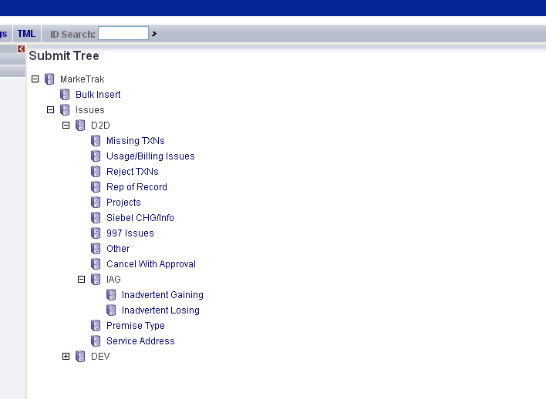

- CR1 (Losing/Original CR) will enter all required information

  - ESIID
  - Original Tran ID

NOTE: The Comments field is optional. Please include any additional information in this box.

Select "OK" to create the IAG – Inadvertent Losing MarkeTrak Issue.
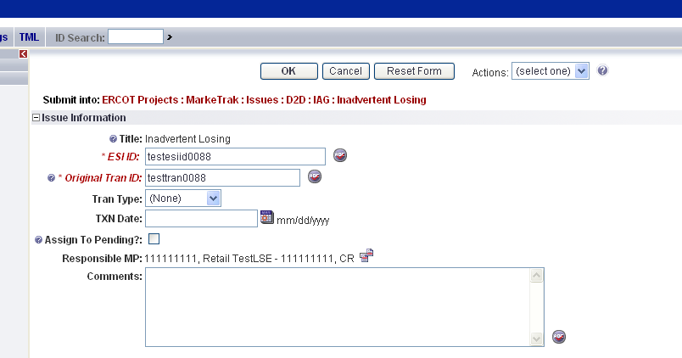

- By selecting OK, the issue enters ERCOT’s queue in a state of New and is visible only by the Submitting CR and ERCOT.
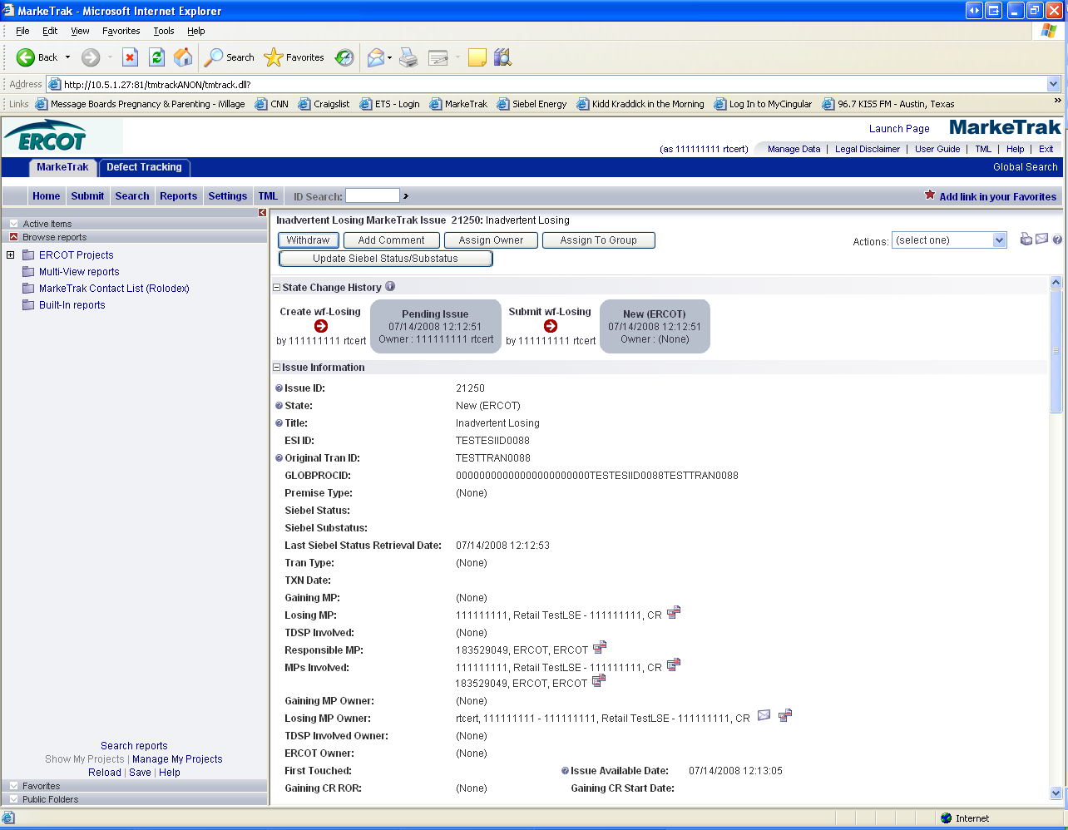

- The Submitting CR has the option to Withdraw the issue at this point.

- ERCOT will populate the “Premise Type”, “Gaining CR Start Date” , “Gaining CR ROR”, and the TDSP.

- An ERCOT Representative will select Begin Working to assign CR2 (Gaining CR) & TDSP. The ERCOT Rep will then select “OK” to move issue to CR2 (Gaining CR).

- At this point, the Submitting CR can no longer Withdraw the issue.

Note: After the initial “Begin Working” is selected and the “Withdraw” is not available or the issue is not in a “Complete” state, if the submitting MP feels a resolution is no longer needed, the “Close” button can be selected. Comments will be required with this transition.
All work will stop on the issue at this point.

- CR2 (Gaining CR) will select Begin Working and investigate the Inadvertent Gain issue details to determine if CR1 (Losing/Original CR) should regain ESI ID as of their date of loss.
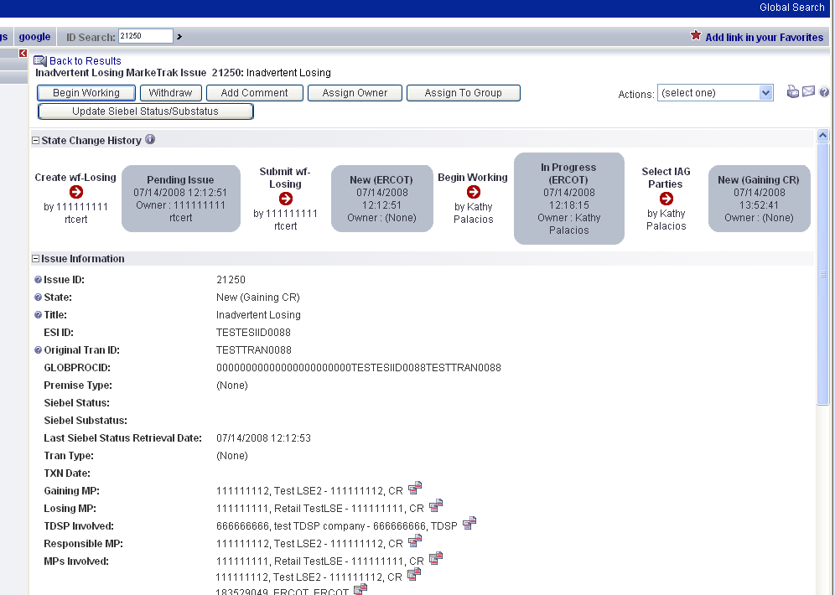

- If CR2 (Gaining CR) determines that an Inadvertent Gain has NOT taken place, they have the option to select “Unexecutable” to stop the Inadvertent Gain process. Invalid IAG Reason is required, enter one of the following:

Valid Reject Reasons are described in the RMG Section 7.2.2.4 are as follows:

- 3rd party CR involved
- “Authorized Enrollment Confirmed”,
- “Duplicate Issue”
- Other (should require comments)

Note: Unexecutable ends the ability to do any other work on the issue.

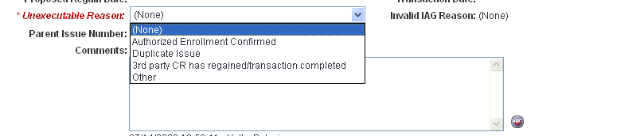

- If CR2 (Gaining CR) determines that an Inadvertent Gain has taken place, they will select Send to Losing CR, enter comments and select “OK” to move issue to CR1 (Losing/Original CR).

Selecting Send to Losing CR, the Gaining CR is agreeing to all fees associated with transitioning the premise back to the Losing CR.

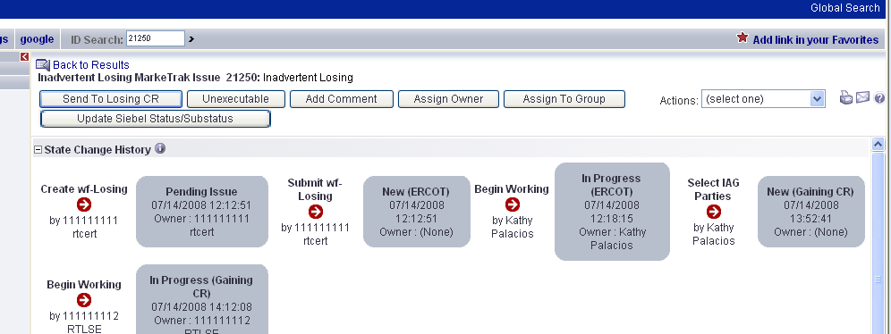

- CR1 (Losing/Original CR) will select Begin Working and Investigate Market Conditions to determine the appropriate regain date. CR1 (Losing/Original CR) will select Send to TDSP, enter the proposed regain date, add comments and select “OK” to move the issue to the TDSP. If CR1 (Losing/Original CR) determines that an Inadvertent Gain has NOT taken place, they have the option to select Unexecutable. NOTE: Before selecting the Unexecutable Transition, as a courtesy please contact the CR to state reason for choosing Unexecutable. Once selected this stops the Inadvertent Gain process if any of the Valid Reject Reasons per the RMG Section 7.2.2.4 are present.
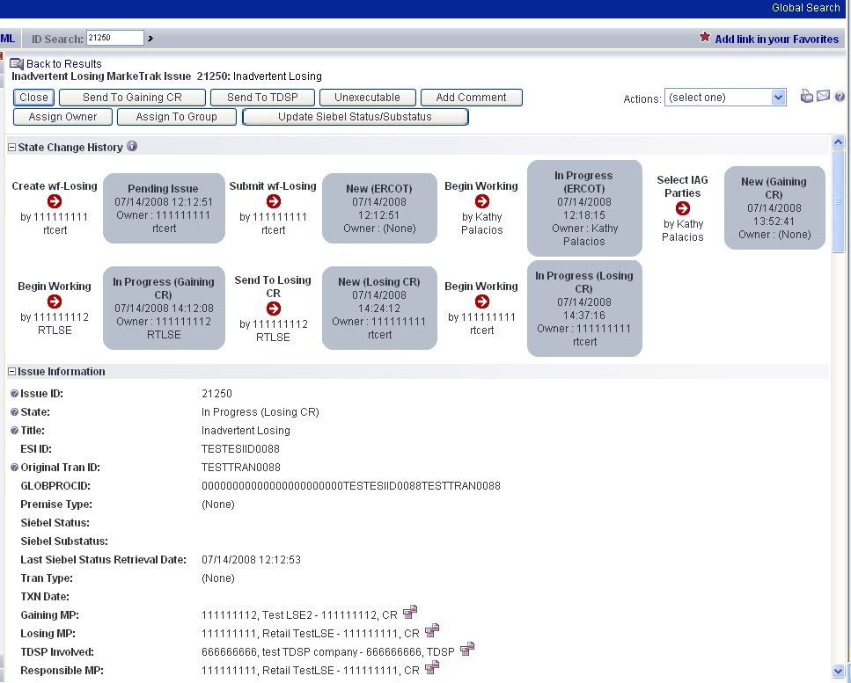

Note: The following validation will occur on the Proposed Regain Date: Validate that the date is less than “Submit Date” + 15 days. If not the following error message will be displayed “Proposed Regain Date is greater than 15 Calendar days from the submittal of MarkeTrak Issue, please update with valid Proposed Regain date.”

- The TDSP will select Begin Working, investigate the issue details, then select Ready to Receive to send the issue back to CR1 (Losing/Original CR).
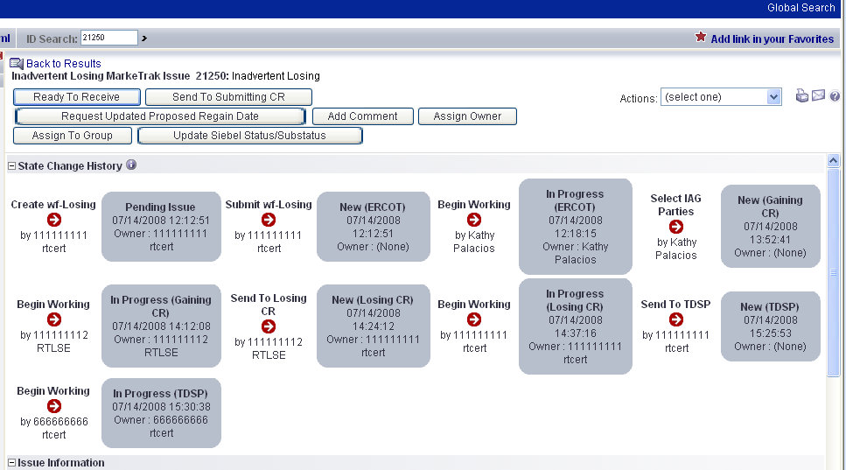

NOTE: It is extremely important that CR1 (Losing/Original CR) wait for the TDSP to select Ready to Receive indicating TDSP’s systems have been prepared to receive the Original MP’s transaction before the EDI is actually sent. If not, the EDI will be rejected at the TDSP.

- CR1 (Losing/Original CR) will select Begin Working then select Provide Regaining BGN. CR1 (Losing/Original CR) will provide the BGN02 and Transaction Date for the submitted transaction then select “OK”.

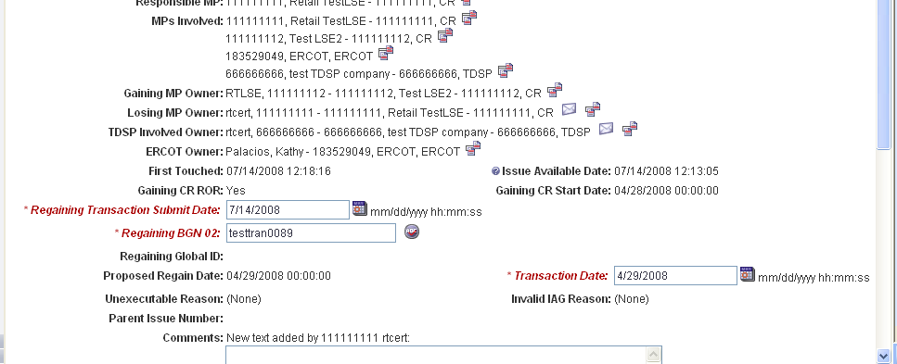

- All parties should continue to monitor TML and internal systems for the successful delivery and completion of the EDI transaction being sent by CR1 (Losing/Original CR) to the Market to regain a premise and resolve the associated Inadvertent Gain MarkeTrak issue.

- Once the regaining transaction has been successfully sent to the Market by CR1 (Losing/Original CR), Siebel will automatically:
- Check Regaining Transaction Siebel Status every 30 minutes using the BGN 02 from the new initiating transaction
- Update the issue with the current Regaining Transaction Siebel Status
- Assign the state of Complete with the Submitting MP as the Responsible Party once the Regaining Transaction Siebel Status is Complete.

2.1.3.2 Example: CR Submits Inadvertent Gain as the Gaining CR

- CR1 (Gaining CR) will select the “Inadvertent Gain - Issue Type/Sub Type” of “Inadvertent Gains - Gaining” from the MarkeTrak Submit Tree within MarkeTrak via GUI.

- CR1 (Gaining CR) will enter all required information:

  - ESIID
  - Original Tran ID

and select "OK" to create the Inadvertent Gain MarkeTrak Issue.
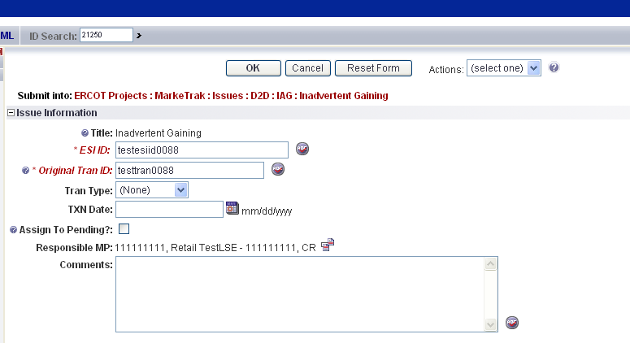

- By selecting OK, the issue enters ERCOT’s queue in a state of New and is visible only by the Submitting CR and ERCOT.
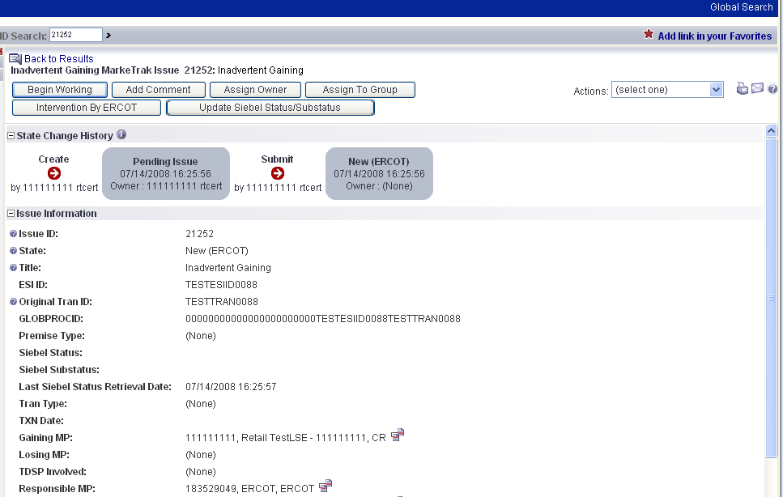

- The Submitting CR has the option to Withdraw the issue at this point.
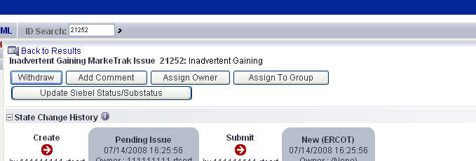

- ERCOT will populate the “Premise Type”, “Gaining CR Start Date” and “Gaining CR ROR” and the TDSP.

- An ERCOT Representative will select Begin Working to assign CR2 (Losing/Original CR) & TDSP. The ERCOT Rep will then select “OK” to move issue to CR2 (Losing/Original CR).

- At this point, the Submitting CR can no longer Withdraw the issue.

Note: After the initial “Begin Working” is selected and the “Withdraw” is not available or the issue is not in a “Complete” state, if the submitting MP feels a resolution is no longer needed the “Close” button can be selected. Comments will be required with this transition. All work will stop on the issue at this point.

- CR2 (Losing/Original CR) will select Begin Working and Issue details and Investigate Market Conditions to determine the appropriate regain date.
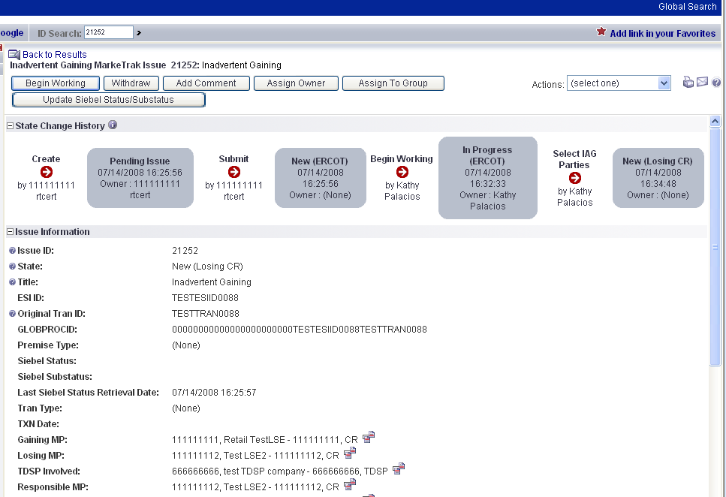

- If CR2 (Losing/Original CR) determines that an Inadvertent Gain has NOT taken place, they have the option to select Unexecutable. NOTE: Before selecting the Unexecutable Transition, as a courtesy please contact the CR to state reason for choosing Unexecutable. Once selected, this stops the Inadvertent Gain process. Invalid IAG Reason is required, enter one of the following:

Valid Reject Reasons are described in the RMG Section 7.2.2.4 are as follows:

- 3rd party CR involved
- “Authorized Enrollment Confirmed”,
- “Duplicate Issue”
- Other (should require comments)

Note: Unexecutable ends the ability to do any other work on the issue.

Also when an issue has been Closed by Submitter the Reject Reason and the Invalid IAG reason will show as None. No further action can be taken.

- If CR2 (Losing/Original CR) determines that an Inadvertent Gain has taken place, they will select Send to TDSP, enter the proposed regain date, add comments and select “OK” to move the issue to the TDSP.

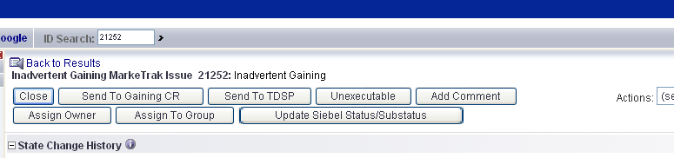

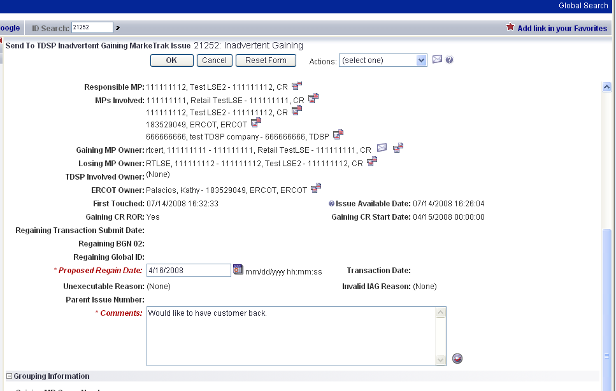

- The TDSP will select Begin Working, investigate the issue details, then select Ready to Receive to send the issue back to CR2 (Losing/Original CR).
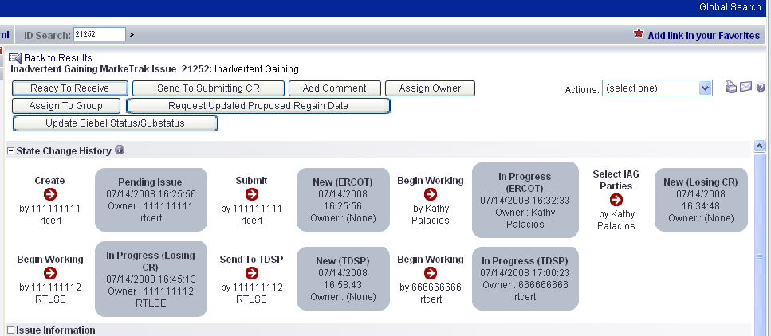

NOTE: It is extremely important that CR2 (Losing/Original CR) wait for the TDSP to select Ready to Receive indicating TDSP’s systems have been prepared to receive the Original MP’s transaction before the EDI is actually sent. If not, the EDI will be rejected at the TDSP.

- CR2 (Losing/Original CR) will select Begin Working, then select Provide Regaining BGN. CR2 (Losing/Original CR) will provide the BGN02 and Transaction Date for the submitted transaction, then select “OK”.
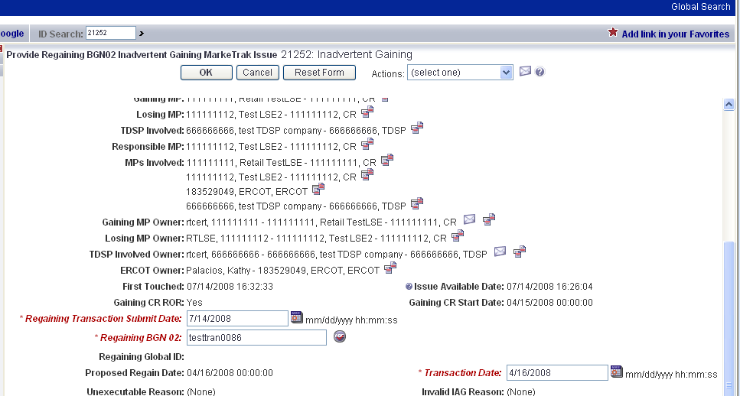

- All parties should continue to monitor TML and internal systems for the successful delivery and completion of the EDI transaction being sent by CR2 (Losing/Original CR) to the Market to regain a premise and resolve the associated Inadvertent Gain MarkeTrak issue.

- Once the regaining transaction has been successfully sent to the Market by CR2 (Losing/Original CR), Siebel Will Automatically:
- Check “Regaining Transaction Siebel Status” every 30 minutes using the BGN 02 from the new initiating transaction
- Update the issue with the current “Regaining Transaction Siebel Status”
- Assign the state of Complete with the Submitting MP as the Responsible Party once the “Regaining Transaction Siebel Status” is ”Complete”.

Note – new escalations

If an IAG issue (either type) is in “New (Losing CR submit) and remains unmodified for 20 days the issue will Auto Close and transition to a new state of “Closed – Inactivity”

