MarkeTrak Users Guide
Section 9: Background Reports

Table of Contents
MarkeTrak Users Guide 1
9.1 Background Reports 3
9.1.1 Required Fields for Background Reports 3
9.1.2 Description of Background Reports 3
9.1.3 Submitting a Background Report
5
9.1 Background Reports

9.1.1 Required Fields for Background Reports
Issue type: Background Report
Report Name | Submitted By | Report Destination | MarkeTrak Projects | Start Date | End Date | Benchmark Days | ESIID'S | Issue ID's | User Login ID
Average Days Open | TDSP/CR/ERCOT | Req | Req | Opt | Opt | N/A | N/A | N/A | N/A
Count of Active and Inactove Issues | TDSP/CR/ERCOT | Req | Req | Opt | Opt | N/A | N/A | N/A | N/A
Count of Issues Resolved Outside Benchmark | TDSP/CR/ERCOT | Req | Req | Opt | Opt | Req | N/A | N/A | N/A
Count of Issues Resolved Within Benchmark | TDSP/CR/ERCOT | Req | Req | Opt | Opt | Req | N/A | N/A | N/A
Count of Issues in State | TDSP/CR/ERCOT | Req | Req | Opt | Opt | N/A | N/A | N/A | N/A
Details for Issues Resolved Outside of Benchmark | TDSP/CR/ERCOT | Req | Req | Opt | Opt | Req | N/A | N/A | N/A
Issue Details by ESIID | TDSP/CR/ERCOT | Req | Opt | N/A | N/A | N/A | Req | N/A | N/A
Issue Details by Issue ID | TDSP/CR/ERCOT | Req | Opt | N/A | N/A | N/A | N/A | Req | N/A
New User Issue Access | TDSP/CR/ERCOT | Req | Opt | N/A | N/A | N/A | N/A | N/A | Req
Time in State | TDSP/CR/ERCOT | Req | Req | Req | Req | N/A | N/A | N/A | N/A
Total No. Closed | TDSP/CR/ERCOT | Req | Req | Opt | Opt | N/A | N/A | N/A | N/A
Issues Open Outside Benchmark | TDSP/CR/ERCOT | Req | Req | Opt | Opt | Req | N/A | N/A | N/A

9.1.2 Description of Background Reports
The Background Reports will provide the following functionality:
- Increase number of exportable rows when running a report
- Allow users to run a report and work in the GUI at the same time
- Allow users to search multiple inputs within each search criteria category and have issues returned in a report format, for example:
        - Multiple Issue IDs
        - Multiple ESI IDs

The report will execute in the backend system and a CSV file will generate with the results. The report can be attached to an issue or it can be posted to TML. A TML Report Explorer URL will be added to the Toolbar. If the output CSV file exceeds 10MB in size, the report will automatically post to TML.

Background Report Issues will not be available through the API.

List of Reports

Report Name | Report Description | Parameters
Average Days Open | Report to Provide average days open by subtype for the time frame specified. | Parameter 1: (Start Date) (optional): Only issues closed after this date will be returned in the report (format is yyyy-mm-ddThh:mm:ss)  Parameter 2: (End Date) (optional): Only issues closed prior to this date will be returned in the report (format is yyyy-mm-ddThh:mm:ss)
Count of Active and Inactive Issues | Report to provide a count of Active and Inactive issues for the time frame specified. | Parameter 1: (Start Date) (optional): Only issues submitted after this date will be returned in the report (format is yyyy-mm-ddThh:mm:ss)  Parameter 2: (End Date) (optional): Only issues submitted prior to this date will be returned in the report (format is yyyy-mm-ddThh:mm:ss)
Count of Issues Resolved Outside Benchmark | Returns a count of issues closed outside of the specified benchmark number of days for a particular time frame. | Parameter 1: (Benchmark Days) (required): Target number of days after submission for an issue to be resolved  Parameter 2: (Start Date) (optional): Only issues closed after this date will be returned in the report (format is yyyy-mm-ddThh:mm:ss)  Parameter 3: (End Date) (optional): Only issues closed prior to this date will be returned in the report (format is yyyy-mm-ddThh:mm:ss)
Count of Issues Resolved Within Benchmark | Returns a count of issues resolved within the specified benchmark number of days for a particular time frame. | Parameter 1: (Benchmark Days) (required): Target number of days after submission for an issue to be resolved  Parameter 2: (Start Date) (optional): Only issues closed after this date will be returned in the report (format is yyyy-mm-ddThh:mm:ss)  Parameter 3: (End Date) (optional): Only issues closed prior to this date will be returned in the report (format is yyyy-mm-ddThh:mm:ss)
Count of Issues in State | Report to provide the total number of issues in each state for the selected subtype(s) for the time frame specified. | Parameter 1: (Start Date) (optional): Only issues submitted after this date will be returned in the report (format is yyyy-mm-ddThh:mm:ss)  Parameter 2: (End Date) (optional): Only issues submitted prior to this date will be returned in the report (format is yyyy-mm-ddThh:mm:ss)
Details for Issues Resolved Outside of Benchmark | Returns details for issues closed outside of the selected benchmark number of days within the time frame specified. | Parameter 1: (Benchmark Days) (required): Target number of days after submission for an issue to be resolved  Parameter 2: (Start Date) (optional): Only issues closed after this date will be returned in the report (format is yyyy-mm-ddThh:mm:ss)  Parameter 3: (End Date) (optional): Only issues closed prior to this date will be returned in the report (format is yyyy-mm-ddThh:mm:ss)
Issue Details by ESIID | Issue Details for a select group of ESIIDs for the subtype(s) selected. | Parameter 1: (ESIIDs) (required): List of ESIIDs to retrieve issue details for. Input values should be comma separated format (‘esiid1’,’esiid2’,’esiid3’,...) and entire list must not exceed 4,000 characters
Issue Details by Issue ID | Issue Details for a select group of Issue IDs for the subtype(s) selected. | Parameter 1: (Issue IDs) (required): List of Issue IDs to retrieve issue details for. Input values should be comma separated (format is issueID1,issueID2,...) and entire list must not exceed 4,000 characters
New User Issue Access | Report to add a new user to the existing issues for the purpose of granting visibility. | Parameter 1: (User Login ID) (required): Login ID (from user profile) of the person to be added as a Secondary Owner on all company issues (format is duns$username)
Time in State | Report to provide the days an issue spent in each distinct state both the first time it moves into the state as well as the last time if applicable. | Parameter 1: (Start Date) (required): Only issues touched after this date will be returned in the report (format is yyyy-mm-ddThh:mm:ss)  Parameter 2: (End Date) (optional): Only issues touched prior to this date will be returned in the report. Date must be no more than three months after Parameter 1 - Start Date (format is yyyy-mm-ddThh:mm:ss)
Total No. Closed | Report to provide a count by subtype of all issues closed within the specified time frame. | Parameter 1: (Start Date) (optional): Only issues that have been closed after this date will be returned in the report (format is yyyy-mm-ddThh:mm:ss)  Parameter 2: (End Date) (optional): Only issues that have been closed prior to this date will be returned in the report (format is yyyy-mm-ddThh:mm:ss)
Issues Open Outside Benchmark | Report to Provide the active issues that have been open outside of the selected benchmark number of days. | Parameter 1: (Benchmark Days) (required): Target number of days after submission for an issue to be resolved

9.1.3 Submitting a Background Report

9.1.3.1 Example: TDSP Submits Background Report – Issue Details by ESIID

- TDSP will select the ‘Background Report’ Sub-Type from the MarkeTrak Submit Tree within MarkeTrak GUI. (See Fig. 9.1a)

Fig. 9.1a
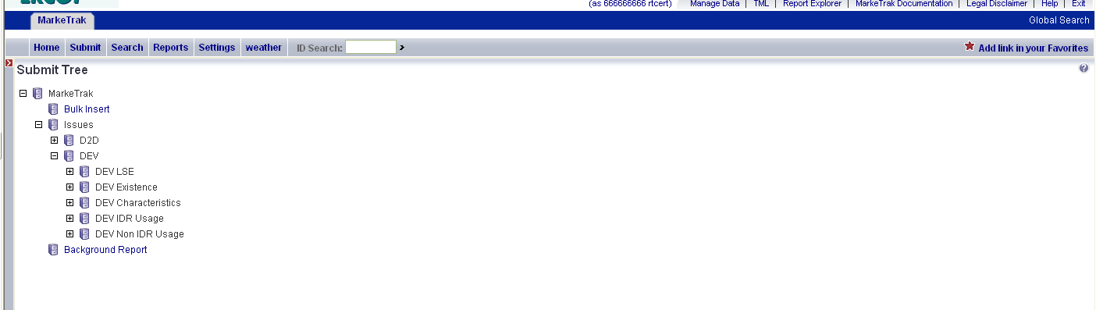

- User will select the Report Name to be generated from the drop down list. For this example, TDSP will select Issue Details by ESIID. (See Fig. 9.1b)

Fig. 9.1b
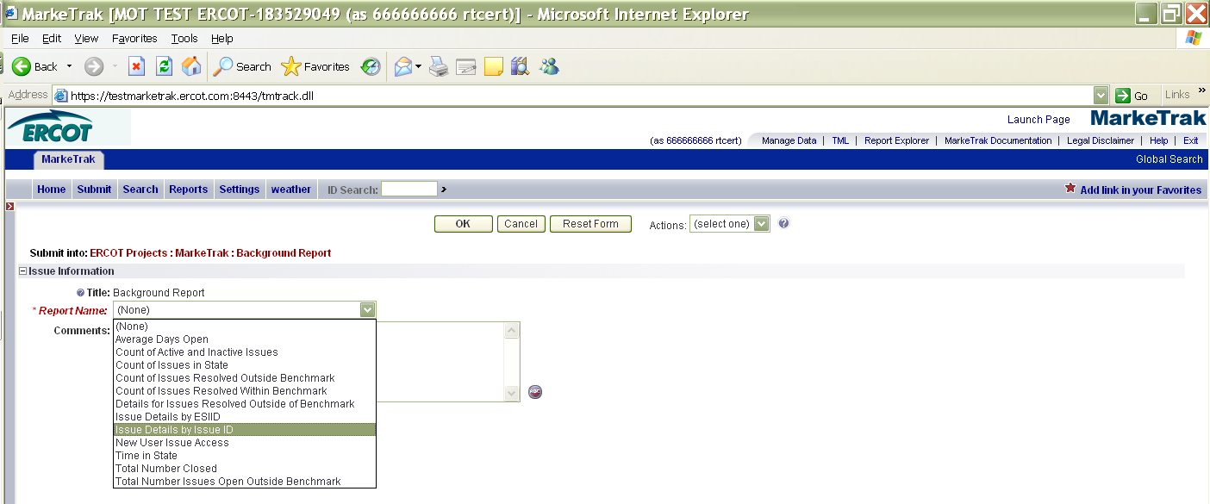

- User selects OK. Comments are optional on this transition.

- By selecting OK, the issue is created and the User has the option to Provide Parameters, Withdraw the report, or Add Comment. (See Fig. 9.1c)

Fig. 9.1c
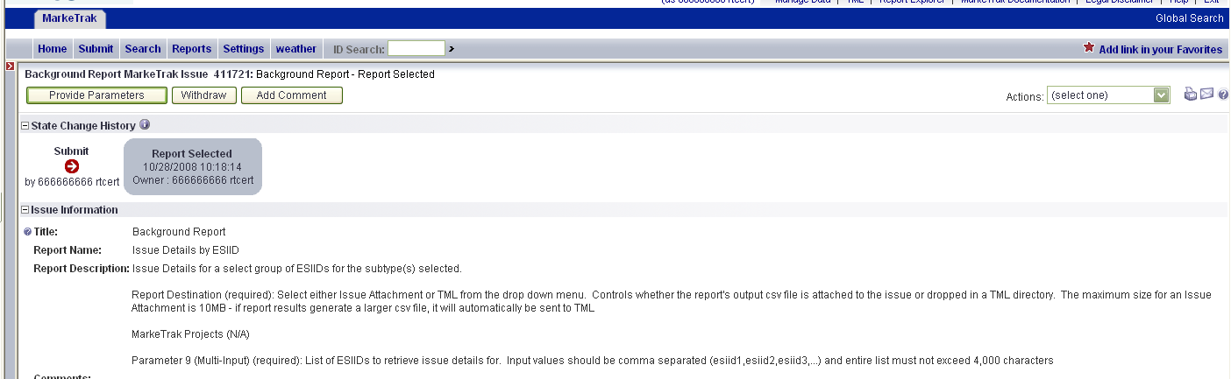

- By selecting Provide Parameters, the User will be prompted to enter the required information for the selected report.

- All required parameters for the report type selected will be shown above the Report Destination drop-down field. (See Fig. 9.1d)

Fig. 9.1d
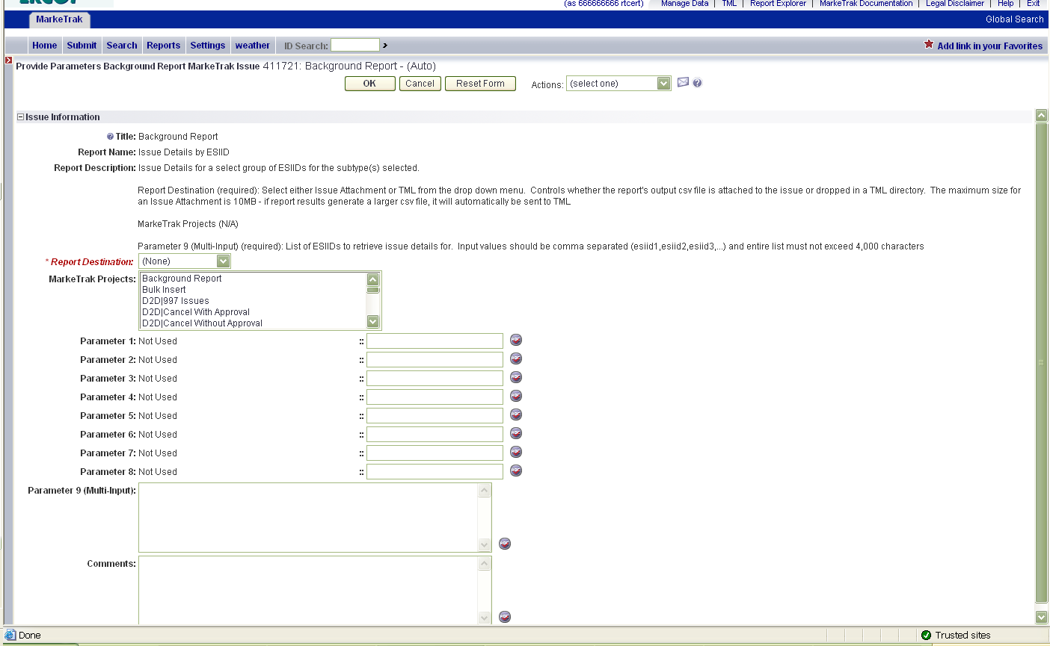

- The User will select the Report Destination which is a required field. The User has the option to attach the report to the issue or to post the report to TML. There is a file size limitation of 10MB. If the results generate a CSV file that exceeds 10MB, it will automatically be sent to TML.

- The User has the option to select a MarkeTrak Project (issue sub-type). All reports provide the option to select a project but it is not a required field for all reports. The User also has the ability to select multiple projects by holding down the Ctrl key while making their selection(s).

- The User inputs the parameters required for the type of Background Report that is being requested. Different reports have different parameters. Any parameters that are not available will either not be visible or will display the ‘Not Used’ label.

- For Multi-Input parameters (such as ESIID and/or Issue ID), the data must be comma separated (esiid1, esiid2, esiid3,…) and the list cannot exceed 4,000 characters.

- Once all parameters have been entered, the User selects OK.

- The User now has the ability to review the data entered and, by selecting the buttons at the top of the screen, can Submit Report, Update Parameters, Withdraw the issue, or Add Comment.

- Once submitted, the report will run in the background and the issue will remain open until the report posts to either the issue or to TML. The User can choose to be notified via email when the report has generated by clicking the ‘Actions’ drop-down menu, selecting the ‘Add Item Notification’ and ‘MT – Background Report has been prepared’. This must be done prior to clicking the Submit Report button. (See Fig. 9.1e)

Fig. 9.1e
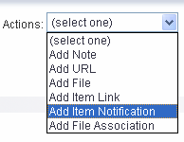
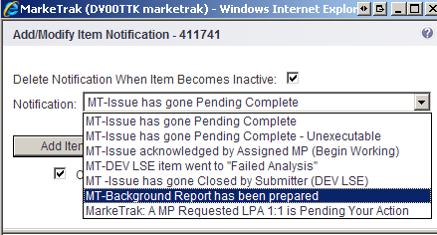

- The User selects Submit Report and the report request is initiated in the background. The report will post to the issue or to TML upon completion depending upon the Report Destination chosen by the User and/or the size of the results file. (See Fig. 9.1f)

Fig. 9.1f
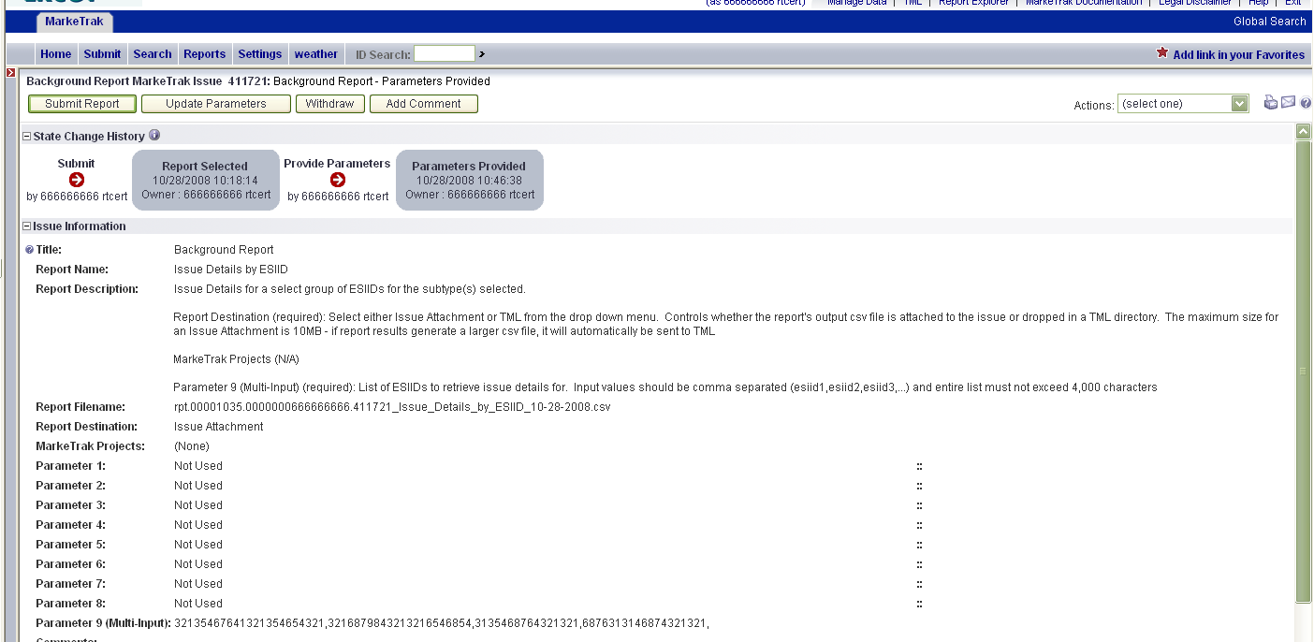

- Once the report has completed and posted to the designated location, a notification email will be generated (if applicable) and the issue will Auto-Close. (See Fig 9.1g)

Fig 9.1g
