PRR Number | 779 | PRR Title | Transparency for PSS and Full Interconnection Studies
Date |  | October 23, 2008
Submitter’s Information
Name |  | Marguerite Wagner
E-mail Address |  | Marguerite.Wagner@pseg.com
Company |  | PSEG TX
Phone Number |  | 201-202-5468
Cell Number
Market Segment |  | Independent Generator

Comments

Overall Market Benefit
Overall Market Impact
Consumer Impact

Thanks to everyone for their considered and thoughtful comments. Below are responses intended to address the concerns/comments.

Responding to the comments from Luminant on the PSS issue:

PRR 779 is not intended to reflect real time operational status of the PSS. The intent of the posting is to provide baseline information for use in development of the models used for stability studies. To this end, the idea is to have a static set of rudimentary information on the Transmission Planning website for use in stability modeling. Data access would require the normal login process for the Planning data. The table of information envisioned would look like:

Unit Name | PSS (Y or N) | PSS in Service (Y or N) | PSS Tuned (Regional or Local)

So there is no intent to reflect anything other than the general operational status of PSS for modeling purposes.

Responding to the comments from FPL on the location of resources requesting Full Interconnection Studies:

As demonstrated below, other major electricity markets in the United States including New England, New York, and PJM make the specific interconnection point for interconnection requests public.

ISO-New England includes the following information (which is a subset of all that is posted) and the information includes the specific point of interconnection. Notably a variety of resources are siting in New England.

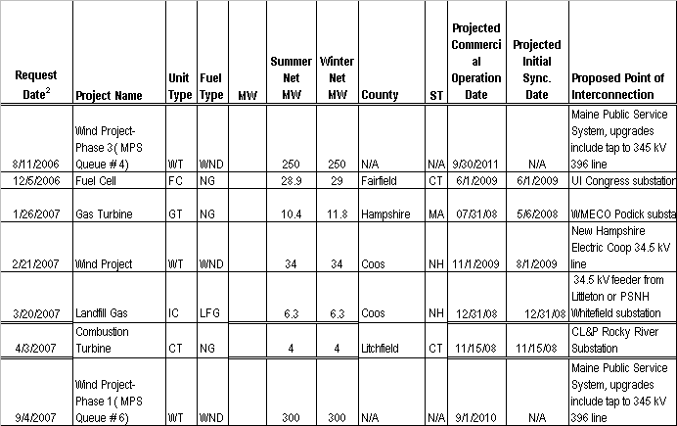

This information may be found at:

http://iso-ne.com/genrtion_resrcs/nwgen_inter/status/interconnection_request_queue_10172008.xls

PJM has a three step study process: a Feasibility Study, a System Impact Study and then a Facilities Study. Prior to the 2nd study the following information is available: Point of Interconnection (which is the substation through which the unit will connect to the grid), MW size, fuel type and projected in-service date. This comports with what is proposed in PRR 779.

New York - ISO posts very detailed information, including the point of interconnection, as can be seen below. Notably, many types of resources appear to be siting in the NYISO. The information is posted at:

http://www.nyiso.com/public/webdocs/services/planning/nyiso_interconnection_queue/nyiso_interconnection_queue.xls

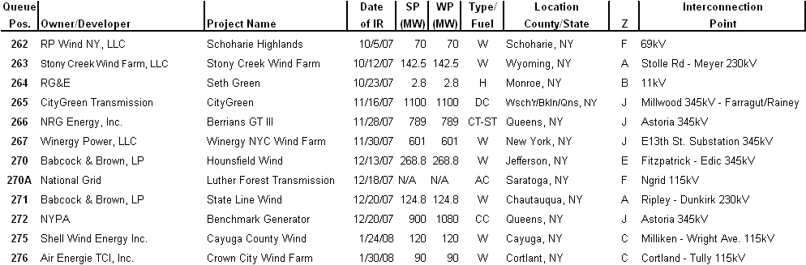

ERCOT Market Participants should be afforded transparency to aid in planning similar to that provided in other regions.

Revised Proposed Protocol Language
None.

