ERCOT Operations Report
Sep 2008 ROS & OWG

Frequency Control
Time | Freq(Hz) | Duration (s)
9/1/2008 17:17 | 59.861 | 28 | Unit trip with 610 MW online
9/3/2008 4:25 | 59.882 | 12 | Unit trip with 615 MW online
9/5/2008 18:21 | 59.88 | 12 | Unit trip with 665 MW online
9/7/2008 22:34 | 59.858 | 62 | Unit trip with 545 MW online
9/10/2008 21:59 | 59.895 | 2 | SCE changed -580 MW in 3 mins
9/13/2008 0:16 | 59.885 | 2 | Unit trip with 140 MW online, SCE changed -640 MW in 4 mins
9/13/2008 4:04 | 60.103 | 67 | Out of DRS, Steel Mill Load drop 145 MW in 7 mins, System Load drop 100 MW in 7 mins
9/14/2008 7:41 | 60.102 | 276 | Out of DRS, SCE change +500 MW in 6 mins
9/14/2008 10:50 | 60.106 | 60 | Out of DRS, SCE change +405 MW in 9 mins, Steel Mill Load drop 80 MW instantly
9/15/2008 19:05 | 60.101 | 12 | Out of DRS, SCE change +205 MW in 1 min
9/16/2008 6:45 | 60.105 | 346 | QSE showed 3554 MW online but the base power schedule show 831 MW, which caused a wrong offset to be entered
9/16/2008 14:07 | 60.105 | 70 | Out of DRS, SCE change +185 MW in 4 mins
9/19/2008 0:05 | 60.106 | 148 | SCE change +315 MW in 3 mins
9/20/2008 22:08 | 60.105 | 17 | Units came online with 400 MW
9/24/2008 13:30 | 59.89 | 8 | Unit trip with 600 MW online
9/27/2008 1:05 | 60.103 | 4 | SCE changed +970 MW in 10 mins
9/27/2008 10:01 | 59.894 | 22 | Unit trip with 480 MW online
9/27/2008 11:58 | 59.843 | 92 | Unit trip with 610 MW online
9/29/2008 14:47 | 59.841 | 56 | Unit trip with 575 MW online
Note: Time of frequency excursions outside the range of +/- 0.1 Hz.
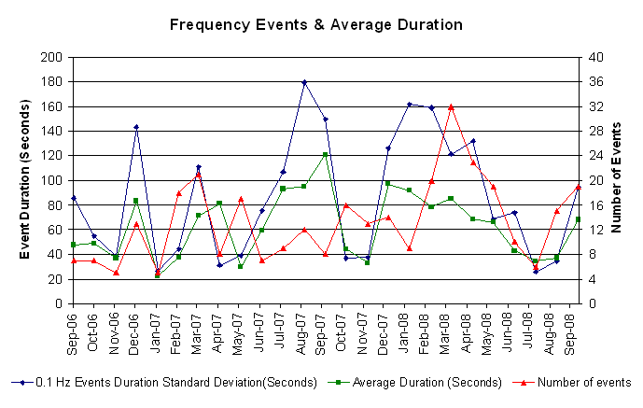
Deployed Responsive (Reported Above)
Time of deployed | Stop Time | Duration | Max deployed | Details
9/01 11:07:51 | 9/01 11:20:26 | 0:12:35 | 322.90 | Unit Trip
9/01 17:17:48 | 9/01 17:36:25 | 0:18:37 | 640.59
9/03 04:25:06 | 9/03 04:45:26 | 0:20:20 | 458.31
9/05 18:21:30 | 9/05 18:36:24 | 0:14:54 | 510.38
9/07 22:34:06 | 9/07 22:52:54 | 0:18:48 | 583.29 | Unit Trip
9/10 06:05:06 | 9/10 06:16:32 | 0:11:26 | 343.74 | SCE change -1330 MW in 10m
9/10 21:59:08 | 9/10 22:12:28 | 0:13:20 | 390.60
9/13 00:16:34 | 9/13 00:40:08 | 0:23:34 | 442.70
9/14 09:55:44 | 9/14 10:08:48 | 0:13:04 | 328.10 | Out of Up Reg. Higher morning load pick up, possibly due to Hurricane Ike. Not anticipated in the offset.
9/14 11:57:06 | 9/14 12:24:16 | 0:27:10 | 328.10 | Out of Up Reg, Steel Mill load pick up 130 in 15 mins, System load pick up 680 in 15 mins.
9/18 20:35:16 | 9/18 20:45:58 | 0:10:42 | 338.53 | Bad Offset
9/21 01:19:30 | 9/21 01:30:48 | 0:11:18 | 317.69 | Unit Ramp down 350 MW.
9/22 15:37:50 | 9/22 15:43:47 | 0:05:57 | 317.69 | Unit Trip
9/24 13:30:14 | 9/24 13:44:26 | 0:14:12 | 416.65
9/27 10:01:30 | 9/27 10:14:04 | 0:12:34 | 401.01
9/27 11:58:21 | 9/27 12:27:14 | 0:28:53 | 697.89
9/27 19:04:50 | 9/27 19:17:12 | 0:12:22 | 333.33 | Input error in offset calculation.
9/29 14:47:22 | 9/29 15:03:08 | 0:15:46 | 671.84
9/30 6:06:18 | 9/30 6:18:44 | 0:12:26 | 359.35 | Slow Unit Response. SCE change -330 MW in 3m

Day-Ahead OOMC and RMR Capacity Purchases

Details | RMR | OOMC | RPRS S1 | RPRS S2 | Total
Austin | 0 | 2 | 7 | 13 | 22
Bryan Area | 0 | 0 | 0 | 0 | 0
Corpus | 0 | 6 | 2 | 8 | 16
DFW | 0 | 21 | 0 | 28 | 49
E RIO | 0 | 2 | 0 | 0 | 2
Houston | 0 | 14 | 0 | 26 | 40
Laredo | 0 | 2 | 6 | 3 | 11
North | 0 | 12 | 14 | 19 | 45
Northeast | 0 | 0 | 0 | 20 | 20
San Antonio | 0 | 0 | 0 | 17 | 17
South | 0 | 0 | 1 | 1 | 2
W RIO | 0 | 0 | 0 | 0 | 0
Western | 0 | 2 | 0 | 14 | 16
 | 0 | 61 | 30 | 149 | 240

Historical Totals | Sep-07 | Aug-08 | Sep-08
Austin | 3 | 41 | 22
Bryan Area | 0 | 2 | 0
Corpus | 0 | 2 | 16
DFW | 19 | 34 | 49
E RIO | 0 | 0 | 2
Houston | 0 | 76 | 40
Laredo | 90 | 12 | 11
North | 8 | 82 | 45
Northeast | 0 | 22 | 20
San Antonio | 0 | 19 | 17
South | 0 | 2 | 2
W RIO | 0 | 0 | 0
Western | 0 | 21 | 16
Total | 120 | 313 | 240

http://www.ercot.com/mktinfo/services/rprsdr/index.html
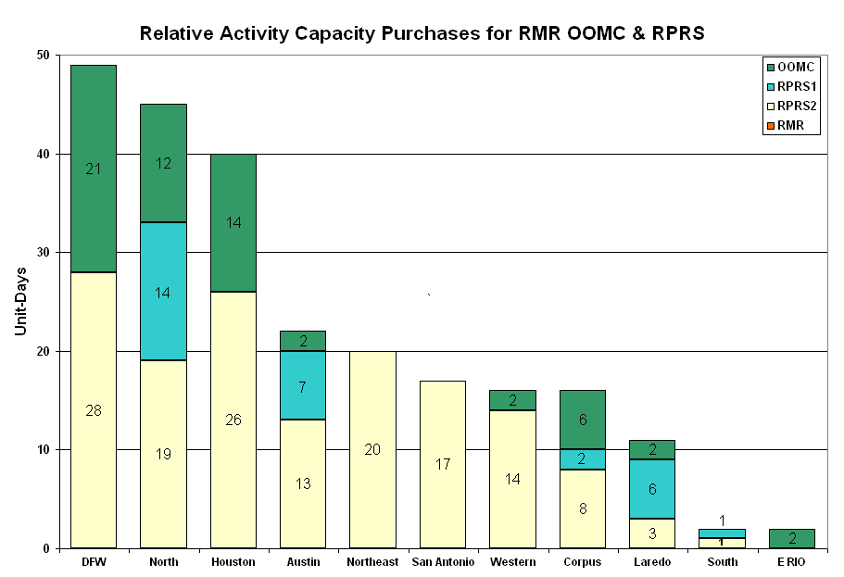
OOME and Congestion Management Activity
Congestion affected by outages
Remedial action plan has been developed for the element
Contingency | Overloaded Element | Days
Austrop 345/138kV autotransformer #2 | Austrop 345/138kV autotransformer #1 | 19
Elkton - Tricorner - Martin Lake 345KV | Tyler Northeast - Delek 138KV | 11
Enterprise - Trinidad SES & Martin Lake SES - Stryker Creek SES 345kV | Nacogdoches SE 345/138kV autotransformer #1 | 10
STP - Elm Creek 345KV | Blessing - Lolita 138KV | 7
Menard - Gillespie 138kV | Menard 138/69kV autotransformer #1 | 7
Dilley Switch - North Laredo 138kV | North Laredo - Asherton 138kV | 6
Jack County - Reno 138kV | Rhome - Decatur 138kV | 6
Sandow Switch - Austrop 345kV | Sandow Switch - Elgin Switch | 5
Fort Mason T1 138/69kV autotransformer | Menard T1 138/69kV autotransformer | 5
Odessa EHV Switch 345/138kV autotransformer #2 | Odessa EHV Switch 345/138kV autotransformer #1 | 4
Marion - Zorn - Clear Springs 345KV | Seguin - Seguin West 138KV | 4
Austrop - Daffin - Decker 138kV | Austrop - Decker 138kV | 4
Royce Switch - Farmersville 345kV | the other Royce Switch - Farmersville 345kV | 3
STP - Whitepoint 138kV | Blessing - Lolita 138kV | 3
Dilley - San Miguel 138KV | Derby - Pearsall 69KV | 3
STP - Hillje - Whitepoint 345KV | Blessing - Lolita 138KV | 3
Monticello SES - Allen Switch & Sulphur Springs Switch 345kV | Farmerville TU - Royse Switch 345kV | 2
Bosque Switch - Whitney TU 138KV | Lake Whitney - Whitney TU 138KV | 2
Dyann - East Bernard 138KV | Lane City - Blessing 138KV | 2
San Angelo Red Creek 345/138kV autotransformer #2 | San Angelo Red Creek 345/138kV autotransformer #1 | 2
Chamber - King and Cedar Bayou - North Belt 345kV | South Channel - Shell 138kV | 1
Elgin Switch - Sandow Switch 138kV | Sandow Switch - Salty 138kV | 1
Marion - Hill Country and Skyline 345kV | Marion - Elm Creek 345kV | 1
Calaveras - Ball Park 138kV | Five Points - Westside CPS | 1
Derby - Pearsall 138KV | Derby - Pearsall 69KV | 1
San Miguel 138/69KV autotransformer | Pearsall 138/69KV autotransformer | 1
Basecase | Menard 138/69kV autotransformer#1 | 1
STP - Blessing 345kV | Columbus - Stafford 69kV | 1
Martin Lake - Shamburger 345kV | Elkton 345/138kV autotransformer | 1
Temple Pecan Creek - Tradinghouse and Temple Switch - Lake Creek 345kV | Goldthwaite - Brownwood 138kV | 1
Jewett - Big Brown 345kV | Jewett - Big Brown 345kV | 1
Elgin - Gilleland Creek 138kV | Elgin Switch - Taylor 138kV | 1
Baytown Energy - Chambers 345 | Baytown transformer AT1 and AT2 | 1
Lytton Springs - Holman and Fayette Plant 2 345kV | Lost Pines - Austrop 345kV | 1
Graham - Benbrook and Graham - Parker Switch 345kV | Flat creek - Leon Switch 138kV | 1
Big Brown - Venus 345kV | Richland Chambers - Trinidad 345kV | 1
Deepwater - Goodyear 138KV | Lydell - Green Bayou 138KV | 1
Allen Switch - Royse Switch & Monticello 345KV | Anna Switch - Collin 345KV | 1
San Miguel 138KV autotransformer | Leakey - Campwood 69kV | 1
Tradinghouse - Venus 345KV | Bosque Switch - Rogers Hill 138KV | 1

Zonal OC1
CSC | Days
South-North | 1
North-South | 6
North-Houston | 6
North-West | 1

New RAP (Date indicates last update of RAP not implementation date.)

None

New Procedures/Forms/Operations Bulletins

Date | Subject | Bulletin No.
09/03/2008 | Transmission & Security Desk V 3 Rev 95 | 385
09/03/2008 | Shift Supervisor Desk V 3 Rev 50 | 384
09/03/2008 | Day Ahead Desk V 3 Rev 36 | 383
09/03/2008 | Frequency Control Desk V 3 Rev 69 | 382

Blackout/Load Shed Incidences

None

EECP

None

Major System Voltage Problems

None

Major Computer Problems, Enhancements & Fixes

None

Communication

None

ERCOT peak (Unofficial)
09/02 17:00 56,315 MW

Yearly MTLF Error Comparison
Yearly Mid-Term (Hourly) Load Forecast Error Comparison for the ERCOT Forecast
Month | MAPE for MTLF at 16:00 Day-Ahead
Month | 2005 | 2006 | 2007 | 2008
January | 5.02 | 4.79 | 4.55 | 3.30
February | 3.47 | 4.81 | 3.75 | 3.59
March | 3.41 | 4.95 | 2.70 | 3.29
April | 3.37 | 5.59 | 3.00 | 2.45
May | 4.21 | 3.59 | 3.22 | 3.01
June | 3.91 | 2.65 | 4.46 | 2.81
July | 5.22 | 2.62 | 4.29 | 2.55
August | 4.86 | 2.09 | 3.11 | 3.66
September | 6.24 | 4.03 | 3.78 | 4.99
Annual Average | 4.56 | 3.79 | 3.55 | 3.29

OCN, Advisory, Alerts & Emergency Notices
Capacity
Date | Start | End | Event
9/1/08 | 12:45 | 17:42 | Advisory ARR below 3000 MW.
9/1/08 | 12:05 | 17:42 | Alert projected capacity shortage for HE 1600 - 1800.
9/1/08 | 15:00 | 17:00 | Deployed NSRS in the South and Houston Zones.
9/1/08 | 10:05 | 12:05 | OCN projected capacity shortage for HE 1600 - 1800.
9/5/08 | 15:30 | 18:00 | Advisory ARR below 3000 MW.
9/5/08 | 0:30 | 18:00 | OCN projected capacity shortage for HE 15:00 - 18:00.
9/7/08 | 16:45 | 19:00 | Advisory ARR below 3000 MW.
9/16/08 | 10:25 | 21:00 | Advisory ARR below 3000 MW.
9/18/08 | 6:50 | 11:20 | Advisory ARR below 3000MW.
9/20/08 | 12:45 | 21:15 | Advisory ARR below 3000 MW.
9/22/08 | 16:11 | 20:25 | Advisory ARR below 3000 MW.
9/23/08 | 13:31 | 19:09 | Advisory ARR below 3000 MW.
9/24/08 | 10:10 | 19:47 | Advisory ARR below 3000 MW.
9/25/08 | 15:21 | 20:00 | Advisory ARR below 3000 MW.
9/26/08 | 13:40 | 18:10 | Advisory ARR below 3000 MW.
9/26/08 | 6:25 | 15:30 | OCN projected capacity shortage for HE 16:00 - 17:00.
9/27/08 | 12:51 | 18:17 | Advisory ARR below 3000 MW.
9/28/08 | 14:38 | 20:54 | Advisory ARR below 3000 MW.
9/28/08 | 7:30 | 11:00 | OCN projected capacity shortage for HE 1600 - 1900.
9/29/08 | 13:55 | 19:07 | Advisory ARR below 3000 MW.
9/29/08 | 16:26 | 18:00 | Deployed NSRS in North zone due to projected depletion of balancing bids.
9/30/08 | 15:45 | 19:50 | Advisory ARR below 3000 MW.
9/30/08 | 16:06 | 18:00 | Deployed NSRS in North zone due to projected depletion of up balancing bids.

Transmission
Date | Start | End | Event
9/3/08 | 13:16 | 14:16 | Emergency notice issued due to a potential voltage collapse in the Houston area with the loss of double circuit Jewett - TH Wharton and Tomball 345KV.
9/8/08 | 7:00 | 7:50 | Transmission Alert issued due to a forced outage in Presidio area.
9/11/08 | 22:35 | 0:00 | Alert issued due to loss of Presidio - Alamito Creek 69KV, implemented a BLT transferring 4 MW of ERCOT load to CFE.
9/12/08 | 0:15 | 1:10 | Alert issued due to loss of Presidio - Alamito Creek 69KV, implemented a BLT transferring 4 MW of ERCOT load to CFE.
9/12/08 | 20:35 | 0:00 | Emergency Notice issued for Hurricane Ike making landfall along the Texas Coast causing large scale service disruption of load and transmission outages.
9/13/08 | 0:15 | 0:00 | Emergency Notice issued for Hurricane Ike making landfall along the Texas Coast causing large scale service disruption of load and transmission outages.
9/14/08 | 19:12 | 23:00 | Emergency Notice issued for the Laredo Area due to forced outages. Received 70 MW of emergency energy from CFE across the Laredo VFT.
9/14/08 | 18:56 | 19:12 | ERCOT is issuing an Alert for the Laredo area due to the loss of Roma to Falcon 138kV line.
9/14/08 | 0:15 | 0:00 | Emergency Notice issued for Hurricane Ike making landfall along the Texas Coast causing large scale service disruption of load and transmission outages.
9/15/08 | 15:00 | 0:00 | BLT at Crosby, ERCOT supplying 15 MW load for ENTERGY due to Hurricane Ike.
9/15/08 | 0:15 | 0:00 | Emergency Notice issued due to large scale service disruption of load and transmission service as a result of Hurricane Ike.
9/16/08 | 14:20 | 0:00 | BLT at Keith and Roans Prairie TMPP, ERCOT supplying 2.5 MW load for ENTERGY due to Hurricane Ike.
9/16/08 | 15:00 | 0:00 | BLT at Crosby, ERCOT supplying 15 MW load for ENTERGY due to Hurricane Ike.
9/16/08 | 0:15 | 0:00 | Emergency Notice issued due to large scale service disruption of load and transmission service as a result of Hurricane Ike.
9/17/08 | 0:15 | 0:00 | BLT at Crosby, ERCOT supplying 15 MW load for ENTERGY due to Hurricane Ike.
9/17/08 | 0:15 | 0:00 | BLT at Keith and Roans Prairie TMPP, ERCOT supplying 2.5 MW load for ENTERGY due to Hurricane Ike.
9/17/08 | 0:15 | 0:00 | Emergency Notice issued due to large scale service disruption of load and transmission service as a result of Hurricane Ike.
9/18/08 | 0:15 | 0:00 | BLT at Crosby, ERCOT supplying 15 MW load for ENTERGY due to Hurricane Ike.
9/18/08 | 0:15 | 0:00 | BLT at Keith and Roans Prairie TMPP, ERCOT supplying 2.5 MW load for ENTERGY due to Hurricane Ike.
9/18/08 | 0:01 | 0:00 | OCN issued due to large scale service disruption of load as a result of Hurricane Ike.
9/19/08 | 0:15 | 17:09 | BLT at Crosby, ERCOT supplying 15 MW load for ENTERGY due to Hurricane Ike.
9/19/08 | 0:01 | 0:00 | OCN issued due to large scale service disruption of load as a result of Hurricane Ike.
9/20/08 | 0:01 | 0:00 | OCN issued due to large scale service disruption of load as a result of Hurricane Ike.
9/21/08 | 0:01 | 0:00 | OCN issued due to large scale service disruption of load as a result of Hurricane Ike.
9/22/08 | 0:01 | 9:00 | OCN issued due to large scale service disruption of load as a result of Hurricane Ike.
9/24/08 | 23:24 | 0:00 | Implemented a BLT, ERCOT supplying 2 MW of load for ENTERGY due to Hurricane Ike repairs.
9/25/08 | 0:15 | 4:00 | Implemented a BLT, ERCOT supplying 2 MW of load for ENTERGY due to Hurricane Ike repairs.

9/03 13:16 Emergency notice issued due to a potential voltage collapse in the Houston area with the loss of double circuit Jewett - TH Wharton and Tomball 345KV.

Weather

9/01 00:15 Advisory issued due to Hurricane Gustav in the Gulf of Mexico.

9/09 15:00 Advisory issued for Hurricane Ike entering the Gulf of Mexico. Currently a reasonable expectation is Ike will make landfall on the Texas coast impacting the ERCOT region.

9/10 00:15 Advisory issued for Hurricane Ike entering the Gulf of Mexico. Currently a reasonable expectation is Ike will make landfall on the Texas coast impacting the ERCOT region.

9/11 00:15 Advisory issued for Hurricane Ike entering the Gulf of Mexico. Currently a reasonable expectation is Ike will make landfall on the Texas coast impacting the ERCOT region.

9/11 11:00 Alert issued for Hurricane Ike expected to make landfall on the Texas Coast, impacting the ERCOT Region.

9/12 00:15 Alert issued for Hurricane Ike expected to make landfall on the Texas Coast, impacting the ERCOT Region.

Texas RE Event Analysis

9/14 19:12 Emergency Notice issued for the Laredo Area due to forced outages. Forced Outages of Roma – Falcon 138 kV line and two units. The primary cause of the unit trips was a series of voltage spikes triggered by lightning strikes with flashover at the 138kV switchyard, resulting in loss of loads to the plant auxiliary equipment. Received 70 MW of emergency energy from CFE across the Laredo VFT.
Other

9/12 23:45 ERCOT held interval ending 23:45 real-time balancing deployments for interval ending 2400.

9/13 02:00 ERCOT held interval ending 02:00 real-time balancing deployments for interval ending 02:15.

