Commercial Operations Market Guide
Section 8: Settlement Statement and Invoice Detail
Month XX, 2008

8. Settlement Statements and Invoices 1
8.1 Congestion Revenue Rights (CRR) Statements and Invoices 1
8.1.1 CRR DAM and RTM Statement and Invoice 1
8.1.2 CRR Auction Statements and Invoices 1
8.1.2.1 CRR Auction Statements and Invoices Timeline 1
8.1.2.2 CRR Monthly & Annual Auction Invoice Example 2
8.1.3 CRR Auction Revenue Distribution (CARD) 3
8.1.3.1 CARD Timeline 3
8.1.3.2 CARD Invoice Examples 3
8.1.3.2.1 Initial Disbursement 3
8.1.3.2.2 Final Disbursement 4
8.1.4 CRR Balancing Account Invoice 4
8.1.4.1 CRR Balancing Account Invoice Timeline 5
8.1.4.2 CRR Balancing Account Invoice Examples 5
8.1.4.2.1 Load-Allocated CRR Amount per QSE 5
8.1.4.2.2 CRR Refund Amount 5
8.2 Day Ahead Market Statement/Invoice 6
8.2.1 Day Ahead Market Statement/Invoice Timeline 6
8.2.2 DAM Statement/Invoice Examples 7
8.2.2.1 DAM Invoice – Initial Invoice for CRR Account Holder 7
8.2.2.2 DAM Invoice – Initial Invoice for QSE 8
8.2.2.3 DAM Inovice – Resettlement Invoice for CRR Account Holder 8
8.2.2.4 DAM Invoice – Resettlement Invoice for QSE 9
8.2.2.5 Late Fee Invoice 9
8.3 Real-Time Market Statements and Invoices 9
8.3.1 Timeline 9
8.3.2 RTM Statement Examples 10
8.3.2.1 RTM Initial Statement for CRR Account Holder 10
8.3.2.2 RTM Initial Statement for QSE 10
8.3.2.3 RTM Final Statement for CRR Account Holder 10
8.3.2.4 RTM Final Statemnt for QSE 10
8.3.2.5 RTM True-Up Statement for CRR Account Holder 10
8.3.2.6 RTM True-Up Statement for QSE 10
8.3.2.7 RTM Resettlement Statement for CRR Account Holder 10
8.3.2.8 RTM Resettlemnet Statement for QSE 10
8.3.2.9 RTM Invoice Examples 10
8. 3.2.10 RTM Settlement Invoice for CRR Account Holder 10
8. 3.2.11 RTM Settlement Invoice for QSE 10
8.3.2.12 RTM Up-lift Invoice for CRR Account Holder 11
8.3.2.13 RTM Up-lift Invoice for QSE 11
8.3.2.14 RTM Late Fee Invoice for CRR Account Holder 11
8.3.2.15 RTM Late Fee Invoice for QSE 11
8.4 Miscellaneous Invoices 11

Settlement Statements and Invoices
The Congestion Revenue Rights (CRR) Auction, Day –Ahead Market (DAM) and Real-Time Market (RTM) will be settled seperately. There will be three different settlement statements, three different invoices, and the potential for three different settlement timelines – initial, final and true-up.
Details regarding Settlement Statement posting processes are located in Section 9.1.1 of ERCOT Prootcol.

8.1 Congestion Revenue Rights (CRR) Statements and Invoices
Details regarding CRRs are located in Section 13 (Congestion Revenue Rights) of this guide.

8.1.1 CRR DAM and RTM Statement and Invoice
Details regarding DAM Statements and Invoices are located in Section 8.1.2 (Day Ahead Market Statement/Invoice) of this guide.
Details regarding RTM Statements and Invoices are located in Section 8.1.3 (Real Time Market Statement/Invoice) of this guide.

8.1.2 CRR Auction Statements and Invoices

8.1.2.1 CRR Auction Statements and Invoices Timeline

ERCOT will issue CRR statements on the first Business Day after a CRR Auction. A CRR Account Holder who purchased CRRs during the CRR Auction will pay ERCOT for those CRRs purchased on the third Business Day. On the fourth Business day following the CRR Auction and after ERCOT receives payment from the purchasing CRR Account Holders, ERCOT pays the selling CRR Account Holder.
If a Statement date occurs on a day that is not a bank Business Day, the statements will be issued on the next bank Business Day.

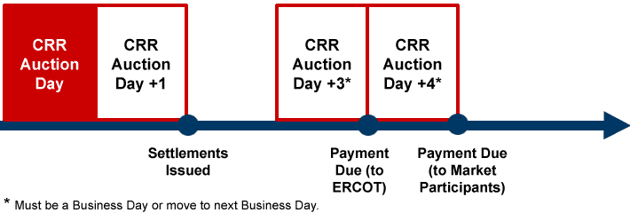

8.1.2.2 CRR Monthly & Annual Auction Invoice Example
Monthly and Annual Invoices are issued as separate invoices, however the formatting is the same for each. The invoice will indicate whether it pertains to Monthly or Annual Auction.
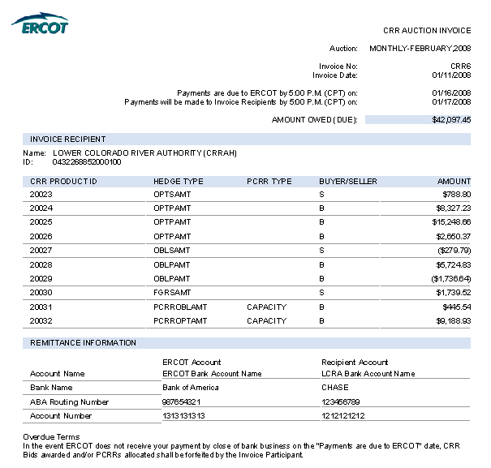

8.1.3 CRR Auction Revenue Distribution (CARD)
Details regarding CARD are located in Section 13 (Congestion Revenue Rights) of this guide.

8.1.3.1 CARD Timeline

8.1.3.2 CARD Invoice Examples

8.1.3.2.1 Initial Disbursement
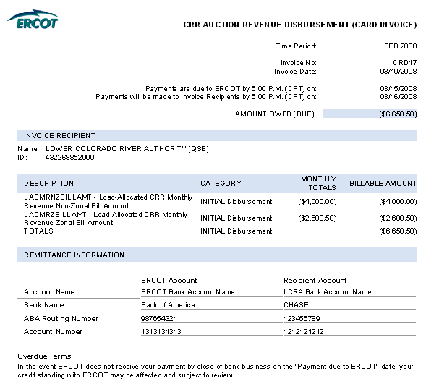

8.1.3.2.2 Final Disbursement
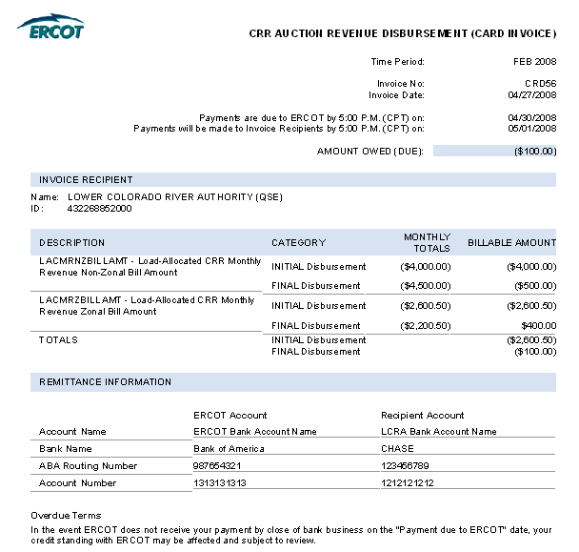

8.1.4 CRR Balancing Account Invoice
Details regarding CRR Balancing Accounts are located in Section 13 (Congestion Revenue Rights) of this guide.

8.1.4.1 CRR Balancing Account Invoice Timeline

8.1.4.2 CRR Balancing Account Invoice Examples

8.1.4.2.1 Load-Allocated CRR Amount per QSE
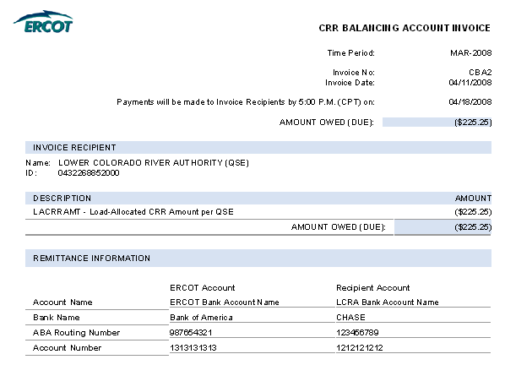

8.1.4.2.2 CRR Refund Amount
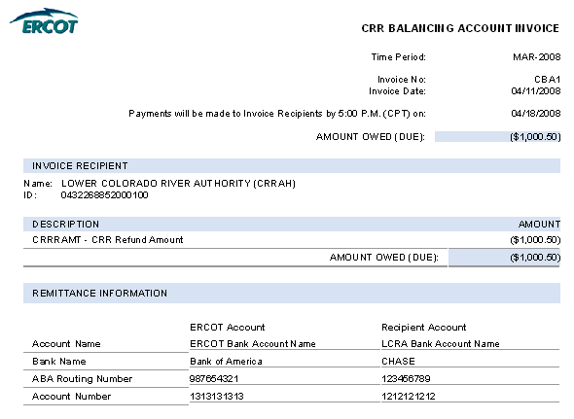

8.2 Day Ahead Market Statement/Invoice

8.2.1 Day Ahead Market Statement/Invoice Timeline
The Day-Ahead Market (DAM) statements and invoices for CRR Account Holders and QSEs are issued two days after the operating day. Payments due to ERCOT shall occur on the 4th Business Day from receipt of invoice, which equals the Operating Day +6. On day seven, ERCOT pays those QSEs who are entitled to money from their participation in the DAM.
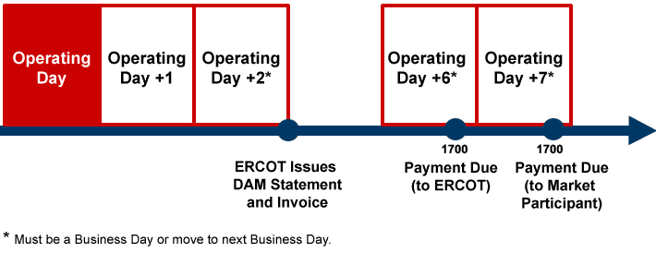

8.2.2 DAM Statement/Invoice Examples

8.2.2.1 DAM Invoice – Initial Invoice for CRR Account Holder
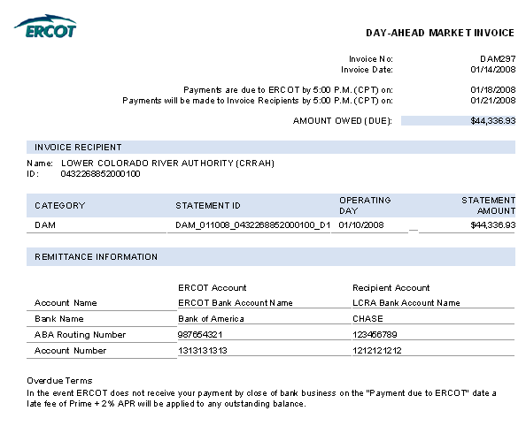

8.2.2.2 DAM Invoice – Initial Invoice for QSE
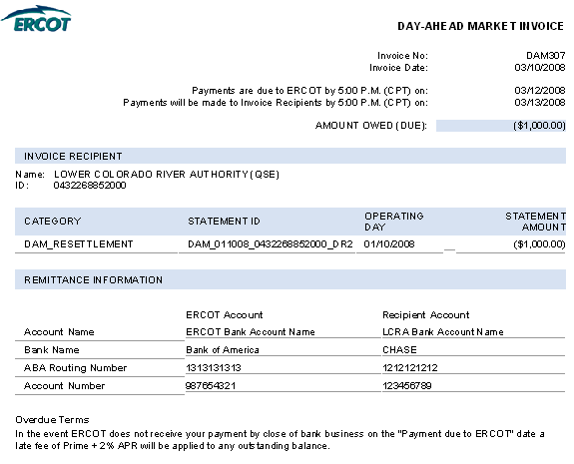

8.2.2.3 DAM Inovice – Resettlement Invoice for CRR Account Holder
Provide Example

8.2.2.4 DAM Invoice – Resettlement Invoice for QSE
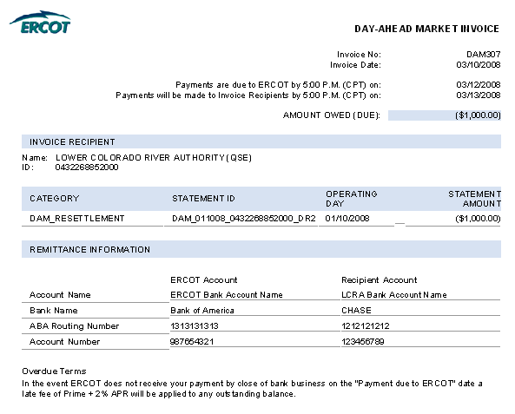

8.2.2.5 Late Fee Invoice
Provide Example

8.3 Real-Time Market Statements and Invoices

8.3.1 Timeline
Add language about timeline
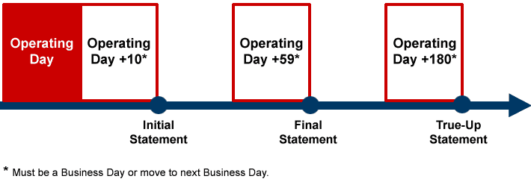

8.3.2 RTM Statement Examples

8.3.2.1 RTM Initial Statement for CRR Account Holder

8.3.2.2 RTM Initial Statement for QSE
Provide Example

8.3.2.3 RTM Final Statement for CRR Account Holder

8.3.2.4 RTM Final Statemnt for QSE
Provide Example

8.3.2.5 RTM True-Up Statement for CRR Account Holder

8.3.2.6 RTM True-Up Statement for QSE
Provide Example

8.3.2.7 RTM Resettlement Statement for CRR Account Holder

8.3.2.8 RTM Resettlemnet Statement for QSE
Provide Example

8.3.2.9 RTM Invoice Examples

8. 3.2.10 RTM Settlement Invoice for CRR Account Holder

8. 3.2.11 RTM Settlement Invoice for QSE
Provide Example

8.3.2.12 RTM Up-lift Invoice for CRR Account Holder

8.3.2.13 RTM Up-lift Invoice for QSE
Provide Example

8.3.2.14 RTM Late Fee Invoice for CRR Account Holder

8.3.2.15 RTM Late Fee Invoice for QSE
Provide Example

8.4 Miscellaneous Invoices

