ERCOT Operations Report
July 2008 ROS & OWG

Frequency Control
Time | Freq(Hz) | Duration (s)
7/10/2008 22:03 | 59.859 | 78 | Unit Trip with 463 MW online
7/27/2008 9:11 | 59.89 | 35 | Unit Trip with 589 MW online
7/27/2008 12:15 | 59.898 | 7 | Unit Trip with 800 MW online
7/28/2008 20:55 | 59.882 | 9 | Unit Trip with 750 MW online
7/28/2008 22:11 | 60.103 | 36 | Out of URS. SCE change + 500 MW in 10 min
7/29/2008 14:32 | 59.853 | 42 | Unit Trip with 710 MW online
Note: Time of frequency excursions outside the range of +/- 0.1 Hz.
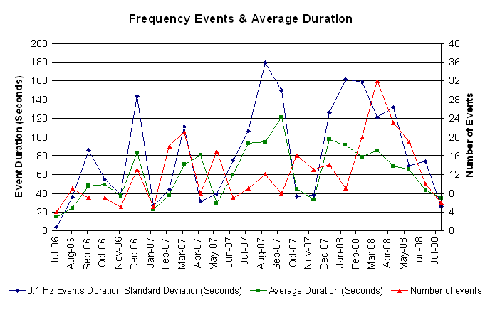
Deployed Responsive (Reported Above)

Time of deployed | Stop Time | Duration | Max deployed | Details
7/04 23:02:08 | 7/04 23:26:12 | 0:24:04 | 343.74 | Load did not drop as expected & Out of URS
7/06 21:04:16 | 7/06 21:19:22 | 0:15:06 | 348.94 | Held interval after ramp had begun. Out of URS due to Input Error.
7/06 22:01:02 | 7/06 22:07:18 | 0:06:16 | 317.69 | Base power schedule drop by 4300 MW & SCE change - 800 MW in 5m
7/08 19:32:52 | 7/08 19:50:24 | 0:17:32 | 333.33 | Out of URS & SCE change - 700 MW in 15m
7/09 07:05:56 | 7/09 07:31:34 | 0:25:38 | 328.10 | Overshot Down balancing while recovering down regulation
7/10 22:03:33 | 7/10 22:17:52 | 0:14:19 | 578.09
7/12 15:16:56 | 7/12 15:27:38 | 0:10:42 | 348.94 | Unit Trip
7/19 00:19:48 | 7/19 00:29:39 | 0:09:51 | 343.74 | DC Tie curtailment & Unit Trip
7/23 08:38:40 | 7/23 08:45:07 | 0:06:27 | 359.35 | SCE change - 520 MW in 15m followed by a Unit Trip
7/27 09:11:46 | 7/27 09:28:32 | 0:16:46 | 635.38
7/27 12:15:33 | 7/27 12:23:51 | 0:08:18 | 380.18
7/28 20:55:44 | 7/28 21:05:25 | 0:09:41 | 458.31
7/29 14:32:20 | 7/29 14:49:33 | 0:17:13 | 609.34

Day-Ahead OOMC and RMR Capacity Purchases

Details | RMR | OOMC | RPRS S1 | RPRS S2 | Total
Austin | 0 | 1 | 12 | 4 | 17
Bryan Area | 0 | 0 | 2 | 0 | 2
Corpus | 0 | 0 | 1 | 1 | 2
DFW | 0 | 12 | 2 | 15 | 29
E RIO | 0 | 1 | 0 | 0 | 1
Houston | 0 | 5 | 38 | 11 | 54
Laredo | 87 | 0 | 0 | 0 | 87
North | 0 | 26 | 24 | 7 | 57
Northeast | 0 | 1 | 0 | 1 | 2
San Antonio | 0 | 0 | 7 | 5 | 12
South | 0 | 0 | 1 | 0 | 1
W RIO | 0 | 0 | 0 | 0 | 0
Western | 0 | 1 | 3 | 11 | 15
 | 87 | 47 | 90 | 55 | 279

Historical Totals | Jul-07 | Jun-08 | Jul-08
Austin | 33 | 70 | 17
Bryan Area | 4 | 10 | 2
Corpus | 0 | 0 | 2
DFW | 19 | 13 | 29
E RIO | 1 | 19 | 1
Houston | 3 | 67 | 54
Laredo | 86 | 81 | 87
North | 36 | 56 | 57
Northeast | 0 | 5 | 2
San Antonio | 8 | 69 | 12
South | 7 | 15 | 1
W RIO | 0 | 3 | 0
Western | 0 | 136 | 15
Total | 197 | 544 | 279

http://www.ercot.com/mktinfo/services/rprsdr/index.html
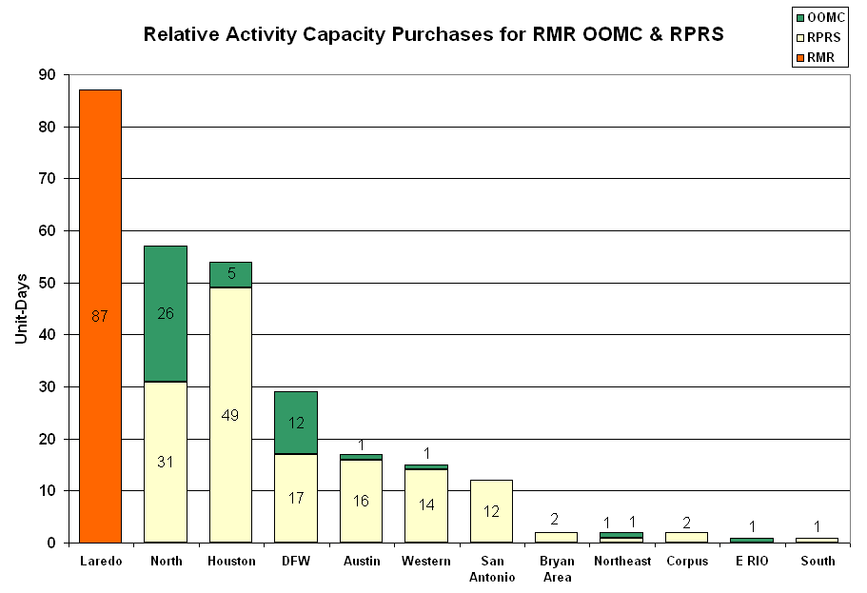

OOME and Congestion Management Activity
Congestion affected by outages
Remedial action plan has been developed for the element
Contingency | Overloaded Element | Days
Trinidad -Stryker Creek and Mount Enterprise 345kV | Elkton - Athens | 16
Austrop 345/138kV Auto #2 | Austrop 345/138kV Auto #1 | 15
Lytton Spring - Zorn and Austrop 345kV | Canyon - Rohr 138kV | 10
West Denton 345/138KV transformer | Collin - Frisco 138KV | 7
Austrop 345/138 KV autotransformer 1 | Austrop 345/138 KV autotransformer 2 | 6
Greenville Steam Transformer 1 138/69KV | Greenville Steam Transformer 2 138/69KV | 5
Bosque - Whitney TU 138KV | Lake Whitney - Whitney TU 138KV | 4
Enterprise -Trinidad & Martin Lake -Stryker Creek 345kV | Nacogdoches autotransformer #1 | 6
Dyann - East Bernard 138KV | Lane City - South Lane City 138KV | 4
Morgan Creek - Quail Switch - Longshore Switch 345KV | Stanton East - Big Spring West 138KV | 3
North Denton Auto 1 138/69KV | North Denton Auto 2 138/69KV | 3
West Levee Switch 345/138KV Autotransformer #1 | West Levee Switch 345/138KV Autotransformer #2 | 3
Temple Pecan Creek - Tradinghouse SES and Temple Switch - Lake Creek SES 345KV | Ridge - Watson Chapel 138KV | 3
Odessa EHV 138/69 KV autotransformer 1 | Odessa EHV 138/69 KV autotransformer 2 | 3
Menard - Gillespie 138KV | Menard 138/69KV Transformer 1 | 2
Trinidad - Stryker Creek SES and Mount Enterprise 345kV | Stryker Creek - Cherokee POI 138KV | 2
Hamilton - Sonora 138kV | Sonora - Fries Ranch 69kV | 2
Big Brown - Venus 345kV | Big Brown - Jewett 345kV | 2
Odessa EHV 138/69 KV autotransformer 2 | Odessa EHV 138/69 KV autotransformer 1 | 2
West Denton 345/138kV autotransformer | Airport - West Denton 138kV | 2
San Angelo Red Creek 345/138kV Transformer T1 | San Angelo Red Creek 345/138kV Transformer T2 | 2
Lytton - Zorn - Austrop 345kV | Goforth - Turnersville 138kV | 2
Graham - Long Creek 345kV | Abilene South - Potosi Tap 138kV | 1
Elkton - Stryker Creek 138KV | Troup Auto #1 | 1
Sandow Switch - Austrop 345kV | Butler - Elgin Switch 138kV | 1
Fort Mason 138/69KV Transformer 1 | Menard 138/69KV Transformer 1 | 1
Brenham - Salem 138kv | Mill Creek - Gay Hill 138KV | 1
Moss Switch - Holt Switch 138kV | Odessa North - North Cowden 69kV | 1
Lytton Springs - Zorn - Austrop 345kV | Rohr - Goforth 138kV | 1
Watermill - Tricorner & Trinidad SES 345kV | Big Brown SES - Jewett 345kV | 1
Austrop - Lost Pines 345kV | Fayette 345/138kV autotransformer 26AT2 | 1
Gibbons Creek - Twin Oak 345kV | Ridge - Watson Chapel | 1
Post Oak College Station - College Station 138kV | Gibbons Creek - Greens Prairie 138kV | 1
Comanche Peak SES - Decordova SES & Wolf Hollow - Rocky Creek 345kV | Concord 345/138kV autotransformer | 1
West Levee T2 345/138KV Auto | West Levee T1 345/138KV auto | 1
North Edinburg - Lon Hill 345kV | MVEC Weslaco - MVEC Heidelberg 138kV | 1
Sonora - Friend Ranch 138kV | San Angelo Concho - San Angelo Nasworthy 69kV | 1
Morgan Creek SES - Quail Switch & Longshore Switching Station 345kV | Midland East - Stanton East Switching Station 138kV | 1
Collin T1 345/138KV transformer | Allen Switch - Plano Custer 138KV | 1
Watermill - Tricorner & Trinidad SES 345kV | Seagoville - Seagoville Switch 138kV | 1
Denton 138/69kV autotransformer | Spencer- King Co 69kV | 1
Watermill Switch - West Levee Switch & Sargent Road 345kV | Cedar Hill Switch 345/138kV autotransformer | 1
Allen Switch - Royse Switch - Monticello 345kV | Collin - Anna Switch 345kV | 1

Zonal OC1
CSC | Days
North-West | 1
North-South | 5
West-North | 11

New RAP (Date indicates last update of RAP not implementation date.)

7/30 Sandow - Elgin Switch 138 kV Single Circuit RAP.

New Procedures/Forms/Operations Bulletins
Date | Subject | Bulletin No.
07/24/2008 | Transmission and Security Desk V 3 Rev 94 | 381
07/24/2008 | Frequency Control Desk V 3 Rev 68 | 380
07/24/2008 | Shift Supervisor Desk V 3 Rev 49 | 379

Blackout/Load Shed Incidences

7/24 14:03 Requested 34 MW of Load Shed for Public Utility of Brownsville (PUB) due to Hurricane Dolly.

7/24 14:06 Requested 6 MW of Load Shed for Magic Valley Electric Co-operative (MVEC) due to Hurricane Dolly.

EECP

None

Major System Voltage Problems

None

Major Computer Problems, Enhancements & Fixes

7/08 Held IE 01:30 real-time balancing deployments for IE 01:45 - IE 0230, resumed with the IE 02:45 deployments.

Communication

None

ERCOT peak (Unofficial)

07/31 17:00 61,077 MW

Yearly MTLF Error Comparison

Yearly Mid-Term (Hourly) Load Forecast Error Comparison for the ERCOT Forecast
Month | MAPE for MTLF at 16:00 Day-Ahead
Month | 2005 | 2006 | 2007 | 2008
January | 5.02 | 4.79 | 4.55 | 3.30
February | 3.47 | 4.81 | 3.75 | 3.59
March | 3.41 | 4.95 | 2.70 | 3.29
April | 3.37 | 5.59 | 3.00 | 2.45
May | 4.21 | 3.59 | 3.22 | 3.01
June | 3.91 | 2.65 | 4.46 | 2.81
July | 5.22 | 2.62 | 4.29 | 2.55
Annual Average | 4.56 | 3.79 | 3.55 | 3.00

OCN, Advisory, Alerts & Emergency Notices

Capacity
Date | Start | End | Event
7/3/08 | 9:23 | 14:00 | Alert issued for capacity shortage for HE 1500 -1900.
7/3/08 | 4:15 | 14:00 | OCN issued for capacity shortage for hours ending 1600 -1900.
7/9/08 | 11:00 | 13:30 | OCN issued for projected capacity shortage from HE 15:00 - 18:00.
7/11/08 | 4:00 | 10:30 | OCN for possible capacity shortage for HE 17:00.
7/12/08 | 15:36 | 19:45 | Advisory ARR below 3000 MW.
7/14/08 | 15:10 | 19:14 | Advisory ARR below 3000 MW.
7/19/08 | 15:40 | 19:50 | Advisory ARR below 3000 MW.
7/19/08 | 6:00 | 9:00 | Alert issued due to projected capacity shortage for HE 14:00-19:00.
7/19/08 | 4:00 | 6:00 | OCN issued due to projected capacity shortage for HE 15:00-17:00.
7/20/08 | 8:00 | 12:00 | Alert issued due to projected capacity shortage for HE 15:00-19:00.
7/20/08 | 9:00 | 9:45 | ERCOT opened an Adjustment Period RPRS Market due to Alert for projected capacity shortage.
7/20/08 | 5:24 | 8:00 | OCN issued for projected capacity shortage for hours 15:00 - 18:00.
7/21/08 | 7:00 | 17:00 | OCN issued for projected capacity shortage for HE 1700.
7/22/08 | 5:30 | 14:30 | OCN issued for projected capacity shortage for HE 1600 -1700.
7/22/08 | 21:10 | 23:30 | Advisory ARR below 3000 MW.
7/23/08 | 14:24 | 18:35 | Advisory ARR below 3000 MW.
7/26/08 | 17:15 | 19:00 | Advisory ARR below 3000 MW.
7/27/08 | 9:00 | 11:00 | Alert issued for a projected capacity shortage for HE 16:00 - 19:00.
7/27/08 | 8:00 | 9:00 | OCN issued for a projected capacity shortage for HE 16:00 - 18:00.
7/27/08 | 16:25 | 18:00 | Advisory ARR below 3000 MW.
7/28/08 | 16:41 | 18:30 | Advisory ARR below 3000 MW.
7/29/08 | 14:59 | 16:20 | Alert for projected capacity shortage for He 17:00
7/29/08 | 14:40 | 18:50 | Advisory ARR below 3000 MW.
7/30/08 | 6:00 | 10:45 | Alert issued for projected capacity shortage for HE 1600 - 1900.
7/30/08 | 15:30 | 18:45 | Deployed NSRS in all zones due to projected depletion of UBES.
7/30/08 | 3:25 | 10:45 | OCN issued for projected capacity shortage for HE 1600 - 1900.
7/30/08 | 15:08 | 18:52 | Advisory ARR below 3000 MW.
7/31/08 | 6:15 | 17:10 | Alert issued for projected capacity shortage for HE 1600 - 2000.
7/31/08 | 14:50 | 19:30 | Deployed NSRS in all zones due to projected depletion of UBES.
7/31/08 | 3:25 | 17:10 | OCN issued for projected capacity shortage for HE 1600 - 2000.
7/31/08 | 9:51 | 10:15 | Advisory ARR below 3000 MW.
7/31/08 | 15:00 | 19:32 | Advisory ARR below 3000 MW.

Transmission

7/15 15:30 Emergency Notice was issued due to local congestion management techniques were unsuccessful. North – South zonal techniques were used to control.

7/27 20:00 Emergency Notice was issued due to BLT of 2 MW for Turkey area was initiated from ERCOT to SPP due to forced outage.

7/28 18:10 Emergency Notice was issued due to Zonal congestion management techniques being unsuccessful in controlling the North - South CSC congestion. Local techniques were utilized.

Weather

7/22 09:00 OCN issued for Tropical Storm Dolly

7/22 16:00 Alert issued due to Hurricane Dolly.

7/23 00:15 Alert issued due to Hurricane Dolly.

7/23 16:03 Emergency Notice issued due to Hurricane Dolly causing damage in Brownsville area.

7/24 00:15 Alert issued due to Hurricane Dolly.

7/24 00:15 Emergency Notice issued due to Hurricane Dolly causing damage in Brownsville area.

7/24 00:30 OCN issued due to Tropical Storm Dolly and expected heavy rainfall amounts.

7/25 00:15 Emergency Notice issued due to Hurricane Dolly causing damage in Brownsville area.

Texas RE Event Analysis

7/27 20:00 Loss of three 69 kV lines to the Matador substation disconnecting an SPS related unit. AEP had to order a 2 MW BLT for Turkey area and on the 28th. Under preliminary analysis.

Other
7/06 Held IE 21:00 real-time balancing deployment for IE 21:15, resumed with IE 21:30.

7/12 21:00 BLT of 3 MW was initiated to ERCOT from SPP due to Storm Damage. BLT required due to storm damage at Union substation.

7/24 Held IE 13:15 balancing deployments and resumed with IE 13:45 balancing deployments.

7/30 15:00 Emergency Notice was issued due to not able to meet the Day Ahead market close time.

