

2009 CSC Study

Version 3.0

Document Revisions
Date | Version | Description | Author(s)
07/02/2008 | 1.0 | First draft | Jeff Billo
07/09/2008 | 1.1 | Draft – added scenario 4 | Jeff Billo
07/09/2008 | 1.2 | Draft – added 2008 congestion data and minor edits | Isabel Flores
07/10/2008 | 1.3 | Add scenario 5 and congestion costs | Isabel Flores
07/16/2008 | 2.0 | Add scenarios 3a, 3b, 3c, 3d, 3e | Jeff Billo
07/21/2008 | 2.1 | Add scenarios 3f, 6a, 6b, 6c | Jeff Billo
07/24/2008 | 3.0 | Add scenario 3g | Jeff Billo

Table of Contents
2009 CSC Study 1
1. Background 1
2. 2009 Significant Changes to the ERCOT grid 1
3. Transfer Study 1
4. Evaluation of Current Congestion Events 2
5. Projection of Future Congestion 4
6. Cluster Analysis 5
6.1. Scenario 1 6
6.2. Scenario 2 7
6.3. Scenario 3 8
6.4. Scenario 3a 9
6.5. Scenario 3b 10
6.6. Scenario 3c 11
6.7. Scenario 3d 12
6.8. Scenario 3e 13
6.9. Scenario 3f 14
6.10. Scenario 3g 15
6.11. Scenario 4 16
6.12. Scenario 5 17
6.13. Scenario 6a 18
6.14. Scenario 6b 19
6.15. Scenario 6c 20
6.16. Cluster Analysis Discussion 21

2009 CSC Determination Study

Background
Protocol Section 7.2.1 requires ERCOT Staff to conduct an annual analysis to determine the upcoming year’s Commercially Significant Constraints (CSCs). This analysis may include a transfer study, an evaluation of past congestion costs, and a projection of congestion costs for the upcoming year; ERCOT’s analysis includes all of these features.

2009 Significant Changes to the ERCOT grid
Per the May 2008 TPIT, these are the significant transmission projects scheduled to go in-service by the end of 2009:
- Jack Creek 345/138-kV substation and associated projects (Sept. 2008)
- Brownwood-Goldthwaite 138-kV line reconductor (Dec. 2008)
- Singleton Switch (May 2009)
- Waller-Prairie View-Seaway-Macedonia 138-kV line upgrade (Sept. 2009)
- West Levee-Norwood 345-kV line (Dec. 2009)
- Leon-Flat Creek 138-kV line upgrade (Dec. 2009)

Generation projects scheduled to go in-service by the end of 2009:
- Victoria Power Station (July 2008)
- Bosque Expansion (Mar. 2009)
- Dansby 3 (Apr. 2009)
- VH Braunig Peakers (May 2009)
- Oak Grove 1 (July 2009)
- Sandow 5 (July 2009)
- Winchester (July 2009)
- Sandhill Peakers (Nov. 2009)
- 7981 MW (total) of west Texas wind, 173 MW of north Texas wind, and 590 MW of south Texas wind scheduled to be in-service by the end of 2008
- 8206 MW of west Texas wind, 173 MW of north Texas wind, and 688 MW of south Texas wind scheduled to be in-service by September 2009

Transfer Study
The Steady State Working Group (SSWG) 2009 Data Set A 2009 summer peak base case was used for the transfer analysis. A congestion management (CM) zone to CM zone transfer analysis was performed by mapping all generators to their respective 2008 CM zones. New generation units were mapped to their assumed CM zone.

Transfer analysis was performed for the following zone to zone generation transfers:
- West to North
- South to North
- North to South
- North to Houston
- North to West

The Singleton Switch Station was included in the base case because it is scheduled to be in-service by May 2009. However, since it will not be in-service for all of 2009 a second transfer analysis was performed. The base case was modified by removing the Singleton Switch Station and replacing the connected branches with the existing branch data for the Jewett-Tomball, Jewett-TH Wharton, Gibbons Creek-Roans Prairie, and Gibbons Creek-Obrien 345-kV lines. The North to Houston transfer study was rerun on the modified base case.

The results of the transfer studies are presented in the attached spreadsheet:

Evaluation of Current Congestion Events
Table 1 is an estimate of zonal congestion costs for the period January through May; costs were assigned to contingency and overloaded elements based on those identified when determining CSC limits:

CSC | Contingency | Overloaded Element | Costs | % of total
N_H | DCKT Jewett - TH Wharton & Tomball 345kV | Watson Chapel - Robertson 138kV | $59,822,113.66 | 66.52%
N_S | DCKT Temple Creek - Trading House & Temple Switch - Lake Creek 345kV  DCKT Temple Switch – Lake Creek & Temple Pecan Creek 345 kV | Watson Chapel - Robertson 138kV  Temple Pecan Creek – Temple 138kV | $30,914,645.57 | 42.48%
N_S | DCKT Temple Creek - Trading House & Temple Switch - Lake Creek 345kV | Lorena - Waco West 69 kV | $6,175,256.24 | 8.49%
N_S | DCKT Temple Pecan Creek - Tradinghouse & Temple Switch - Lake Creek 345kV | Watson Chapel - Robertson 138kV | $3,497,318.90 | 4.81%
N_S | DCKT Temple Switch - Lake Creek & Temple Pecan Creek 345 kV | Temple Pecan Creek - Temple 138kV | $ 2,999,633.29 | 4.12%
N_S | DCKT Temple Creek - Trading House & Temple Switch - Lake Creek 345kV | Waco - Waco West 69kV | $1,615,205.93 | 2.22%
N_S | DCKT Temple Pecan Creek - Tradinghouse & Temple Switch - Lake Creek 345kV | Waco West - Waco Woodway 138kV | $1,415,734.42 | 1.95%
N_S | DCKT Temple Creek - Trading House & Temple Switch - Lake Creek 345kV | Temple Creek - Temple Switch 138kV | $932,185.42 | 1.28%
N_S | DCKT Sandow - Temple 345 kV | Killeen Clark Road – Copperas Cove 138kV | $932,185.42 | 1.28%
N_S | DCKT Austrop - Sandow SW 345kV | Sandow SW - Salty 138kV | $90,688.89 | 0.12%
N_S | DCKT Temple Creek - Trading House & Temple Switch - Lake Creek 345kV | Waco Woodway - Waco West 138kV | $ 63,462.48 | 0.09%
N_W | SCKT San Angelo Red Creek - Comanche Switch 345kV | Flat Creek – Leon Switch 138kV | $6,125,626.21 | 52.43%
N_W | DCKT Comanche Switch - San Angelo Red Creek 345kV | Flat Creek – Leon Switch 138kV | $1,608,457.00 | 13.77%
N_W | DCKT Graham - Benbrook & Parker 345kV | Flat Creek – Leon Switch 138kV | $1,263,529.13 | 10.82%
S_N | DCKT Zorn - Austrop & Lytton Spring 345kV | Canyon - Rohr 138kV | $(13,486,519.15) | 73.81%
W_N | SCKT Fisher Road - Oklaunion & Bowman 345kV | Graham - Long Creek 345kV | $47,774,440.25 | 64.36%
W_N | SCKT Fisher Rd - Bowman 345kV | Abilene South - Putnam 138kV | $7,498,835.67 | 10.10%
W_N | SCKT Fisher Rd - Oklaunion & Bowman 345kV | Graham -Murray 138kV | $2,227,997.54 | 3.00%
W_N | DCKT Graham - Sweetwater & Long Creek 345kV | Abilene South - Putnam 138kV | $1,755,511.34 | 2.36%
W_N | SCKT Fisher Road - Oklaunion & Bowman 345kV | Bomarton - Seymour 69kV | $1,258,758.69 | 1.70%
W_N | SCKT Tonkawa Switch - Graham 345kV | Abilene South - Putnam 138kV | $630,863.91 | 0.85%

Table 2 shows the top congested contingency and overloaded element pairs for the January through May timeframe:

Contingency | Overloaded Element | total - ytd
Comanche Peak SES- Decordova SES & Wolf Hollow - Rocky Creek 345KV | Concord 345/138KV Autotransformer | 8
Menard - Gillespie 138KV | Menard autotransformer 1 | 7
North Edinburg - Rio Hondo 345kV | South McAllen - Stewart Road 138kV | 7
Temple Switch - Killeen Switch & Sandow Switch 345kV | Killeen Switch - Harker Heights South | 7
Austrop 345/138kV auto #2 | Austrop 345/138kV Auto #1 | 6
Decker - McNeil & Dessau - Daffin 138KV | Decker - Sprinkle 138KV | 6
Matador – Paducah Clare Street 69kV | Girard Tap – DKEC Jayton 69kV | 6
Matador - Paducah Clare Street/ SPUR 69kV | Matador - Paducah REA Tap 69kV | 6
Morgan Creek SES – Quail SW & Odessa EHV 345kv | Big Springs SW – Big Spring West 138kV | 6
North Edinburg - Rio Hondo 345kV | South McAllen - Las Milpas 138kV | 6
Odessa EHV - Morgan Creek SES - Quail Switch 345kV | Morgan Creek SES - Cal Energy 345kV | 6
San Angelo Red Creek 345/138kV Auto #1 | San Angelo Red Creek 345/138kV Auto #2 | 6
Spur 138/69kV Auto #1 | Spur - Girard Tap 69kV | 6

Note: counts provided are for the number of days these pairs appeared as congested.

Table 3 contains local congestion costs for the period January through June, 2008; these are the top ten congested contingency and overload element pairs thus far:

Contingency | Overloaded Element | Estimated Cost
Moss - Holt 138kV | Odessa North - North Cowden 69kV | $992,273
Menard - Gillespie 138kV | Menard 138/69KV Transformer | $918,948
Austrop – Sandow 345kV | Milano-Minerva area potential voltage collapse | $630,529
Temple Pecan Creek - Tradinghouse - Lake Creek 345kV | Ridge - Watson Chapel 138kV | $563,443
Calaveras - Skyline & Walzem Road 138kV | Calaveras – Ball Park 138kV | $562,468
Morgan Creek SES - CAL Energy 345kV | Big Springs Switch - Big Spring West 138kV | $512,003
Trinidad - Stryker Creek & Mt. Enterprise 345kV | Athens – Elkton 138kV | $479,106
San Angelo Red Creek – Bluff Creek 345kV | Abilene Mulberry Creek East Reactor Series 138kV | $445,831
Fisher Road – Oklaunion & Bowman 345kV | Lake Pauline Autotransformer 138/69kV | $386,078
Austrop 345/138kV Autotransformer #1 | Austrop 345/138kV Autotransformer #2 | $343,624

Note: dollars shown are estimates and not Settlement quality.

Projection of Future Congestion
The attached spreadsheet contains the 2009 annual congestion report from the 2007 Five-Year Plan. The elements are sorted based on shadow price.

Cluster Analysis
Cluster analysis was performed on the base case and the modified base case with the Singleton Switch Station removed. Below are the scenarios studied.

Scenario 1
Scenario 1 was clustered using the modified base case with the Singleton Switch Station removed. The 2008 CSCs were used and the model was clustered into four zones.

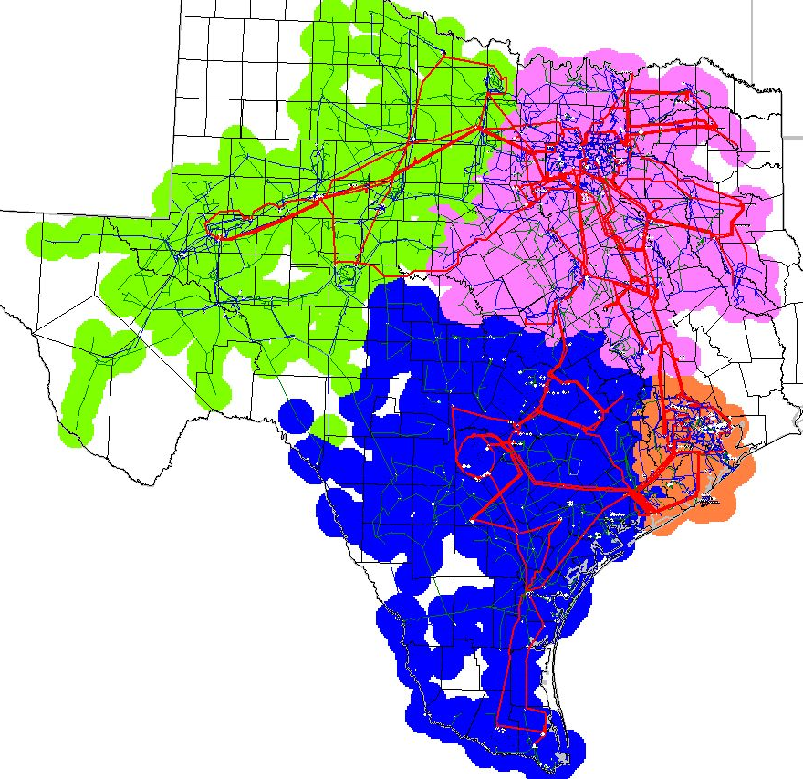

Scenario 2
Scenario 2 was clustered using the base case (with Singleton Switch Station). The 2008 CSCs were used with the exception that the North to Houston CSC was represented by the Jewett-Singleton 345-kV double circuit. The model was clustered into four zones.

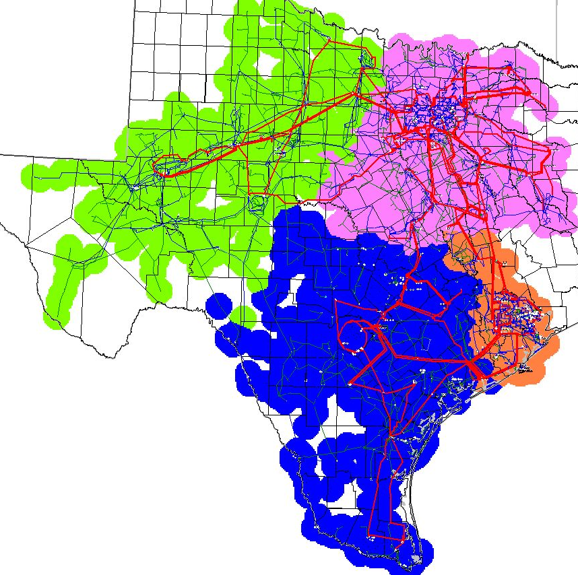

Scenario 3
Scenario 3 was clustered using the base case (with Singleton Switch Station). The 2008 CSCs were used with the exception that the North to Houston CSC was represented by the Singleton-Obrien/ Singleton-TH Wharton 345-kV double circuit. The model was clustered into four zones.

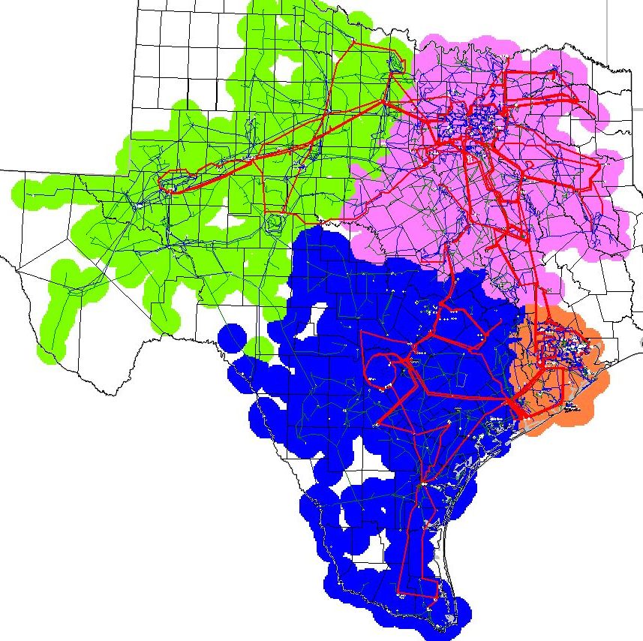

Scenario 3a
Scenario 3a was clustered using the base case (with Singleton Switch Station). The 2008 CSCs were used with the following exceptions: (1) the North to Houston CSC was represented by the Singleton-Obrien/ Singleton-TH Wharton 345-kV double circuit; (2) a West-South CSC was represented using the Goldthwaite-Evant 138-kV line. The Goldthwaite-Evant 138-kV line was chosen since it is the only section of the Brownwood-Lampasas 138-kV line that is not scheduled to be upgraded by the end of 2008. The model was clustered into four zones.

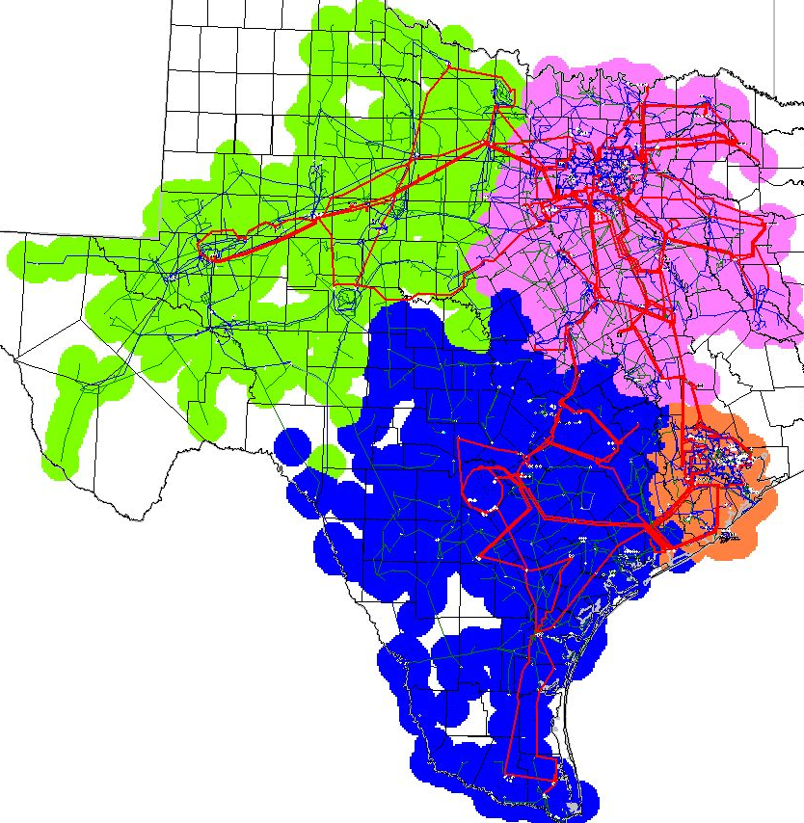

Scenario 3b
Scenario 3b was clustered using the base case (with Singleton Switch Station). The 2008 CSCs were used with the following exceptions: (1) the North to Houston CSC was represented by the Singleton-Obrien/ Singleton-TH Wharton 345-kV double circuit; (2) the North to South/ South to North CSCs were represented using the Lake Creek-Temple/ Tradinghouse-Temple Pecan Creek 345-kV double circuit. The model was clustered into four zones.

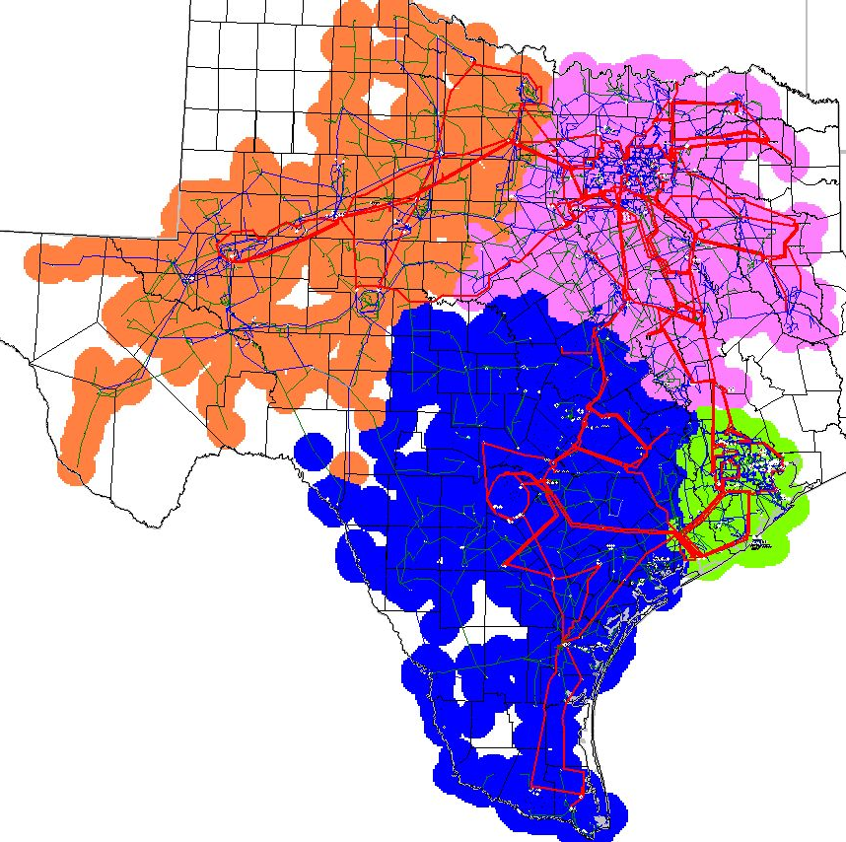

Scenario 3c
Scenario 3c was clustered using the base case (with Singleton Switch Station). The 2008 CSCs were used with the following exceptions: (1) the North to Houston CSC was represented by the Singleton-Obrien/ Singleton-TH Wharton 345-kV double circuit; (2) the North to South/ South to North CSCs were represented using the Lake Creek-Temple/ Tradinghouse-Temple Pecan Creek 345-kV double circuit; (3) a West-South CSC was represented using the Goldthwaite-Evant 138-kV line. The model was clustered into four zones.

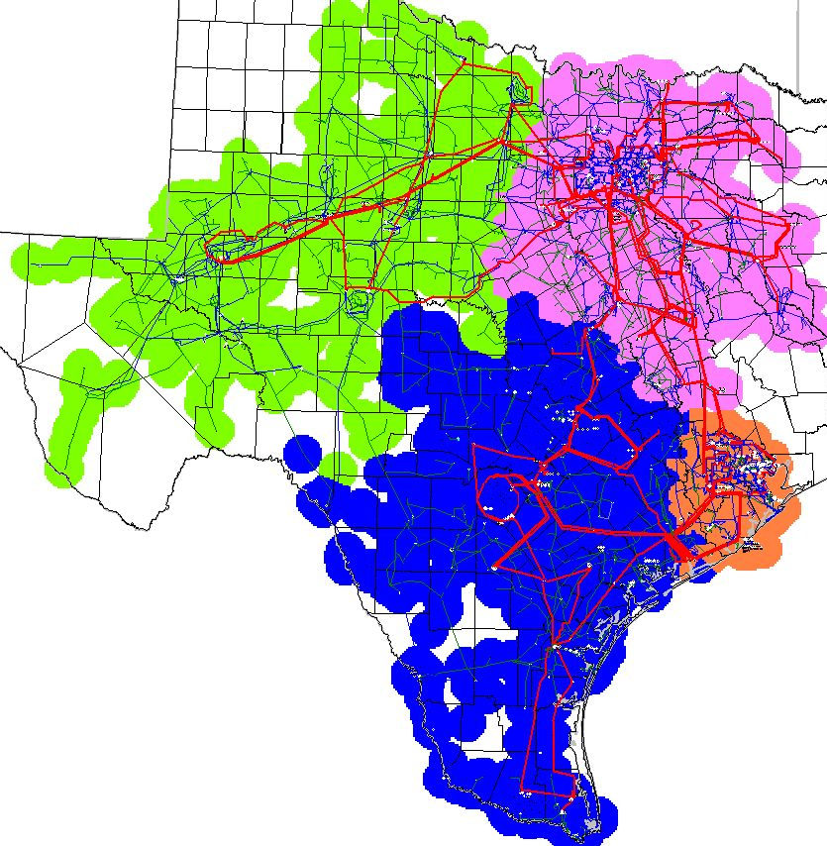

Scenario 3d
Scenario 3d was clustered using the base case (with Singleton Switch Station). The 2008 CSCs were used with the following exceptions: (1) the North to Houston CSC was represented by the Singleton-Obrien/ Singleton-TH Wharton 345-kV double circuit; (2) the North to West/ West to North CSCs were represented using the Sweetwater-Long Creek/ Abilene Mulberry Creek-Long Creek 345-kV double circuit. The model was clustered into four zones.

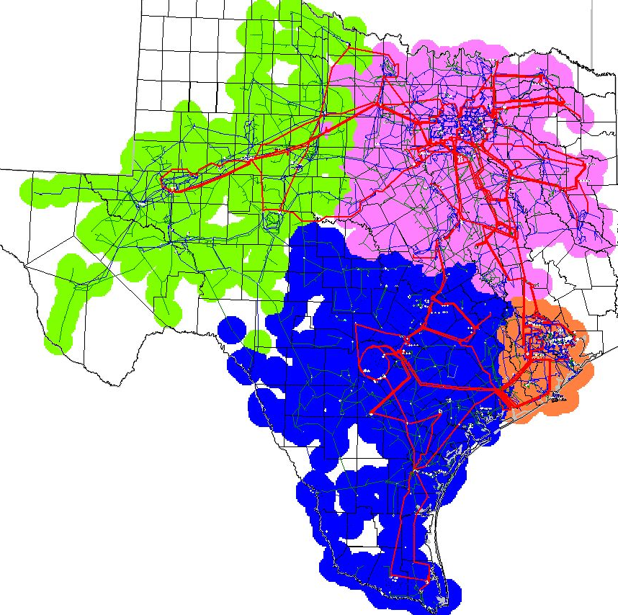

Scenario 3e
Scenario 3e was clustered using the base case (with Singleton Switch Station). The 2008 CSCs were used with the following exceptions: (1) the North to Houston CSC was represented by the Singleton-Obrien/ Singleton-TH Wharton 345-kV double circuit; (2) the North to West/ West to North CSCs were represented using the Sweetwater-Long Creek/ Abilene Mulberry Creek-Long Creek 345-kV double circuit; (3) a West-South CSC was represented using the Goldthwaite-Evant 138-kV line. The model was clustered into four zones.

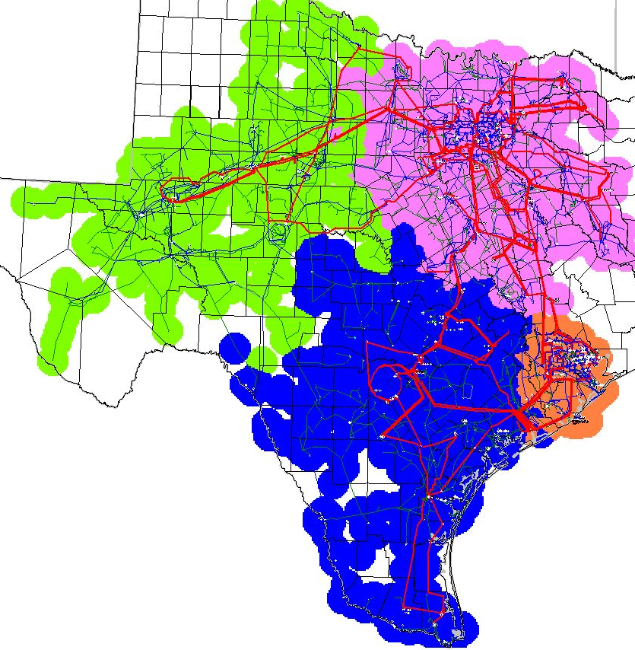

Scenario 3f
Scenario 3f was clustered using the base case (with Singleton Switch Station). The CSCs were defined as follows:
- the North to Houston CSC was represented by the Singleton-Obrien/ Singleton-TH Wharton 345-kV double circuit;
- the North to South/ South to North CSCs were represented using the Lake Creek-Temple/ Tradinghouse-Temple Pecan Creek 345-kV double circuit;
- the West to North/ North to West CSCs were represented using the Graham-Long Creek/ Graham-Cook Field Road 345-kV double circuit
- a West-South CSC was represented using the Goldthwaite-Evant 138-kV line.

The model was clustered into four zones.

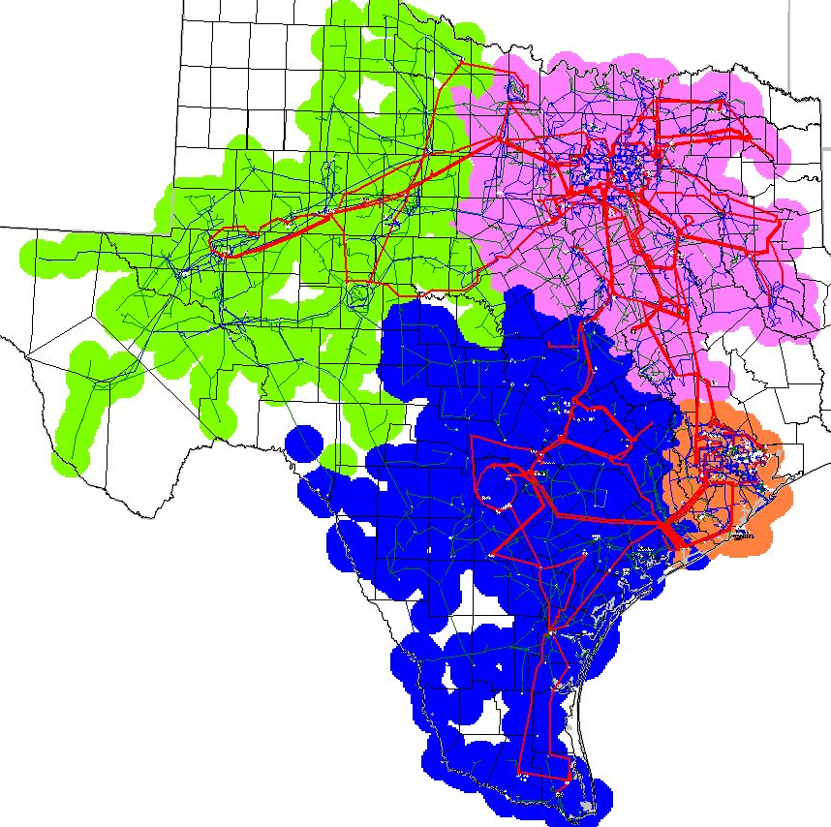

Scenario 3g
Scenario 3g was clustered using the base case (with Singleton Switch Station). The CSCs were defined as follows:
- the North to Houston CSC was represented by the Singleton-Obrien/ Singleton-TH Wharton 345-kV double circuit;
- the North to South/ South to North CSCs were represented using the Lake Creek-Temple/ Tradinghouse-Temple Pecan Creek 345-kV double circuit;
- the West to North/ North to West CSCs were represented using the Graham-Long Creek/ Graham-Cook Field Road 345-kV double circuit

The model was clustered into four zones.
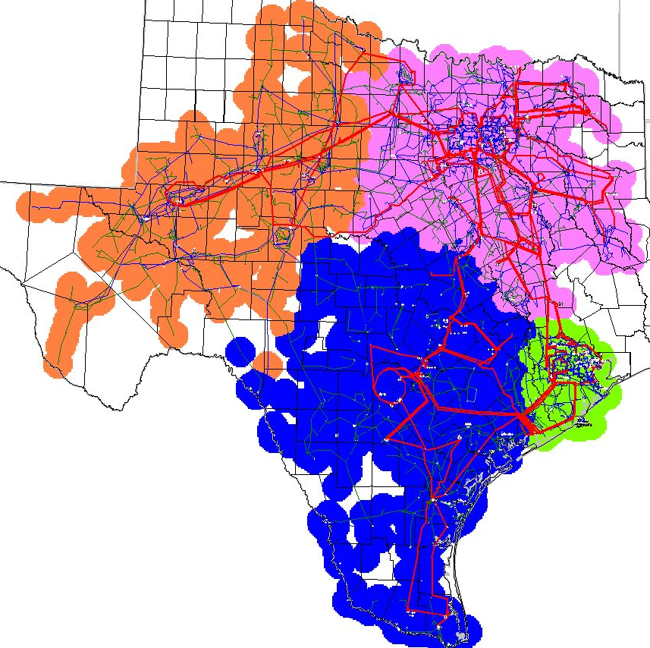

Scenario 4
Scenario 4 was clustered using the base case (with Singleton Switch Station). The 2008 CSCs were used with the exception that the North to Houston CSC was removed and the model was clustered into three zones.

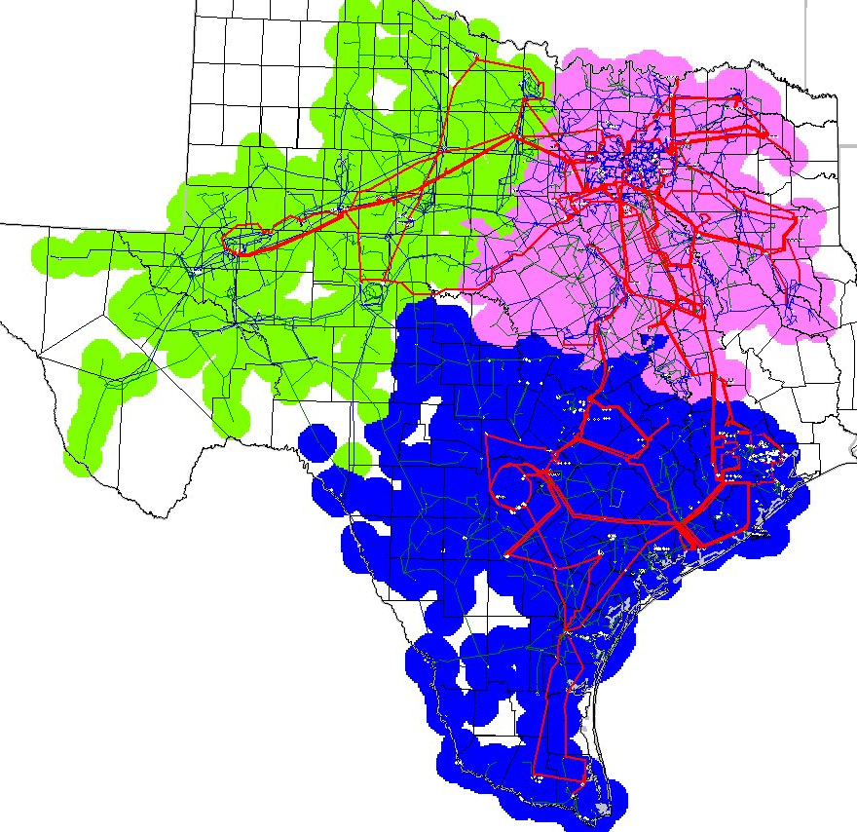

Scenario 5
Scenario 5 is a five zone cluster using the base case (with Singleton Switch Station).

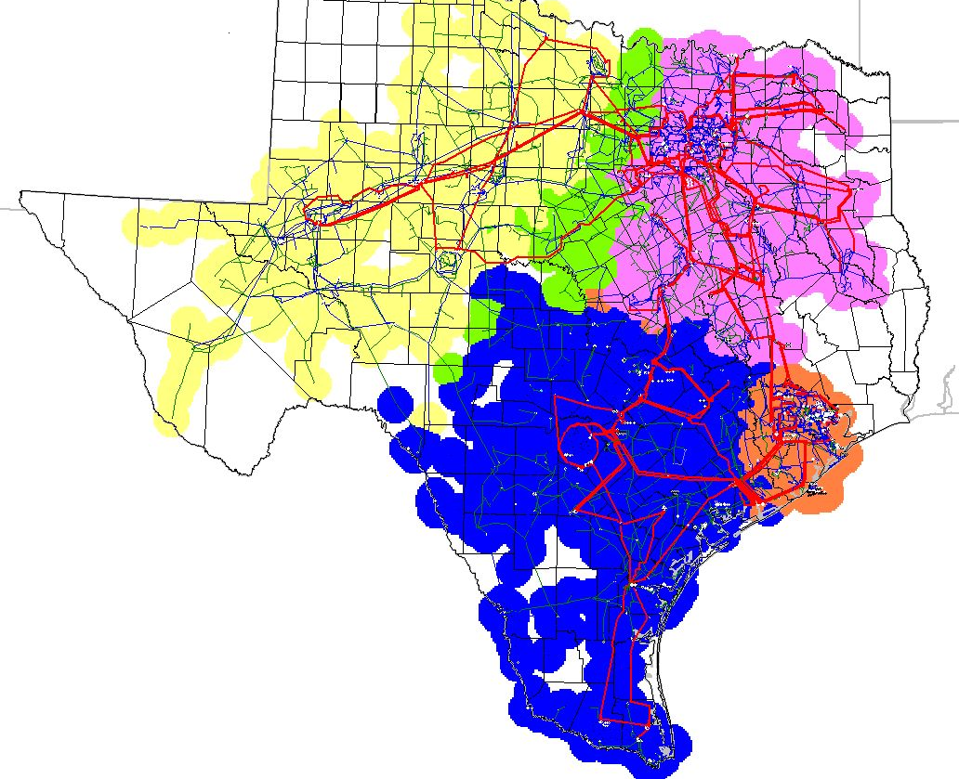

Scenario 6a
Scenario 6a is a five zone cluster using the base case (with Singleton Switch Station) and the following CSCs:
- the North to Houston CSC was represented by the Singleton-Obrien/ Singleton-TH Wharton 345-kV double circuit;
- the North to South/ South to North CSCs were represented using the Lake Creek-Temple/ Tradinghouse-Temple Pecan Creek 345-kV double circuit;
- the West to North/ North to West CSCs were represented using the Graham-Parker/ Graham-Benbrook 345-kV double circuit;
- a Far West to West CSC was represented by the Tonkawa-Graham 345-kV line.

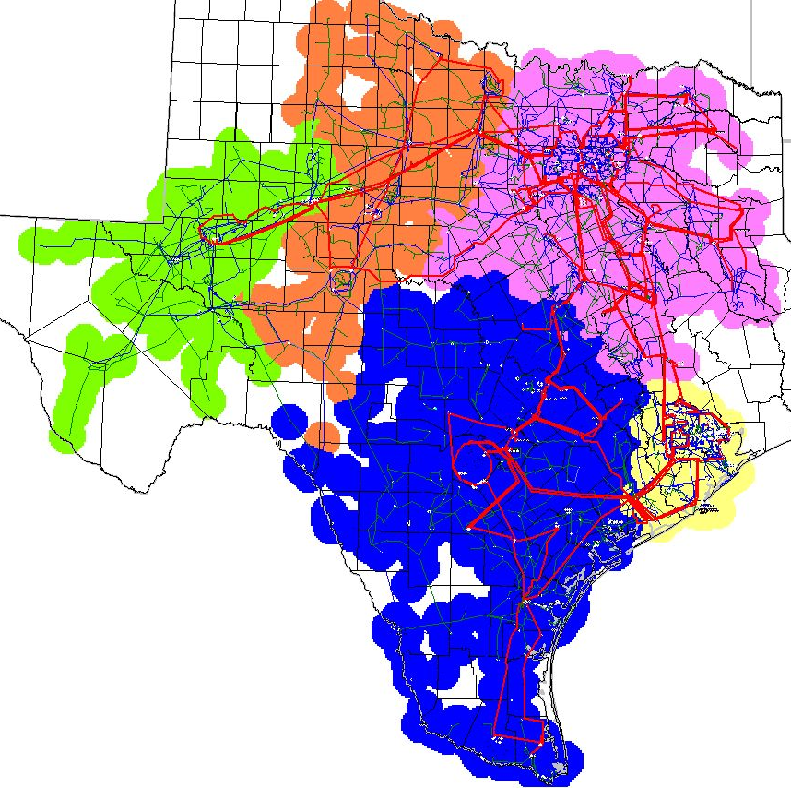

Scenario 6b
Scenario 6b is a five zone cluster using the base case (with Singleton Switch Station) and the following CSCs:
- the North to Houston CSC was represented by the Singleton-Obrien/ Singleton-TH Wharton 345-kV double circuit;
- the North to South/ South to North CSCs were represented using the Lake Creek-Temple/ Tradinghouse-Temple Pecan Creek 345-kV double circuit;
- the West to North/ North to West CSCs were represented using the Graham-Parker/ Graham-Benbrook 345-kV double circuit;
- a Far West to West CSC was represented by the Murray-Graham 138-kV line.

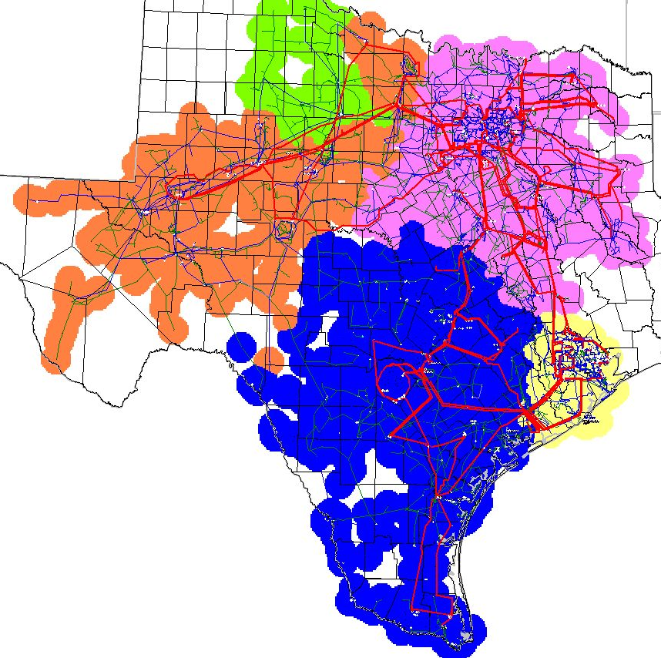

Scenario 6c
Scenario 6b is a five zone cluster using the base case (with Singleton Switch Station) and the following CSCs:
- the North to Houston CSC was represented by the Singleton-Obrien/ Singleton-TH Wharton 345-kV double circuit;
- the North to South/ South to North CSCs were represented using the Lake Creek-Temple/ Tradinghouse-Temple Pecan Creek 345-kV double circuit;
- the West to North/ North to West CSCs were represented using the Graham-Parker/ Graham-Benbrook 345-kV double circuit;
- a Far West to West CSC was represented by the Radium Tap-Paint Creek 138-kV line.

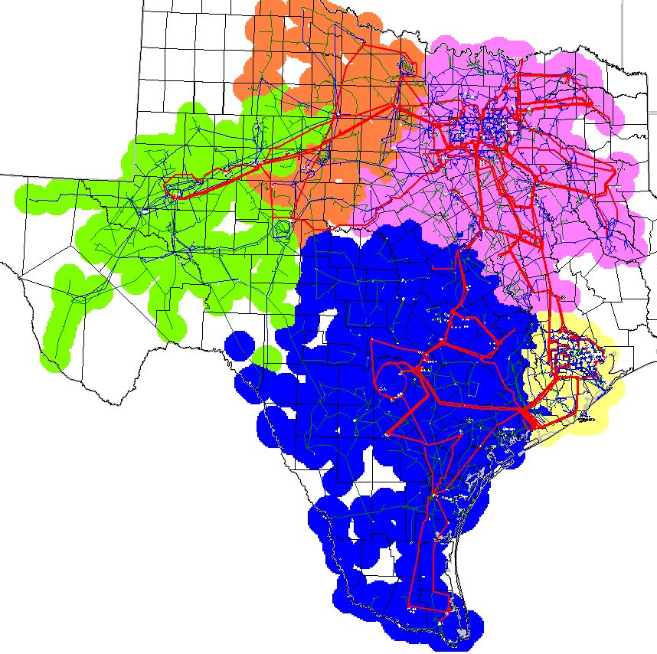

Cluster Analysis Discussion
When compared to the 2008 CM zone bus mapping, no generator buses changed zones in scenarios 1 and 3. In scenario 2, Gibbons Creek, Dansby, Atkins, Texas A&M, and Frontier shift from the North zone to the Houston zone. Additionally, all of Bryan and College Station shift from the North zone to the Houston zone in scenario 2.

In scenario 4 the Houston and South zones merged together. Besides this merge no generator buses changed zones from the 2008 CM zone bus mapping. Some buses (load serving only) located in the North zone in 2008 moved to the South zone in the scenario 4 clustering.

An additional CRE test was performed on scenario 4 to see if the Singleton-Obrien and Singleton-TH Wharton 345-kV lines would qualify as North-South CREs. It was found that both lines passed the Protocol requirements to be North-South CREs.

The following buses changed CM zones in scenario 1 when compared to the 2008 CM zone bus mapping:

Bus Number | Bus Name | Load MW | 2009 Scenario 1CM Zone | 2008 CM Zone
291 | DELEON | 1.18 | West | North
616 | CARTER | 3.84 | North | West
631 | NEWPORT | 1.13 | North | West
1470 | NEWPRT_P |  | North | West
1471 | CARTR_P8 |  | North | West
1633 | DELEON_9 | 6.45 | West | North
5560 | BAYCITYS | 5.1 | Houston | South
6376 | CRM1TP2A |  | South | West
6377 | CRM12A | 3.8 | South | West
46220 | PETERS__ |  | Houston | South
46230 | PETERS__ | 2.03 | Houston | South

The following are select Impact Matrices for scenarios 3 and 4:

Impact Matrix Scenario 3 N-H
 | North | South | Houston | West
North | 0.000 | 0.238 | 0.338 | 0.029
South | -0.238 | 0.000 | 0.100 | -0.209
Houston | -0.338 | -0.100 | 0.000 | -0.309
West | -0.029 | 0.209 | 0.309 | 0.000

Impact Matrix Scenario 3 N-S
 | North | South | Houston | West
North | 0.000 | 0.365 | 0.228 | 0.004
South | -0.365 | 0.000 | -0.137 | -0.361
Houston | -0.228 | 0.137 | 0.000 | -0.224
West | -0.004 | 0.361 | 0.224 | 0.000

Impact Matrix Scenario 4 N-S
 | North | South | West
North | 0.000 | 0.295 | 0.004
South | -0.295 | 0.000 | -0.291
West | -0.004 | 0.291 | 0.000

The following are the generators that changed CM zones in scenarios 3d and 3e when compared to the 2008 CM zone bus mapping:

Bus Number | Bus Name | Gen MW | 2008 CM Zone | Scenario 3d CM Zone | Scenario 3e CM Zone
344 | MRSSHPRD | 12 | West | North | North
345 | MRSSHPRD | 12 | West | North | North
1432 | GRHAMSES | 366 | West | North | North
1433 | GRHAMSES | 242 | West | North | North
1437 | MESQUITW | 400 | West | North | North
1438 | MESQUITW | 236 | West | North | North
1479 | WFCOGEN_ | 40 | West | North | North
1482 | WFCOGEN_ | 40 | West | North | North
1600 | BARTNWND | 120 | West | North | North

In Scenario 6b there are only two plants – both wind generation facilities – in the Far West zone.

The following spreadsheet contains the bus-CM zone mapping for scenarios 1, 3, 3a, 3b, 3c, 3d, 3e, 3f, 3g, 4, 6a, 6b, 6c:

