
Texas Nodal Market Implementation:
Proposal to Produce CRR Network Model Diagrams
Version 0.04

Document Revisions
Date | Version | Description | Author(s)
2008 Jun 25 | 0.01 | First draft | M. Legatt
2008 Jun 26 | 0.02 | Updated, added new sections | G. Macomber
2008 Jul 14 | 0.03 | Updated reqs, text, images | G. Macomber
2008 Jul 22 | 0.04 | Updated – Feedback from BG and DE | G. Macomber

Sign-Offs

Title
Name Date

Title
Name Date

Table of Contents
1. Purpose 1
1.1. Network-level view 1
1.2. Drill-down Network View 2
1.3. Substation-level view 2
2. Issues 3
2.1. Model Complexity 3
2.1.1. Number of Substations 3
2.1.2. Distribution of Substations 3
2.1.3. Number of buses 4
2.2. Diverse sets of Users 4
3. Steps Involved 4
3.1. Overall Flow 4
3.2. Flow for Processing the CRR Viewable Model 4
3.3. Client-side web pages and ERCOT web services 5

Purpose
This document is intended to address the ERCOT business requirements and market participant user needs to view the Congestion Revenue Rights Network Model for a particular auction. The end-user requires two major views, a network view and a One-Line view of stations with resources. In addition there will be a table that defines the relationships between electrical buses, load zones, stations, and related attributes.

Images presented here are prototypes and are to provide an indication of the current design direction. After requirements have been approved and ERCOT has completed the design investigation, another set of prototypes will be produced and reviewed with stakeholders.

Network-level view
The end user would initially start with an overall view of the ERCOT grid, with substations graphically displayed. This data would be driven from the NMMS CIM Server. The Texas map can be used to see the Weather Zones, Load Zones, and Hub Buses within the ERCOT Control Area. The representation is not necessarily GPS accurate, but is designed to show the approximate location of the facilities.

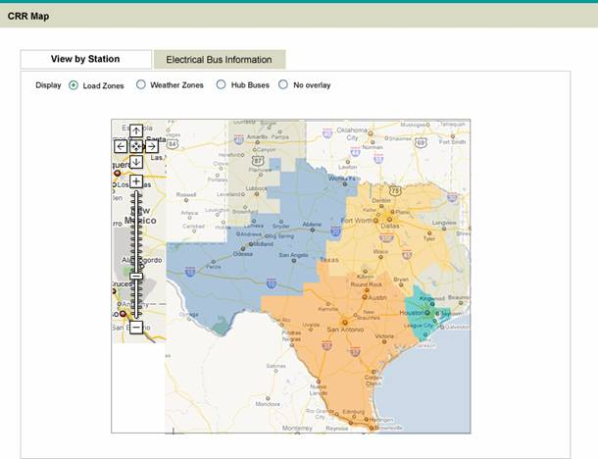
Figure 1: Prototype of a network-level map

The user would have the ability within the user interface to select a substation to view.

Drill-down Network View
Drilling down into the network map brings increasing levels of detail. The user will have to drill down to select a substation for viewing due to the number of substations and their distribution around the Control Area. Below is an example of the drill down.

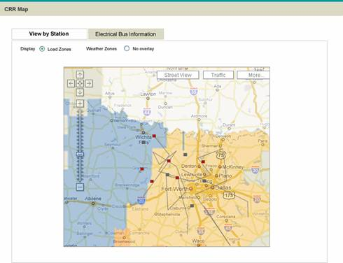
Figure 2: Prototype of a network-level map expanded to show stations

Substation-level view
A customized version of the substation one-line can be presented to users in order to facilitate greater detail on particular substation that is selected for bidding.

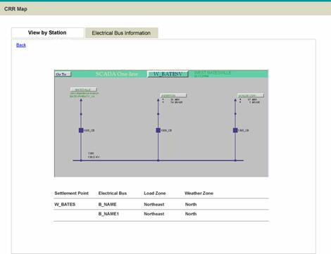
Figure 3: A sample substation view

Substation details, breakers, switches and substation configuration, will only be available for those substations available as sources or sinks in CRR markets and the information is available from the Network Model Management System. For planned facilities only limited information may be available. The one-line view is accessed by clicking on the substation in the network map.

Issues

Model Complexity

Number of Substations
With approximately 3,600+ substations, including 500+ sources/sinks for CRRs there is a high density of points to be displayed.

This can be dealt with by providing a high level “orienting” view and either a set of views that are able to show the detail or thru a zoom-in capability in the map.

Distribution of Substations
The substations are not evenly distributed across the control area. In some parts (populated areas) they are tightly packed and in others, they are more disbursed. This increases the amount of zooming in necessary to be able to select a substation to view the one line diagram.

Number of buses
The total number of individual electrical buses (<9,000) makes it problematic to display in a single spreadsheet format and downloadable file.

Diverse sets of Users
The potential target audience for this capability is CRR Market Participants. This is a potentially diverse group as the CRR program is open to the general public to apply for participation in. This requires that we use the lowest common denominator solutions and not expect to require the CRR Participant to have upgraded equipment for displaying and using the map.

Steps Involved

Overall Flow

The image below depicts the steps involved in generating the downloadable and viewable CRR Network Model. The process starts when the CRR Business analyst or Network Modeler builds the network model in the network Model Management System. It ends with the CRR Participant requesting and receiving the model (download) or navigating the viewable CRR Network Model.

Flow for Processing the CRR Viewable Model
The image below depicts the steps involved in creating the separate items for the viewable CRR map, relating the items together and posting them to MIR.

The process begins after the CRR Network Model has been exported from NMMS. The first steps involve constructing the maps and the necessary images. Also the table of information needs to be created from the network data.

Client-side web pages and ERCOT web services
Components of a client-side web page and web service system are already in place, particularly in the overview map currently being used for LMPs. The MIS database storing contours can also be configured to store CRR Network Model information. New javascript subroutines would need to be added to handle mouse movement and clicking, to handle bringing up the one-line displays.

Additional client-side HTML and AJAX would need to be developed in order to support viewing substation one-lines, although the configuration for the pages is stored in XML, and as such, a service to pass the XML or transform it via XSL to render the One-Lines.

