
MMS User Interface Task Flow
Draft – July 22, 2008

Introduction
The purpose of this document is to present prototypes for the MMS User Interface (UI) in a sequence that suggests the task flow. Each screen is annotated. The basic flow will be the same for each type of market submission, so the tasks are detailed only in the first section, Trades. All other market submissions will work the same way, unless otherwise noted.

ERCOT values market participant feedback on the MMS UI design. Please be aware that UI design suggestions that would create advanced functionality above approved business requirements may not be possible due to system limitations. In particular, "Landing Page" designs which potentially involve retrieval of large amounts of data may not be implementable due to system performance implications.
Trades

Trades Landing Page
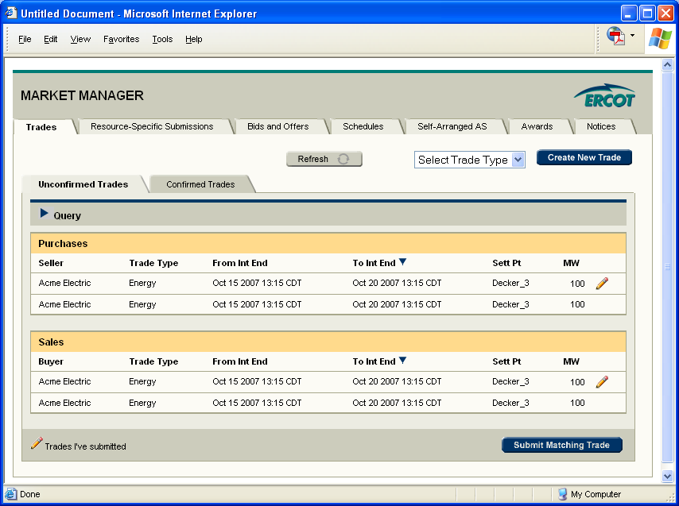

This page displays your unconfirmed trades.

From this page you can:

- Click the Refresh button to refresh the screen
- Select a trade type and create a new trade
- Click the Confirmed Trades tab to view confirmed trades
- Click the Query button to open the query section (see next screen). The default view shows all unconfirmed trades.
- Click once on a row to select an unconfirmed trade that someone else has submitted. Click Submit Matching Trade to submit a matching trade.
- Double-click on a trade row to view details for that trade. Details open in a new window. If it’s a trade you submitted the details are editable. If not, it’s read-only.
- Navigate to a different part of MMS by clicking on one of the top-row tabs

Trades Landing Page with Query Expanded
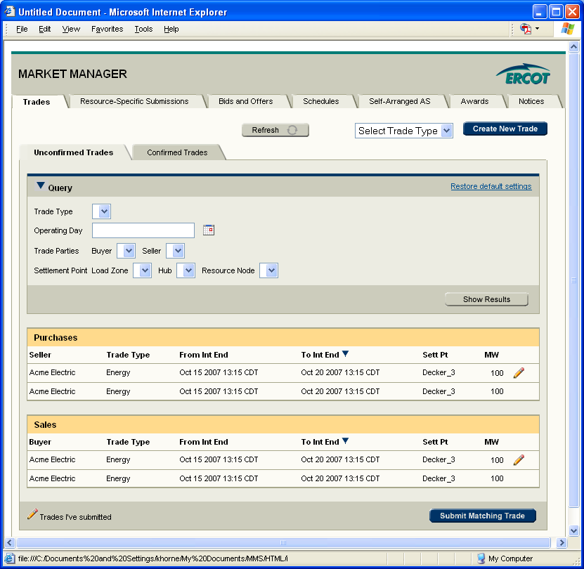

If you clicked on the Query button from the previous screen, the query section expands.

From this page you can:

- Search for a subset of unconfirmed trades.
- Click “Restore default settings” to reset the page to its default settings. This action also clears the query table.
- Click the blue arrow to collapse the query table.

Confirmed Trades
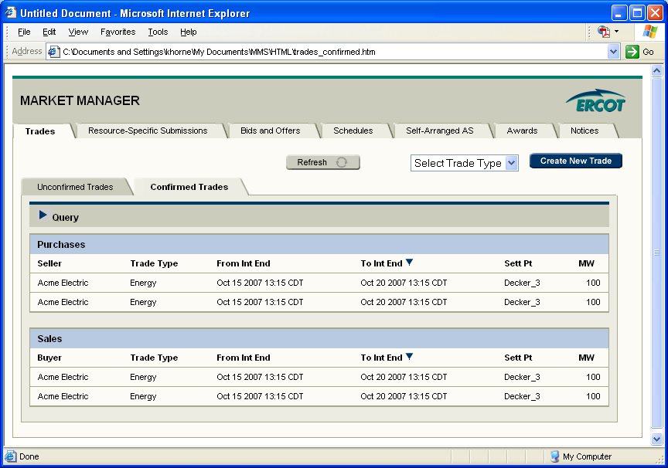

This page displays your confirmed trades.

From this page you can:
- Double-click on a trade row to view details for that trade. Details open in a new window.
- Click the Query button to open the query section (see previous screen). The default view shows all confirmed trades for the next seven days (and the previous day for energy trades).

Create New Trade (Energy)
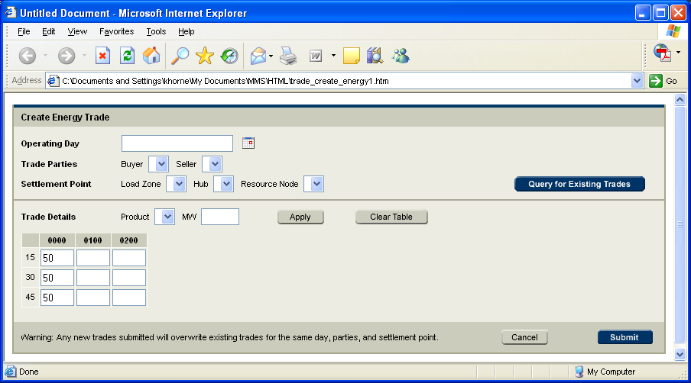

If you selected Energy as the trade type and clicked the Create New Trade button, this screen would open in a new browser window.

From this screen you can:

- Select an operating day
- Select the buyer or seller. The drop-down lists both default to your company.
- Select a load zone or hub or resource node
- Click to query for existing trades

Note: Although not required, we strongly recommend you click Query for Existing Trades. If you submit a new trade and you already have an existing trade for the same operating day, trade parties and settlement point, the new trade will overwrite the existing trade.

Create New Energy Trade – no existing trades found
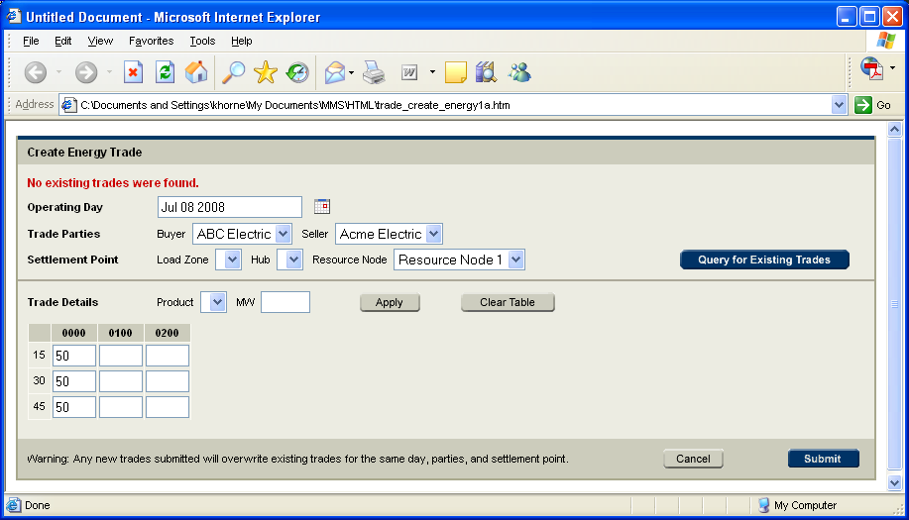

If no existing trades were found, this message displays.

Create New Energy Trade – existing trade found
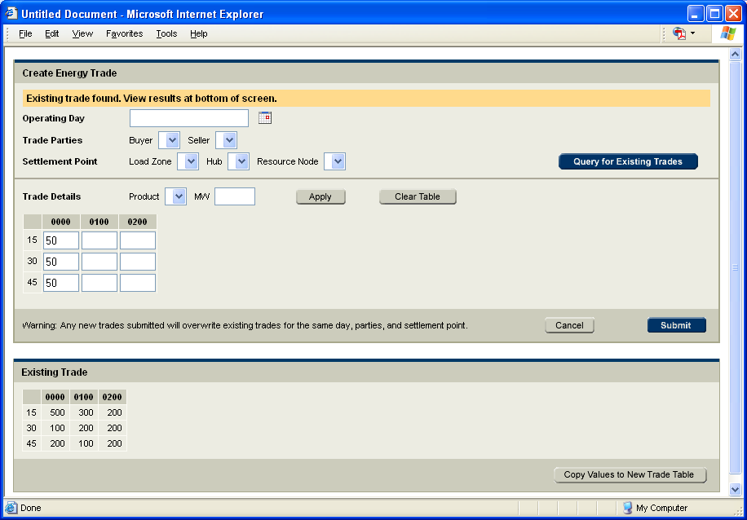

If trade exists, the trade details display in a table below in read-only format.

Note: The table containing hours and MW values is a placeholder to show developers correct style. The actual table will display all the hours. This applies to all prototypes in this document.

From this page you can:

- Select rows and/or columns from the Existing Trade table and click Copy Values to New Trade Table. This will populate the new trade details table with your selected information.
- Select a Product (24 hours, On-Peak hours, Off-Peak hours), enter a MW value and click Apply. This will populate the new trade details table.
- Manually enter values in the new trade details table. This table has a copy and paste feature that works similarly to Excel.
- Click the Clear Table button to clear the table.
- Click Submit to submit the new trade.
- Click Cancel to close the window without saving changes. No trade is submitted.

Note: If you are viewing an existing trade as shown above and you change the buyer, seller, settlement point or operating day, you should check again for existing trades.

Note: The latest action overwrites previous actions. For example, if you copy values from the existing trade into the new trade details table and then select 24 hours/50 MW and click Apply, that latest action will overwrite the previous action and fill in all the cells with 50 MW.

Energy Trade Successfully Submitted
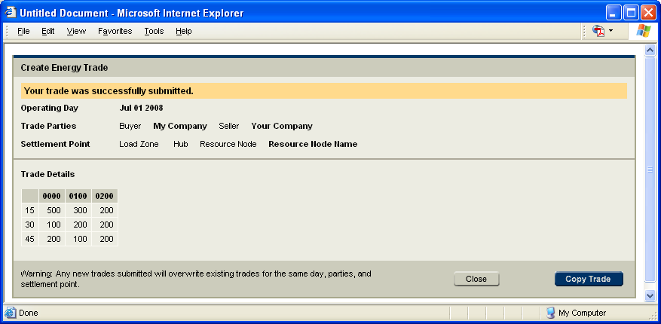

This screen displays a confirmation that your trade was successfully submitted.

From this screen you can:

- Close the window. You will be viewing the Trades landing page. If you click the Refresh button on the Unconfirmed Trades screen, you should see your new trade displayed on the screen. If your counterparty happened to submit their half of the trade at the same time, your new trade should display on the Confirmed Trades screen.
- Copy trade. (See next screen)

Need to decide whether this screen or the details screen displays here.

Copy Energy Trade
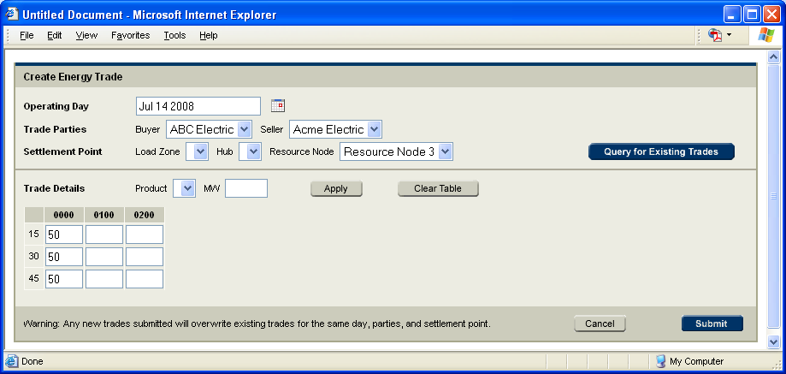

This screen displays an editable version of the trade you just submitted.

From this screen you can:
- Modify the operating day, buyer, seller or settlement point.
- Query for Existing Trades
- Submit the trade – this is not advised because it would overwrite any existing trade that may exist.
- Cancel – closes the window without saving changes

From this point, you can cycle through steps 4-8 until you have finished copying this trade.

Resource-Specific Submissions

Resource-Specific Submissions Landing Page - COP
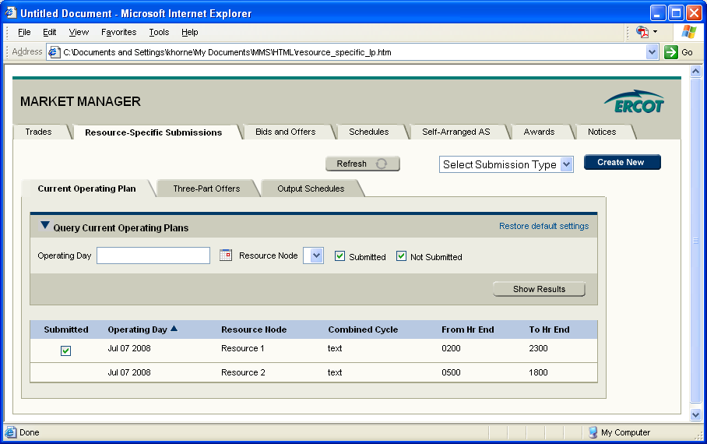

This page displays all of your resources, for the current operating day, sorted by operating day. A check box (not-editable) indicates if you have submitted a COP. If more than one COP has been submitted for a resource, each submission would display on a separate row.

From this page you can:

- Click the Refresh button to refresh the screen
- Select a submission type and create a new trade
- Click the other tabs to view three-part offers, output schedules or view by resource
- Click the Query arrow to open/close the query section (see Trades section for explanation of Query feature).
- Double-click on a trade row to view details for that submission. Details open in a new window.
- Navigate to a different part of MMS by clicking on one of the top-row tabs

Resource-Specific Submissions Landing Page - TPO
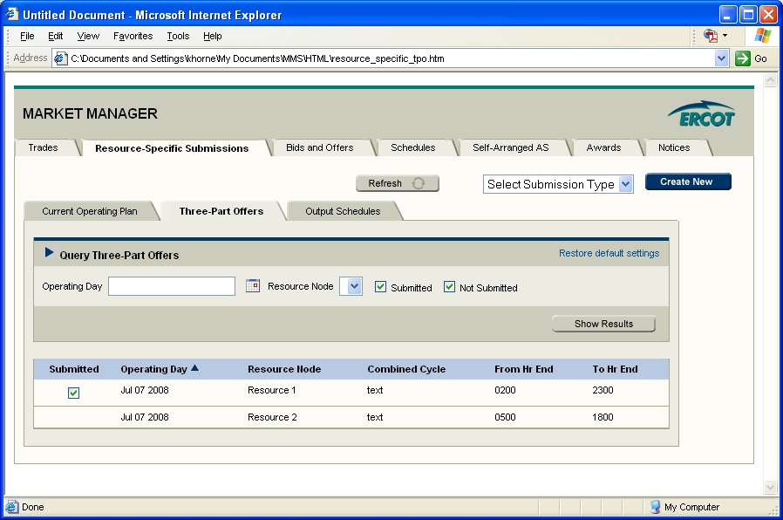

Resource-Specific Submissions Landing Page – OS
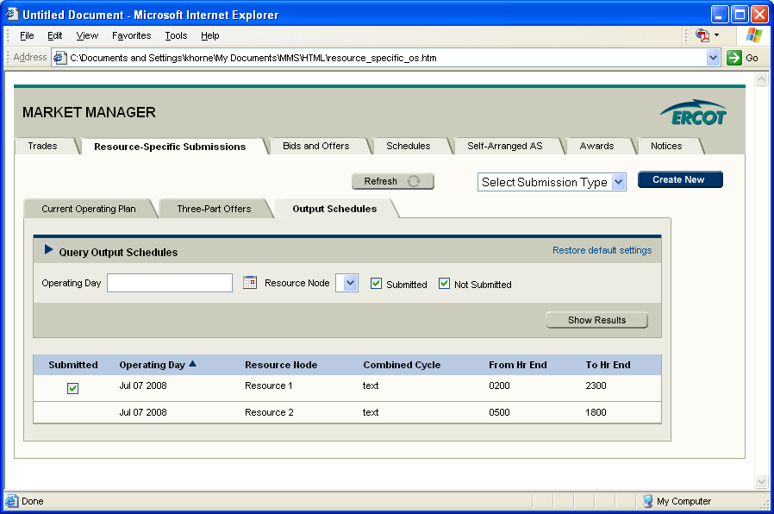

Create New COP
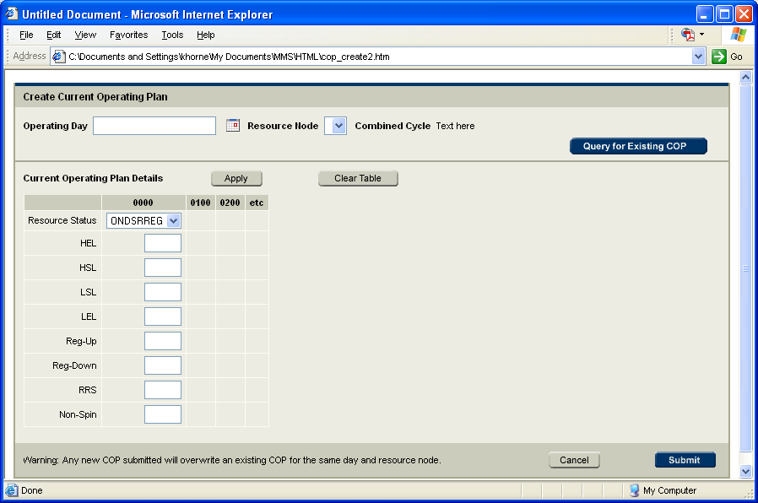

If you selected COP as the submission type and clicked the Create New button, this screen would open in a new browser window.

From this screen you can:

- Select an operating day
- Select a resource node
- Click to query for existing COPs

Create New COP – existing COP found
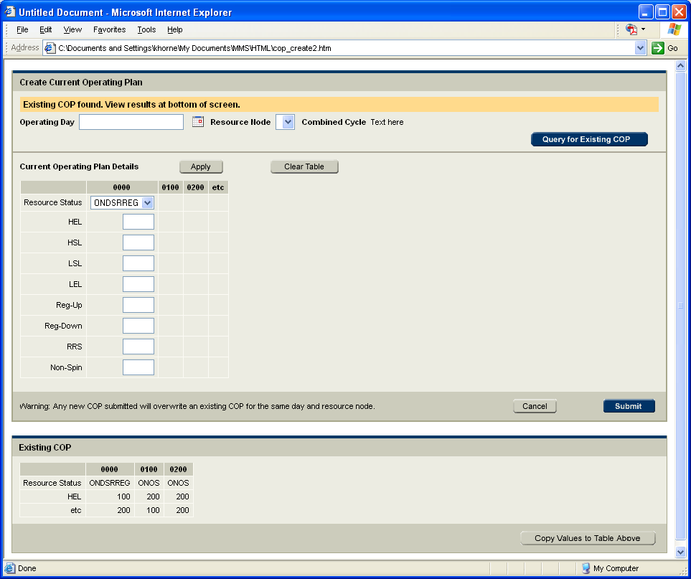

If existing COP is found, it displays as read-only at the bottom of the screen. Refer to trades, figures 6-8 for how to submit and copy COPs. This flow also applies to three-part offers and output schedules.

Create Three-Part Offer
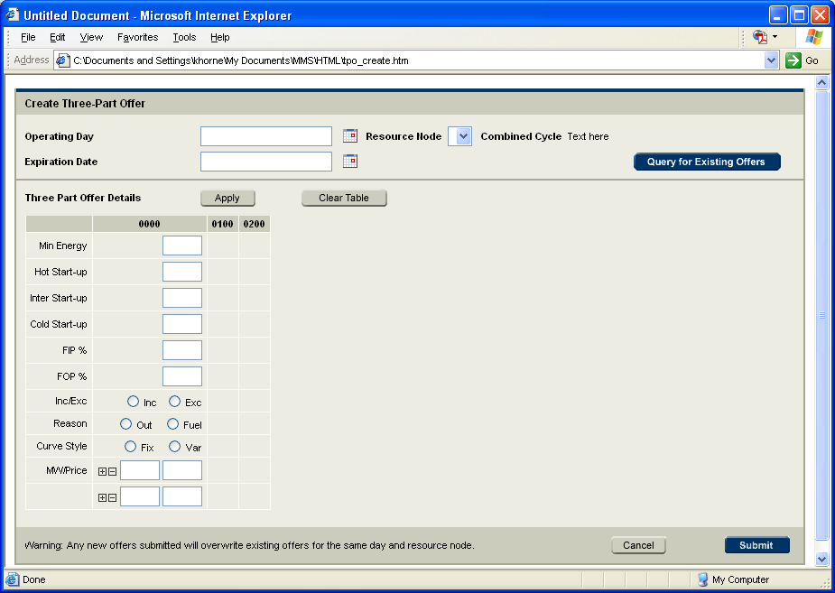

Create Output Schedule
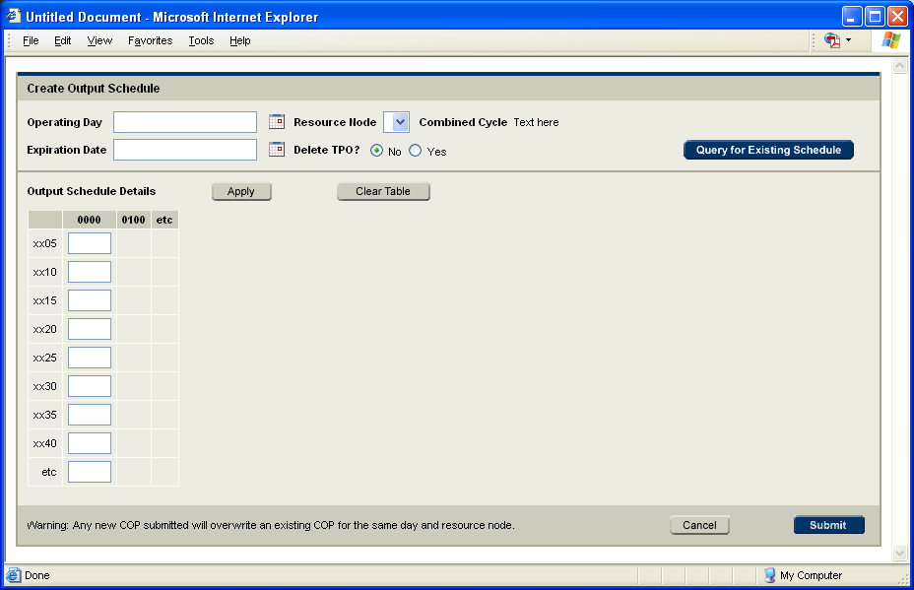

Bids and Offers

Task flow for viewing details and submitting new transactions is the same as for trades.

Bids and Offers Landing Page – DAM EOC
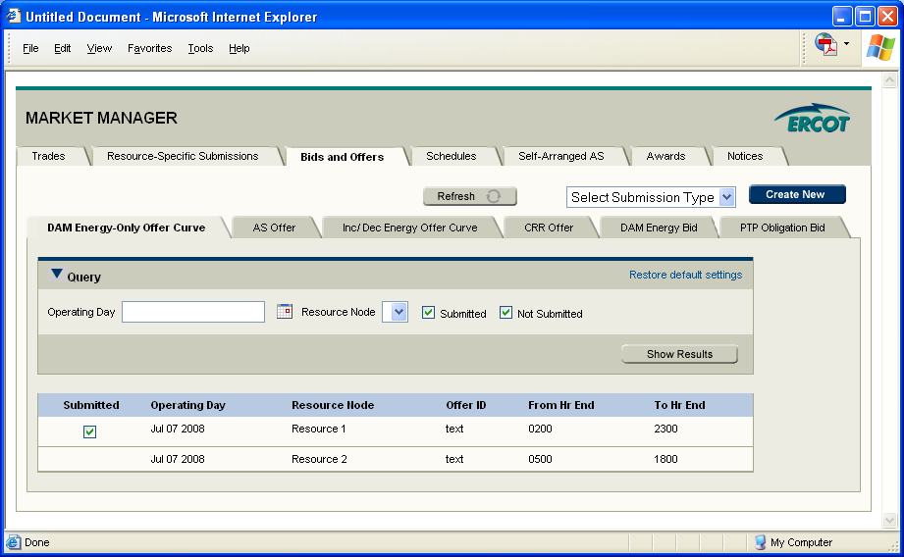

Landing Page – AS Offer
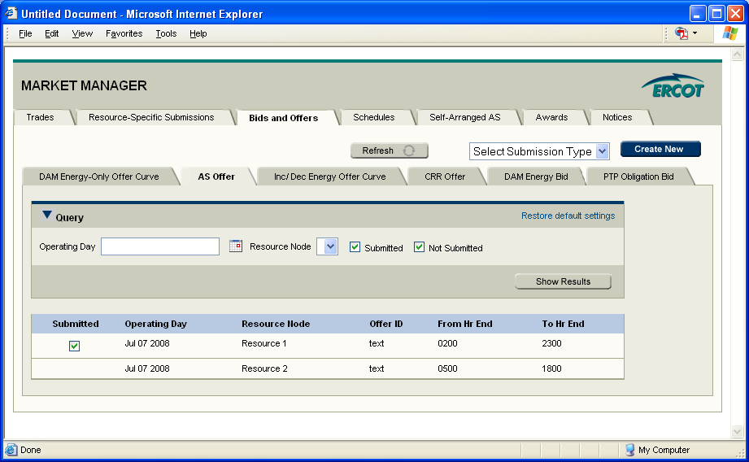

Landing Page – Incremental/Decremental Offer Curve
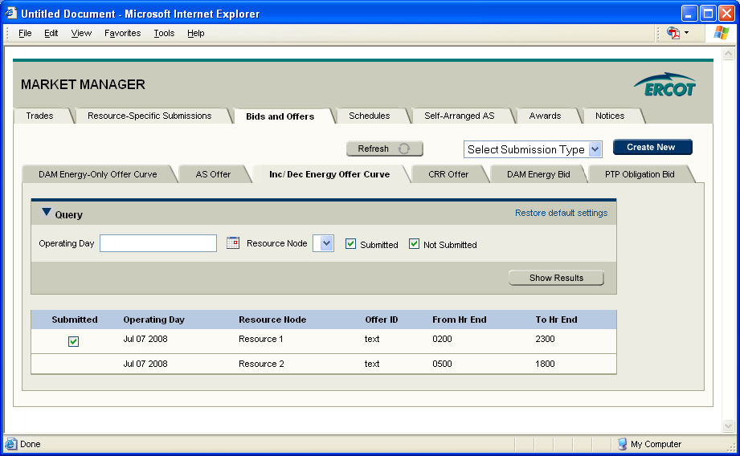
Is it helpful to add a column called Curve Type?

Landing Page – CRR Offer

Landing Page – DAM Energy Bid
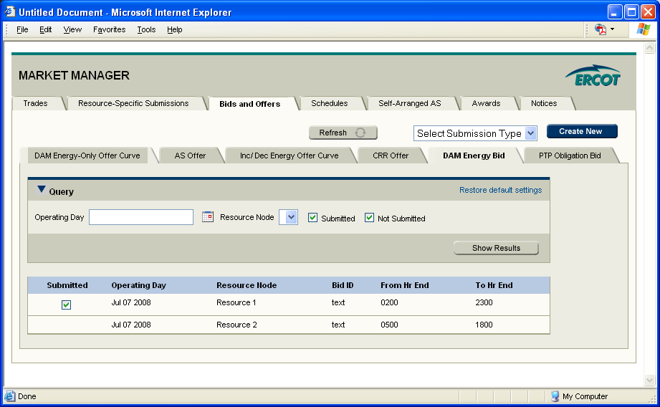

PTP Obligation Bid
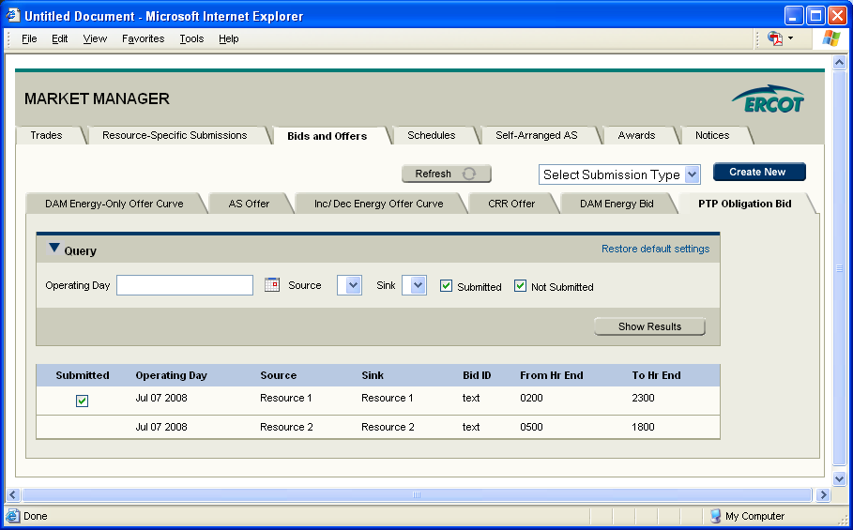

Create DAM Energy-Only Offer Curve
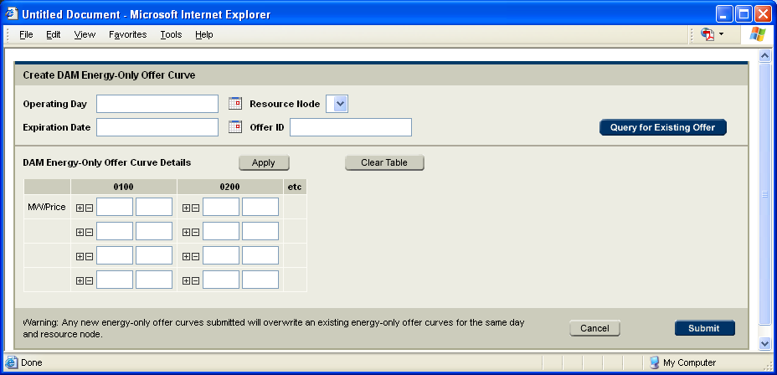

Create AS Offer
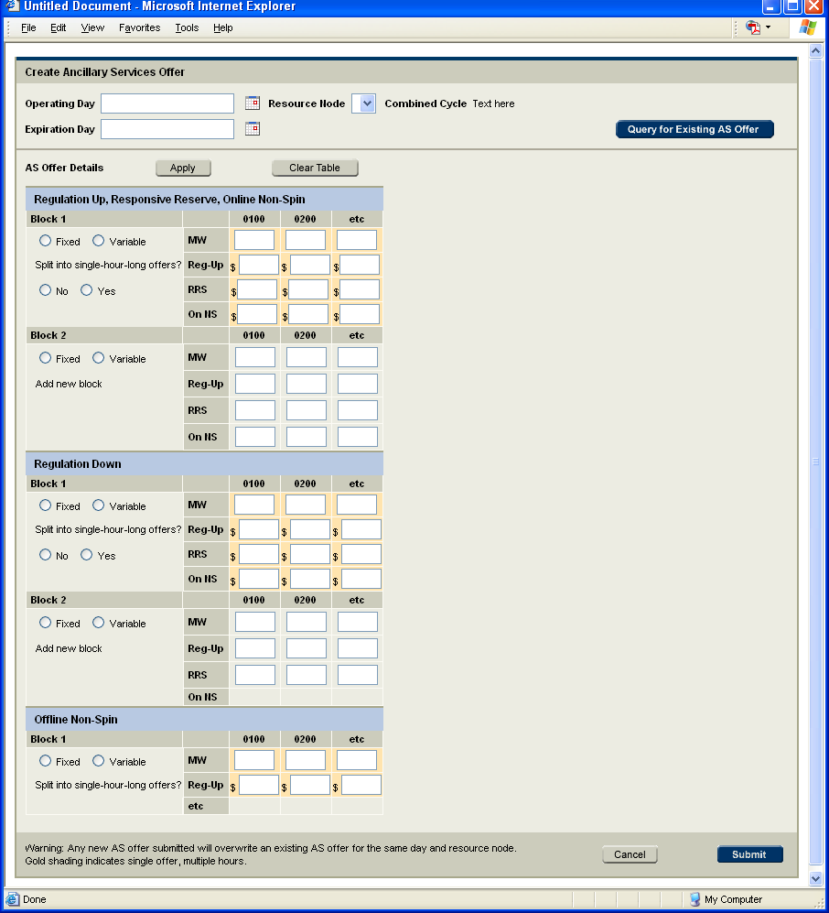

Create Incremental/Decremental Offer
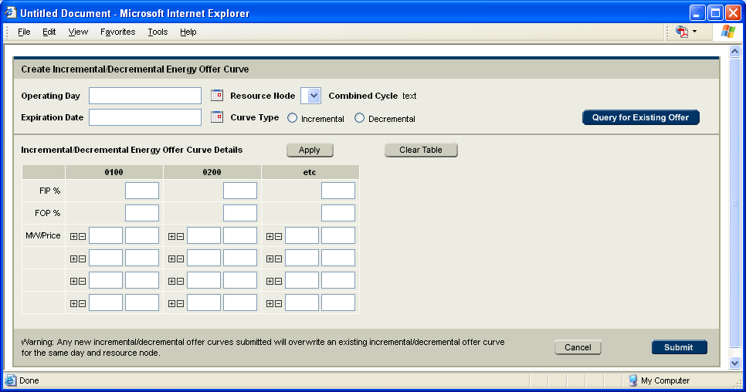

Create CRR Offer

Create DAM Energy Bid
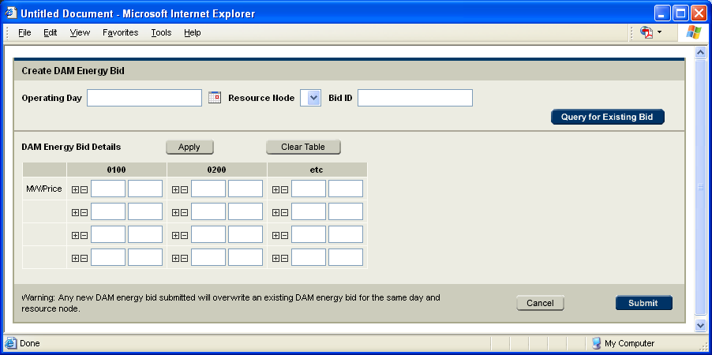

Create PTP Obligation Bid
