ERCOT Operations Report
June 2008 ROS & OWG

Frequency Control
Time | Freq(Hz) | Duration (s)
6/2/2008 22:00 | 59.895 | 00:05 | SCE change -1200 MW
6/9/2008 4:26 | 59.899 | 00:04 | Unit Trip with 655 MW online
6/9/2008 16:40 | 60.101 | 00:11 | Estimated load higher than actual.
6/10/2008 11:55 | 59.896 | 00:06 | Unit Trip with 384 MW online
6/15/2008 23:09 | 60.102 | 01:49 | SCE change +800 MW
6/17/2008 1:05 | 60.104 | 03:53 | SCE change +700 MW
6/17/2008 11:54 | 60.102 | 00:28 | Estimated load higher than actual.
6/18/2008 2:09 | 59.862 | 00:04 | Multiple unit trips with 540 MW online
6/22/2008 18:29 | 59.84 | 00:24 | Unit trip with 792 MW online.
6/24/2008 16:48 | 59.886 | 00:06 | Unit trip with 540 MW online.

Note: Time of frequency excursions outside the range of +/- 0.1 Hz.

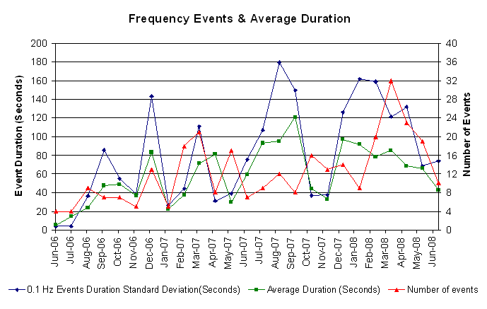
Deployed Responsive (Reported Above)

Time of deployed | Stop Time | Duration | Max deployed | Details
6/1 21:59:43 | 6/1 22:10:01 | 0:10:18 | 322.9 | SCE dropped 1010 MW in 4m
6/2 4:14:30 | 6/2 4:27:34 | 0:13:04 | 322.9
6/2 22:00:54 | 6/2 22:10:56 | 0:10:02 | 390.6 | SCE dropped 1360 MW in 5m & Unit trip
6/3 21:59:50 | 6/3 22:14:38 | 0:14:48 | 343.7 | SCE dropped 680 MW in 5m
6/9 4:26:26 | 6/9 4:38:25 | 0:11:59 | 369.7
6/10 11:55:14 | 6/10 12:15:04 | 0:19:50 | 395.8
6/17 12:39:48 | 6/17 13:07:36 | 0:27:48 | 322.9 | Out of URS & System Load pick up
6/17 23:56:38 | 6/18 0:07:38 | 0:11:00 | 338.5 | SCE dropped 480 MW in 3m
6/18 2:09:36 | 6/18 2:24:10 | 0:14:34 | 562.4
6/18 5:09:24 | 6/18 5:24:04 | 0:14:40 | 333.3 | SCE dropped 1240 MW in 15m & Out of URS
6/21 8:10:42 | 6/21 8:21:52 | 0:11:10 | 328.1 | Out of URS & Steel Mill Load pick up
6/22 18:29:40 | 6/22 18:53:56 | 0:24:16 | 677.0
6/23 8:10:14 | 6/23 8:18:04 | 0:07:50 | 343.7 | Unit trip
6/24 16:48:28 | 6/24 16:57:18 | 0:08:50 | 453.1

Day-Ahead OOMC and RMR Capacity Purchases

Details | RMR |  | OOMC |  | RPRS S1 |  | RPRS S2 |  | Total
Austin | 0 |  | 2 |  | 64 |  | 4 |  | 70
Bryan Area | 0 |  | 0 |  | 10 |  | 0 |  | 10
Corpus | 0 |  | 0 |  | 0 |  | 0 |  | 0
DFW | 0 |  | 5 |  | 2 |  | 6 |  | 13
E RIO | 0 |  | 1 |  | 18 |  | 0 |  | 19
Houston | 0 |  | 5 |  | 3 |  | 59 |  | 67
Laredo | 81 |  | 0 |  | 0 |  | 0 |  | 81
North | 0 |  | 7 |  | 39 |  | 10 |  | 56
Northeast | 0 |  | 0 |  | 0 |  | 5 |  | 5
San Antonio | 0 |  | 0 |  | 63 |  | 6 |  | 69
South | 0 |  | 0 |  | 15 |  | 0 |  | 15
W RIO | 0 |  | 0 |  | 3 |  | 0 |  | 3
Western | 0 |  | 0 |  | 131 |  | 5 |  | 136
 | 81 |  | 20 |  | 348 |  | 95 |  | 544
Historical Totals |  | Jun-07 |  | May-08 |  | Jun-08
Austin |  | 65 |  | 36 |  | 70
Bryan Area |  | 2 |  | 2 |  | 10
Corpus |  | 2 |  | 1 |  | 0
DFW |  | 3 |  | 44 |  | 13
E RIO |  | 0 |  | 11 |  | 19
Houston |  | 8 |  | 33 |  | 67
Laredo |  | 90 |  | 64 |  | 81
North |  | 12 |  | 41 |  | 56
Northeast |  | 0 |  | 4 |  | 5
San Antonio |  | 11 |  | 45 |  | 69
South |  | 2 |  | 19 |  | 15
W RIO |  | 0 |  | 6 |  | 3
Western |  | 2 |  | 26 |  | 136
Total |  | 197 |  | 332 |  | 544

http://www.ercot.com/mktinfo/services/rprsdr/index.html

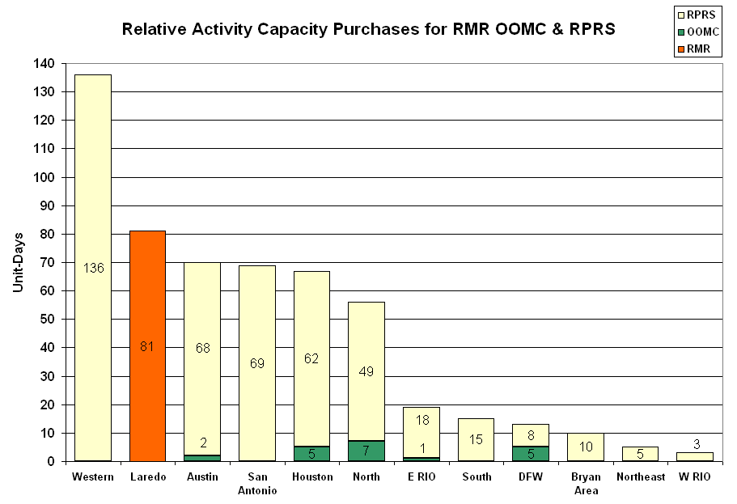

OOME and Congestion Management Activity
Congestion affected by outages
Remedial action plan has been developed for the element
Contingency | Overloaded Element | Days
Trinidad - Stryker Creek & Trinidad- Mount Enterprise 345KV | Athens-Elkton 138KV | 19
Austrop 345/138KV Auto #2 | Austrop 345/138KV Auto #1 | 12
Midland East - Odessa SW EHV 345KV | Odessa Southwest - Moss Switch 138KV | 12
Austrop 345/138KV Auto #1 | Austrop 345/138KV Auto #2 | 8
Temple Pecan Creek - Tradinghouse SES & Temple Switch - Lake Creek SES 345kV | Watson Chapel - Ridge 138kV | 7
Moss Switch - Holt Switch 138KV | Odessa North 138/69KV autotransformer | 7
Austrop - Daffin & Decker 138KV | Austrop - Decker 138KV | 6
Trinidad - Stryker Creek and Mount Enterprise 345kV | Stryker Creek - Stryker Cherokee POI 138kV | 6
Lytton Springs - Zorn & Austrop - Zorn 345kV | Canyon - Rohr 138kV | 4
Hamilton Road - Sonora 138KV | Sonora - Friess Ranch 69KV | 4
La Palma 138/69KV autotransformer #2 | Harlingen Switch - Harlingen #1 69KV | 3
Fisher Road - Oklaunion and Bowman 345KV | Lake Pauline Auto 138/69KV | 3
San Angelo Red Creek 345/138KV Auto #2 | San Angelo Red Creek 345/138KV Auto #1 | 3
San Angelo Red Creek 345/138KV Auto #1 | San Angelo Red Creek 345/138KV Auto #2 | 3
Odessa EHV - Morgan SES and Quail Switch 345KV | Big Spring Switch - Big Spring West 138KV | 3
Sandow Switch - Temple Switch 345kV | Killeen Fort Hood West - Killeen Clark Road POI 138kV | 2
Lytton Springs - Zorn & Austrop - Zorn 345kV | Kendall - Kendall CTEC 138KV | 2
Kendall 345/138KV autotransformer #2 | Killeen Fort Hood West - Killeen Clark Road POI 138KV | 2
Hicross - Pilot Knob & Garfield 138kV | Grove - Advanced Micro Devices 138kV | 2
Duke - Pharr 138KV | Duke - Aderhold 138KV | 2
Comanche Peak SES- Decordova SES & Wolf Hollow - Rocky Creek 345KV | Concord 345/138KV Autotransformer | 2
Greenville Steam 138/69kV autotransformer #1 | Greenville Steam 138/69kV autotransformer #2 | 2
Temple Pecan Creek - Tradinghouse SES and Temple Switch Lake Creek SES 345kV | Goldthwaite - Brownwood Switch 138kV | 2
Marion - Zorn and Clear Springs 345KV | Seguin West 138KV | 1
Marion - Hill Country & Skyline 345KV | Marion - Elm Creek (MARN_ELMCRK2) 345KV | 1
Oklaunion - Fisher Road - Bowman 345kV | Sand Vernon Tap - Sand Road 69kV | 1
Austrop - Lost Pines 345kV | Fayettville 345/138kV autotransformer #2 | 1
Brownwood - Goldthwaite 138KV | Killeen Forthood - Killeen Clark Road | 1
Post Oak College - College Station 138kV | Gibbons Creek - Bryan Greens Prairie 138kV | 1
Abilene Mulberry Auto | Abilene Mulberry - Abilene Northwest 138KV | 1
Sandow Switch - Temple Switch 345kV | Killeen Fort Hood West - Killeen Clark Road POI 138kV | 1
Graham - Long Creek 345KV | Abilene East - Abilene plant 69KV | 1
Graham - Long Creek 345KV | Abilene Plant - Abilene Elmdale 69KV | 1
Fisher Road - Oklaunion 345kV | Abilene Mulberry Creek-Long Creek Switching Station 345kV | 1

Zonal OC1

CSC | Days
North-Houston | 1
North-South | 26
West-North | 12

New RAP

None

New Procedures/Forms/Operations Bulletins

Date | Subject | Bulletin No.
06/16/2008 | Shift Supervisor Desk, Ver3, Rev 48 | 376
06/21/2008 | Transmission and Security Desk V3 Rev92 | 375
06/13/2008 | Frequency Control Desk V3R66 | 374

Blackout/Load Shed Incidences

None

EECP

6/18 16:25 – 18:15 EECP Step 1 declared.
Major System Voltage Problems

None

Major Computer Problems, Enhancements & Fixes

None

Communication

6/11 08:16 Loss of SCADA primary and backup control computer and ICCP link for a Transmission Operator due to corrupted database.

ERCOT peak (Unofficial)

06/16 17:00 59,579 MW

Yearly MTLF Error Comparison
Yearly Mid-Term (Hourly) Load Forecast Error Comparison for the ERCOT Forecast
Month | MAPE for MTLF at 16:00 Day-Ahead
Month | 2005 | 2006 | 2007 | 2008
January | 5.02 | 4.79 | 4.55 | 3.30
February | 3.47 | 4.81 | 3.75 | 3.59
March | 3.41 | 4.95 | 2.70 | 3.29
April | 3.37 | 5.59 | 3.00 | 2.45
May | 4.21 | 3.59 | 3.22 | 3.01
June | 3.91 | 2.65 | 4.46 | 2.81
Annual Average | 4.56 | 3.79 | 3.55 | 3.08

OCN, Advisory, Alerts & Emergency Notices

Capacity
Date | Start | End | Event
6/1/08 | 14:53 | 19:00 | Non Spin Reserve Service (NSRS) deployed in the South due to the depletion of UBES.
6/3/08 | 15:54 | 18:00 | NSRS deployed in the Houston due to the depletion of UBES.
6/3/08 | 15:55 | 19:00 | NSRS deployed in the South due to the depletion of UBES.
6/3/08 | 11:00 | 17:00 | ERCOT issued an Operation Condition Notice for Insufficient Capacity for Hour Ending 17:00.
6/6/08 | 12:43 | 14:30 | ERCOT issued an OCN for a capacity shortage for hour ending 17:00.
6/7/08 | 15:43 | 23:59 | Advisory ARR below 3000 MW.
6/9/08 | 8:43 | 20:00 | Advisory ARR below 3000 MW.
6/9/08 | 12:15 | 18:00 | NSRS deployed in South & Houston due to the depletion of UBES.
6/9/08 | 13:57 | 17:15 | NSRS deployed in North & West due to the depletion of UBES.
6/12/08 | 1:56 | 5:30 | Alert issued due to capacity shortage for hours 16:00 to 18:00.
6/12/08 | 0:01 | 1:56 | OCN issued due to capacity shortage for hours 15:00 to 19:00.
6/13/08 | 8:35 | 18:00 | Alert issued due to capacity shortage for hour 17:00.
6/13/08 | 15:00 | 18:00 | NSRS deployed in the South due to depletion of UBES.
6/13/08 | 6:10 | 8:35 | OCN issued due to capacity shortage for hour 17:00.
6/15/08 | 15:49 | 18:30 | NSRS deployed in the South due to depletion of UBES.
6/16/08 | 16:10 | 18:00 | NSRS deployed in the South due to depletion of UBES.
6/17/08 | 15:57 | 19:00 | NSRS deployed in the South due to depletion of UBES.
6/18/08 | 13:22 | 19:00 | Alert issued due to capacity shortage for hours 16:00 to 19:00.
6/18/08 | 13:45 | 21:00 | NSRS deployed in the West and South due to depletion of UBES.
6/18/08 | 14:34 | 20:01 | Advisory ARR below 3000 MW.
6/18/08 | 15:59 | 16:01 | Alert ARR below 2500 MW.
6/18/08 | 15:00 | 20:00 | NSRS deployed in the North and Houston due to depletion of UBES.
6/18/08 | 16:25 | 18:15 | ERCOT implemented Emergency Electric Curtailment Plan Step 1 (EECP) due to Adjusted Responsive Reserve below 2300 MW.
6/18/08 | 19:30 | 23:30 | OCN issued due to capacity shortage for operating day 06/19/08 for hours 15:00 to 19:00.
6/20/08 | 15:20 | 18:06 | Advisory ARR below 3000 MW.
6/20/08 | 16:45 | 17:30 | NSRS deployed in the North, Houston and South due to Hour Ahead study projecting depletion of UBES.
6/21/08 | 10:30 | 14:30 | OCN issued due to capacity insufficient for HE 16:00- 18:00.
6/23/08 | 12:05 | 13:25 | Alert issued due to capacity shortage for hours 16:00 and 17:00.
6/23/08 | 15:00 | 17:00 | NSRS deployed in the South due to depletion of UBES.
6/23/08 | 10:10 | 12:05 | OCN issued due to capacity shortage for hours 15:00 to 17:00.
6/25/08 | 14:52 | 18:00 | Advisory ARR below 3000 MW.
6/25/08 | 9:00 | 18:00 | Alert issued for a capacity shortage for hours 16:00 to 18:00.
6/25/08 | 14:36 | 18:00 | NSRS deployed in the South due to depletion of UBES.
6/25/08 | 8:00 | 9:00 | OCN issued for a capacity shortage for hours 16:00 to 18:00.
6/27/08 | 9:17 | 13:58 | Alert issued for capacity shortage for hours 14:00 to 17:00.
6/27/08 | 8:05 | 9:17 | OCN issued for capacity shortage for hours 15:00 to 17:00.
6/28/08 | 14:30 | 18:50 | Advisory ARR below 3000 MW.
6/28/08 | 9:51 | 18:25 | Alert issued for capacity shortage for hours 14:00 to 18:00.
6/28/08 | 15:00 | 18:00 | NSRS deployed in all Zones due to depletion of UBES.
6/28/08 | 4:15 | 18:25 | OCN issued for capacity shortage for hours 13:00 to 20:00.
6/29/08 | 14:22 | 19:40 | Advisory ARR below 3000 MW.
6/29/08 | 15:32 | 18:00 | NSRS deployed in all Zones.
Transmission

6/13 15:55 Emergency notice for Killeen Ft Hood West – Killeen Clark 138 kV basecase violation over the normal rating relieved with generation. A line was energized through the substation Ding Dong on June 27th which helps relieve the congestion along the line mentioned above.

6/18 5:05 Transmission Alert for China Grove Area due to storm damage.

6/27 14:50 Transmission forced outage causing loss of RMR generating unit.

Other

6/02 Held IE 04:00 real-time balancing deployment for IE 04:15, resumed with IE 04:30 due to a data input error.

6/03 15:30 Emergency Notice for the Laredo Area due to planned and forced outages. Also issued Emergency for the Laredo Area on 06/04. An alert for the Laredo area was issued on the 2nd, 3rd and 4th.

6/03 Held IE 22:45 real-time balancing deployment for IE 23:00, resumed with IE 23:15 due to issues with a Market Participant not being able to submit energy schedules.

6/06 15:34 Due to numerous weather related forced outages in the Lake Pauline area ERCOT issued an emergency notice to facilitate a Block Load Transfer (BLT). Emergency notices and the Block Load Transfers were also issued on the 7th through the 11th.

6/16 00:00 Due to weather related forced outages in the West Childress area ERCOT issued an emergency notice to facilitate a BLT. Emergency notice and BLT was also issued for the 17th.

6/18 02:09 Simultaneous loss of several wind farms (7), a total of 9 wind farms within 3 minutes totaling approximately 540 MW. Severe weather active in the area.

6/29 06:30 Emergency Notice issued for the Presidio area to facilitate a BLT with CFE of
5 MW to ERCOT.

Texas RE Event Analysis

6/07 03:25 Stanton Wind Energy Center SPS Activation: ERCOT determination operated as intended.

6/09 05:27 McDonald SPS Activation: ERCOT determination operated as intended.

