Metrics Overview

6.20.2008

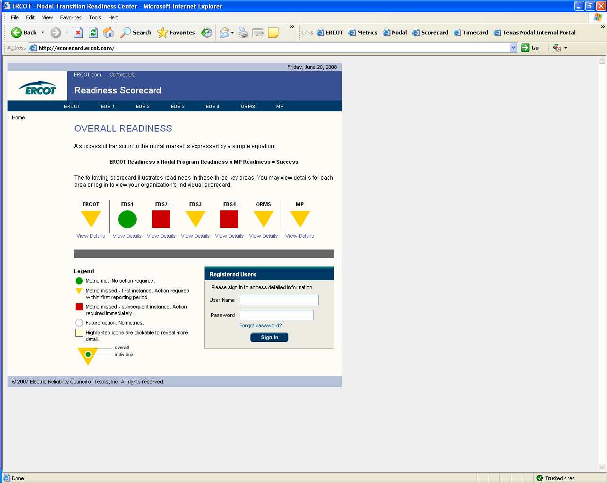

Note: All information contained in these pages is current as of 12:00 noon on 6.20.2008.
Information is subject to subsequent change.

SallyRose Anderson
sanderson@ercot.com
512 248 3109

ERCOT Staff Readiness
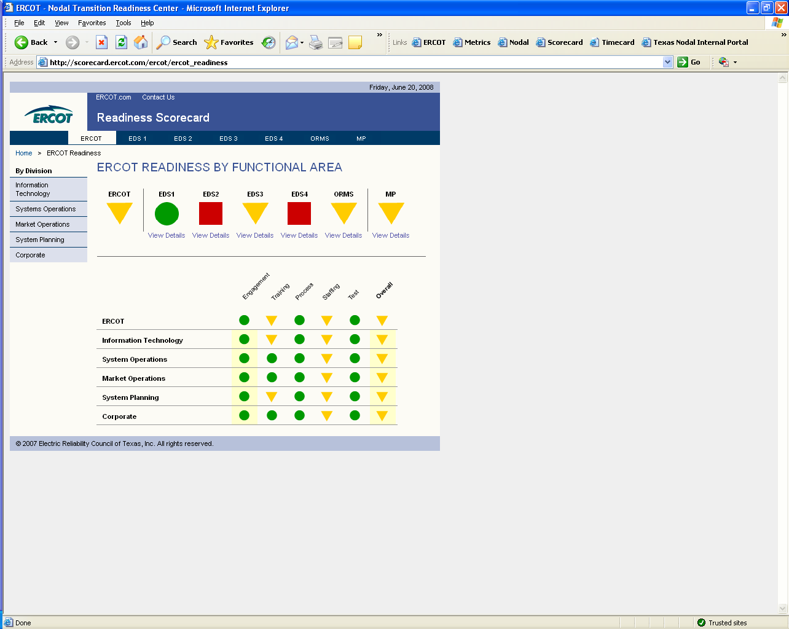

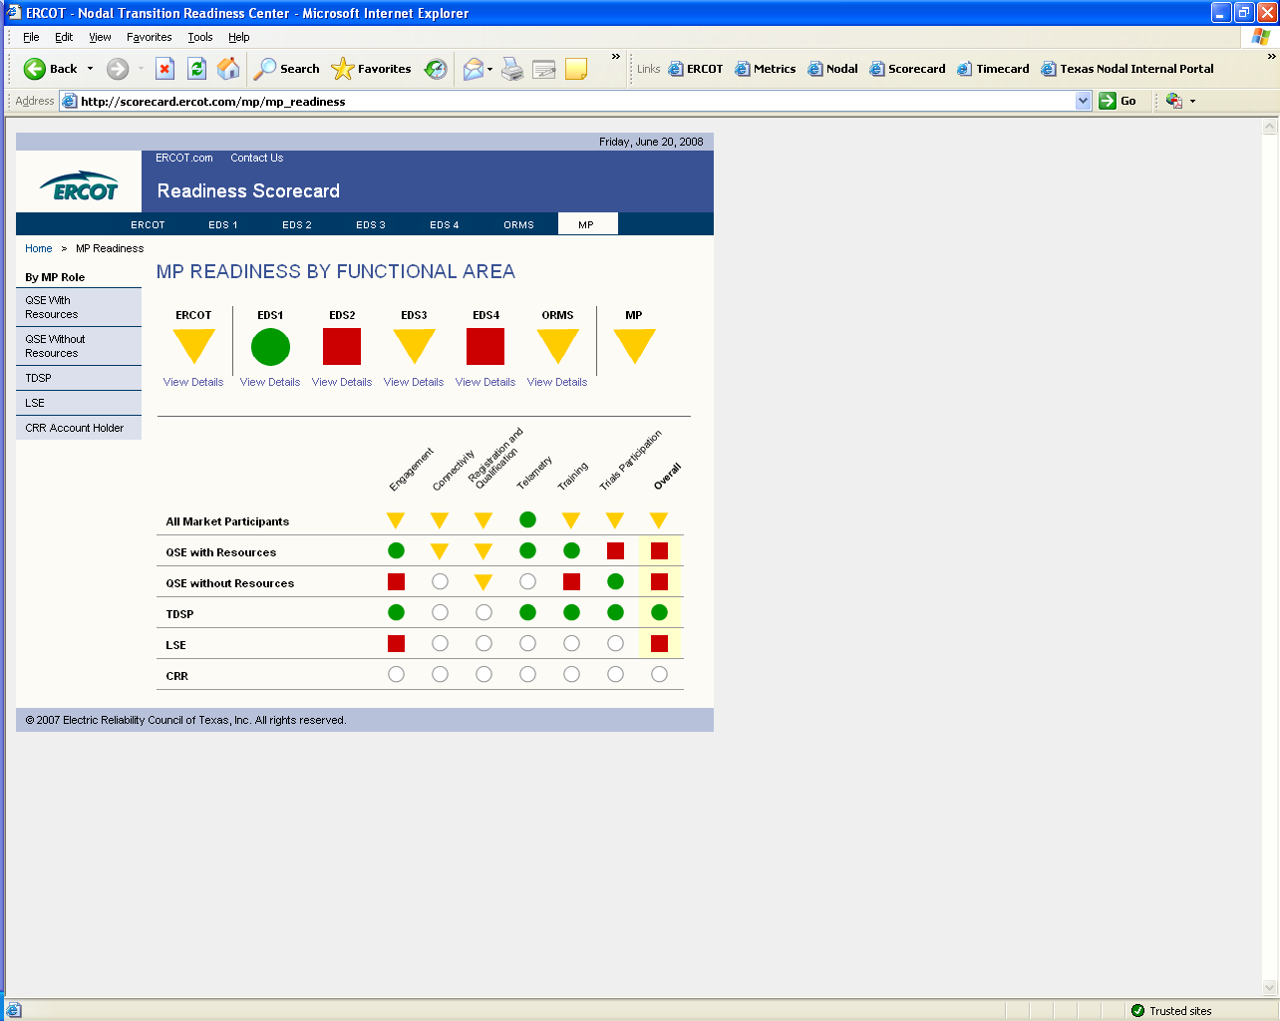
Market Participant Readiness

QSEs with Resources

QSEs without Resources

TDSPs

LSEs

EDS 1

EDS 2

EDS 3

EDS 4

ORMS

