ERCOT Operations Report
May 2008 ROS & OWG

Frequency Control
Time | Freq(Hz) | Duration (s)
5/3/2008 0:06 | 60.101 | 00:15 | SCE change +550 MW. Steel Mill load drop 100 MW
5/5/2008 0:06 | 60.102 | 00:07 | SCE change +450 MW. Steel Mill load drop 100 MW
5/6/2008 0:05 | 59.898 | 01:48 | SCE change -600 MW
5/7/2008 5:58 | 60.116 | 02:04 | Out of DRS. SCE change +1000 MW
5/9/2008 0:04 | 60.103 | 04:24 | SCE change +500 MW and Steel Mill load drop 100 MW
5/10/2008 12:03 | 60.101 | 02:25 | Out of DRS. SCE change +600 MW in 10 min
5/12/2008 21:44 | 60.102 | 01:40 | SCE change +500 MW in 8 min. Steel Mill load drop 100 MW
5/14/2008 15:54 | 59.885 | 00:58 | Unit trip with 338 MW online. SCE change -800 MW
5/15/2008 2:19 | 59.897 | 00:06 | Overcorrection due to recovering down reg and large change in SCE
5/15/2008 22:04 | 60.102 | 00:39 | Out of DRS. SCE change +400 MW and Steel Mill load drop
5/25/2008 15:56 | 59.865 | 00:22 | Unit Trip with 700 MW online
5/26/2008 2:36 | 59.86 | 00:50 | Unit Trip with 550 MW online
5/26/2008 6:52 | 60.101 | 00:22 | Out of DRS. Aggregate SCE +500 MW.
5/27/2008 19:28 | 59.876 | 00:08 | Unit Trip with 650 MW online
5/29/2008 5:50 | 60.101 | 00:52 | Out of DRS. SCE change +400 MW. Steel Mill load drop 100 MW
5/30/2008 21:58 | 59.899 | 00:34 | SCE change -700 MW
5/3/2008 0:06 | 60.101 | 00:15 | SCE change +550 MW. Steel Mill load drop 100 MW
5/5/2008 0:06 | 60.102 | 00:07 | SCE change +450 MW. Steel Mill load drop 100 MW
5/6/2008 0:05 | 59.898 | 01:48 | SCE change -600 MW
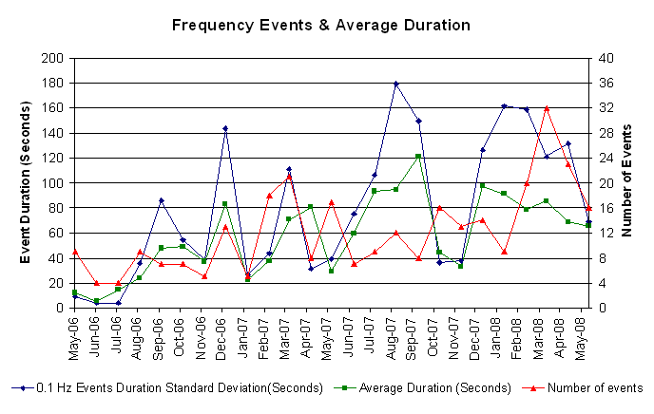

Deployed Responsive (Reported Above)

Time of deployed | Stop Time | Duration | Max | Details
5/1 9:22:51 | 5/1 9:32:11 | 0:09:20 | 317.69 | SCE
5/3 0:54:52 | 5/3 1:21:51 | 0:26:59 | 364.56 | SCE
5/5 3:38:05 | 5/5 3:46:59 | 0:08:54 | 322.9 | Out of URS & Steel Mill load pickup
5/6 0:02:02 | 5/6 0:30:21 | 0:28:19 | 489.56
5/9 0:34:12 | 5/9 1:01:07 | 0:26:55 | 354.15 | SCE & System load pickup
5/9 14:55:49 | 5/9 15:13:23 | 0:17:34 | 317.69 | Unit trip
5/9 22:05:39 | 5/9 22:13:22 | 0:07:43 | 317.69 | SCE
5/12 22:03:07 | 5/12 22:26:59 | 0:23:52 | 364.56 | Held Interval at 2140 - 2200
5/14 3:45:12 | 5/14 4:01:46 | 0:16:34 | 322.9 | Out of URS & SCE
5/14 15:54:08 | 5/14 16:04:05 | 0:09:57 | 442.7
5/14 22:46:56 | 5/14 23:20:28 | 0:33:32 | 348.94 | Out of URS due to bad offset
5/15 0:02:28 | 5/15 0:16:42 | 0:14:14 | 333.33 | SCE
5/15 2:19:22 | 5/15 2:42:10 | 0:22:48 | 380.19
5/15 21:05:48 | 5/15 21:27:06 | 0:21:18 | 337.53 | Out of URS & SCE
5/15 22:28:48 | 5/15 22:36:02 | 0:07:14 | 354.15 | SCE & Steel Mill load pick up & Down balance instruction to recover down reg
5/20 14:24:56 | 5/20 14:36:44 | 0:11:48 | 328.1 | SCE & Steel Mill load pickup
5/23 8:24:18 | 5/23 8:38:34 | 0:14:16 | 328.1 | Steel Mill load pickup & Unit trip
5/25 15:56:10 | 5/25 16:32:22 | 0:36:12 | 651
5/26 2:37:00 | 5/26 3:18:46 | 0:41:46 | 609.34
5/27 19:28:46 | 5/27 19:44:56 | 0:16:10 | 536.43
5/28 7:59:58 | 5/28 8:31:58 | 0:32:00 | 354.15 | Out of URS & SCE
5/30 21:58:26 | 5/30 22:29:54 | 0:31:28 | 401.01
5/31 7:58:16 | 5/31 8:28:01 | 0:29:45 | 317.69 | Out of URS & SCE

Day Ahead OOMC and RMR Capacity Purchases
Details | RMR | OOMC | RPRS S1 | RPRS S2 | Total
Austin | 0 | 0 | 33 | 3 | 36
Bryan Area | 0 | 0 | 2 | 0 | 2
Corpus | 0 | 0 | 1 | 0 | 1
DFW | 0 | 30 | 10 | 4 | 44
E RIO | 0 | 0 | 11 | 0 | 11
Houston | 0 | 0 | 2 | 31 | 33
Laredo | 64 | 0 | 0 | 0 | 64
North | 0 | 11 | 20 | 10 | 41
Northeast | 0 | 2 | 0 | 2 | 4
San Antonio | 0 | 0 | 34 | 11 | 45
South | 0 | 0 | 19 | 0 | 19
W RIO | 0 | 0 | 6 | 0 | 6
Western | 0 | 0 | 25 | 1 | 26
 | 64 | 43 | 163 | 62 | 332

Historical Totals | May-07 | Apr-08 | May-08
Austin | 48 | 7 | 36
Bryan Area | 3 | 13 | 2
Corpus | 1 | 1 | 1
DFW | 4 | 103 | 44
E RIO | 4 | 34 | 11
Houston | 2 | 31 | 33
Laredo | 77 | 59 | 64
North | 8 | 4 | 41
Northeast | 0 | 4 | 4
San Antonio | 10 | 1 | 45
South | 4 | 0 | 19
W RIO | 20 | 18 | 6
Western | 2 | 17 | 26
Total | 183 | 292 | 332
http://www.ercot.com/mktinfo/services/rprsdr/index.html

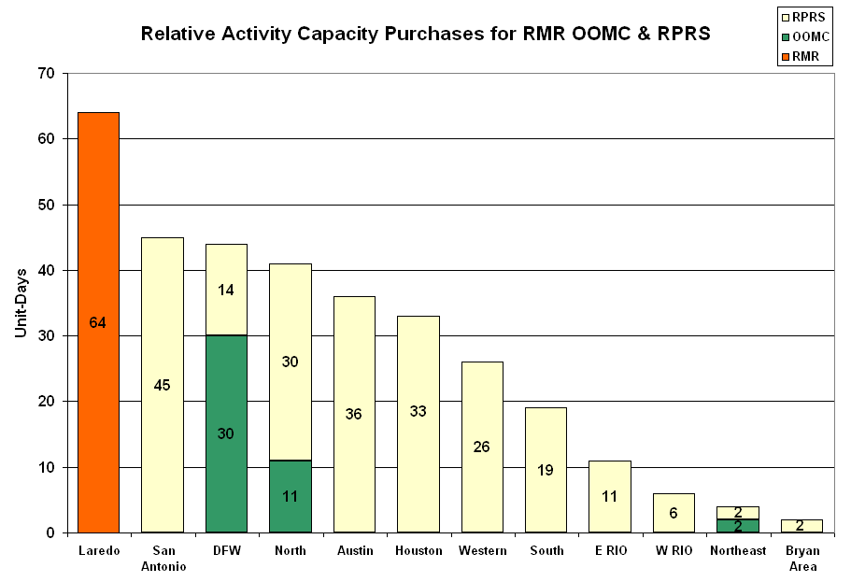

OOME and Congestion Management Activity

Congestion affected by outages
Remedial action plan has been developed for the element
Contingency | Overloaded Element | Days
Comanche Peak SES- Decordova SES & Wolf Hollow - Rocky Creek 345KV | Concord 345/138KV Autotransformer | 8
Menard - Gillespie 138KV | Menard autotransformer 1 | 7
Decker - McNeil & Dessau - Daffin 138KV | Decker - Sprinkle 138KV | 6
Trinidad - Stryker Creek & Trinidad- Mount Enterprise 345KV | Athens-Elkton 138KV | 5
Austrop 345/138KV Auto #2 | Austrop 345/138KV Auto #1 | 5
East - College Station Switch 138KV | Gibbons Creek – Greens Prairie 138KV | 5
North Edinburg - Rio Hondo 345KV | Stewart Road - Weslaco Unit 138KV | 3
East - College Station Switch 138KV | Greens Prairie - South Bryan Switch 138KV | 3
Trinidad - Stryker Creek and Mt. Enterprise 345KV | Stryker Creek - Cherokee POI 138KV | 3
Mt. Enterprise - Trinidad and Martin Lake - Stryker 345KV | Nacogdoches SE 345/138KV Auto | 3
STP - Hillje and STP - Whitepoint 345KV | Blessing - Lolita 138KV | 2
Trinidad - Stryker Creek & Trinidad- Mount Enterprise 345KV | Athens Tap - Athens North Switch 138KV | 2
Fort Mason autotransformer-1 138/69KV | Menard autotransformer-1 | 2
Sam Rayburn - Loop 463 138KV | Rayburn 138/69KV Auto | 2
Marion - Hill Country & Skyline 345KV | Marion - Elm Creek 345KV | 2
Midland East – Odessa EHV 345 kV | Moss Switch – Odessa Southwest 138 kV | 2
Midland East – Odessa EHV 345 kV | Odessa Switch – Moss Switch 138 kV | 2
Midland East – Odessa EHV 345 kV | Odessa EHV – Big Three Odessa Tap 138 kV | 1
Holly – Barney Davis 138 kV | Westside – Cabaniss 138 KV | 1
Martin Lake SES- Stryker Creek SES - MT Enterprise SW. 345KV | Tyler Northeast - Delek POI 138KV | 1
Pawnee - Sam Rayburn Switchyard 138KV | Sam Rayburn Switchyard 138/69KV Autotransformer #2 | 1
Gibbons Creek - Twin Oaks 345KV | Robertson - Watson Chapel 138KV | 1
Marion - Skyline - Elm Creek 345KV | Marion - Hill Country 345KV | 1
Temple Pecan Creek - Tradinghouse SES and Temple Switch - Lake Creek SES 345KV | Robinson - Watson Chapel | 1
Temple Pecan Creek - Tradinghouse SES and Temple Switch - Lake Creek SES 345KV | Evant - Adamsville 138KV | 1
North Edinburg - Rio Hondo 345KV | Weslaco - MVEC Weslaco 138KV | 1
Quail Switch - Odessa EHV Switch 345KV | Big Spring Switch - Big Spring West 138KV | 1
Farmersville - Monticello SES 345KV | Monticello SES - Paris Switch 345KV | 1
Citgo N Oak Park - Hiway 9 138kV | Nueces Bay - Morris Street 138kV | 1
Oasis - PH Robinson 345KV | Garrott - Midtown 138KV | 1
Jewett - TH Wharton and Tomball 345KV | Killeen Fort Hood West - Killeen Clark Road 138KV | 1
Austrop 345/138KV Auto #1 | Austrop 345/138KV Auto #2 | 1
Duke - Pharr MVEC 138KV | South McAllen - Hall Acres 138KV | 1
Fisher Road - Oklaunion and Bowman 345KV | Graham - Long Creek 345KV | 1
Trinidad - Stryker Creek & Trinidad- Mount Enterprise 345KV | Lufkin Switch - Lufkin Chipper Mill 138KV | 1
Dilley Switch - North Laredo 138KV | Asherton - North Laredo 138KV | 1
Calaveras - Skyline & Walzem 138KV | Calaveras - Ball Park 138KV | 1
Jack County - Reno 138KV | Rhome - Decatur Tap 138 KV | 1
Kendall Auto 345/138KV auto 2 | Killeen Fort Hood West - Killeen Clark Road 138KV | 1
King - Kuykendahl and Jewett - Tomball 345KV | Garrett - Midtown 138KV | 1
Lytton - Zorn and Austrop - Zorn 345KV | Zorn - Luling 138KV | 1
Fredericksburg - Gillespie LCRA 138KV | Gillespie LCRA - Live Oak LCRA 69KV | 1

Zonal OC1
CSC | Days
North-Houston | 17
South-North | 8
North-South | 28
West-North | 20
North –West | 1

New RAP

None

New Procedures/Forms/Operations Bulletins

Date | Subject | Bulletin No.
05/23/2008 | Transmission & Security Desk, V3Rev91 | 373
05/23/2008 | Frequency Control Desk, V3Rev65 | 372
05/23/2008 | Shift Supervisor Desk, V3Rev47 | 371
05/01/2008 | Transmission & Security Desk VDI-JOU | 370
05/01/2008 | Frequency Control Desk VDI-JOU | 369

Blackout/Load Shed Incidences

None

EECP

None

Major System Voltage Problems

5/1 08:10 ONCOR was switching the Morgan Creek – Tonkawa Switch 345KV line in preparation for a planned bus outage at Morgan Creek. When the line was opened the 345KV voltage at Tonkawa Switch went to 367.3KV.

Major Computer Problems, Enhancements & Fixes

5/12 Held IE 21:45 real-time balancing deployment due to real-time balancing failure.
Communication

None

ERCOT peak (Unofficial)

05/23 17:00 56,540 MW

Yearly MTLF Error Comparison

Yearly Mid-Term (Hourly) Load Forecast Error Comparison for the ERCOT Forecast
Month | MAPE for MTLF at 16:00 Day-Ahead
Month | 2005 | 2006 | 2007 | 2008
January | 5.02 | 4.79 | 4.55 | 3.30
February | 3.47 | 4.81 | 3.75 | 3.59
March | 3.41 | 4.95 | 2.70 | 3.29
April | 3.37 | 5.59 | 3.00 | 2.45
May | 4.21 | 3.59 | 3.22 | 3.01
June | 3.91 | 2.65 | 4.46 | NA
July | 5.22 | 2.62 | 4.29 | NA
August | 4.86 | 2.09 | 3.11 | NA
September | 6.24 | 4.03 | 3.78 | NA
October | 4.51 | 3.63 | 3.08 | NA
November | 4.53 | 3.28 | 2.95 | NA
December | 5.95 | 3.44 | 3.74 | NA
Annual Average | 4.56 | 3.79 | 3.55 | 3.13

OCN, Advisory, Alerts & Emergency Notices

Capacity
Date | Start | End | Event
5/5/08 | 2:00 | 4:00 | OCN issued for capacity insufficiency for HE 08:00 - 11:00.
5/5/08 | 4:00 | 5:14 | Alert issued for capacity insufficiency for HE 08:00 - 11:00.
5/8/08 | 16:30 | 19:00 | NSRS deployed in South and Houston Zone due to depletion of UBES in those zones.
5/9/08 | 4:00 | 10:20 | OCN issued for capacity insufficiency projected for HE 1800.
5/9/08 | 16:00 | 18:00 | NSRS deployed in Houston and West zones due to depletion of UBES
5/9/08 | 16:15 | 18:00 | NSRS deployed in South zone due to depletion of UBES.
5/9/08 | 15:00 | 19:25 | Advisory ARR below 3000 MW.
5/13/08 | 3:15 | 5:45 | OCN issued for a capacity shortage for hours 16:00 - 18:00.
5/13/08 | 5:45 | 9:44 | Alert issued for capacity shortage for hours 14:00 - 22:00.
5/13/08 | 7:00 | 7:45 | ERCOT opened an Adjustment Period Replacement Reserve Market for hours 14:00 - 22:00.
5/14/08 | 13:27 | 18:10 | Advisory ARR below 3000 MW.
5/15/08 | 13:39 | 18:10 | Advisory ARR below 3000 MW.
5/18/08 | 6:30 | 22:00 | OCN issued for insufficient capacity for HE 1800 - 2200.
5/19/08 | 16:17 | 20:00 | Advisory ARR below 3000 MW.
5/19/08 | 14:00 | 19:00 | NSRS deployed in Houston Zone for depletion of UBES due to North - Houston congestion.
5/19/08 | 15:00 | 20:00 | NSRS deployed in South Zone for depletion of UBES due to North - South congestion.
5/20/08 | 6:00 | 6:24 | OCN issued for capacity insufficiency projected for HE 1700 & 1800.
5/20/08 | 14:30 | 19:15 | Deployed NSRS in the Houston Zone due to the depletion of UBES.
5/20/08 | 14:30 | 18:15 | Deployed NSRS in the South Zone due to the depletion of UBES.
5/22/08 | 15:46 | 18:00 | Advisory ARR below 3000 MW.
5/23/08 | 10:30 | 19:00 | Alert issued for capacity insufficiency for HE1300 - 1900.
5/23/08 | 2:24 | 18:10 | OCN issued for projected capacity shortage HE 1600 - 1800 and 2300.
5/23/08 | 13:37 | 20:00 | OCN issued for insufficient up balancing bids for HE 1600 - 2000.
5/23/08 | 14:15 | 19:00 | NSRS deployed in the South and Houston Zone due to the depletion of UBES.
5/23/08 | 16:53 | 18:30 | Advisory ARR below 3000 MW.
5/23/08 | 20:00 | 0:00 | Alert issued for capacity insufficiency for HE 2000 - 2400.
5/24/08 | 14:30 | 17:30 | Advisory ARR below 3000 MW.
5/26/08 | 13:15 | 15:00 | OCN issued due to capacity insufficiency for HE 17 and 18:00.
5/26/08 | 16:53 | 18:26 | Advisory ARR below 3000 MW.
5/30/08 | 14:51 | 18:00 | NSRS deployed in the Houston Zone due to the depletion of UBES.
5/30/08 | 14:52 | 21:00 | NSRS deployed in the South Zone due to the depletion of UBES.
5/31/08 | 15:50 | 18:30 | NSRS deployed in the Houston Zone due to the depletion of UBES.
5/31/08 | 15:50 | 19:00 | NSRS deployed in the South Zone due to the depletion of UBES.

Transmission

5/14 16:05 – 17:25 Transmission Emergency Notice issued due to a forced outage Magic Valley area in the Rio Grande Valley.

5/20 14:33 – 20:00 Emergency Notice issued for Laredo Area due to forced outage. ERCOT received 50 MW of emergency energy from CFE.

Other

5/1 Held IE 05:00 real-time balancing deployments due to incorrect input in offset calculation.

5/6 Held IE 11:30 & 17:30 real-time balancing deployment due to a CSC constraint input error.

5/12 Held IE 13:30 real-time balancing deployment due to a CSC constraint input error.

5/14 14:27 Pharr Magic Valley 138 kV bus tripped. Approximately 48 MW of load was lost between Pharr MVEC, MV-Merett, and MV Palmhurst substations.

5/15 08:15 Pharr Magic Valley 138 kV bus tripped. Approximately 24 MW of load was lost between Pharr MVEC, MVEC Merett, and MVEC Palmhurst substations.

5/16 16:21 Loss of 138 kV bus in West Texas disconnecting 90 MW of generation.

5/27 21:53 Loss of 345 kV line in West Texas tripping 301 MW of generation.

Texas RE Event Analysis

5/09 20:26 Simultaneous loss of one 345 kV bus, and four 345 kV lines to Elm Mott, Lake Creek, Venus, and Temple Pecan Creek at Tradinghouse SES.

5/19 02:51 Stanton Wind Energy Center SPS Activation: ERCOT determined the SPS operated as intended.

