4.2 Day to Day Issues – Usage/Billing Issues

4.2.1 Required Fields for Usage Billing
 | Assignee | ESI ID | Original Tran ID | Tran Type | Gaining/ Losing Rep | TXN Date | GS Number | Comments
Usage/Billing Issues | Req | Req | Req | Opt | N/A | Opt | N/A | Opt

4.2.2 Definition of Usage/Billing Issues
4.2.2.1 Examples of Usage/Billing Issues

- Questions pertaining to point-to-point transactions (such as 810s) with TDSPs, excluding the 867 Contingency Plan
- If a CR is missing an 867_03 usage transaction
- If a CR is missing an 867_03 Final transaction
- If a CR is missing an 810 transaction
- If a CR is missing an 867_03 and an 810 transaction

- If a CR has a billing issue

4.2.3 Submitting Usage/Billing Issues

A CR or a TDSP can submit this sub type.

4.2.3.1 Example: A CR submits Usage/Billing to the TDSP

- The CR selects the Submit tab (Fig 4.2a)
- From the Submit Tree, select Usage/Billing

Fig 4.2a
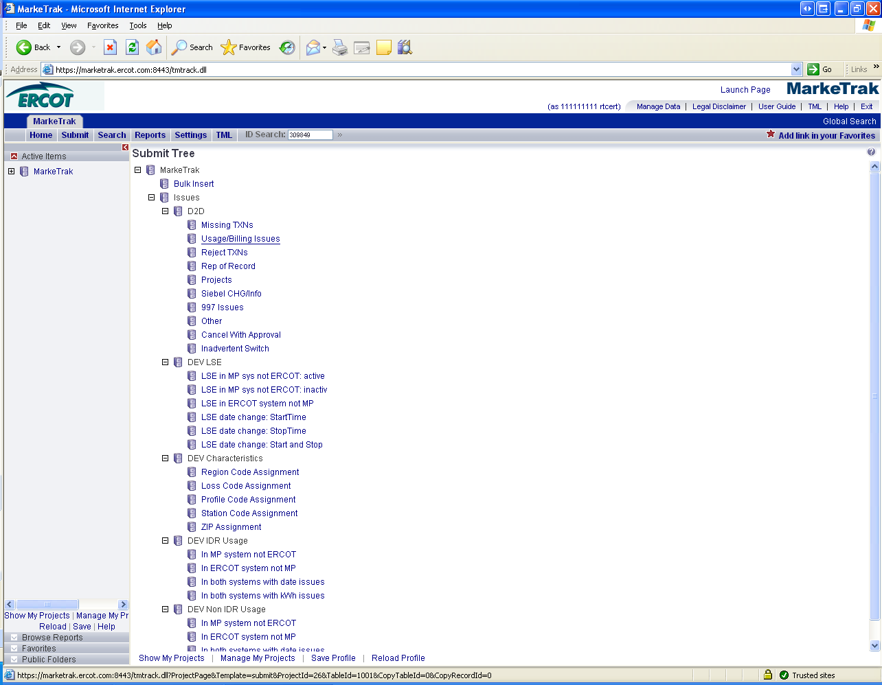

- The following fields must be populated for successful submission of Day to Day issue sub type Usage/Billing Issues:
(For this example, the submitter selects the TDSP.)
Assignee
ESIID
Original Tran ID (Optional except for 867_03 Final)
Service Period Start Date
Transaction Date
Tran ID (Required when the issue is designated as a dispute)

NOTE: The Comments field is optional. Please include any additional information in this box. New field added: Service Period Stop Date. Although optional it is encouraged to be populated. If left blank it will be assumed that the Stop date is the date the MarkeTrak issue was created.

- To expedite the request a couple of drop down boxes have been added.
  - IDR/NIDR – drop down box used to designate whether the transaction is tied to an IDR or NIDR account
  - Missing/Dispute - drop down box used to designate whether the transaction is missing or is being disputed by the CR

- Select OK. (Fig 4.2b)

Fig 4.2b
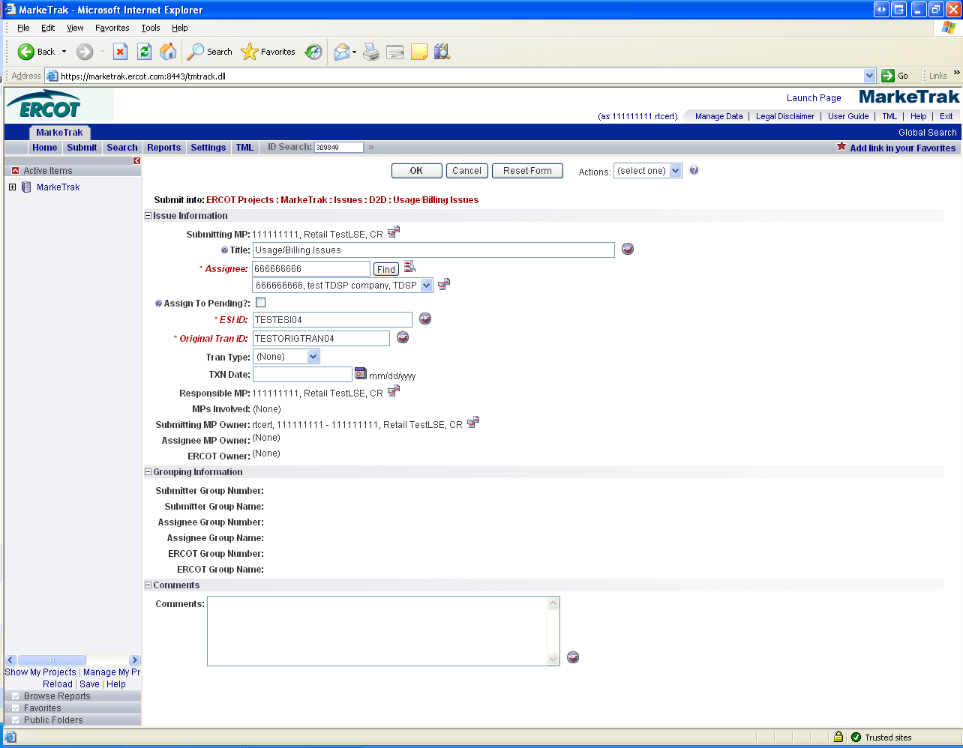

The issue enters TDSP queue in a state of New TDSP and is visible only by the Submitting CR and TDSP.
- The Submitting CR can Withdraw the issue at this point. (Fig 4.2c)

Fig 4.2c
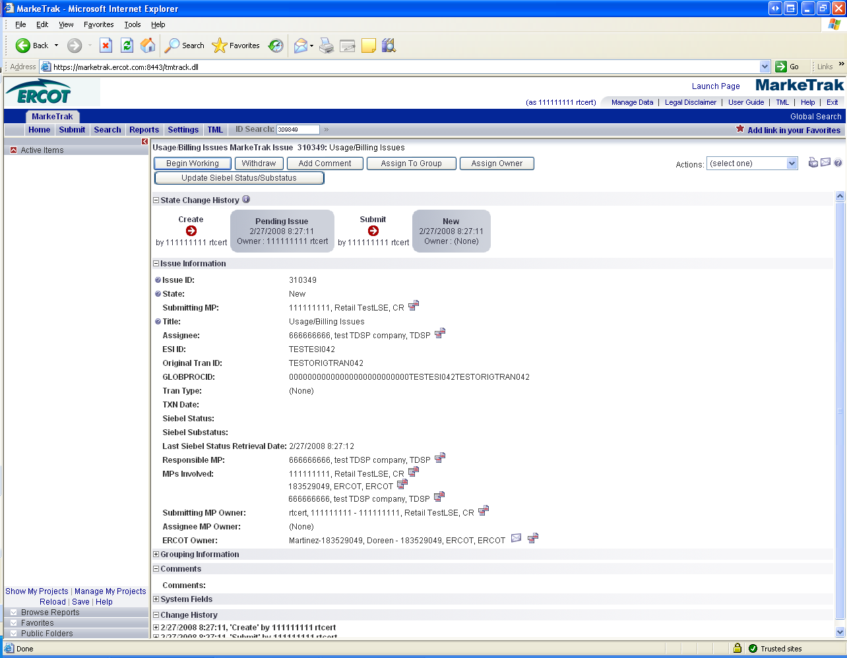

- The TDSP selects Begin Working and the issue is transitioned in a new state of In Progress (Assignee). (Fig 4.2d)
- At this point, the Submitting CR can no longer Withdraw the issue.

Add close verbiage.

Fig 4.2d
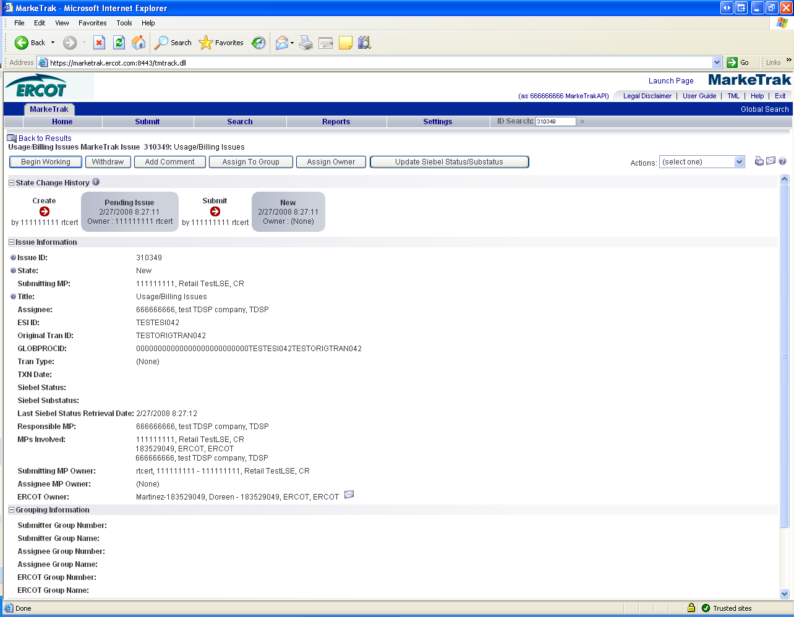

- TDSP reviews the issue and has the options: (Fig 4.2e)
  - Unexecutable, which results in state Unexecutable- Pending Complete
  - Return to Submitter, which requires comments and then the issue is transitioned back to the Submitter for additional information
  - Complete, which transitions to a state of Pending Complete.
.

Fig 4.2e

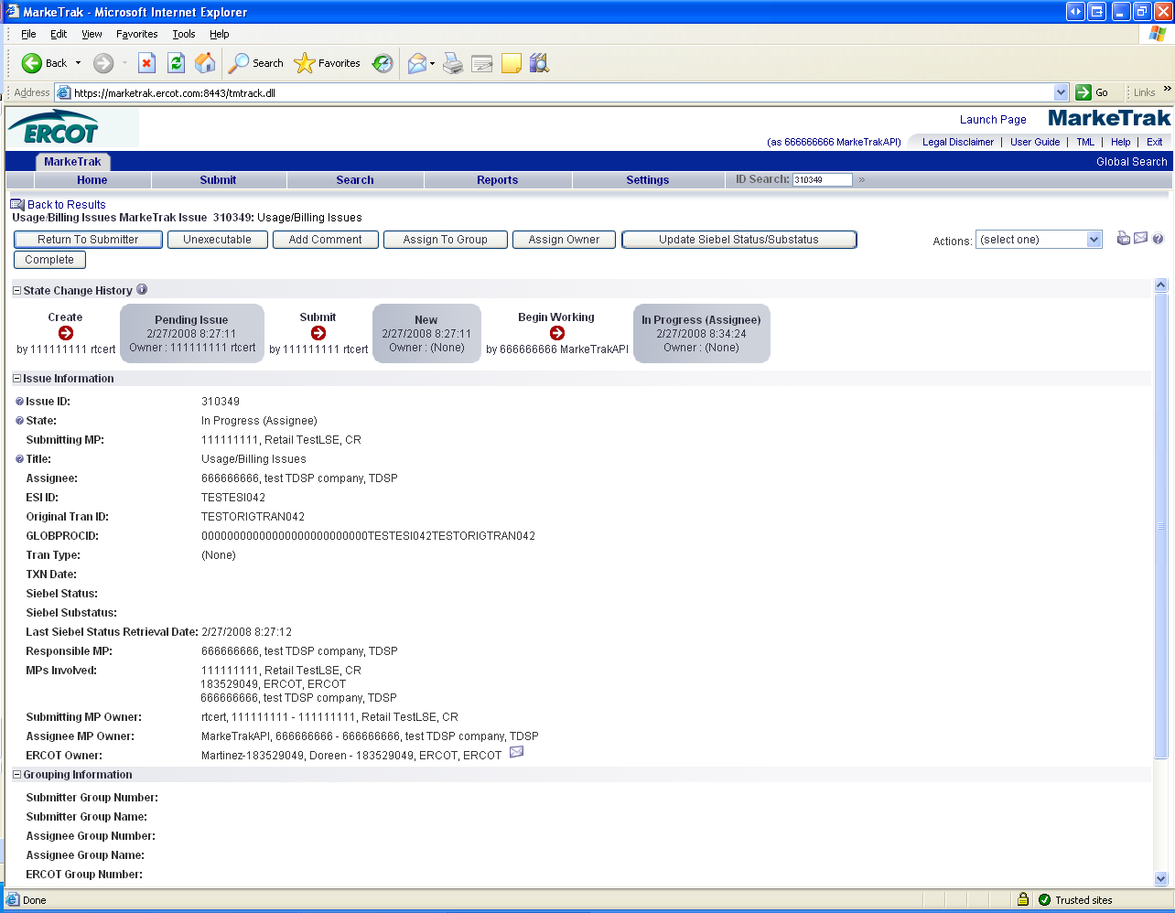

- In this example the TDSP selects Complete and the issue is transitioned to the submitting CR in a state of Pending Complete. If the issue was designated as Missing, during the “Complete” transaction, the TDSP is required to provide the Tran ID
- The Submitting CR has the option to close the issue by selecting Complete or the issue will be Auto Closed in 14 Calendar days. (Fig 4.2f)

Fig 4.2f
