4.1 Day to Day Issues – Missing Transaction

4.1.1 Required Fields for Missing Transaction
 | Assignee | ESI ID | Original Tran ID | Tran Type | Gaining/ Losing Rep | TXN Date | GS Number | Comments
Missing TXNS | Req | Req | Req | Req | N/A | Opt | N/A | Opt

4.1.2 Definition of Missing Transaction
4.1.2.1 Examples of Missing Transactions

Examples of missing transactions are if a CR is missing any 814’s or an 867_04.

Before Submitting a D2D issue, MPs must validate the issue against the market reports and market resources:
- Service order Full Extract Report
- Located on the Texas Market Link (TML)
- ERCOT TML ESIID Look-Up/Transaction Look-Up
- ERCOT Market Participant (MP) Transaction Report
- Located in the FTP Reports Mailbox for each Market Participant

4.1.3 Submitting a Missing Transaction

4.1.3.1 Example: CR Submits Missing Transactions to TDSP

- The CR selects the Submit tab (Fig 4.1a)
- From the Submit Tree, select Missing TXNs

Fig 4.1a
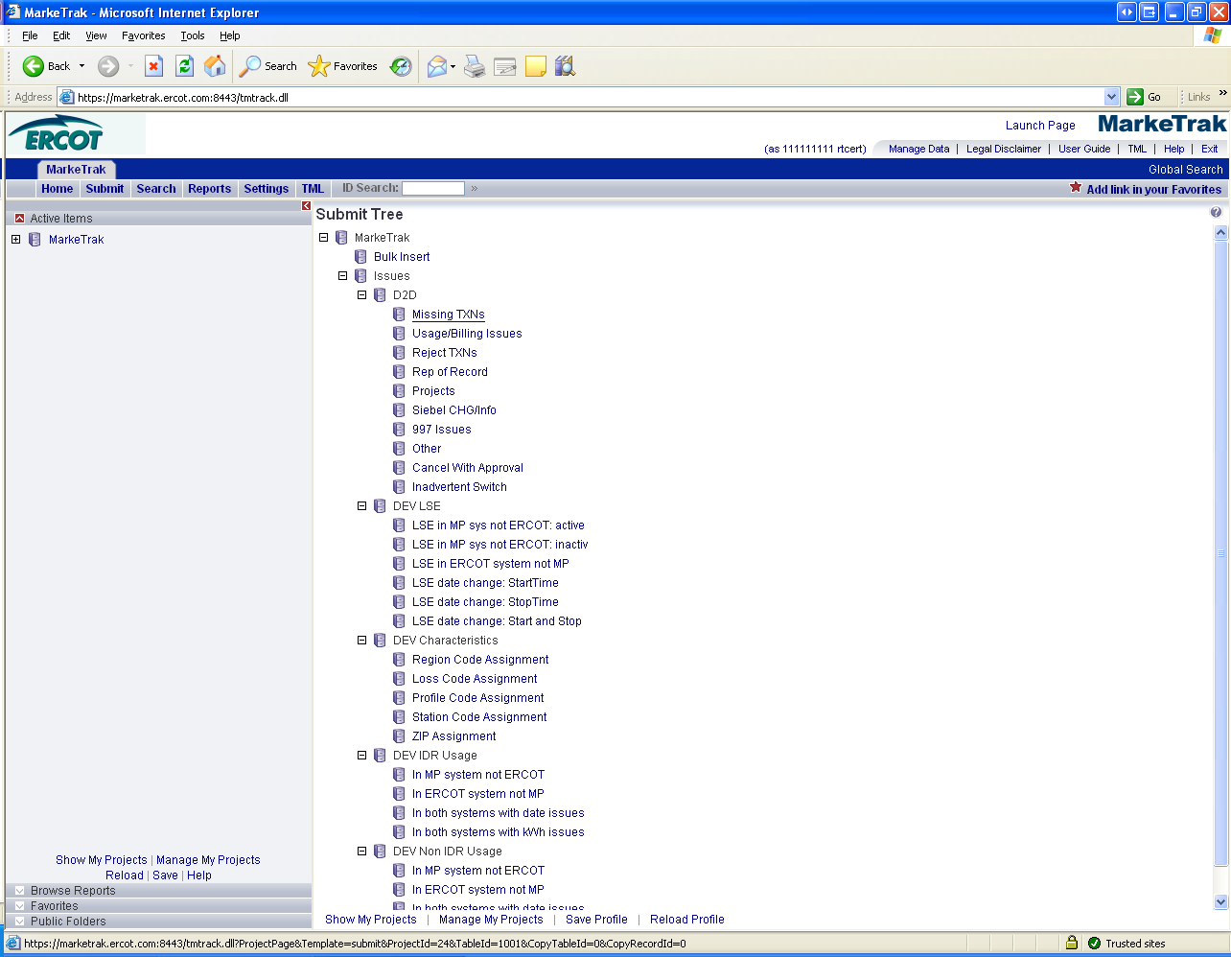

- The following fields must be populated for successful submission of Day to Day issue sub type Missing TXNs: (Fig 4.1b)

(For this example, the submitter selects TDSP)
Assignee
ESI ID
Original Tran ID
Tran Type

NOTE: The Comments field is optional. Please include any additional information in this box. New field added: Service Period Start Date. Although optional it is encouraged to be populated.

- Select OK.

Fig 4.1b

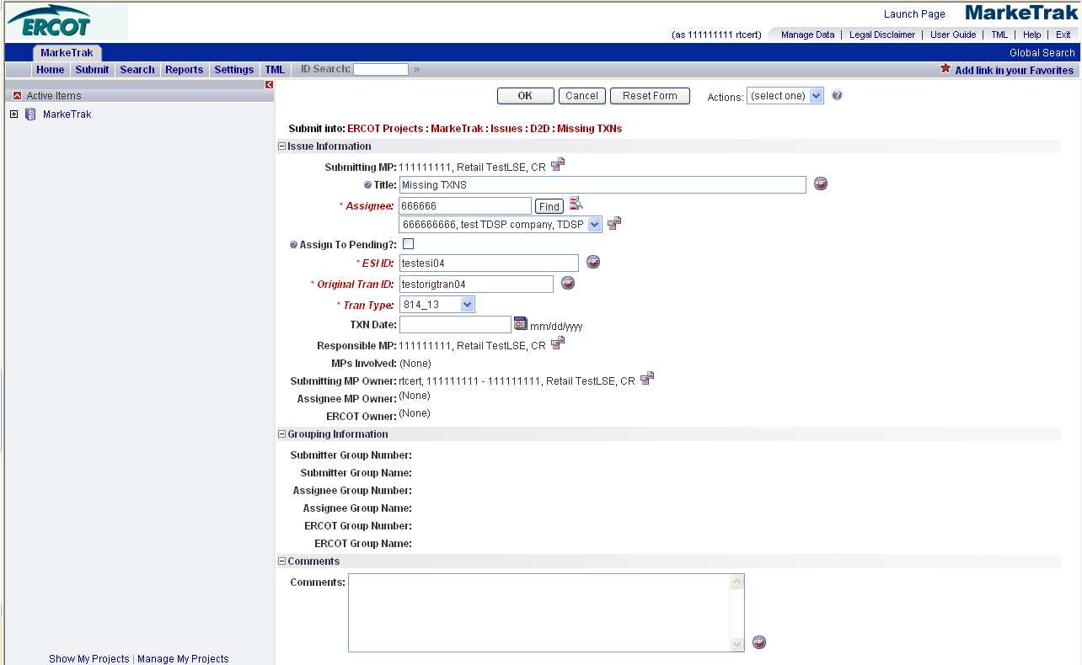

- The issue enters the TDSP’s queue in a state of New TDSP and is visible only by the Submitting CR and the TDSP.
- The Submitting CR can Withdraw the issue at this point. (Fig 4.1c)

Fig 4.1c
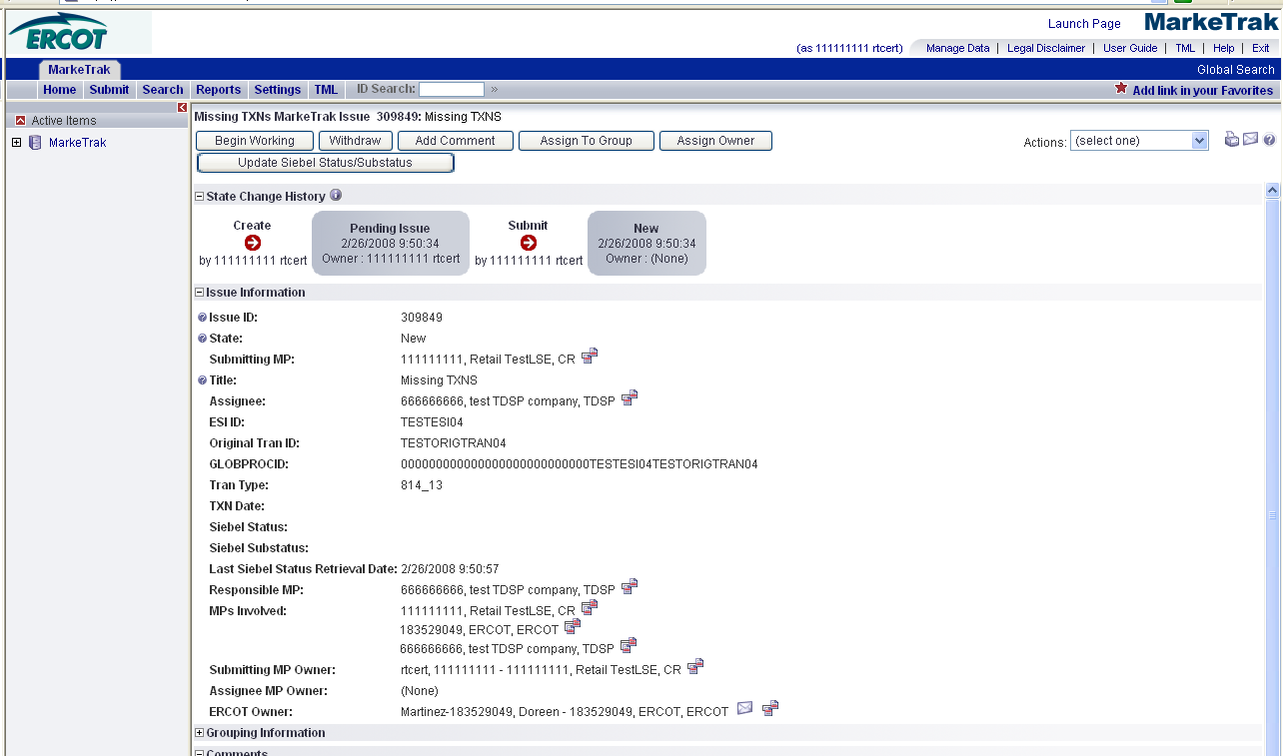

- TDSP selects Begin Working and the issue is transitioned in a new state of In Progress (Assignee) TDSP. (Fig 4.1d)
- At this point, the Submitting CR can no longer Withdraw the issue.

Add close verbiage

Fig 4.1d
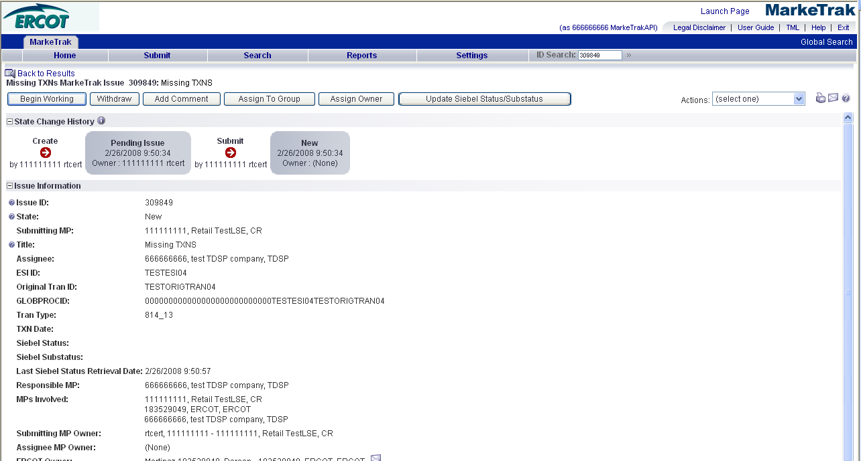

- TDSP reviews the issue and has the below options: (Fig 4.1e)

- Unexecutable, which results in state Unexecutable- Pending Complete
- Return to Submitter, which requires comments and then the issue is transitioned back to the Submitter for additional comments
- Complete, which transitions to a state of Pending Complete.

Fig 4.1e
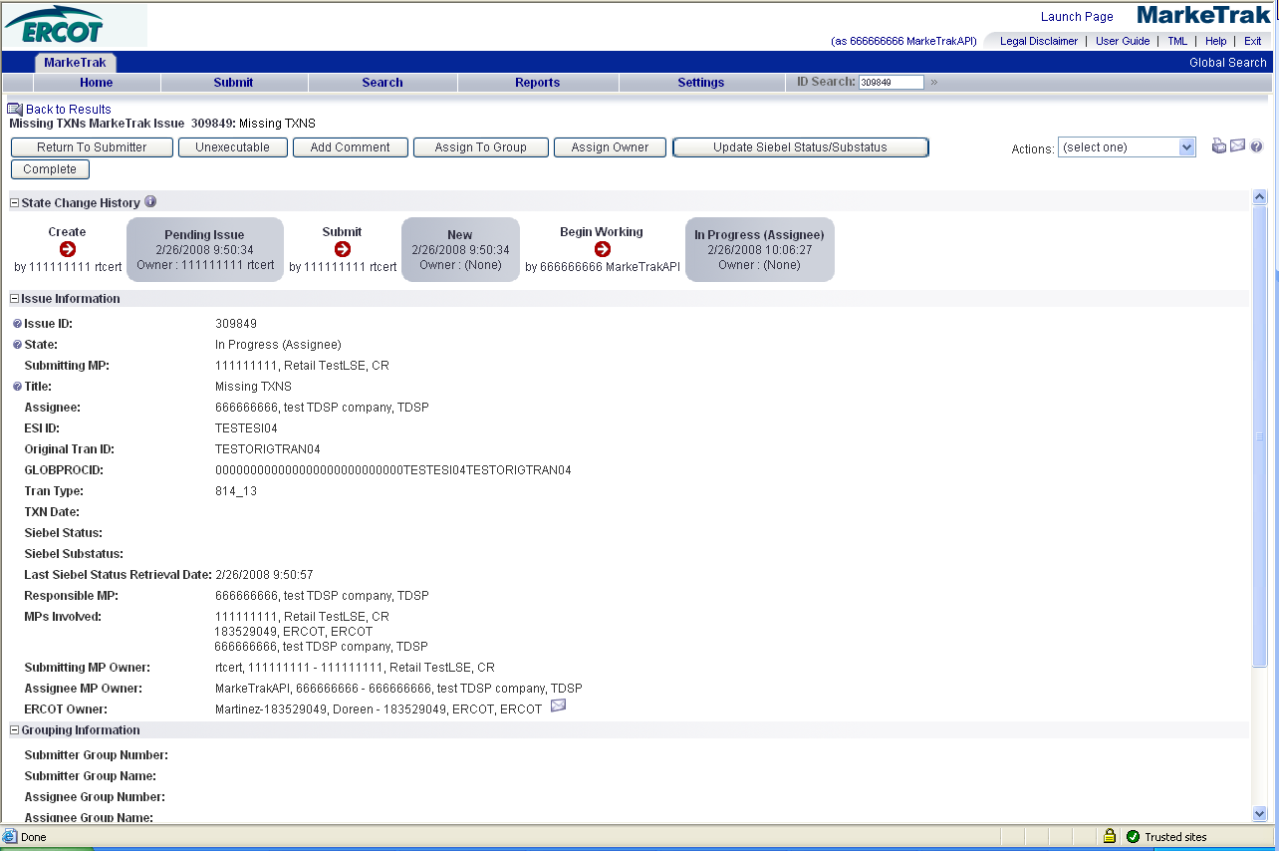

- If the TDSP selects Complete, the issue will transition to the Submitter in a state of Pending Complete. The Submitter then has the option to close the issue by selecting Complete or the issue will be auto closed in 14 calendar days.

