Usage DEV Issues

Usage DEV issues must be submitted by meter type (IDR/Non-IDR) and Issue Type. ERCOT Data Extract Usage Variances may only be submitted to ERCOT by TDSPs. The TDSPs will not be able to assign a party for the variance. Usage Variances that are CR to TDSP should include only the ESI IDs for the resolving TDSP and must be filed as Data Extract Variance – Usage Issues (IDR/Non-IDR).

*** IDR usage rows with an ORIGIN of ‘C’ or ‘G’ are calculated by ERCOT. These usage rows should NOT be filed as DEV IDR Usage ‘In ERCOT system not MP’ Variance Issues. ***

Requests to load negative usage will be rejected.

For all Usage DEV issues that require changes to usage data or loading of missing data at ERCOT into Lodestar per the resolution, the TDSP should send the usage to ERCOT in accordance with the 867_03 usage loading validations. These validations are performed whether the data is submitted via transaction or file for manual loading. The issue shall not be marked as Complete until the corrected usage has properly loaded into ERCOT systems.

For all Usage DEV issues that require changes to usage data or loading of missing data into the CR’s system per the resolution, the TDSP shall confirm that a TX SET compliant 867_03 transaction was sent with the variance issue submitter as the forwarding DUNS number for the usage in question. If it is determined that the CR needs the 867_03 for customer billing purposes, the TDSP shall send the requested usage.

For Usage DEV issue type DEV IDR/Non IDR Usage ‘In MP system not in ERCOT’ the following processes shall be followed:

Situation 1: If the TDSP confirms via the ESI ID Extract that usage is loaded at ERCOT and matches the usage in the TDSP system, the TDSP shall transition the issue back to the CR as Unexecutable with comments and/or transactions submitted for explanation.

Situation 2: The TDSP will transition the issue back to the CR for assignment to ERCOT for assignment (Assign Owner) SIR (10908) if ALL the following conditions are met:

- The TDSP determines via the ESI ID Extract that usage data is not loaded at ERCOT.
- The TDSP confirms ERCOT acknowledged acceptance of the transaction(s) in all levels of the 997 response.
- The TDSP determine the usage was reported as loaded successfully via the 867_03 activity report as of August 6, 2003.

Situation 3: The TDSP shall submit usage data to ERCOT via transaction in cases where either condition (b) or (c) above is not met. The issue shall not be marked as Complete until such usage data has been properly loaded into ERCOT systems.

For Usage DEV issues filed by the TDSP to ERCOT that result in manual loading or correction of usage by ERCOT, it is the TDSP’s responsibility to communicate any changes to the appropriate CR(s). Neither ERCOT nor the TDSP shall mark the issue as Resolved until the necessary changes have been completed.

Changes made to Usage records where usage is currently loaded at ERCOT in either the LSCHANNELCUTHEADER or ESIIDUSAGE must cover the entire time period in error to prevent the creation of usage gaps.

***NOTE: REQ 15 Validate TDSP is Associated with Issue will be applied to ALL DEV submissions

***NOTE: REQ 35 will allow the Submitter to ‘CLOSE’ an DEV issue IF the Submitter is the Responsible Party.

DEV Issues – IDR – In MP system not ERCOT
CR to TDSP
The DEV issue of In MP system not ERCOT should be submitted when the ESI ID IDR meter data is in the MP’s system, but not in the data extract from ERCOT.

Action: IDR Usage needs to be loaded at ERCOT.

Situation 1: If the TDSP confirms via the ESI ID Extract that usage is loaded at ERCOT and matches the usage in the TDSP system, the TDSP shall transition the issue back to the CR as Unexecutable with comments and/or transactions submitted for explanation.

Situation 2: The TDSP will transition the issue back to the CR for assignment to ERCOT for assignment (Assign Owner) SIR (10908) if ALL the following conditions are met:
- The TDSP determines via the ESI ID Extract that usage data is not loaded at ERCOT,
- The TDSP confirms ERCOT acknowledged acceptance of the transaction(s) in all levels of the 997 response, and
- The TDSP determine the usage was reported as loaded successfully via the 867_03 activity report as of August 6, 2003.

Situation 3: The TDSP shall submit usage data to ERCOT via transaction in cases where either condition (b) or (c) above is not met. The issue shall not be marked as Complete until such usage data has been properly loaded into ERCOT systems.
If the TDSP determines that the usage data is not loaded at ERCOT, then the TDSP is responsible for submitting the usage data to ERCOT via transaction.

TDSP to ERCOT
The TDSP will submit In MP system not ERCOT to ERCOT if ALL the above conditions in Situation 2 are met.

For all Usage Variance Issues that require changes to usage data or loading of missing data at ERCOT into Lodestar per the resolution, the TDSP should send the usage to ERCOT in accordance with the 867_03 usage loading validations. These validations are performed whether the data is submitted via transaction or file for manual loading.

It is the TDSP’s responsibility to communicate all ESI ID Service History and Usage (IDR and Non-IDR) data changes to the appropriate CR(s).

Requests to load negative usage will be rejected.

Assignee field:
For TDSP to ERCOT – Assignee will auto populate with ERCOT
For CR to TDSP - Assignee will be required for submission
The Assignee can be located by using the search feature through the ‘Find’ button by typing in all or part of the MPs name or DUNS number. The Comments field is optional.

DEV Issues – IDR – In MP system not ERCOT
 | Submitted By/To | New Start Time | New Stop Time | NEW TOTAL | Comments | ESIID | STARTTIME | STOPTIME | UIDCHANNELCUT | CHANNEL | ADDTIME | Origin | Title | Assignee
In MP system  not ERCOT | CR/TDSP | Req | Req | Req | Opt | Req | N/A | N/A | N/A | Req | N/A | N/A | Opt | Opt  Req
In MP system  not ERCOT | TDSP/ERCOT | Req | Req | Req | Opt | Req | N/A | N/A | N/A | Req | N/A | N/A | Opt | Opt  Req

Example of IDR – In MP system not ERCOT

Example: CR submits In MP system not ERCOT to TDSP

      - Select the Submit tab. (Fig 11.7.1a)
      - From the Submit Tree, select In MP system not ERCOT
Fig 11.7.1a
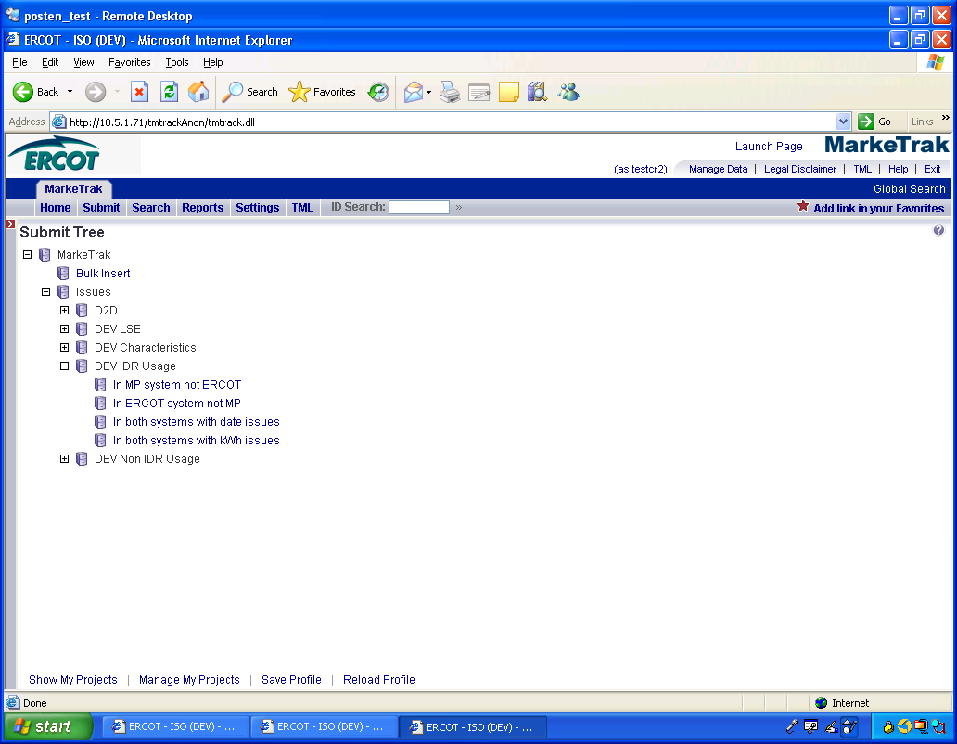

      - The following fields must be populated for successful submission:
Assignee
New STARTTIME
New STOPTIME
ESIID
CHANNEL – CR to TDSP CHANNEL should = ‘4’
New Total
      - Select OK (Fig 11.7.1b)
Fig 11.7.1b
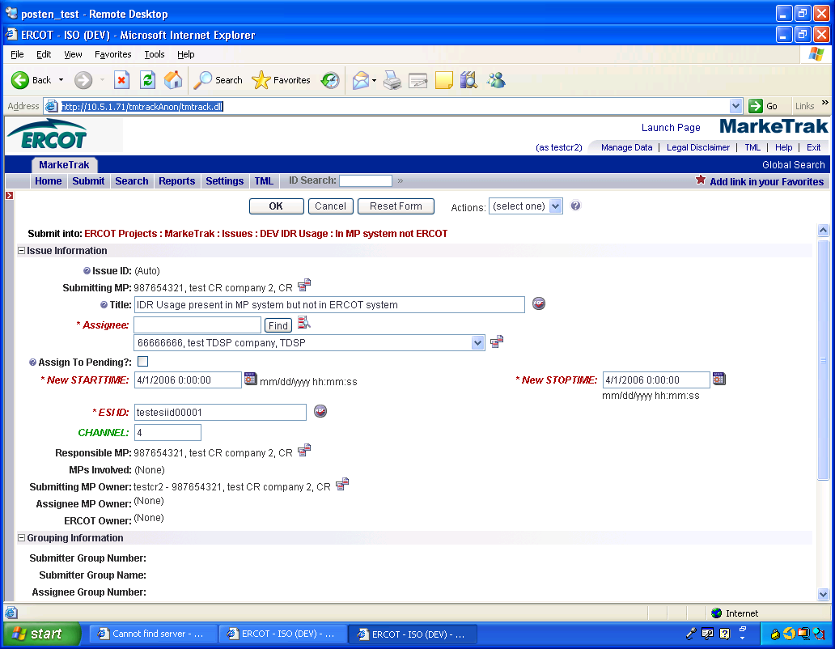

      - The issue enters TDSP’s queue in the state of New. (Fig 11.7.1c)
      - The CR only may Withdraw the issue prior to acknowledgement by the TDSP
Fig 11.7.1c
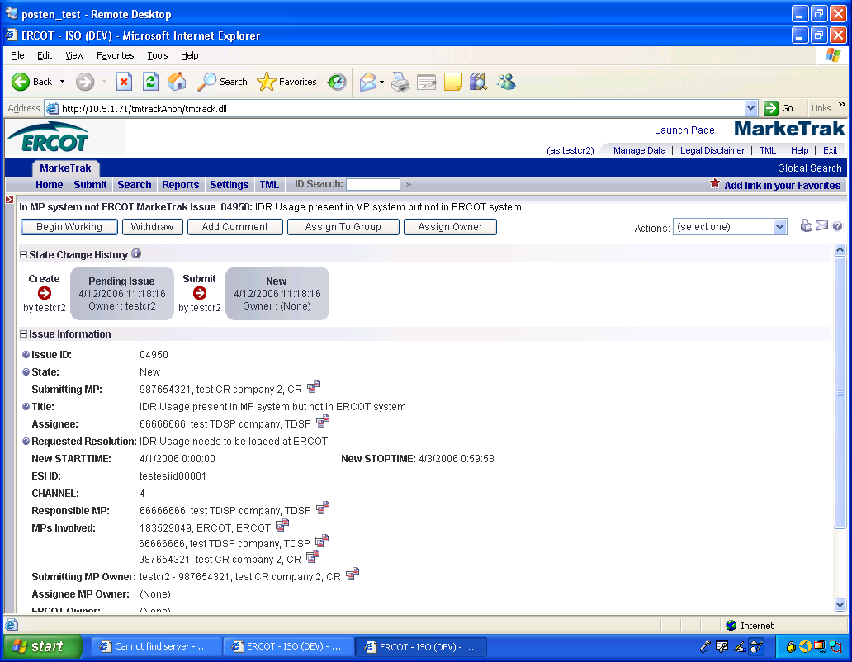

      - TDSP selects Begin Working and the CR can no longer Withdraw the issue. (Fig 11.7.1d)
Fig 11.7.1d
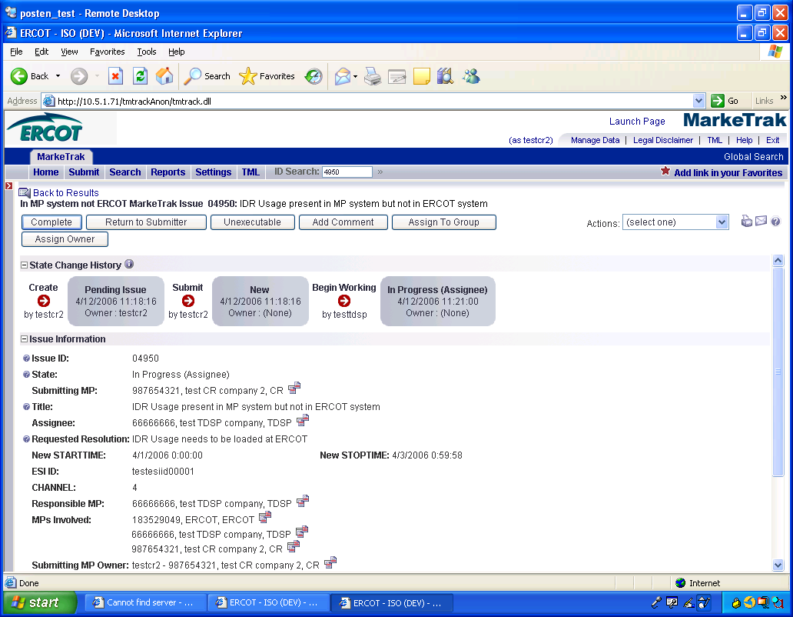

      - TDSP has the options of Complete, or Unexecutable. (Fig 11.7.1e)
Fig 11.7.1e
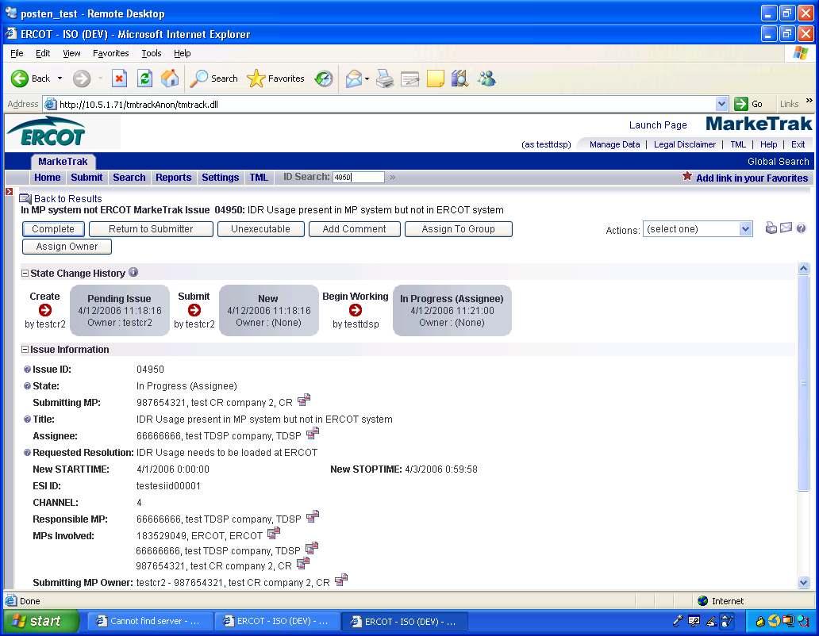

      - If in agreement TDSP will take appropriate action then select Complete which transitions the issue to Pending Complete with the CR. (Fig 11.7.1f)
Fig 11.7.1f
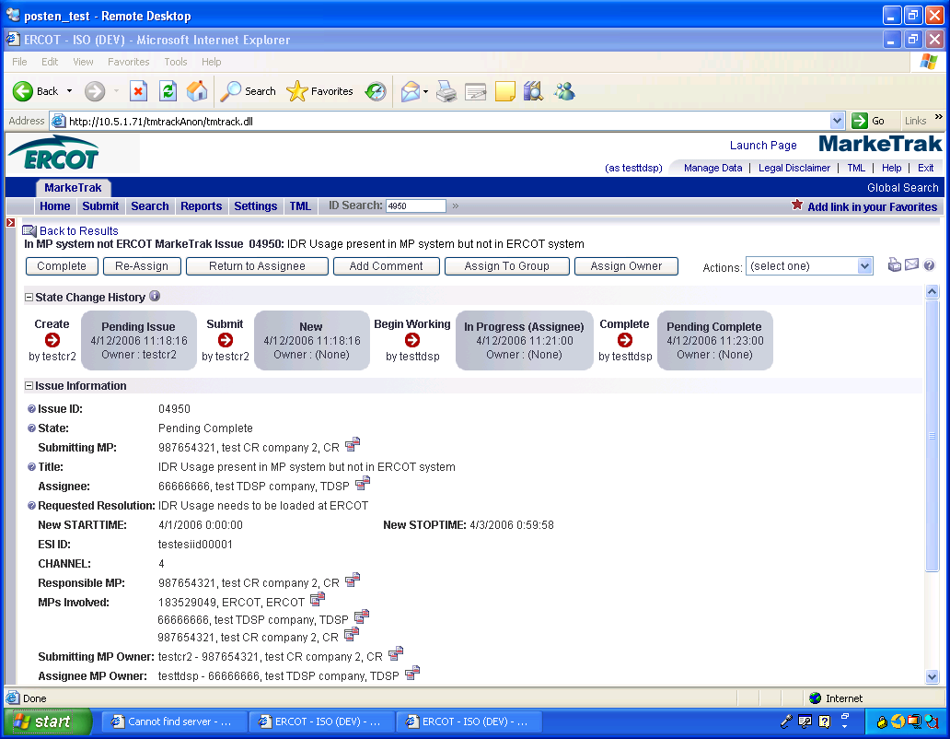

      - The CR selects Complete and the issue is closed
      - If not in agreement TDSP may:
      - .
      - Select Unexecutable which will require a comment and return the issue back to CR’s queue as Unexecutable (Pending Complete).
      - Once in the Pending Complete state, The submittor can complete the issue by selecting the transition ‘Complete’, but if the issue is not transitioned for 14 calendar days the issue will automatically go to Auto Complete. The issue will then be closed.

NOTE:CR to TDSP submissions, the channel will auto populate with ‘4’. For TDSP to ERCOT submissions, TDSP must enter value ‘1’ or ‘4’.

DEV Issues – IDR – In ERCOT system not MP
The DEV issue of In ERCOT system not MP should be submitted when the ESI ID IDR meter data is in the data extract from ERCOT, but not in the MP’s system.

TDSP to ERCOT
Action: Data needs to be cancelled from ERCOT system.

CR to TDSP
Prior to correcting or resending usage, the TDSP will verify that the requesting CR is the LSE of record for requested timeframe.

Action: TDSP to submit IDR Usage to CR

It is the TDSP’s responsibility to communicate all ESI ID Service History and Usage (IDR and Non-IDR) data changes to the appropriate CR(s).

Assignee field:
For TDSP to ERCOT – Assignee will auto populate with ERCOT
For CR to TDSP - Assignee will be required for submission
The Assignee can be located by using the search feature through the ‘Find’ button by typing in all or part of the MPs name or DUNS number. The Comments field is optional.

Required fields for IDR – In ERCOT system not MP

 | Submitted By/To | New Start Time | New Stop Time | Comments | ESIID | STARTTIME | STOPTIME | UIDCHANNELCUT | CHANNEL | ADDTIME | Origin | Title | Assignee
In ERCOT system  not MP | TDSP/ERCOT | N/A | N/A | Opt | Req | Req | Req | Req | N/A | Req | Req | Opt | Opt  Req
In ERCOT system  not MP | CR/TDSP | N/A | N/A | Opt | Req | Req | Req | Req | N/A | Req | Req | Opt | Opt  Req

        - Example of IDR – In ERCOT system not MP

Example: CR submits In ERCOT system not MP to TDSP

- Select the Submit tab
- From the Submit Tree, select In ERCOT system not MP
- The following fields must be populated for successful submission:
Assignee
ESIID
STARTTIME (STARTTIME - SCR727 Extract)
STOPTIME (STOPTIME - SCR727 Extract)
UIDCHANNELCUT
ADDTIME (ADDTIME - SCR727 Extract)
Origin – Must be ‘M’

- Select OK
- The issue enters TDSP’s queue in the state of New
- The CR only may Withdraw the issue prior to acknowledgement by the TDSP
- TDSP selects Begin Working and the CR can no longer Withdraw the issue
- TDSP has the options of Complete, or
Unexecutable
- If in agreement TDSP will take appropriate action then select Complete which transitions the issue to Pending Complete with the CR
- The CR selects Complete and the issue is closed
- If not in agreement TDSP may:

  - Select Unexecutable which will require a comment and return the issue back to CR’s queue as Unexecutable (Pending Complete)
- Once in the Pending Complete state, The submittor can complete the issue by selecting the transition ‘Complete’, but if the issue is not transitioned for 14 calendar days the issue will automatically go to Auto Complete. The issue will then be closed.

DEV Issues – IDR – In both systems with date issues
The DEV issue of In both systems with date issues should be submitted when the ESI ID IDR meter data is in the data extract from ERCOT and in the MP’s system, but has STARTTIME and/or STOPTIME issues.

TDSP to ERCOT
Action: Dates of IDR data are incorrect. Delete and reload LSE file.

CR to TDSP
Action: TDSP to verify IDR Usage values

For all Usage Variance Issues that require changes to usage data or loading of missing data at ERCOT into Lodestar per the resolution, the TDSP should send the usage to ERCOT in accordance with the 867_03 usage loading validations. These validations are performed whether the data is submitted via transaction or file for manual loading.

Requests to load negative usage will be rejected.

It is the TDSP’s responsibility to communicate all ESI ID Service History and Usage (IDR and Non-IDR) data changes to the appropriate CR(s).

Assignee field:
For TDSP to ERCOT – Assignee will auto populate with ERCOT
For CR to TDSP - Assignee will be required for submission
The Assignee can be located by using the search feature through the ‘Find’ button by typing in all or part of the MPs name or DUNS number. The Comments field is optional.

Required fields for IDR – In both systems with date issues
 | Submitted By/To | New Start Time | New Stop Time | NEW TOTAL | Comments | ESIID | STARTTIME | STOPTIME | UIDCHANNELCUT | CHANNEL | ADDTIME | Origin | Title | Assignee
In both systems  with date issues | TDSP/ERCOT | Req | Req | Req | Opt | Req | Req | Req | Req | N/A | Req | Req | Opt | Opt  Req
In both systems  with date issues | CR/TDSP | Req | Req | Req | Opt | Req | Req | Req | Req | N/A | Req | Req | Opt | Opt  Req

Example of IDR – In both systems with date issues

Example: CR submits In both systems with date issues to TDSP

- Select the Submit tab
- From the Submit Tree, select In MP system not ERCOT
- The following fields must be populated for successful submission:
Assignee
New STARTTIME
New STOPTIME
ESIID
STARTTIME (STARTTIME - SCR727 Extract)
STOPTIME (STOPTIME - SCR727 Extract)
UIDCHANNELCUT
ADDTIME (ADDTIME - SCR727 Extract)
Origin – Must be ‘M’
New Total
- Select OK
- The issue enters TDSP’s queue in the state of New
- The CR only may Withdraw the issue prior to acknowledgement by the TDSP
- TDSP selects Begin Working and the CR can no longer Withdraw the issue
- TDSP has the options of Complete or Unexecutable
- If in agreement TDSP will take appropriate action then select Complete which transitions the issue to Pending Complete with the CR
- The CR selects Complete and the issue is closed
- If not in agreement TDSP may:

  - Select Unexecutable which will require a comment and return the issue back to CR’s queue as Unexecutable (Pending Complete)
- Once in the Pending Complete state, The submittor can complete the issue by selecting the transition ‘Complete’, but if the issue is not transitioned for 14 calendar days the issue will automatically go to Auto Complete. The issue will then be closed.

DEV Issues – IDR – In both systems with kWh issues
The DEV issue of In both systems with kWh issues should be submitted when the ESI ID IDR meter data is in the data extract from ERCOT and in the MP’s system, but has kWh issues.

TDSP to ERCOT
Action: Load the corrected LSE file

CR to TDSP
Action: TDSP to verify IDR Usage values

For all Usage Variance Issues that require changes to usage data or loading of missing data at ERCOT into Lodestar per the resolution, the TDSP should send the usage to ERCOT in accordance with the 867_03 usage loading validations. These validations are performed whether the data is submitted via transaction or file for manual loading.

Requests to load negative usage will be rejected.

It is the TDSP’s responsibility to communicate all ESI ID Service History and Usage (IDR and Non-IDR) data changes to the appropriate CR(s).

This Variance Issue cannot be used to request changes to usage dates.

Assignee field:
For TDSP to ERCOT – Assignee will auto populate with ERCOT
For CR to TDSP - Assignee will be required for submission
The Assignee can be located by using the search feature through the ‘Find’ button by typing in all or part of the MPs name or DUNS number. The Comments field is optional.

Required fields for IDR – In both systems with kWh issues
 | Submitted By/To | New Start Time | New Stop Time | NEW TOTAL | Comments | ESIID | STARTTIME | STOPTIME | UIDCHANNELCUT | CHANNEL | ADDTIME | Origin | Title | Assignee
In both systems  with kWh issues | TDSP/ERCOT | N/A | N/A | Req | Opt | Req | Req | Req | Req | Req | Req | Req | Opt | Opt  Req
In both systems  with kWh issues | CR/TDSP | N/A | N/A | Req | Opt | Req | Req | Req | Req | Req | Req | Req | Opt | Opt  Req

Example of IDR – In both systems with kWh issues

Example: CR submits In both systems with kWh issues to TDSP

- Select the Submit tab
- From the Submit Tree, select In both systems with kWh issues

- The following fields must be populated for successful submission:
Assignee
ESIID
STARTTIME (STARTTIME - SCR727 Extract)
STOPTIME (STOPTIME - SCR727 Extract)
UIDCHANNELCUT
CHANNEL– CR to TDSP CHANNEL should = ‘4’
ADDTIME (ADDTIME - SCR727 Extract)
Origin – Must be ‘M’
New Total
- Select OK
- The issue enters TDSP’s queue in the state of New
- The CR only may Withdraw the issue prior to acknowledgement by the TDSP
- TDSP selects Begin Working and the CR can no longer Withdraw the issue
- TDSP has the options of Complete or Unexecutable
- If in agreement TDSP will take appropriate action then select Complete which transitions the issue to Pending Complete with the CR
- The CR selects Complete and the issue is closed
- If not in agreement TDSP may:

- Select Unexecutable which will require a comment and return the issue back to CR’s queue as Unexecutable (Pending Complete)
- Once in the Pending Complete state, The submittor can complete the issue by selecting the transition ‘Complete’, but if the issue is not transitioned for 14 calendar days the issue will automatically go to Auto Complete. The issue will then be closed.

NOTE:CR to TDSP submissions, the channel will auto populate with ‘4’. For TDSP to ERCOT submissions, TDSP must enter value ‘1’ or ‘4’.

