MarkeTrak Users Guide
Section 6: NON LSE DEV

ESI ID Characteristic DEV Issues
*** This applies to all Characteristic, IDR and Non-IDR DEVs. Corrected ‘Assignee’ on the grid. Striked through OPT and added ‘Req.’ This field is NOT Optional via Bulk Insert nor the GUI. If the TDSP is the Submitter (ERCOT) is auto populated but still required. Therefore, I believe ‘Req’ should be in the grid under ‘Assignee’. ***

ESI ID Characteristic DEV issues are issues filed by MPs regarding the characteristics assigned (i.e. Profile Code, Zip Code, etc.) to an ESI ID in ERCOT systems. For CR to TDSP issues, the CR is requesting the TDSP to submit an 814_20 MAINTAIN to ERCOT to reconcile the characteristic discrepancy between ERCOT systems and CR systems. For TDSP to ERCOT issues, the TDSP is requesting ERCOT to manually update the characteristics in ERCOT systems due to an 814_20 processing exception in ERCOT systems.

DEV Issues – Characteristics – Region Code Assignment
TDSP to ERCOT or CR to TDSP
The DEV Issue of Region Code Assignment should be submitted when the ESI ID is in the data extract from ERCOT and in the MP’s system, but there is an issue with the REGIONCODE of the ESI ID.

Action: Need to update REGIONCODE with new effective date

CR should contact TDSP if they believe an ESI ID has been assigned an incorrect Region Code.

The STARTTIME of an update in the ESIIDSERVICEHIST row is equivalent to the DTM~152 Effective Date of Change in 814_20 Maintain.

Assignee field:
For TDSP to ERCOT – Assignee will auto populate with ERCOT
For CR to TDSP - Assignee will be required for submission
The Assignee can be located by using the search feature through the ‘Find’ button by typing in all or part of the MPs name or DUNS number. The Comments field is optional.

6.1.5.1.1 Required fields for Characteristics – Region Code Assignment
 | Submitted By/To | New Start Time | New Region Code | New Loss Code | New Profile Code | New Station Code | New Zip Code | Comments | ESIID | UIDESIID | STARTTIME | STOPTIME | STATION CODE | PROFILE CODE | LOSS CODE | ADDTIME | REGION CODE | ZIP | Title | Assignee
Region Code Assignment | TDSP/ERCOT or CR/TDSP | Req | Req | N/A | N/A | N/A | N/A | Opt | Req | Req | Req | Opt | N/A | N/A | N/A | Req | Req | N/A | Opt | Req

6.1.5.1.2 Example of Characteristics – Region Code Assingment

Example: TDSP submits Region Code Assignment to ERCOT

- Select the Submit tab (Fig 11.6a)
- From the Submit Tree, select Region Code Assignment
Fig 11.6a
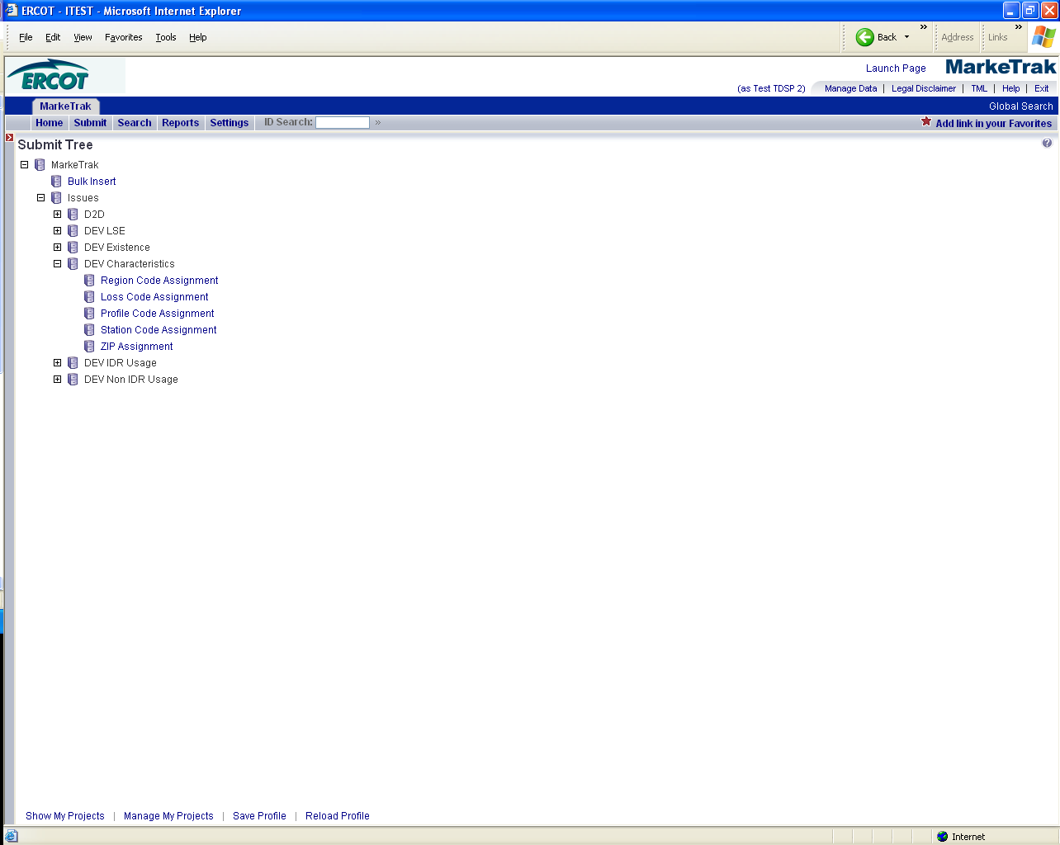
The following fields must be populated for successful submission:
New STARTTIME
New REGIONCODE
ESIID
UIDESIID
STARTTIME (STARTTIME - SCR727 Extract)
ADDTIME (ADDTIME – SCR727 Extract)
REGIONCODE
- Select OK (Fig 11.6b)
Fig 11.6b
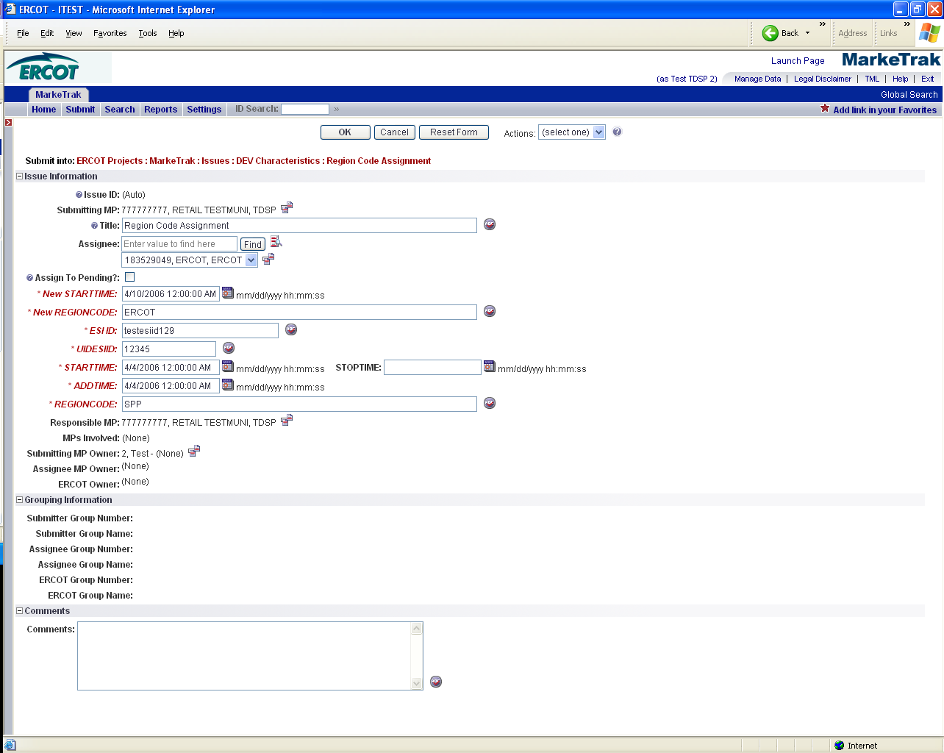

- The issue enters ERCOT’s queue in the state of New.
- The TDSP only may Withdraw the issue prior to acknowledgement by ERCOT. (Fig 11.6c)
Fig 11.6c
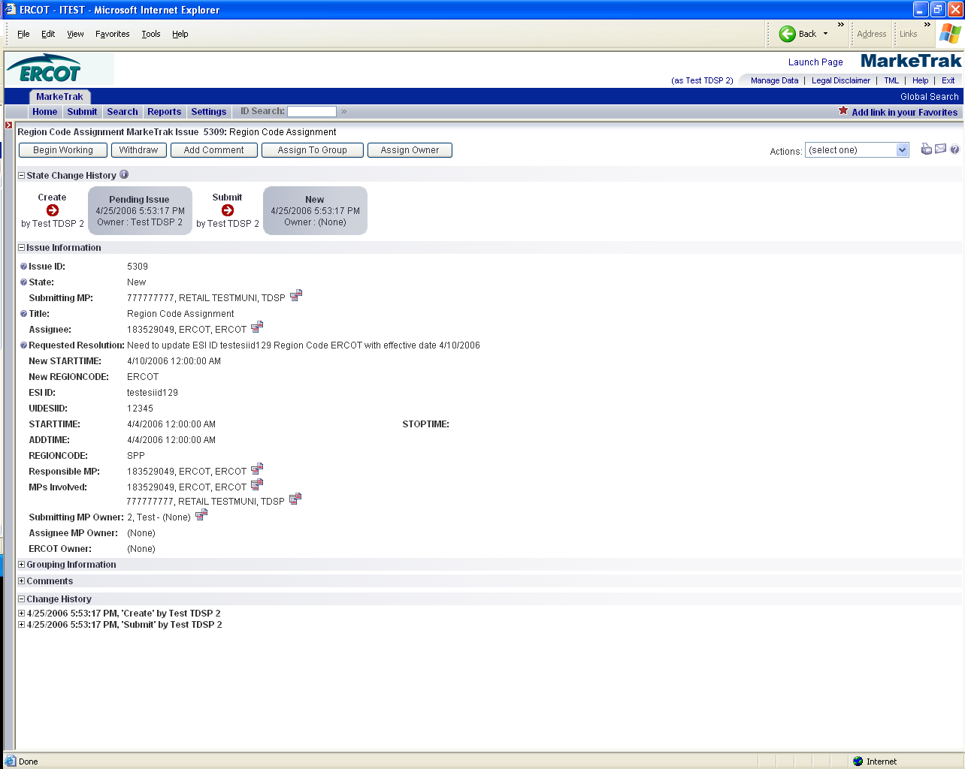

- ERCOT selects Begin Working and the TDSP can no longer Withdraw the issue. (Fig 11.6d)
Fig 11.6d
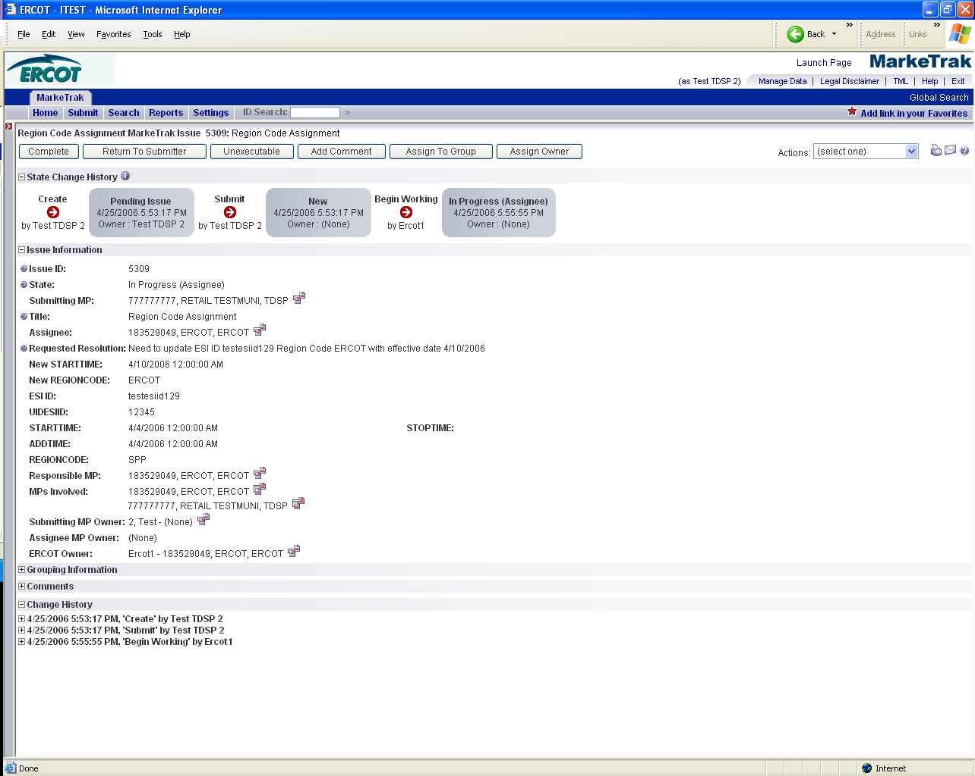

- ERCOT has the options of Complete, Return to Submitter, Unexecutable and Intervention by ERCOT. Intervention by ERCOT is used only by ERCOT to close the issue regardless of who is the Responsible MP. (Fig 11.6e)
Fig 11.6e
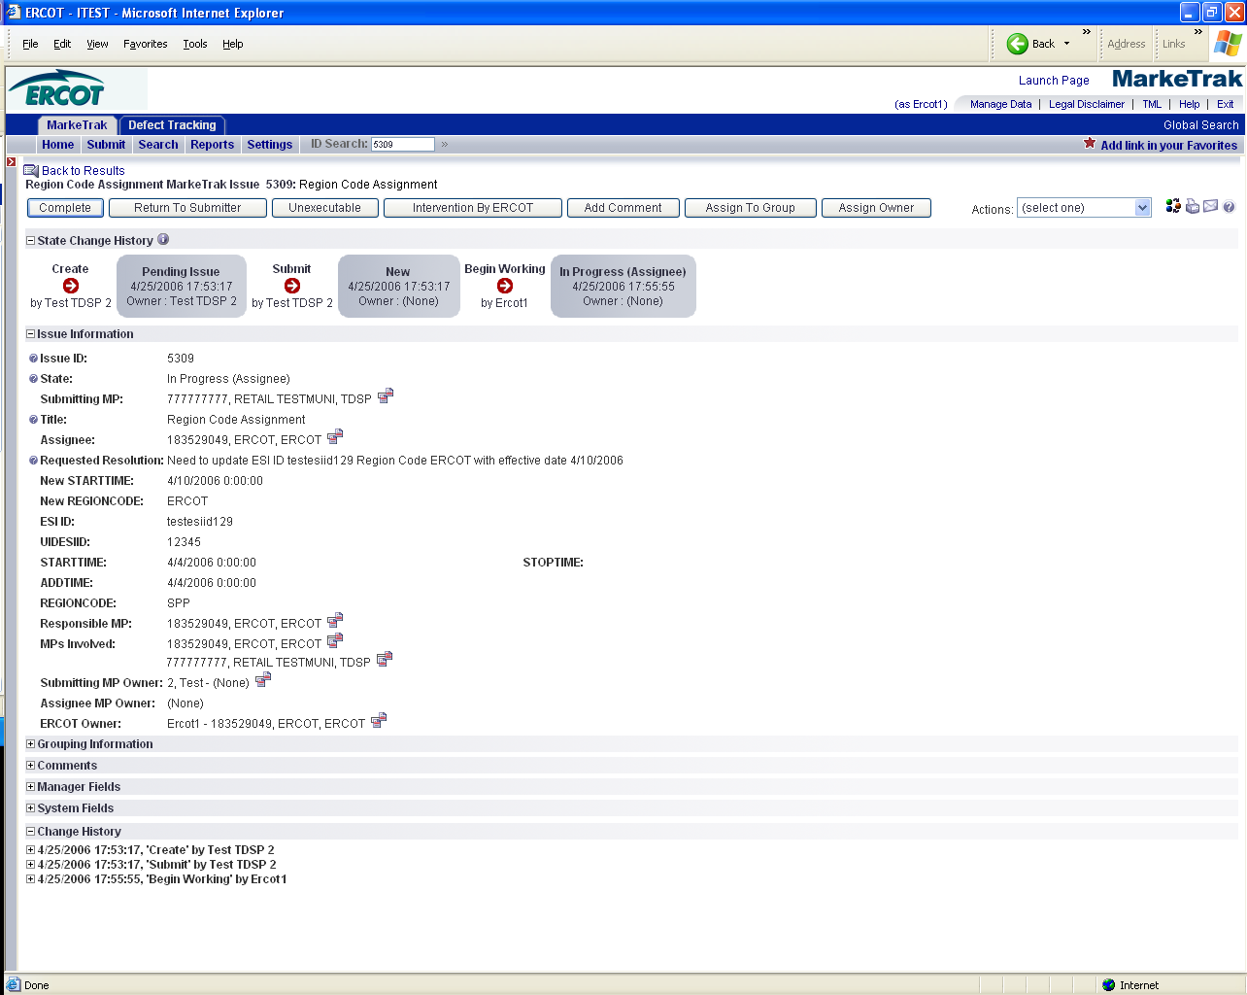

- If in agreement ERCOT will take appropriate action and select Complete which transitions the issue to Pending Complete with the TDSP. (Fig 11.6f)
Fig 11.6f
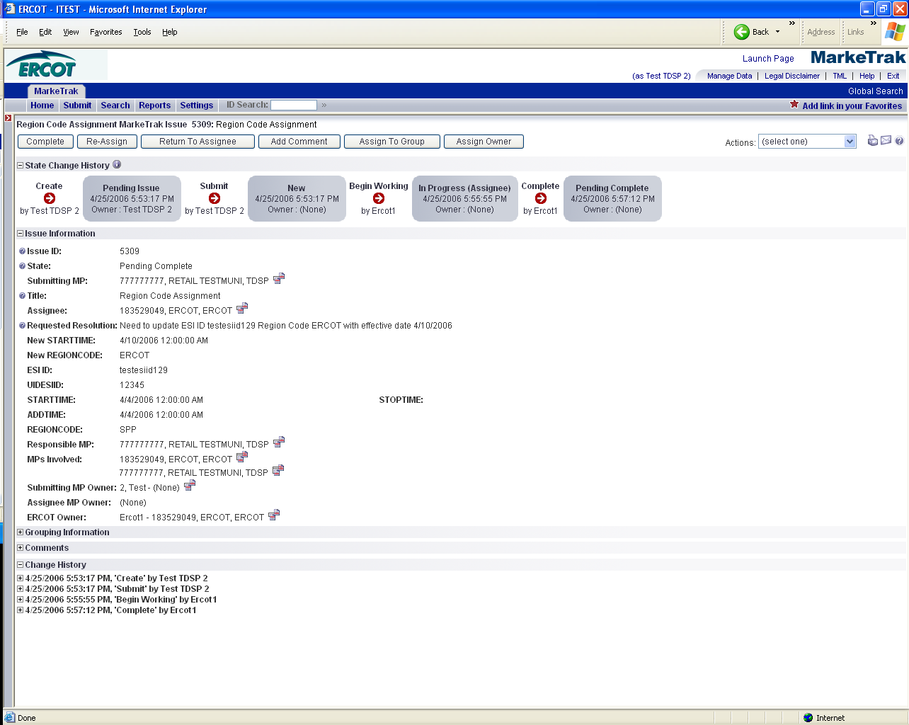

- The TDSP selects Complete and the issue is closed
- If not in agreement ERCOT may:
  - Select Return to Submitter which will require a comment and return the issue back to TDSP’s queue in the state of New-All.
  - Select Unexecutable which will require a comment and return the issue back to TDSP’s queue as Unexecutable (Pending Complete).
- Once in the Pending Complete state, if the issue is not transitioned for 14 calendar days the issue will automatically go to Auto Complete. The issue will then be closed.

DEV Issues – Characteristics – Loss Code Assignment
TDSP to ERCOT or CR to TDSP
The DEV issue of Loss Code Assignment should be submitted when the ESI ID is in the data extract from ERCOT and in the MP’s system, but there is an issue with the LOSSCODE of the ESI ID.

Action: Need to update Loss Code with new effective date

CR should contact TDSP if they believe an ESI ID has been assigned an incorrect Loss Code.

The STARTTIME of an update in the ESIIDSERVICEHIST row is equivalent to the DTM~152 Effective Date of Change in 814_20 Maintain.

Assignee field:
For TDSP to ERCOT – Assignee will auto populate with ERCOT
For CR to TDSP - Assignee will be required for submission
The Assignee can be located by using the search feature through the ‘Find’ button by typing in all or part of the MPs name or DUNS number. The Comments field is optional.

Required fields for Characteristics – Loss Code Assignment
 | Submitted By/To | New Start Time | New Region Code | New Loss Code | New Profile Code | New Station Code | New Zip Code | Comments | ESIID | UIDESIID | STARTTIME | STOPTIME | STATION CODE | PROFILE CODE | LOSS CODE | ADDTIME | REGION CODE | ZIP | Title | Assignee
Loss Code Assignment | TDSP/ERCOT or CR/TDSP | Req | N/A | Req | N/A | N/A | N/A | Opt | Req | Req | Req | Opt | N/A | Req | Req | Req | N/A | N/A | Opt | Req

        - Example of Characteristics – Loss Code Assignment

Example: TDSP submits Loss Code Assignment to ERCOT

- Select the Submit tab
- From the Submit Tree, select Loss Code Assignment (add screen shot)
- The following fields must be populated for successful submission: (add screen) shot
New STARTTIME
New LOSSCODE
ESIID
UIDESIID
STARTTIME (STARTTIME - SCR727 Extract)
PROFILECODE (PROFILECODE – SCR727 Extract)
LOSS CODE (LOSSCODE – SCR727 Extract)
ADDTIME (ADDTIME – SCR727 Extract)

Note: Reference screen shots Fig 11.6c-11.6f for the remaing steps

- Select OK
- The issue enters ERCOT’s queue in the state of New
- The TDSP only may Withdraw the issue prior to acknowledgement by ERCOT
- ERCOT selects Begin Working and the TDSP can no longer Withdraw the issue
- ERCOT has the options of Complete, Return to Submitter, Unexecutable and Intervention by ERCOT. Intervention by ERCOT is used only by ERCOT to close the issue regardless of who is the Responsible MP.
- If in agreement ERCOT will take appropriate action and select Complete which transitions the issue to Pending Complete with the TDSP
- The TDSP selects Complete and the issue is closed
- If not in agreement ERCOT may:
  - Select Return to Submitter which will require a comment and return the issue back to TDSP’s queue in the state of New-All
  - Select Unexecutable which will require a comment and return the issue back to TDSP’s queue as Unexecutable (Pending Complete).
- Once in the Pending Complete state, if the issue is not transitioned for 14 calendar days the issue will automatically go to Auto Complete. The issue will then be closed.

6.1.5.2.2 Example of Characteristics – Loss Code Assignment

Example: CR submits Loss Code Assignment to TDSP

- Select the Submit tab
- From the Submit Tree, select Loss Code Assignment (add screen shot)
- The following fields must be populated for successful submission: (add screen shot)

New STARTTIME
New LOSSCODE
Assignee
ESIID
UIDESIID
STARTTIME (STARTTIME - SCR727 Extract)
PROFILECODE (PROFILECODE – SCR727 Extract)
LOSS CODE (LOSSCODE – SCR727 Extract)
ADDTIME (ADDTIME – SCR727 Extract)

- Select OK
- The issue enters ERCOT’s queue in the state of New
- The CR only may Withdraw the issue prior to acknowledgement by ERCOT
- ERCOT selects Begin Working and the CR can no longer Withdraw the issue
- ERCOT has the options of Complete, Return to Submitter, Unexecutable and Intervention by ERCOT. Intervention by ERCOT is used only by ERCOT to close the issue regardless of who is the Responsible MP.
- The issue is transitioned to a state of New-Pending Approval. The visibility of the issue remains unchanged. Only the Responsible MP(TDSP) can transition and the only option is Begin Working.
- The Responsible party selects Begin Working.
- From the state of In Progress-Pending Approval the Responsible party has three options: Update Approved, No Agreement Reached or Modify/reassign for approval transitioning to a New-Pending Approval State with the submitting CR as the only entity with transition capabilities. (add screen shot)

  - Selection of Update Approved, the Responsible party is agreeing to the current requested resolution. The Responsible party selects OK and the issue is transitioned back as New in ERCOT queue. ERCOT selects Begin Working. ERCOT has the following options:

    - Additional Info Required, if ERCOT needs additional information to make the change, this option is selected and the issue will be transitioned back to the TDSP. The TDSP selects Begin Working and provides additional information in the comments field and selects Update Approved to transition the issue back to ERCOT or select Modify/Reassign to transition the issue to the Submitter to provide the additional information.
    - Complete, the change would be made in Siebel/Loadstar and any notifications would be sent to any MPs affected by the change. The issue is transitioned to a Pending Complete state. The submitter has the option to close the issue by selecting Accept or the issue will be auto closed in 14 calendar days.

  - Selection of No Agreement Reached, the Responsible MP did not agree with the current requested resolution and the issue is transitioned back to the Submitter in an Unexecutable (Pending Complete) state. In this state the Submitter has the option to close the issue by selecting Accept or the issue will auto closed in 14 calendar days.

DEV Issues – Characteristics – Profile Code Assignment
TDSP to ERCOT or CR to TDSP
The DEV issue of Profile Code Assignment should be submitted when the ESI ID is in the data extract from ERCOT and in the MP’s system, but there is an issue with the PROFILECODE of the ESI ID.

CR should contact TDSP if they believe an ESI ID has been assigned an incorrect Profile Code.

Action: Need to update Profile Code with new effective date

The STARTTIME of an update in the ESIIDSERVICEHIST row is equivalent to the DTM~152 Effective Date of Change in 814_20 Maintain.

Assignee field:
For TDSP to ERCOT – Assignee will auto populate with ERCOT
For CR to TDSP - Assignee will be required for submission
The Assignee can be located by using the search feature through the ‘Find’ button by typing in all or part of the MPs name or DUNS number. The Comments field is optional.

Required fields for Characteristics – Profile Code Assignment
 | Submitted By/To | New Start Time | New Region Code | New Loss Code | New Profile Code | New Station Code | New Zip Code | Comments | ESIID | UIDESIID | STARTTIME | STOPTIME | STATION CODE | PROFILE CODE | LOSS CODE | ADDTIME | REGION CODE | ZIP | Title | Assignee
Profile Code Assignment | TDSP/ERCOT or CR/TDSP | Req | N/A | N/A | Req | N/A | N/A | Opt | Req | Req | Req | Opt | N/A | Req | Req | Req | N/A | N/A | Opt | Req

6.1.5.3.2 Example of Characteristics – Profile Code Assignment
Example: TDSP submits Profile Code Assignment to ERCOT

- Select the Submit tab
- From the Submit Tree, select Profile Code Assignment (add screen shot)
- The following fields must be populated for successful submission: (add screen shot)
New STARTTIME
New PROFILECODE
ESIID
UIDESIID
STARTTIME (STARTTIME - SCR727 Extract)
PROFILECODE (PROFILECODE - SCR727 Extract)
LOSS CODE (LOSSCODE - SCR727 Extract)
ADDTIME (ADDTIME - SCR727 Extract)

Note: Reference screen shots Fig 11.6c-11.6f for the remaing steps

- Select OK
- The issue enters ERCOT’s queue in the state of NEW
- The TDSP only may Withdraw the issue prior to acknowledgement by ERCOT
- ERCOT selects Begin Working and the TDSP can no longer Withdraw the issue
- ERCOT has the options of Complete, Return to Submitter, Unexecutable and Intervention by ERCOT. Intervention by ERCOT is used only by ERCOT to close the issue regardless of who is the Responsible MP.
- If in agreement ERCOT will take appropriate action and select Complete which transitions the issue to Pending Complete with the TDSP
- The TDSP selects Complete and the issue is closed
- If not in agreement ERCOT may:
  - Select Return to submitter which will require a comment and return the issue back to TDSP’s queue in the state of New-All
  - Select Unexecutable which will require a comment and return the issue back to TDSP’s queue as Unexecutable (Pending Complete).
- Once in the Pending Complete state, if the issue is not transitioned for 14 calendar days the issue will automatically Auto Complete. The issue will then be closed.

DEV Issues – Characteristics – Station Code Assignment
TDSP to ERCOT or CR to TDSP
The DEV issue of Station Code Assignment should be submitted when the ESI ID is in the data extract from ERCOT and in the MP’s system, but there is an issue with the STATIONCODE of the ESI ID.

Action: Need to update Station Code with new effective date

CR should contact TDSP if they believe an ESI ID has been assigned an incorrect Station Code.

The STARTTIME of an update in the ESIIDSERVICEHIST row is equivalent to the DTM~152 Effective Date of Change in 814_20 Maintain.

Assignee field:
For TDSP to ERCOT – Assignee will auto populate with ERCOT
For CR to TDSP - Assignee will be required for submission
The Assignee can be located by using the search feature through the ‘Find’ button by typing in all or part of the MPs name or DUNS number. The Comments field is optional.

Required fields for Characteristics – Station Code Assignment
 | Submitted By/To | New Start Time | New Region Code | New Loss Code | New Profile Code | New Station Code | New Zip Code | Comments | ESIID | UIDESIID | STARTTIME | STOPTIME | STATION CODE | PROFILE CODE | LOSS CODE | ADDTIME | REGION CODE | ZIP | Title | Assignee
Station Code Assignment | TDSP/ERCOT or CR/TDSP | Req | N/A | N/A | N/A | Req | N/A | Opt | Req | Req | Req | Opt | Req | N/A | N/A | Req | N/A | N/A | Opt | Req

Example of Characteristics – Station Code Assignment
Example: TDSP submits Station Code Assignment to ERCOT

- Select the Submit tab
- From the Submit Tree, select Station Code Assignment (add screen shot)
- The following fields must be populated for successful submission: (add screen shot)
New STARTTIME
New STATIONCODE
ESIID
UIDESIID
STARTTIME (STARTTIME - SCR727 Extract)
STATIONCODE (STATIONCODE - SCR727 Extract)
ADDTIME (ADDTIME - SCR727 Extract)

Note: Reference screen shots Fig 11.6c-11.6f for the remaing steps

- Select OK
- The issue enters ERCOT’s queue in the state of NEW
- The TDSP only may Withdraw the issue prior to acknowledgement by ERCOT
- ERCOT selects Begin Working and the TDSP can no longer Withdraw the issue
- ERCOT has the options of Complete, Return to Submitter, Unexecutable and Intervention by ERCOT. Intervention by ERCOT is used only by ERCOT to close the issue regardless of who is the Responsible MP.
- If in agreement ERCOT will take appropriate action and select Complete which transitions the issue to Pending Complete with the TDSP
- The TDSP selects Complete and the issue is closed
- If not in agreement ERCOT may:
  - Select Return to Submitter which will require a comment and return the issue back to TDSP’s queue in the state of New-All
  - Select Unexecutable which will require a comment and return the issue back to TDSP’s queue as Unexecutable (Pending Complete)
- Once in the Pending Complete state, if the issue is not transitioned for 14 calendar days the issue will automatically go to Auto Complete. The issue will then be closed.

DEV Issues – Characteristics – Zip Assignment

TDSP to ERCOT or CR to TDSP
The DEV issue of ZIP Assignment should be submitted when the ESI ID is in the data extract from ERCOT and in the MP’s system, but there is an issue with the ZIP of the ESI ID.

Action: Need to update Zip Code with new effective date

CR should contact TDSP if they believe an ESI ID has been assigned an incorrect Zip.

The STARTTIME of an update in the ESIIDSERVICEHIST row is equivalent to the DTM~152 Effective Date of Change in 814_20 Maintain.

Assignee field:
For TDSP to ERCOT – Assignee will auto populate with ERCOT
For CR to TDSP - Assignee will be required for submission
The Assignee can be located by using the search feature through the ‘Find’ button by typing in all or part of the MPs name or DUNS number. The Comments field is optional.

Required fields for Characteristics – Zip Assignment
 | Submitted By/To | New Start Time | New Region Code | New Loss Code | New Profile Code | New Station Code | New Zip Code | Comments | ESIID | UIDESIID | STARTTIME | STOPTIME | STATION CODE | PROFILE CODE | LOSS CODE | ADDTIME | REGION CODE | ZIP | Title | Assignee
ZIP Assignment | TDSP/ERCOT or CR/TDSP | Req | N/A | N/A | N/A | N/A | Req | Opt | Req | Req | Req | Opt | N/A | N/A | N/A | Req | N/A | Req | Opt | Req

Example of Characteristics – ZIP Assignment
Example: TDSP submits ZIP Assignment to ERCOT

- Select the Submit tab
- From the Submit Tree, select ZIP Assignment (add screen shot)
- The following fields must be populated for successful submission: (add screen shot)
New STARTTIME
New ZIPCODE
ESIID
UIDESIID
STARTTIME (STARTTIME - SCR727 Extract)
ADDTIME (ADDTIME - SCR727 Extract)
ZIP (ZIPCODE - SCR727 Extract)

Note: Reference screen shots Fig 11.6c-11.6f for the remaing steps

- Select OK
- The issue enters ERCOT’s queue in the state of NEW
- The TDSP only may Withdraw the issue prior to acknowledgement by ERCOT
- ERCOT selects Begin Working and the TDSP can no longer Withdraw the issue
- ERCOT has the options of: Complete, Return to Submitter, Unexecutable and Intervention by ERCOT. Intervention by ERCOT is used only by ERCOT to close the issue regardless of who is the Responsible MP.
- If in agreement ERCOT will take appropriate action and select Complete which transitions the issue to Pending Complete with the TDSP

- The TDSP selects Complete and the issue is closed
- If not in agreement ERCOT may:
  - Select Return to Submitter which will require a comment and return the issue back to TDSP’s queue in the state of New-All
  - Select Unexecutable which will require a comment and return the issue back to TDSP’s queue as Unexecutable (Pending Complete).
- Once in the Pending Complete state, if the issue is not transitioned for 14 calendar days the issue will automatically go to Auto Complete. The issue will then be closed.

