DEV Issues – Non-IDR – In MP system not ERCOT
CR to TDSP
The DEV issue of In MP system not ERCOT should be submitted when the ESI ID Non-IDR meter data is in the MP’s system, but not in the data extract from ERCOT.

Action: NIDR Usage needs to be loaded at ERCOT

Situation 1: If the TDSP confirms via the ESI ID Extract that usage is loaded at ERCOT and matches the usage in the TDSP system, the TDSP shall transition the issue back to the CR as Unexecutable with comments and/or transactions submitted for explanation.

Situation 2: The TDSP will transition the issue back to the CR for assignment to ERCOT for assignment (Assign Owner) SIR (10908) if ALL the following conditions are met:
a) The TDSP determines via the ESI ID Extract that usage data is not loaded at ERCOT,
b) The TDSP confirms ERCOT acknowledged acceptance of the transaction(s) in all levels of the 997 response, and
c) The TDSP determine the usage was reported as loaded successfully via the 867_03 activity report as of August 6, 2003.

Situation 3: The TDSP shall submit usage data to ERCOT via transaction in cases where either condition (b) or (c) above is not met. The issue shall not be marked as Complete until such usage data has been properly loaded into ERCOT systems.

If the TDSP determines that the usage data is not loaded at ERCOT, then the TDSP is responsible for submitting the usage data to ERCOT via transaction.

TDSP to ERCOT
The TDSP will submit In MP system not ERCOT to ERCOT if ALL the above conditions in Situation 2 (above) are met.

Action: NIDR Usage needs to be loaded at ERCOT

Requests to load negative usage will be rejected.

For all Usage Variance Issues that require changes to usage data or loading of missing data at ERCOT into Lodestar per the resolution, the TDSP should send the usage to ERCOT in accordance with the 867_03 usage loading validations. These validations are performed whether the data is submitted via transaction or file for manual loading.

Assignee field:
For TDSP to ERCOT – Assignee will auto populate with ERCOT
For CR to TDSP - Assignee will be required for submission
The Assignee can be located by using the search feature through the ‘Find’ button by typing in all or part of the MPs name or DUNS number. The Comments field is optional.

Required fields for Non-IDR – In MP system not ERCOT
 | Submitted By/To | New Start Time | New Stop Time | New Total | New ONPK | New OFFPK | New MDPK | New SPK | Comments | ESIID | UIDESIID | STARTTIME | STOPTIME | TIMESTAMP | Meter Type | Total | Title | Assignee
In MP system  not ERCOT | TDSP/ERCOT or CR/TDSP | Req | Req | Req | Opt | Opt | Opt | Opt | Opt | Req | N/A | N/A | N/A | N/A | Req | N/A | Opt | Opt  Req

Example of Non-IDR – In MP system not ERCOT

Example: CR submits In MP system not ERCOT to TDSP

- Select the Submit tab (Fig 11.7.5a)
- From the Submit Tree, select In MP system not ERCOT

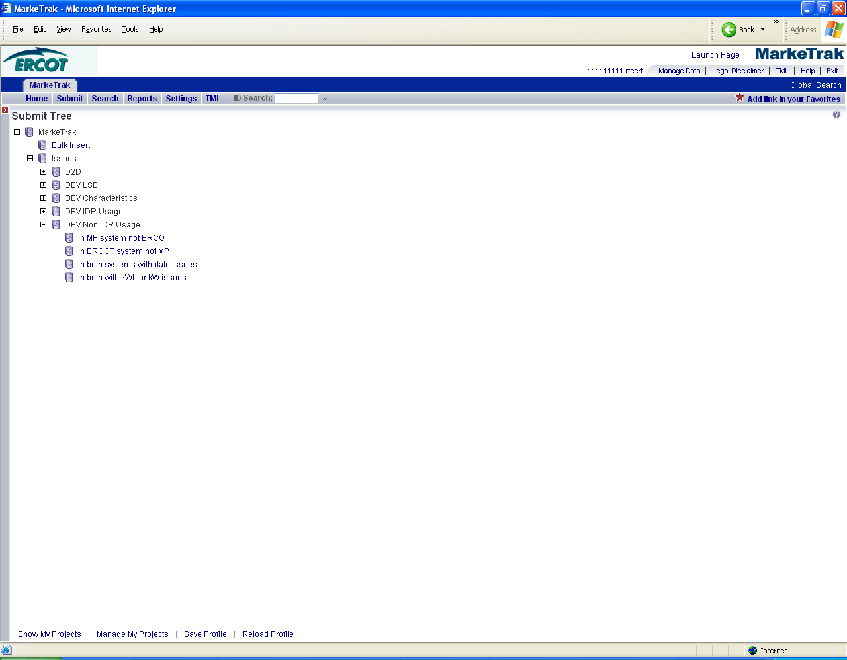
- The following fields must be populated for successful submission:
Assignee
New STARTTIME
New STOPTIME
New Total
ESIID
Meter Type
- Select OK (Fig 11.7.5b)
Fig 11.7.5b
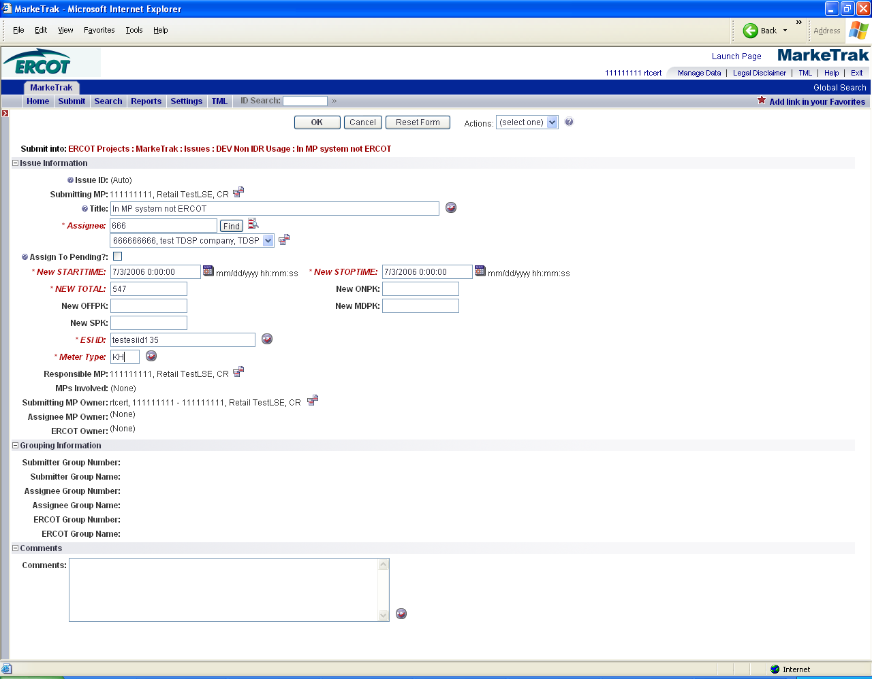

- The issue enters TDSP’s queue in the state of New.
- The CR only may Withdraw the issue prior to acknowledgement by the TDSP. (Fig 11.7.5c)
Fig 11.7.5c
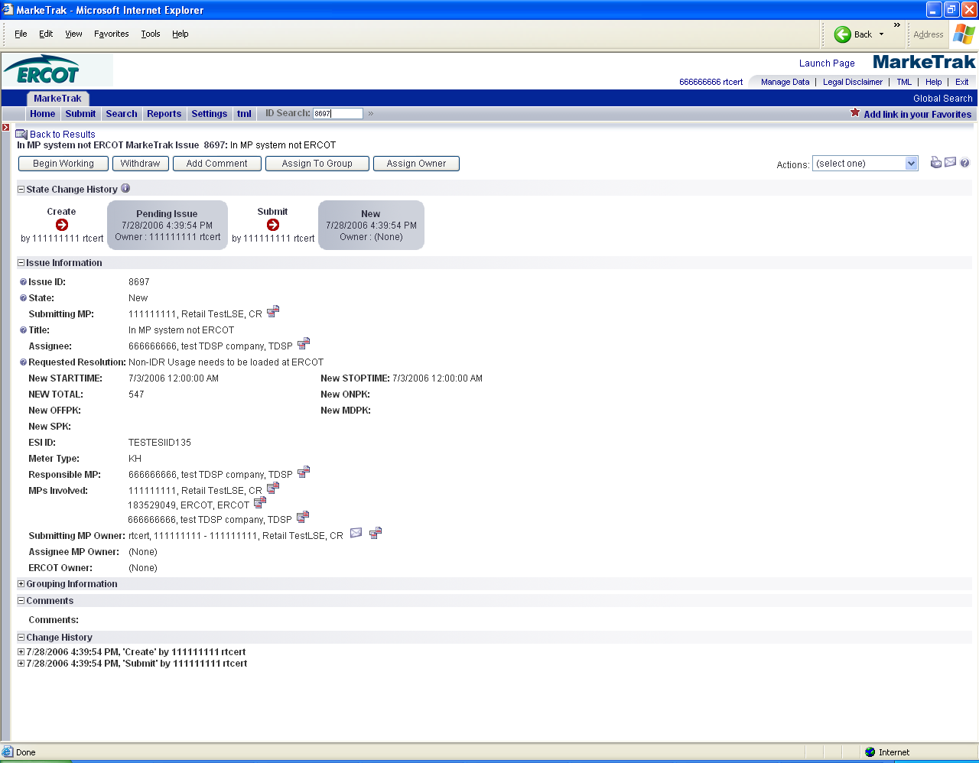

NOTE: Requirement 15 – Validate TDSP Associated with Issue will take place by ERCOT.
TDSP selects Begin Working and the CR can no longer Withdraw the issue. (Fig 11.7.5d)
Fig 11.7.5d
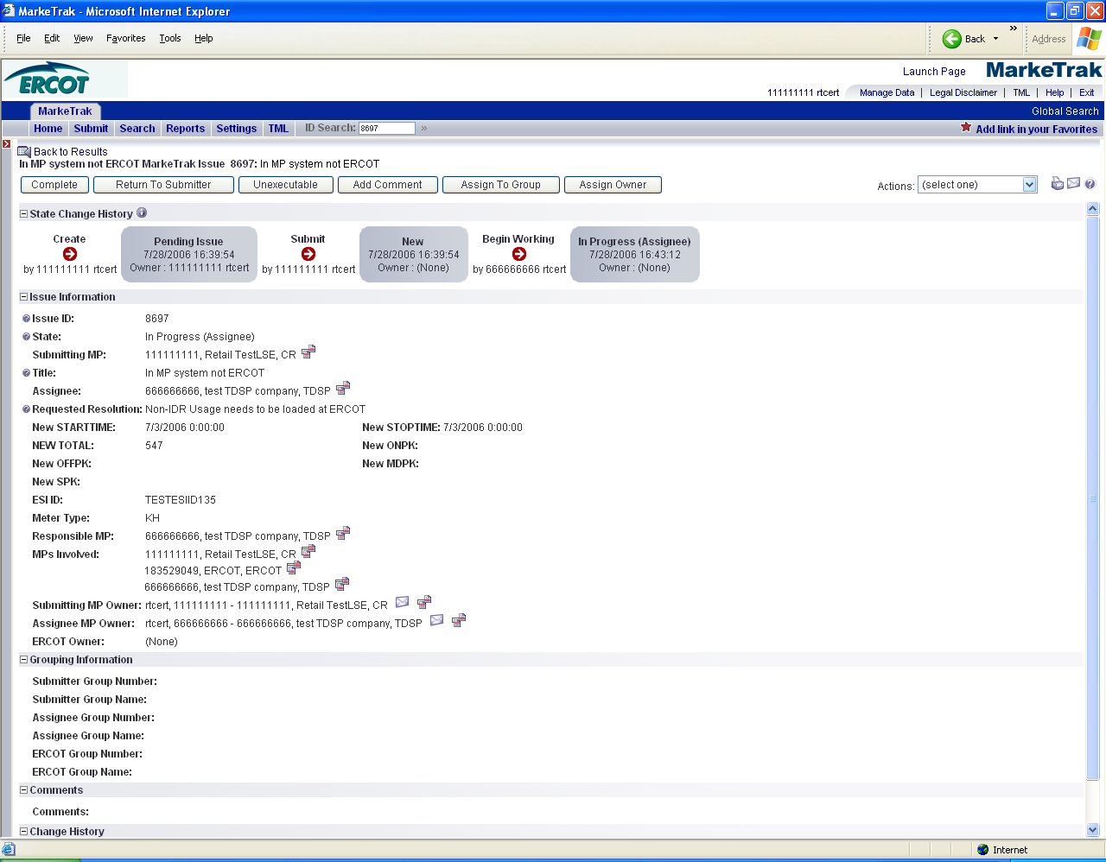

- TDSP has the options of Complete, or Unexecutable. (Fig 11.7.5e)
Fig 11.7.5e
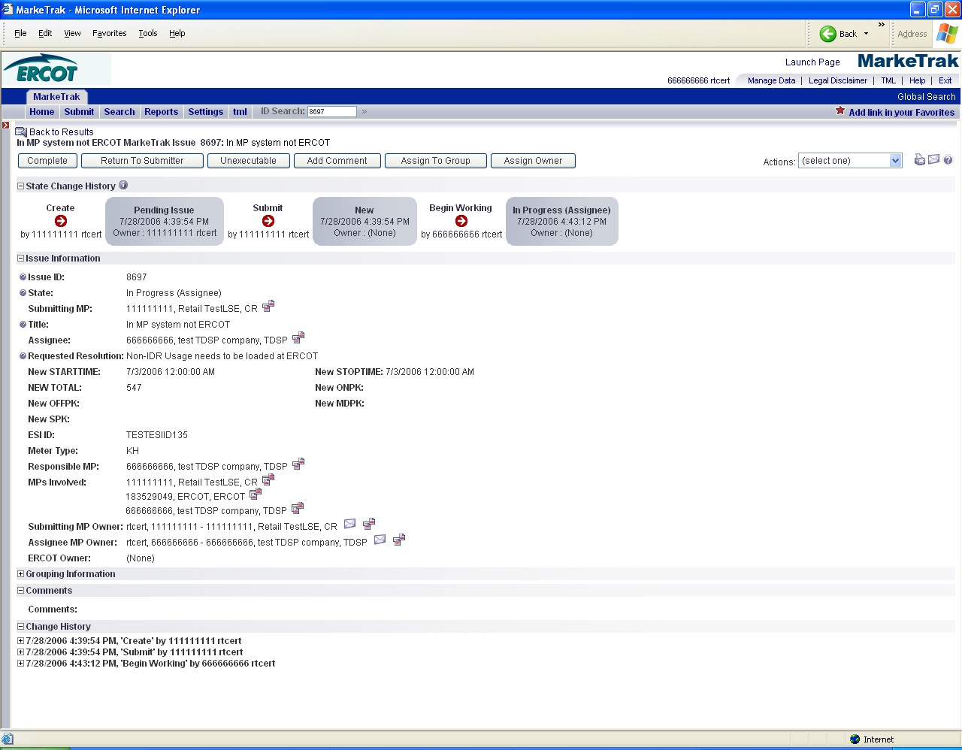
- If in agreement TDSP will take appropriate action then select Complete which transitions the issue to Pending Complete with the CR
- The CR selects Complete and the issue is closed
- If not in agreement TDSP may:
  - Select Unexecutable and Add Comments (Fig 11.7.5f)
Fig 11.7.5f
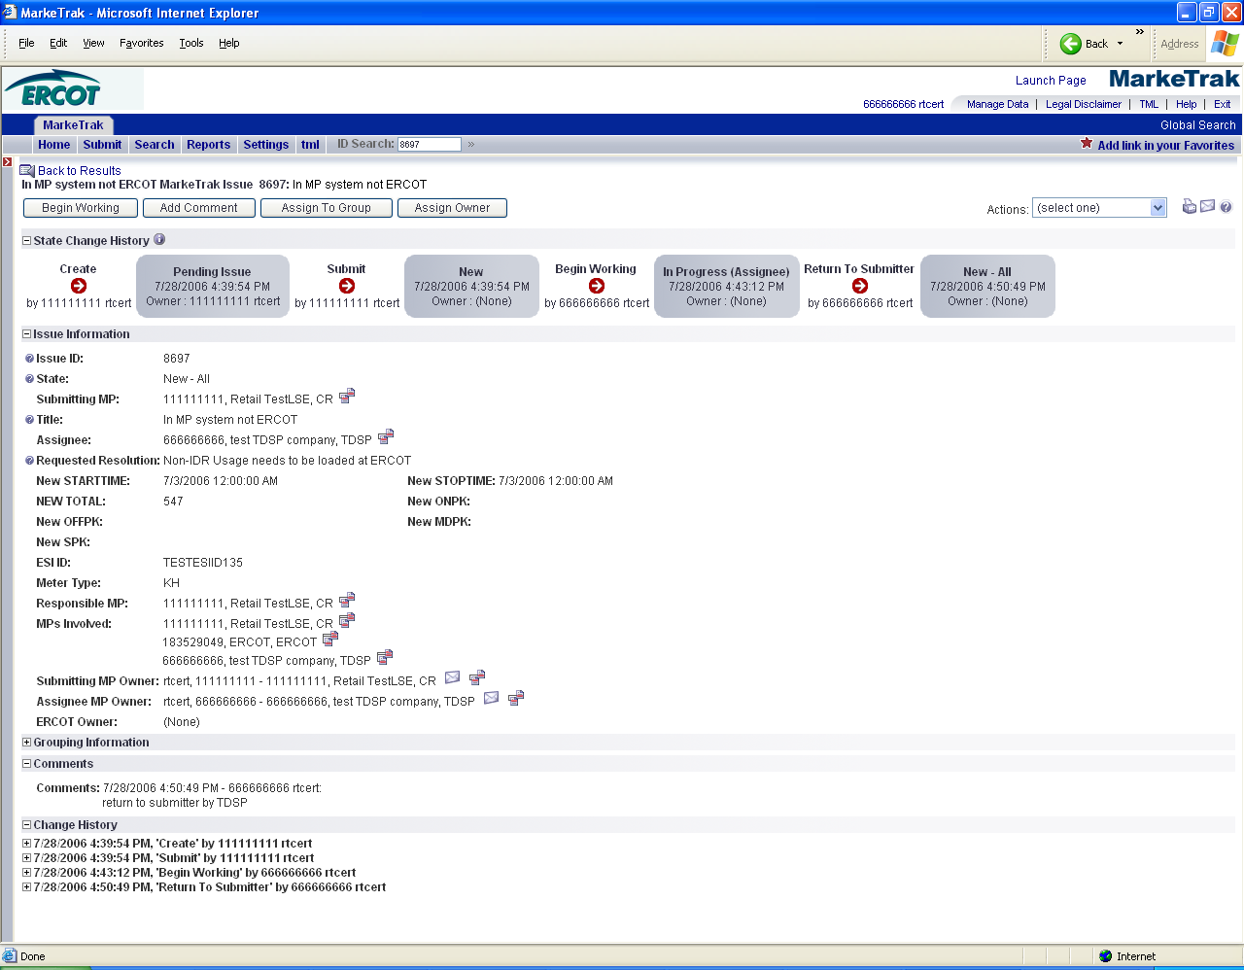

  - Issue will return back to CR’s queue as Unexecutable (Pending Complete).
  - The Submittor would select ACCEPT to close this issue. ??(What if not accepted”??
  - Once in the Pending Complete state, if the issue is not Accepted it will transitioned for 14 calendar days and the issue will automatically Auto Complete. The issue will then be closed. (Fig 11.7.5f)
Fig 11.7.5f
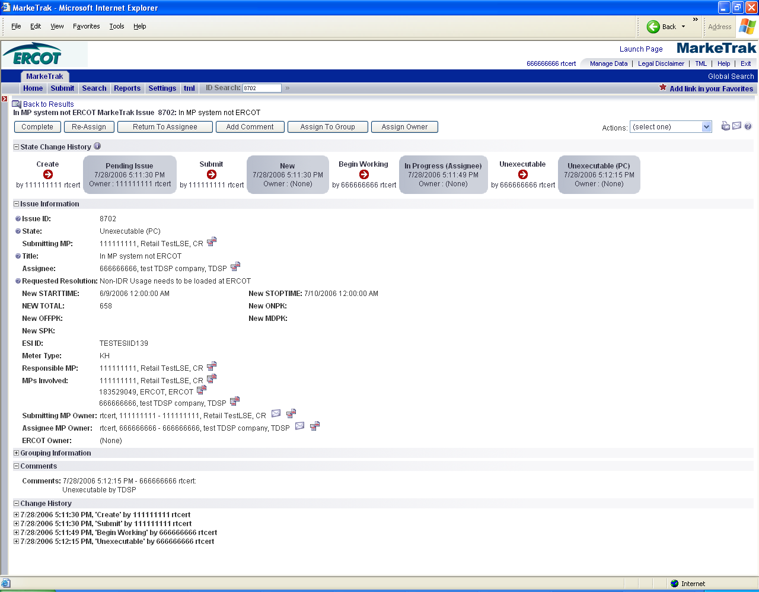
- Submittor may “CLOSE” when they are Responsible MP on the issue and WITHDRAW is not available or the issue is not in a “Complete” state. Comments will be required for the “CLOSE” transition. All work will stop on thie issue at this point.

Note: Requirement 35 (Add notification)

User may subscribe to new notification that will send email when an issue transitions to “Closed” by Submittor. Refer to Section 1 - General

DEV Issues – Non-IDR – In ERCOT system not MP
The DEV Issue of In ERCOT system not MP should be submitted when the ESI ID Non-IDR meter data is in the data extract from ERCOT, but not in the MP’s system.

TDSP to ERCOT
Action: Data needs to be cancelled from ERCOT system.

CR to TDSP
Prior to correcting or resending usage, the TDSP will verify that the requesting CR is the LSE of record for requested timeframe.

Action: TDSP to submit Non-IDR Usage to CR

It is the TDSP’s responsibility to communicate all ESI ID Service History and Usage (IDR and Non-IDR) data changes to the appropriate CR(s).

Assignee field:
For TDSP to ERCOT – Assignee will auto populate with ERCOT
For CR to TDSP - Assignee will be required for submission
The Assignee can be located by using the search feature through the ‘Find’ button by typing in all or part of the MPs name or DUNS number. The Comments field is optional.

Required fields for Non-IDR – In ERCOT system not MP
 | Submitted By/To | New Start Time | New Stop Time | New Total | New ONPK | New OFFPK | New MDPK | New SPK | Comments | ESIID | UIDESIID | STARTTIME | STOPTIME | TIMESTAMP | Meter Type | Total | Title | Assignee
In ERCOT system  not MP | TDSP/ERCOT | N/A | N/A | N/A | N/A | N/A | N/A | N/A | Opt | Req | Req | Req | Req | Req | Req | Req | Opt | Opt  Req
In ERCOT system  not MP | CR/TDSP | N/A | N/A | N/A | N/A | N/A | N/A | N/A | Opt | Req | Req | Req | Req | Req | Req | Req | Opt | Opt  Req

Example of Non-IDR – In ERCOT system not MP

Example: CR submits In ERCOT system not MP to TDSP

- Select the Submit tab
- From the Submit Tree, select In ERCOT system not MP Screen shot
- The following fields must be populated for successful submission:
Assignee
ESIID
UIDESIID
STARTTIME (STARTTIME - SCR727 Extract)
STOPTIME (STOPTIME - SCR727 Extract)
TIMESTAMP (TIMESTAMP - SCR727 Extract)
METERTYPE
TOTAL (TOTAL - SCR727 Extract)

- Select OK
- The issue enters TDSP’s queue in the state of New
- The CR only may Withdraw the issue prior to acknowledgement by the TDSP
- TDSP selects Begin Working and the CR can no longer Withdraw the issue
- TDSP has the options of Complete, and
Unexecutable
- If in agreement TDSP will take appropriate action then select Complete which transitions the issue to Pending Complete with the CR
- The CR selects Complete and the issue is closed
- If not in agreement TDSP may:
a. Select
Unexecutable which will require a comment and return the issue back to CR’s queue as Unexecutable-Pending Complete.
The Submittor would select ACCEPT to close this issue.
- Once in the Pending Complete state, if the issue is not transitioned for 14 calendar days the issue will automatically go to Auto Complete. The issue will then be closed.
- Submittor may “CLOSE” when they are Responsible MP on the issue and WITHDRAW is not available or the issue is not in a “Complete” state. Comments will be required for the “CLOSE” transition. All work will stop on this issue at this point.

Note: Requirement 35 (Add notification)

User may subscribe to new notification that will send email when an issue transitions to “Closed” by Submittor. Refer to Section 1- General

DEV Issues – Non-IDR – In both systems with date issues
TDSP to ERCOT or CR to TDSP
The DEV Issue of In both system with date issues should be submitted when the ESI ID Non-IDR meter data is in the data extract from ERCOT and in the MP’s system, but has a STOPTIME issue. The TDSP must select the earliest affected record to file this Variance Issue. STARTTIME issues by themselves cannot be filed. STARTTIME issues become STOPTIME issues of the prior record.

Action: Dates of Usage data are incorrect. Update to new STOPTIME.

For all Usage Variance Issues that require changes to usage data or loading of missing data at ERCOT into Lodestar per the resolution, the TDSP should send the usage to ERCOT in accordance with the 867_03 usage loading validations. These validations are performed whether the data is submitted via transaction or file for manual loading.
Requests to load negative usage will be rejected.

It is the TDSP’s responsibility to communicate all ESI ID Service History and Usage (IDR and Non-IDR) data changes to the appropriate CR(s).

TDSPs need to consider that the TDSP may have submitted usage for a date range which has more than one LSE of record (i.e. CR may not be the “owner” of all days).

Prior to correcting or resending usage, the TDSP will verify that the requesting CR is the LSE of record for requested timeframe.

Required fields for Non-IDR – In both systems with date issues
 | Submitted By/To | New Start Time | New Stop Time | New Total | New ONPK | New OFFPK | New MDPK | New SPK | Comments | ESIID | UIDESIID | STARTTIME | STOPTIME | TIMESTAMP | Meter Type | Total | Title | Assignee
In both systems  with date issues | TDSP/ERCOT or CR/TDSP | N/A | Req | Req | Opt | Opt | Opt | Opt | Opt | Req | Req | Req | Req | Req | Req | Req | Opt | Opt  Req

Example of Non-IDR – In both systems with date issues

Example: CR submits In both systems with date issues to TDSP

- Select the Submit tab
- From the Submit Tree, select both systems with date issues
- The following fields must be populated for successful submission:
Assignee
New STOPTIME
New Total
ESIID
UIDESIID
STARTTIME (STARTTIME - SCR727 Extract)
STOPTIME (STOPTIME - SCR727 Extract)
TIMESTAMP (TIMESTAMP - SCR727 Extract)
METERTYPE
TOTAL (TOTAL - SCR727 Extract)
NOTE: The Assignee can be located by using the search feature through the ‘Find’ button by typing in all or part of the MPs name or DUNS number. The Comments field is optional.

- Select OK
- The issue enters TDSP’s queue in the state of New.
- The CR only may Withdraw the issue prior to acknowledgement by the TDSP
- TDSP selects Begin Working and the CR can no longer Withdraw the issue
- TDSP has the options of Complete, and Unexecutable
- If in agreement TDSP will take appropriate action then select Complete which transitions the issue to Pending Complete with the CR
- The CR selects Complete and the issue is closed
- If not in agreement TDSP may:

  - Select Unexecutable which will require a comment and return the issue back to CR’s queue as Unexecutable-Pending Complete

  - The Submittor would select ACCEPT to close this issue.
- Once in the Pending Complete state, if the issue is not transitioned for 14 calendar days the issue will automatically go to Auto Complete. The issue will then be closed.
- Submittor may “CLOSE” when they are Responsible MP on the issue and WITHDRAW is not available or the issue is not in a “Complete” state. Comments will be required for the “CLOSE” transition. All work will stop on this issue at this point.

Note: Requirement 35 (Add notification)

User may subscribe to new notification that will send email when an issue transitions to “Closed” by Submittor. Refer to Section 1- General

DEV Issues – Non-IDR – In both systems with kWh or kW issues
The DEV issue of In both system with kWh or kW issues should be submitted when the ESI ID Non-IDR meter data is in the data extract from ERCOT and in the MP’s system, but has kWh and/or kW issue.

TDSP to ERCOT
Action: Need to update loaded usage data

For all Usage Variance Issues that require changes to usage data or loading of missing data at ERCOT into Lodestar per the resolution, the TDSP should send the usage to ERCOT in accordance with the 867_03 usage loading validations. These validations are performed whether the data is submitted via transaction or file for manual loading.
It is the TDSP’s responsibility to communicate all ESI ID Service History and Usage (IDR and Non-IDR) data changes to the appropriate CR(s).

Requests to load negative usage will be rejected.

This DEV issue cannot be used to request changes to usage dates.

CR to TDSP

Action: TDSP to verify Non-IDR usage values

Requests to load negative usage will be rejected.

This DEV issue cannot be used to request changes to usage dates.

CRs must populate the kWh or kW total they have in their system in the <Field New Total> to assist the TDSP in analyzing the Issue. CR must also populate the <Field STARTTIME> and <Field STOPTIME> with the STARTIME and STOPTIME of the usage loaded in their system.

Required fields for Non-IDR – In both systems with kWh or kW issues
 | Submitted By/To | New Start Time | New Stop Time | New Total | New ONPK | New OFFPK | New MDPK | New SPK | Comments | ESIID | UIDESIID | STARTTIME | STOPTIME | TIMESTAMP | Meter Type | Total | Title | Assignee
In both with kWh or kW issues | TDSP/ERCOT | N/A | N/A | Req | Opt | Opt | Opt | Opt | Opt | Req | Req | Req | Req | Req | Req | Req | Opt | Opt  Req
In both with kWh or kW issues | CR/TDSP | N/A | N/A | Req | Opt | Opt | Opt | Opt | Opt | Req | Req | Req | Req | Req | Req | Req | Opt | Opt  Req

Example of Non-IDR – In both systems with kWh or kW issues

Example: CR submits In both systems with date issues to TDSP

- Select the Submit tab
- From the Submit Tree, select In both systems with date issues
- The following fields must be populated for successful submission:
Assignee
New Total
ESIID
UIDESIID
STARTTIME (STARTTIME - SCR727 Extract)
STOPTIME (STOPTIME - SCR727 Extract)
TIMESTAMP (TIMESTAMP - SCR727 Extract)
METERTYPE
TOTAL (TOTAL - SCR727 Extract)
- Select OK
- The issue enters TDSP’s queue in the state of New
- The CR only may Withdraw the issue prior to acknowledgement by the TDSP
- TDSP selects Begin Working and the CR can no longer Withdraw the issue
- TDSP has the options of Complete, and Unexecutable
- If in agreement TDSP will take appropriate action then select Complete which transitions the issue to Pending Complete with the CR
- The CR selects Complete and the issue is closed
- If not in agreement TDSP may:

a. Select Unexecutable which will require a comment and return the issue back to CR’s queue as Unexecutable (Pending Complete).
  - b. The Submittor would select ACCEPT to close this issue.
- Once in the Pending Complete state, if the issue is not transitioned for 14 calendar days the issue will automatically go to Auto Complete. The issue will then be closed.
- Submittor may “CLOSE” when they are Responsible MP on the issue and WITHDRAW is not available or the issue is not in a “Complete” state. Comments will be required for the “CLOSE” transition. All work will stop on this issue at this point.

Note: Requirement 35 (Add notification)

User may subscribe to new notification that will send email when an issue transitions to “Closed” by Submittor. Refer to Section 1- General

