6.1.4 NON LSE Relationship DEV Existence Issues

6.1.4.1 ESI ID Existence DEV Issues - Existence – In TDSP system not ERCOT
ESI ID Existence DEV issues are issues filed by the TDSP to ERCOT regarding the establishment or retirement of an ESI ID in ERCOT systems. These issues are filed to ERCOT when an 814_20 ADD or 814_20 RETIRE cannot be submitted.

TDSP to ERCOT
The DEV issue of In TDSP system not ERCOT should be submitted when the ESI ID is in the TDSP’s system, but not in the data extract from ERCOT.

Action: ERCOT needs to Add ESI ID

The ESIID needs to be added to ERCOT systems and cannot be added via an 814_20 ADD transaction.

TDSP cannot add and activate an ESI ID at the same time. After the ESI ID Existence issue is resolved, the MPs should resume using normal transactions to activate the ESI ID (i.e. 814_16 Move In)

CRs cannot file a Data Extract Variance for ESI ID existence. If a CR believes that an ESI ID should be active, then the CR should file a Variance Issue regarding the Start Time or existence of an LSE relationship.

6.1.4.1.1 Required fields for Existence – In TDSP system not ERCOT
 | Submitted By/To | New Start Time | New Stop Time | Comments | ESIID | UIDESIID | STARTTIME | STOP TIME | STATION CODE | PROFILE CODE | LOSS CODE | ADDTIME | REGION CODE | ZIP | Service Address | Premise Type | Title | Service City | Service State
In TDSP system not ERCOT | TDSP/ERCOT | Opt | N/A | Opt | Req | N/A | Req | N/A | Req | Req | Req | R/O | Req | Req | Req | Req | Opt | Req | Req

6.1.4.1.2 Example of Existence: In TDSP system not ERCOT

- Select the Submit tab (Fig 11.5a)
- From the submit Tree, select In TDSP system not ERCOT
Fig 11.5a
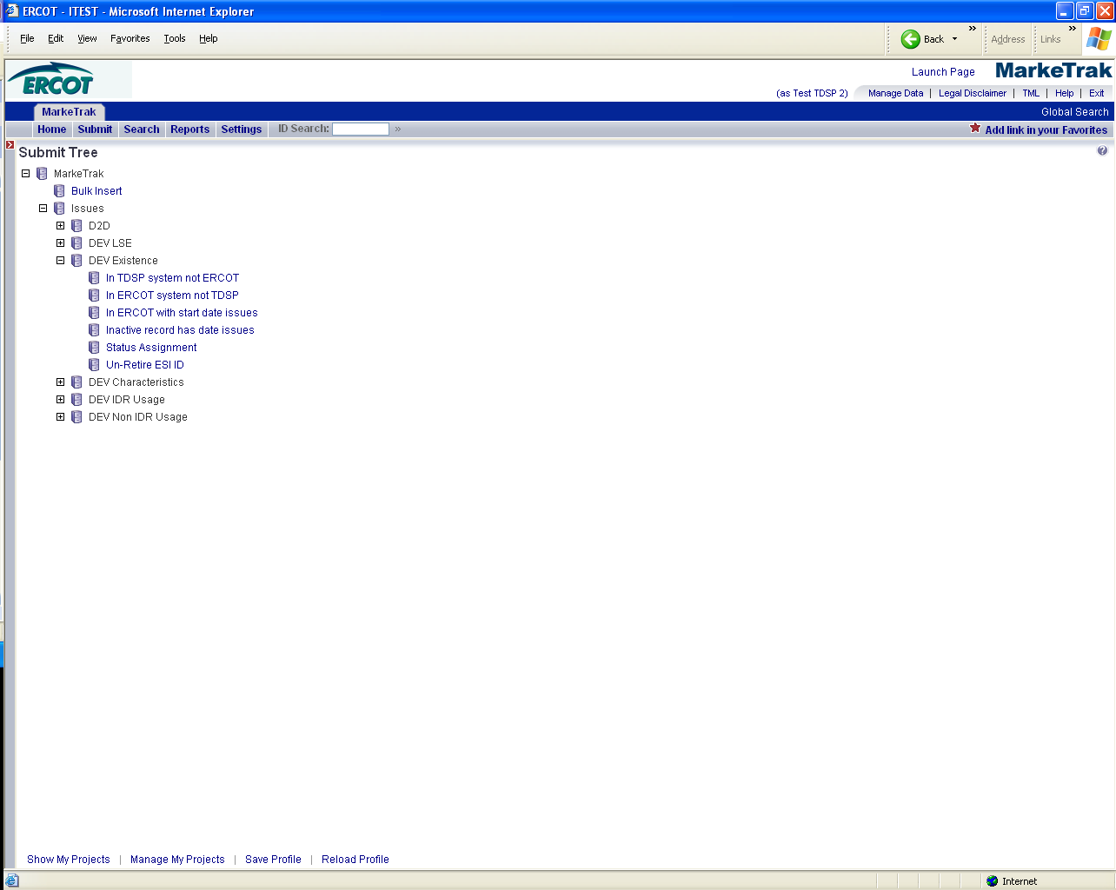

- The following fields must be populated for successful submission:
ESIID
STARTTIME
STATIONCODE
PROFILECODE
LOSSCODE
ADDTIME (default to current day)
REGIONCODE
ZIP
SERVICE ADDRESS
SERVICE CITY
SERVICE STATE
PREMISE TYPE
- Select OK (Fig 10.5b)

Fig 11.5b
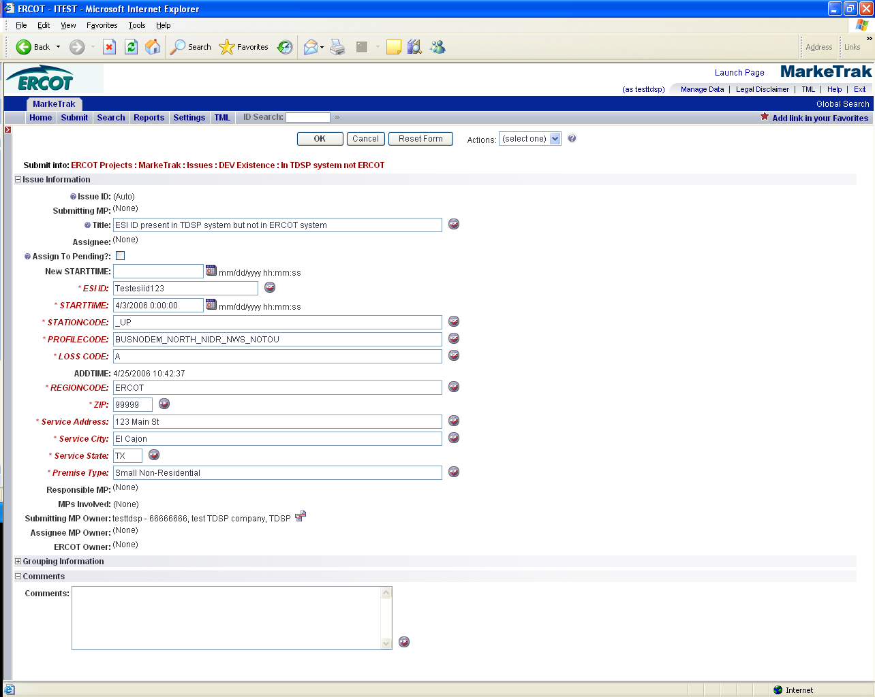

- The issue enters ERCOT’s queue in the state of NEW
- The TDSP only may Withdraw the issue prior to acknowledgement by ERCOT (Fig 11.5c)
Fig 11.5c
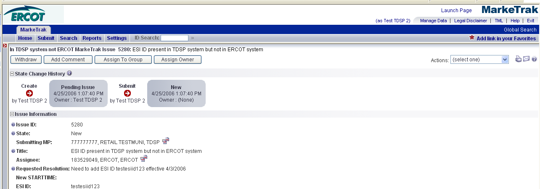

- ERCOT selects Begin Working and the TDSP can no longer Withdraw the issue. (Fig 11.5d)
Fig 11.5d
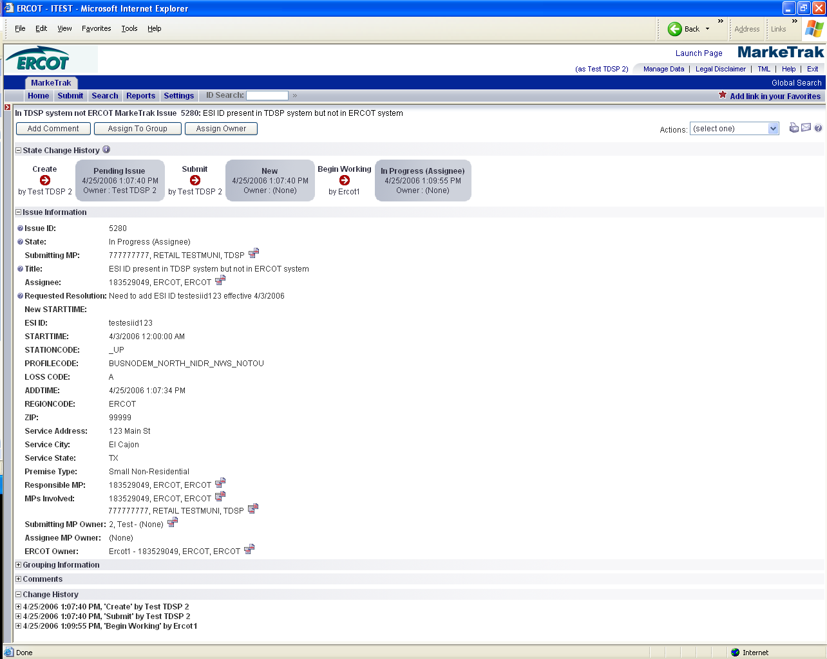

- ERCOT has the options of Complete, Unexecutable and Intervention by ERCOT. Intervention by ERCOT is used only by ERCOT to close the issue regardless of who is the Responsible MP. (Fig 11.5e)

Fig 11.5e
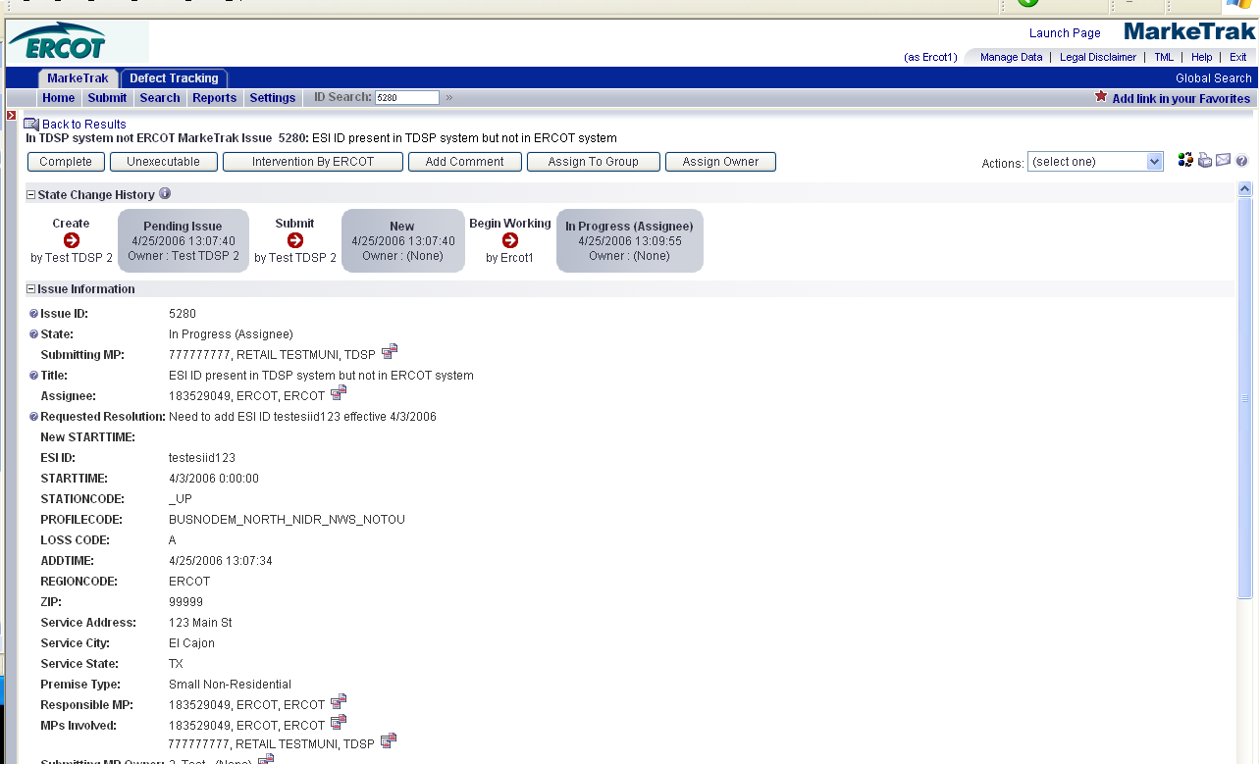

- If in agreement ERCOT will take appropriate action and select Complete which transitions the issue to Pending Complete with the TDSP. (Fig 11.5f)

Fig 11.5f
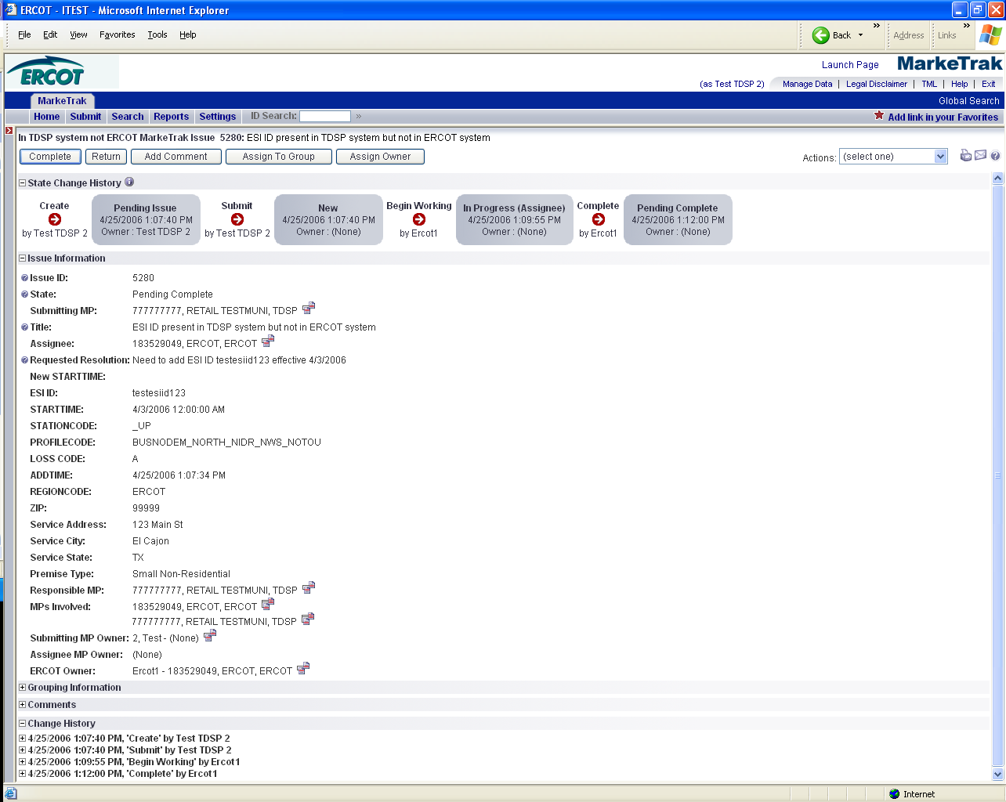

- The TDSP selects Complete and the issue is closed
- If not in agreement ERCOT may select Unexecutable which will require a comment and return the issue back to TDSP’s queue as Unexecutable (Pending Complete).
- TDSP will add comment and select Pending Complete.
- ERCOT will select ACCEPT and issue will be closed.
- Once in the Pending Complete state, if the issue is not transitioned for 14 calendar days the issue will then automatically go to Auto Complete. The issue will then be closed.

Submittor may “CLOSE” when they are Responsible MP on the issue and WITHDRAW is not available or the issue is not in a “Complete” state. Comments will be required for the “CLOSE” transition. All work will stop on thie issue at this point.

Note: Requirement 35 (Add notification)

User may subscribe to new notification that will send email when an issue transitions to “Closed” by Submittor. Refer to Section 1 - General

DEV Issues – Existence – In ERCOT system not TDSP
TDSP to ERCOT
The DEV issue of In ERCOT system not TDSP should be submitted when the ESI ID is in the data extract from ERCOT, but not in the TDSP’s system.

Action: ERCOT needs to inactivate ESI ID

The ESIID needs to be inactivated in ERCOT systems and TDSP is unable to submit an 814_20 RETIRE transaction.

TDSP cannot de-energize and retire/inactivate an ESI ID at the same time. If the ESI ID needs to be de-energized, the TDSP/CR should file a Variance Issue regarding the Stop Time of the last relationship record. Once that Variance Issue has been completed, then the MPs should resume using normal transactions to retire the ESI ID (i.e. 814_20 Retire).
CRs cannot file a Data Extract Variance for ESI ID existence. If a CR believes that an ESI ID should be inactive, then the CR should file a Variance Issue regarding the Stop Time of an LSE relationship.

Retired ESI IDs will not be deleted from ERCOT - just inactivated as of the end date as provided by the TDSP.

ESI IDs that should never have been registered at ERCOT will not be deleted from ERCOT systems. Upon request by the TDSP, the ESI ID may be retired back prior to market open (07-30-01).

The STOPTIME in the ESIID table is the end date provided in the 814_20 Retire plus 23:59:59. The STARTTIME of the ESIIDSERVICEHIST row with the Status of ‘I’ is 1 second greater than the ESI ID Stoptime (equivalent to one day greater than the DTM~197 End Date in 814_20Retire).

Required fields for Existence – In ERCOT system not TDSP
 | Submitted By/To | New Start Time | New Stop Time | Comments | ESIID | UIDESIID | STARTTIME | STOP TIME | STATION CODE | PROFILE CODE | LOSS CODE | ADDTIME | REGION CODE | ZIP | Service Address | Premise Type | Title | Service City | Service State
In ERCOT system not TDSP | TDSP/ERCOT | N/A | Req | Opt | Req | Req | Req | Opt | N/A | N/A | N/A | Req | N/A | N/A | N/A | N/A | Opt | N/A | N/A

6.1.4.2.2 Example of Existence – In ERCOT system not TDSP

- Select the Submit tab
- From the Submit Tree, select In ERCOT system not TDSP
- The following fields must be populated for successful submission:
New STOPTIME
ESIID
UIDESIID
STARTTIME (STARTTIME - SCR727 Extract)
ADDTIME (ADDTIME - SCR727 Extract)
- Select OK
- The issue enters ERCOT’s queue in the state of NEW
- The TDSP only may Withdraw the issue prior to acknowledgement by ERCOT
- ERCOT selects Begin Working and the TDSP can no longer Withdraw the issue
- ERCOT has the options of Complete, Unexecutable and Intervention by ERCOT.
Intervention by ERCOT is used only by ERCOT to close the issue regardless of who is the Responsible MP.
- If in agreement ERCOT will take appropriate action and select Complete which transitions the issue to Pending Complete with the TDSP
- The TDSP selects Complete and the issue is closed
- If not in agreement ERCOT may select Unexecutable which will require a comment and return the issue back to TDSP’s queue as Unexecutable (Pending Complete).
- TDSP will add comment and select Pending Complete.
- ERCOT will select ACCEPT and issue will be closed.
- Once in the Pending Complete state, if the issue is not transitioned for 14 calendar days the issue will automatically go to Auto Complete. The issue will then be closed.

Submittor may “CLOSE” when they are Responsible MP on the issue and WITHDRAW is not available or the issue is not in a “Complete” state. Comments will be required for the “CLOSE” transition. All work will stop on thie issue at this point.

Note: Requirement 35 (Add notification)

User may subscribe to new notification that will send email when an issue transitions to “Closed” by Submittor. Refer to Section 1 - General

DEV Issues – Existence – In ERCOT with start date issues
TDSP to ERCOT
The DEV issue In ERCOT with start date issues should be submitted when the ESI ID is in the data extract from ERCOT and in the TDSP’s system, but there is an issue with the STARTTIME of the ESI ID.

Action: ERCOT needs to update ESI ID start date

The ESIID needs to have the start date updated in ERCOT systems, which cannot be performed via the 814_20.

CRs cannot file a Data Extract Variance for ESI ID Existence. If a CR believes that an ESI ID should exist at ERCOT with a different start date, then the CR should file a Variance Issue regarding the Start Time of an LSE relationship.

No activity should occur prior to the start date of the ESI ID as provided by the TDSP. Meaning, LSE relationships cannot begin prior to the Start Time of an ESI ID.

The STARTTIME in the ESI ID table is the begin date provided in the 814_20 Add. The STARTTIME of the first ESIIDSERVICEHIST row with the Status of ‘D’ is the date the ESI ID is ready to be energized (equivalent to the DTM~196 Start Date in 814_20 Add).

6.1.4.3.1 Required fields for Existence – In ERCOT with start date issues

 | Submitted By/To | New Start Time | New Stop Time | Comments | ESIID | UIDESIID | STARTTIME | STOP TIME | STATION CODE | PROFILE CODE | LOSS CODE | ADDTIME | REGION CODE | ZIP | Service Address | Premise Type | Title | Service City | Service State
In ERCOT with start date issues | TDSP/ERCOT | Req | N/A | Opt | Req | Req | Req | Opt | N/A | N/A | N/A | Req | N/A | N/A | N/A | N/A | Opt | N/A | N/A

6.1.4.3.2 Example of Existence – In ERCOT with start date issues

- TDSP selects Submit tab
- From the Submit Tree, select In ERCOT with start date issues
- The following fields must be populated for successful submission:
New STARTTIME
ESIID
UIDESIID
STARTTIME (STARTTIME - SCR727 Extract)
ADDTIME (ADDTIME - SCR727 Extract)

- Select OK
- The issue enters ERCOT’s queue in the state of NEW
- The TDSP only may Withdraw the issue prior to acknowledgement by ERCOT
- ERCOT selects Begin Working and the TDSP can no longer Withdraw the issue
- ERCOT has the options of Complete, Unexecutable and Intervention by ERCOT. Intervention by ERCOT is used only by ERCOT to close the issue regardless of who is the Responsible MP
- If in agreement ERCOT will take appropriate action and select Complete which transitions the issue to Pending Complete with the TDSP
- The TDSP selects Complete and the issue is closed
- If not in agreement ERCOT may select Unexecutable which will require a comment and return the issue back to TDSP’s queue as Unexecutable (Pending Complete).
- TDSP will add comment and select Pending Complete.
- ERCOT will select ACCEPT and issue will be closed.
- Once in the Pending Complete state, if the issue is not transitioned for 14 calendar days the issue will automatically go to Auto Complete. The issue will then be closed.

Submittor may “CLOSE” when they are Responsible MP on the issue and WITHDRAW is not available or the issue is not in a “Complete” state. Comments will be required for the “CLOSE” transition. All work will stop on thie issue at this point.

Note: Requirement 35 (Add notification)

User may subscribe to new notification that will send email when an issue transitions to “Closed” by Submittor. Refer to Section 1 - General

DEV Issues – Existence – Inactive record has date issues
TDSP to ERCOT
The DEV issue Inactive record has date issues should be submitted when the ESI ID is in the data extract from ERCOT and in the MP’s system, but there is an issue with the STARTTIME of the ESI ID Inactive ESIIDSERVICEHIST record. This date is equivalent to one day greater than the End Date in the 814_20 Retire.

Action: ERCOT needs to update ESI ID inactive status effective date
The ESIID inactive status effective date needs to be updated in ERCOT systems, which cannot be performed via 814_20 transactions.
CRs cannot file a Data Extract Variance for ESI ID existence or status. If a CR believes that an ESI ID should no longer exist at ERCOT, then the CR should file a Variance Issue regarding the Stop Time of an LSE relationship.
The STOPTIME in the ESIID table is the end date provided in the 814_20 Retire plus 23:59:59. The STARTTIME of the ESIIDSERVICEHIST row with the Status of ‘I’ is 1 second greater than the ESI ID Stoptime (equivalent to one day greater than the DTM~197 End Date in 814_20Retire.

Required fields for Existence – Inactive record has date issues

 | Submitted By/To | New Start Time | New Stop Time | Comments | ESIID | UIDESIID | STARTTIME | STOP TIME | STATION CODE | PROFILE CODE | LOSS CODE | ADDTIME | REGION CODE | ZIP | Service Address | Premise Type | Title | Service City | Service State
Inactive record has date issues | TDSP/ERCOT | Req | N/A | Opt | Req | Req | Req | Opt | N/A | N/A | N/A | Req | N/A | N/A | N/A | N/A | Opt | N/A | N/A

6.1.4.4.2 Example of Existence – Inactive record has date issues

- Select the Submit tab
- From the Submit Tree, select Inactive record has date issues
- The following fields must be populated for successful submission:
New STARTTIME
ESIID
UIDESIID
STARTTIME (STARTTIME - SCR727 Extract)
ADDTIME (ADDTIME - SCR727 Extract)
- Select OK
- The issue enters ERCOT’s queue in the state of NEW
- The TDSP only may Withdraw the issue prior to acknowledgement by ERCOT
- ERCOT selects Begin Working and the TDSP can no longer Withdraw the issue
- ERCOT has the options of Complete, Unexecutable and Intervention by ERCOT. Intervention by ERCOT is used only by ERCOT to close the issue regardless of who is the Responsible MP.
- If in agreement ERCOT will take appropriate action and select Complete which transitions the issue to Pending Complete with the TDSP
- The TDSP selects Complete and the issue is closed
- If not in agreement ERCOT may select Unexecutable which will require a comment and return the issue back to TDSP’s queue as Unexecutable (Pending Complete).
- TDSP will add comment and select Pending Complete.
- ERCOT will select ACCEPT and issue will be closed.

- Once in the Pending Complete state, if the issue is not transitioned for 14 calendar days the issue will automatically go to Auto Complete. The issue will then be closed.

Submittor may “CLOSE” when they are Responsible MP on the issue and WITHDRAW is not available or the issue is not in a “Complete” state. Comments will be required for the “CLOSE” transition. All work will stop on thie issue at this point.

Note: Requirement 35 (Add notification)

User may subscribe to new notification that will send email when an issue transitions to “Closed” by Submittor. Refer to Section 1 - General

DEV Issues – Existence – Status Assignment
TDSP to ERCOT
The DEV issue Status Assignment should be submitted when the TDSP needs to change the status of the ESIID to Inactive.

Action: ERCOT needs to change status of ESI ID to Inactive as of new start time

CRs cannot file a Data Extract Variance for ESI ID existence. If a CR believes that an ESI ID should be inactive, then the CR should file a Variance Issue regarding the Stop Time of an LSE relationship.

TDSP cannot de-energize and retire/inactivate an ESI ID at the same time. If the ESI ID needs to be de-energized, the TDSP/CR should file a Variance Issue regarding the Stop Time of the last relationship record. Once that Variance Issue has been completed, then the MPs should resume using normal transactions to retire the ESI ID (i.e. 814_20 Retire).

Required fields for Existence – Status Assignment
 | Submitted By/To | New Start Time | New Stop Time | Comments | ESIID | UIDESIID | STARTTIME | STOP TIME | STATION CODE | PROFILE CODE | LOSS CODE | ADDTIME | REGION CODE | ZIP | Service Address | Premise Type | Title | Service City | Service State
Status Assignment | TDSP/ERCOT | Req | N/A | Opt | Req | Req | Req | Opt | N/A | N/A | N/A | Req | N/A | N/A | N/A | N/A | Opt | N/A | N/A

6.1.4.5.2 Example of Existence – Status Assignment

- Select Submit tab
- From the Submit Tree, select Status Assignment
- The following fields must be populated for successful submission:
New STARTTIME
ESIID
UIDESIID
STARTTIME (STARTTIME - SCR727 Extract)
ADDTIME (ADDTIME - SCR727 Extract)
- Select OK
- The issue enters ERCOT’s queue in the state of NEW
- The TDSP only may Withdraw the issue prior to acknowledgement by ERCOT
- ERCOT selects Begin Working and the TDSP can no longer Withdraw the issue
- ERCOT has the options of Complete, Unexecutable and Intervention by ERCOT. Intervention by ERCOT is used only by ERCOT to close the issue regardless of who is the Responsible MP.
- If in agreement ERCOT will take appropriate action and select Complete which transitions the issue to Pending Complete with the TDSP
- The TDSP selects Complete and the issue is closed
- If not in agreement ERCOT may select Unexecutable which will require a comment and return the issue back to TDSP’s queue as Unexecutable (Pending Complete).
- Once in the Pending Complete state, if the issue is not transitioned for 14 calendar days the issue will go to automatically Auto Complete. The issue will then be closed.

DEV Issues – Existence – Un Retire ESI ID
TDSP to ERCOT
The DEV issue Un-Retire ESI ID should be submitted when the TDSP needs to update Inactive ESIID from status Inactive to De-energize.

Action: ERCOT needs to update inactive ESI ID to De-energized

CRs cannot file a Data Extract Variance for ESI ID existence. If a CR believes that the status of an ESI ID should be active, then the CR should file the appropriate LSE DEV to ERCOT.
ERCOT will remove stop time of ESI ID and update all ESIIDServicehistory status ‘I’ rows to ‘D’.

TDSP must use the minimum start time row in a status of ‘I’ when reporting the extract variance to ERCOT.

TDSP must send appropriate characteristic changes and usage transactions to ERCOT to bring the ESI ID information to current.

Required fields for Existence – Un-Retire ESI ID
 | Submitted By/To | New Start Time | New Stop Time | Comments | ESIID | UIDESIID | STARTTIME | STOP TIME | STATION CODE | PROFILE CODE | LOSS CODE | ADDTIME | REGION CODE | ZIP | Service Address | Premise Type | Title | Service City | Service State
Un-Retire ESI ID | TDSP/ERCOT | N/A | N/A | Opt | Req | Req | Req | Opt | N/A | N/A | N/A | Req | N/A | N/A | N/A | N/A | Opt | N/A | N/A

6.1.4.6.2 Example of Existence – Un-Retire ESIID

- Select Submit tab
- From the Submit Tree, select Un-Retire ESIID
- The following fields must be populated for successful submission:
ESIID
UIDESIID
STARTTIME (STARTTIME - SCR727 Extract)
ADDTIME (ADDTIME - SCR727 Extract)
- Select OK
- The issue enters ERCOT’s queue in the state of NEW
- The TDSP only may Withdraw the issue prior to acknowledgement by ERCOT
- ERCOT selects Begin Working and the TDSP can no longer Withdraw the issue
- ERCOT has the options of Complete, Unexecutable and Intervention by ERCOT. Intervention by ERCOT is used only by ERCOT to close the issue regardless of who is the Responsible MP.
- If in agreement ERCOT will take appropriate action and select Complete which transitions the issue to Pending Complete with the TDSP
- The TDSP selects Complete and the issue is closed
- If not in agreement ERCOT may select Unexecutable which will require a comment and return the issue back to TDSP’s queue as Unexecutable (Pending Complete).
- TDSP will add comment and select Pending Complete.
- ERCOT will select ACCEPT and issue will be closed.
- Once in the Pending Complete state, if the issue is not transitioned for 14 calendar days the issue will automatically go to Auto Complete. The issue will then be closed.
Submittor may “CLOSE” when they are Responsible MP on the issue and WITHDRAW is not available or the issue is not in a “Complete” state. Comments will be required for the “CLOSE” transition. All work will stop on thie issue at this point.

Note: Requirement 35 (Add notification)

User may subscribe to new notification that will send email when an issue transitions to “Closed” by Submittor. Refer to Section 1 - General

