MarkeTrak Users Guide
Section 4: Other Day to Day

4.7 Day to Day Issues – 997 Issues

4.7.1 Required Fields for 997 Issues
 | Assignee | ESI ID | Original Tran ID | Tran Type | Gaining/ Losing Rep | TXN Date | GS Number | Comments
997 Issues | Req | N/A | N/A | N/A | N/A | Req | Req | Opt

4.7.2 Definition of 997-Add brief description or definition
4.7.2.1 Examples of 997

- Verification of a 997 sent or received

4.7.3 Submitting a 997
A CR or a TDSP can submit this sub type.

4.7.3.1 Examples for 997 submitted by CR to ERCOT

- The CR selects the Submit tab (Fig 4.7a)
- From the Submit Tree, select 997 Issues (Fig 4.7)

Fig 4.7a
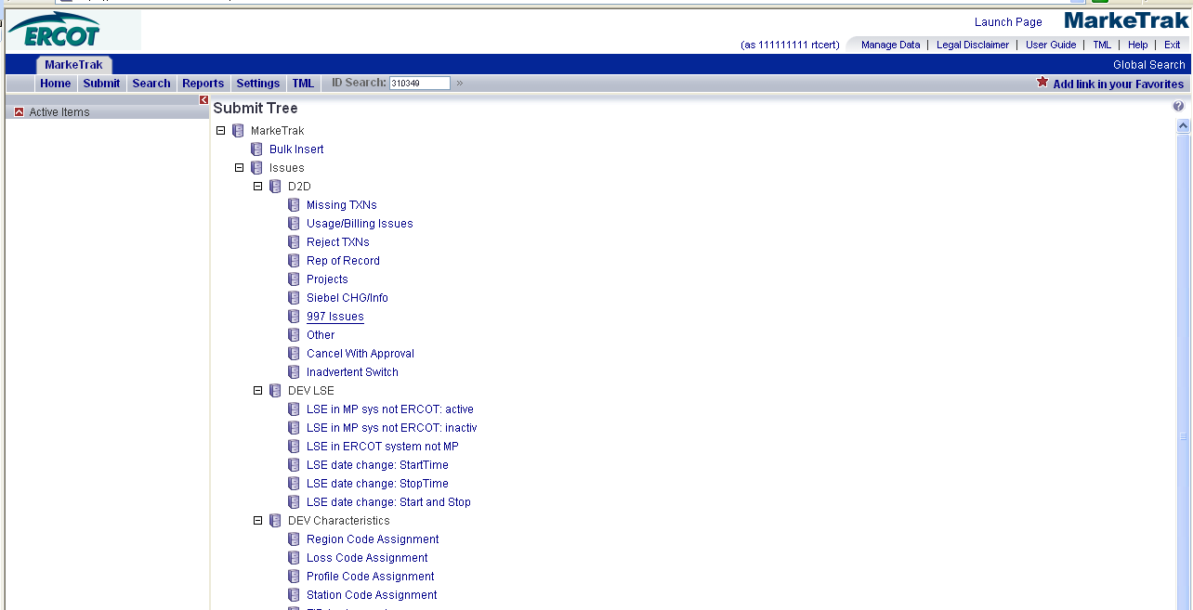

- The following fields must be populated for successful submission of Day to Day issue sub type 997 Issues: (Fig 4.7b)

(For this example, the submitter selects the ERCOT.)
ASSIGNEE
TXN Date
GS Number

NOTE: The Comments field is optional. Please include any additional information in this box.

- Select OK.

Fig 4.7b
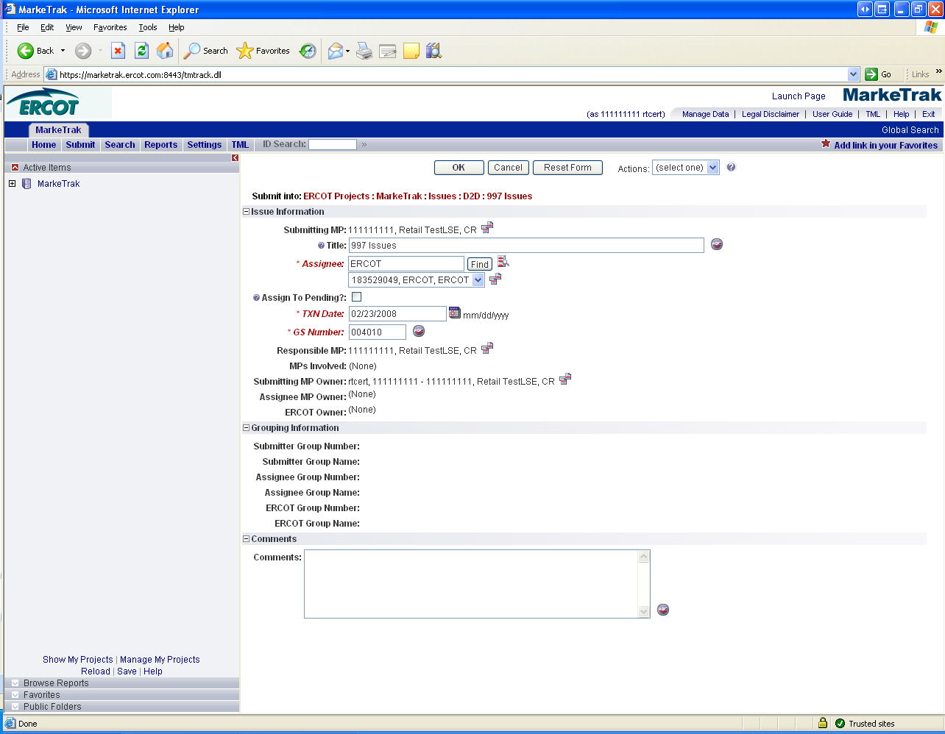

- The issue enters ERCOT’s queue in a state of New and is visible only by the Submitting CR and ERCOT.
- The Submitting CR can Withdraw the issue at this point. (Fig 4.7c)

Fig 4.7c
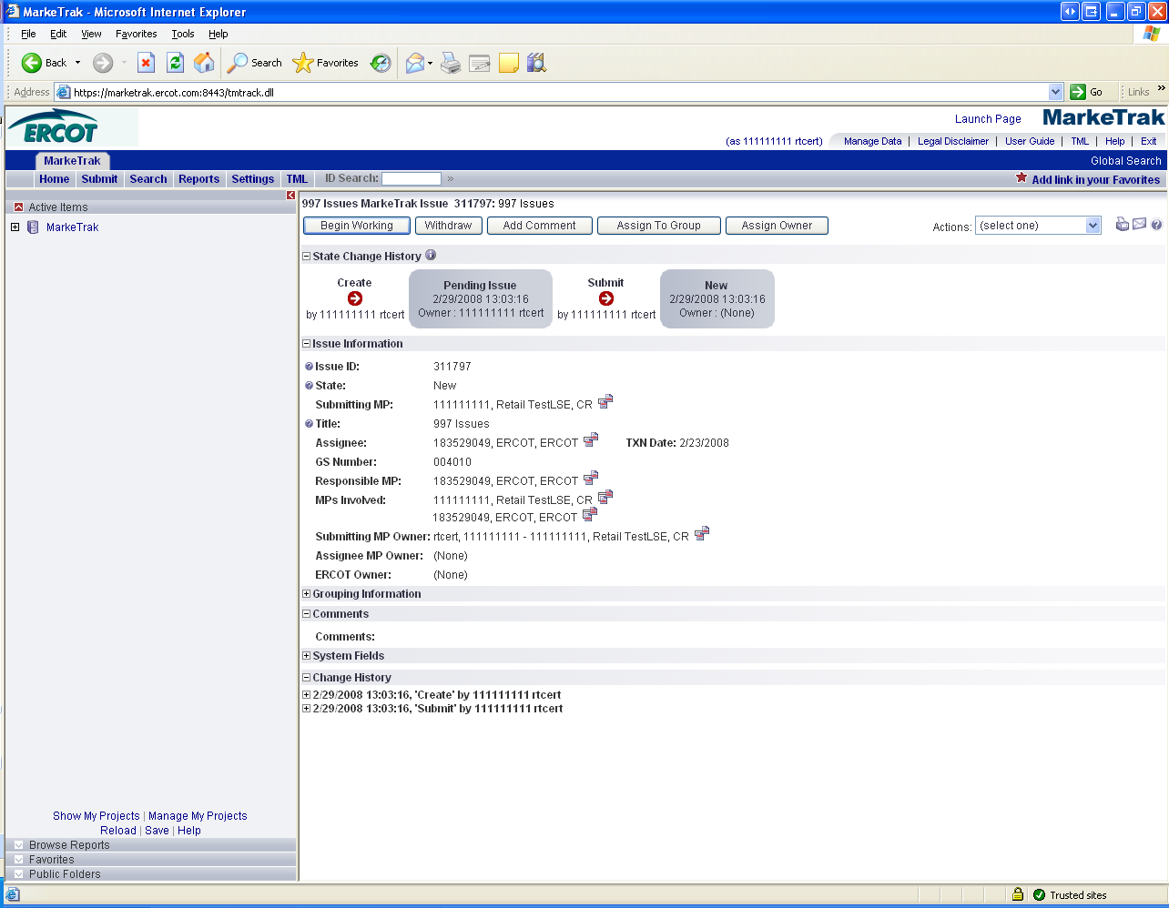
- ERCOT selects Begin Working(Fig 4.7d) and the issue is transitioned to a new state of In Progress-Assignee. (Fig 4.7e)
- At this point, the Submitting CR can no longer Withdraw the issue.

Fig 4.7d
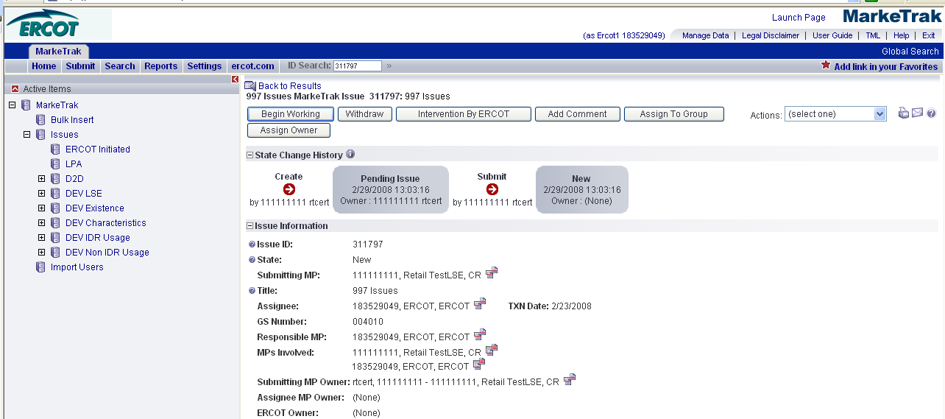

- ERCOT reviews the issue and has the options: (Fig 4.7e)
- Unexecutable, which results in state Unexecutable- Pending Complete
- Return to Submitter, which requires comments and then the issue is transitioned back to the Submitter for additional information
- Complete, which transitions to a state of Pending Complete. The Submitter has the option to close the issue by selecting Accept Complete or the issue will be auto closed in 14 calendar days.

Fig 4.7e

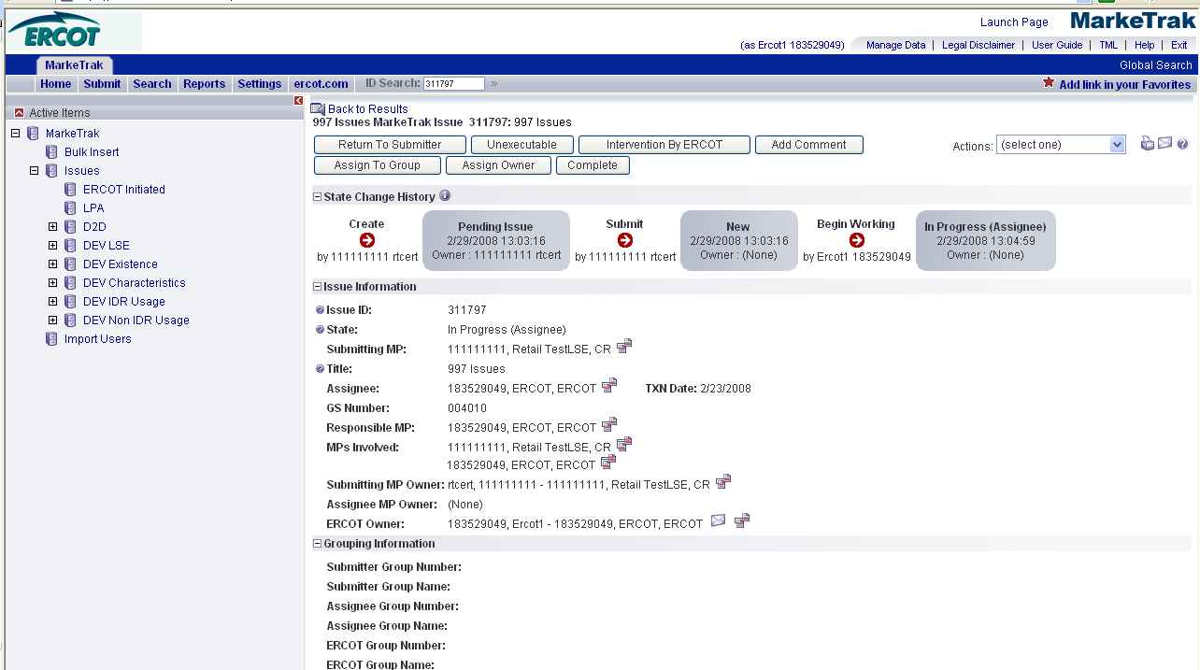

- In this example ERCOT selects Complete and the issue is transitioned to the submitting CR in a state of Pending Complete.
- The Submitting CR has the option to close the issue by selecting Complete or the issue will be Auto Closed in 14 Calendar days. (Fig 4.7f)

Fig 4.7f
