1.7 MarkeTrak Rolodex

1.7.1 Rolodex
One Admin user will be assigned to each MP. The Admin user has permission to view and edit Contact information in the “Rolodex” Contact List auxiliary table. “MP Users” have rights to view the entire Contact List (Rolodex).

1.7.1.1 Contact Category and Issue Type/Sub-Type Relationships

Contact Category Issue Type Sub Type
D2D – Inadvertent = D2D Inadvertent Switch (IAS)
D2D – Safety Net = D2D NONE
D2D – Other = D2D All Besides IAS
DEV – LSE = DEV LSE
DEV – Usage = DEV IDR Usage, Non-IDR Usage
DEV – Other = DEV All besides LSE, IDR Usage, Non-IDR Usage
LPA - Other =DEV Load Profile

VIEW
Users with permission to view the MarkeTrak Contacts list will be able to access via the Manage Data button on their MarkeTrak Launch Page: (Fig 1.7a)
Fig 1.7a
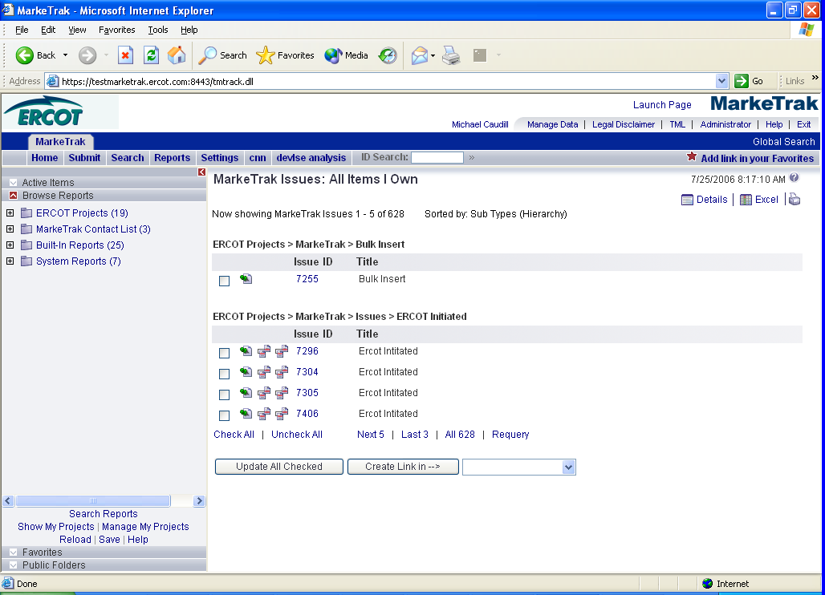

The user can then select the MarkeTrak Contacts List for viewing (Fig 1.7b)

Fig 1.7b
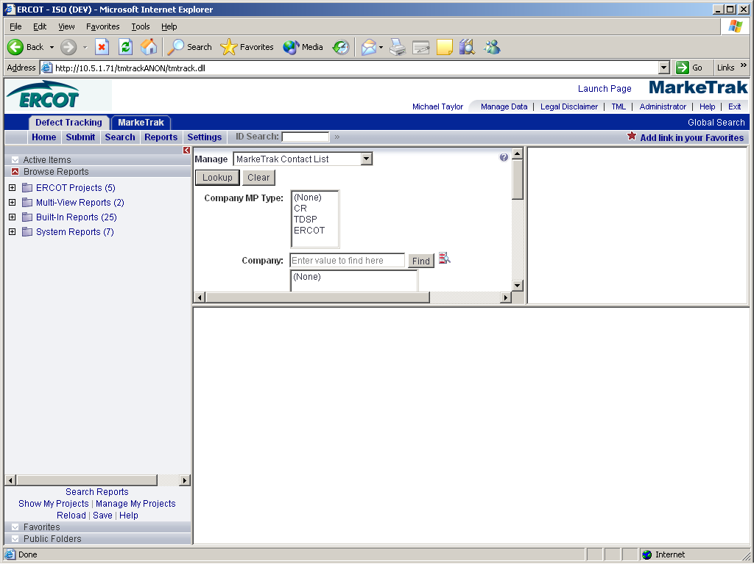

After entering search criteria and pushing Lookup, a list results list will display to the right and the 1st contact listed information will display below. User can scroll thru the list and select the contact of choice. (Fig 1.7c)

Fig 1.7c
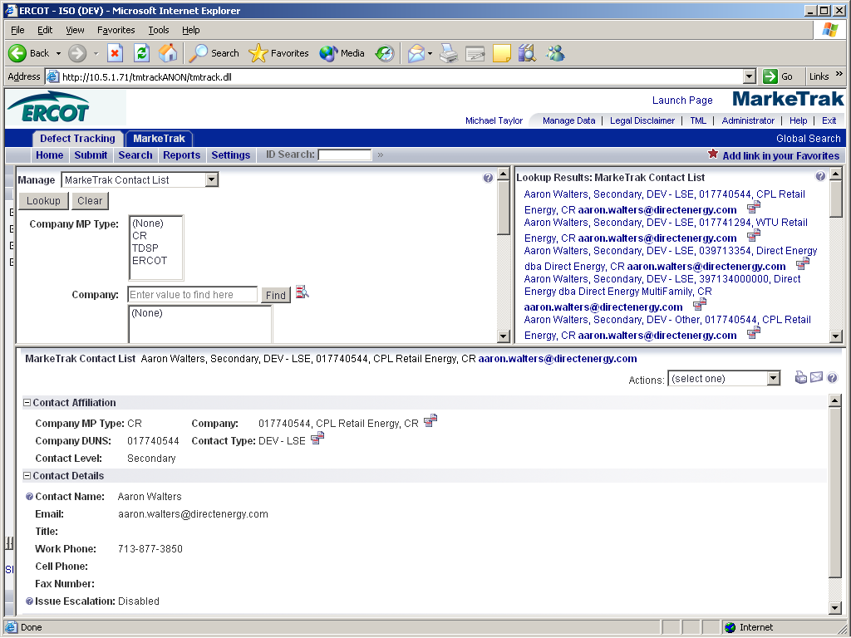

MP Contact Information will be displayed to the user in this format: (Fig 1.7d)

Fig 1.7d
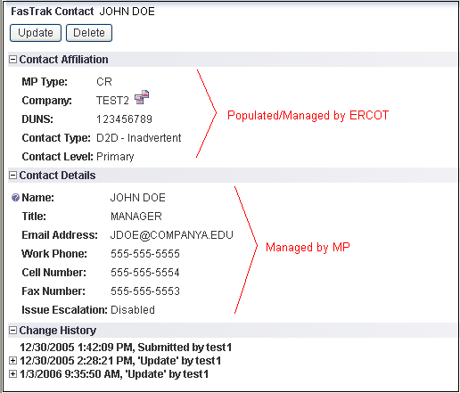

All users will have the permission to view, but not update any fields in the MarkeTrak Contacts table.

Change History will be logged for all changes to each record. The ability to view the Change History can be controlled as needed in the Privilege settings.

UPDATE
A user with proper permissions can update MarkeTrak Contacts information. The user would follow the VIEW method and by pushing the Update button, the user will be taken to an edit window. From here, the user can update the contact information. (Fig 1.7e)

Fig 1.7e
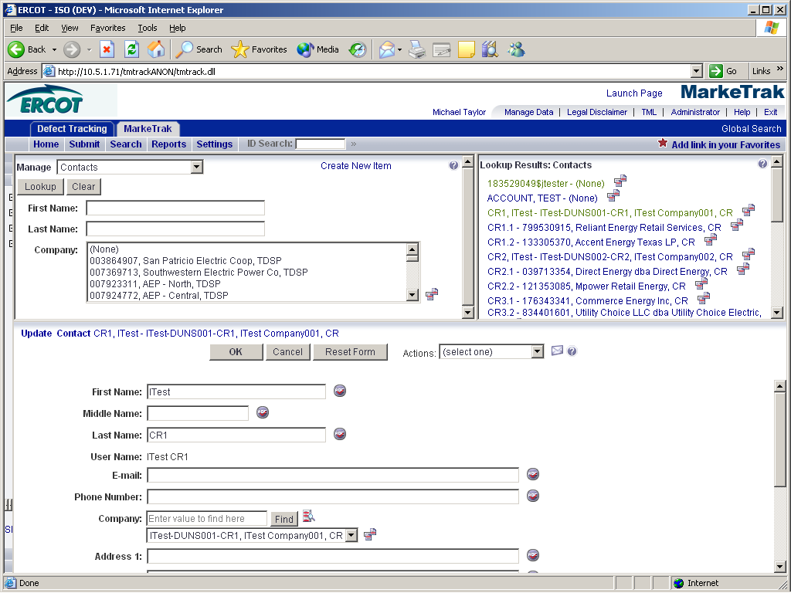

Note: Each contact category has an Escalation Primary and Escalation Secondary contact. A valid email address should be populated for both. It will be used by the Escalation Program to email Escalation Primary and Escalation Secondary contacts of issues that need to be transitioned. The issues identified have not proceeded down the workflow process to resolution in a “timely manner” and are in need of attention.

If an Escalation Primary or Escalation Secondary contact does not wish to receive escalation notifications, the Issue Escalation field should be disabled on the contact report.

Each MP may have only one (1) Escalation Primary and one (1) Escalation Secondary contact.

Only ERCOT may add new or delete contact categories.

1.7.1.2 Reporting
Reports can easily be created for users to search and display MP Contacts Table information. (Fig 1.7f)

Fig 1.7f
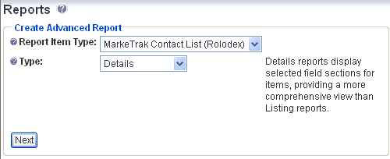

Fig 1.7g (Create Details Report & Search Filter)
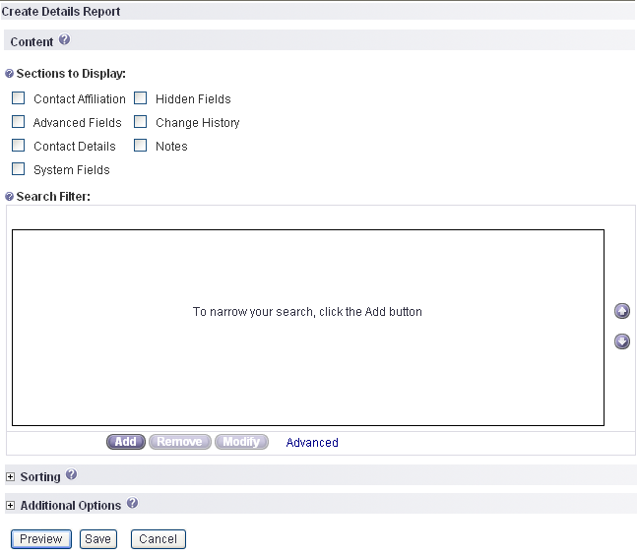

Above is an example of report building screen of a MarkeTrak Contact List (Rolodex) report. The output of this report is displayed in a customizable column view in the browser and may also be saved as an
Excel spreadsheet.

1.7.1.3 Escalation Email Process
The escalation email process is initiated once a MarkeTrak issue has exceeded the time allowed in a particular transition. Once the time allotted for a Transition State has passed, the Escalation Contact for the issue’s Responsible MP can expect an Escalation Email with an attached comma separated file containing the qualifying issues.
Example of the Escalation Email
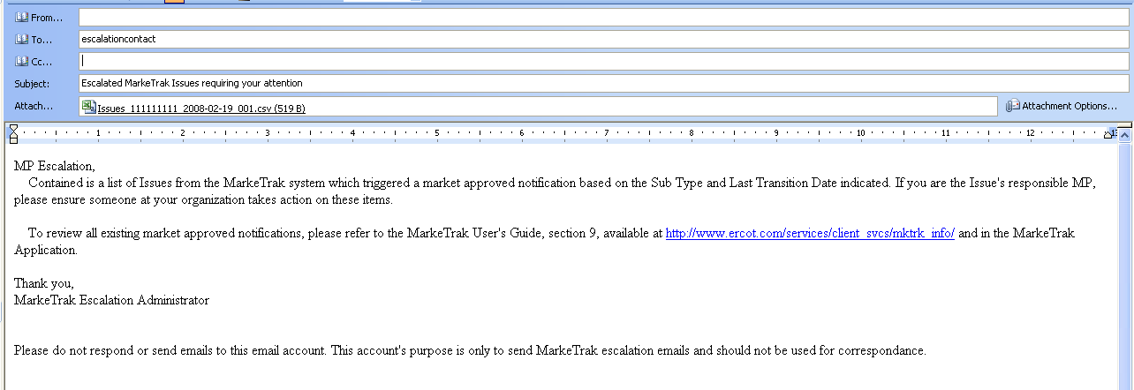

Columns included in the CSV attached to the Escalation Email
