MarkeTrak Users Guide
Section 9: Appendix

Table of Contents
MarkeTrak Users Guide 1
9.1 Appendix A – Issue Data Fields 3
9.2 Appendix B – MarkeTrak States and Transitions 7
9.3 Appendix C – Mass Update Attention Message: Causes/Resolutions 7
9.3.1 Required Fields for Missing Transaction 7
9.3.2 Mass Update on Non-Implemented Transition 8
9.3.2 Mass Update without Transition Permissions 10

9.1 Appendix A – Issue Data Fields
The following tables detail the data fields, per Issue type and subtype, and the field ordering, left to right, expected for the Issue Data Source. If a field is optional, this means its value may be specified or left empty with a comma only, or nothing if at the end of a text-row line.
Issue subtype
Row data field
Required (Req) Optional (Opt) Not Applicable (N/A) Read-Only (R/O)
Submitted By/To - additional Issue subtype that may modify field requirements

Issue type: DEV Characteristics

 | Submitted By/To | New Start Time | New Region Code | New Loss Code | New Profile Code | New Station Code | New Zip Code | Comments | ESIID | UIDESIID | STARTTIME | STOPTIME | STATION CODE | PROFILE CODE | LOSS CODE | ADDTIME | REGION CODE | ZIP | Title | ESIID Duplicate Check | Assignee | ESIID Validation
Region Code Assignment | TDSP/ERCOT or CR/TDSP | Req | Req | N/A | N/A | N/A | N/A | Opt | Req | Req | Req | Opt | N/A | N/A | N/A | Req | Req | N/A | Opt | Opt | Req | Opt
Loss Code Assignment | TDSP/ERCOT or CR/TDSP | Req | N/A | Req | N/A | N/A | N/A | Opt | Req | Req | Req | Opt | N/A | Req | Req | Req | N/A | N/A | Opt | Opt | Req | Opt
Profile Code Assignment | TDSP/ERCOT or CR/TDSP | Req | N/A | N/A | Req | N/A | N/A | Opt | Req | Req | Req | Opt | N/A | Req | Req | Req | N/A | N/A | Opt | Opt | Req | Opt
Station Code Assignment | TDSP/ERCOT or CR/TDSP | Req | N/A | N/A | N/A | Req | N/A | Opt | Req | Req | Req | Opt | Req | N/A | N/A | Req | N/A | N/A | Opt | Opt | Req | Opt
ZIP Assignment | TDSP/ERCOT or CR/TDSP | Req | N/A | N/A | N/A | N/A | Req | Opt | Req | Req | Req | Opt | N/A | N/A | N/A | Req | N/A | Req | Opt | Opt | Req | Opt

Issue type: DEV non-IDR

 | Submitted By/To | New Start Time | New Stop Time | New Total | New ONPK | New OFFPK | New MDPK | New SPK | Comments | ESIID | UIDESIID | STARTTIME | STOPTIME | TIMESTAMP | Meter Type | Total | Title | ESIID Duplicate Check | Assignee | ESIID Validation
In MP system  not in ERCOT | TDSP/ERCOT or CR/TDSP | Req | Req | Req | Opt | Opt | Opt | Opt | Opt | Req | N/A | N/A | N/A | N/A | Req | N/A | Opt | Opt | Req | Opt
In ERCOT system  not in TDSP | TDSP/ERCOT | N/A | N/A | N/A | N/A | N/A | N/A | N/A | Opt | Req | Req | Req | Req | Req | Req | Req | Opt | Opt | Req | Opt
In ERCOT system  not in MP | CR/TDSP | N/A | N/A | N/A | N/A | N/A | N/A | N/A | Opt | Req | Req | Req | Req | Req | Req | Req | Opt | Opt | Req | Opt
In both systems  with date issues | TDSP/ERCOT or CR/TDSP | N/A | Req | Req | Opt | Opt | Opt | Opt | Opt | Req | Req | Req | Req | Req | Req | Req | Opt | Opt | Req | Opt
In both systems  with kWh or kW issues | TDSP/ERCOT | N/A | N/A | Req | Opt | Opt | Opt | Opt | Opt | Req | Req | Req | Req | Req | Req | Req | Opt | Opt | Req | Opt
In both systems  with kWh or kW issues | CR/TDSP | N/A | N/A | Req | Opt | Opt | Opt | Opt | Opt | Req | Req | Req | Req | Req | Req | Req | Opt | Opt | Req | Opt
Issue type: DEV IDR

 | Submitted By/To | New Start Time | New Stop Time | Comments | ESIID | STARTTIME | STOPTIME | UIDCHANNELCUT | CHANNEL | ADDTIME | Origin | Title | ESIID Duplicate Check | Assignee | ESIID Validation
In MP system  not in ERCOT | CR/TDSP | Req | Req | Opt | Req | N/A | N/A | N/A | Req | N/A | N/A | Opt | Opt | Req | Opt
In MP system  not in ERCOT | TDSP/ERCOT | Req | Req | Opt | Req | N/A | N/A | N/A | Req | N/A | N/A | Opt | Opt | Req | Opt
In ERCOT system  not in MP | TDSP/ERCOT | N/A | N/A | Opt | Req | Req | Req | Req | N/A | Req | Req | Opt | Opt | Req | Opt
In ERCOT system  not in MP | CR/TDSP | N/A | N/A | Opt | Req | Req | Req | Req | N/A | Req | Req | Opt | Opt | Req | Opt
In both systems  with date issues | TDSP/ERCOT | Req | Req | Opt | Req | Req | Req | Req | N/A | Req | Req | Opt | Opt | Req | Opt
In both systems  with date issues | CR/TDSP | Req | Req | Opt | Req | Req | Req | Req | N/A | Req | Req | Opt | Opt | Req | Opt
In both systems  with kWh issues | TDSP/ERCOT | N/A | N/A | Opt | Req | Req | Req | Req | Req | Req | Req | Opt | Opt | Req | Opt
In both systems  with kWh issues | CR/TDSP | N/A | N/A | Opt | Req | Req | Req | Req | Req | Req | Req | Opt | Opt | Req | Opt

Issue type: DEV Existence

 | Submitted By/To | New Start Time | New Stop Time | Comments | ESIID | UIDESIID | STARTTIME | STOP TIME | STATION CODE | PROFILE CODE | LOSS CODE | ADDTIME | REGION CODE | ZIP | Service Address | Premise Type | Title | ESIID Duplicate Check | ESIID Validation | Service City | Service State
In TDSP system not ERCOT | TDSP/ERCOT | Opt | N/A | Opt | Req | N/A | Req | N/A | Req | Req | Req | R/O | Req | Req | Req | Req | Opt | Opt | Opt | Req | Req
In ERCOT system not TDSP | TDSP/ERCOT | N/A | Req | Opt | Req | Req | Req | Opt | N/A | N/A | N/A | Req | N/A | N/A | N/A | N/A | Opt | Opt | Opt | N/A | N/A
In ERCOT with start date issues | TDSP/ERCOT | Req | N/A | Opt | Req | Req | Req | Opt | N/A | N/A | N/A | Req | N/A | N/A | N/A | N/A | Opt | Opt | Opt | N/A | N/A
Inactive record has date issues | TDSP/ERCOT | Req | N/A | Opt | Req | Req | Req | Opt | N/A | N/A | N/A | Req | N/A | N/A | N/A | N/A | Opt | Opt | Opt | N/A | N/A
Status Assignment | TDSP/ERCOT | Req | N/A | Opt | Req | Req | Req | Opt | N/A | N/A | N/A | Req | N/A | N/A | N/A | N/A | Opt | Opt | Opt | N/A | N/A
Un-Retire ESI ID | TDSP/ERCOT | N/A | N/A | Opt | Req | Req | Req | Opt | N/A | N/A | N/A | Req | N/A | N/A | N/A | N/A | Opt | Opt | Opt | N/A | N/A

Issue type: DEV LSE

 | New Start Time | New Stop Time | Comments | ESIID | UIDESIID | STARTTIME | STOPTIME | PROFILE CODE | Rep Code | ADDTIME | STATUS | Title | ESIID Duplicate Check | Assignee | ESIID Validation
LSE in MP sys not ERCOT: active | Req | N/A | Opt | Req | Req | Req | N/A | Req | Req | Req | Req | Opt | Opt | Req | Opt
LSE in MP sys not ERCOT: inactive | Req | Req | Opt | Req | Req | Req | Opt | Req | Req | Req | Req | Opt | Opt | Req | Opt
LSE in ERCOT system not MP | N/A | N/A | Opt | Req | Req | Req | Opt | Req | Req | Req | Req | Opt | Opt | Req | Opt
LSE date change: StartTime | Req | N/A | Opt | Req | Req | Req | Opt | Req | Req | Req | Req | Opt | Opt | Req | Opt
LSE date change: StopTime | N/A | Req | Opt | Req | Req | Req | Opt | Req | Req | Req | Req | Opt | Opt | Req | Opt
LSE date change: Start and Stop | Req | Req | Opt | Req | Req | Req | Opt | Req | Req | Req | Req | Opt | Opt | Req | Opt

Issue type: D2D

 | ESI ID | Orig Tran ID | Tran Type | Gaining/Losing Rep | Date of Txn  (required if 867_03 or 867_03F) | GS Number | Comments | Title | ESIID Duplicate Check | Global ID Duplicate Check | Assignee | ESIID Validation
Inadvertent Switch | Req | Req | Opt | Req | Opt | N/A | Opt | Opt | Opt | Opt | N/A | Opt
Cancel With Approval | Req | Req | N/A | N/A | N/A | N/A | Opt | Opt | Opt | Opt | Req | Opt
Cancel Without Approval | Req | Req | N/A | N/A | N/A | N/A | Opt | Opt | Opt | Opt | N/A | Opt
Missing TXNS | Req | Req | Req | N/A | Opt | N/A | Opt | Opt | Opt | Opt | Req | Opt
Usage/Billing Issues | Req | Req | Opt | N/A | R/O | N/A | Opt | Opt | Opt | Opt | Req | Opt
Reject TXNS | Req | Req | Req | N/A | Opt | N/A | Opt | Opt | Opt | Opt | Req | Opt
Rep of Record | Req | N/A | N/A | N/A | N/A | N/A | Opt | Opt | Opt | N/A | Req | Opt
Projects | Opt | Opt | Opt | N/A | Opt | Opt | Opt | Opt | Opt | Opt | Req | Opt
Siebel CHG/Info | Req | Req | N/A | N/A | Opt | N/A | Opt | Opt | Opt | Opt | Req | Opt
997 Issues | N/A | N/A | N/A | N/A | Req | Req | Opt | Opt | N/A | N/A | Req | N/A
Other | Opt | Opt | Opt | N/A | Opt | Opt | Opt | Opt | Opt | Opt | Req | Opt

Field formats:
Field | Max Length/Field Description
ADDTIME | Example: 05/02/2006 16:26:45 (19 characters)
Assignee | DUNS
CHANNEL | Any integer
Comments | Text - max of 4000 characters
ESI ID | Text - max of 36 characters
ESIID Duplication Check | 0=false or 1=true
ESIID Validation | 0=false or 1=true
Gaining or Losing Rep? | List of values
GS Number | Text - max of 9 characters
LOSS CODE | Text - max of 64 characters
Meter Type | Text - max of 2 characters
New LOSSCODE | Text - max of 64 characters
New MDPK | Numeric Value with floating decimal place
New OFFPK | Numeric Value with floating decimal place
New ONPK | Numeric Value with floating decimal place
New PROFILECODE | Text - max of 64 characters
New REGIONCODE | Text - max of 64 characters
New SPK | Numeric Value with floating decimal place
New STARTTIME | Example: 05/02/2006 16:26:45 (19 characters)
New STATIONCODE | Text - max of 64 characters
New STOPTIME | Example: 05/02/2006 16:26:45 (19 characters)
NEW TOTAL | Numeric Value with floating decimal place
New ZIPCODE | Text - max of 5 characters
Origin | Text - max of 64 characters
Original Tran ID | Text - max of 30 characters
Owner To Assign | Text - max of 64 characters
Premise Type | Text - max of 64 characters
PROFILECODE | Text - max of 64 characters
REGIONCODE | Text - max of 64 characters
REP CODE | Text - max of 5 characters
Requested Resolution | Text - max of 4000 characters
Service Address | Text - max of 80 characters
Service City | Text - max of 80 characters
Service History with DUNS for Affected Period | Text - max of 4000 characters
Service State | Text - max of 2 characters
STARTTIME | Example: 05/02/2006 16:26:45 (19 characters)
STATIONCODE | Text - max of 64 characters
STATUS | Text - max of 64 characters
STOPTIME | Example: 05/02/2006 16:26:45 (19 characters)
TDSP Involved | DUNS
TIMESTAMP | Example: 05/02/2006 16:26:45 (19 characters)
Title | Text - max of 80 characters
Total | Numeric Value with floating decimal place
Tran Type | List of values
TXN Date | Example: 05/02/2006 (10 characters)
UIDCHANNELCUT | Text - max of 19 characters
UIDESIID | Text - max of 19 characters
ZIP | Text - max of 5 characters

9.2 Appendix B – MarkeTrak States and Transitions

Included in this appendix is an explanation of each of the MarkeTrak state names and transitions represented in two formats, a Visio workflow diagram and an Excel spreadsheet. They are organized by workflow and represent the issues and sub types available in the MarkeTrak toolset.

The Visio documents are workflow diagrams detailing:

State Name
Responsible MP (currently assigned Duns number)
MPs Involved (all Duns numbers with visibility to an issue)
Transition Name (button available and resulting state on the GUI)

The Excel spreadsheets are a written representation of states, transitions, and fields:

State Name
Responsible MP
MPs Involved
Transitions Available
Resulting State
Actioned By (party to whom the related transition is available)
Required Fields (for workflows with multiple sub types, this is a hyperlink to additional tabs with individualized information)
Notes (additional scripting that is associated with the transition in question)

**Note ERCOT is ALWAYS represented in the MPs Involved field due to the fact that ERCOT has visibility into all issues in the MarkeTrak toolset. This has not been referenced in these diagrams.

Flows are within the zip file attached.

9.3 Appendix C – Mass Update Attention Message: Causes/Resolutions

9.3.1 Required Fields for Missing Transaction
ERCOT has identified 2 causes why a user executing a Mass Update might get error:
Attention. You can continue with this operation; however the following items will not be transitioned as requested. This may be caused by permission problems.

- User selected an issue that belongs to a type/sub-type that does not implement the requested transition or the transition is not applicable to an issue (at this time). For example, Bulk Insert does not implement the “Add Comments” transition. If a user attempted to “Add Comments” in Mass Update to a list of issues and one or more of those issues was a Bulk Insert issue; the user would see this error message followed by the issue numbers that will fail.

- User selected an issue that he has visibility to, but does not have transition permissions to. Note: a User is granted permissions to transition an issue if that User is listed in the issue’s Secondary Owner field. If an issue exists prior to the User’s UserId being added to MarkeTrak and the issue has not been transition since the User was added, the issue’s Secondary Owner field does not contain the User’s UserId, thus the User will not be able to transition that issue. If a user attempted to “Add Comments” in Mass Update to a list of issues and the User was not in one or more of those issues’ Secondary Owner field, the user would see this error message followed by the issue numbers that will fail.

9.3.2 Mass Update on Non-Implemented Transition
9.3.2.1 Problem

User “Checks” 1 or more Issues to Transition and presses “Update All Checked”

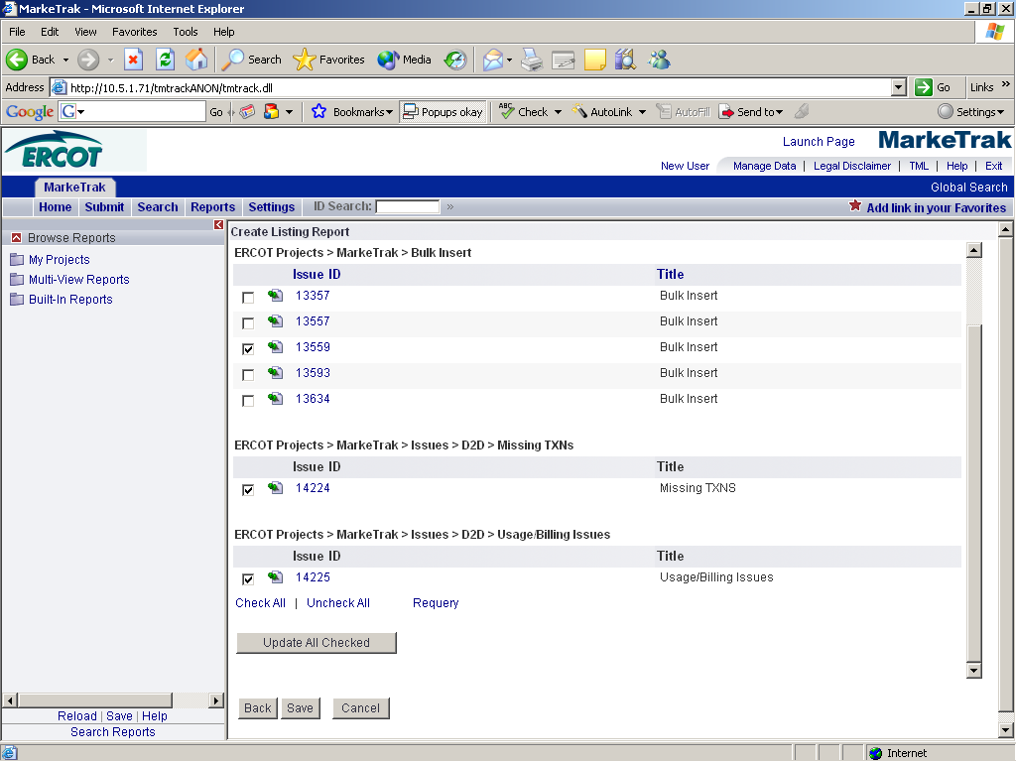

User selects the “Add Comments from Any” from drop down transition list and presses “Next”. User sees Transition field screen with Attention message listing Issue numbers.

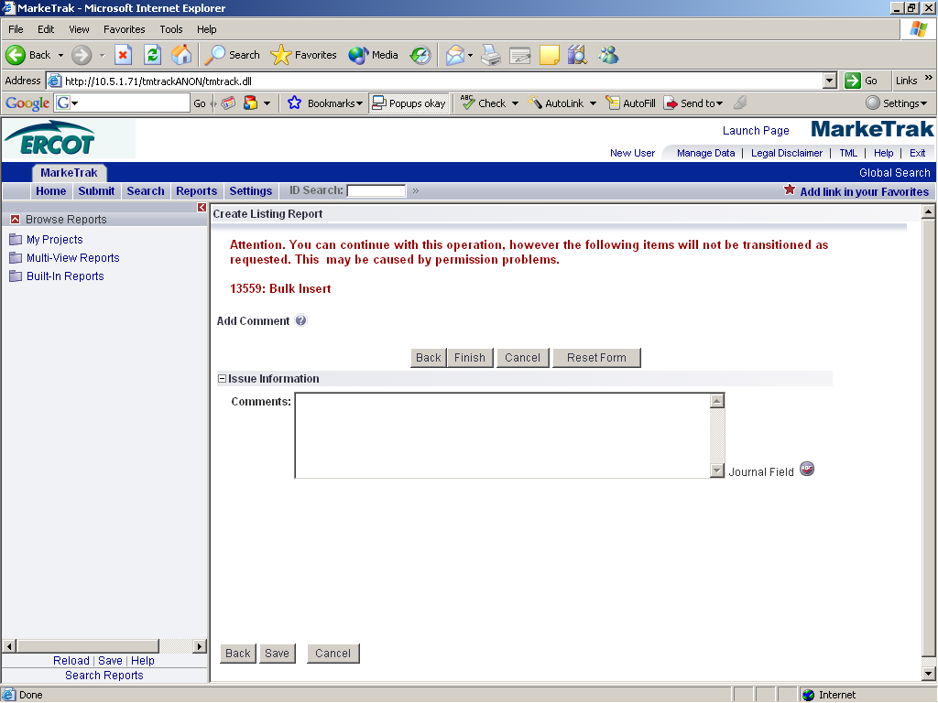

If user enters appropriate information into Transition fields and presses “Finish”, user will receive Mass Update Transition Report with failure message on Attention listed issue numbers (see screenshot below)

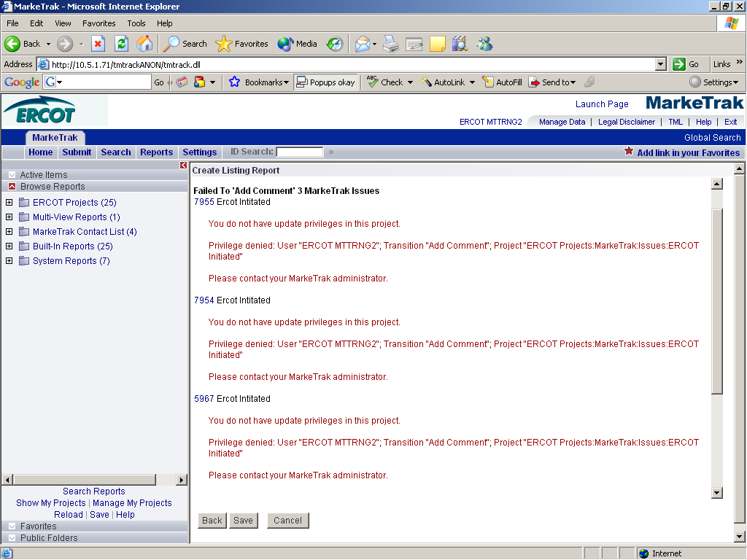

9.3.2.1 Root Cause

User selected Issues to Mass Update and a Transition that not all the selected issues have the transition applicable. And issue may have the transition applicable if the Workflow has the transition, but the issue is not in a valid state for the transition or the Workflow does not implement this transition.

9.3.2.1 Resolution

Not much the user can do, except have the Mass Update transition in mind when creating reporting to only list the Issue that have the transition enabled and applicable.

9.3.2 Mass Update without Transition Permissions
9.3.2.1 Problem

User “Checks” 1 or more Issues to Transition and presses “Update All Checked”

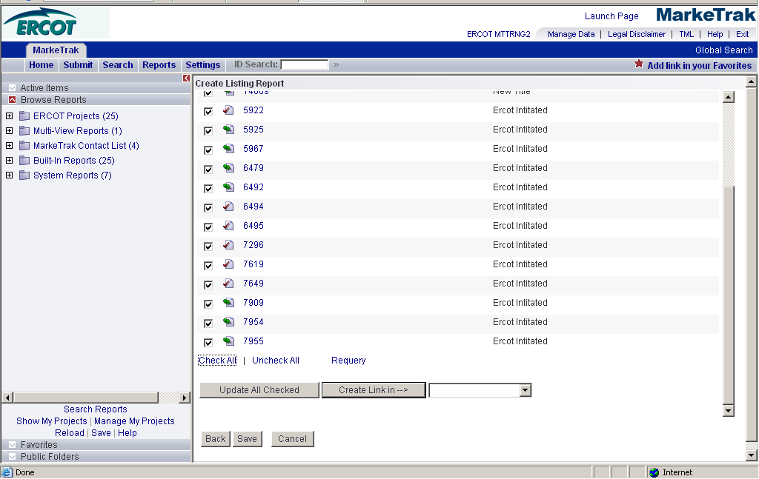

User selects the “Add Comments from Any” from drop down transition and presses “Next”. User sees Transition field screen with Attention message listing Issue Numbers.

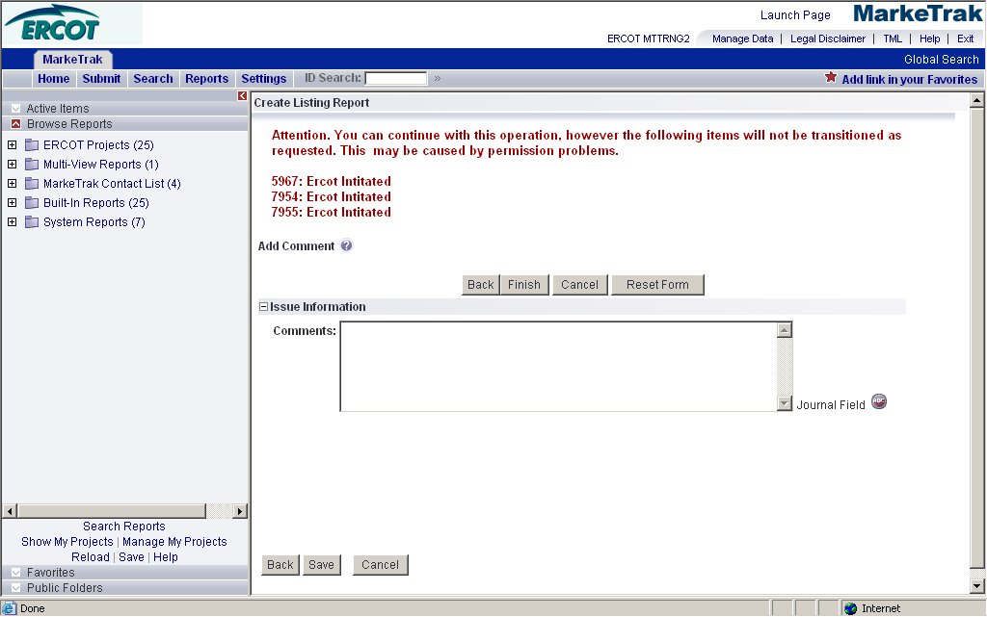

If the user enters the appropriate information into Transition fields and presses “Finish”, user will receive Mass Update Transition Report with failure message on Attention listed issue numbers.

9.3.2.1 Root Cause

User selected Issues to Mass Update that the User’s UserId is not listed in the Issue’s Secondary Owner field. A user may have visibility to the Issue, but not have Transition. To verify, the user can select (click on issue number) on the Report list. This will take the user to the Issue details. The User isn’t listed in the Issue’s Secondary Owner field; they should not see any Transition “buttons” available to press at the top of the issue screen. This may happen when a User tries to Mass Update an Issue that was created before the User’s UserId was added to the MarkeTrak application and the Issue has not been updated since the User was added.

9.3.2.1 Resolution

Serena has identified this as a product issue and is developing a product change to make the Secondary Owner field UserIds dynamically referenced. Currently the Secondary Owner field is populated statically or at the time of issue creation or update.

To avoid the Attention message and subsequent failure messages, a MP Admin can choose to run a report identifying the current active issues who’s Secondary Owner field does not contain the “new” UserId and Mass Update all or some (depending on which issues the MP Admin wants to give transition access to) Issues. The issue update will cause the issue’s Secondary Owner field to update with any new UserIds. The User may then Mass Update the Issue.

Currently not implemented in FasTrak.

