MarkeTrak Users Guide
Section 7: Admin

Table of Contents
MarkeTrak Users Guide 1
7.1 MarkeTrak Administrator’s Guide 3
7.1.1 Add a New User 3
7.2.1 Delete a User 7

7.1 MarkeTrak Administrator’s Guide
The MP Administrator will be responsible to for establishing and maintaining the users associated with their Market Participant organization. This section of the MP User Guide will provide detailed instruction for adding, editing and deleting users from the MarkeTrak system. MP Administrators will only be able to establish or maintain users associated with their organization.

Note: ERCOT must establish the MP Administrator account for a particular MP organization before any of these instructions can be accomplished.

7.1.1 Add a New User
The addition of a new user is a process by which the MP Administrator will establish a Login Id based on the digital certificate, establish group associations, enter user contact information and associate the user to the MP company record.

- The MP Administrator logs into MarkeTrak and selects the Administrator link (Fig 7.1a)

Fig 7.1a
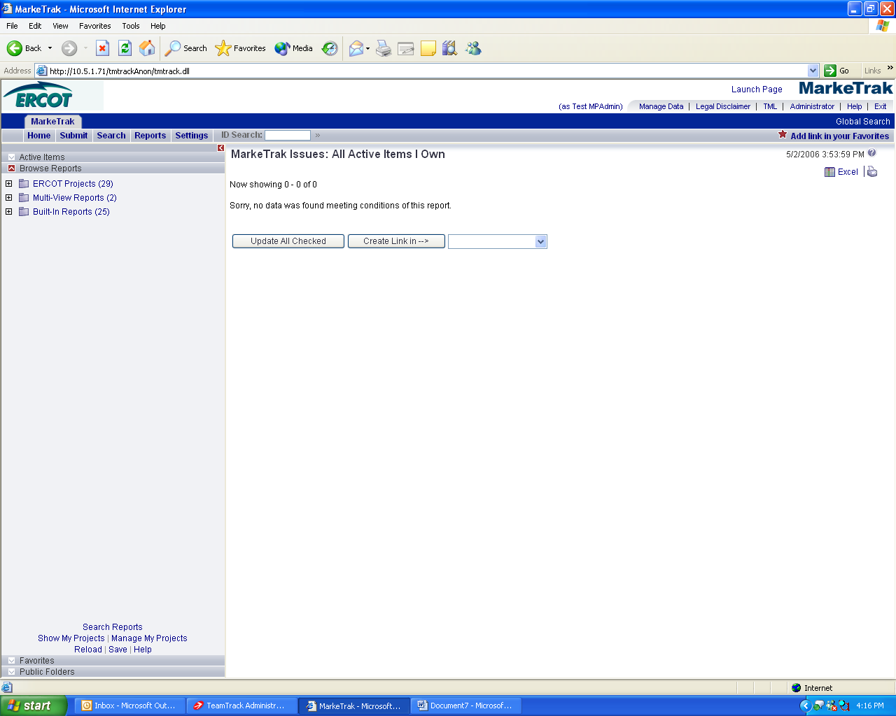

- In the new window, select the Add User link (Fig 7.1b)

Fig 7.1b
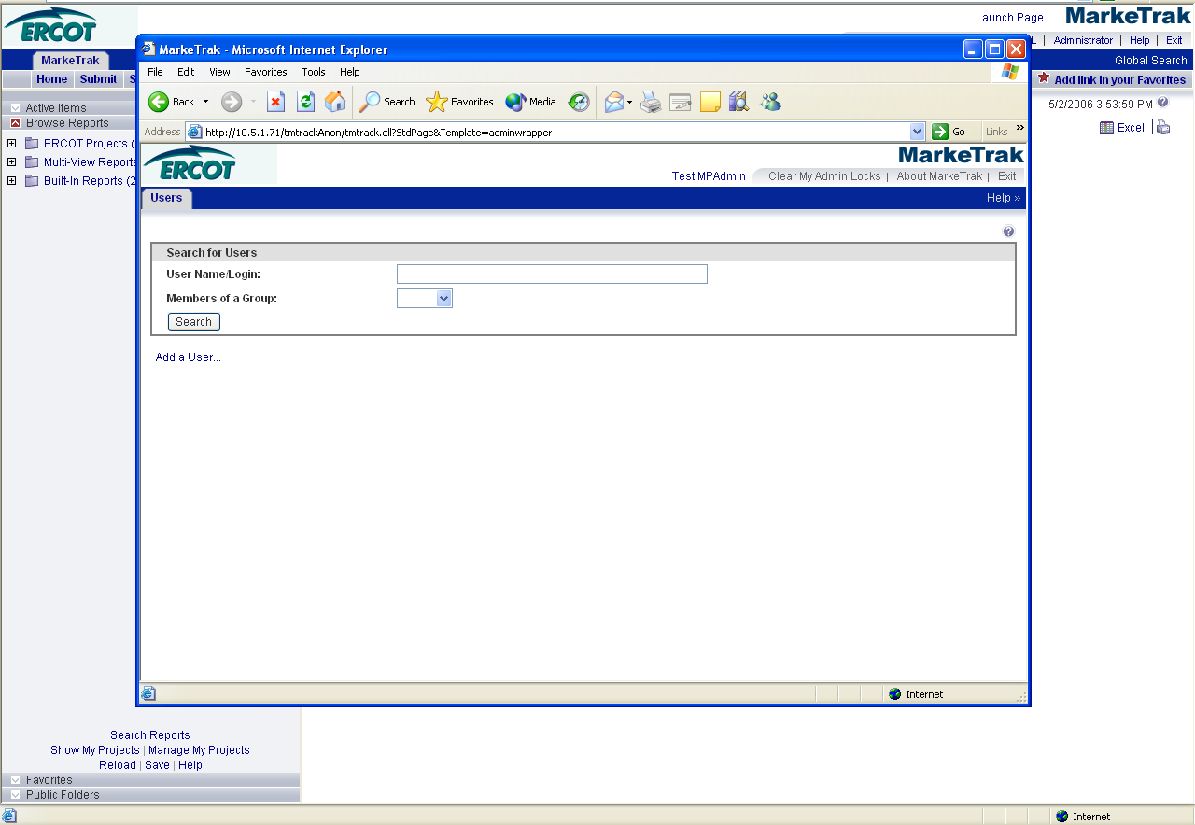

- On the General Tab, key in the user information requested. Be sure to select user for product access and Create/Update Record from user in the Associated Contacts box. The Login ID must match the digital certificate exactly. (Fig 7.1c)

Fig 7.1c
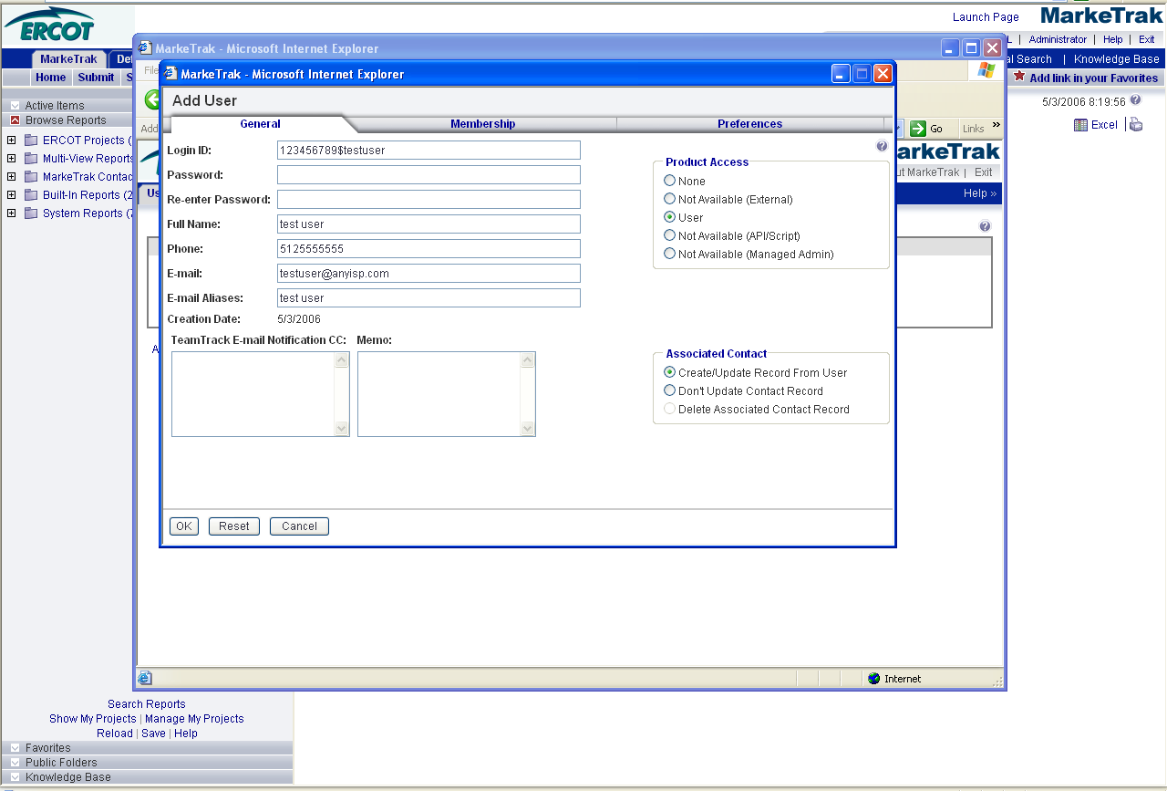

- On the Membership tab, select your DUNS for the list, All FT_ALL Users – External (TDSP/CR) and your MP type queue (either TDSP queue or CR queue). (Fig 7.1d)

Fig 7.1d
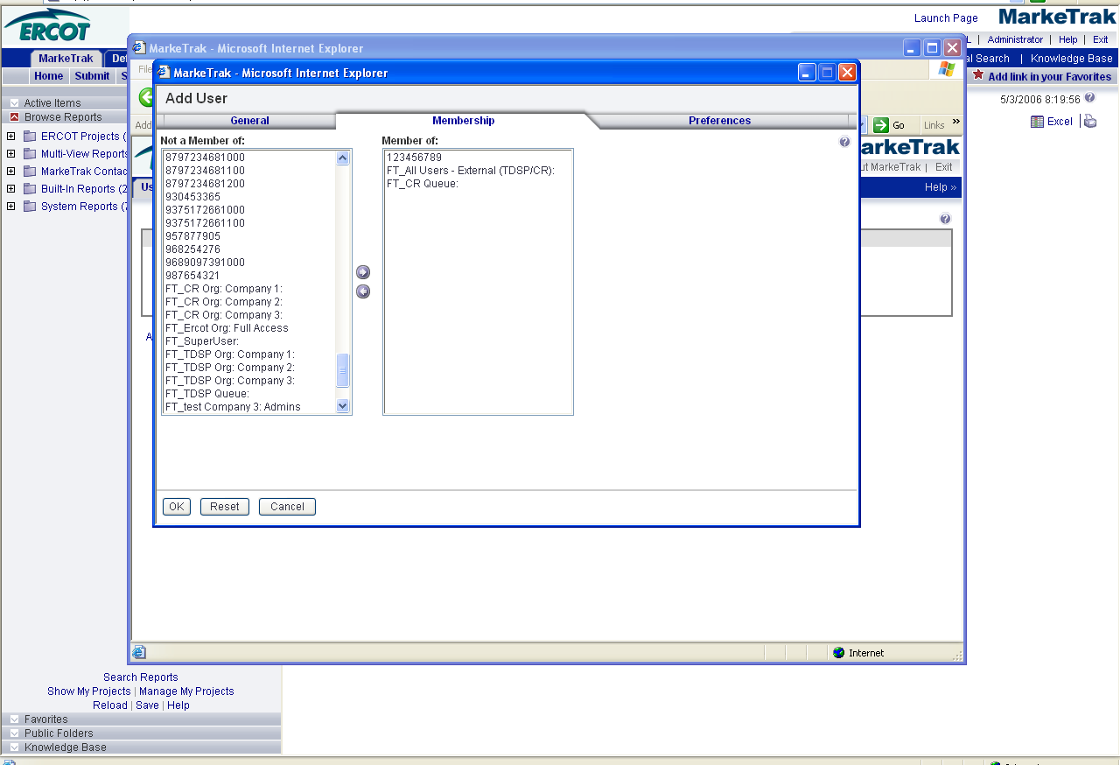

- On the preferences tab, select use 24 hour clock. User this screen shot as a starting point for other preferences settings. Click the OK button when complete. (Fig 7.1e)

Fig 7.1e
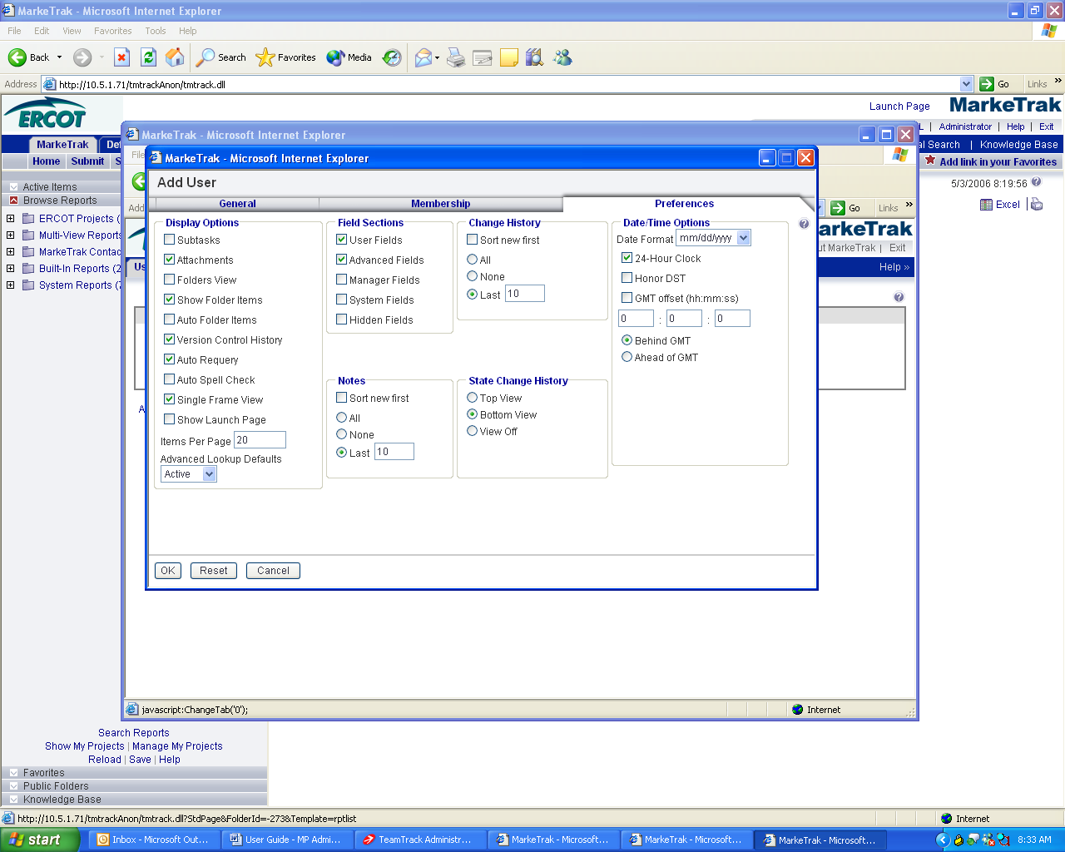

- The next step in the user creation process is to associate the newly created user with your company. This step is accomplished by selecting Manage Data from the MarkeTrak main screen. (Fig 7.1f)

Fig 7.1f
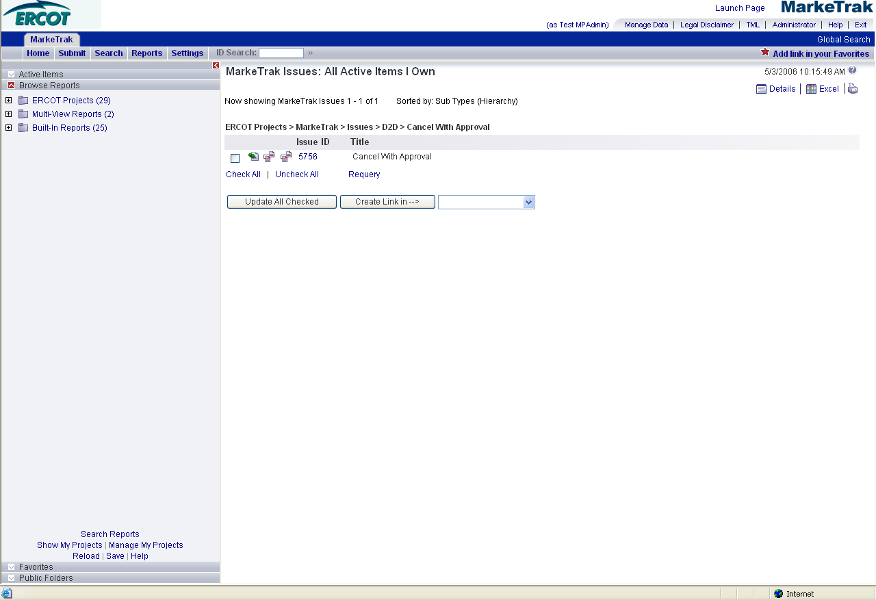

- On the Manage Data screen, select Contacts from the Manage drop down list. Lookup the user that you just created by first and/or last name. Select the user you created and click the Update button. (Fig 7.1g)

Fig 7.1g
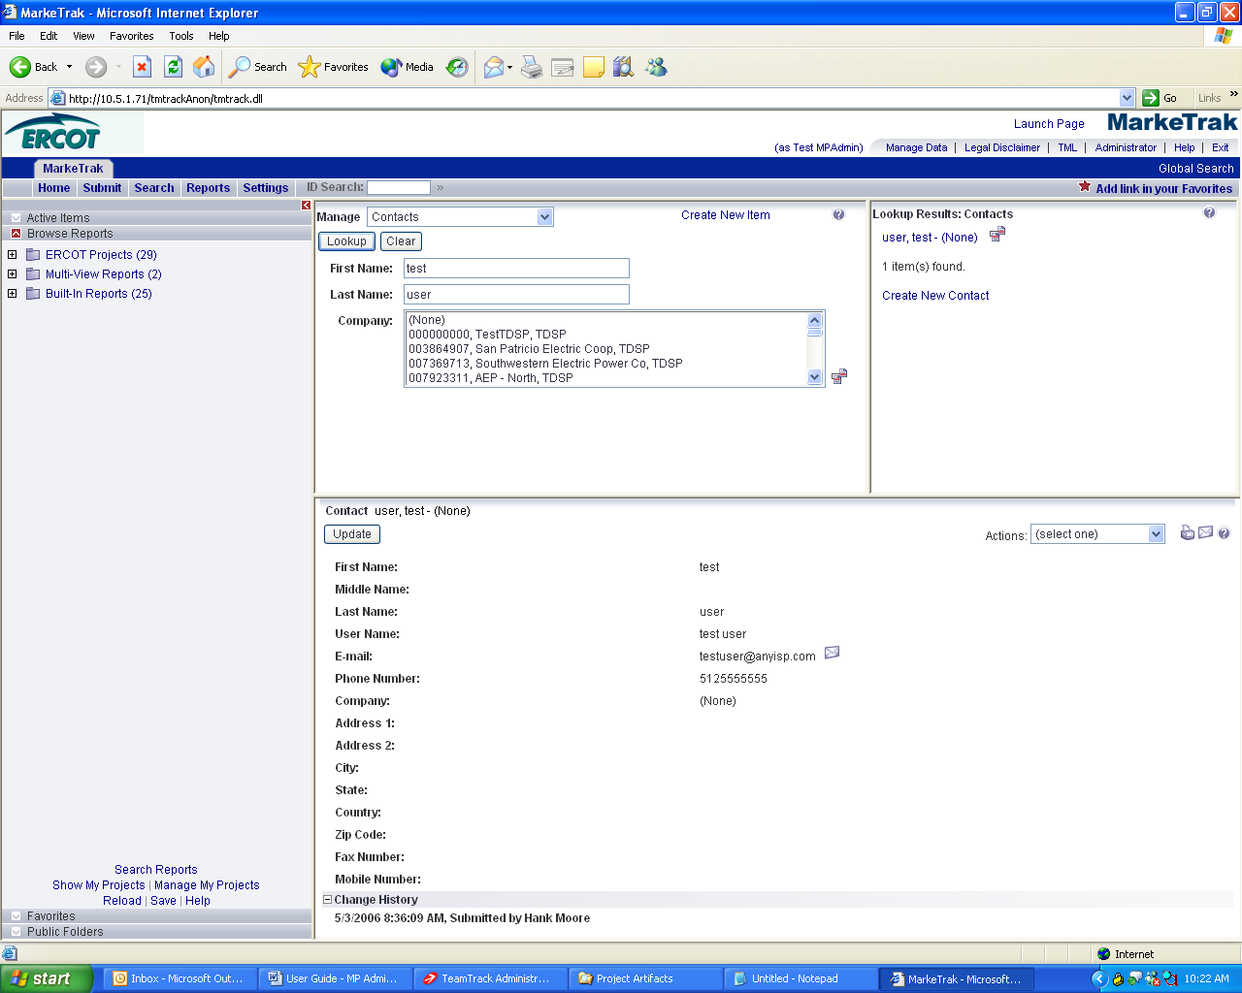

- You are required to select a company record to associate the new user to. You can search by DUNs, company name or MP type. For simplicity, it is recommended you search by DUNs for the company search. Once the appropriate company has been selected click the OK button to complete this step. (Fig 7.1h)

Fig 7.1h
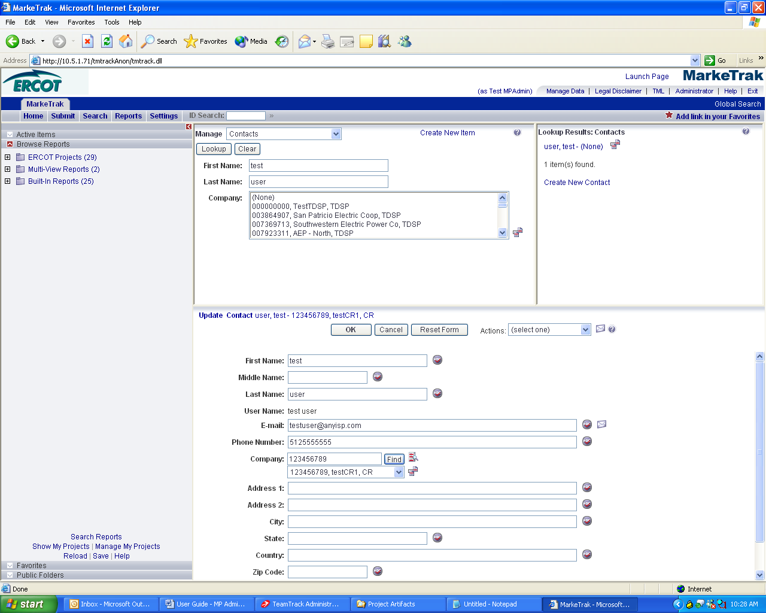

7.2.1 Delete a User
The deletion of an existing MarkeTrak user is a process by which the MP Administrator will remove product access for a user associated with their company. The user’s contact record must be deleted.

Note: Extreme caution should be used when executing this process. ERCOT assistance will be required if a mistake occurs.

- The MP Administrator logs into MarkeTrak and selects the Administrator link (Fig 7.2a)

Fig 7.2a

- Search for the user to be deleted by either username or Login ID. (Fig 7.2b)

Fig 7.2b
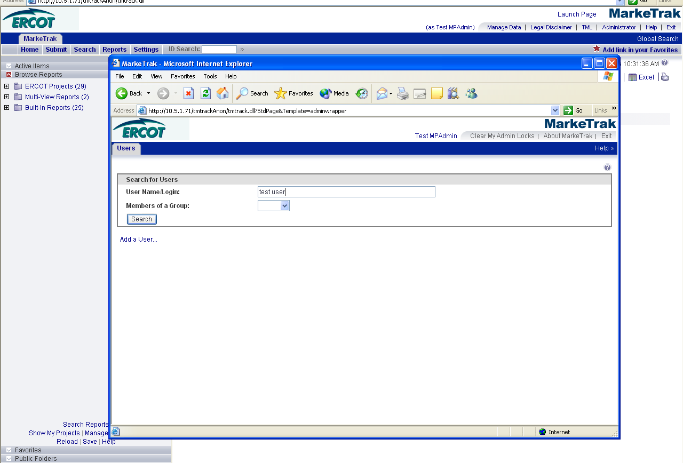

- Highlight the user and click the Edit User link. (Fig 7.2c)

Fig 7.2c
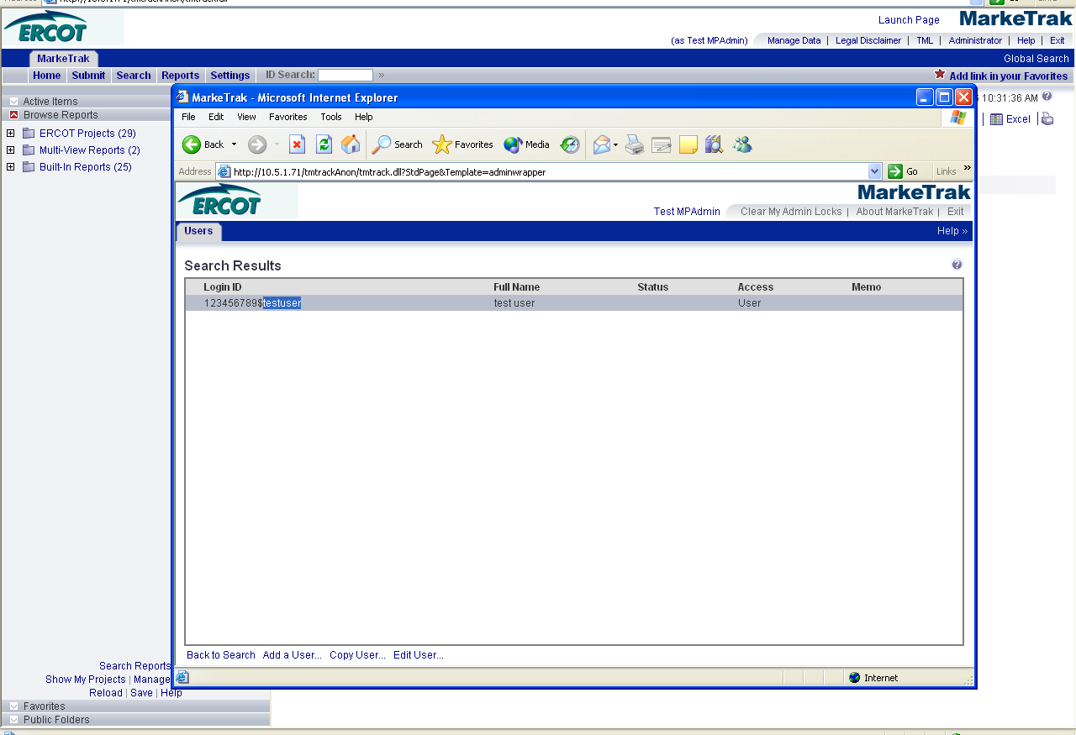

- On the Membership tab, highlight all groups and click the left arrow button to remove group membership association with this user. (Fig 7.2d)

Fig 7.2d
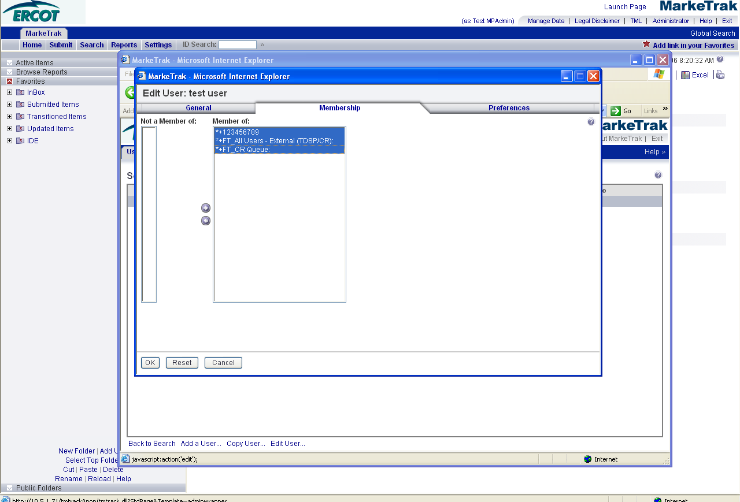

- On the General Tab, Set Product Access to None and select Delete Associated Contact Record. Once this is complete click the OK button the complete the process. (Fig 7.2e)

Fig 7.2e
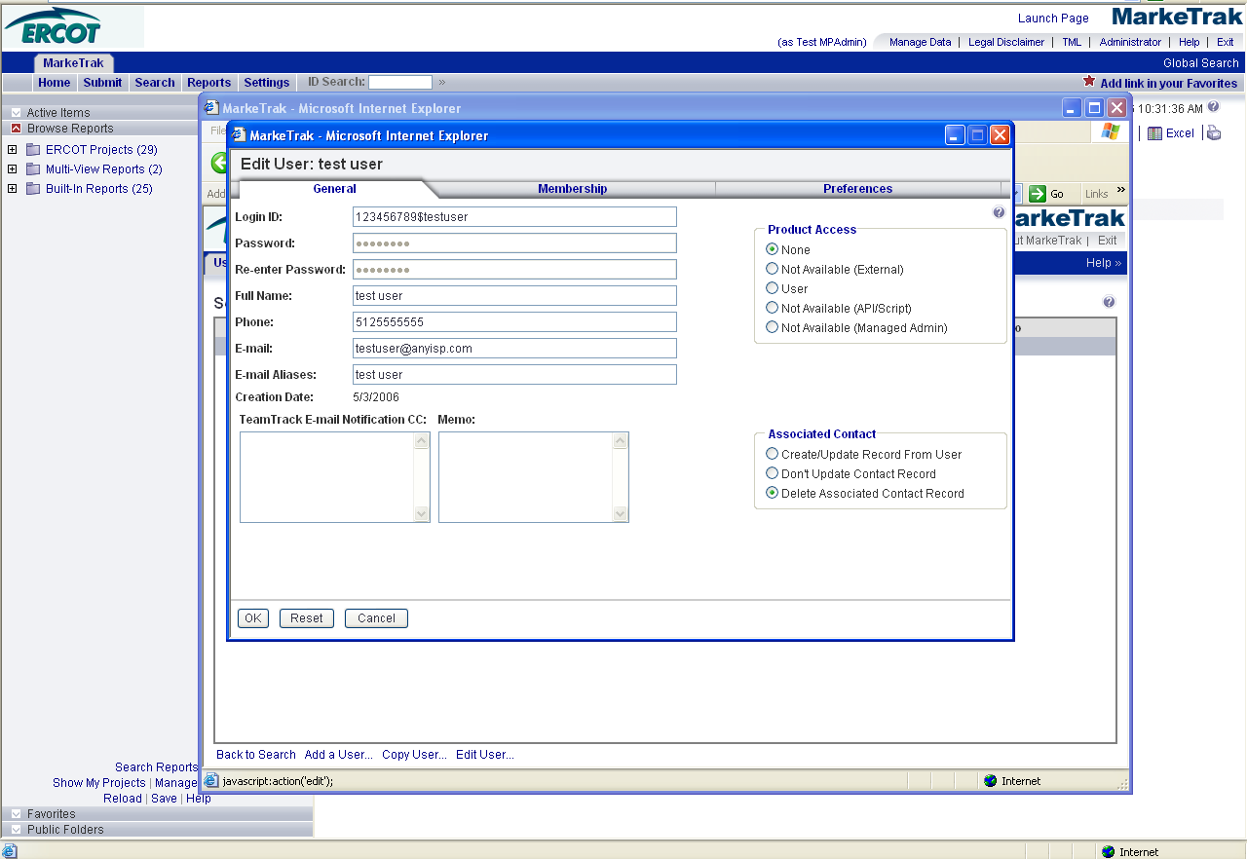

- Product Access is now set to none. The system will no longer allow this user access to MarkeTrak (Fig 7.2f)

Fig 7.2f
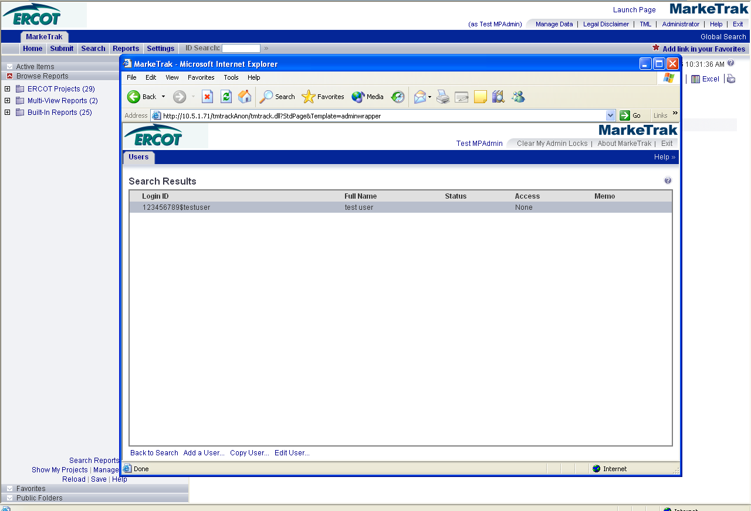

- If the user attempts to sign on to MarkeTrak the following error screen will be presented to the user. (Fig 7.2g)

Fig 7.2g
