MarkeTrak Users Guide
Section 3: Cancel

3.1 Day to Day Issues – Cancel with Approval 3
3.1.1 Required Fields for Cancel with Approval 3
3.1.2 Definition of Cancel with Approval 3
3.2 Day to Day (D2D) Issues – Cancel without Approval 13
3.2.2 Definition of Cancel without Approval 14
3.2.2.1 TDSP Initiated Manual Cancellations on Pending Orders – Not Requiring CR Approval 14
3.2.3 Submitting a Cancel without Approval 15
3.2.3.1 Example: A TDSP submits a Cancel without Approval and ERCOT Cancels 15

3.1 Day to Day Issues – Cancel with Approval

3.1.1 Required Fields for Cancel with Approval

 | Assignee | ESI ID | Original Tran ID | Tran Type | Gaining/ Losing Rep | TXN Date | GS Number | Comments
Cancel w/ Approval | Req | Req | Req | N/A | N/A | N/A | N/A | Opt

3.1.2 Definition of Cancel with Approval
3.1.2.1 CR Initiated Manual Cancels
- CRs can only request cancellation of their own service orders.
- All CR initiated manual cancellations of service orders require TDSP approval.
- The CR must obtain this approval by having TDSP select OK to Cancel sending the issue to ERCOT. The TDSP can also add a comment stating they will send the 814_28 09 and select Already Cancelled when the Siebel Status shows Cancelled Unexecutable on the MarkeTrak issue.
- TDSP must be made the Assigned MP of MarkeTrak issue
- CR must send the Cancel on a Scheduled order:
- Five (5) Retail Business Days prior to the effectuating Switch date
- Two (2) Retail Business Days prior to the effectuating Move-in date
- Two (2) Retail Business Days prior to the effectuating Move-out date

- For MP’s that cannot generate an 814_08 for an order that is in an In Review status in Siebel, a cancel with approval will need to be submitted, requesting ERCOT to manually cancel and send the 814_08

Before Submitting a Cancel With Approval, MPs must validate the issue against the market reports and market resource:
- Service order Full Extract Report
- Located on the Texas Market Link (TML)
- ERCOT TML ESIID Look-Up/Transaction Look-Up
- ERCOT Market Participant (MP) Transaction Report
- Located in the FTP Reports Mailbox for each Market Participant

3.1.2.2 TDSP Initiated Manual Cancels – Requiring CR approval
- If the Service Order to be cancelled is Scheduled or In Review in Siebel, and is not an approved reason in the TDSP Approved Cancellation Reasons Table CR approval is necessary prior to manual cancellation.
- For a Service Order that has completed in Siebel, a Siebel CHG/Info issue will need to be submitted. (See Section 1.12 of the User’s Guide)
- The TDSP must obtain this approval by having CR select OK to Cancel on the MarkeTrak issue.

3.1.3 Submitting Cancel with Approval

A CR or a TDSP can submit a Cancel with Approval

3.1.3.1 Example: A CR submits a Cancel with Approval and TDSP approves

- Select the Submit tab. (Fig 3.1a)
- From the Submit Tree, select Cancel with Approval

Fig 3.1a

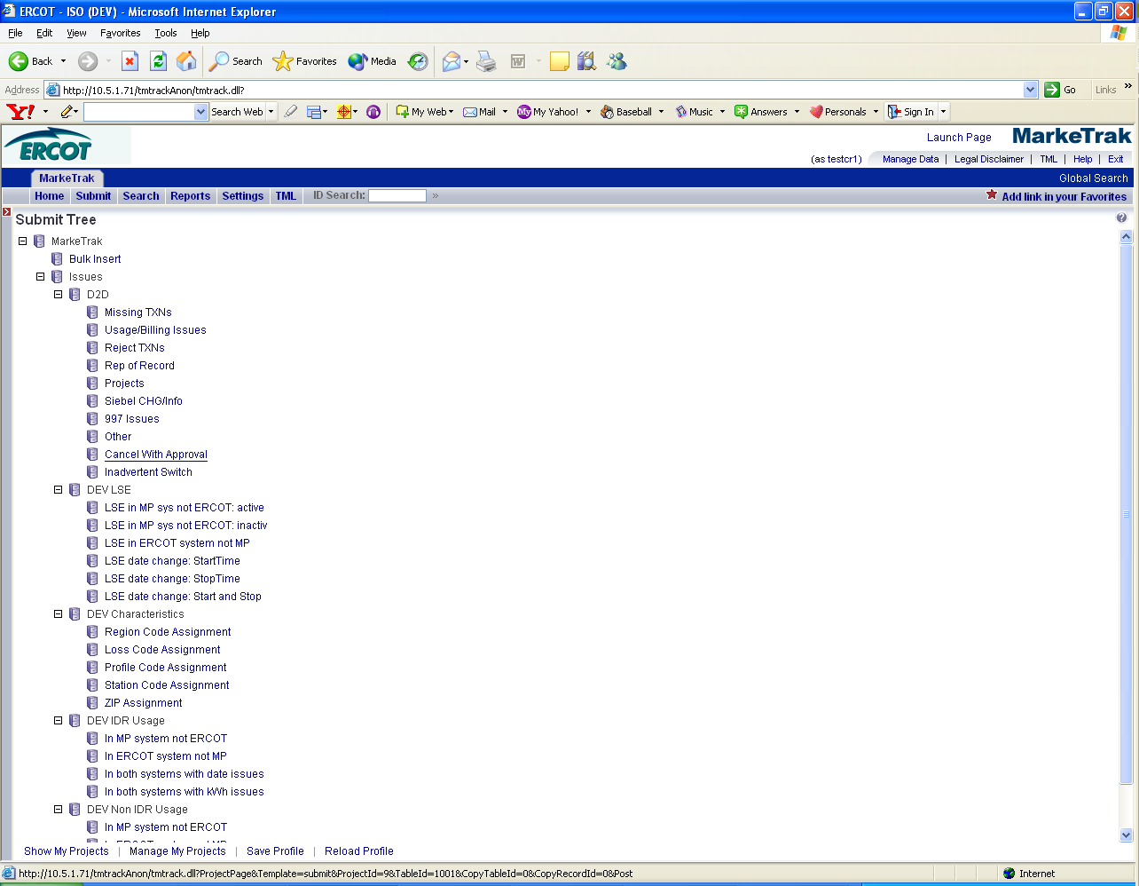

3. The following fields must be populated for successful submission of Day to Day issue sub type Cancel with Approval: (Fig 3.1b)
(For this example, the TDSP is selected)
Assignee
ESI ID
Original Tran ID
NOTE: The Assignee can be located by using the search feature through the ‘Find’ button by typing in all or part of the MPs name or DUNS number. The Comments field is optional.
4. Select OK.

Fig 3.1b
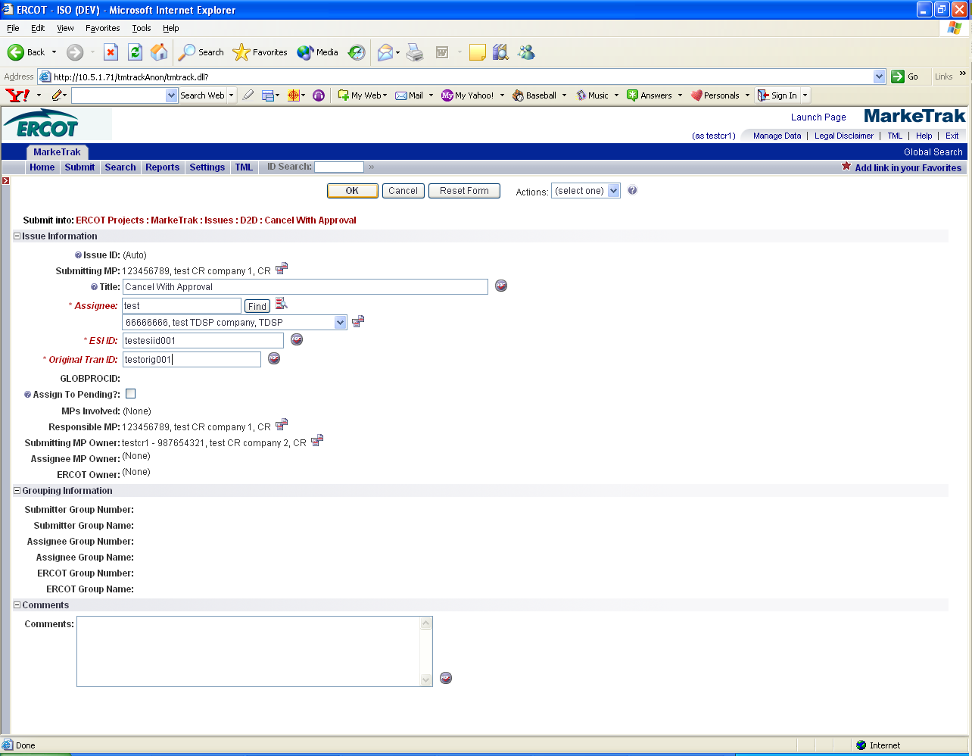

5. By selecting OK, the issue is transitioned to the Assigned MP (TDSP) and is showing as New in the TDSP’s queue. The Submitter has the option to Withdraw the issue at any time until the Begin Working has been selected by someone other than the submitter. There are three buttons that will appear on every state throughout the issue: Add Comment, Assign to Group, Assign to Owner. At any state a comment can be added by selecting the Add Comment button. Assign to Group and Assign to Owner are explained in section 8.1. (Fig 3.1c)

Fig 3.1c
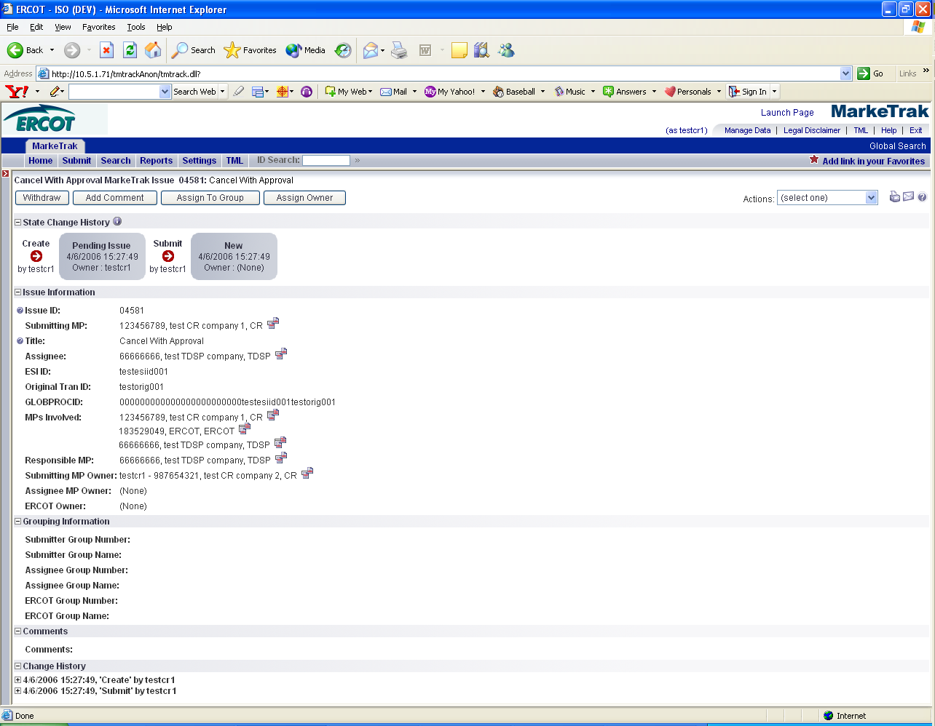

6. The TDSP becomes the Responsible MP.
7. The TDSP selects Begin Working. The issue becomes In Progress with the TDSP and the CR is no longer able to Withdraw the issue. (Fig 3.1d)

Fig 3.1d
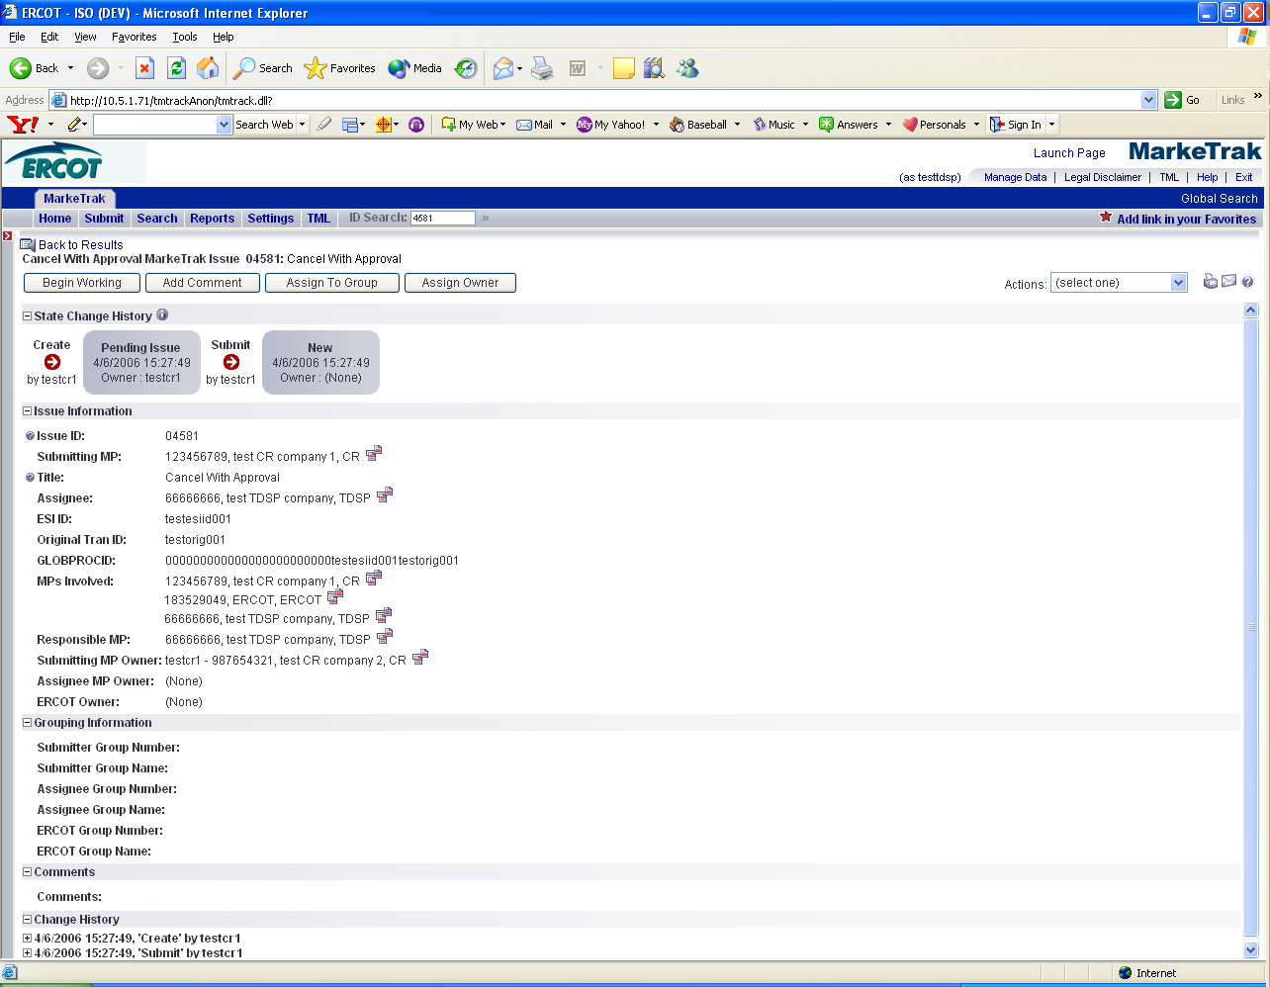

- The TDSP reviews the issue. The TDSP must select Add Comment and add a comment for ERCOT to issue 814_08s or if they will send an 814_28 09 to ‘Unexecute’ the order. The TDSP selects OK. (Fig 3.1e & 3.1f)

Fig 3.1e
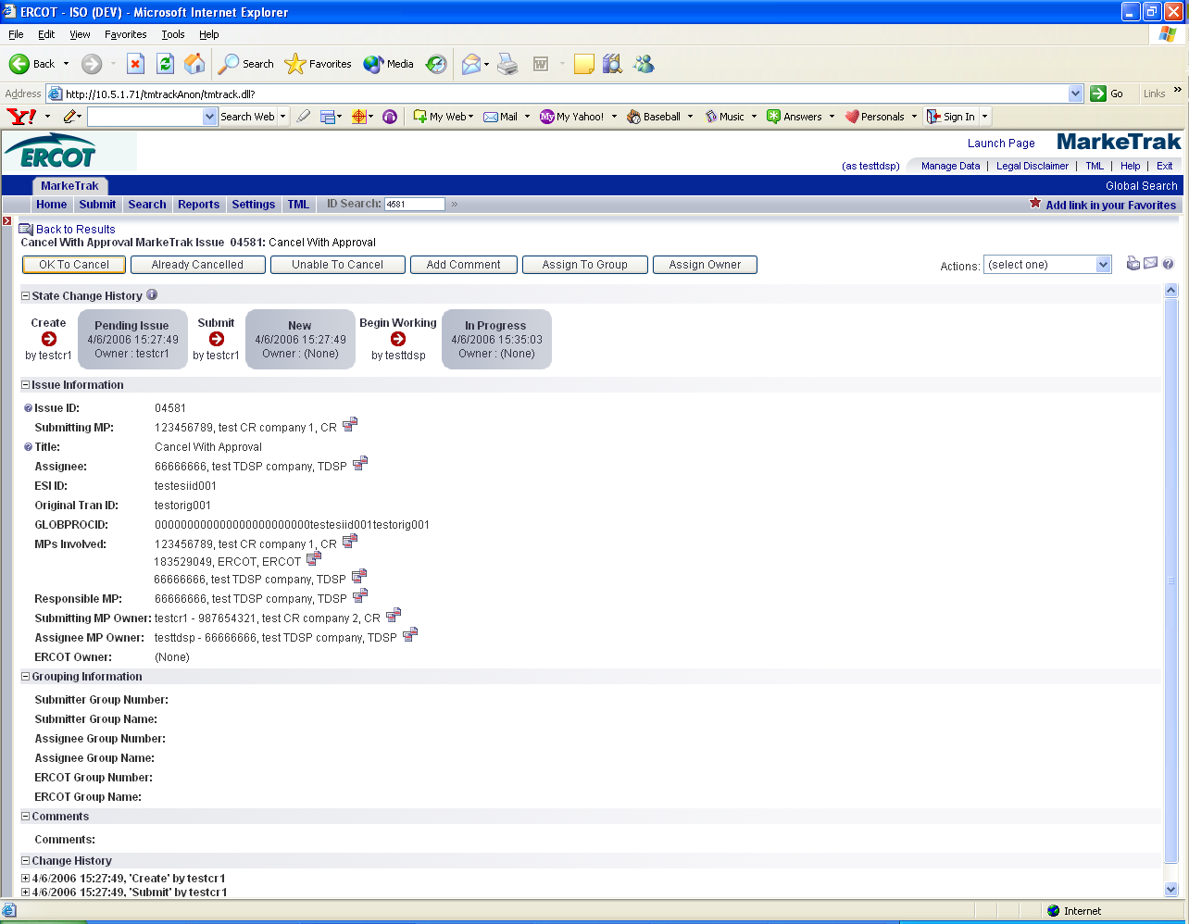

Fig 3.1f
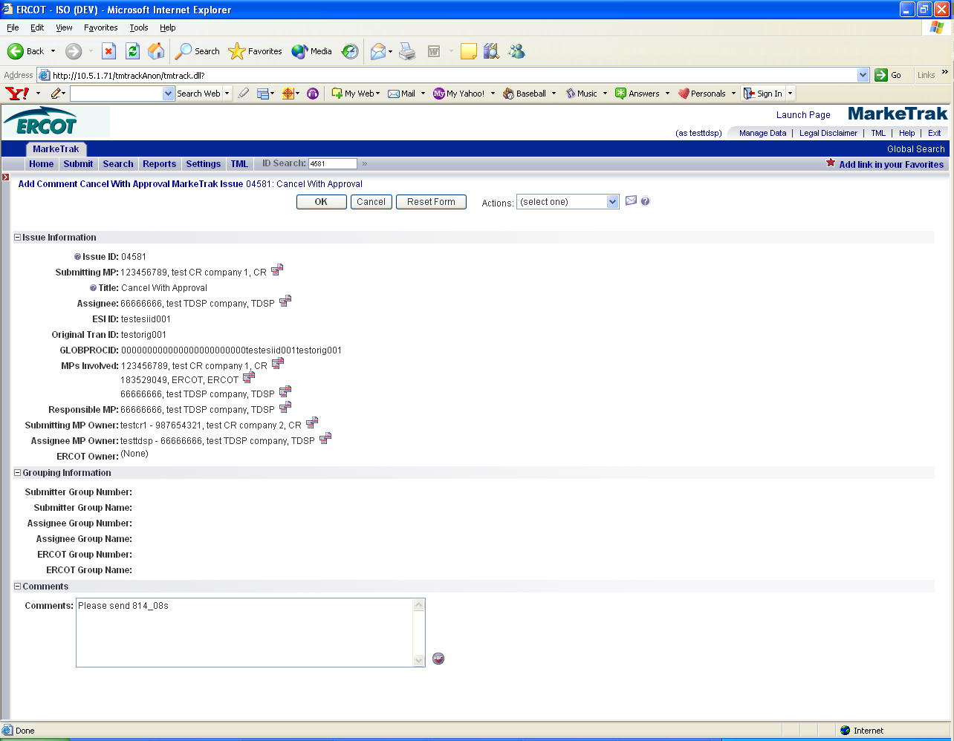

9. If the TDSP intends to cancel the order with an 814_28_09 they should:
- Not transition the issue to ERCOT by selecting OK to cancel. Instead the TDSP shall monitor the issue until it shows Cancelled Unexecutable in Siebel.
- Once the Siebel Status shows Cancelled Unexecutable, the TDSP selects Already Cancelled. This type of issue should not transition to ERCOT.
- With the TDSP selecting Already Cancelled the issue is transitioned back to the submitter in a Cancelled (PC) state.

10. If the TDSP indicates that they will be sending the 814 28_09 but still selects Ok to Cancel transitioning the item, ERCOT will:

- One (1) business day after the TDSP has stated their intentions to send the 814_28_09, and upon verification at ERCOT that this transaction has not been received, ERCOT will send an email to the Assignee MP owner (or submitting MP Owner if submitted by TDSP), stating ‘Awaiting receipt of 814_28_09 per TDSP comments. Please send.’ MT comments will also be updated.
- Two (2) business days after the TDSP has stated their intention to send the 814_28_09, and upon verification at ERCOT that this transaction has not been received, ERCOT will send an email to the Submitting MP Owner, Assignee MP Owner, and Escalation Primary D2D stating ‘The TDSP has indicated on this issue that they will be sending an 814_28_09 Unexecutable. This has not been received at ERCOT at this time. Please complete this transaction or update comments on this issue indicating you wish ERCOT to complete this cancel with an 814_08. ERCOT will mark this issue Unable to Cancel after 1 further business day.’
- COB on the Third (3) business day after the TDSP has stated their intention to send the 814_28_09, and upon verification at ERCOT that this transaction has not been received, ERCOT will select Unable to Cancel and update the comments field.
11. If the TDSP wishes ERCOT to issue 814_08s, they will select OK to Cancel. (Fig 3.1g) ERCOT will manually cancel the order in Siebel and send 814_08s to all market participants involved. The issue shows as NEW in ERCOT queue.

Fig 3.1g
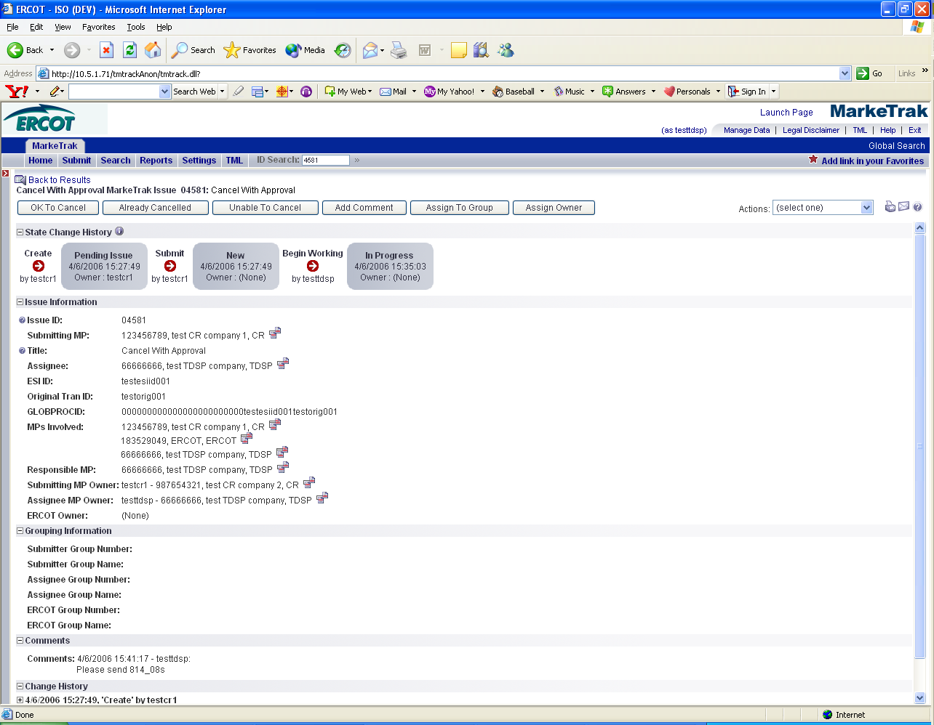

12. ERCOT will select Begin Working. Once the button is selected, the issue becomes In Progress with ERCOT. (Fig 3.1h)

Fig 3.1h
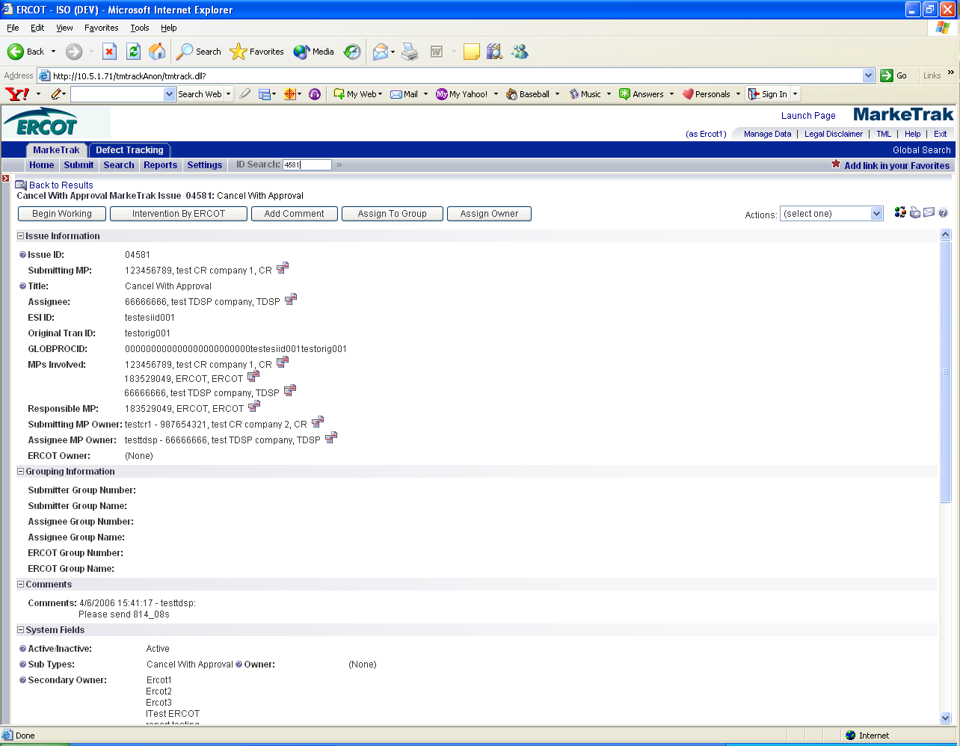

13. ERCOT will review the issue checking for comments from the TDSP indicating whether or not the TDSP will be sending an 814_28 09 or if ERCOT should manually cancel and send 814_08s.
- If the TDSP did not make a comment, the issue will be transitioned back to the TDSP by selecting ERCOT Return and the TDSP will follow Step #8. (Fig 3.1i)

Fig 3.1i
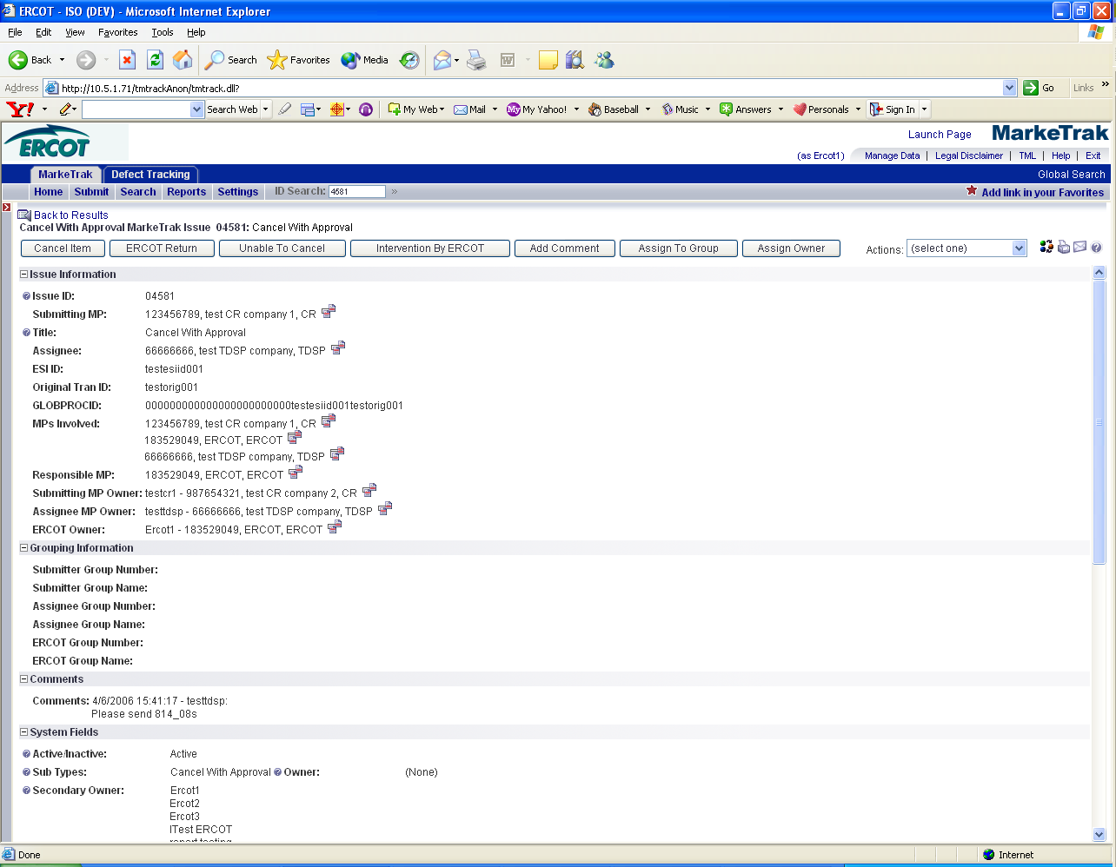

  - If the TDSP indicates to issue 814_08s, ERCOT will manually cancel the order in Siebel and send 814_08s to all market participants involved. ERCOT selects Cancel Item. (Fig 3.1j)
  - If the TDSP indicates in the comments field that they will be sending the 814_28 09 and transitions the issue to ERCOT by selecting OK to Cancel, ERCOT will not manually cancel the order or transition to pending complete, but will wait until the 814_28 09 is received and processed before selecting Cancel Item. Please refer back to step 10 for details.

Fig 3.1j
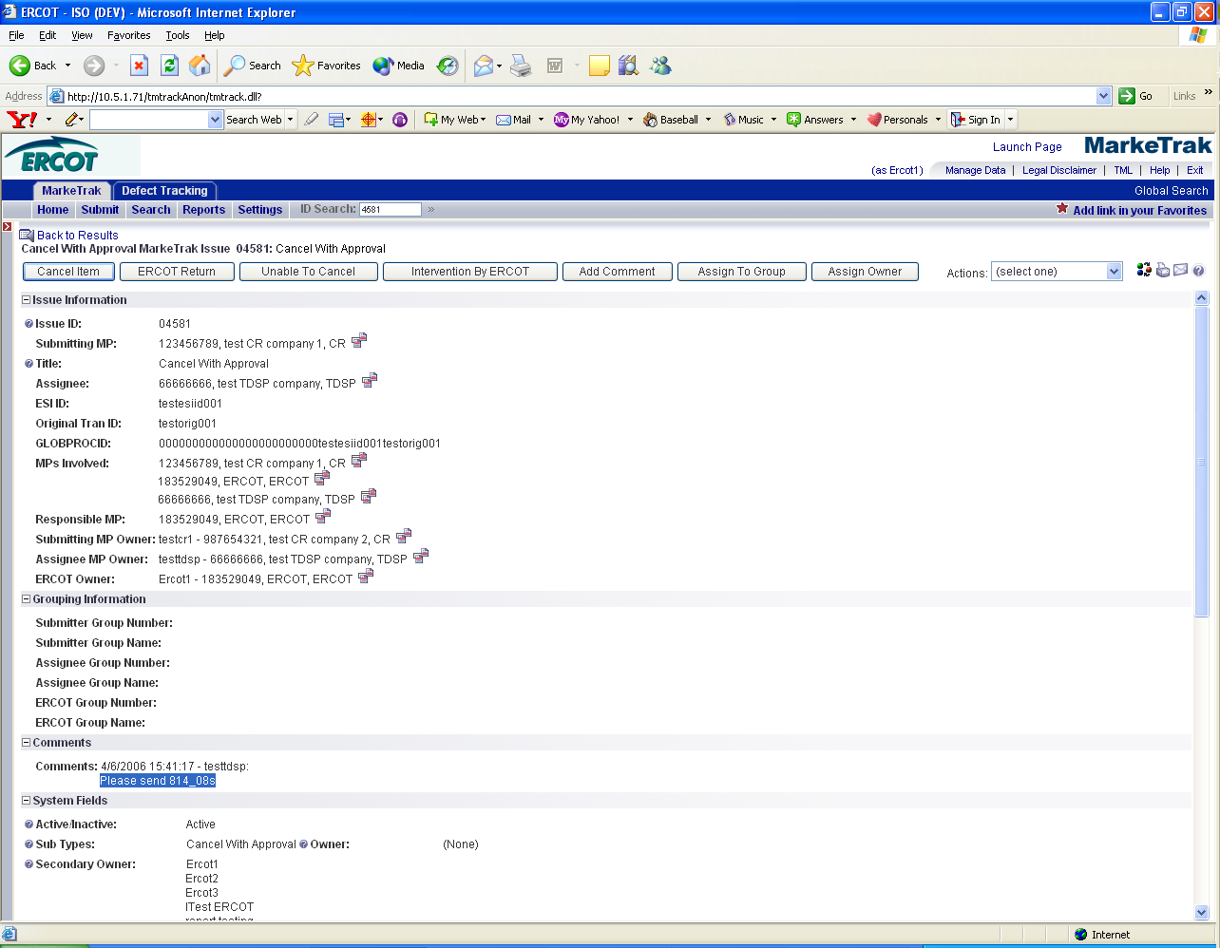

14. By ERCOT selecting Cancel Item. The issue is transitioned back to the Submitter in a Cancelled (PC) Pending Complete state.

15. In this state, the Submitter has the option to close the issue by selecting Accept or the issue will be auto closed in 14 calendar days. (Fig 3.1k)

Fig 3.1k
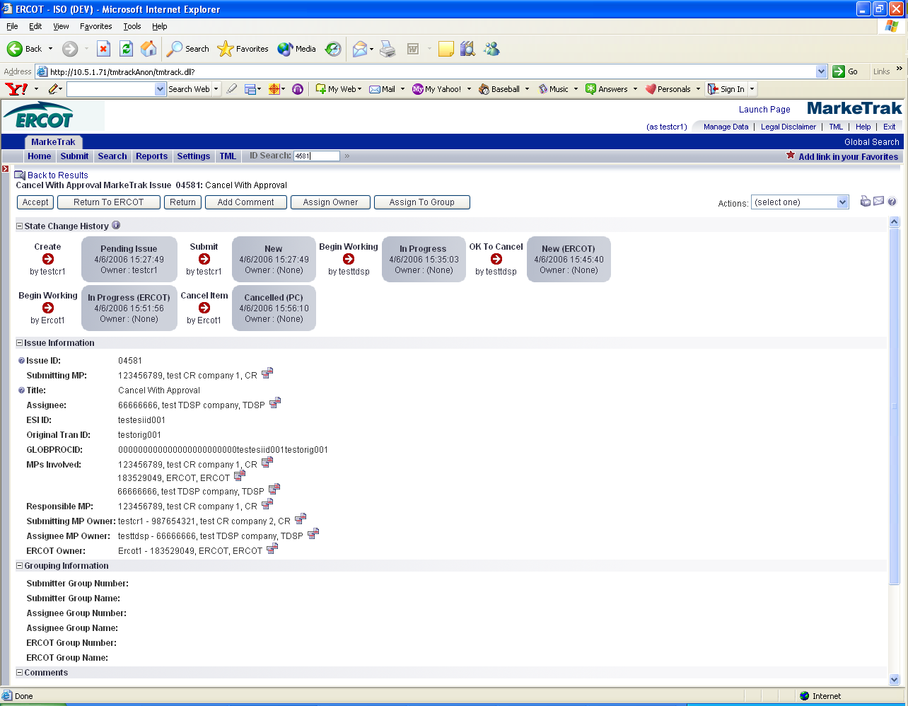

3.1.3.2 Example: A CR submits a Cancel with Approval and TDSP selects ‘Unable to Cancel’

- Select the Submit tab.
- From the Submit Tree, select Cancel with Approval.
- The following fields must be populated for successful submission of Day to Day issue sub type Cancel with Approval: (For this example the TDSP is selected)
Assignee
ESI ID
Original Tran ID
NOTE: The Assignee can be located by using the search feature through the Find button by typing in all or part of the MPs name or DUNS number. The Comments field is optional.
- Select OK. (Fig 3.1l)

Fig 3.1l
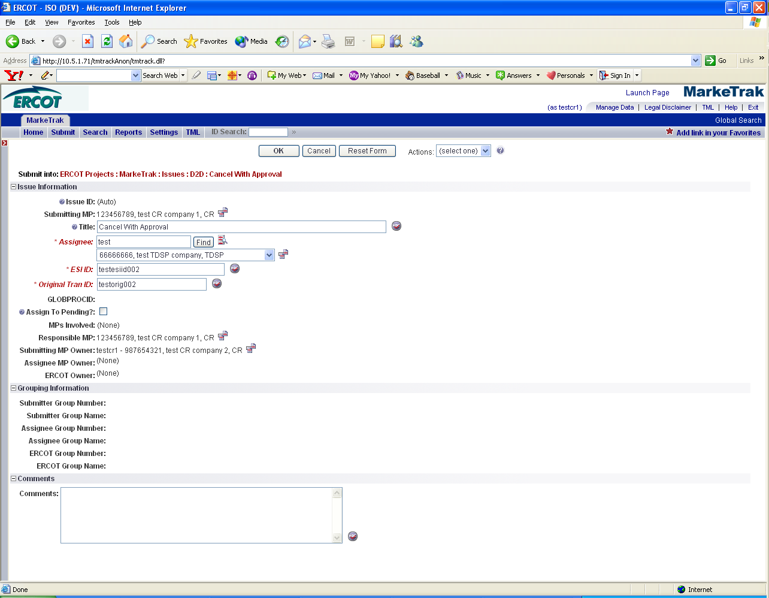

- By selecting OK, the issue is transitioned to the Assigned MP (TDSP) and is showing as New in the TDSP’s queue. The Submitter has the option to Withdraw the issue at this point.
- The TDSP becomes the Responsible MP.
- The TDSP selects Begin Working. The issue becomes In Progress with the TDSP and the Submitter is no longer able to Withdraw the issue.

The TDSP reviews the issue. The TDSP has two negative path options: Already Cancelled or Unable to Cancel. (Fig 3.1m) A negative path always requires a comment in the comment field. For this example, the TDSP selects Unable to Cancel, includes a comment and selects OK. (Fig 3.1n)

Fig 3.1m
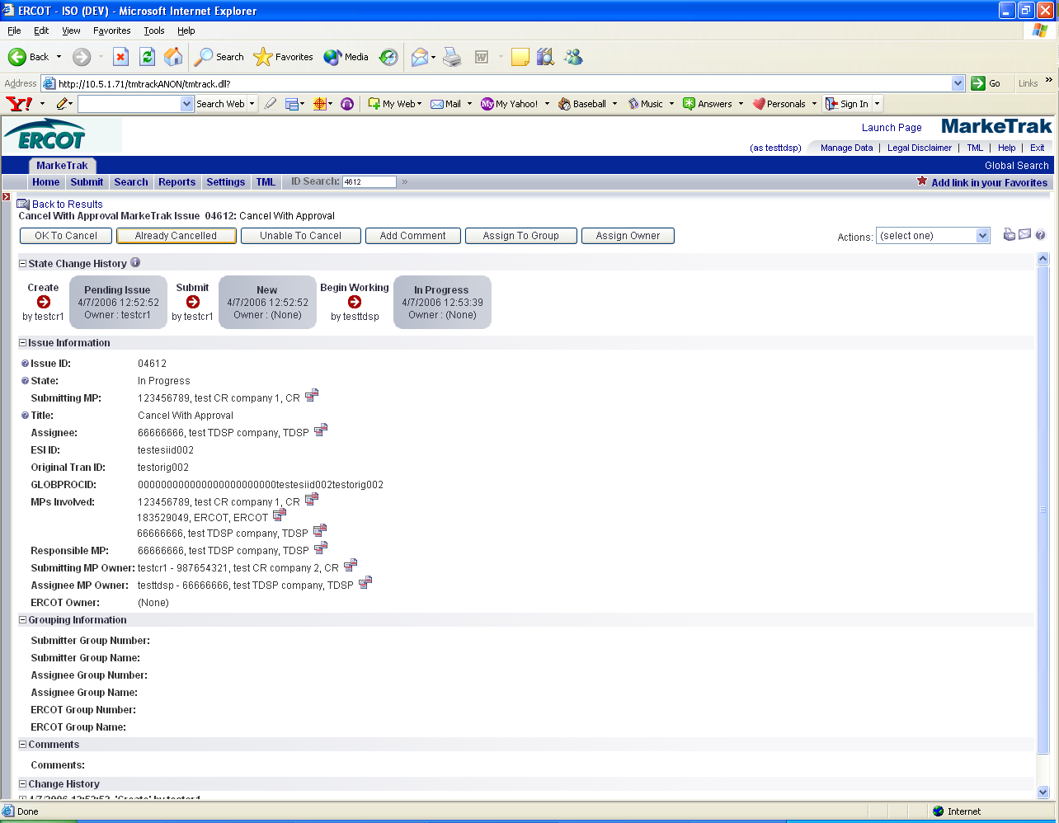

Fig 3.1n
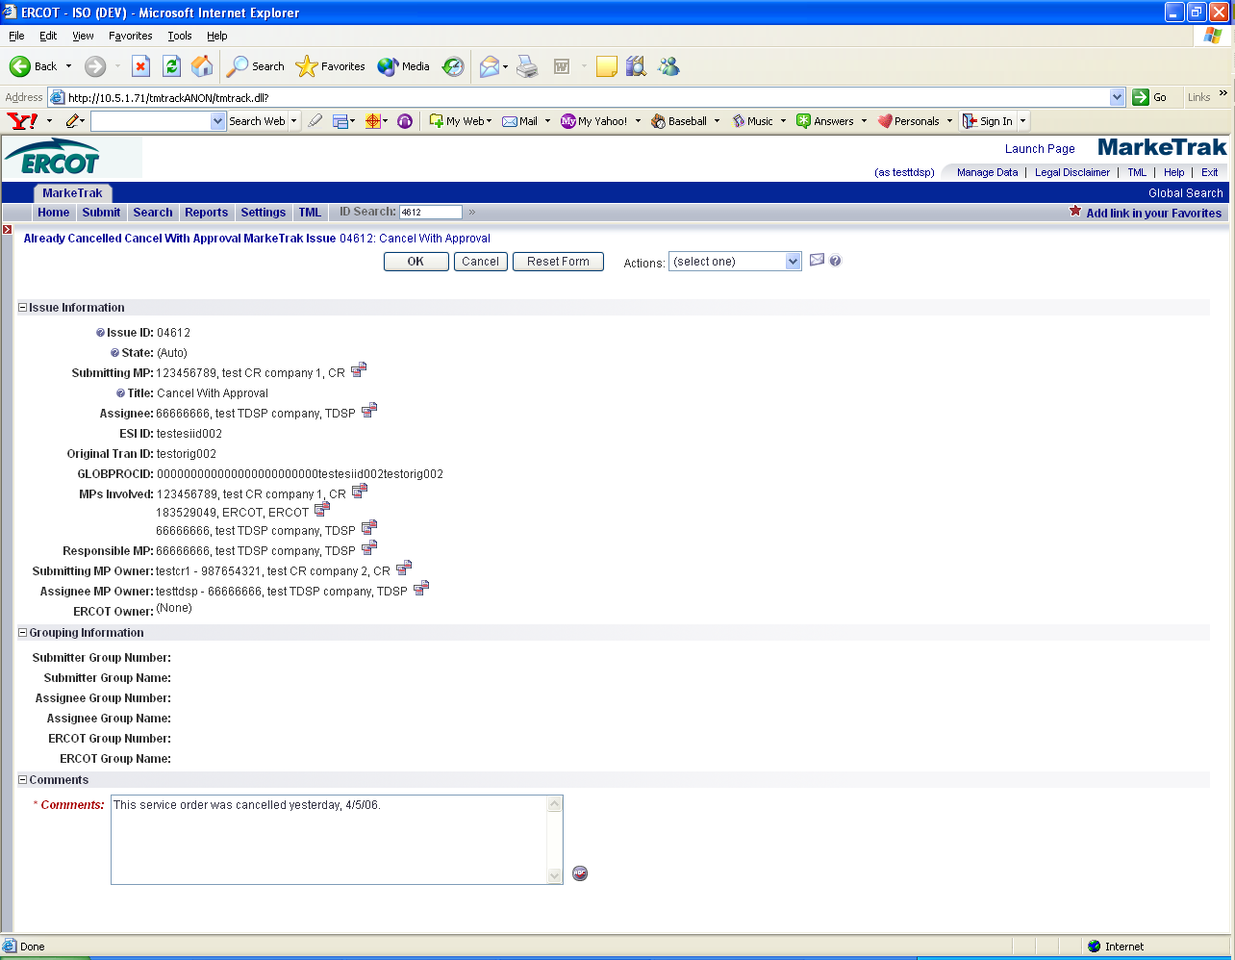

- By the TDSP selecting OK, the issue is transitioned to an Unable to Cancel (PC) state back to the Submitter. (Fig 3.1o)
- In this state, the Submitter has the option to close the issue by selecting Accept to transition to a state of Complete and close the issue. If the issue is not transitioned within 14 calendar days, on the 14th calendar day the item will automatically move to Auto Complete and close.

Fig 3.1o
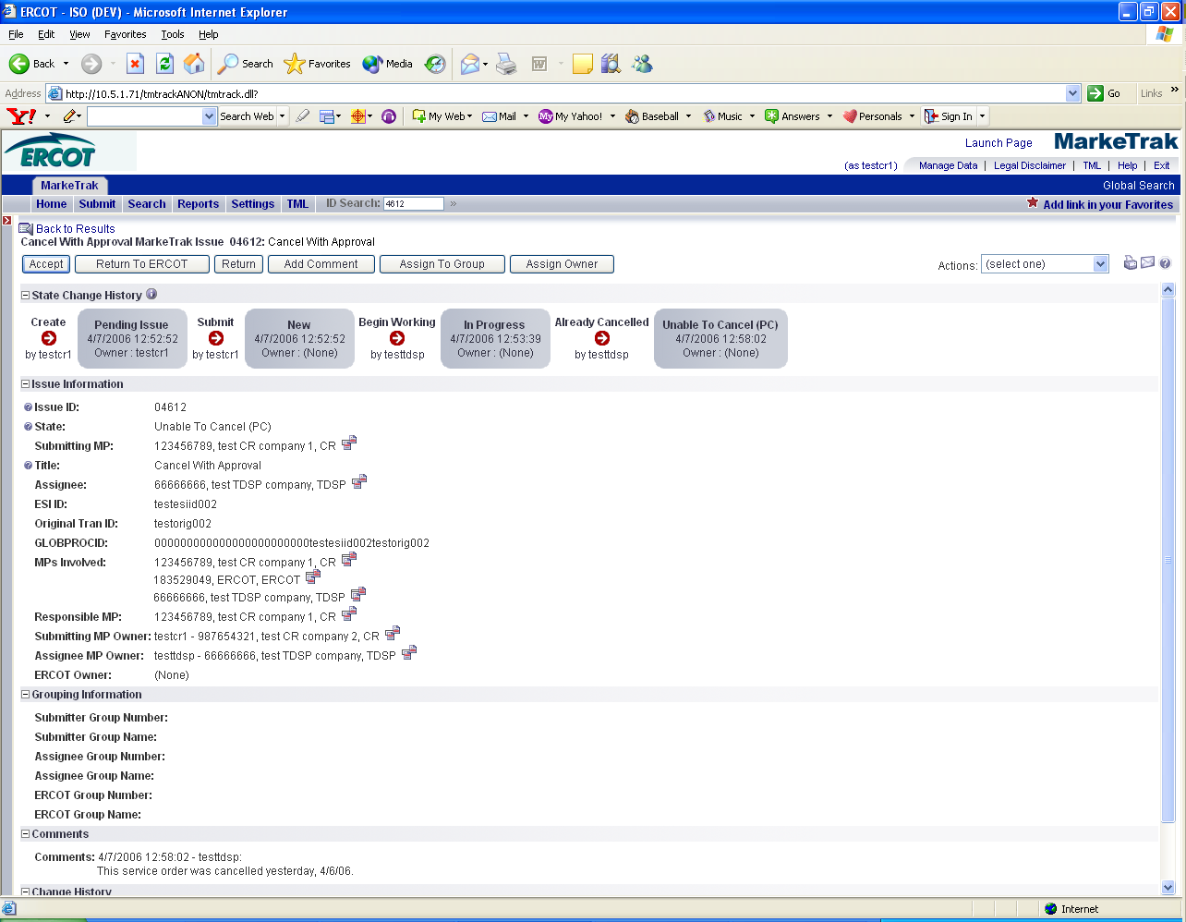

3.2 Day to Day (D2D) Issues – Cancel without Approval
3.2.1 Required fields for Cancel without approval

 | Assignee | ESI ID | Original Tran ID | Tran Type | Gaining/ Losing Rep | TXN Date | GS Number | Comments
Cancel w/o Approval | N/A | Req | Req | N/A | N/A | N/A | N/A | Opt

3.2.2 Definition of Cancel without Approval

3.2.2.1 TDSP Initiated Manual Cancellations on Pending Orders – Not Requiring CR Approval

- TDSPs must provide one of the following approved cancellation reasons (see chart below) for each pending service order.
- Standardized language will be provided along with the MarkeTrak number in the 814_08s sent to Market Participants (see chart below for standard language).
- This procedure is only applicable if the order is scheduled in Siebel and the meter read has not been sent.

TDSP Approved Cancellation Reasons | 814_08 Text
Scenario A  - Rep A submits a MVO  - Rep B submits MVI which precedes or is the same day as a scheduled MVO  - TDSPs can request cancel MVO, after MVI completed, thru MarkeTrak without CR approval. | MVO or MVO to CSA cancelled because MVI worked instead MT ________ (to be inserted by ERCOT)
Scenario B  - TDSP wants to cancel a switch because it received a safety net MVI before the switch effectuated.  - ERCOT will cancel the switch. | TDSP works a safety net move in instead of pending Drop or Switch MT ____________ (to be inserted by ERCOT)
Scenario C  - Expired (20 days) 814_28 PT transactions because 814_04 has not been received by ERCOT  - ERCOT will send a cancel with exception 814_08 on day 21 | Per TDSP request Order should have expired MIMO 23 MT ______________ (to be inserted by ERCOT)
Scenario D  - A safety net MVI is requested prior to a scheduled drop to AREP  - TDSP enters a MarkeTrak ticket to request cancellation of drop to AREP  - ERCOT will cancel Drop to AREP | TDSP works a safety net move in instead of pending Drop or Switch MT __________________ (to be inserted by ERCOT)
Scenario E  - Service Order is unexecutable (e.g., when meter removed from a premise but no ESID retired)  - TDSP enters a MarkeTrak ticket to request cancellation of Service Order  - ERCOT will cancel Service Order | Per TDSP request Unexecutable MT ____________ (to be inserted by ERCOT)

3.2.3 Submitting a Cancel without Approval
NOTE: Only the TDSP has access to submitting this sub type

3.2.3.1 Example: A TDSP submits a Cancel without Approval and ERCOT Cancels
1. The TDSP selects the Submit tab.
- From the Submit Tree, selects Cancel without Approval. (Fig 3.2a)
Fig 3.2a
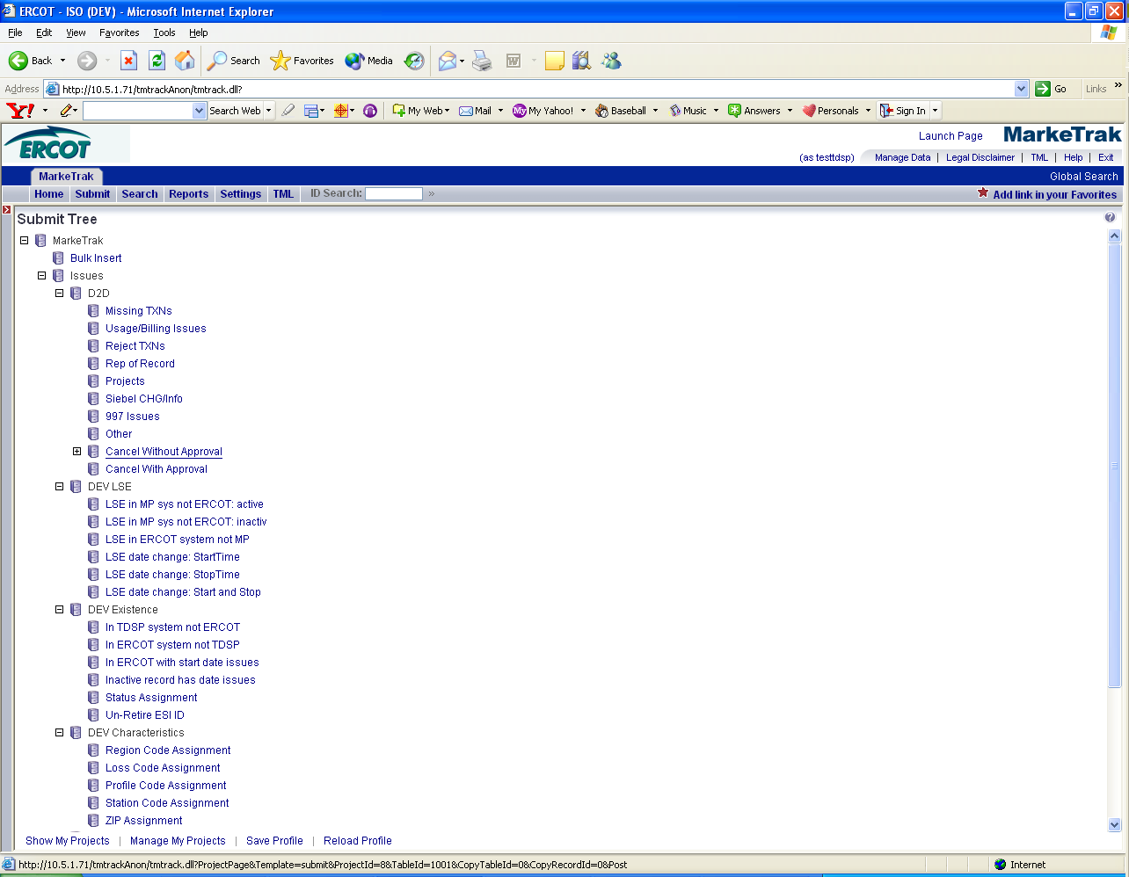

- The following fields must be populated for successful submission of Day to Day issue sub type Cancel without Approval: (Fig 3.2b)
ESIID
Original Tran ID
**NOTE: Please include the TDSP Approved Cancellation Reason from Section 10.5.2.1 in the COMMENTS field. The Reason will need to be given in order for ERCOT to work the issue. If the reason not given, ERCOT will return the issue back to the TDSP.

- Select OK.
Fig 3.2b

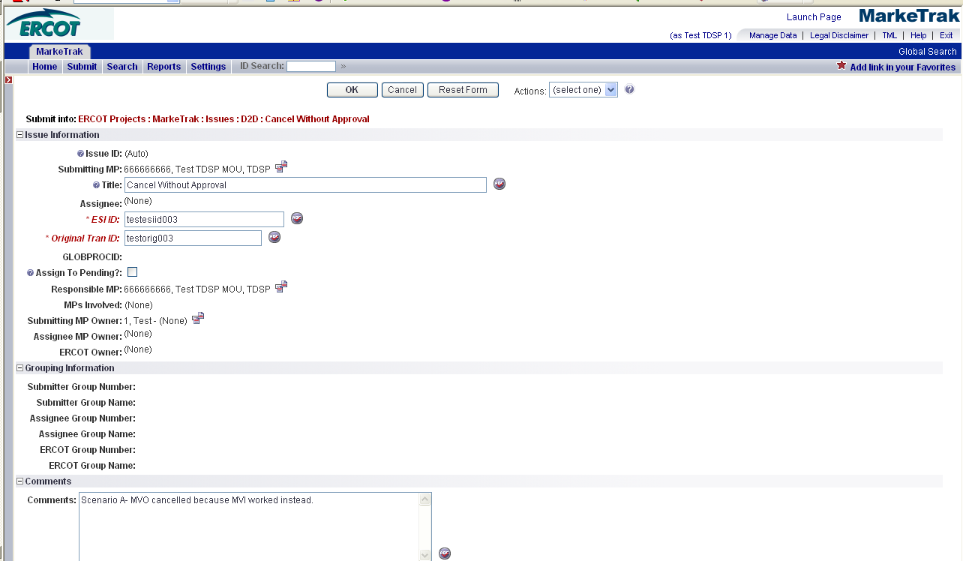
- By selecting OK, the issue is transitioned to ERCOT’s queue in the state of New and is visible only by the TDSP and ERCOT. The TDSP has the option to Withdraw the issue at this point. There are four buttons that will appear on every transition throughout the issue: Add Comment, Assign to Group, Assign to Owner and Update Siebel Status/Substatus. (Fig 3.2c) At any state a comment can be added by selecting the Add Comment button. Assign to Group and Assign to Owner are explained in section 8.1. Update Siebel Status/Substatus is explained in section 9.4

Fig 3.2c
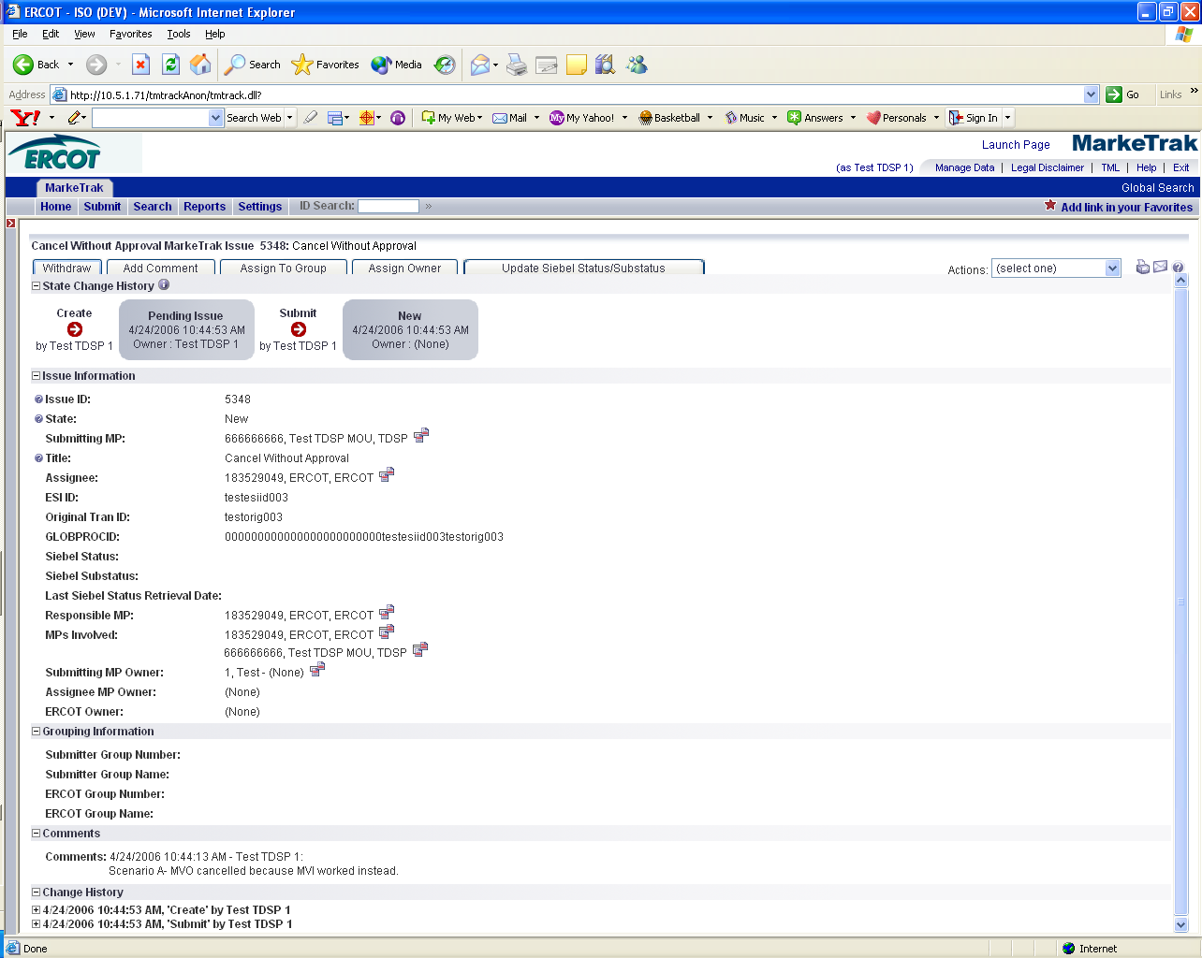

- ERCOT selects Begin Working. The TDSP is no longer able to Withdraw the issue. (Fig 3.2d)

Fig 3.2d
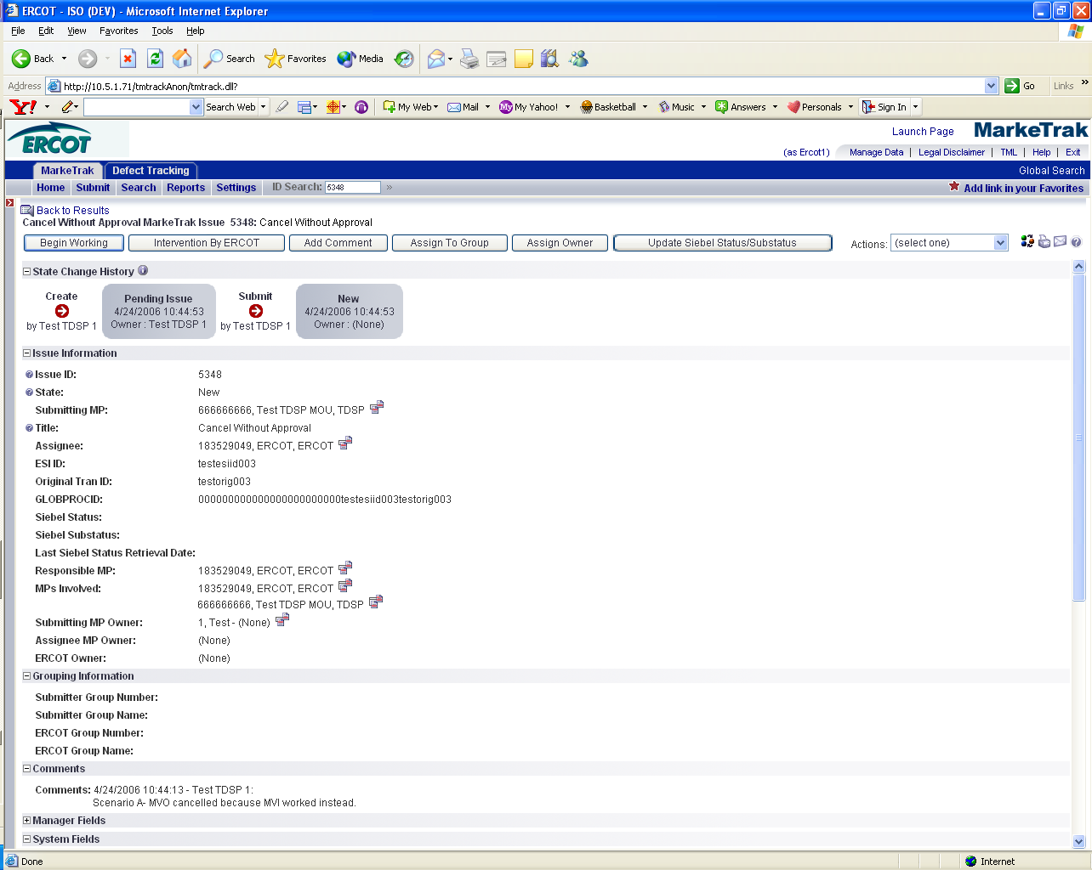

- ERCOT has the options to Cancel Item or Unable to Cancel. If ERCOT is able to cancel and the TDSP Cancellation Reason is included in the Comments field, ERCOT will manually cancel the Siebel service order and send 814_08s to all market participants involved. ERCOT selects Cancel Item and has the option to add any comments. (Fig 3.2e)

Fig 3.2e
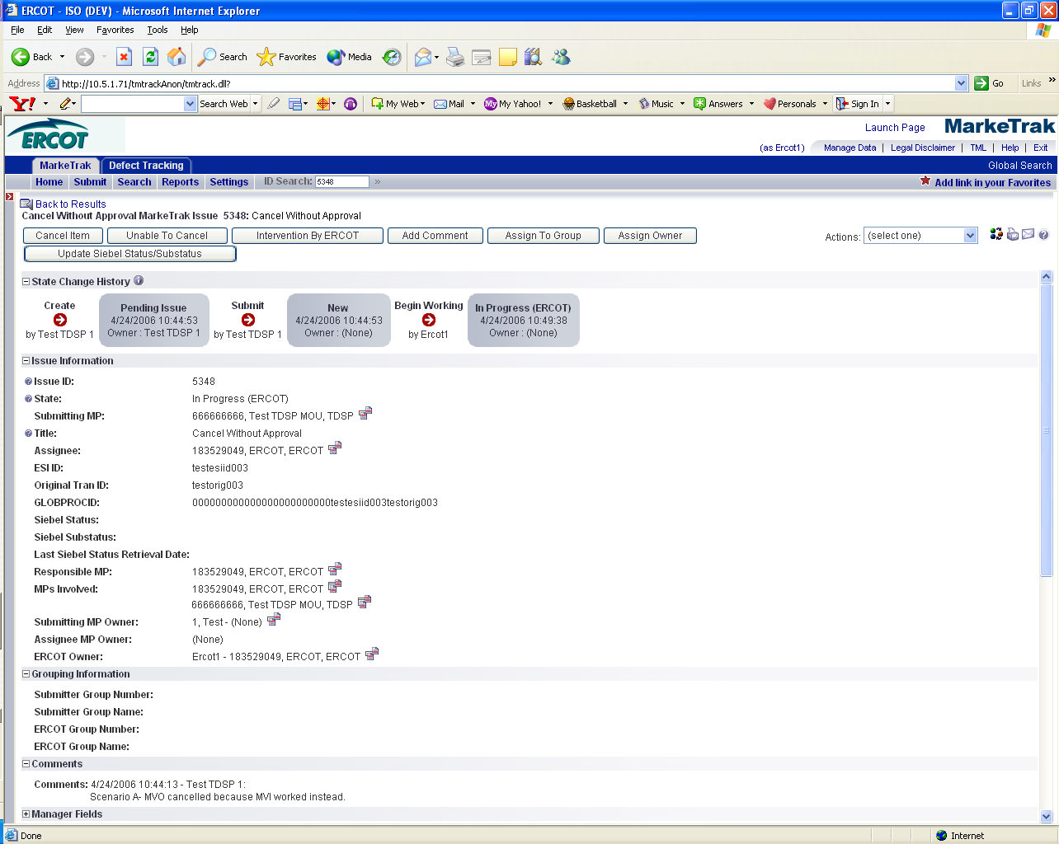
.

- The issue is now in a Cancelled- PC (Pending Complete) state. The TDSP can select to Return to ERCOT (to return to state New ERCOT) or Accept to transition to a state of Complete and close the issue. If the issue is not transitioned for 14 calendar days, then the item will automatically move to Auto Complete and close. (Fig 3.2f)

Fig 3.2f
