MarkeTrak Users Guide
Section 2: Inadvertent Switch

Table of Contents
MarkeTrak Users Guide 1
2.1 Day to Day Issues – Inadvertent Switch 3
2.1.1 Required Fields for Inadvertent Switch 3
2.1.2 Definition of Inadvertent Switch 3
2.1.3 Submitting an Inadvertent Switch 4

2.1 Day to Day Issues – Inadvertent Switch

2.1.1 Required Fields for Inadvertent Switch
 | Assignee | ESI ID | Original Tran ID | Tran Type | Gaining/ Losing Rep | TXN Date | GS Number | Comments
Inadvertent Switch | N/A | Req | Req | Opt | Req | Opt | N/A | Opt

2.1.2 Definition of Inadvertent Switch
Note: For purposes of this section of the MarkeTrak Users Guide, CR2 is defined as the non-submitting CR. For example, if the submitting rep indicates they are the Gaining CR then CR2 is the losing rep and vice versa.

An inadvertent issue begins upon the discovery of an inadvertent Switch or Move-In transaction submission. Upon identification of an Inadvertent Switch or Move-in, the CR will check the transaction status via the ERCOT TML.
1. If transaction Status is pending, and the Inadvertent CR is the submitting CR, then the CR will cancel their submitting transaction either by submitting an EDI cancel transaction or following the procedures outlined in Section 10.5.
2. For other Status types or if the CR was not the submitter of the transaction, the CR will log a MarkeTrak Inadvertent issue.
a. Only one ESI ID is allowed per MarkeTrak issue.
b. CR’s should refer to and follow additional steps that are outlined in the Retail Market Guide under “TDSP’s Inadvertent Switch Process”.
3. CR’s will work together in a manner outlined in Section 7.2 of the Retail Market Guide (RMG) to determine appropriate resolution. The Retail Market Guide is available in the Market Guides section of www.ercot.com. See 10.2.2 of the MarkeTrak Manual for response timelines required. If responses are not received in an adequate timeframe, the CR should escalate to the CR Inadvertent MarkeTrak contact.
4. If the CR/TDSP resolution requires a backdated move-in being generated by the Original CR, then the date should be at least the Gaining CR start date plus 1 day to avoid creating transaction business process exceptions at ERCOT and the TDSP.

NOTE: Move-Outs should not be used to resolve an inadvertent issue on an energized ESI ID

2.1.2.1 ERCOT’s Receipt of Inadvertent Switch Issue

- Confirm the pending or actual change of CR relationship.
- Assign CR2 and the TDSP to the MarkeTrak issue.
- Update the issue with the following information:
  - If the ESI ID transfer is pending in ERCOT systems:
    - Pending Original CR stop date (scheduled read date minus 1)
    - Pending Gaining CR start date (scheduled read date)
  - If the ESI ID transfer has completed in ERCOT systems:
    - Original CR stop date
    - Gaining CR start date
  - The ESI ID type as maintained in ERCOT systems by the TDSP
- ERCOT will transition the MarkeTrak issue to the parties involved with CR2 as the Responsible MP.
- CR2 is responsible for selecting Begin Working to transition the item into a Vote State.
- The Original CR must notify the TDSP of the BGN02 prior to sending the MVI.

2.1.2.2 Examples of Invalid Inadvertent Switch Issue
Sometimes, ERCOT will immediately return the issue to the submitter. This is done by ERCOT selecting Unable To Complete and entering in a required comment with the reason the issue could not be worked.

Possible reasons include:

- Invalid ESI ID
- Wrong or Invalid Tran ID
- Invalid Order Type (order something other than MVI or Switch)
- Submitter selected Gaining and is not the Gaining CR
- Submitter selected Losing and is not the Losing CR
- ESI ID was De-Energized prior to completion of MVI
- The Losing and Gaining CR are the same
- Losing CR has left the Market
- Gaining CR has left the Market
- Order was Cancelled – No IAS
- Other

NOTE: ERCOT will monitor the volume of Inadvertent MarkeTrak Issues and provide reporting on an as-needed basis to RMS or the PUC. Reports will identify the submitting and resolving/monitoring party as logged in the MarkeTrak issue and will not attempt to identify the party responsible for the inadvertent issue

2.1.3 Submitting an Inadvertent Switch
Only a CR can submit an Inadvertent Switch

2.1.3.1 Example: CR Submits Inadvertent Switch as the Losing CR

- The CR selects the Submit tab (Fig 2.1a)
- From the Submit Tree, select Inadvertent Switch

Fig 2.1a
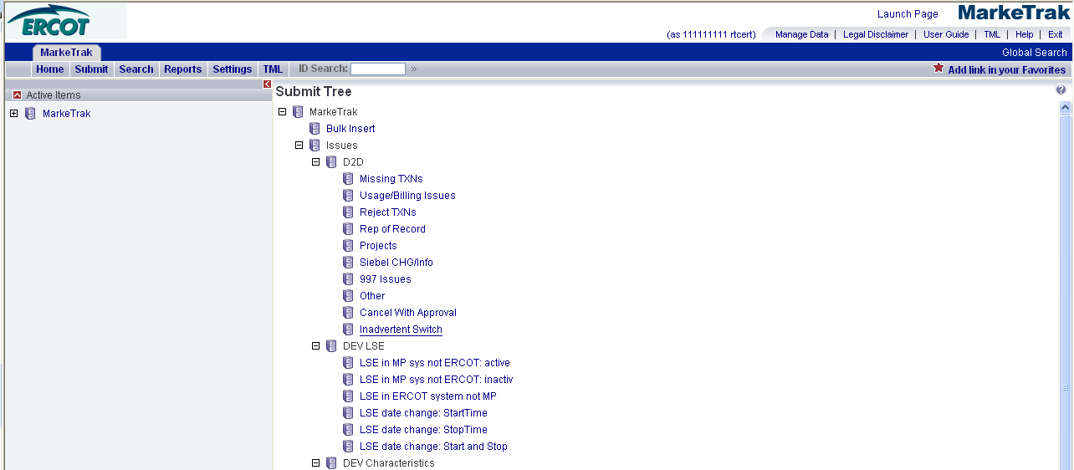

- The following fields must be populated for successful submission of Day to Day issue sub type Inadvertent Switch: (Fig 2.1b)

(For this example, the submitter selects Losing CR)

ESI ID
Original Tran ID
Gaining or Losing Rep?

NOTE: The Comments field is optional. Please include any additional information in this box.

- Select OK.

Fig 2.1b
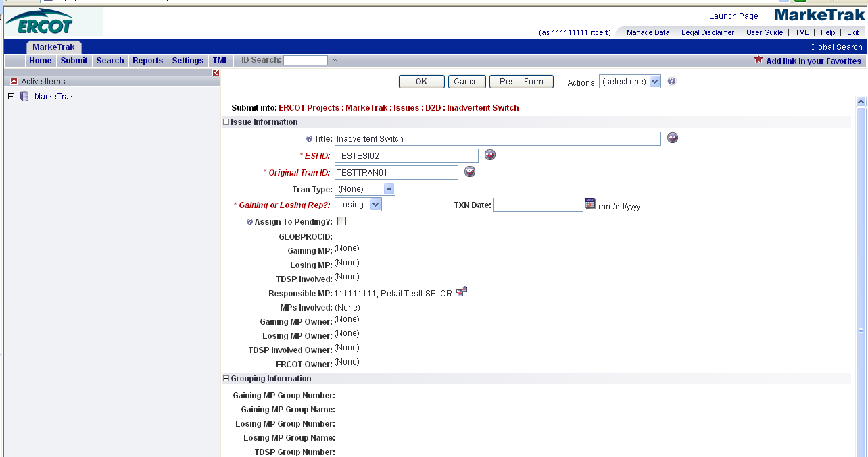

- By selecting OK, the issue enters ERCOT’s queue in a state of New and is visible only by the Submitting CR and ERCOT.
- The Submitting CR has the option to Withdraw the issue at this point. There are four buttons that will appear on every state throughout the issue: Add Comment, Assign to Group, Assign to Owner and Update Siebel Status/Substatus. At any state a comment can be added by selecting the Add Comment button. Assign to Group and Assign to Owner are explained in section 8.1. Update Siebel Status/Substatus is explained in section 9.4. (Fig 2.1c)

Fig 2.1c
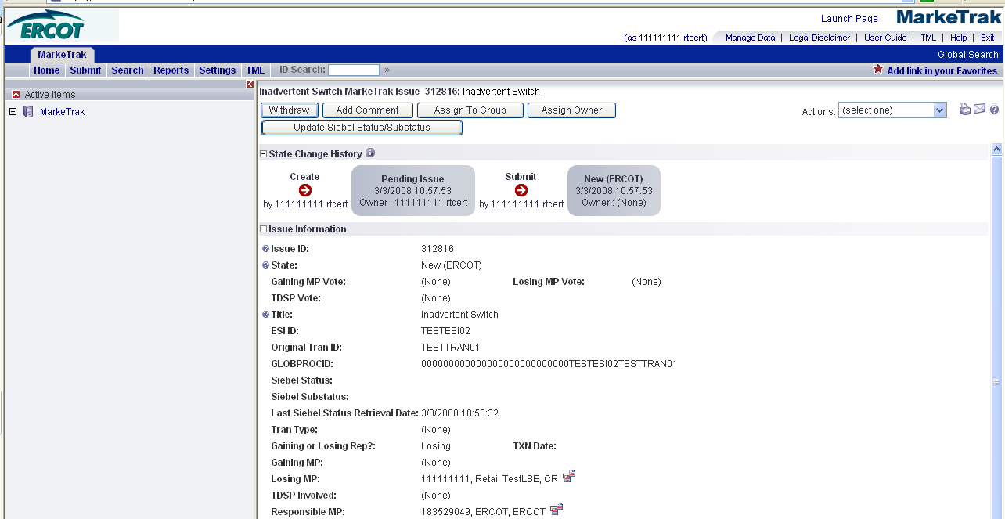

- ERCOT selects Begin Working and the issue is transitioned in a new state of In Progress-Assignee. (Fig 2.1d)
- At this point, the Submitting CR can no longer Withdraw the issue.

Fig 2.1d
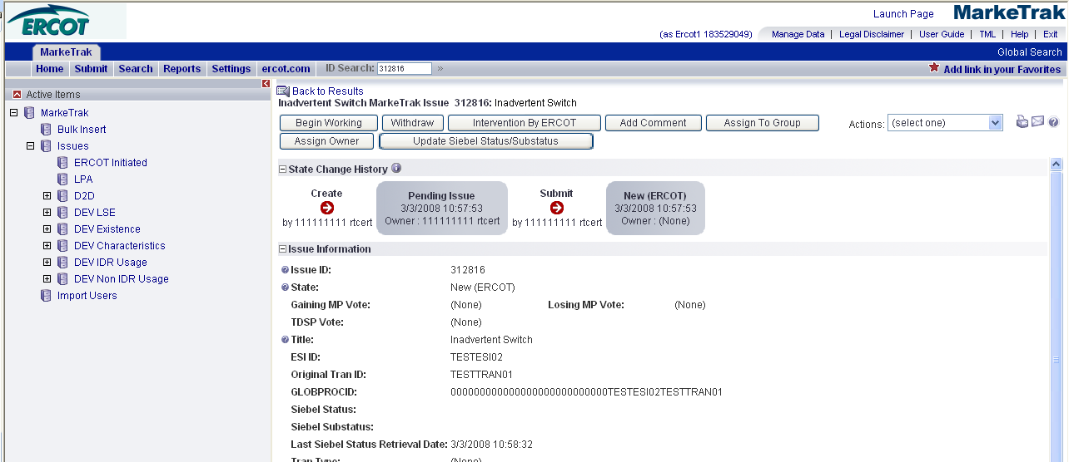

- ERCOT selects Select IAS Parties. ERCOT will verify the service order reported by the Submitting CR and service history in Siebel. (Fig 2.1e)

Fig 2.1e
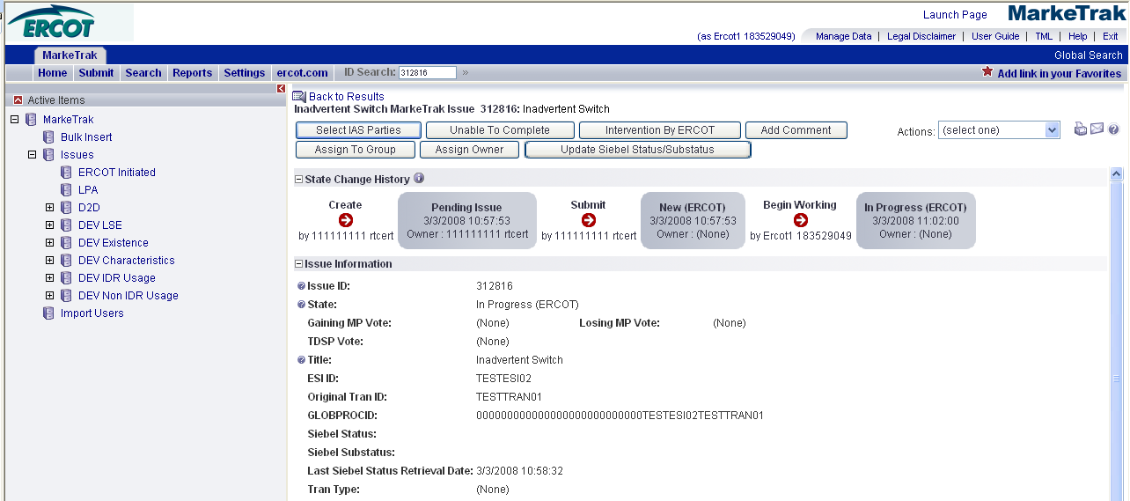

- Once everything is verified, ERCOT will populate CR2 (Gaining Rep), the TDSP and Comments. (Fig 2.1f)
- ERCOT selects OK.

Fig 2.1f
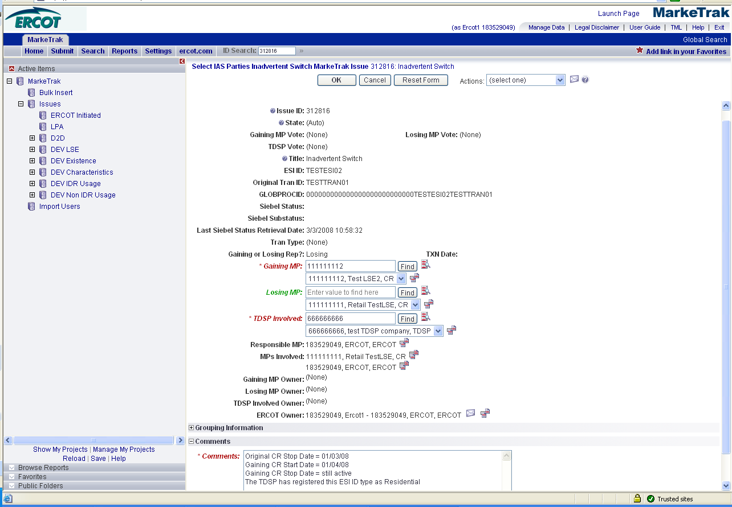

- CR2 (Gaining Rep) is now the Responsible MP. (Fig 2.1g)

Fig 2.1g
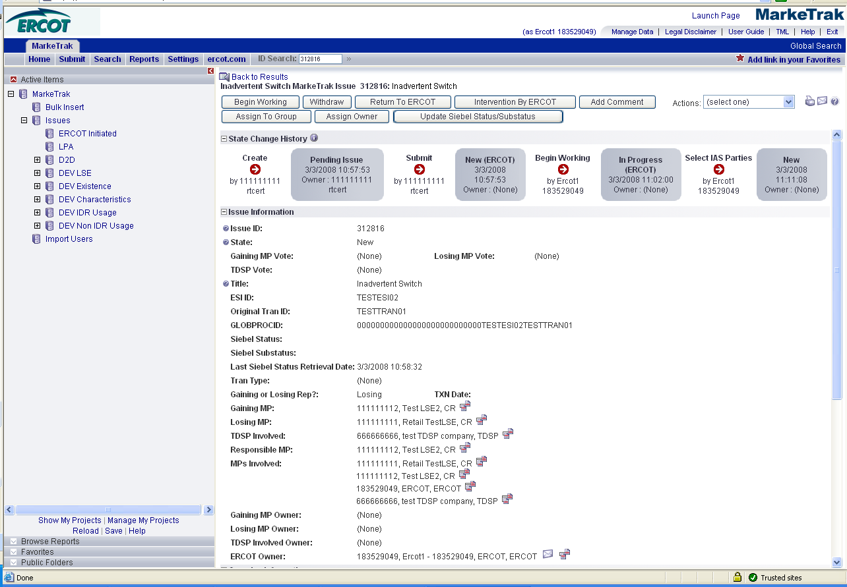

- Only CR2 (Gaining Rep) can Begin Working, which transitions the issue to a state of Vote. Visibility remains unchanged from Submitting CR, CR2 (Gaining Rep), TDSP and ERCOT. (Fig 2.1h)

Fig 2.1h
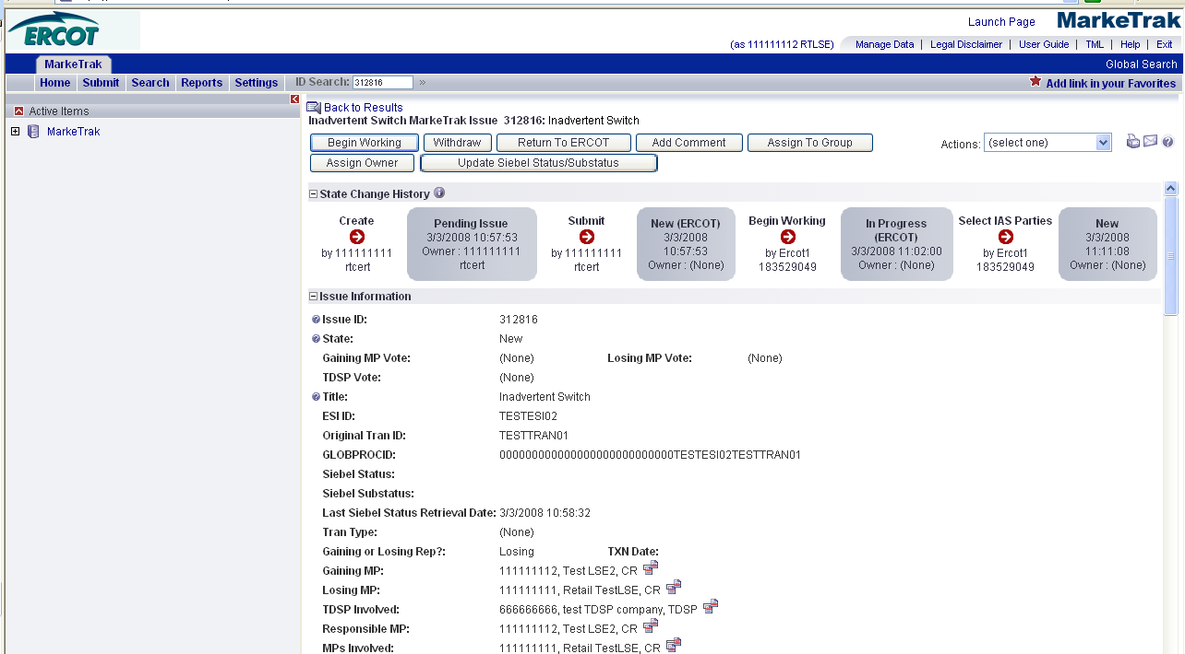
- CR2 selects Begin Working and the issue is transitioned to a state of Vote. (Fig 2.1i) The Submitting CR, CR2 (Gaining Rep) and the TDSP have the ability to select either Agree or Unexecutable to the requested resolution, and add comments. Vote (or lack of vote) is displayed on the issue.
  - Note: the Agree/Unexecutable binary can be changed at any time by the appropriate entity while the item is in this state. (Fig 2.1j)
    - If at any time one of the three entities selects the transition Unexecutable, the issue will transition to a state of Unexecutable-Pending Complete.
    - When/If all three entities have selected Agree simultaneously, the issue will transition to a state of Agreement Reached – Pending Complete immediately upon the third agreement.

Fig 2.1i
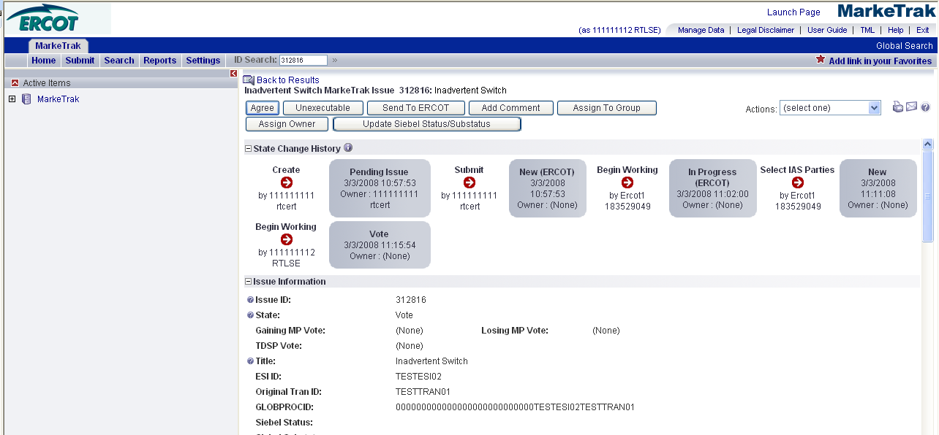

Fig 2.1j
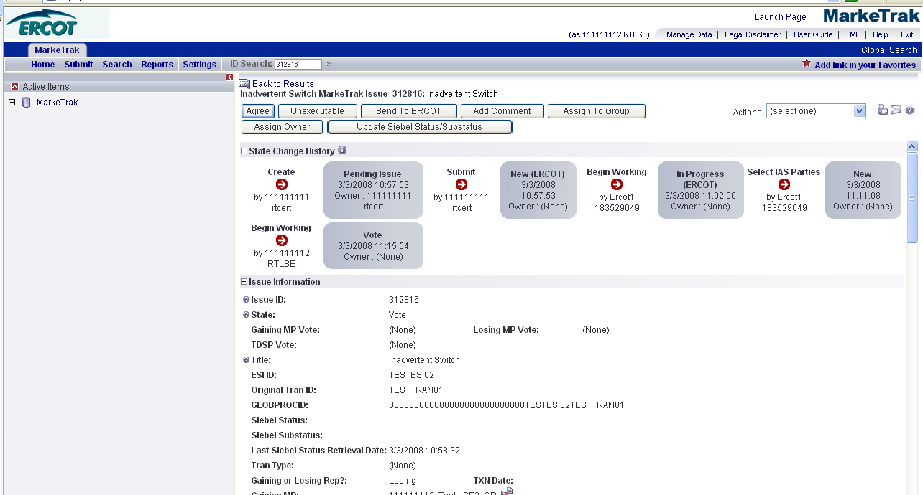

- CR1 will begin researching the issue after CR2 (Gaining CR) has voted Agree. CR1 would select Add comments, updating the issue with any relevant comments, including the BGN02 of the Enrollment transaction and vote Agree. (Fig 2.1k)
  - Once BOTH CR’s have selected Agree, the TDSP will begin researching the IAS. Upon completion, the TDSP will update the MarkeTrak issue to acknowledge the fact that their system has been prepared to receive the Enrollment Transaction sent by CR1 to regain the ESI ID, thus resolving the IAS. (Fig 2.1l)
NOTE: It is extremely important that CR1 wait for the TDSP to update with a comment stating that the TDSP’s systems have been prepared to receive the Original MP’s transaction before the EDI is actually sent. If not, the EDI will be rejected at the TDSP.

Fig 2.1k
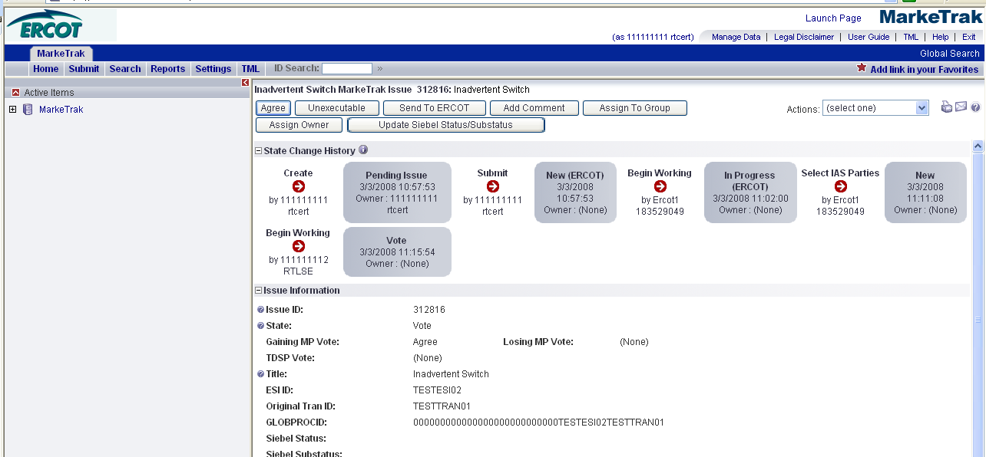

Fig 2.1l
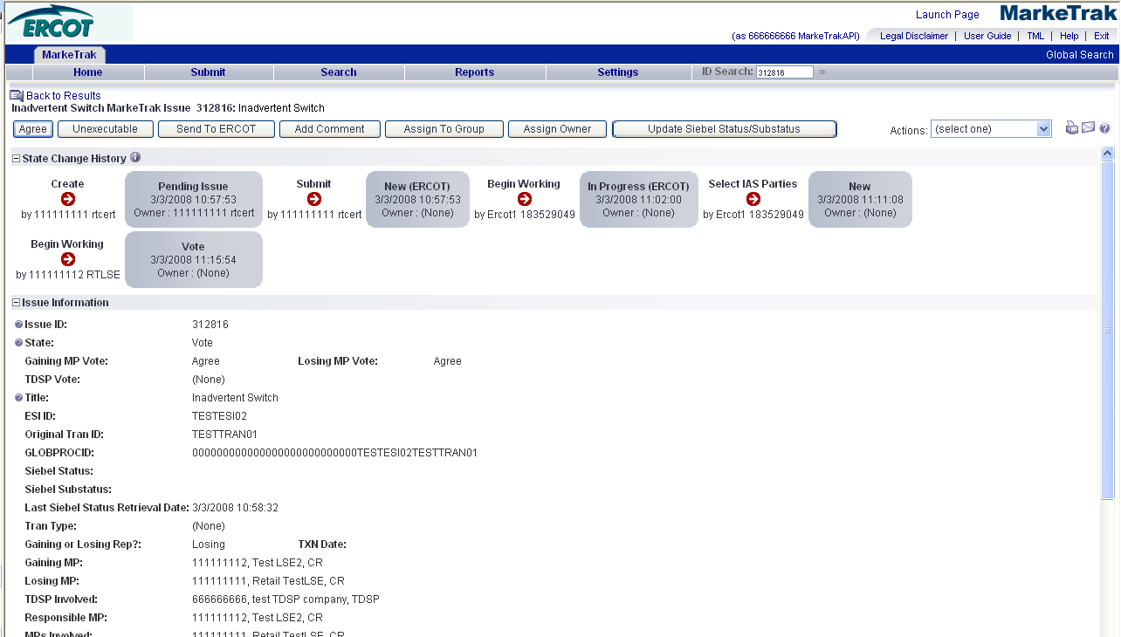
- Agree from all parties will transition the issue to a state of Agreement Reached (PC) and the Submitting CR will be the Responsible MP for completing the issue. The Submitting CR can Accept and transition the issue to Complete or if the issue is not transitioned for 14 calendar days from Agreement Reached (PC), the issue will automatically move to Auto Complete and Close. (Fig 2.1m)

Fig 2.1m
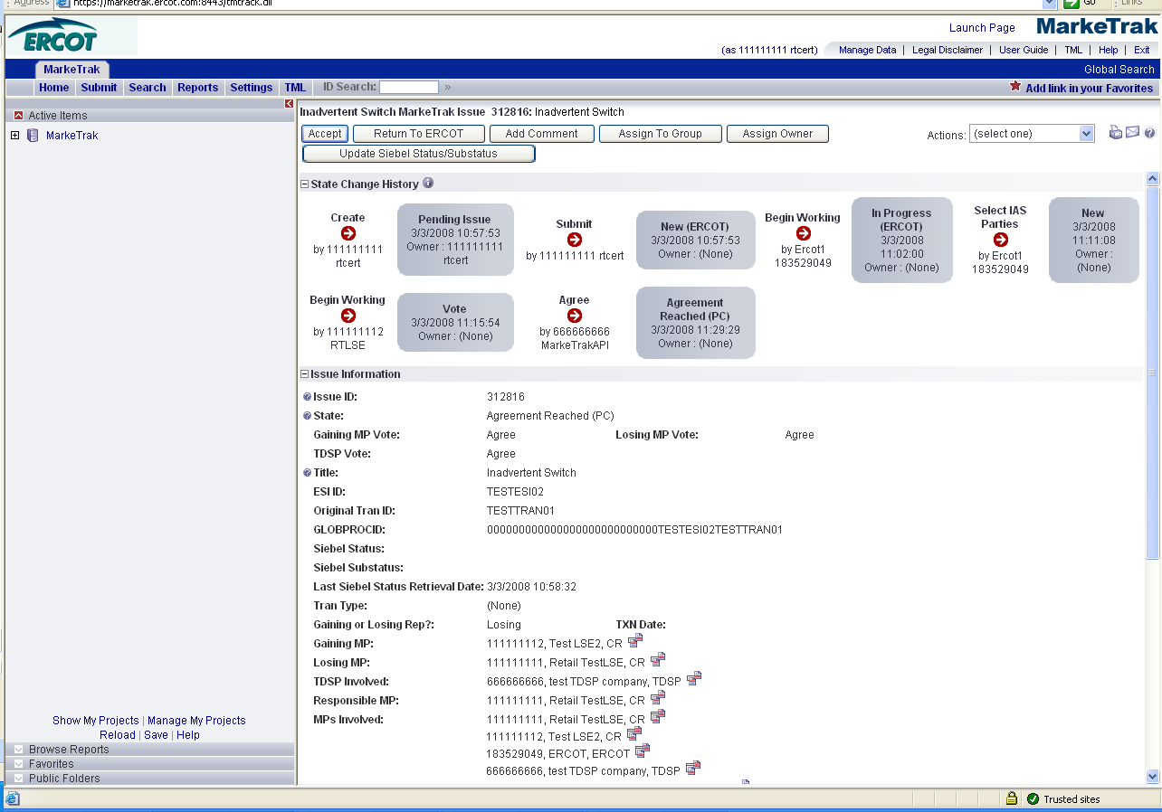

- If one party disagrees (No Agreement Reached (PC)), the Submitting party can either: (Fig 2.1n)
  - Accept and transition the issue to a state of Complete and Close the Issue.
  - Return to ERCOT will transition to a state of New ERCOT. ERCOT’s Selection of Return to Vote will transition the issue to a state of Vote.
  - The most recent selection of the binary option will be wiped out for CR1, CR2 and TDSP any time an item returns to the state of Vote (New).

Fig 2.1n
