MarkeTrak Users Guide
Section 1: General Section

Table of Contents

1.1 MarkeTrak General Overview

1.1.1 Background
The MarkeTrak tool is a web based database application used to track, manage, and store data utilized by ERCOT and the Market Participants (MPs). This tool is the supported method to track ERCOT Retail market issue management and data discrepancies in the market.

Since 2001, the Retail market has experienced significant growth, and in 2004 there were over 40,000 issues logged from over 50 MPs and ERCOT.

The high level objectives for MarkeTrak:
- Improve reporting functionality
- Improve tracking/metrics functionality
- Create usable issue status
- Create usable issue types and sub types
- Create a method to allow users to interface the solution
- Improve search functionality
- Improve monitoring and response capabilities
- Improve the usability
- Provide all functionality that is deemed required with the legacy tool as part of the enhanced solution

1.1.2 Document Purpose
This document is to be used as a reference tool for Market Participants using the MarkeTrak tool. The document is organized to provide users of MarkeTrak the details of how to interact with the toolset as well as the business processes supported by the tool.

1.1.3 Business Drivers (Market, ERCOT)
Market Participants worked with ERCOT to document the business needs and requirements to track ERCOT Retail market issue management in both SCR732 and SCR738, which initiated the project.

1.1.4 Anticipated Benefits
The high level benefits expected from MarkeTrak include improved usability, reporting and tracking

1.1.4.1 Business Benefits

The business benefits expected from MarkeTrak include improved usability, reporting and issue tracking. Users will be able to search, monitor and report on issues using either the Graphic User Interface (GUI) or Application Programming Interface (API) to access the information.

1.1.4.2 IT Benefits

The IT benefits expected from MarkeTrak include improved production support and management of development/code changes according to ERCOT’s internal processes in support of internal and external audits.

1.1.5 Digital Certificates
Digital Certificates identify each user to ERCOT by associating a secured identity with a MarkeTrak user. Digital Certificates are used to secure private information from Market Participants. Digital Certificates provide a “digital signature” that tells the recipient that the information actually came from the sender and has not been forged or tampered with. Without a Digital Certificate, the MarkeTrak system cannot be accessed.

1.1.5.1 User Authentication Process via Texas Market Link (TML)

A MarkeTrak user attempting to access MarkeTrak via TML should use the following steps:

- Siteminder intercepts the request and asks user for Digital Certificate
- User then selects Digital Certificate
- Siteminder takes Digital Certificate and validates it and verifies the credentials
- If Client certificate is valid individual user is logged into the MarkeTrak application.

1.1.5.1 User Authentication Process directly to MarkeTrak

A MarkeTrak user attempting to access MarkeTrak directly should use the following steps:

- Individual user access MarkeTrak via MarkeTrak URL.
- Siteminder intercepts the request and asks user for Digital Certificate
- User then selects Digital Certificate
- Siteminder takes Digital Certificate and validates it and verifies the credentials
- If Client certificate is valid individual user is logged into the MarkeTrak application.

1.2 MarkeTrak Starting Points

1.2.1 Launch Page
Upon successful login, the user is initially taken to the MarkeTrak Launch Page. This view is a split screen of two distinct panes: Things I Can Do and My Favorites. You can use the Launch Page as your starting point upon each login, or you can hide the Launch Page as your default profile and use the Full MarkeTrak Interface.

1.2.1.1 Using the Things I Can Do Pane

The Things I Can Do pane offers links to commonly used areas of MarkeTrak, such as a list of all reports which the current user has visibility (based upon the user’s privileges). To return to the Launch Page after visiting one of these areas click the Launch Page link near the User Name display on any screen in the tool.
The following links are available in the Things I Can Do pane based on user privileges:
• View All Items I Own - Click this link to open a built-in report that displays all Issues submitted by current user that are in a state of Pending Issue. Items are sorted by issue type/sub type, issue number, and title. To view an item in the list, click the Issue Number link. The Item Details page opens in the main browser window.
• Submit Item - Click this link to open a list of subtypes you can submit into based on user privileges and MP type.
• Search Items - Click this link to open the Basic Search page for the selected solution.
• Go to My Reports - Click this link to view all reports that the user authored.
• Built-in Reports - Click this link to open a list of built-in MarkeTrak reports in the main browser window.
• Find Report - Click this link to open the Reports form that enables you to find existing reports.
• Create Report - Click this link to open the Reports form that enables you to create new reports.
• Hide This Launch Page - Click this link to hide the Launch Page and open full MarkeTrak interface. You can re-enable the Launch Page by clicking the Launch Page link located in the upper right corner of your browser window.

1.2.2 Home Page
If the MarkeTrak Launch Page is not defaulted as the initial starting point for a user, or if the Hide this Launch Page link is selected, the user will be directed to the Full MarkeTrak Interface. The primary pane will display the report selected by the user as the default Home Page Report via the Settings Tab. Any report the user has access to (both built-in and custom) based on login credentials and privileges will be available on a drop down list to be selected as the home page.

1.2.3 My Favorites Pane
The My Favorites pane allows the user to view and access your customized folders and links. Favorites enable the user to add links to frequently used features, forms, items, and reports to folders that you create or that are provided by the system. Favorites provide a personal view of items in the system; other users cannot view your favorites, and vice versa.
To view a favorite link from the list, expand the desired folder and choose an item. The favorite item opens in the main browser window.
To return to your designated initial starting point in MarkeTrak, select the Home link.

1.3 Full MarkeTrak Interface Overview

1.3.1 Interface Page
The full interface offers complete functionality and navigation to MarkeTrak based on login criteria and privileges.
To open the full interface, click the Hide This Launch Page link located at the bottom of the Things I Can Do pane of the Launch page.

1.3.2 MarkeTrak Toolbar
1.3.2.1 Solution Toolbar

Solution Toolbar - The Home, Submit, Search, Reports, Settings, and TML buttons as well as the ID Search and Add link to our Favorites options are available across the top of each window view in the MarkeTrak application. (Fig 1.3a)

Fig 1.3a
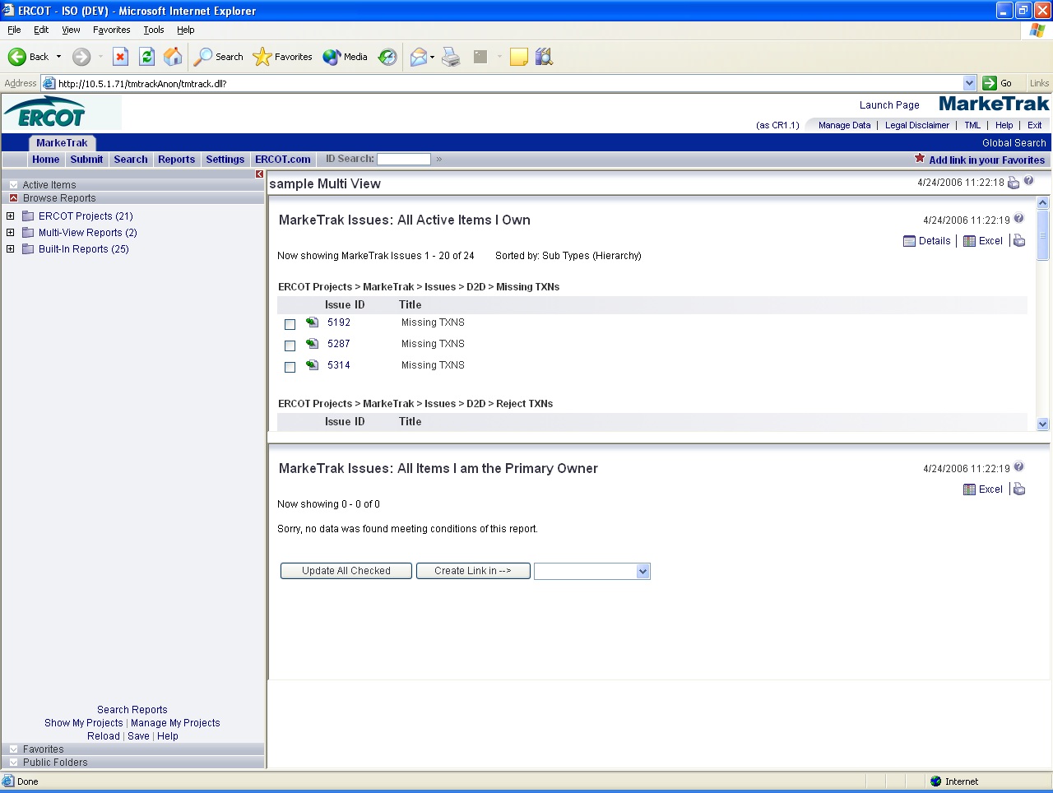

- Home - This button returns to the Home Page report. Depending on settings, this may be a custom Home Page report or one that the MP administrator has assigned.

- Submit - Click this button to open the Submit Tree. Items available are dependant on user MP type and privileges. All issue type and sub type submit requirements are detailed individually in subsequent sections.

- Search – This function returns the Basic Search page, which allows the search for primary items by keyword, Issue ID, issue type/sub type, submitter, and active/inactive status. The Basic Search page also allows access to the Advanced Search page and the Advanced Lookup Tool.

- Reports - Click this button to open the Reports page in the main browser window and the Browse Reports list in the left pane. The list of reports available in the Folders View and the Reports page is based on those available per login credentials and privileges.

- Settings – Opens the Solution Settings page, which allows individual users to select a Home Page (Fig 1.3b) report and Quick Links to add to the Solution Toolbar. To select a home page report the user selects it from a drop down of all available reports and Saves as indicated below. This will now be the result set(s) displayed in the main browser interface each time this user logs into the application or selects the Home button from the Solution Toolbar. Quick link functionality is detailed in the next bullet.

Fig 1.3b
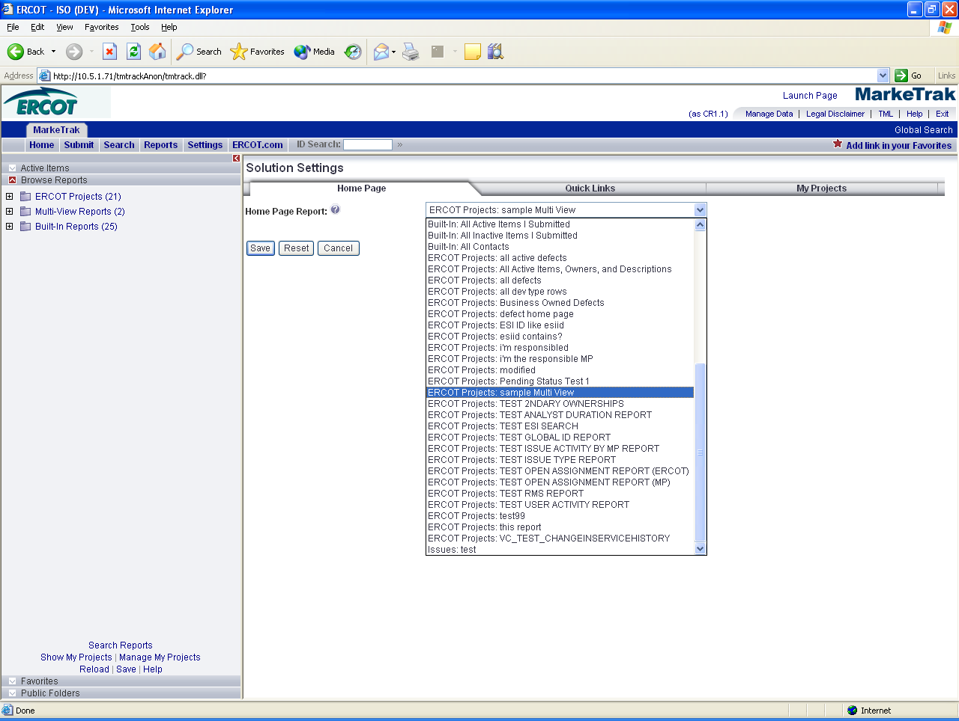

- Quick Links - These are links updated to an individual user toolbar. This can include useful URLs such as ERCOT.com as indicated above or common reports a user may wish to access in one click as demonstrated below: (Fig 1.3c)

Fig 1.3c
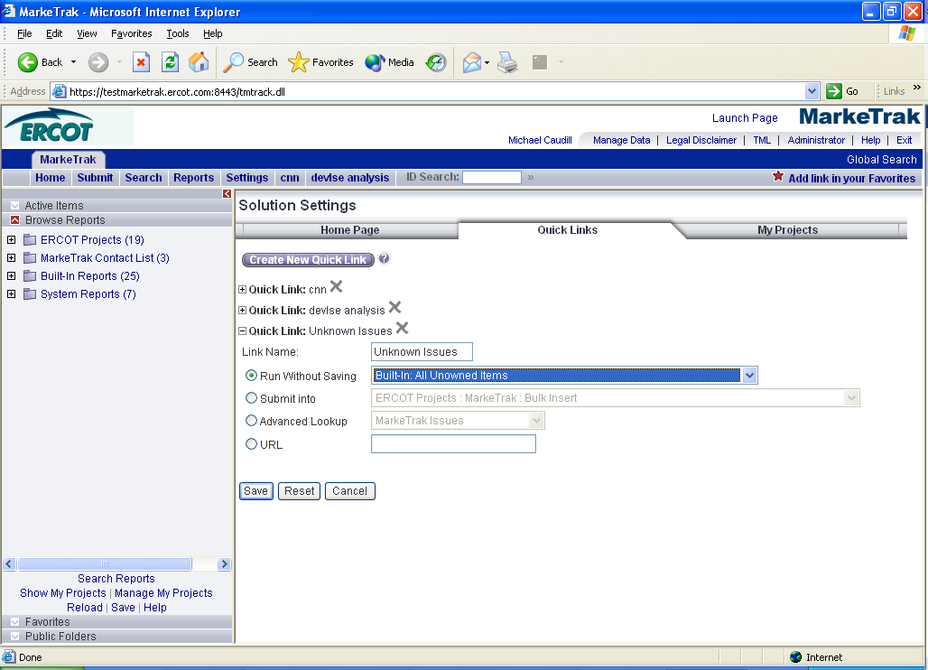

- ID Search – Populating this field with a numeric value returns a quick search of all Issue IDs that contain the value entered.

**Note: when searching for a particular item number the most complete criteria known should be entered due to the nature of the result set. For example entering the criteria ‘7’ in the ID Search could produce a result set including Issues 7, 17, 70, 71, etc**
- Add Link in your Favorites - Click this link to add any list, item, or form displayed in the main browser window to your favorites.
- Actions Drop Down (Fig 1.3d) – Available in the header of the issue details pane:

Fig 1.3d
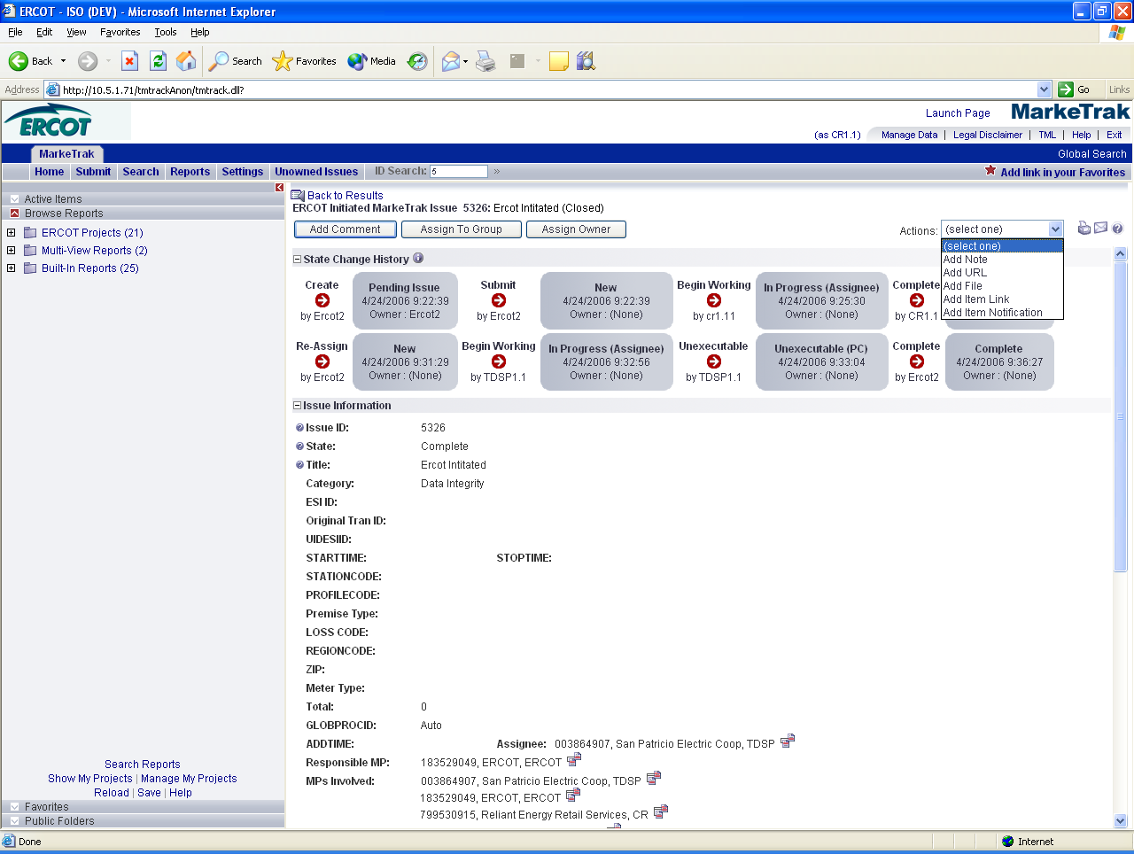

- Add Note - This allows the user to include a text message on the individual issue.
**Note: The checkbox labeled- Unrestricted (visible by anyone who can view the item) has been disabled. Anyone with access to an issue has the ability to view notes added by other users to an issue**
- Add URL - Creates a hyperlink on an individual issue to an external website
- Add File - Allows the user to locate and attach an external file to an item which will be visible by all MPs Involved.
- Add Item Link - This action gives the user the ability to create several different kinds of links to other issues within the MarkeTrak application. In order to successfully create these links, the current user must have visibility rights to both linked items.
- Add Item Notification (Fig 1.3e) - Selecting this action allows the user to choose one of four distinct item notifications. These differ from the system generated notifications in that they are selected individually on items by any user with visibility. A complete description of these four initial options is located in this document in the section detailing Notifications.

Fig 1.3e
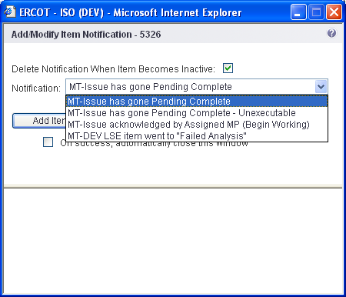

1.3.2.2 Toolbar Options (Fig 1.3f)
Toolbar Options – Non-issue related toolbar options includes the User Name/Profile, Manage Data, Legal Disclaimer, User Guide, TML, Help, Exit and Global Search options.
Fig 1.3f
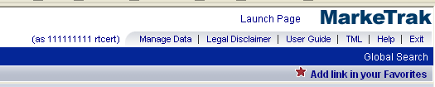
- User Name/Profile - Setting General Preferences
Subscribing to Notifications
Setting Section Preferences
Setting Date/Time Options
Setting Advanced Options

- Manage Data – Also referred to as the Rolodex within this document. Allows the user to perform a quick search to locate contact information from any Market Participant parsed by Contact Type. This is the list owned by each MP Administrator which determines the destination of Notification Emails.
- Legal Disclaimer – A quick link to the legal disclaimer relevant to the MarkeTrak application entitled:
ANTITRUST GUIDELINES FOR MEMBERS OF ERCOT COMMITTEES, SUBCOMMITTEES AND WORKING GROUPS
- User Guide – This link will take you to the MarkeTrak Information page on ERCOT.com where you can open the MarkeTrak User Guide under Key Documents. The User Guide gives details of how to interact with the MarkeTrak toolset as well as associated business practices.
- Help – The help feature is an indexed and searchable resource with a thorough explanation of ‘out-of-the-box’ tool functionality. The purpose of this guide and appendix is to bridge the gap between the application and the ERCOT configuration and concepts.
- Exit – This is the method to log out of the MarkeTrak tool. This will present the opportunity to re-login to the application.
- Global Search (Fig 1.3g)– Allows a more detailed and advanced method to search for items the user has visibility to as determined by login criteria and privileges. Includes options such as Submitter, current owner, Submit Date, Closed Date, and Last Modified Date. The screen shot below shows an example of the Global Search screen

Fig 1.3g
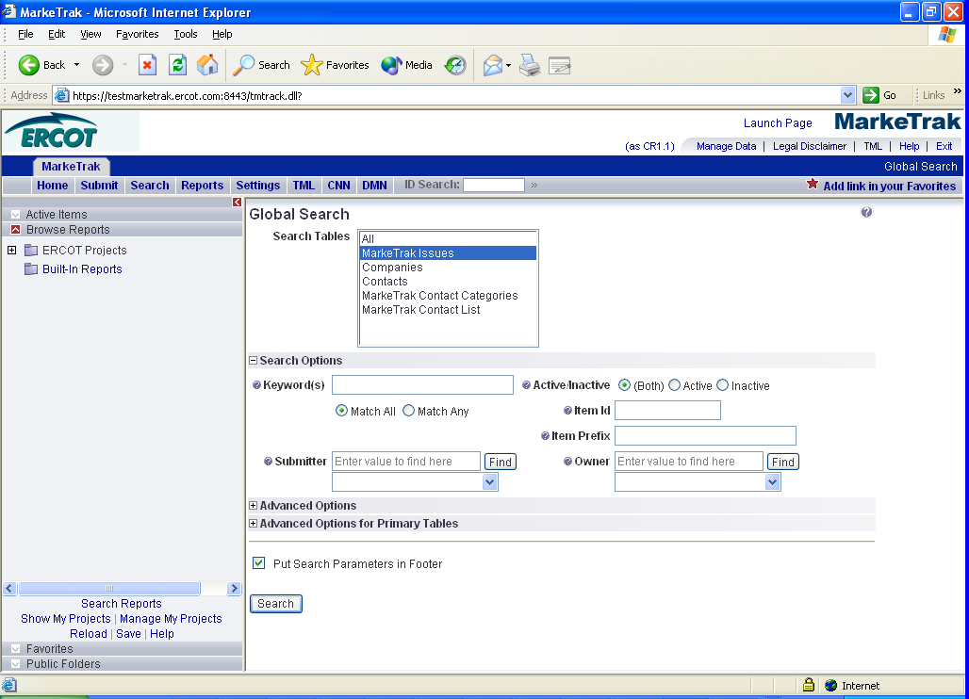

1.3.3 Folders View and Functionality
The Folders View provides easy access to active items in selected reports as well as favorite and public folders.
1.3.3.1 Full MarkeTrak Interface Functionality

• Excel – Selecting this link from either the Item List or Item Details view converts the main browser window of the Full MarkeTrak Interface to an Excel spreadsheet format. With this functionality the user is able to perform many of the functions available in Microsoft Excel including manipulation/insertion/deletion of columns and row, formatting calls, and using formulas. In addition, this view is a convenient method of copy/pasting the data into a separate Excel spreadsheet.
• Create Link In→ - (Fig 1.3h) Available at the bottom of the screen on any Listing style Search and Report. Creates a link to the result set in any of the folders available to the user via the drop down box provided.

Fig 1.3h
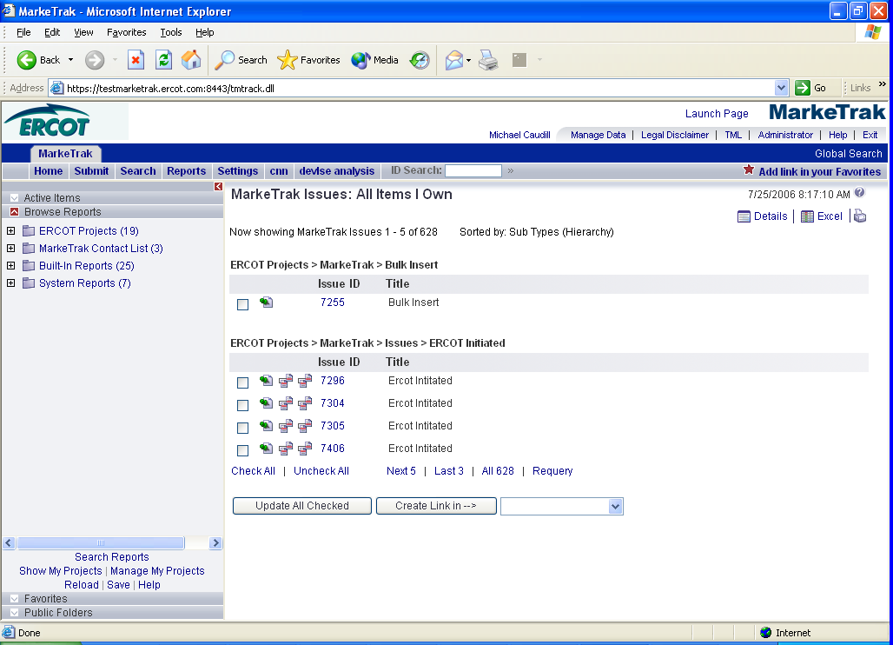

1.3.3.2 Folder Functionality
MarkeTrak folders are available from the Full MarkeTrak Interface (Fig 1.3i) view on the left pane. This pane may be collapsed to increase visible real estate for the main results pane if desired via the red Close Folder View arrow indicated below:

Fig 1.3i
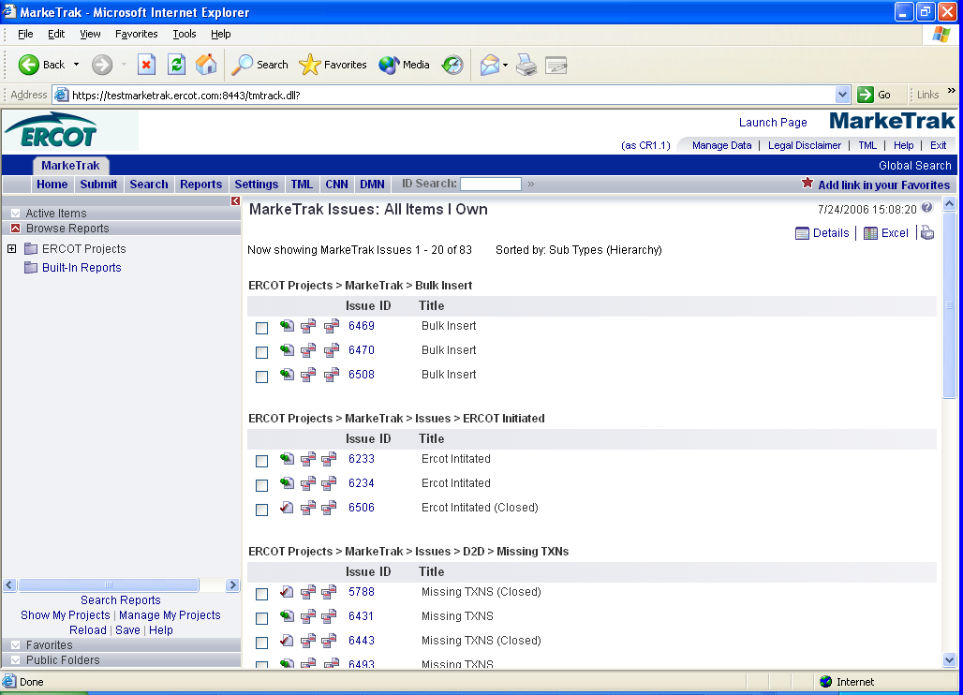

Folders can contain a wide variety of items defined by the user including: links to predefined and ad hoc searches and reports, direct links to a specific issue via the Add link in your Favorites option, and URLs.

You can use the folders pane (Fig 1.3j) to access and manage the following containers:

- Active Items - Displays all active issues in MarkeTrak for which the current user has visibility. These items are parsed by Type and Sub Type for ease of browsing.
- Browse Reports - Displays reports you have privileges to run, modify, or delete. Reports are organized in folders based on creator: Built-in Reports, ERCOT generated Reports, and private reports generated by individual Market Participants are available based on login credentials and privileges.
- Favorites - Displays links to frequently used features, forms, items, and reports in folders that you create or that are provided by the system. These folders can be created, deleted, renamed or updated by individual users.
- Public Folders - Displays links, reports, URLs, etc that can be viewed by all other MarkeTrak users unless specifically restricted by MarkeTrak Administrators.

Fig 1.3j
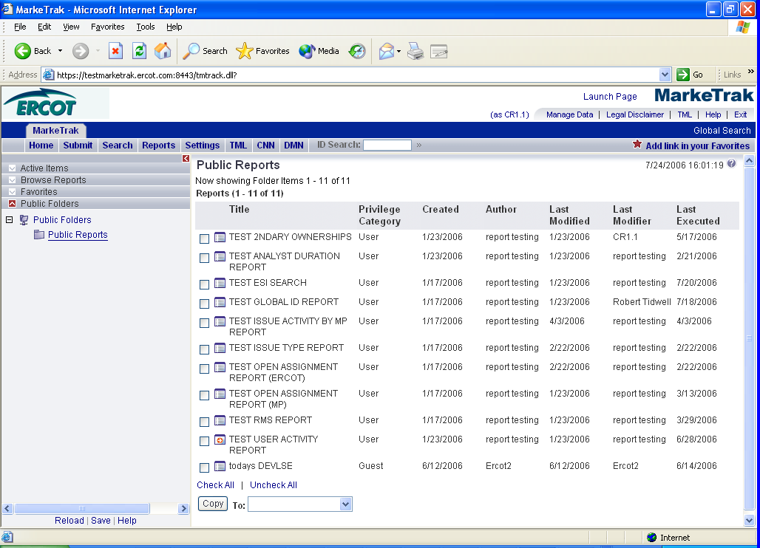

1.3.4 Submitting a Missing Transaction
In general, the main browser window contains two views:

1.3.4.1 Item List

Item lists are typically generated from report and search queries and when you display the contents of folders. In addition, if you are viewing a Multi-View report or graphical Trend of Distribution Report, the results display in the Item List frame. (Fig 1.3k)

Fig 1.3k
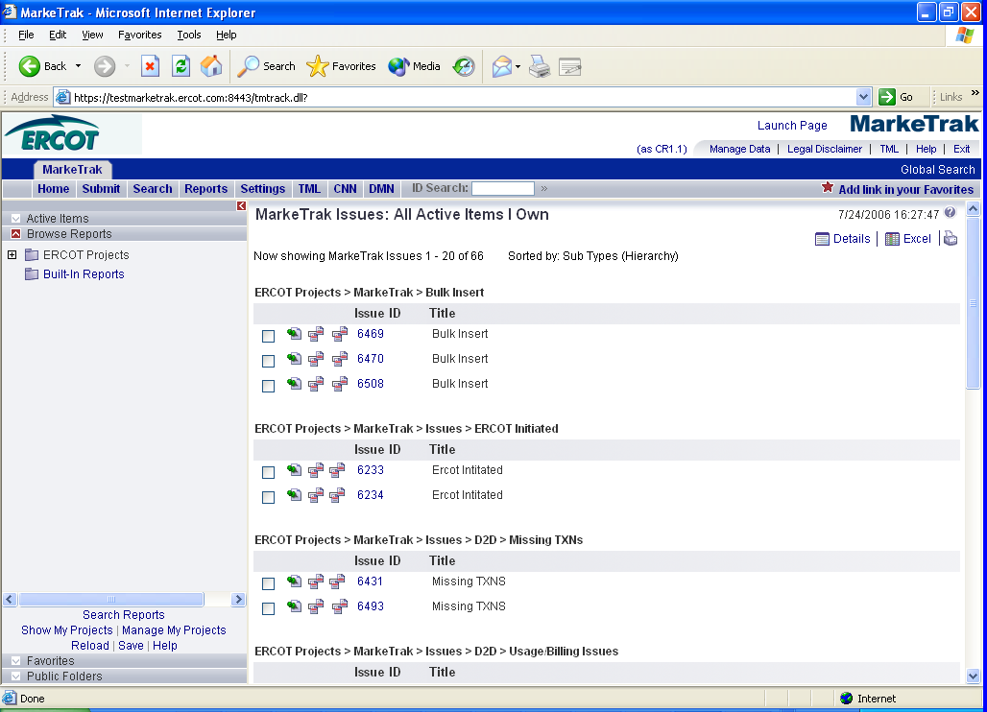

1.3.4.2 Item Details (Fig 1.3l)

Item Details - The Item Details frame displays details for items selected in the Item List frame. User profile settings determine how the Item Details frame displays. For example, the user may choose to view items in a single-frame view, or in two frames with the item lists at the top and the item details at the bottom. Depending on user privileges, the user may work with individual items in the Item Details frame by updating data in them or transitioning them to another state in the workflow, or by adding comments and attachments to them.

Fig 1.3l
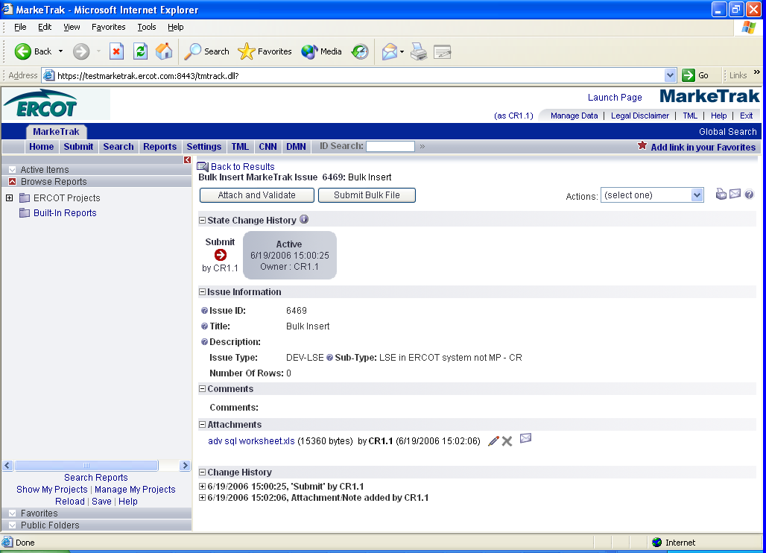
1.4 MarkeTrak General Issues

1.4.1 States and Transitions
All issues in the MarkeTrak tool are routed into one of several workflows based on the Type and Sub Type selected by the submitter. Several of the more common issue types have consistent, predictable processes which are always necessary to reach a resolution. Several of these have been pre-defined in the MarkeTrak tool as a method of improving efficiency and metrics.

These Issue Type/Sub Types are: Day to Day Issues Cancel with Approval, Cancel without Approval and Inadvertent Switch as well as Data Extract Variance Issues- LSE Relationship.

All other issue Type and Sub Types combinations will be funneled into an ‘open-ended’ workflow which will allow much more flexibility as the issue moves towards a resolution.

The fundamental architecture of the MarkeTrak tool is based on States and Transitions.

A state is the position of an issue in the workflow process; this is often similar to the concept of an issue status combined with the issue’s current ‘owner’. Examples of this include: New with ERCOT, In Progress-Assignee, the Voting State of an Inadvertent Switch, or Unable to Cancel - Pending Complete.

Transitions are the movement of an issue from one state to another. Available transitions are associated on the GUI with buttons. Selection of different buttons from the same state will typically result in the issue appearing in different states when the transition successfully completes. One example is a Day to Day Issue - Cancel with Approval currently in state In Progress with TDSP. If TDSP user selects transition button OK to Cancel, the item will move to state New with ERCOT. Alternately if the TDSP user is unable to approve the cancel and selects transition button Unable to Cancel, the issue would appear in the submitting CR’s queue in state Unable to Cancel – Pending Complete. Some transitions, such as Unable to Cancel, require additional steps to complete; in this case completion of a required field: Comments.

1.4.2 Issue Visibility
Visibility to an issue is determined by several factors. These factors determine a user’s ability to find the item by directly searching for the Issue ID as well as having the issue return as part of a result set in searches and reports. The submitter of an issue is always able to view the item regardless of the state in the workflow. ERCOT is able to view all items in the MarkeTrak tool at any time. All other MPs must be selected as the assignee in order to have visibility. This occurs in several ways:
- By the submitter (often but not always during submission).
- Current assignee (as shown on the GUI in field: Responsible MP) at designated times based on workflow association.
- By ERCOT, particularly when the Market Participants may not know who the ‘other’ parties involved should be (i.e. IAS).

As soon as an MP is selected as a party to an issue (field name MPs Involved) that participant is able to view the item from that point forward.

**NOTE that it is NOT possible for an MP to remove an assignee from the MPs Involved list once they have been added. If a mistake is made and the wrong assignee is selected (and confirmed) an ERCOT analyst should be notified immediately. It is necessary for ERCOT to close the issue and remove ALL visibility except for that of ERCOT and the submitter for proprietary information considerations. The issue must then be resubmitted with appropriate assignee(s) selected.

1.4.3 Transition Ability
Transition ability and selection is based on the particular workflow to which an Issue Sub Type is associated. Any user at an MP that is on the MPs Involved list is able to: add comments to the issue, assign an issue to a group, or assign an individual within the same MP to an issue at any time. Other transition options are determined by the state in which the issue currently resides. Refer to the appendix (Appendix A – MarkeTrak States and Transitions) for a complete list of transitions.

1.4.3.1 Mass Transitioning of Issues
It is possible to commit multiple like transitions simultaneously should the following conditions exist:
- Mass Transition privilege must be assigned to the user by their MP Administrator.
- User’s MP must have transition ability available on all selected issues.
- Desired transition is available on all issues selected.
- List of available issues must be returned utilizing one of the methods detailed in the list below.

The following list defines locations in the MarkeTrak tool where this functionality is available:

  - Basic Search results
  - Advanced Search results
  - Listing report preview lists
  - Listing report results
  - Built-in reports
  - ID search results

Mass updates may be preformed from the following item lists:

- Global search results
- Manage Data search results
- Folder lists

From any result set that allows mass transition, a check box is located next to each issue. Items can be individually selected or deselected; or the user can select the Check All link. When all items that wish to be transitioned are selected, the user selects the Update All Checked button. (Fig 1.4a)
NOTE: Only one page can be updated or checked at one time. A checked box will be lost once Next Page button is selected.

Fig 1.4a
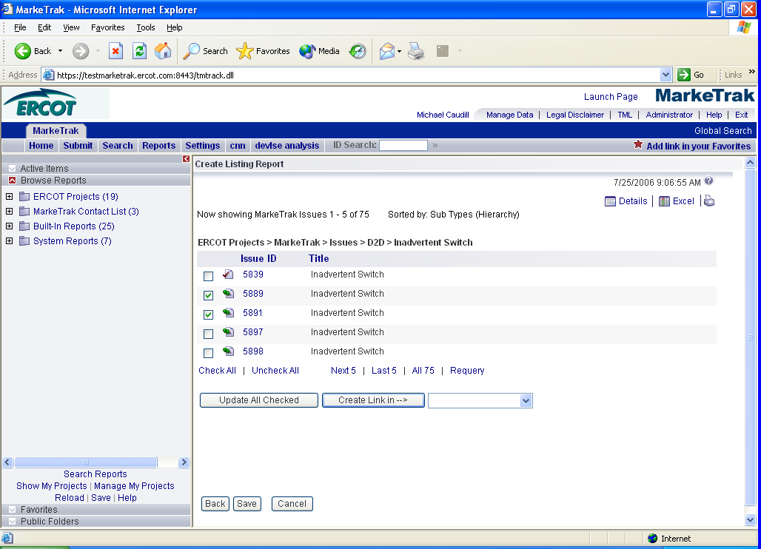

The user is now presented a drop down list of any transitions available to every issue selected. If each of these items is in the same state, a complete list of button names that would be presented on the GUI is available. If any of the selected issues in the result set are not in the same state, only three transitions will be available to be executed in mass: Add Comment from Any, Assign to Group from Any, and Assign Owner from Any. (Fig 1.4b)

Fig 1.4b
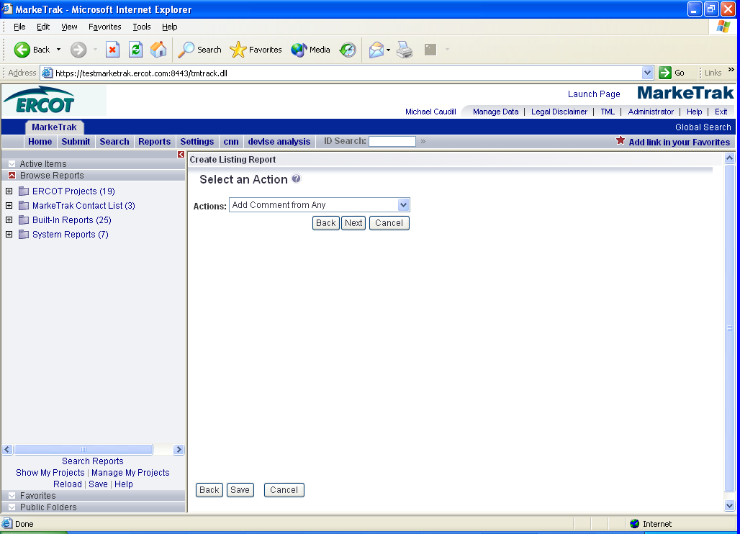

1.4.4 Issue Ownership Model
1.4.4.1 Variety of Ownership
There are several varieties of ownership in the MarkeTrak application: Submitter, Responsible MP, MP’s Involved, and Assigned Owner.

- The Submitter of the item is indicated near the top of each primary data pane on the issue details window. Submitter Duns number is also incorporated into the title of each issue and listed in the MPs Involved field discussed below.

- Responsible MP is the single Duns number contained in the MPs Involved list that is considered to be the next participant responsible for transitioning the item towards a resolution. Examples include: the TDSP when an issue is waiting for approval to cancel a service order, ERCOT when the approval has been granted, and the CR when the cancel is complete and the issue is waiting for acceptance of the resolution.

- MP’s Involved is defined in MarkeTrak as a Secondary Owner. It is a list of all MP duns numbers which are party to an issue. As additional assignments are made to an item the MPs Involved field will be updated with the selected DUNs numbers, reflecting an increase in market participants with the ability to view the item. As ERCOT can always view any issue in the system, this will always be reflected in the MPs Involved list.

- Assigned Owner is null when an issue is initially assigned to a Market Participant. Assigned owners are individual users. These are assigned by the Responsible MP automatically as issue is acknowledged by way of transition, Begin Working. Taking this action will populate the associated individual’s user id as the Assigned Owner. It will also transition the issue from the state of New into an In Progress state as detailed in the workflow sections of this document. Taking primary ownership has no effect on market rules or responsibilities (i.e. notifications and market-wide metrics); it is used exclusively for contact information, ease of searching and workload management internally to a market participant.

1.4.4.2 Assigning Individual Owners to Issues

Each entity with a unique association to an issue in MarkeTrak has the ability to assign individual ownership to that issue. Individual user assignments have no bearing on the functionality of either visibility or transition capability; the purpose of is to facilitate workload management and provide contact information. Individuals can run a report with their username as part of the criteria which will return all in progress issues that they have been assigned. Assignment to issues can be created or overwritten at anytime the user has visibility to a given user.

There are three ways that an individual can gain ownership of an issue:

- Begin Working:
When an MP is designated as the Responsible MP on an issue they are given the option to change the state from New to In Progress via a Begin Working button. The user who executes this transition will automatically be populated as the Owner of the item for the appropriate association type.

- Assign Owner:
Anytime a user has visibility to an item (per details in 4.2 Issue Visibility) an Assign Owner transition is available. Executing this will present the user with a search list of individual users. The user can assign any individual in their MP to the item in this manner, overriding any previous associations.

- Mass Transition:
Assignment of individual ownership can also be handled en masse via the mass transition feature as detailed in 4.3.1 Mass Transition of Issues.

While making assignments via the search lists in methods 2 and 3, the user is able to return the entire population of assignable individuals regardless of MP. However, the selection of a user not associated with the same MP Duns will return an error messaged as shown below and will not execute the assignment. (Fig 1.4c)

Fig 1.4c
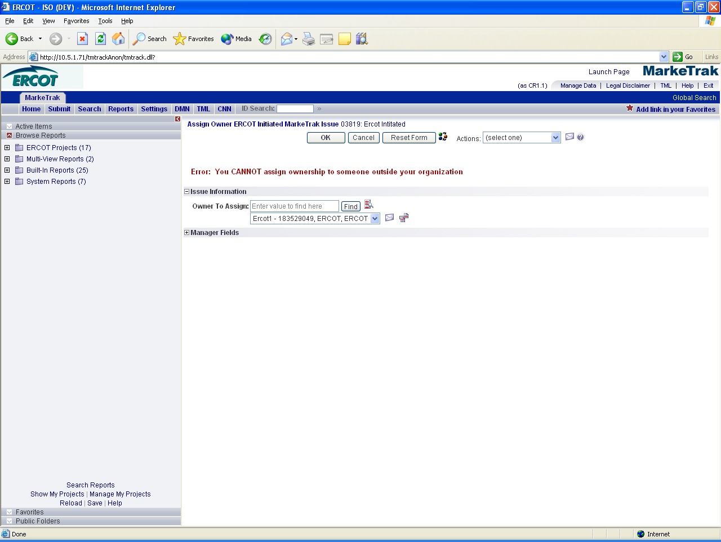

A successful assignment will populate the username into the field representing their affiliation to the item. Examples include: Submitter or Assignee Owner, Gaining MP Owner for an inadvertent switch, and ERCOT Owner. Located beside each individual’s naming convention used in MarkeTrak (user name, MP Duns, MP name, MP type) is a link to a pop up window containing contact information. This contact information is created and administered by one member of each Market Participant as detailed in 1.7. Rolodex.

NOTE: Please See Appendix C about Mass Update Attention Message

1.4.5 Workflow Principals
1.4.5.1 Common Workflow Principals
- Issue Type and Sub Type combinations that are not available to the submitter based on login credentials will not appear in the Submit Tree.
- Only the Submitter entity can Withdraw an issue.
- The Withdraw can only be performed before the issue has been acknowledged by another entity.
- Only the Submitter can be allowed to close an issue. This occurs only from a Pending Complete state either by accepting the resolution via a transition or failing to transition the issue within the prescribed Auto Close time limit (14 days). There are two exceptions to this rule:
- The Failed Analysis transition for issue types DEV-LSE as detailed later in this document.
- If proprietary information is entered on an issue and the ‘wrong’ Market Participant is inadvertently associated with the item, ERCOT has the ability to transition to an Inactive state. In this state only the submitting MP and ERCOT have visibility to the item. This unilateral closing of an issue by ERCOT should not be used for any circumstances besides those described above or determined at a later date.
- The initial state of New has no individual owner but is owned by a market participant group.
- The assigned MP must select Acknowledge to move the issue into an In Progress state before transitioning it to a new assignee.
- The state of In Progress has both an individual owner and the same participant group owner as the “New” state.
- Each of the workflows contains two Pending Complete states owned by the submitter (Cancelled, Unexecutable, etc).
- Visibility to an issue is determined by user access to the MP assigned only. Individuals for this entity not designated primary owner still have access to the same views.
- Transition capabilities function in the same manner as visibility but can be further restricted by the Managed Administrator for each Market Participant by Sub-Type.
  - Admin – all functionality plus ability to add/edit/delete users within their own MP.
  - Manager – all User functionality.
  - User – all regular viewing and transition capability but may be further restricted based on group associated by sub-type restriction needs.
  - Read-Only – read only, user will not be able to change or work issues.
- Comments can be added to an issue by any entity with visibility while it is in an active state.
- Any entity with visibility to an issue can assign it to an individual user within the same organization or to a group designation from any state.
- Transitions which indicate an inability to complete the request (i.e. No Agreement Reached, Unable to Complete) or which request ERCOT intervention require Comments to complete.

1.5 MarkeTrak Searching and Reporting

1.5.1 Internet Explorer Configuration Changes
The following Internet Explorer configuration change must be performed to allow MarkeTrak report/search data to be opened or saved to Excel format.

Open the Internet Explorer browser. Select the Tools tab in the upper selection bar. Select the Internet Options selection from the drop down list. (Fig 1.5a)

Fig 1.5a
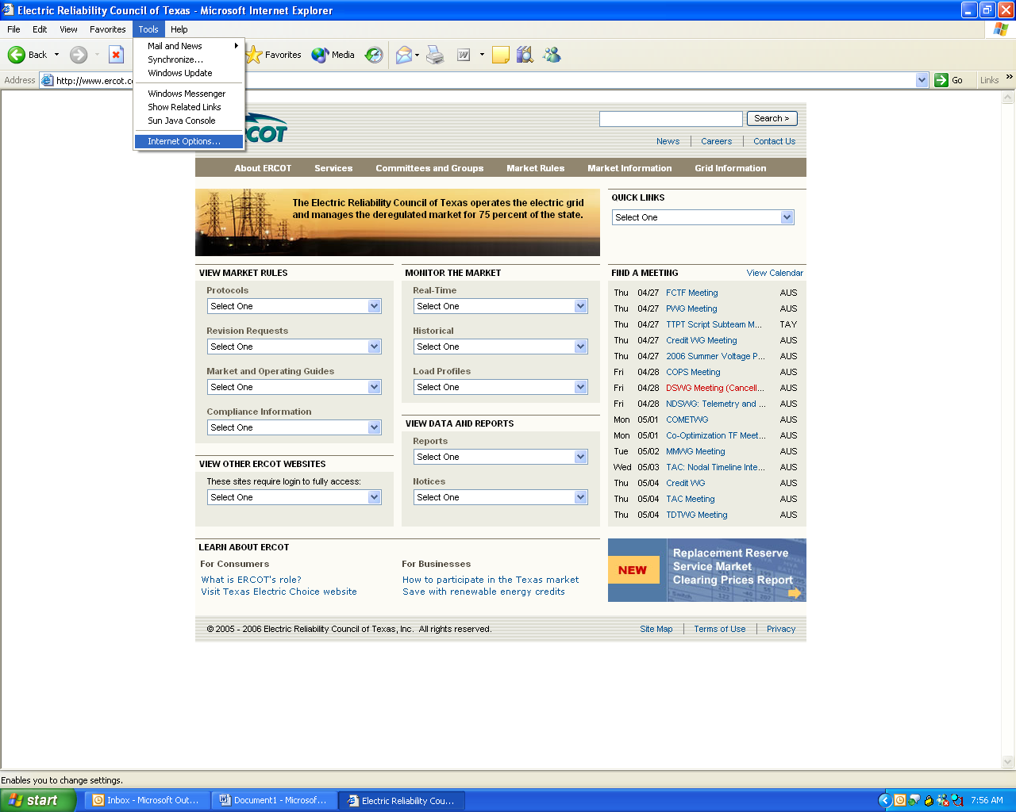

After the Internet Options popup window displays, select the Advanced tab. (Fig 1.5b)

Fig 1.5b
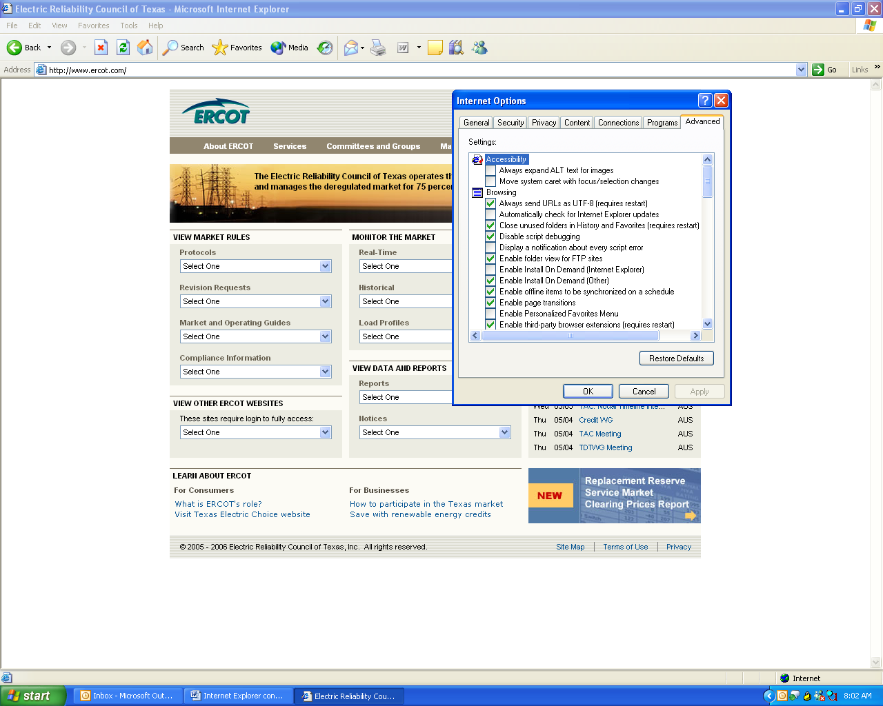

On the Advanced tab, scroll down to the Security section. Check the box beside Do not save encrypted pages to disk. Click the OK button to save the change. (Fig 1.5c)

Fig 1.5c
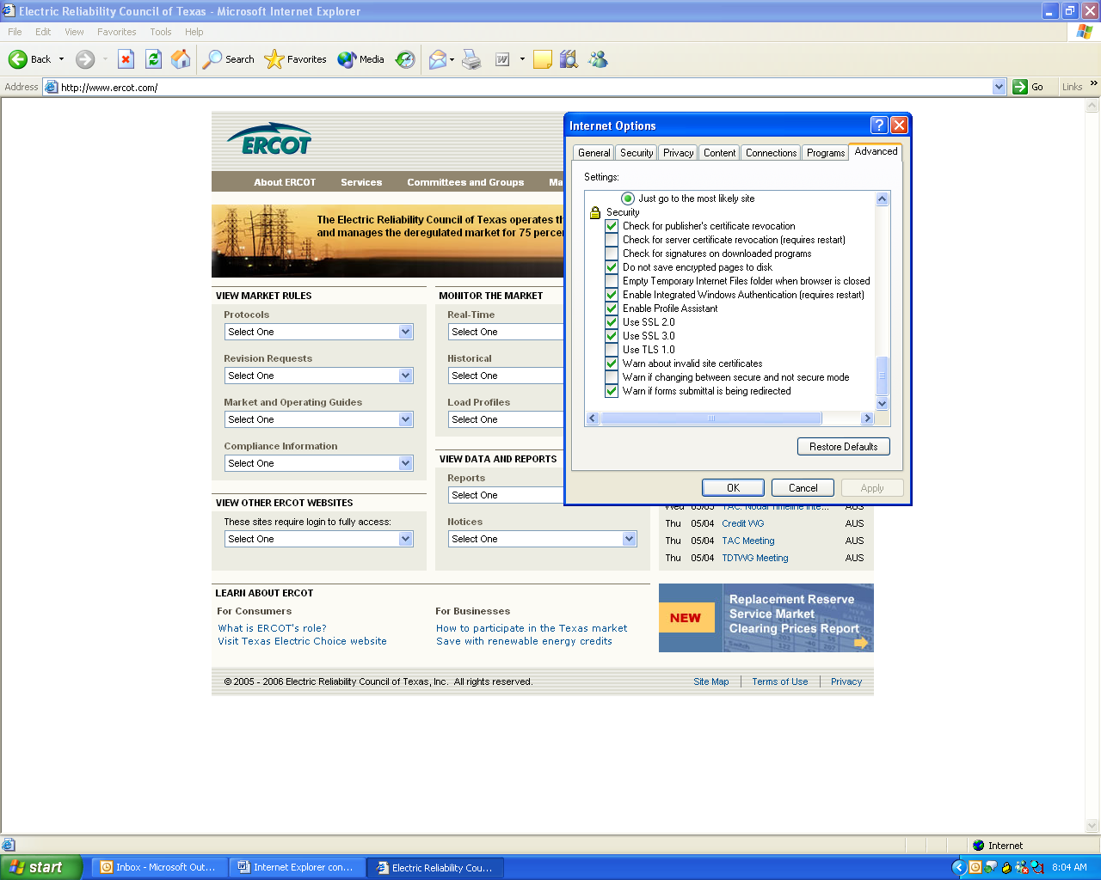

You will now be able to open or save MarkeTrak report and search data to Excel format.

1.5.2 Searching
Searching in the MarkeTrak application is largely based on the visibility model described in section 4.2 Issue Visibility. When searching, those issues available to the user based on login credentials will be returned in any result set.

In comparison with Reports, searches are a quicker and more efficient way to reach a result set if multiple criteria are not necessary.

Available fields that can be utilized are:
- Issue ID: entering a number in this field will return all issues that are visible to the user and contain the value entered
- Keyword(s): compares text strings populated by the user with any text fields associated with an issue. This will allow the user to search the following fields:
  - Comments
  - Description
  - ESI ID
  - Original Tran ID
- Project(s): (Fig 1.5d) A selection of each of the issue Sub Types the user wishes to return in the search. Multiple selections are possible via standard Shift and Control key functionality
- Submitter: UserID of the individual who submitted a particular issue. Only those items submitted by a user with the same MP DUNS association will return.
- Active/Inactive: Allows the user to decide if the result set should include only Active, only Inactive, or both Active and Inactive issues

Fig 1.5d
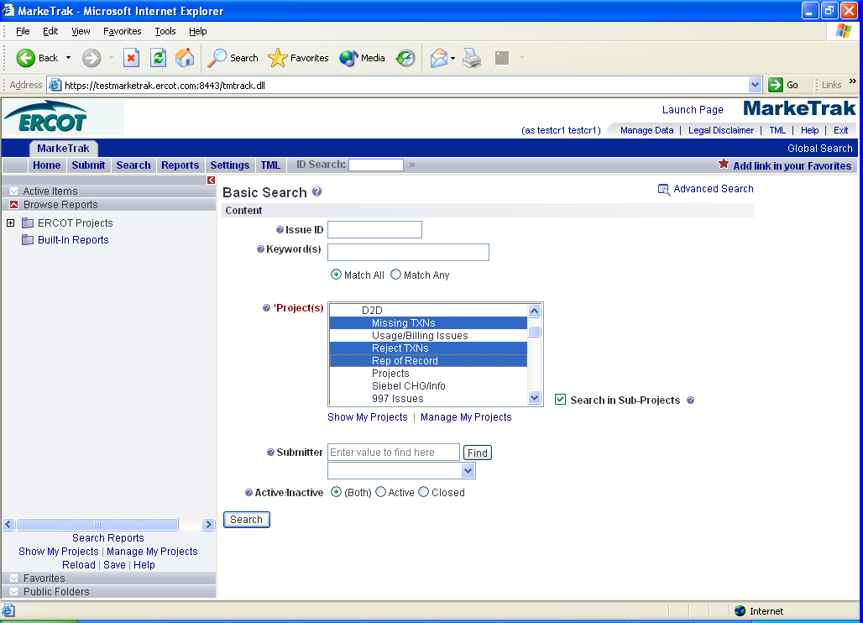

1.5.3 Reporting
The MarkeTrak application contains a vast amount of reporting options. Report types include Distribution, Trend, Change History, Multi-View, and most commonly Listing Reports. A thorough explanation of each of these report types is available via the Help option.

Many of the reports that a user will find useful have already been created and saved into the application. These can be accessed in the Browse Reports folder on the left hand side of the screen or located in the Reports tab – Find a Report.(Fig 1.5e) This method of searching for an existing report involves entering all or part of the report’s title or the report’s author.

The user can also create and save ad hoc reports through the Create a Report (Fig 1.5e) option accessed via the Reports tab.

Fig 1.5e
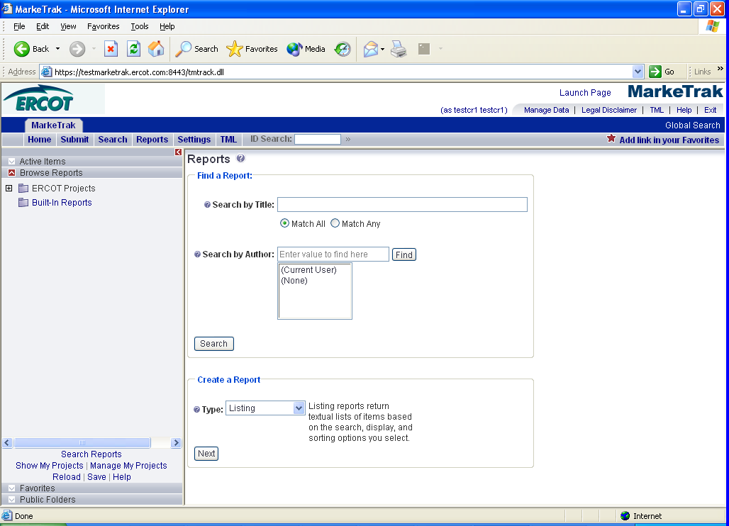

The screen below (Fig 1.5f) will appear after selection of Create a Report, Type: Listing as indicated above. Select Columns to Display: is a complete population of fields available to the user based on privileges and functions like the ‘Select’ statement of an SQL statement. Multiple fields can be selected to return in the result set and moved into the request via the left and right arrows.

Fig 1.5f
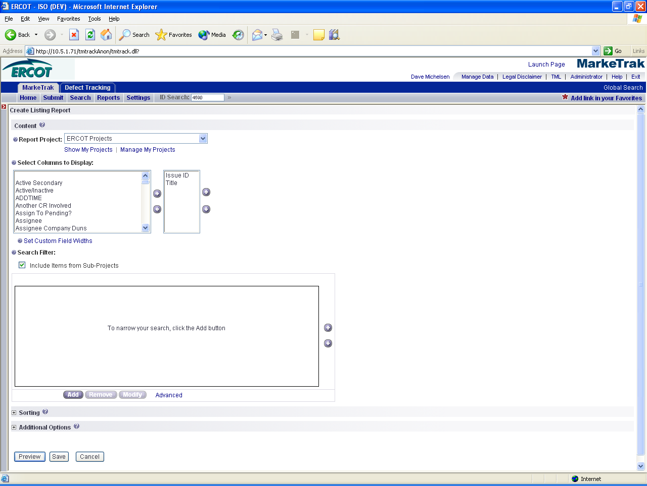

The Search Filter: Selection of Add will allow the specification of criteria specific to the field chosen from the drop down. For example choosing Submitting MP will populate all MPs in the MarkeTrak system in the Field Values. The same functionality is available to locate the desired MP as in other MP searches, i.e. all or part of Duns number, MP Name, MP type. Executing the report below with criteria Submitting MP in ERCOT will return all issues submitting by ERCOT to which the current user has visibility. In other words, the same report will return different result sets for different MP users. (Fig 1.5g)

Fig 1.5g
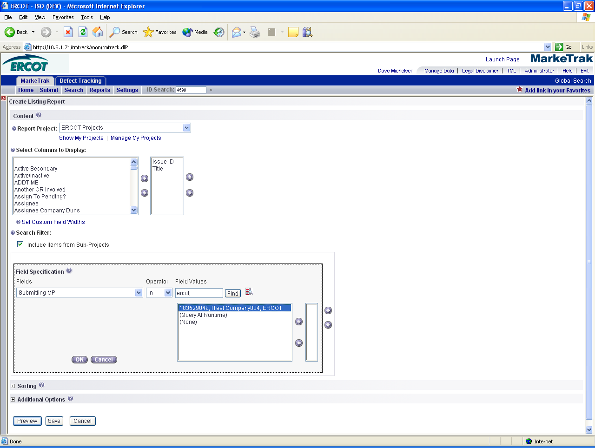

Adding additional criteria to the report will create additional filters for the search. Other fields many users may find most useful include: State, Responsible MP, Submit Date, and Active/Inactive.

Query at Run Time – This feature allows the user to create a report against a field without specifying a value at the time the report is created for some number of criteria. An example of this is below (Fig 1.5h); this report will return all issues to which the user executing it has visibility and the Responsible MP is ERCOT. In addition, each time the report is run the user will be prompted for a new ESI ID to function as the third filter. If this report is saved to the user home page, each time this screen is accessed the prompt will appear.

Fig 1.5h
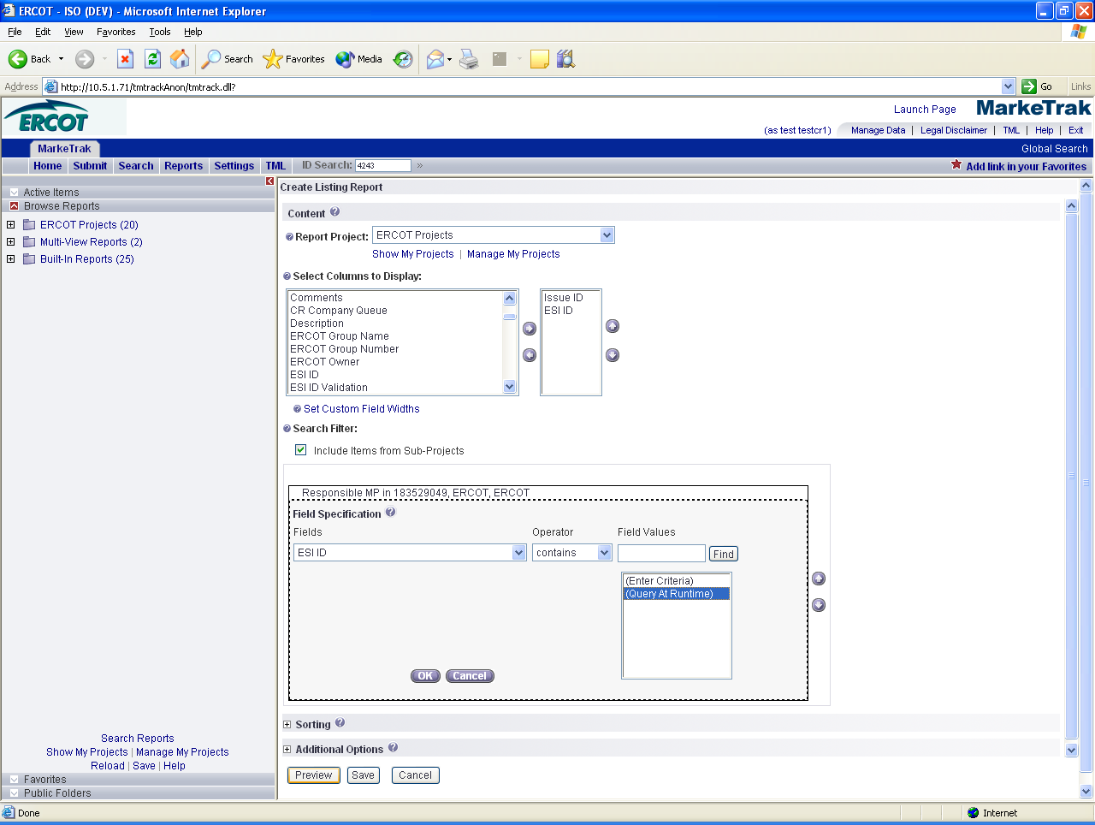

After selecting the Preview button: (Fig 1.5i)

Fig 1.5i
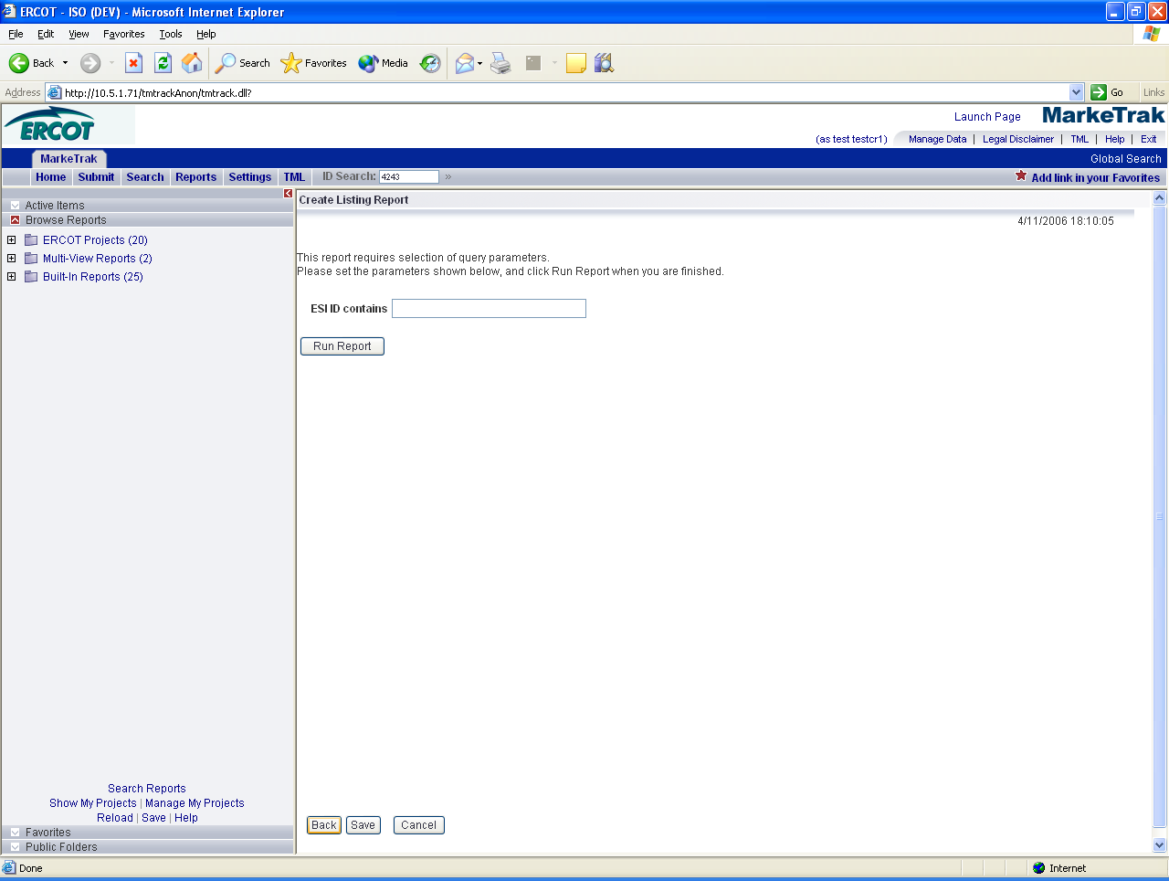

Change History Reports – These reports are similar to Listing Reports but the criteria and result sets relate to the issue change histories. To access Change History Reports, navigate to the Reports tab and on Create a Report- Type: select Other Reports followed by Next. On the following screen Change History is defaulted as the Type: (Fig 1.5j)

Fig 1.5j
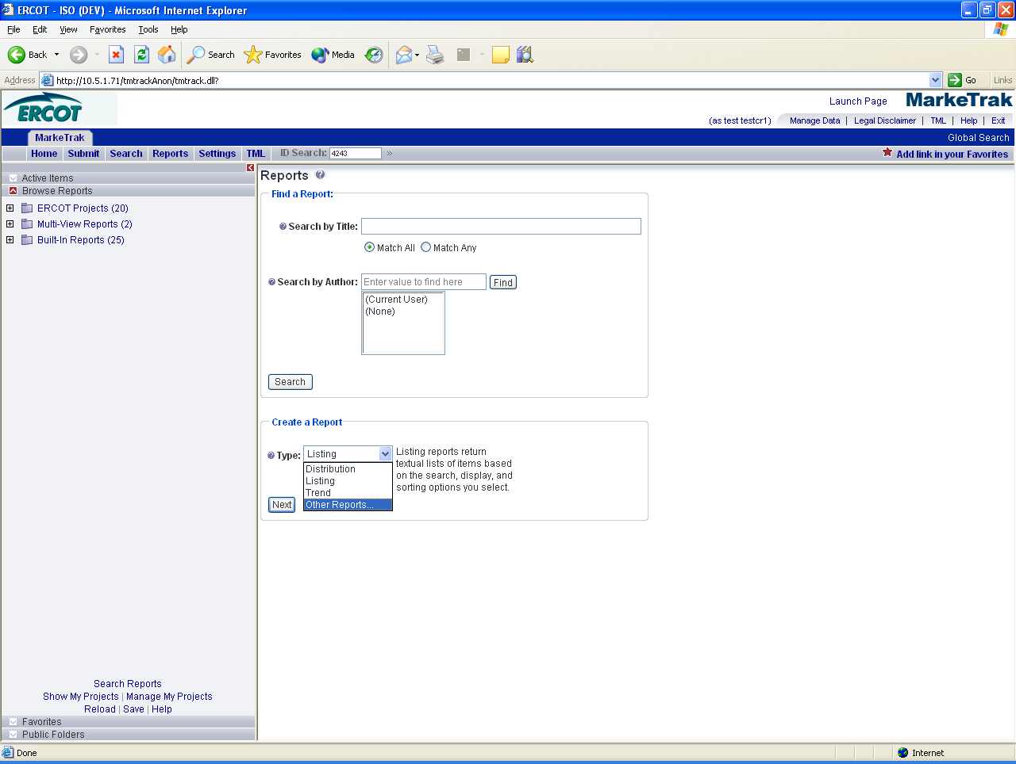

1.6 MarkeTrak Excel Format View
The MarkeTrak application allows for the user to view (open) and export (save) data in an Excel spreadsheet format. Listing-type, tabular-formatted, and graphical reports, as well as most search results may be exported in Excel format. (Fig 1.6a)

Fig 1.6a

1.6.1 Excel View in the MarkeTrak Application
The result set of listing Searches and Reports has a link that will replace the entire Main Browser Window with an Excel view. (Fig 1.6b) This will be accomplished by selecting open from the file download prompt after hitting the Excel export button.The data may then be manipulated in the same browser with much of the functionality, look, and feel of an Excel spreadsheet. This includes copy and pasting, formatting of cells, calculations, and functions (fx).
Fig 1.6b
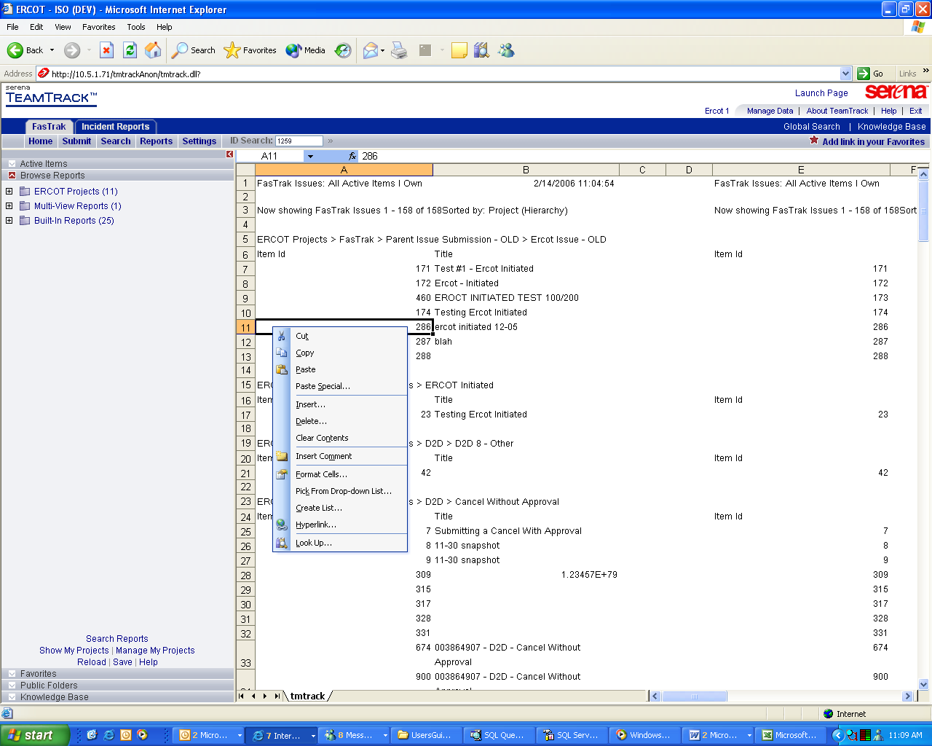

1.6.2 Exporting Result Sets to Excel
Information from the MarkeTrak Browser can also be exported into a separate Excel spreadsheet. This is a built-in function that will allow users to export data from the main browser window into an Excel spreadsheet format. Select the Excel function button from the upper right hand corner of the browser winder. (Fig 1.6c)
Fig 1.6c
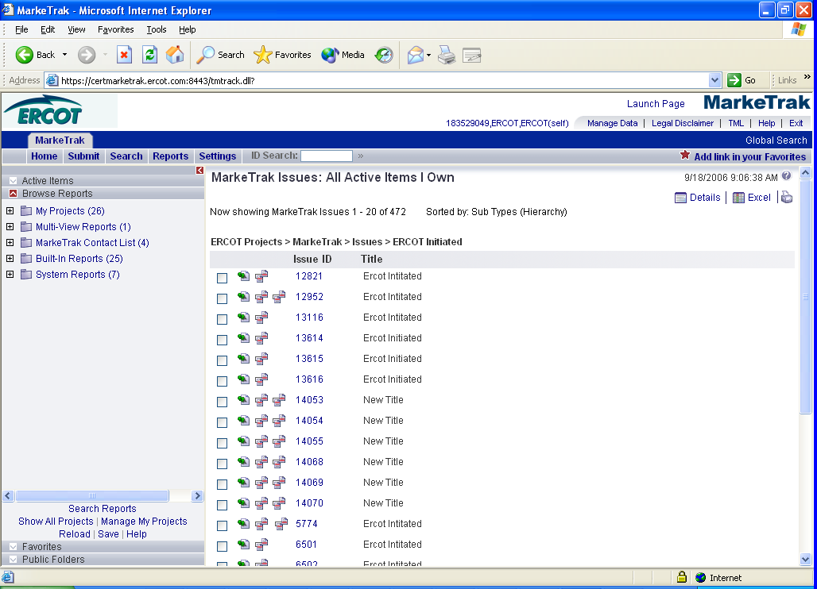

The user will then be prompted to open, save, or cancel the file download. The user must select save in order to have a separate MS Excel spreadsheet for further data manipulation. (Fig 1.6d)

NOTE: There is a Microsoft built in feature that allows you to right-click in Internet Explorer and export to Excel. This is not a MarkeTrak feature and does not guarantee the correct formatting of the spreadsheet, which may result in data corruption.
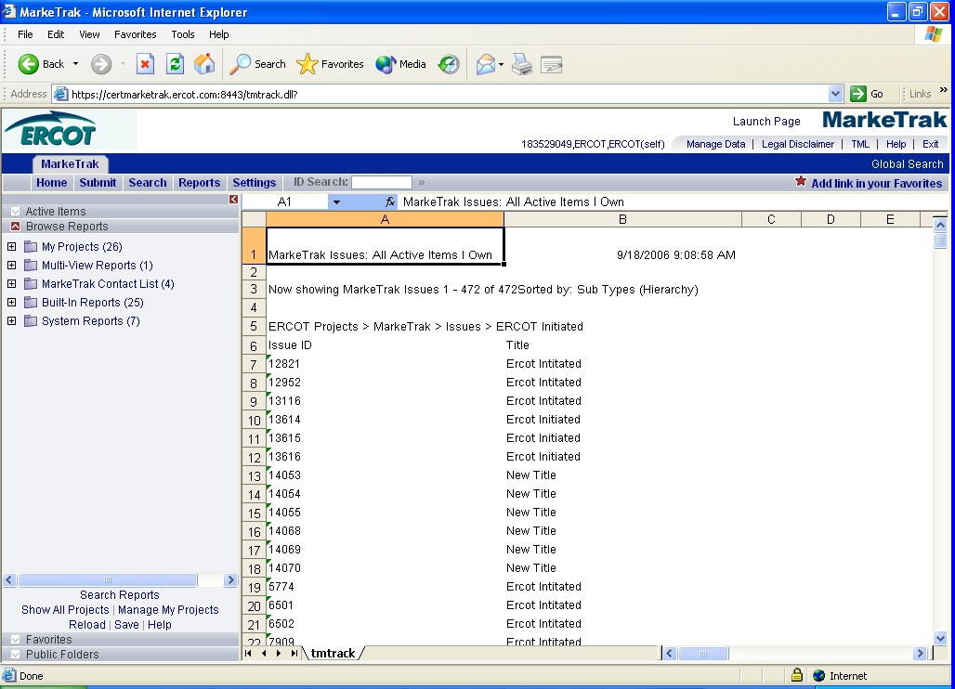

1.7 MarkeTrak Rolodex

1.7.1 Rolodex
One Admin user will be assigned to each MP. The Admin user has permission to view and edit Contact information in the “Rolodex” Contact List auxiliary table. “MP Users” have rights to view the entire Contact List (Rolodex).

1.7.1.1 Contact Category and Issue Type/Sub-Type Relationships

Contact Category Issue Type Sub Type
D2D – Inadvertent = D2D Inadvertent Switch (IAS)
D2D – Safety Net = D2D NONE
D2D – Other = D2D All Besides IAS
DEV – LSE = DEV LSE
DEV – Usage = DEV IDR Usage, Non-IDR Usage
DEV – Other = DEV All besides LSE, IDR Usage, Non-IDR Usage
LPA - Other =DEV Load Profile

VIEW
Users with permission to view the MarkeTrak Contacts list will be able to access via the Manage Data button on their MarkeTrak Launch Page: (Fig 1.7a)
Fig 1.7a

The user can then select the MarkeTrak Contacts List for viewing (Fig 1.7b)

Fig 1.7b
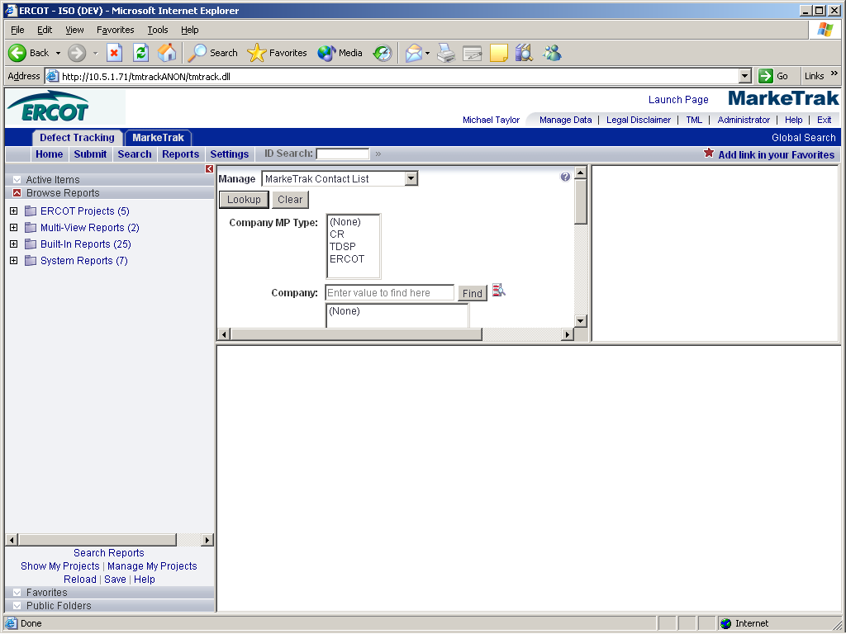

After entering search criteria and pushing Lookup, a list results list will display to the right and the 1st contact listed information will display below. User can scroll thru the list and select the contact of choice. (Fig 1.7c)

Fig 1.7c
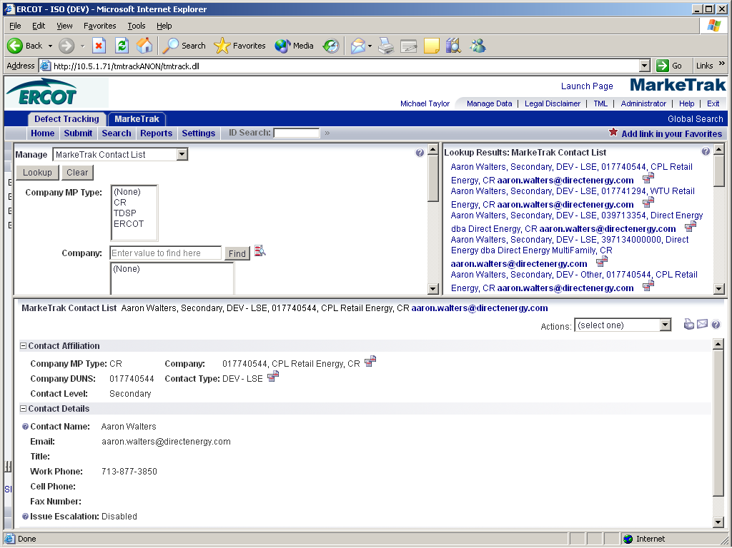

MP Contact Information will be displayed to the user in this format: (Fig 1.7d)

Fig 1.7d
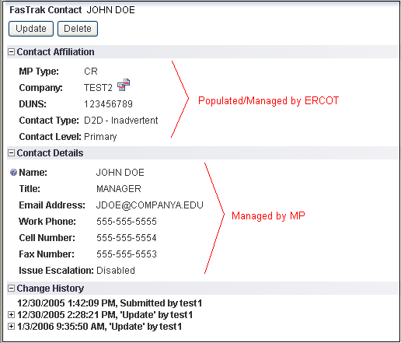

All users will have the permission to view, but not update any fields in the MarkeTrak Contacts table.

Change History will be logged for all changes to each record. The ability to view the Change History can be controlled as needed in the Privilege settings.

UPDATE
A user with proper permissions can update MarkeTrak Contacts information. The user would follow the VIEW method and by pushing the Update button, the user will be taken to an edit window. From here, the user can update the contact information. (Fig 1.7e)

Fig 1.7e
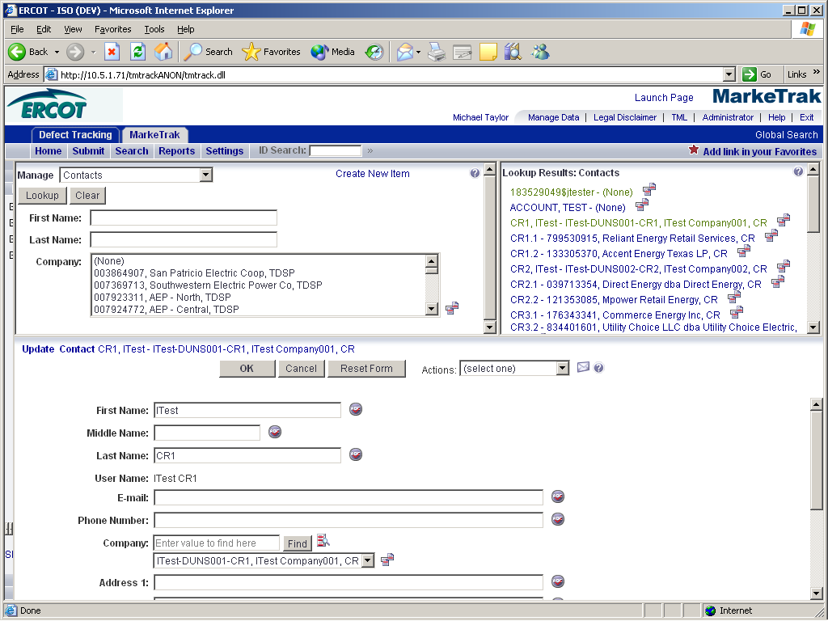

Note: Each contact category has an Escalation Primary and Escalation Secondary contact. A valid email address should be populated for both. It will be used by the Escalation Program to email Escalation Primary and Escalation Secondary contacts of issues that need to be transitioned. The issues identified have not proceeded down the workflow process to resolution in a “timely manner” and are in need of attention.

If an Escalation Primary or Escalation Secondary contact does not wish to receive escalation notifications, the Issue Escalation field should be disabled on the contact report.

Each MP may have only one (1) Escalation Primary and one (1) Escalation Secondary contact.

Only ERCOT may add new or delete contact categories.

1.7.1.2 Reporting
Reports can easily be created for users to search and display MP Contacts Table information. (Fig 1.7f)

Fig 1.7f
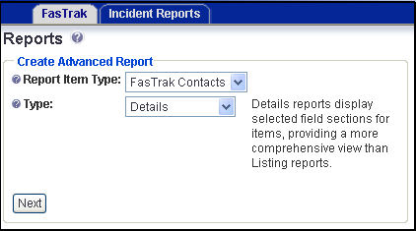

Fig 1.7g (Search Filter)
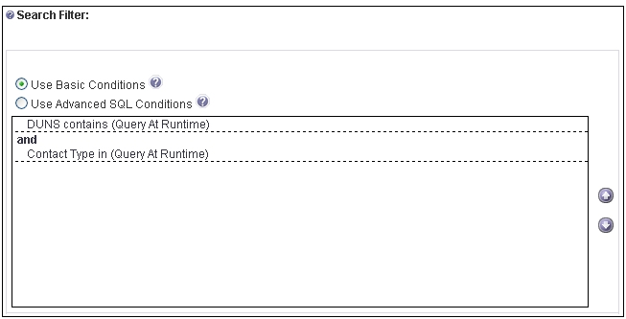

Fig 1.7h (Report Query)
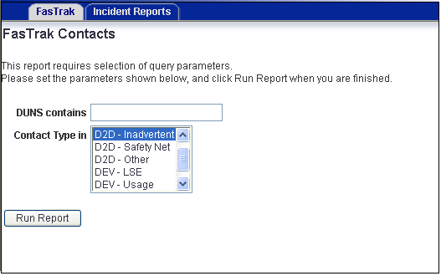

Above is an example of a MarkeTrak report that returns a list of MarkeTrak Contacts from a query based on DUNS number and Contact Type. The output of this report is displayed in a customizable column view in the browser and may also be saved as an Excel spreadsheet.

1.8 MarkeTrak Issue Grouping

1.8.1 Grouping
Each individual item submitted into the MarkeTrak application (one service order to be cancelled, one UIDESIID characteristic to be changed, etc) is treated as a separate issue. However, many issue types lend themselves to being worked en masse. Examples include: all variances from an extract on one particular day that a CR wishes to track together or a service history list of many ESI IDs that are retrieved by a TDSP more efficiently collectively. To meet this need, the MarkeTrak application has been designed to allow each Market Participant associated with an issue the ability to create logical groups of items according to their unique business needs. The groups take the form of a Group Number, a Group Name, or both.

Any user with visibility to an issue can view all user groups. This is to aid with communication between different parties. All available group designations are:

Assignee Group –
ERCOT Group –
Gaining MP Group –
Losing MP Group –
Submitter Group –
TDSP Group –

There are 2 primary methods of grouping items. During submission, the user has the option of updating a check box labeled Assign to Pending. If this functionality is used, the item will not be submitted to a New state when completed but will be transitioned to a state of Pending Issue as shown: (Fig 1.8a)

Fig 1.8a
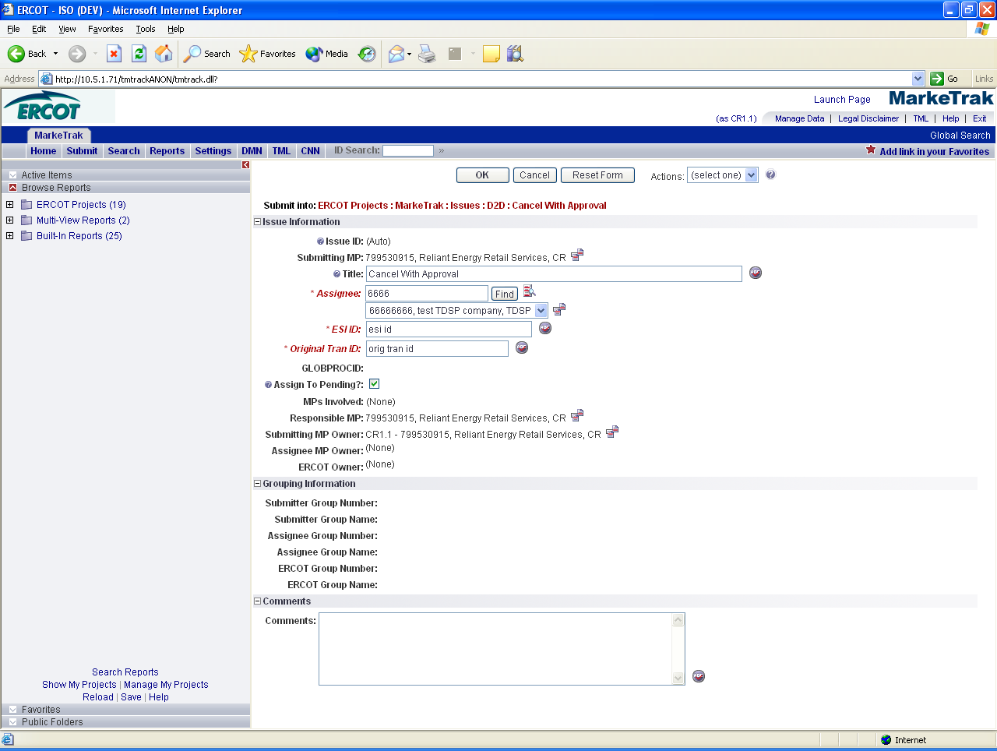

If a user wishes to submit numerous items and have them submitted for consideration simultaneously with the same group name and/or number a report would be executed including criteria- State = Pending Issue. (Fig 1.8b)

Fig 1.8b
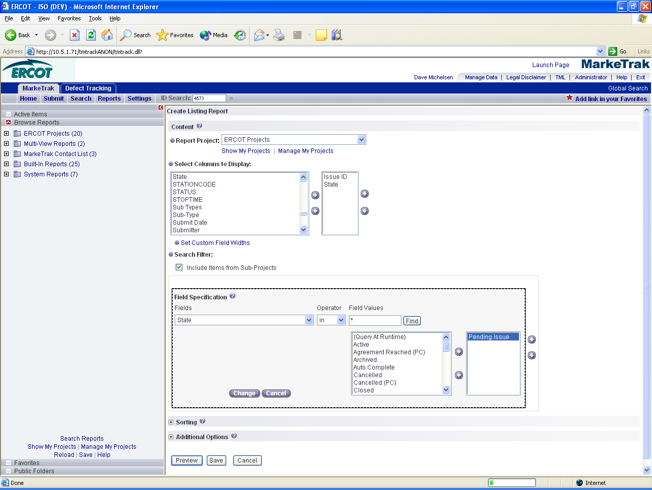

At this point the items can all be grouped together and submitted via a Mass Transition as detailed in that section. Items that are not in the same state can also be grouped together using this method due to the fact that the Assign to Group transition is available on any issue the user has visibility to. Indicate the issues individually from the result set or select the Check All option. Next select the Update All Checked button. From the drop down choose Assign to Group from Any. You will be presented a screen similar to one below: (Fig 1.8c) In this case you will have a choice of selecting Replace or Append; you will either chose to replace the group or append or add to the existing group. Append means to add as a supplement or appendix.

Fig 1.8c
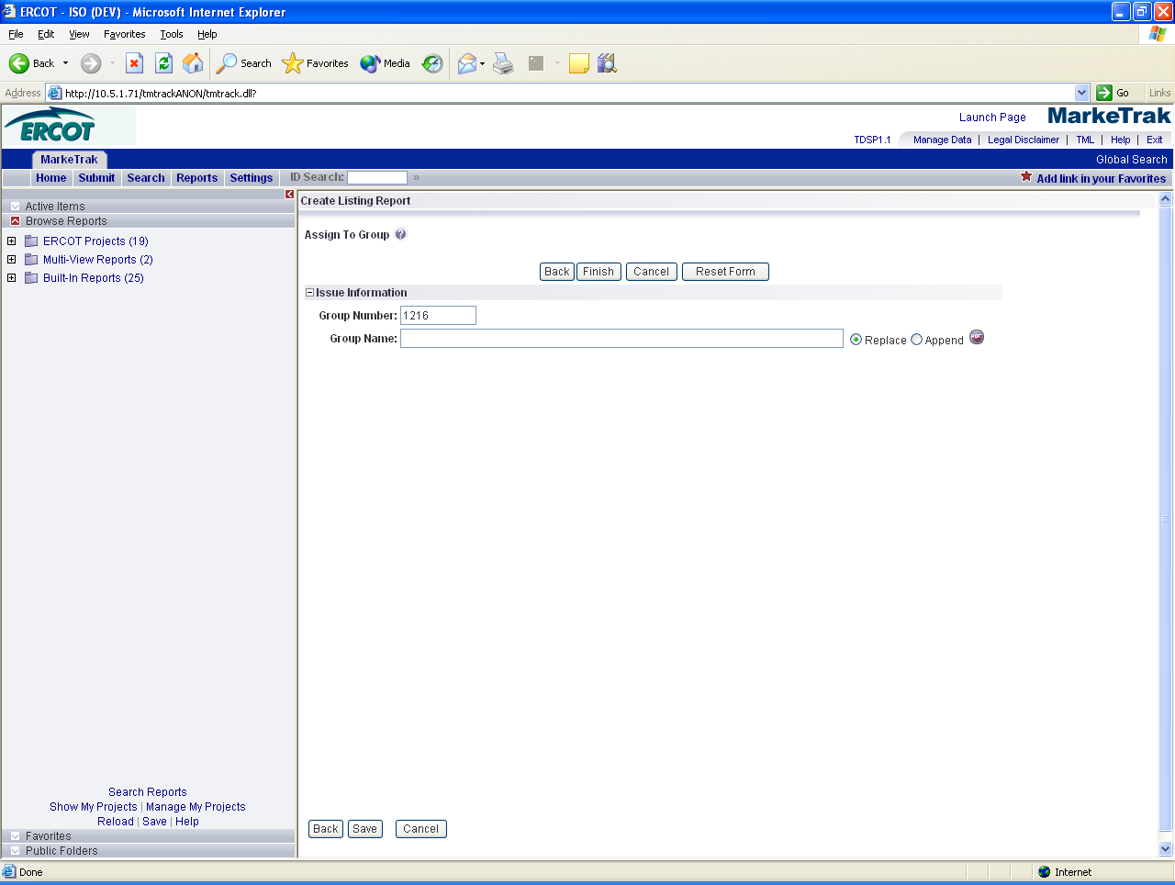

The Group Number is defaulted as an incremented value by MarkeTrak. It can be changed to a new value. Note that if a group currently exists with this number already assigned this will cause an addition to that group.

The second method of grouping involves placing a single item into a logical group via the Assign to Group transition on each visible issue: (Fig 1.8d)

Fig 1.8d
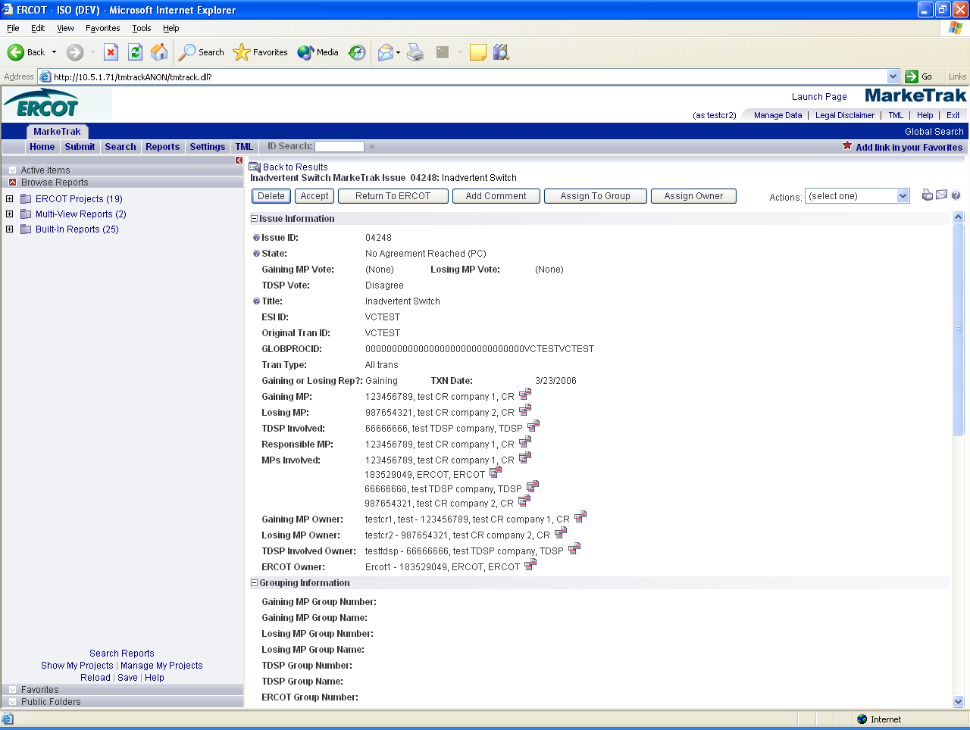

This will present the option of choosing a Group Number and Group Name in a manner similar to that of the mass transition functionality. However, when assigning issues into groups individually, an incremented Group Number is not generated. This method is designed primarily to allow users to assign issues into preexisting logical groups:

1.9 MarkeTrak Miscellaneous Information

1.9.1 Auto Close Function
Each of the workflows in the MarkeTrak application has two states that are designated as Pending Complete (PC). Generally one of these states equates to a successful resolution of the request and one indicates the item is Unexecutable. The issue submitter in both of these is the Responsible MP; they alone have the ability to transition the item to another assignee. If necessary the submitter may also request ERCOT Intervention if they do not agree that the issue is complete as indicated.
In the event that the submitter does not transition the item to another owner within a defined period of time (initially 14 calendar days) the issue will auto-transition to state Auto Closed. If the submitter does not agree to the resolution after this transition a new issue will have to be submitted. Issues cannot be reopened in the MarkeTrak Application.

1.9.2 Notifications
1.9.2.1 Automated Email Notifications

The notification system is comprised of emails sent to MP Administrator assigned contacts. The instruction for designating contacts is detailed in section 7 MarkeTrak Rolodex. If triggered, MarkeTrak will generate one email per day per contact type. Contacts are parsed in the tool based on sub type combined with escalation primary or escalation secondary designations in the Rolodex function explained in section 7. Included in each notification is an attachment (.csv format) containing issue specific information such as IssueID, Date Submitted, and Date of Last Update. Receipt of these emails is indication that the issue has surpassed the time allotted to complete a transition based on issue sub type. Any issue(s) indicated in the attachment not acted upon (transitioned to a different Responsible MP) before the end of the day will be included in a similar email the follow day.

States are not used exclusively to determine how long a particular MP has owned an issue. This is due to the fact that a Market Participant will typically have each item in a New state followed by an In Progress state. Therefore, MarkeTrak calculates the time an item has had the same Responsible MP. For example, a Cancel with Approval issue is submitted to a state of New with assignee designated as TDSP A. During the time the issue is both New and In Progress, it is pending TDSP approval. After 7 days, in an aggregate of these two states details of this issue would be included in an email to the primary and secondary Day to Day: Other contact for TDSP A. This contact information is available to be edited by MP Admins and viewed by all users in the Rolodex feature.

Day to Day Issues:
Cancellation:
- Escalation after 7 days without transition

Inadvertent Switch:
- Escalation after 14 days without an acknowledgement by CR2

All other D2D Sub Types:
- Escalation after 28 days

DEV LSE Issues:
LSE Variances:
- 14 calendar days for initial validation and analysis by ERCOT
- 21 calendar days for analysis and response by TDSP or CR
- 40 calendar days for ERCOT & CR to take corrective action.
DEV NIDR and IDR Usage Variances:
- 45 calendar days for TDSP validation and analysis to be completed
- 30 calendar days for TDSP to send transactions (if necessary) or for CR to manually update their system (if needed)
DEV ESI ID Characteristics:
- 45 calendar days for TDSP validation and analysis to be completed
- 30 calendar days for TDSP to send transactions (if necessary) or for CR to manually update their system (if needed)
DEV ESI ID Existence:
- calendar days for initial validation and analysis by ERCOT
- 65 calendar days for TDSP to send transactions (if necessary)

Load Profile Assignment (LPA) Issues:
LPA Profile Type:
- Escalation after 30 days

LPA Premise Type:
- Escalation after 30 days

LPA Zip Code:
- Escalation after 45 days

LPA Meter Type:
- Escalation after 30 days

LPA Weather Sensitivity:
- Escalation after 60 days

LPA Weather Zone:
- Escalation after 90 days

LPA Sub-Station:
- Escalation after 45 days

1.9.2.2 Individual Email Notifications

Each user with access to an item has the ability to manually select a notification related specifically to that individual issue. There are currently four such notifications created. The email address entered in MarkeTrak for the user who selects this option from the Actions: drop down list will be the destination for this email notification. (Fig 1.9a)

Fig 1.9a
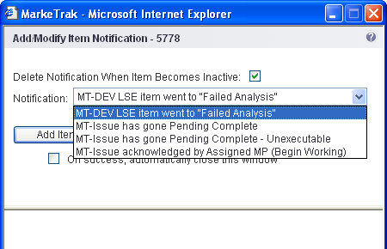

The available options are:

- MT- Issue has gone Pending Complete
Email notification will be sent to the user if the issue enters the appropriate Pending Complete state for the workflow to which it is associated.
- MT – Issue has gone Pending Complete –Unexecutable
Email notification will be sent to the user if the issue enters the appropriate Unexecutable- Pending Complete state for the workflow to which it is associated.
- MT – Issue acknowledged by Assigned MP (Begin Working)
Email notification will be sent to the user anytime an MP selects the transition Begin Working which identifies the issue owner.
- MT – DEVLSE item went to “Failed Analysis”
Email notification will be sent to the user if the DEVLSE issue enters the state Failed Analysis as detailed in the DEVLSE section of this document.

1.9.3 Duplicate Checking
There are two types of duplicate checking in the MarkeTrak system: ESI ID and GLOBPROCID. These checks are designed to help avoid MPs submitting an issue if the same request is already ‘in flight’. A common example of this is an Inadvertent Switch which can be submitted by two CRs and DEVLSE issues which can be submitted by multiple CRs and the TDSP involved. As with the ESI ID Validation described above, the submitter can elect to press OK to continue with submission or Cancel if it is realized that the same request has already been submitted.

- After the ESI ID validation described in 9.3, another check occurs exclusively in the MarkeTrak application. If this ESI ID has been submitted on an issue that the current submitting MP has visibility to, a warning message will appear indicating the Issue ID and issue sub type of those issues. As detailed in the relevant section of this document, visibility is determined by the current user’s MP Duns being populated in the MPs Involved field of the potential duplicate issue.
- GLOBALPROCID (or Global_ID) functions in exactly the same manner as ESI ID above with the exception that it only occurs when both an ESI ID and Original Tran ID are included in the submission info. This will most likely occur on Day to Day (D2D) Issues. A duplicate GLOBPROCID message indicates that the exact originating transaction the submitter is requesting has already been submitted against. (Fig 1.9b)

Fig 1.9b
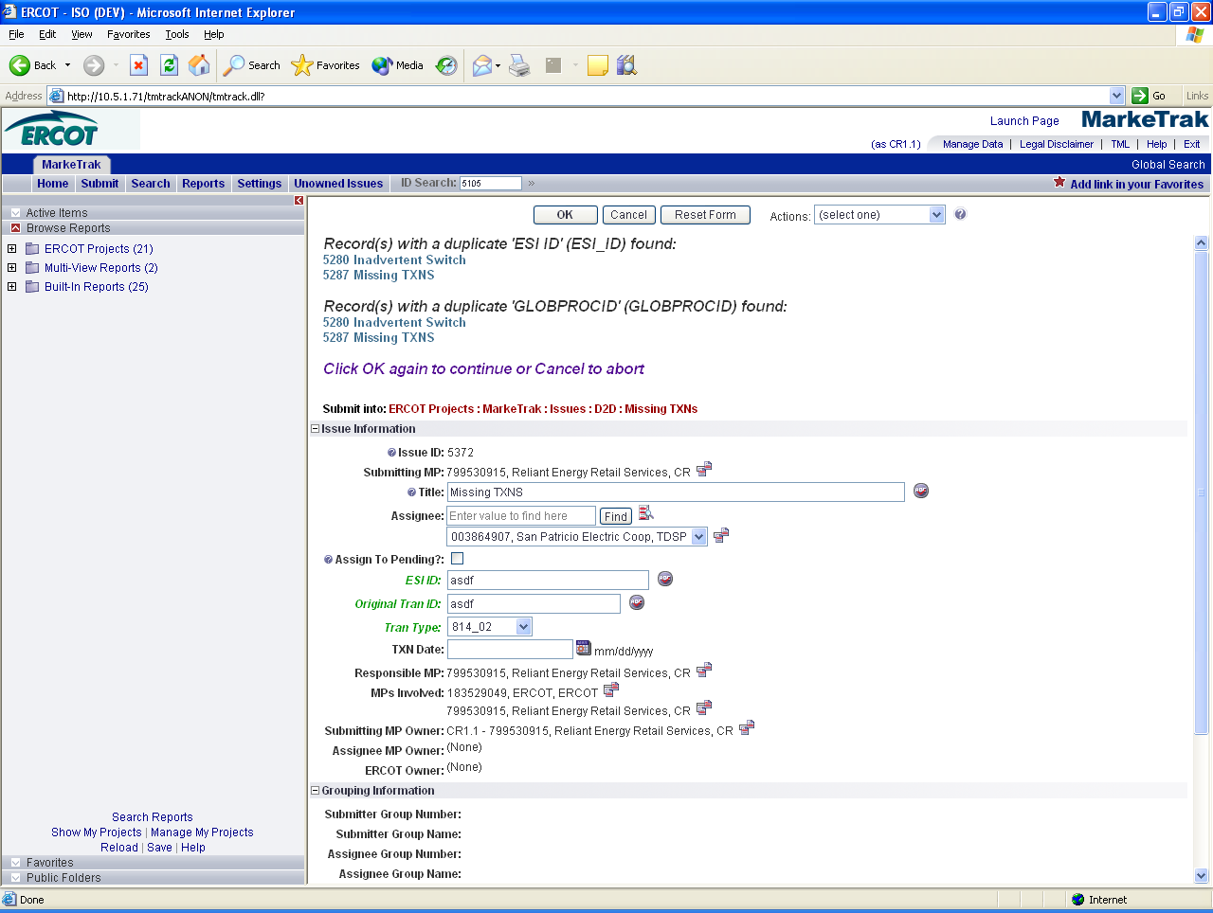

1.9.4 ERCOT Registration System Validation
Each time an ESI ID is submitted on an issue in MarkeTrak, a validation is performed against the ERCOT Registration System. On the first screen after the initial data is entered, a warning message could populate near the top of the Main Browser window indicating that the ESI ID does not exists at ERCOT. This is merely a warning; if the user deems the issue is nonetheless valid the screen can be bypassed by clicking on the OK button. If the user determines the ESI ID entered was entered in error, a corrected ESI ID could be populated and re-validated or Cancel could be selected to discontinue the submit process.

Below is a demonstration of the message received when the ESI ID submitted does not exist in ERCOT’s Registration System. (Fig 1.9c)

Fig 1.9c
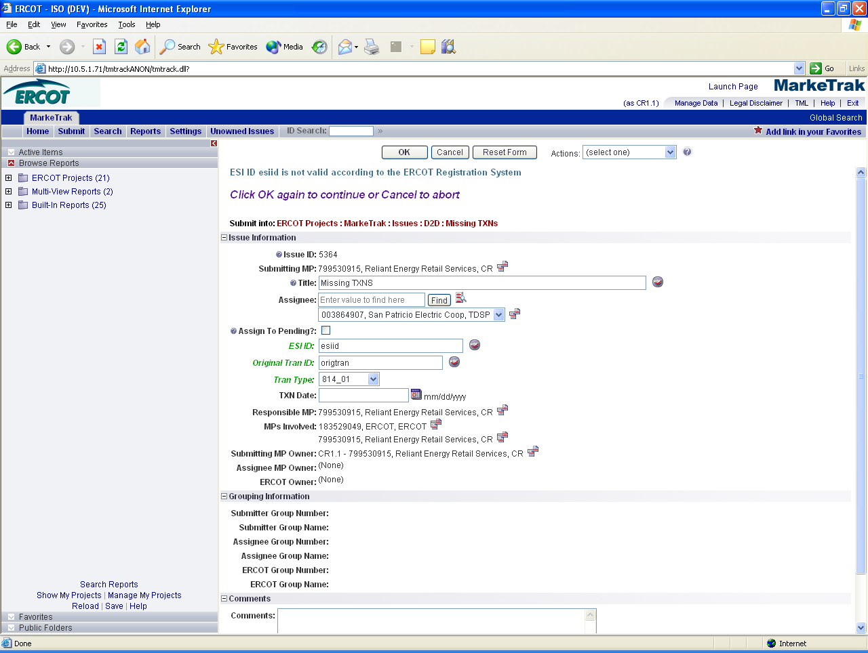

1.9.5 Siebel Status and Sub Status
Certain Day to Day (D2D) Issue Sub Types either require or allow the entry of both an ESI ID and Original Tran ID. In these instances a GLOBPROCID (Global_ID) will be created by the MarkeTrak application.

In these instances a Siebel Status and Siebel Sub status will be populated. (Fig 1.9d) This will aid both the Submitter and Assignee(s) in determining the proper resolution to the request. Additionally, the Last Siebel Status Retrieval Date is populated. Each of these three fields can be updated at any time via a transition labeled Update Siebel Status/Sub status which is available on all appropriate issues to any of the MPs Involved. The example above demonstrates a use for this data; a Cancel with Approval request has been submitted by a CR. By the time the TDSP received the issue for consideration of approval, the transaction had already cancelled due to an ERCOT Operating Rule. The TDSP could therefore select transition Already Cancelled which would place the request into a Pending Complete state. Should the Siebel Status indicate a pending status for the transaction in question, the TDSP could update the Siebel Status/Substatus via the button indicated above. This would ensure the request is still valid before the user begins work outside of the MarkeTrak application.

Fig 1.9d

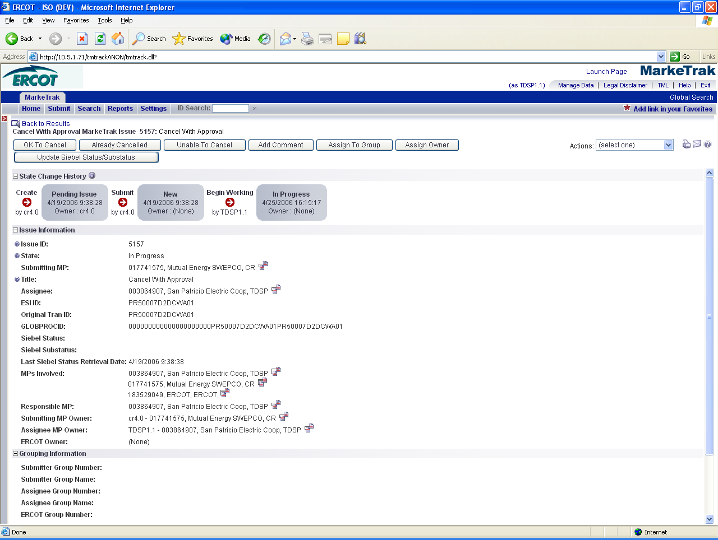

1.9.6 Item Lock
An item becomes locked in the MarkeTrak application when a transition is initiated and not completed. This typically results from two scenarios.
- The first one involves a transition that is initiated by a user with necessary rights, but who navigates to another location in the application before completion. An example of this is the selection of the Reports tab before confirmation or cancellation of the transaction below: (Fig 1.9e)

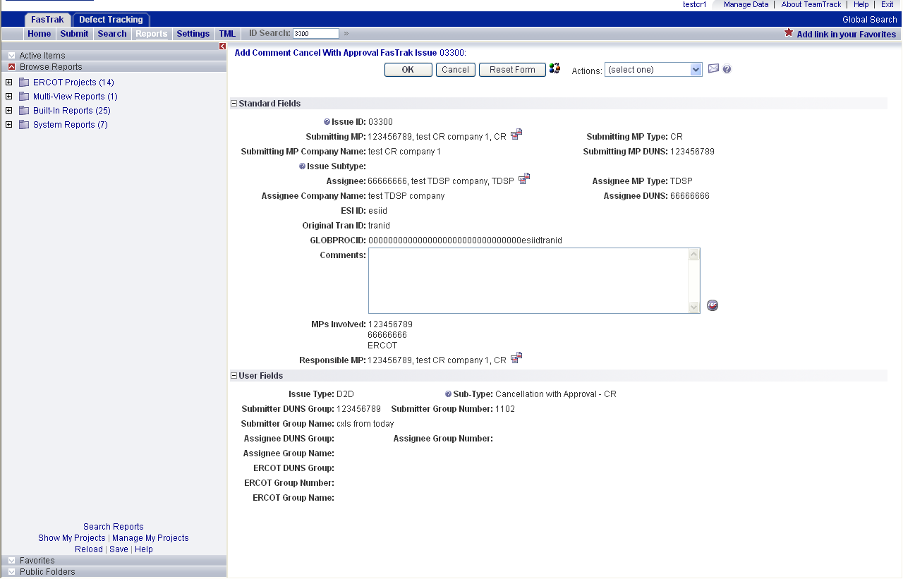

- A second scenario which would result in an issue being locked begins with the initiation of an invalid transition. There are circumstances in certain workflows in which a Market Participant may have visibility to a transition button but not the right to execute it. This is a result of the visibility and ownership model necessary to meet all business needs of each MP types simultaneously. This will display an error message with the reason for the failed transition. At this point if the user navigates to another location in the application without selecting the Cancel button the item will become locked. An example is provided below: (Fig 1.9f)
Fig 1.9f
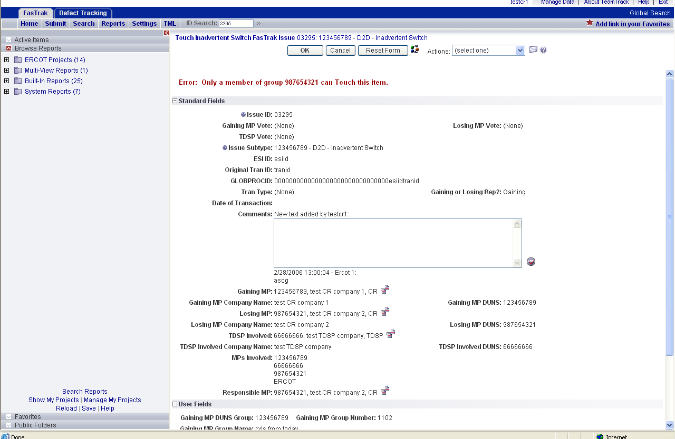

Any time an error message such as this is received indicating that the current user is not able to execute a transition, the Cancel button must be selected to avoid locking the item.

If an item has been locked and another user attempts to transition the item, a screen similar to the one below will be displayed. This will indicate that the transition cannot be completed as well as the username of the person who created the lock: (Fig 1.9g)

Fig 1.9g

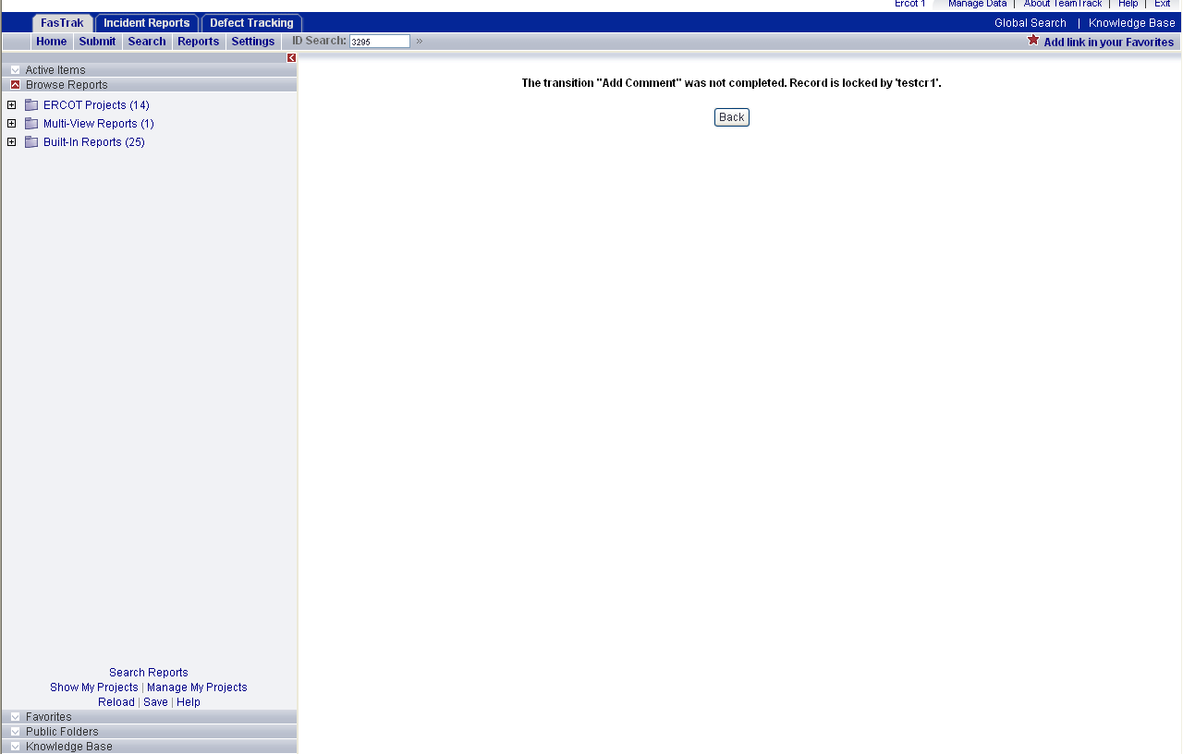

If the user who created the item lock does not Cancel the failed transition, the item will unlock itself in one of two ways. Logging out of the application will clear any locks the user has created. In addition, if the user closes the browser the MarkeTrak application is on the item will automatically unlock itself after a predetermined amount of time.

1.10 Day to Day (D2D) Issues

1.10.1 What Constitutes a MarkeTrak D2D Issue?
There are many possible scenarios that may require the logging of a MarkeTrak. The following list provides only a small sampling of some of these scenarios.

CRs
• Questions pertaining to why an ESIID is not in ERCOT system
• Questions pertaining to Inadvertent Switches
• Questions pertaining to Siebel Reports
• Questions pertaining to Rejected transactions
• Questions pertaining to request for filenames
• Questions pertaining to 997 reports
• Questions pertaining to transaction status updates
• Questions pertaining to CSAs
• Questions pertaining to Reject Reasons (i.e. why a CR received a “Not First In” response to transaction they submitted
• Questions pertaining to missing usage transactions
• Questions pertaining to Inadvertent Switches
• Questions pertaining to whether or not ERCOT received a specific transaction
CR or TDSP
• Requests for cancellation of transactions
• Questions pertaining to why a transaction was cancelled
• Questions pertaining to missing information on non required EDI fields
• Request for processing of transactions
• Questions pertaining to Texas SET
• Questions pertaining to who ERCOT shows as the Rep of Record in ERCOT system
• Questions pertaining to the processing time of transactions (Protocols)
• Questions pertaining to TML
• Questions pertaining to point-to-point transactions (such as 810s) with TDSPs, excluding the 867 Contingency Plan

TDSP
• Questions pertaining to Siebel not reflecting the correct status based on that the TDSP has submitted

1.10.2 Day to Day Issue Guidelines
1.10.2.1 Validating Issues

Before Submitting a D2D issue, MPs must validate the issue against the market reports and market resource:
- Service order Full Extract Report
- Located on the Texas Market Link (TML)
- ERCOT TML ESIID Look-Up/Transaction Look-Up
- ERCOT Market Participant (MP) Transaction Report
- Located in the FTP Reports Mailbox for each Market Participant

1.10.2.2 Working Issues

ERCOT D2D issues received by noon will be worked in the queue (from New to In Progress or further along in the workflow) by 5:00 p.m. the same business day. ERCOT D2D issues received after noon will be worked in the queue by noon the next business day.

1.10.3 Day to Day Issues Required Fields
1.10.3.1 Day to Day Required Fields
 | Assignee | ESI ID | Orig Tran ID | Tran Type | Gaining/ Losing Rep | TXN Date | GS Number | Comments
Inadvertent Switch | N/A | Req | Req | Opt | Req | Opt | N/A | Opt
Cancel w/ Approval | Req | Req | Req | N/A | N/A | N/A | N/A | Opt
Cancel w/o Approval | Req | Req | Req | N/A | N/A | N/A | N/A | Opt
Missing TXNS | Req | Req | Req | Req | N/A | Opt | N/A | Opt
Usage/Billing Issues | Req | Req | Req | Opt | N/A | Opt | N/A | Opt
Reject TXNS | Req | Req | Req | Req | N/A | Opt | N/A | Opt
Rep of Record | Req | Req | N/A | N/A | N/A | N/A | N/A | Opt
Projects | Req | Opt | Opt | Opt | Opt | Opt | Opt | Opt
SIEBEL CHG/Info | Req | Req | Req | N/A | N/A | Opt | N/A | Opt
997 Issues | Req | N/A | N/A | N/A | N/A | Req | Req | Opt
OTHER | Req | Opt | Opt | Opt | N/A | Opt | Opt | Opt

1.10.3.2 Day to Day Field Definitions
FIELD NAME | DESCRIPTION | Populated By
Issue ID | Incremented number per issue submitted | System
Submitting MP | Submitting MP DUNS # + MP name + MP type | Digital Certificate of the User
Submitting MP Type | Entity type of the Submitting MP | Company list
Submitting MP Company Name | The name of the entity Submitting the issue | Company list
Submitting MP DUNS | DUNS number of the entity Submitting the issue | Company list
Issue Subtype | Sub Type of issue selected | User-submit tree
Assignee | Assignee MP DUNS # + MP name + MP Type | Defined per workflow-user or workflow populated
Assignee MP Type | Entity type of the Assigned Market Participant | Company list
Assignee Company name | Name of the MP in the Assignee field | Company list
Assignee DUNS | DUNS number of the entity in the Assignee field | Company list
Assign To Group: | Check box. Activating sends the issue to a pending state when submit process completes | User-submit process
ESIID: | It is the Electric Service Identifier that is stored in ERCOT system | User-submit process
Original Tran ID: | It is the BGN02 of the initiating transaction | User-submit process
GLOBPROCID: | Formula involving the ESIID and Original Tran Id. This is stored in ERCOT system and will be auto populated when the ESIID and Original Tran Id or given | System generated from user populated info
Tran Type: | The transaction that pertains to the issue | User-submit process
Date of Transaction: | Date the transactions was submitted to ERCOT | User-submit process
GS Number: | Group Number | User-submit process
Comments: | Free form field | User-log throughout issue lifecycle
Responsible MP: | MP with current transition responsibility | Defined per workflow-user or workflow populated
MPs involved: | List of market participants involved in the issue; the submitter, the assignee(s) and ERCOT | Defined per workflow-user or workflow populated

D2D Inadvertent Switch Unique
FIELD NAME | DESCRIPTION | Populated By
Gaining or Losing Rep: | Binary selection-Gaining or Losing | User-submit process
Gaining MP: | Search field of all CRs | submitter per Gaining/Losing Rep field or ERCOT- via Siebel adapter or manual selection
Gaining MP Company Name: | Name of MP per Gaining MP field | Company list
Gaining MP DUNS: | MP DUNS # per Gaining MP field | Company list
Losing MP: | Search field of all CRs | Submitter per Gaining/Losing Rep field or ERCOT- via Siebel adapter or manual selection
Losing MP Company Name: | Name of MP per Losing MP field | Company list
Losing MP DUNS: | MP DUNS # per Losing MP field | Company list
TDSP involved: | TDSP DUNS # + TDSP name + MP Type | ERCOT - via Siebel adapter or manual selection
TDSP Involved Company Name: | TDSP Company Name per TDSP involved field | Company list
TDSP Involved DUNS: | TDSP DUNS # per TDSP Involved field | Company list

