1. Market →Settlements Landing Page
DAM and RTM Statements and Invoices Portlet:

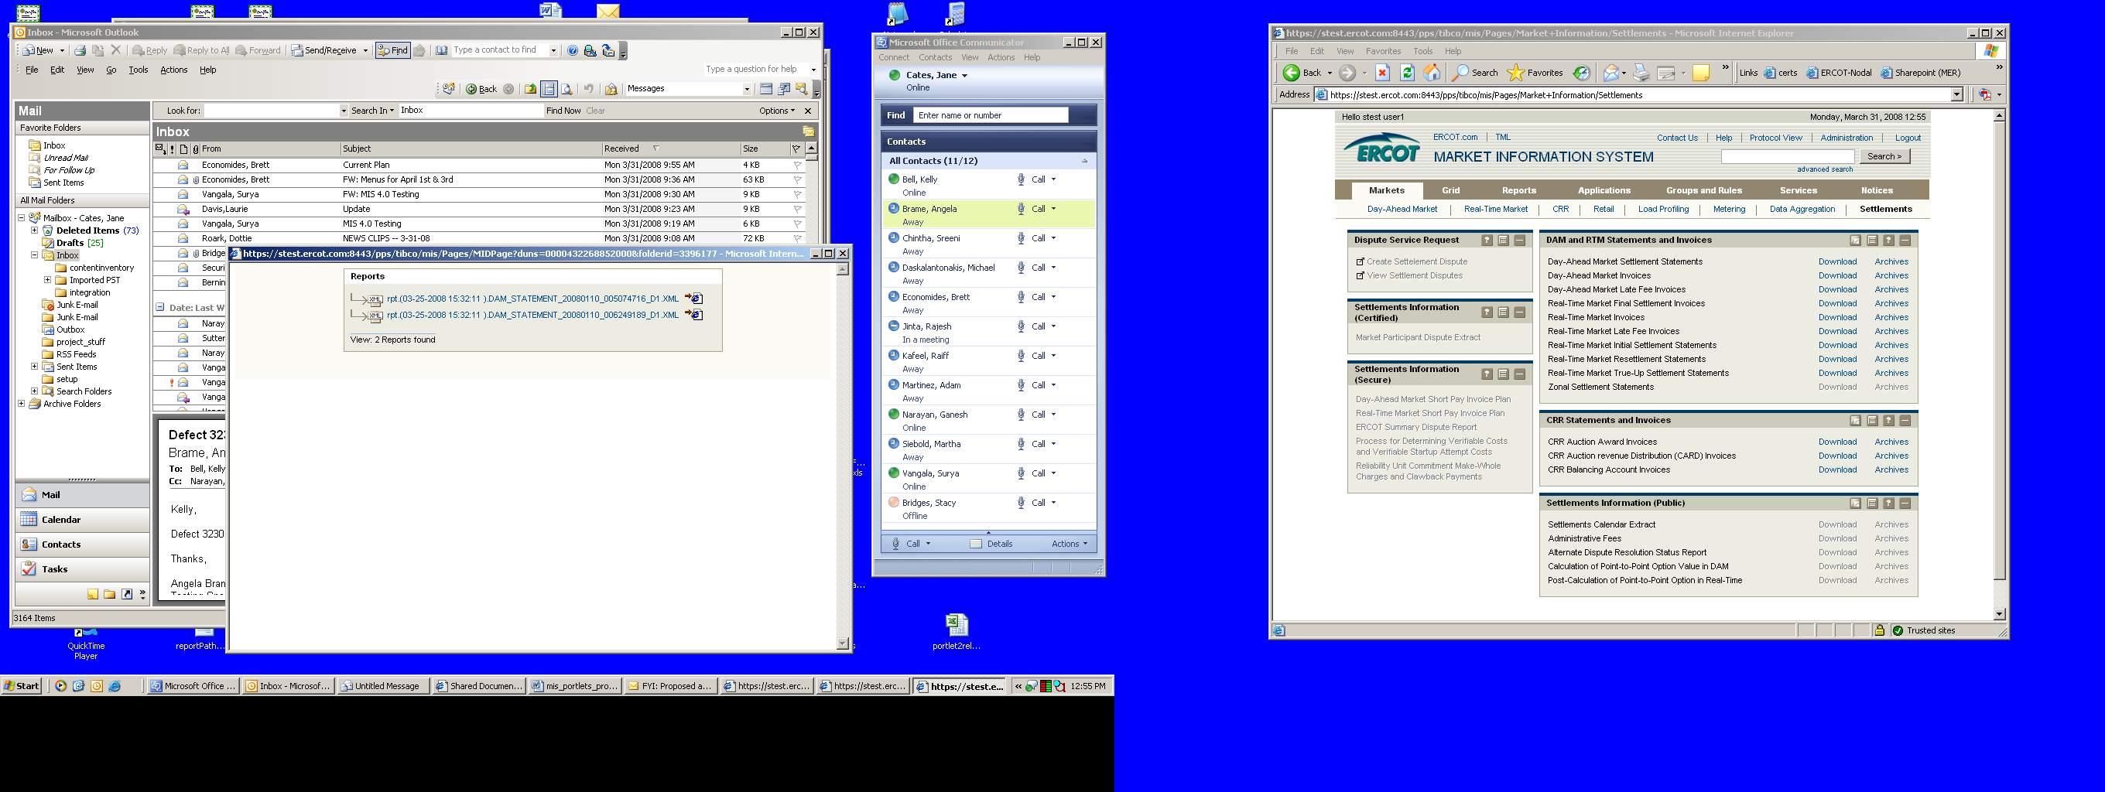

2. Click the Archives link for the report you want to open to display available
reports in the Reports Portlet.
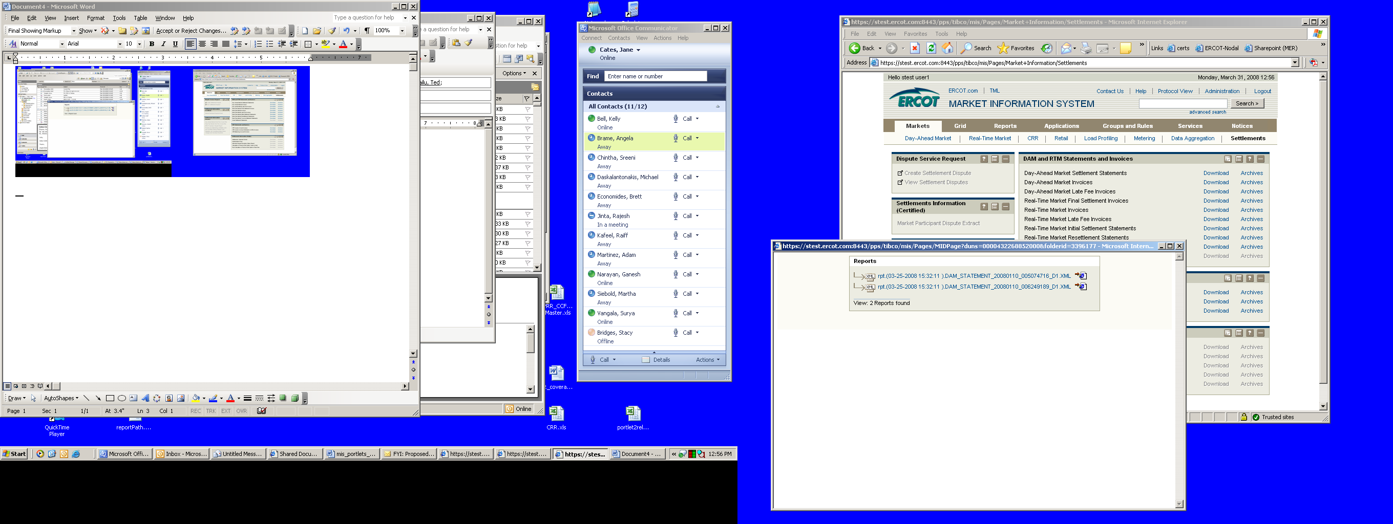

3. Click the underlined report name to view the report in xml format:

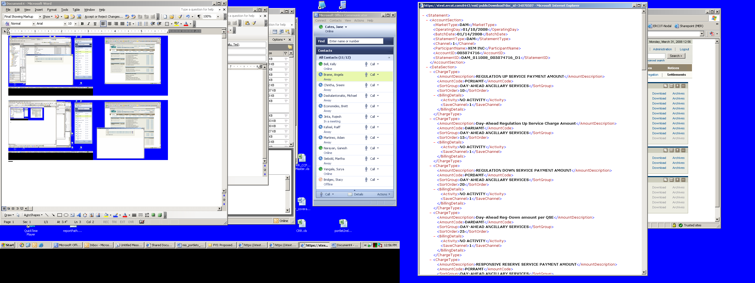

4. Click the IE icon (shown in Step 2) to the right of the report name to display
a formatted report.
