EDS 3 LFC Testing
Market Participant Handbook
This is a living document. The document and its contents have been drafted for discussion during the EDS LFC Market Participant Workshop. Based on the Workshop, ongoing planning meetings, and Nodal Project deliveries the details will be further refined.
v 1.02
Friday, March 21, 2008
Revision History

Document Revisions
Date | Version | Description | Author(s)
5/23 | 0.01 | Draft document created for EDS 3 LFC Planning Test Period w/ Market Participants. This version is a working draft for planning discussion with Participants. | IRT
7/23 | 0.02 | Draft Updated from meeting comments. | IRT and Operations
9/12 | 0.03 | Draft updated from internal meeting comments. | IRT, Operations and Settlements
10/17 | 0.04 | Draft updated from TPTF and LFC Workshop comments. | IRT, Operations and Settlements
10/18 | 0.90 | Finalized comments and incremented to v 0.90 for TPTF vote | IRT, Operations and Settlements
2/13 | 1.01 | Change to ACE Calculation Verification Completion Criteria | Operations
3/21 | 1.02 | Change to ACE Calculation Verification Completion Criteria | Operations

Table of Contents

1 Introduction 3
1.1 Market Participant LFC Handbook 3
1.2 Document Structure 3
2 EDS3 R6 Overview 3
2.1 Early Deliveries 3
2.2 Supporting Documents 3
3 R6.1 - ACE Calculation and Pre-Condition Validation 3
3.1 EDS3 R6.1 Overview 3
3.2 EDS3 R6.1 Test Activities 3
3.3 EDS3 R6.1 Market Participant Involvement 3
4 R6.2 - Load Frequency Control Individual QSE 3
4.1 EDS3 R6.2 Overview 3
4.2 EDS3 R6.2 Test Activities 3
4.3 EDS3 R6.2 Market Participant Involvement 3
5 R6.3 - Load Frequency Control (Total System) 3
5.1 EDS3 R6.3 Overview 3
5.2 EDS3 R6.3 Test Activities 3
5.3 EDS3 R6.3 Market Participant Involvement 3
6 EDS Communications 3
6.1 EDS Planning Workshops 3
6.2 Online Readiness Center 3
6.3 EDS Kickoff Session 3
6.4 EDS Weekly Conference Calls 3
6.5 Weekly Status Bulletin 3
6.6 Issue Tracking Process 3
6.7 Entry / Exit Criteria 3
7 Appendix 3
7.1 Sample R6.1 Test Form 3
7.2 Example Resource-Specific Five Minute Base Point Schedule 3
7.3 Issue Submission Lifecycle 3
7.4 Draft Issue Submission Form 3

- Introduction
The ERCOT Nodal Transition Plan, approved by the Technical Advisory Committee (TAC), organizes transition activities into four tracks, which requires participation from both ERCOT and Market Participants (MPs). The Texas Nodal Program defined four Early Delivery Systems (EDS) sequences to meet the requirements of the Systems Testing and Nodal Market Implementation track of the Transition Plan. These sequences were further refined based on the Nodal project delivery schedules to group Nodal functionality and features into nine incremental software releases that will be used to meet the requirements outlined in the Nodal Transition Plan.

The EDS sequences and releases are outlined below:

EDS 1
- Release 1 – Alarm Processing
- Release 2 – Point-to-Point Checkout
EDS 2
- Release 3 – Trial Operation of State Estimator & Network Security Analysis
- Release 4 – Trial Operation of NMMS (Network Model Validation)
EDS 3
- Release 5 – Trial Operation of SCED, 6 month LMP posting
- Release 6 – Trial Operation of LFC, ACE (LFC Handbook)
- Release 7 – Trial Operation of CRR, sample Settlement Statements
EDS 4
- Release 8 – Trial Operation of RT Settlements (No Extracts)
- Release 9 – Trial Operation of DAM, RUC, SASM, Full Settlements, EDW Extracts
- TXMACS 1.0 – Full Nodal Functionality & 168 hour testing

Market Participant LFC Handbook
The Market Participant LFC Handbook has been created to provide a detailed testing guide for participation in the Early Delivery System (EDS) activities. The Handbook is one of the guiding documents to help Market Participants understand how to prepare, participate and when to engage in EDS. This Handbook will cover the details for Release 6 – Load Frequency Control Testing. The LFC Handbook will describe any effects to Zonal Settlements and any changes to the Zonal Protocols will be managed through the Protocol Revision Request process.

The testing areas described in this document will be guided by the Nodal Transition Plan and the Nodal delivery schedule; however, the detailed testing activities and schedule will be completed by working collaboratively with ERCOT subject matter experts and MP Representatives.

Document Structure
It is critical that all participants have a common understanding of EDS activities, start dates, and participation expectations. This document will cover the following topics to ensure that ERCOT and MPs are ready for each EDS phase.

Release Overview – This section outlines the specific phases, objectives, and supporting documents for the Release 6 – Load Frequency Control Testing.

For Each Phase
- EDS Phase Overview
  - EDS Environment
  - Testing Schedule
  - EDS Functionality

- EDS Testing Activities
  - Testing Structure
  - Test Procedures

- Market Participant Involvement
  - Target Roles
  - Preparation Activities
  - System Readiness
  - Ongoing involvement

EDS3 R6 Overview

For EDS 3, LFC will be the second business functionality released to the EDS environment. The release procedure will follow the ERCOT release mechanism described earlier in this document. The initial system delivery will provide QSE’s and ERCOT the opportunity to validate the Nodal Generation Systems calculation of Area Control Error (ACE), Resource Limit Calculator (RLC), and Emergency Base Point calculation. Later phases of Release 6 will also test the QSEs ability to follow LFC Regulation and Updated Desired Base Point (UDBP) Dispatch Instructions with their Resources, control their Resources in Constant Frequency Mode, update their Resource schedules as a result of Responsive Reserve Service (RRS) dispatch requests, and finally, maintain ERCOT system frequency through the Nodal system control of Generation Resources and Controllable Load Resources.

All marketing activity during testing periods will be monitored by the Independent Market Monitor.

Early Deliveries
The Trial Operations of LFC will be executed in three phases, validating pre-conditions before executing operational control over physical Resources deployment from the Nodal LFC/Generation Subsystem. The Early Delivery System approach will allow ERCOT and MPs to begin testing as early as practical.

Beginning January 14th 2008, QSEs shall have activated all ICCP points including those listed below to provide actual and testing data as required for its Generation and Load Resources to facilitate the R6.1 testing activities. Beginning March 17th 2008, QSE’s shall be providing only actual data in order to facilitate R6.2 and R6.3 testing activities.

  - Regulation Up Resource Responsibility
  - Regulation Down Resource Responsibility
  - Responsive Reserve Resource Responsibility
  - Non-Spin Resource Responsibility
  - Responsive Reserve Schedule
  - Non-Spin Schedule
  - Regulation Up Participation Factor
  - Regulation Down Participation Factor

The following phases and objectives have been defined:

R6.1 - ACE Calculation and Pre-conditions
- Compare continuously for seven days Nodal ACE results with Zonal ACE results for accuracy.
- Verify calculations of HASL, LASL, SURAMP, SDRAMP, HDL and LDL by the ERCOT RLC.
- Verify the ability of LFC to calculate and issue Emergency Base Points and the system-wide Emergency Base Point Flag to QSEs.

R6.2 - Load Frequency Control (LFC) Individual QSE testing
- Verify for each QSE with Resources the ability to follow the four second UDBPs on Nodal Systems.
- Verify for each QSE with Resources nominated for Regulation service the ability to provide Reg-Up Service and Reg-Down Service in the Nodal Market
- Verify for each QSE providing Regulation Service the ability to operate on Constant Frequency control mode.
- Verify for each QSE with Resources nominated for RRS the ability to deploy and recall Responsive Reserve by updating their Resource schedules.

R6.3 - Load Frequency Control (LFC) Total System testing
- Verify the ability of LFC to maintain system frequency with all QSEs and Resources being dispatched by the Nodal system.
- Verify the ability of LFC to meet NERC control systems performance criteria.

Supporting Documents
The following documentation should be reviewed for a better understanding of the overall EDS 3 Approach, Market System Requirements, Generation Subsystem Requirements and ICCP specification details.

Reference: Nodal Website | Description | Version
Generation Subsystem | Texas Nodal Energy Management System Requirement Specifications For the Generation Subsystem | 1.0.0
SCED Requirements | Texas Nodal Market Management Systems (MMS) Requirement Specification For SCED and Real-Time MMS Processes | 1.0.0
ICCP Handbook | ERCOT Nodal ICCP Handbook | 1.0.0
EDS 3 Approach Document | EDS 3 Approach Document | 1.0
EMS Design | Texas Nodal EMS Conceptual System Design Document | 0.11
EMS SCADA Requirements | Texas Nodal EMS Requirements Specification For SCADA | 1.0

R6.1 - ACE Calculation and Pre-Condition Validation

EDS3 R6.1 Overview
EDS Environment
R6.1 will check the accuracy of the Nodal calculation of the ACE compared to the Zonal system for seven days. R6.1 will also verify that the QSEs supporting Nodal ICCP systems can communicate with ERCOT Nodal ICCP systems and that other EMS upgrades of the Generation Subsystem have been completed. The calculations performed by the RLC will be verified, and testing will be carried out to confirm ERCOT’s ability to calculate and issues Emergency Base Points and a QSE’s ability to receive correct Emergency Base Points and the system-wide Emergency Base Point Flag. All QSEs with Resources will be required to participate in the RLC and Emergency Base Point Validation testing.

The diagram below highlights the components tested during R6.1:

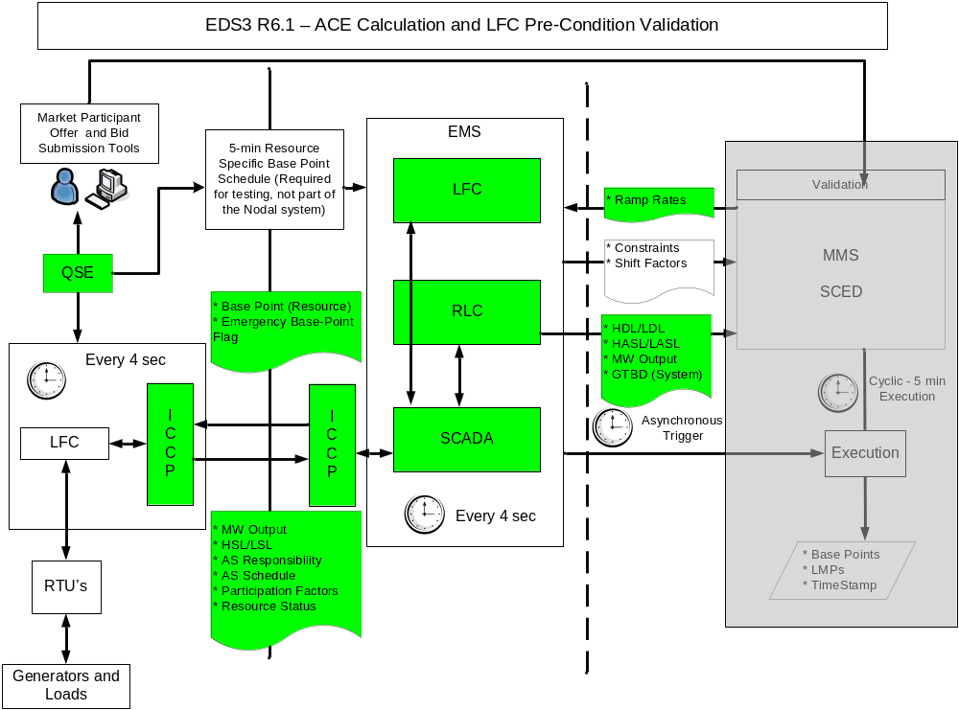
* Note: Only the colored components will be used for R6.1 testing.

The ERCOT applications deployed for phase R6.1 of LFC testing will be installed on ERCOT production hardware rather than testing hardware. These systems are intended to perform to ERCOT production standards for LFC testing.
In general, the EDS systems will be available and supported from 8am to 5pm on designated “EDS Testing Days” based on the defined EDS calendar. During off hours and non-testing days the system may be unavailable for system updates, ERCOT testing, or other testing activities. Any changes in testing schedules will be reflected in the EDS testing calendar and communicated to MPs. However all the LFC testing phases will involve tightly coordinated activities between QSEs with Resources and ERCOT LFC testing personnel, the system will be available only to scheduled QSEs during their designated test times.

Testing Schedule
The R6.1 testing is targeted to take place from January 2008 to the end of February 2008. During this period, QSEs should finish testing EDS2 back-end validation of communications capabilities. This must happen prior to the QSE engaging in R6.2 testing activities.

The diagram below shows a typical R6.1 testing week:

Monday
Tuesday
Wednesday
Thursday
Friday
Monday Conf Call
Morning Test Period
Morning Test Period
Morning Test Period
Friday Conf Call
Channel: Conf Call
Channel: Conf Call
Channel: Conf Call
Channel: Conf Call
Channel: Conf Call
Audience: All QSEs
Audience: Single QSE and
LFC team
Audience: Single QSE and
LFC team
Audience: Single QSE and
LFC team
Audience: All QSEs
Subj: Overview of weekly
activities
Subj: Support R6.1
Activities
Subj: Support R6.1
Activities
R6.1
Activities
Subj: Review R6.1 progress
& issues
Afternoon Test Period
Afternoon Test Period
Afternoon Test Period
Channel: Conf Call
Channel: Conf Call
Channel: Conf Call
Audience: Single QSE and
LFC team
Audience: Single QSE and
LFC team
Audience: Single QSE and
LFC team
Subj: Support R6.1
Activities
Subj: Support R6.1
Activities
Subj: Support R6.1
Activities

- Monday Conference Call - Used to communicate with all R6.1 and EDS3 Release 6 participants on:
  - R6.1 and other EDS3 Release 6 activities planned for the week
  - Updates to online support documents & tools
  - Resolved issues or environment updates

- Mid Week Test Periods - The LFC support team will have two Test Period slots for each day Tue, Wed, and Thurs that Individual QSEs will have the opportunity to signup for support from ERCOT Subject Matter Experts to walk through R6.1 testing activities or work on specific QSE integration issues. A detailed calendar of R6.1 Test Periods will be available on the Nodal Website.

- Friday Conference Call - Used to communicate with all R6.1 and EDS3 Release 6 participants on:
  - R6.1 and other EDS3 Release 6 activities accomplished during the week
  - Updates to online support documents and tools
  - Identified software or environment updates

The EDS team will provide a schedule of when ACE Calculations are being performed and compared to Zonal frequency calculation values. Results from the ACE Calculation Validation will be shared on the Monday and Friday “all QSE” conference calls.

EDS Functionality

Generation Subsystem Functionality (LFC)
The tables below describe the capabilities and requirement coverage of the initial EMS system to support input data validation, operations monitoring and control. The requirements documentation and specific details can be found on the Nodal Readiness Center Website.

ACE Calculations
 | Req | Req Specification Name | Description
1 | GS-FR2 | ACE Calculation
2 | GS-FR3 | Regulation reduction

Resource Limit Calculator
 | Req | Req Specification Name | Description
3 | GS-FR36 | Limit calculations

Validation of Other Calculations
 | Req | Req Specification Name | Description
4 | GS-FR38 | Inputs from SCADA
5 | GS-FR40 | Form of Resource Base Points
6 | GS-FR43 | Data outputs to MMS
7 | GS-FR44 | Database Entry
8 | GS-FR48 | Emergency Base Points

EDS3 R6.1 Test Activities
R6.1 tests the ERCOT Nodal software and communication without physically switching or controlling any Resources. Prior to these testing activities, all Nodal software and communication systems will have been tested in Factory Acceptance Testing (FAT) and ITEST leading to EDS3 and each QSE will have tested its Nodal EMS and communication systems.

Testing Structure

The following testing activities are required for phase R6.1 and will be coordinated by ERCOT:
- Comparison of the Nodal ACE results with Zonal ACE results to test accuracy for a continuous seven day period
- Verification of outputs produced by ERCOT’s RLC for each QSE
- Verification of ERCOT’s ability to calculate and issue Emergency Base Points and the system-wide Emergency Base Point Flag for each QSE

ACE Calculation Verification Test Structure

This test will be carried out as required by the ERCOT Nodal Transition Plan and will be performed solely by ERCOT. No MP involvement during testing periods will be necessary.

The system ACE will be calculated by LFC using the following formula:

Raw ACE = Frequency Bias * (Actual Frequency – Scheduled Frequency)

The Frequency Bias will be equal to the ERCOT Area Frequency Bias in MW/0.1 Hz. This value will then be compared for accuracy to the ACE calculation produced by the Zonal system.

A comparison of the Nodal and Zonal processed ACE value will also be done by ERCOT during LFC tuning and testing.

ACE Calculation Verification Completion Criteria

To complete the seven day continuous test, the Nodal ACE must closely follow the current Zonal ACE and respond to the frequency changes as expected. To achieve this, the performance will be validated using the ACE and frequency data recorded from each of the seven continuous days. ERCOT will provide correlation results of the Zonal and Nodal recorded frequencies and ACE calculations to help identify and address any low performance intervals. When all low performance periods have been addressed, the ACE verification will be complete.

Resource Limit Calculator and Emergency Base Point Verification Test Structure

All QSEs representing Resources should participate in this part of the LFC testing. During the testing:

- Nodal RLC and LFC, Nodal ICCP, and QSE EMS (Nodal) environments will be used for testing.
- Test control signals will be sent from Nodal LFC to QSE EMS (Nodal).
- Only one QSE will participate in testing during a schedule test period.
- Each QSE will select several of its Resources with which to validate the ERCOT RLC calculations.
- Input data for the RLC will be entered manually by the QSE into their Nodal system for each Resource selected for testing. This data will be telemetered to ERCOT via ICCP.
- ERCOT will verify that the RLC outputs update in accordance with the RLC design for each telemetered change by the QSE.
- ERCOT will trigger an Emergency Base Point Calculation and ‘Commit’ the results which will then distribute the Emergency Base Point Incremental MW to the all Resources in the ERCOT system. Only a portion of the Emergency Base Point Incremental MW will be distributed to the QSE under test.
- QSEs will verify that they have received both the Emergency Base Point for the correct Resources and the status flag indicating that the base point was sent from the Emergency Base Point Calculator.

Resource Limit Calculator and Emergency Base Point Verification Test Procedure

The following is the step by step description of the RLC verification approach:

Preconditions
- ICCP and the Generation Subsystem (LFC, RLC and Resource Qualification Testing) will have passed FAT and completed acceptable portions of the ITEST.
- ERCOT will have validated that the RLC outputs and Emergency Base Point calculator values are calculated in the ERCOT Nodal system as expected per the Nodal EMS Design documents.

Before the Test

- QSEs will have forwarded ERCOT a completed R6.1 Test Form. A sample of this form can be found in the appendix.

During the Test

- ERCOT will ask the QSE to manually change SCADA data telemetry for the predetermined Resource(s). The input data will be:

  - Generator Net Real Power MW or Load Resource MW (for Controllable Load Resources)
  - High and Low-Sustainable Limits (HSL and LSL)
  - Reg-Up Ancillary Service Resource Responsibility
  - Reg-Down Ancillary Service Resource Responsibility
  - Responsive Reserve Ancillary Service Schedule
  - Non-Spin Ancillary Service Schedule
- ERCOT will activate the Responsive Reserve deployment flag and verify changes to RLC calculations. For this phase of testing, this flag is being changed solely for RLC calculation and QSEs will not be required to update their Resource schedules at this time.
- ERCOT will verify the various output data produced by RLC. The output data will be:
  - Resource High Ancillary Service Limit (HASL)
  - Resource Low Ancillary Service Limit (LASL)
  - Resource SCED Up Ramp Rate (SURAMP)
  - Resource SCED Down Ramp Rate (SDRAMP)
  - Resource High Dispatch Limit (HDL)
  - Resource Low Dispatch Limit (LDL)
- ERCOT will manually enter an Emergency Base Point Incremental MW value and trigger the Emergency Base Point calculation
- The entered Incremental MW value will then be distributed among the dispatchable Generation Resources in LFC. The QSE under test will receive a new Base Point through ICCP, calculated from the Emergency Base Point calculator. The QSE will also receive a status flag indicating that the Base Point has been provided by the Emergency Base Point Calculator
- The QSE will be asked to verify that its Resource Base Point has updated and that it has received the aforementioned status flag

After the Test
- ERCOT will verify that the RLC calculations and the Emergency Base Point Incremental MW for the Resource(s) were correct.
- ERCOT will verify the Nodal Ancillary Service Capacity Monitor calculations by comparing the results to the Zonal Ancillary Service Capacity calculations
- The data captured and test results will be sent to the respective QSE.
- If a QSE cannot participate in or complete the testing during the scheduled time, it will be required to coordinate with ERCOT to reschedule a new test time.

RLC Calculation Verification Completion Criteria
The RLC verification for each QSE will be completed after each RLC calculation has been verified by ERCOT and the relevant QSE for correctness, and any outstanding issues related to the calculations have been adequately addressed.

Settlement Considerations for R6.1 testing

- QSE Resource portfolios will be controlled by Zonal systems and will not be part of these tests
- No impact to Zonal settlements.

EDS3 R6.1 Market Participant Involvement

Target Roles

The activities and functionality tested in EDS3 R6.1 are relevant to the following MP groups:

QSEs representing Resources: ICCP Validations
ERCOT: ACE calculation and Nodal ACE Comparison, Emergency Base Point and other calculations

While there will be limited involvement necessary from the MPs for validation of the Nodal ACE calculation, participation in the other testing activities will be required before entering R6.2. During the RLC calculation testing, the QSE will be involved in providing input data to ERCOT through their Nodal system. During the Emergency Base Point testing, the QSE will be required to verify that it has received the correct Emergency Base Point Dispatch Instructions for their Resources and the system wide Emergency Base Point Flag.

Many MPs will be on different schedules. It is recommended that QSEs attend conference calls at least once a week and continue checking the Readiness Center for EDS 3 Release 6 documentation updates during the entire period to keep updated on EDS activities, lessons learned, environmental changes, and overall progress.

Preparation Activities

No special training will be provided for participation in phase R6.1 of LFC Testing. A R6.1 Test Form will be provided by ERCOT for the QSE to populate with test data before the test period. The R6.1 Test Form will provide ERCOT and QSE with the input data changes, and allow ERCOT and the QSE to have ‘expected’ calculation values prior to testing. The R6.1 Test Form will also be used as a record of the test and the results.

System Readiness

MP’s must be able to change the necessary input data in their Nodal systems and provide the data changes to ERCOT via ICCP. MP’s should also have provided the necessary Ramp Rate data to ERCOT through the RARF process. Finally, MPs’ systems must be able to receive the correct Resource-level Emergency Base Points and the system wide Emergency Base Point Flag from ERCOT.

Ongoing Involvement

There is a limited set of activities that should be completed at least one time to ensure connectivity and ability to receive outputs and control Resources. Once these are complete, MPs are encouraged to continue testing connectivity and Resource control thoroughly. It is recommended that QSEs continue to attend the weekly conference calls even after their own testing for phase R6.1 has been completed.

R6.2 - Load Frequency Control Individual QSE

EDS3 R6.2 Overview
EDS Environment
R6.2 will be an integrated test of major system components that include the ERCOT Nodal software, the communication from ERCOT to QSEs, the QSE Nodal system and communication from QSEs to physical Resources.
All QSE’s with Resources that will be following a SCED calculated Base Point in Nodal, must participate in R6.2 testing and demonstrate the ability of its Resource(s) to respond correctly to the UDBP’s as calculated by LFC. In addition to the UDBP, QSE’s with Resource(s) intended to provide Regulation in Nodal must demonstrate the ability of its Resource(s) to follow Nodal Regulation Up and Regulation Down dispatch instructions as calculated by LFC.
The integrated test will be performed one QSE at a time, with the Nodal System calculating and sending Regulation Dispatch Instructions and UDBP’s to the single QSE and it’s Resources under test. The Zonal System will continue to calculate and send Regulation Service and Balancing Energy Dispatch Instructions to all QSE’s. The ERCOT Zonal and ERCOT Nodal systems will see the same frequency deviations, calculate the same raw ACE, perform similar ACE processing, and dispatch Regulation asynchronously.
While it is desirable that all Resources planning to follow UDBP’s and/or provide Regulation in the Nodal Market participate in R6.2 testing, it is intended that EDS3 R6.2 testing be accomplished with Resources that are both on-line in the Zonal Market and that the QSE has designated as capable of following such dispatch instructions in the Nodal Market. QSEs are not expected to bring off-line Resources on-line for the purpose of this test and are not required to test every resource designated as capable of following UDBP and/or providing Regulation Service in the Nodal Market. A QSE’s Resources being tested on Nodal will be asked to respond to LFC Regulation Dispatch Instructions based on a current Zonal Ancillary Service obligation for the test period. The ability of the Resources to follow Nodal LFC Regulation Dispatch Instructions and UDBPs will be determined by monitoring the Regulation Dispatch Instructions, Resource’s Base Points, Resource’s UDBP, Resource’s Participation Factors and observed telemetered MW output of the Resources.
The Resource Qualification Testing software is a function within the Nodal EMS Generation System module and will be used to facilitate LFC testing. The Resource Qualification Testing tool will provide the ERCOT Operator and Test Engineer the ability to track Resource response in Real-Time on a Resource-specific basis and allow multiple Resources to be tested during a single test period. During the test, ERCOT and the QSE will be able to easily determine the general capability of LFC to send Dispatch Instructions to the QSE and the QSE to deploy its Resources. ERCOT will inform QSEs of any Resource’s questionable response to the LFC Dispatch Instructions. QSEs will be responsible for addressing Resource control problems identified prior to the start of Nodal “go live” operations.
R6.2 also includes testing to verify that each QSE with Resources to provide Regulation Service in Nodal has the ability to operate on Constant Frequency control mode on their Nodal systems. This test will determine a QSE’s ability to correctly respond to system frequency changes using their Nodal systems.
Lastly, ERCOT will be testing Responsive Reserve Service deployment and recall. QSE’s with Resources intended to provide Responsive Reserve Service in Nodal should participate in the testing. The Responsive Reserve Service test is a communication test of a QSE’s ability to receive a Responsive Reserve Deployment signal, update their Responsive Reserve Ancillary Service Schedule(s) and provide the updated schedules to ERCOT via ICCP. QSE’s will not be required to deploy the Responsive Reserve energy for this test. ERCOT will verify that the RRS schedules are updated within the time specified in Section 8 of the Nodal Protocols, and verify the RLC calculations are updated correctly in response to the RRS schedule changes.

The ERCOT and Market Participant applications deployed for phase R6.2 of testing will be installed on production hardware rather than testing hardware. These systems are intended to perform to production standards for LFC testing. QSE’s must be able to switch control from Zonal to Nodal and vice versa, within two minutes upon request from ERCOT. This ability will be verified as part of the R6.2 testing, but will be a requirement for the R6.3 tests.

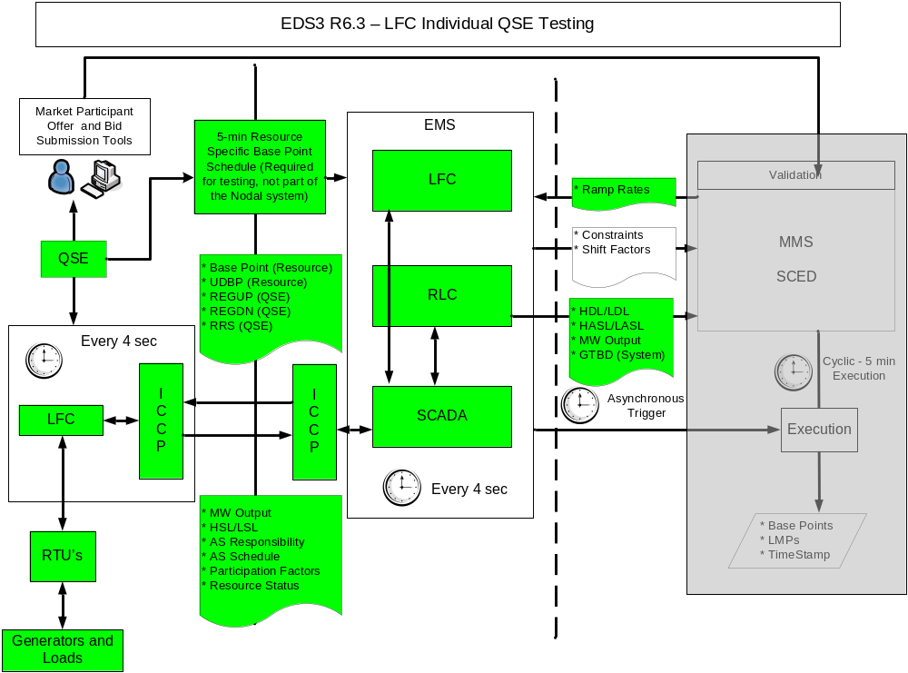
* Note: Only the colored components will be used for R6.2 testing.

Testing Schedule
The R6.2 tests for individual QSEs are targeted to take place between March 2008 and May 2008. Individual LFC testing for QSEs will be available after R6.2; however, these tests must be scheduled such that they do not conflict or impede the continuing EDS3 programmed testing such as SCED testing, R6.3 of LFC testing, etc. Individual QSE testing of Resources not granted qualification through the attestation process should be completed before the start of the Nodal market. Each QSE participating in the R6.2 testing will be scheduled for at least a one and a half hour test period. This time will cover the minimal time needed for all R6.2 testing. However the test period time may be extended if additional testing time is required or requested and agreed upon by the QSE and ERCOT. For QSE’s with a large portfolio of Resources, additional test periods may be scheduled to allow them to manage impact and risk. ERCOT will schedule and coordinate all test periods.

Testing a QSE’s ability to operate on Constant Frequency control mode and RRS schedule change will be ideally scheduled directly before or after the LFC UDBP and Regulation test. The Constant Frequency control mode test is to be coordinated with ERCOT and will be approximately fifteen minutes. The RRS schedule update test will also be approximately fifteen minutes.

It is planned to have two testing periods per day. They will be:
  - 9am to 12pm
  - 1pm to 4pm
These test periods will avoid morning ramp and afternoon peak load times. The three hours should be sufficient time for the QSE and ERCOT to conduct the required tests and allow some time for trouble shooting any issues during the test.

EDS Functionality

Generation Subsystem Functionality (LFC)
The tables below describe the capabilities and requirement coverage of the EMS system to support input data validation, operation monitoring and control in addition to those listed in R6.1. The requirements documentation and specific details can be found on the Nodal Readiness Center Website.

LFC Resource Control
 | Req | Req Specification Name | Description
1 | GS-FR1 | Regulation without optimization
2 | GS-FR4 | Reg-Up and Reg-Down allocation to QSE’s
3 | GS-FR5 | Base Point Ramping and Permissive Blocking
4 | GS-FR6 | LFC Performance
5 | GS-FR7 | Regulation output control signals
6 | GS-FR8 | Allocation of Regulation signals to individual Resources
7 | GS-FR9 | Frequency selection
8 | GS-FR37 | Reg and RRS Qualification Testing feature

Ancillary Service Capacity Monitor
 | Req | Req Specification Name | Description
9 | GS-FR28 | Available ancillary service capacity by Resource
10 | GS-FR30 | Ancillary service reserves
11 | GS-FR32 | Average Generator regulation and Average MW output
12 | GS-FR33 | Expected primary frequency response from Resources
13 | GS-FR34 | Resource not responding Flags
14 | GS-FR35 | Resource Error

Resource Limit Calculator
 | Req | Req Specification Name | Description
15 | GS-FR36 | Limit Calculations

Resource Qualification Testing
 | Req | Req Specification Name | Description
16 | GS-FR37 | Regulation and Responsive Reserve Qualification Testing Feature

Generation Subsystem Inputs and Outputs
 | Req | Req Specification Name | Description
17 | GS-FR38 | Inputs from SCADA
18 | GS-FR39 | Centralized Dispatch
19 | GS-FR44 | Database Entry
20 | GS-FR47 | Updated Desired Base Point
21 | GS-FR49 | LFC Control Modes

EDS3 R6.2 Test Activities

The testing activities for R6.2 involve the physical deployment of Resources. For this reason, all QSE testing activities will be coordinated with ERCOT and any deviation from the testing activities will need to be approved by ERCOT prior to the test date.

Testing Structure

Required testing activities:

- Individual QSE UDBP - verification that each QSE with Resources has the ability to receive and follow the UDBP Dispatch Instructions on their Nodal system.
- Individual QSE Regulation - verification that each QSE and selected Resource designated to provide Reg-Up Service and Reg-Down Service in Nodal has the ability to receive Regulation Dispatch Instructions, and provide Regulation Control on their Nodal System.
- Constant Frequency Operation - verification of each QSE’s ability to operate on Constant Frequency control mode on their Nodal system.
- Responsive Reserve Service – verification that each QSE with Resources designated to provide Responsive Reserve Service in Nodal has the ability to receive a Responsive Reserve Service deployment signal from ERCOT, update the relevant Responsive Reserve Schedules, and deliver the Responsive Reserve Schedule changes to ERCOT via ICCP.

Individual QSE UDBP and Regulation Test Structure
All QSE’s with Resources should participate in the UDBP testing and all QSE Resources designated to provide Regulation Service in Nodal should participate in the LFC Regulation testing. During the Individual QSE LFC UDBP and Regulation tests:
- Each UDBP test period will be at least one hour per QSE
- Each Regulation test period will be at least one hour per QSE.
- UDBP and Regulation testing can be performed simultaneously during a one hour test period.
- A QSE may continue to participate in Zonal Real Time Balancing Energy during the one hour test period only with Resources not participating in the Individual QSE test. Resources participating in the Individual QSE test can not participate in Zonal Real Time Balancing Energy during the scheduled 1-hour test period. For the Resources under test, their capacities to provide Zonal Balancing Energy will be excluded from the QSE balancing bid for the test period.
- A five minute Resource-Specific Base Point Schedule must be provided for each Resource participating in the Individual QSE test and must represent the Resource-Specific fifteen minute Zonal Base Point Schedule for the scheduled test period.
- For the requirement of verifying a QSE’s Resources ability to follow the UDBP, it is necessary that at least one of the QSE Resources being tested has a varying five minute Base Point schedule during the test period such that the specific Resource will respond by changing its MW output accordingly.
- The Resource-Specific Base Point Schedules must be forwarded to ERCOT in the provided file format (see appendix, Section 7.2) and can be adjusted up to thirty minutes before the scheduled test period start time. If the QSE elects to maintain Ancillary Service Capacity on the Resource undergoing test, it must accommodate such capacity in the construction of its five minute Base Point Schedules.
- The five minute Resource-Specific Base Point Schedules should not be adjusted during the test period. If a change to the five minute Resource Specific Base Point Schedule is unavoidable due to system conditions, then the test may need to be cancelled.
- The five minute Resource-Specific Base Points MW values provided by the QSE will represent the SCED Interval Base Points. E.g. the five minute Base Point MW value assigned to a Resource for the time stamp 09:05:00 in the flat file, is representative of where the Resource MW output is schedule to be in five minutes at 09:10:00.
- ERCOT or the QSE may terminate testing for system operations considerations at any time.
- A VDI will be issued for the QSE participating in the test, which will be valid only for the hour before, during test period and one hour after the test period. The QSE will be exempt from Uninstructed Resource Charge and Schedule Control Error settlement charges and deemed compliant with CPS1 for the above hours.

Individual QSE UDBP and Regulation Test Procedure
The following is the step-by-step description of the LFC UDBP and Regulation test:
Preconditions
- ICCP and the Generation Subsystem (LFC, RLC and Resource Qualification Testing) will have passed FAT and completed acceptable portions of the ITEST.
- QSEs will have tested and demonstrated that communication from their EMS (new or significantly changed) to their Resources is functional.
- QSEs will have tested the ability to provide Resource-Specific five minute Base Point Schedules to ERCOT.
- QSEs will have tested the capability to obtain Regulation Service Dispatch Instructions from both the ERCOT Zonal and Nodal system and be able to switch between the Zonal and Nodal systems within two minutes of receiving an instruction from ERCOT via a hot line call.
- QSEs will have tested the capability to obtain the correct Resource level UDBPs from the ERCOT Nodal System, and be able to put the Resources under test on Automatic Generation Control using the UDBPs.
- QSE’s will have tested the capability for their Resources providing Regulation in Nodal to operate in Constant Frequency control on their Nodal system.
- QSE’s will have tested the capability to receive RRS deployments from the ERCOT Nodal System, and be able to update the RRS accordingly.
- Both the ERCOT Zonal and Nodal systems will have the capability to obtain system frequency simultaneously.
- QSEs under test will have the capability to continue to provide data to the ERCOT Zonal system during the Nodal testing.
- ERCOT will have a monitoring tool to enable the testing of multiple Resources within a single QSE.

Before the Test
- ERCOT will confirm the test date and time with the QSE at least two days in advance. ERCOT shall make good faith efforts to accommodate QSE requests to schedule the test to minimize the impact of the test on the QSE’s fleet operations. In order to complete testing within the project schedule time line, QSEs shall make a good faith effort to accommodate the agreed upon test schedule. The following rules shall be applied for Resource / QSE selection for testing:
Where practical, the QSE will have been awarded Regulation Service from the Zonal Day-Ahead Ancillary Services (AS) Market or Self-arrange Regulation Service on its Resources to participate in testing.
- The QSE under test will participate in the Zonal AS Market. The hourly ratio of the Regulation Service obligation of the QSE under test to the total hourly ERCOT requirement will be the same in the Nodal LFC during testing. These ratios will be available after the Zonal AS Market clears.
- The QSE under test must submit Resource-Specific five minute Base Point Schedules to represent the Resource-Specific fifteen minute Zonal Base Point Schedules for the scheduled test period. This will be used as the SCED Base Point input for the LFC calculations and must be provided to ERCOT at least 30 minutes before the start of the test period. An example showing the necessary format for the Resource-Specific five minute Base Point schedule can be found in the appendix.

During the Test
- ERCOT will begin the test by issuing a VDI. If at any time during the test either ERCOT or the QSE terminates the test, ERCOT will issue a VDI documenting the termination event. ERCOT will end the test by issuing a VDI documenting the end of the test and instructing the QSE to return to control under the Nodal System.
- ERCOT will input into their Nodal system the Resource’s Base Points provided by the QSE at five minute intervals.
- ERCOT will honor the hourly ratios of the Reg-Up and Reg-Down obligation of the QSE under test to the total hourly ERCOT requirement in the Nodal system.
- At the scheduled hour, the test will start or, if system conditions do not permit the test, it may be delayed or aborted as necessary. ERCOT will select the QSE Resources under test to Zonal ‘test’ mode. By selecting a Resource to Zonal ‘test’ mode, the Resource will not be included in the Zonal Balancing Energy or Unit specific Local Congestion calculations. However, the Zonal system will continue to include those Resources selected to Zonal ‘test’ mode in the calculation of Zonal Regulation requirements for all QSEs as normal. This will ensure there is no effect on those QSEs and Resources not involved in the R6.2 testing.
- The QSE will switch the Resources being tested to receive Base Point and Regulation Service Dispatch instructions and be controlled from the ERCOT Nodal system.
- For each Resource under test, the QSE must telemeter the Resource’s Reg-Up and a Reg-Down participation factor during the test period.
- ERCOT will use a structured regulation test process for testing the Resources providing Regulation. The structured test will ensure the Regulation deployment from LFC will honor the Zonal obligation. Resources should follow their telemetered Participation Factors. Nodal LFC will send the Regulation Dispatch Instructions to the QSE under test via ICCP.
- The Nodal LFC will compute the UDBP using the five minute Resource-specific Base Points provided by the QSE, and send the UDBP Dispatch Instructions to the QSE under test via ICCP.
- The Zonal system will continue to compute and send the required Regulation Service Dispatch Instructions to all QSE’s, including the QSEs under nodal testing. During the test period, the QSE being tested will ignore the Regulation Dispatch Instructions from the ERCOT Zonal system.
- If a determination is made that a Resource is not responding to Nodal LFC Dispatch Instructions appropriately, that Resource’s performance will be excluded from the test and, if necessary, the test will be discontinued and control will be returned to the Zonal system.
- At the end of the hour, under direction from ERCOT, the QSE under test will switch control back to Zonal and conclude the test or continue to operate on Nodal system for the Constant Frequency Operation test if so directed by ERCOT.
- On the completion of all testing, ERCOT will remove the QSE under test from Zonal ‘test’ mode.

After the Test
- All test data will be compiled for the QSE and each Resource tested.
- ERCOT will determine if each Resource tested responded to the Dispatch Instructions provided by the Nodal LFC. The ability of Resources to respond to Nodal LFC in controlling system frequency will be used to gauge the readiness of the Nodal system.
- QSEs inappropriately responding to the Nodal LFC Regulation test, as defined by the criteria below, will be required to work with ERCOT to resolve the issue(s) and if necessary re-schedule another test period.

Settlement Considerations
- QSEs under test will not be subject to Uninstructed Resource Charges (URC) of Schedule Control Error (SCE) for the hour before the test period, during the test period and the hour following the test period.
- Verbal Dispatch Instructions (VDI) records will be sent to the ERCOT Settlement group for the hours the QSE participated in LFC Regulation and Constant Frequency Operation testing.
- For periods not covered by the VDI, all URC and SCE will apply.

Individual QSE UDBP and Regulation Completion Criteria
Successful Market Participant Readiness will be based on the QSE’s ability to receive UDBP and/or Regulation Dispatch Instructions from ERCOT and distribute those Dispatch Instructions to the Resources under test and also on the changes in each Resources power output being consistent with the QSE UDBP and/or Regulation Dispatch Instructions. ERCOT and the QSE shall jointly evaluate each Resource’s performance by comparing the Resource(s) performance to the AS qualification criteria in Section 8 of the Nodal Protocols.
ERCOT shall report to the QSE the results for each Resource tested. ERCOT shall also provide a calculation of the one minute average of the absolute difference between the Resource Actual MW and the Expected MW output where the Expected MW output equals the sum of the UDBP MW and Regulation requested MW value. Resource expected Governor Response will also be taken into consideration when determining a Resource’s capability.

Constant Frequency Operation Test Structure
All QSE’s with Resource(s) to provide Regulation Service in Nodal are required to participate in the Constant Frequency Operation testing. The testing is planned to be done immediately before or after the LFC testing while QSE’s are operating on their Nodal system.

Constant Frequency Operation Test Procedure
The following is the step-by-step description of the Constant Frequency testing:
- QSE will switch (or be already switched) to their Nodal system.
- ERCOT will request the QSE to switch to Constant Frequency operation.
- The QSE will operate on Constant Frequency for at least fifteen minutes
- ERCOT will request the QSE to cease operating on Constant Frequency mode and return to following Regulation Service Dispatch Instructions from ERCOT Nodal System
- QSEs under test will not be subject to Uninstructed Resource Charges (URC) of Schedule Control Error (SCE) for the hour before the test period, during the test period and the hour following the test period.
- Verbal Dispatch Instructions (VDI) records will be sent to the ERCOT Settlement group for the hours the QSE participated in LFC Regulation and Constant Frequency Operation testing.

Constant Frequency Operation Completion Criteria
ERCOT will monitor QSE and individual Resource response to system frequency to evaluate QSE performance for purpose of meeting Nodal Readiness Criteria. ERCOT will verify that the Resource(s) under test have a change in MW output in response to frequency deviation and that the MW output change is in the correct direction to improve frequency and is an expected amount (Ramp Rate and Governor Response considerations)

Responsive Reserve Service Schedule Test Structure
All QSEs with Generator(s) and/or Controllable Load Resource(s) to provide RRS in Nodal are required to participate in the RRS Schedule testing. Loads acting as a Resource (LaaRs) will not be tested during this Release. This test will be done during the schedule test period, and can be performed before, during or after the other R6.2 tests.

Responsive Reserve Service Schedule Test Procedure
The following is the step-by-step description of the RRS Schedule testing:
- ERCOT will manually initiate the deployment of RRS by entering a positive MW value into it’s Nodal system.
- LFC will calculate the RRS deployment for each QSE. A QSE’s deployment will be proportional to, and also limited to, it’s cumulative Responsive Reserve Ancillary Service Responsibility. When calculating the cumulative Responsive Reserve Ancillary Service Responsibility, unavailable Resources will be excluded.
- After receiving the RRS request, the QSE under test will divide up the resulting responsive reserve deployment signal among the Resources providing responsive reserve, accounting for the amount of Responsive Reserve Ancillary Service Responsibility for each Resource.
- The QSE under test will then telemeter back to ERCOT the Responsive Reserve Ancillary Service Responsibility and the Responsive Reserve Ancillary Service Schedule for each Resource.
- This is only a communication test and the QSE will not be required to deploy the requested RRS energy during this test.
- ERCOT will record the following data for the necessary Resources to validate the RRS deployment process:
  - Responsive Reserve Ancillary Service Responsibility (telemetered from the QSE)
  - Responsive Reserve Ancillary Service Schedule (telemetered from the QSE)
  - HASL (outputted by ERCOT’s RLC)
  - LASL (outputted by ERCOT’s RLC)
  - SURAMP (outputted by ERCOT’s RLC)
  - SDRAMP (outputted by ERCOT’s RLC)
  - HDL (outputted by ERCOT’s RLC)
  - LDL (outputted by ERCOT’s RLC)
- After ERCOT has observed the schedule change, the RRS deployment MW value on the ERCOT Nodal system will be changed to 0 MW to initiate the RRS recall. LFC will send a zero responsive reserve MW deployment value to the QSEs.
- The QSE under test will reset the Responsive Reserve Ancillary Service Schedule to be equal to the Responsive Reserve Ancillary Service Responsibility.
- ERCOT will verify the RRS Schedule has been updated and is reflected in the RLC calculations (repeat Step 6 above)
Responsive Reserve Service Schedule Completion Criteria
The Responsive Reserve Service Schedule test will be completed if all RRS schedules have been updated (deploying and recalling RRS) within the time specified in Section 8 of the Nodal protocols and all RLC calculations have updated correctly in response to the RRS schedule changes.

EDS3 R6.2 Market Participant Involvement
Target Roles

The activities and functionality being tested in EDS 3 R6.2 are relevant to the following MP groups:

QSE’s representing Resources in Nodal: QSE receipt of Dispatch Instructions and Resource response.
ERCOT: Dispatch Instruction and Resource monitoring

Preparation Activities

ERCOT will define a test calendar similar to the one used for Point-to-Point and SCED testing MP’s will be required to sign-up for test periods.

Many MPs will be on different test schedules. MPs should participate in the conference calls at least once per week, checking the Nodal Readiness Center website for EDS 3 documentation updates during the entire period to keep updated on EDS activities, lessons learned, environmental changes and overall progress.

The QSE shall coordinate its LFC Regulation and Constant Frequency testing with ERCOT. This is mandatory testing for QSEs to participate in R6.3 testing as Regulation Service provider.

Systems Readiness

For MP’s with Resource that are providing Regulation in Nodal, their Nodal system must be able to receive Regulation Dispatch Instructions from the ERCOT Nodal System. MPs must be able to provide Resource-level five minute Resource-specific Base Point Schedules to ERCOT. MPs’ Nodal EMS systems must be able to receive ERCOT Regulation Service Dispatch Instructions, regulate Resources as instructed and also operate on Constant Frequency.

For MP’s with Resources that will follow a SCED Base Point in Nodal, their Nodal system must be able to obtain the correct UDBPs from the ERCOT Nodal System, and be able to put the Resources under test on Automatic Generation Control using the UDBPs.

For MP’s providing RRS in Nodal, their Nodal system must be able to receive a RRS deployment from ERCOT Nodal, update their Responsive Reserve Schedules, and provide ERCOT with the updated Responsive Reserve Schedule. MP’s Nodal system must also be able to recall RRS through changing their Responsive Reserve Schedule when requested by ERCOT.

Ongoing Involvement

There is a limited set of activities that should be completed at least one time to ensure connectivity and ability to receive outputs and control Resources. Once these are complete, MPs are encouraged to continue testing connectivity and Resource control thoroughly. It is recommended that QSEs continue to attend the weekly conference calls even after their own testing for phase R6.2 has been completed.

R6.3 - Load Frequency Control (Total System)

EDS3 R6.3 Overview
EDS Environment
R6.3 will test ERCOT’s ability to provide energy balancing and maintain system frequency using the Nodal system for Base Point calculation and Ancillary Service and meet the NERC frequency control criteria using nodal systems software. Phase R6.3 will include three tests and will involve all QSEs to follow the LFC calculated UDBP derived from the SCED Base Point and all QSEs that have completed R6.2 testing to follow Nodal Regulation Dispatch Instructions.. The three tests will have duration periods of two, eight and forty-eight hours, respectively. The first two tests will allow ERCOT and QSEs to build confidence in the Nodal system in controlling both Balancing Energy and Frequency. The forty-eight hour test will ensure the Nodal system is exposed to a complete ERCOT load profile and allow any outstanding ERCOT or QSE issues to be addressed during the test. The Zonal system will continue to operate in parallel to the Nodal test and will produce Balancing Energy (BE) and Regulation Dispatch Instructions; however all BE and Regulation Service will be managed by the ERCOT and QSE Nodal systems. RRS that does not include Loads acting as Resources (LaaR’s) will be managed by the Nodal systems and deployed by LFC when required. RRS provided by LaaR’s will be managed through the existing Zonal systems. Non-Spin Service will be managed using VDI’s if required during the test period and will not be deployed from the Nodal MMS or EMS systems. The QSEs providing Regulation and Responsive Reserve Services in Nodal will receive Dispatch Instructions based on the awarded Ancillary Services in the Zonal self-provision and AS market for the test period. QSE’s must reflect their Zonal obligation(s) for Regulation and RRS in their Nodal Ancillary Service Responsibilities and Schedules during the tests. QSEs not completing Regulation Service or RRS (excluding LaaR’s) testing in R6.2 cannot provide these services in the Nodal system in R6.3 testing nor may they participate in the Zonal Regulation AS self-provision and AS Regulation and RRS (excluding LaaR’s) market for the days in which nodal testing is scheduled.
QSEs must follow the LFC UDBP and Regulation Dispatch instructions as appropriate. QSEs must provide Three-Part Energy Offer Curves, Incremental and Decremental (Inc/Dec) Energy Offer Curves and Output Schedules as necessary for SCED to calculate Base Points. QSE’s must also provide the necessary Ancillary Service Responsibilities and Schedules representative of their Zonal obligation(s) for LFC to provide Regulation Dispatch Instructions and Responsive Reserve deployment. QSE must continue to provide energy schedules to the Zonal market for all hours during the test period. This is a requirement to maintain operation during the testing and during transition periods when QSE’s will be dispatching simultaneously in both Zonal and Nodal systems real time.
The Three-Part Energy Offer Curves, Inc/Dec Energy Offer Curves, Output Schedules and Ancillary Service Responsibilities and Schedules provided by the QSEs for R6.3 testing shall be representative of both their portfolio Balancing Energy Service (BES) bids submitted in the Zonal System and their Zonal AS obligation. The individual Resource Energy Offer Curves should effectively be the same as those the QSE would use to individually dispatch its own Resources assuming it were accepting control from the Zonal system.
The Zonal system will continue to operate as normal and calculate MCPE’s for each Congestion Zone based on the QSE’s submitted BES bids. However, SCED will manage energy balance and will provide Resource-Specific Base Points for all Resources using Three-Part Energy Offer Curves or Output Schedules provided by the QSE. This is possible since the Nodal and Zonal systems will have the same Generation to be Dispatched (GTBD) values. Also, both the Zonal and Nodal systems will see the frequency deviations and calculate the same ACE. ERCOT will not activate instructions in Zonal due to the Commercially Sensitive Constraints (CSC), but will manage CSCs and congestion through SCED Base Point calculation using local congestion methods. ERCOT will activate the same constraints for local congestion management in the Zonal Real Time Constraint Activity Management (RTCAM) and Nodal Transmission Congestion Management (TCM) to ensure the MCPE prices determined by the Zonal System are accurate and suitable for settlements for the testing periods.
The ability of ERCOT to control frequency with the Nodal LFC will be gauged by NERC CPS criterion. The CPS scores are calculated and monitored in the ERCOT EMS system. Regulation Service Dispatch Instructions, Resource Base Point, Resource Participation Factors and observed MW output of the Resources will be monitored and recorded for verifying ERCOT performance. The Resource Qualification Testing software is a function within the Nodal EMS Generation System module and will be used to monitor the performance of QSEs and Resources during the tests.

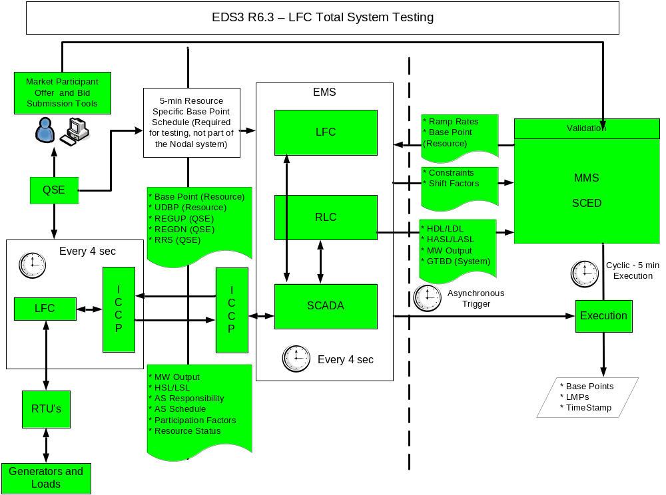
* Note: Only the colored components will be used for R6.3 testing.

Testing Schedule

The R6.3 tests are targeted to take place starting in June 2008. The scheduled date for the first test will depend on the completion of R6.2 testing and will require a predetermined minimum amount of system Resources to have been tested in R6.2 and shown to have the ability to follow the UDBP and provide Regulation and RRS for Nodal. In order to maintain the integrity and reliability of the ERCOT System and to test the LFC system’s ability to maintain system frequency through Regulation, R6.3 will include at least three tests of two, eight and forty-eight hours each. R6.3 testing will be scheduled during ERCOT System conditions favorable to testing with limited exposure to significant transmission congestion. After the first (two hour) test, a complete evaluation of results will be conducted and reported to MPs. Similarly, on completion of the eight hour test, an evaluation of results will be provided to MPs prior to scheduling the forty-eight hour test. During the testing periods, ERCOT may abort the test at any time for any reason and immediately resume energy dispatch using the Zonal systems. All R6.3 operations will be conducted under the direction of the ERCOT Shift Supervisor and QSE dispatch controller/operators.

EDS Functionality

Phase R6.3 testing will enable ERCOT and QSEs to perform energy balancing and frequency control through SCED calculated Base Points and LFC Dispatch Instructions . All previous EMS system requirements for R6.1 and R6.2 will be required for R6.3 testing. Also required are the MMS systems and functionalities to support the SCED process for both the QSEs and ERCOT.

EDS3 R6.3 Test Activities

The testing activities for R6.3 involve the physical deployment of Resources. For this reason, all testing activities will be coordinated with ERCOT and any deviation from the testing activities will need to be approved by ERCOT prior to the test date.

R6.3 will use SCED to calculate and provide Resource-specific Base Points and will manage congestion and real time energy balancing. QSEs must provide their Resource(s) Three-Part Energy Offer Curves and Output Schedules for SCED to calculate the Base Points. LFC will use the SCED Base Points and will calculate an UDBP for each Resource. QSE’s should also submit Ancillary Service Responsibilities and Schedules for Regulation and Responsive Reserve Services (excluding LaaR’s) in Nodal representative of their Zonal obligation. LFC will deploy Regulation and Responsive Reserve based on these responsibilities and schedules.

Testing Structure

Required testing activities:
- Total System: - verify ERCOT’s ability to perform Energy Balancing and Frequency control through SCED and LFC Dispatch Instructions and QSE Nodal systems.

Total System Test Structure
All QSEs representing Resources must participate in the Total System test. All QSEs must follow the UDBP and/or Regulation Dispatch Instructions from LFC. .
- There will be multiple total system tests (a minimum of three).
- SCED will calculate Resource Base Points and manage congestion
- LFC will calculate the UDBPs and the Regulation Service requirements for Resources and QSEs.
- LFC will manage RRS deployment and recall during R6.3 testing periods
- Non-Spin service will be managed with VDI’s during the testing periods
- QSEs must be able to switch back and follow Dispatch Instructions from the ERCOT Zonal system within two minutes if so instructed by ERCOT
- During the test period, the QSEs will not be subjected to URC or SCE in the same manner as in R6.2 testing.
- ERCOT’s Settlement group will use calculated MCPE’s from the Zonal system and OOME Dispatch Instructions from the Zonal system.
- A VDI will be issued for all QSEs participating in the test, which will be valid only for the test period, and provide each QSE exemptions from Uninstructed Resource Charges and Schedule Control Error settlement charges and the exclusion of non-compliant CPS1 intervals.

Total System Test Procedure

This initial portion of each test period is based on the expected time needed to select each QSE participating in Nodal testing, one by one, to verify frequency QSE performance in response to the SCED and LFC instructions. Once all QSEs participating in the test have been selected, an additional fifteen minutes is required to control system frequency and capture testing data for performance analysis and reporting. The eight and forty-eight hour tests will also follow the same initial switching from Zonal to Nodal as the two hour test.

The following is the step-by-step description of the Load Frequency Control Total System test:
Preconditions
- ICCP and the Generation Subsystem (LFC and Resource Qualification Testing) will have passed FAT and completed acceptable portions of the ITEST.
- ERCOT and QSEs following UDBP and/or providing Regulation Service will have participated and completed the necessary testing in R6.2.
- ERCOT and QSEs with Resources providing RRS will have completed the necessary testing in R6.2
- All QSEs must be able to provide Three-Part Energy Offer Curves, Inc/Dec Curves and Output Schedules and all other information to support the SCED functionality. The Energy Offer Curves must be representative of the existing QSE Zonal Portfolio Offers.
- All QSE’s providing Regulation and Responsive Reserve (excluding LaaR’s) in R6.3 must also provide the necessary AS Responsibilities and Schedules representative of their current Zonal obligation.
- QSEs must be able to continue to operate and provide data to ERCOT Zonal system. QSEs will continue to receive data from the ERCOT Zonal system but will ignore these instructions during the test period unless ERCOT specifically instructs them to operate from the Zonal system.
- QSEs must have the capability to obtain Base Points and Regulation Service Dispatch Instructions from the Nodal system or Balancing Energy Service Dispatch Instructions, OOME Dispatch Instructions and Regulation Service Dispatch Instructions from the Zonal system. QSEs must be able to switch between them in less than two minutes.
- Both ERCOT Zonal and Nodal systems will have the capability to simultaneously obtain system frequency.
- Initial LFC tuning parameters shall be established by simulation testing, approved by the LFC Test team and reviewed by the PDC sub-committee of the ROS.
- ERCOT shall verify that the GTBD utilized in the Nodal system is same as that used in the Zonal system.
- ERCOT shall verify SCEDs ability to calculate Base Points prior to R6.3 testing, using Real data, Three-Part Energy Offer curves and Output Schedules provided by the QSE’s (EDS3 Release 5 testing). This will be a critical precondition that will be performed prior to scheduling any of the R6.3 tests.
- ERCOT will compare the constraint management function in Nodal to Zonal and verify that the Nodal system is using the correct Generation Shift factors and is dispatching Resources similar to that in Zonal.

Before the Test
- ERCOT will confirm a three day test window with the MPs at least two days before the first possible test date. ERCOT will then notify MPs of the actual test time at least one hour before the commencement of the test. ERCOT will issue a VDI to document the test initiation and ending events and will issue a VDI in the event that a test is prematurely terminated. The following shall apply for EDS3R6.3 testing:
  - All QSEs representing Resources will participate in the tests.
  - LFC will send Dispatch Instructions according to the Regulation Service Responsibilities provided by the QSE’s which must reflect the Zonal Self-provision or Zonal AS Market
  - LFC will deploy RRS (excluding LaaR’s) if required during the testing and honor the QSE AS Responsibility and Schedule.
  - All QSEs will follow the LFC-calculated UDBPs derived from the SCED calculated Base Points.
- QSEs participating in the test may participate in the Zonal AS Markets. The hourly ratio of the Regulation Service obligation of the QSEs to the total hourly ERCOT requirement will establish the Regulation Service deployment in the R6.3 test. This ratio will be available after the Zonal AS Markets clear. QSE’s must provide AS Responsibilities and Schedules for Regulation and RRS in Nodal that are representative of their Zonal obligations.
- QSEs will participate in the Zonal Real Time Balancing Energy Market during the schedule test period as during normal zonal operations except that QSEs will ignore the BE Service Dispatch Instructions from the Zonal system and follow the UDBP’s provided from LFC and derived from the SCED calculated Base Point . SCED will manage congestion and energy balancing.
- ERCOT shall declare its reasonable satisfaction that the Nodal Systems are emulating the actions of the Zonal System prior to starting the test.

During the Test
- At the scheduled hour, the test will start and, if system conditions do not permit, ERCOT will cancel the test.
- ERCOT will sequentially request QSEs to switch to their Nodal systems and follow LFC UDBP and Regulation Dispatch Instruction, switch the QSE’s Resources to Zonal ‘test’ mode, and verify the continued correct operation for the QSE. Before proceeding to the next QSE, ERCOT will observe the system operation and system frequency control and determine if it can safely add additional QSEs to the Nodal system. ERCOT Operations will continue to add QSEs until all Balancing Energy and Regulation Service is being controlled by the Nodal Systems.
- The Zonal System will continue to receive the system frequency and compute and send the Dispatch Instructions to all QSEs.
- At the discretion of ERCOT Operations, if system frequency is not being effectively controlled, the test will be immediately discontinued and the Resources will return to Zonal control in an orderly sequence as directed by ERCOT Operations. If a significant frequency deviation occurs during the test, QSEs will be instructed by hot line call on specific actions to take.
- At the end of a test period, QSEs participating in the total system test will switch the control back to Zonal in order, one QSE at a time, as instructed by ERCOT to conclude the test.
- ERCOT will remove the ‘test’ mode from each of the QSEs under test in the Zonal system.

After the Test
- The Base Points, Regulation Service requested, Participation Factors, system frequency and Resource actual MW outputs will be compiled for the QSEs and for each Resource.
- ERCOT will analyze the results of the test and report to MPs its findings. Additional tests will be rescheduled by ERCOT as required.
- The Performance Disturbance Compliance committee will be invited to review the test results.

Settlement Considerations
- During the test period, ERCOT will settle transactions based on the Zonal Protocols using MCPEs calculated in the Zonal Market.
- MPs will continue to update their Resource Plans and Base Power Schedules during the test periods. The constraints activated in Zonal RTCAM will also be active in Nodal TCM. MPs shall continue to update their Zonal schedules and BES offers. During the test, QSEs should follow the Base Points provided by the Nodal system and disregard the OOME Dispatch Instructions from the Zonal system unless otherwise instructed by ERCOT. Units deployed by the Zonal Market for OOME and Local Balancing Energy will have their instructed output levels replaced with SCED Base Points,
- QSEs under test will not be subject to Uninstructed Resource Charges (URC) or Schedule control Error (SCE) for the hour before the test period, during the test period and the hour following the test period.
- Verbal Dispatch Instructions (VDI) records will be sent to the ERCOT Settlement group for the hours the QSE participated in LFC Regulation testing.
- If the test is discontinued and Resources are returned to Zonal control, then URC and SCE will apply following the first full hour of resumed zonal operations.
- Any changes to the Zonal Protocols that may need to be effective during the LFC Total System Test will be submitted by ERCOT and go through the normal Protocol Revision Request process.

Nodal Completion Criteria for LFC Total System test

The completion criteria for each Total System tests will be gauged on the following criteria:

- The rolling CPS1 one minute average score must equal or exceed 100% during the test period.
- The rolling CPS2 ten minute average score must equal or exceed 90% during the test period.

EDS3 R6.3 Market Participant Involvement

The activities and functionality being tested in EDS 3 are relevant to the following MP groups:

QSE’s representing Resources which are providers of Regulation Service in Nodal: QSE receipt of instructions and Resource response.
ERCOT: Dispatch Instruction and Resource monitoring
Preparation Activities

Recommend MPs attending conference calls at least one time per week, checking the Readiness Center for EDS 3 documentation and schedule updates during the entire period to keep updated on EDS activities, lessons learned, environmental changes, and overall progress. ERCOT will coordinate the R6.3 tests with participating QSEs.

Systems Readiness

MPs systems must be able to receive UDBP and Regulation Dispatch Instructions from LFC and the ERCOT Nodal System. MPs must be able to follow five minute SCED Base Points and four second LFC Updated Desired Base Points. MP’s must be able to update their RRS Schedules upon receipt of a RRS deployment or recall from the ERCOT Nodal system. MPs must be able to provide Three-Part Energy Offer Curves, Inc/Dec Energy Offer Curves, Output Schedules, AS Responsibility and Schedules and any other supporting data for the SCED and LFC functionality. All Resource Energy Offer Curves and AS Responsibilities must be reflective of the current Zonal energy bids and obligations.

Ongoing Involvement

There is a limited set of activities that should be completed at least one time to ensure connectivity and ability to receive outputs and control resources. Once these are complete, MPs are encouraged to continue testing connectivity and Resource control thoroughly. It is recommended that QSEs continue to attend the weekly conference calls even after their own testing for phase R6.3 has been completed.

EDS Communications

To ensure that Market Participants are kept abreast of the developments before and during the EDS testing, ERCOT has designed the following communication channels

EDS Planning Workshops
To ensure that ERCOT and the MPs maximize the benefits of the EDS, starting in May 2007, the EDS team will schedule monthly planning Workshops and ongoing conference calls to complete the details required for EDS execution. The Workshops will focus on: (i) test preparations; (ii) testing scenarios; (iii) detailed test procedures and schedule of the test sequences; (iv) test sequence planning at the QSE and Resource level; (v) a substantive list of specific entry and exit criteria for each EDS Release; and (vi) the final exit criteria signifying the completion of all Transition Plan activities supporting a declaration of readiness. The EDS planning Workshops will provide input for the test plans and test scenarios to support the day-to-day testing activities.

Online Readiness Center

Online readiness support for the ERCOT and MP transition to the Nodal market, as well as supporting EDS documentation, can be found in the Nodal Transition Readiness Center on the ERCOT Nodal Website: http://nodal.ercot.com/readiness/index.html

EDS Kickoff Session

Channel: Meeting (Austin)
WebEx Audience: NTPM, EDSC
Timing: 3 weeks before EDS start
Materials: Agenda, EDS Handbook
Notes: Cover the following:
• Pre-EDS preparation activities that should be nearing completion
• Review enrollment process for preliminary testing
• Review how MPs will be able to access systems
• Q&A
• After meeting, post meeting notes, Q&A, presentation on web

EDS Weekly Conference Calls

Channel: Conference Call
Audience: Participating MPs
Timing: TBD
Materials: TBD

Weekly Status Bulletin

Channel: Market Notice, web
Audience: EDSC, NTPM
Timing: End of test week
Materials: Weekly status bulletin
Notes: Covers weekly status during formal testing. Interim bulletins may be sent as needed.

Issue Tracking Process
Prior to the delivery of market systems and associated business functionality to the EDS environment, each computer application will be run through a series of testing phases to identify and resolve as many defects as possible. Some of the testing phases include Pre-FAT that would be done at the vendor site, Factory Acceptance Testing (FAT) that would be executed at ERCOT and finally Integration Testing (ITest) aimed to integrate testing all Nodal applications. Defects identified during these phases would be logged and tracked internally for resolution. Given the accelerated release of many of the systems into the EDS environment and the gradual increase in quality of systems, it is anticipated that there will be defects discovered by the MPs. These defects should be reported to ERCOT using a MP Issue Reporting Form (sample in appendix). All items will be investigated by ERCOT testing personnel and logged into the internal defect tracking system. Defect statuses will be discussed at the end of the week wrap-up call as well as posted on the Nodal Readiness Center website which will be updated weekly (process overview in appendix- TBD)

Entry / Exit Criteria
To begin and end each of the EDS 3 Releases, a defined set of entrance and exit criteria must be defined to ensure readiness. Specific criteria will need to be defined for ERCOT and the MPs to help ensure that the test phase will be productive. During the market trials planning phase, the team will be working with MPs to finalize a set of measurable criteria.

Appendix

Sample R6.1 Test Form

This is sample from the test form for validating the LASL value outputted by RLC for a Resource:

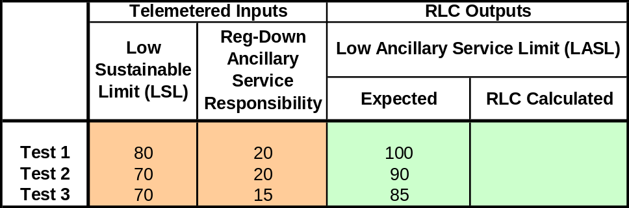

QSE will be responsible for populating the ‘Telemetered Input’ values in the table above that will used for the RLC testing.

Example Resource-Specific Five Minute Base Point Schedule
QSE shall submit the Resource Specific Five Minute Base Points for Resources that will be involved in the R6.2 testing. The QSE, Station Name, Unit Name and Time will be populated by ERCOT with the correct Nodal EMS references. The QSE will be responsible for providing the Five Minute Base Point MW values. The five minute Resource-Specific Base Points MW values provided by the QSE will represent the SCED Interval Base Points. E.g. the five minute Base Point MW value assigned to a Resource for the time stamp 09:05:00 in the flat file, is representative of where the Resource MW output is schedule to be in five minutes at 09:10:00.

QSE | Station Name | Unit Name | Interval Start Time | Interval End Time | Base Point
QSE1 | OUTBACK | UNIT2 | 10/15/2007 9:00 | 10/15/2007 9:05 | 20
QSE1 | OUTBACK | UNIT3 | 10/15/2007 9:00 | 10/15/2007 9:05 | 20
QSE1 | OUTBACK | UNIT1 | 10/15/2007 9:00 | 10/15/2007 9:05 | 50
QSE1 | KANGAROO | UNIT1 | 10/15/2007 9:00 | 10/15/2007 9:05 | 100
QSE1 | KANGAROO | UNIT2 | 10/15/2007 9:00 | 10/15/2007 9:05 | 100
QSE1 | KANGAROO | UNIT3 | 10/15/2007 9:00 | 10/15/2007 9:05 | 100
QSE1 | OUTBACK | UNIT2 | 10/15/2007 9:05 | 10/15/2007 9:10 | 20
QSE1 | OUTBACK | UNIT3 | 10/15/2007 9:05 | 10/15/2007 9:10 | 25
QSE1 | OUTBACK | UNIT1 | 10/15/2007 9:05 | 10/15/2007 9:10 | 45
QSE1 | KANGAROO | UNIT1 | 10/15/2007 9:05 | 10/15/2007 9:10 | 100
QSE1 | KANGAROO | UNIT2 | 10/15/2007 9:05 | 10/15/2007 9:10 | 110
QSE1 | KANGAROO | UNIT3 | 10/15/2007 9:05 | 10/15/2007 9:10 | 95
QSE1 | OUTBACK | UNIT2 | 10/15/2007 9:10 | 10/15/2007 9:15 | 20
QSE1 | OUTBACK | UNIT3 | 10/15/2007 9:10 | 10/15/2007 9:15 | 30
QSE1 | OUTBACK | UNIT1 | 10/15/2007 9:10 | 10/15/2007 9:15 | 40
QSE1 | KANGAROO | UNIT1 | 10/15/2007 9:10 | 10/15/2007 9:15 | 100
QSE1 | KANGAROO | UNIT2 | 10/15/2007 9:10 | 10/15/2007 9:15 | 115
QSE1 | KANGAROO | UNIT3 | 10/15/2007 9:10 | 10/15/2007 9:15 | 90
.. | .. | .. | .. | .. | ..
QSE1 | OUTBACK | UNIT2 | 10/15/2007 11:55 | 10/15/2007 12:00 | 20
QSE1 | OUTBACK | UNIT3 | 10/15/2007 11:55 | 10/15/2007 12:00 | 50
QSE1 | OUTBACK | UNIT1 | 10/15/2007 11:55 | 10/15/2007 12:00 | 20
QSE1 | KANGAROO | UNIT1 | 10/15/2007 11:55 | 10/15/2007 12:00 | 100
QSE1 | KANGAROO | UNIT2 | 10/15/2007 11:55 | 10/15/2007 12:00 | 150
QSE1 | KANGAROO | UNIT3 | 10/15/2007 11:55 | 10/15/2007 12:00 | 50

Issue Submission Lifecycle
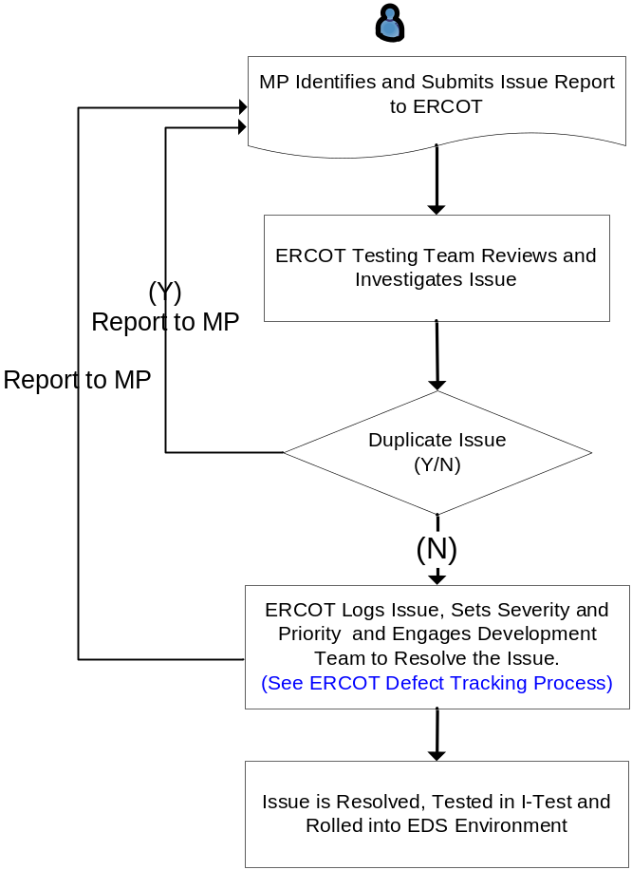

Draft Issue Submission Form



