ERCOT OPERATIONS REPORT
ON THE
EECP EVENT
OF
FEBRUARY 26, 2008

Executive Summary.........................................................................................................................3
Time Line and Description of Significant Events............................................................................4
Observations/Data Review...............................................................................................................7
Load, Day-Ahead Load Forecast, ARR, & RRS 7
Total Wind Output, 80% of Wind Forecast, MW in the Day-Ahead Resource Plan
and Updated Resource Plan 8
Regulation, Remaining Balancing in Bid Stack, and Frequency 9
Non-Wind QSE SCE, Wind-Only QSE SCE, Non-Spin Deployment,
Responsive Reserve Deployment, and Frequency 10
1-HR AVG Real-Time & 1-HR AVG Day-Ahead Online Capacity 11
LaaR RRS Deployment 12
Action Items...................................................................................................................................13
Executive Summary

ERCOT implemented Step Two of its Emergency Electric Curtailment Plan (EECP) on
February 26, 2008. The primary factors leading to the implementation of the EECP was unavailable generation, which was counted as available in the ERCOT operational planning processes and resulted in a deficiency of available generation during the evening load increase.

ERCOT tracks changes in the Resource Plan available capability and the load forecast through a tool called the Market Analyst Interface (MAI). This tool did not give any indication of the approaching capacity deficiency because it based its assessment of available capacity upon the Resource Plan data provided by the QSEs.

ERCOT’s current system depends upon QSE submitted resource plans to calculate available capacity to analyze adequacy for coming hours. The Resource Plans reflected more generation capacity than was actually available, primarily accounted for by inaccurate wind energy expectations.

In addition to the MAI, ERCOT runs an hour-ahead study every hour to determine if there is adequate capacity to meet the demand. The results of this study are used to determine the need for Non-Spin deployments. This study did not indicate an approaching problem because the Resource Plans indicated approximately 1000 MW capacity available that was subsequently unavailable.

Time Line and Description of Significant Events

2/26

- 17:41 ERCOT activated the North - West CSC (N –W OC1) as it was approaching 100% of its 550 MW limit.

- 17:44 QSE A notified ERCOT that Unit A tripped offline with 150 MW output due to bushing problems. QSE A notified ERCOT that it planned to replace this generation by Hour Ending (HE) 20:00.

- 18:24 ERCOT issued an Advisory notifying the market that its Adjusted Responsive Reserves (ARR) dropped below 3000 MW.

- 18:28 ERCOT deployed Non-Spin Reserve Service in the West and South zones for Interval Ending (IE) 19:15 due to depletion of Up Balancing Energy Service (UBES) and up regulation ancillary service..

- 18:29 ERCOT notified QSE B that ERCOT needs Units B, C, D, E, 185 MW total capacity, online for 18:30 to 22:00 due to declining frequency.

- 18:33 ERCOT called QSE C and QSE D to request additional generation, but none was available.

- 18:33 ERCOT deployed 328 MW of Responsive Reserve (RRS) due to low frequency (59.907 Hz) and out of up regulation and up balancing.

- 18:36 ERCOT issued a VDI to QSE E to deploy 150 MW for IE 18:45 to 19:00.

- 18:41 ERCOT declared EECP Step 2 via hotline calls to notify all QSEs and TSPs. TSPs were asked to reduce load by reducing distribution voltage if possible.

- 18:42 ERCOT issued a VDI to QSE F to deploy 500 MW from Units F, G, H, I, J, K, L, M, N, for IE 19:00 through 20:15. (This was later determined to be 496 MW total capacity, and was extended to 22:00 by OOMC)

- 18:42 ERCOT deployed Non-Spin Reserve Service in the North zone for Interval Ending 19:30 due to EECP Step 2.

- 18:43 ERCOT deactivated the North to West CSC for interval ending 1915 to prevent possible constraints to generation deployment in light of EECP implementation.

- 18:45 QSE G initiated load reduction by lowering distribution voltage at 15 sites. QSE G estimated 16 MW load relief was obtained.

- 18:49 ERCOT instructed all QSE’s to deploy available LaaRs via Hotline.

- 18:56 ERCOT notified SPP that ERCOT declared EEA 2 and would be requesting emergency power.

- 18:56 Responsive Reserve deployment ends. (frequency at 60.07 Hz)

- 19:37 ERCOT deployed remaining Non-Spin Reserve Service in Houston zone for IE 20:15 due to EECP Step 2.

- 19:55 ERCOT issued a VDI instruction to Unit O to adjust generation to 695 MW and Unit P to adjust generation to 670 MW. These instructions were issued to restore responsive reserve within the 90 minutes required by NERC standard to gain ARR for IE 20:15.

- 20:00 Called QSE H to inquire about providing emergency EEA1 DC tie schedule of 100MW into ERCOT. NERC tag came through OATi system and was denied by SPP numerous times due to an invalid path.

- 20:01 ERCOT notified QSE H that the assistance was no longer needed and cancelled the NERC tag.

- 20:01 ERCOT requested emergency assistance on the South DC-Ties. QSE H notified ERCOT that CFE only had 30 MW available from Eagle Pass. ERCOT requested 30 MW of Eagle Pass DC-Tie assistance for IE 20:15 through 21:00.

- 20:08 ERCOT moved from EECP Step 2 to EECP Step 1. QSE’s were informed that the LaaR deployment was recalled and TSP’s were notified that load reduction made through distribution voltage reduction could be released.

- 20:13 QSE I reported they voluntarily interrupted load at Load A, Load B and Load C approximately 110 MW to support EECP Step 2.

- 20:15 Eagle Pass DC-Tie ramping to 30 MW into the ERCOT system in response to ERCOT’s request for emergency assistance.

- 20:15 QSE F VDI for 500 MW UBES ended, OOMC’ed Units F - N from 21:00 through 22:00.

- 20: 50 Unit O and Unit P completed their re-dispatch down 100 MW each to recover ARR.

- 21:00 Eagle Pass DC-Tie assistance terminated.

- 21:21 ERCOT notified QSE J of OOMC on Units Q, R, S, T, 301 MW total capacity, for HE 2300 and 2400 for capacity in the west control the N-W CSC congestion. Wind generation was below 75 MW at this time.

- 21:30 ERCOT issued an OOMC-VDI instruction to Units U,V, X, Y, and Z, 406 MW total capacity, to remain on for H.E. 2300 to control the N-W CSC congestion..

- 21:40 ERCOT terminated EECP Step 1. At this time Adjusted Responsive Reserve was at 3560 MW.

- 22:00 ERCOT terminated all Non-Spin deployment.

- 22:44 ERCOT terminated the Advisory for ARR below 3000 MW.

Observations/Data Review

02/26/08 16:00 – 22:00 LOAD, DAY-AHEAD LOAD FORECAST, ARR, AND RRS

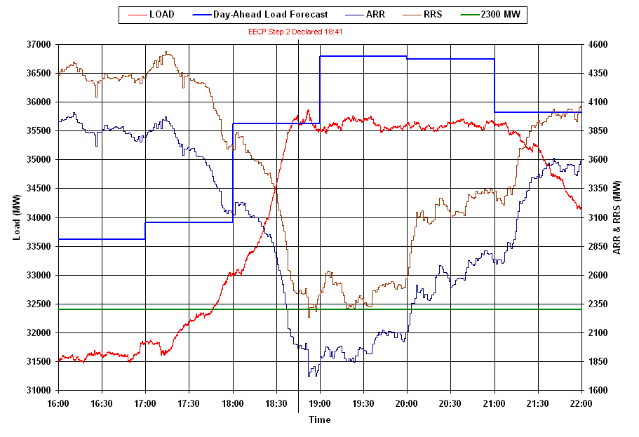
The EECP event was triggered by rapid load growth beginning about 1800 which was paralleled by a matching drop in responsive reserve. As shown in this graphic, the load between 18:00 and 18:41 grew from ~33000 MW to ~35550 MW or an increase of about 2550 MW. During this period ERCOT exhausted its available regulation up service and up balancing energy service.

Load Forecast

The hourly average day-ahead HE 19:00 load predicted was 35,619 MW. The real-time hourly average load was 34,528 MW, below the day-ahead forecast by 1,091 MW. ERCOT experienced an instantaneous peak load of 35,863 MW at 18:52.
02/26/08 15:00 – 21:00 TOTAL WIND OUTPUT, FORECASTS, MW IN THE 16:00 DAY-
AHEAD RESOURCE PLAN AND UPDATED RESOURCE PLAN ^{(*)}
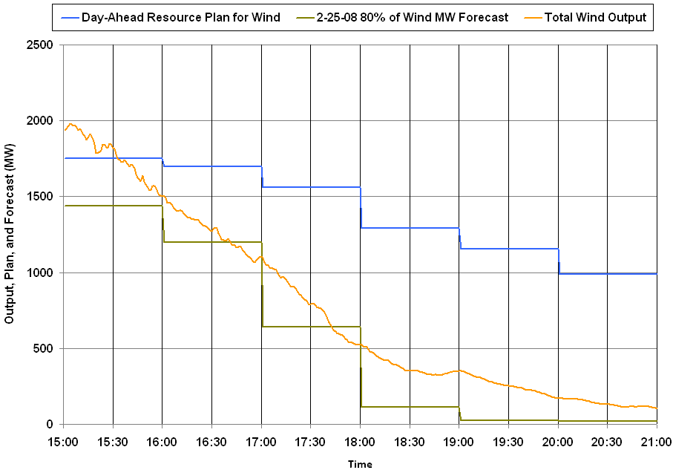
The day-ahead resource plan did not forecast the magnitude of the drop in wind energy encountered. However, the 80% wind forecast that was developed for and will be incorporated into the Nodal system shown in green did predict the wind output with good fidelity.

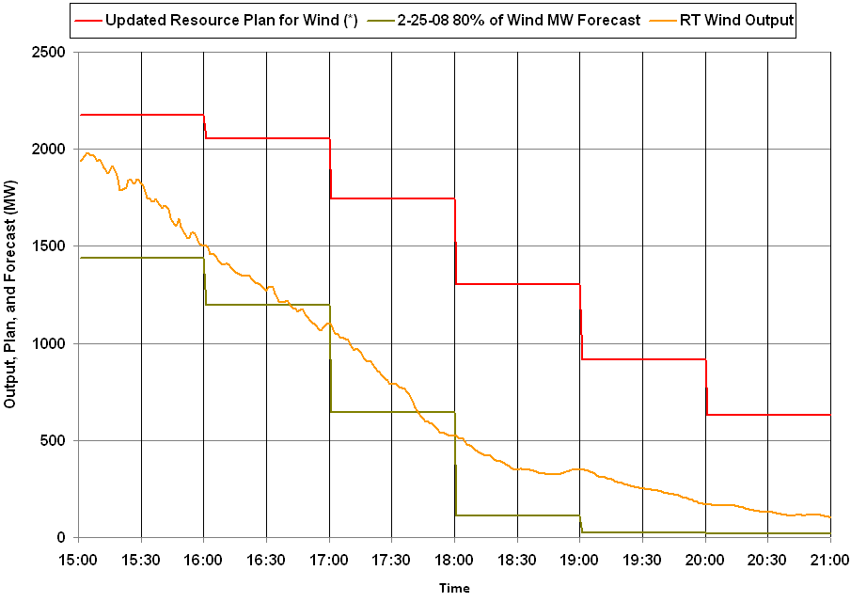
^{(*)} Updated Resource Plans are hourly values captured during the operating hour.
The second graph shows that the updated resource plan for wind (captured 1 hour prior to each hour) and that incorporated into ERCOT’s look-ahead planning tools was still showing large wind energy availability.
02/26/08 18:00 – 19:30 REGULATION, REMAINING BALANCING IN BID STACK,
AND FREQUENCY

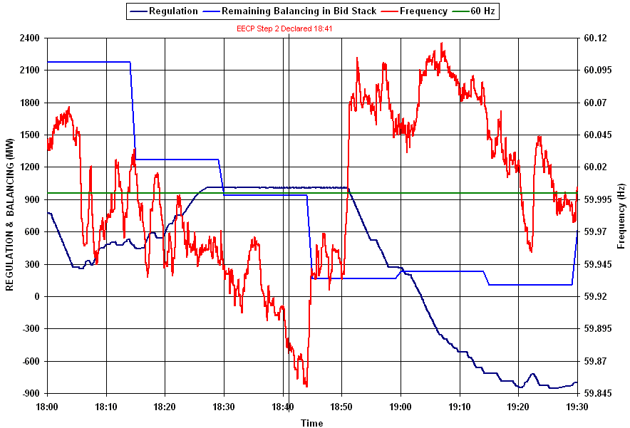

The illustration shown above demonstrates the steady decline in energy available in the Balancing Energy stack, combined with the depletion of up-regulation service between 18:00 and the declaration of EECP at 18:41. As previously noted, ERCOT’s look-ahead tools did not detect the approaching problem due to inaccurate input data from the resource plans.
02/26/08 18:00 – 19:30 NON-WIND QSE SCE, WIND-ONLY QSE SCE, NON-SPIN
(NSRS) DEPLOYMENT, RESPONSIVE RESERVE (RRS) DEPLOYMENT AND FREQUENCY

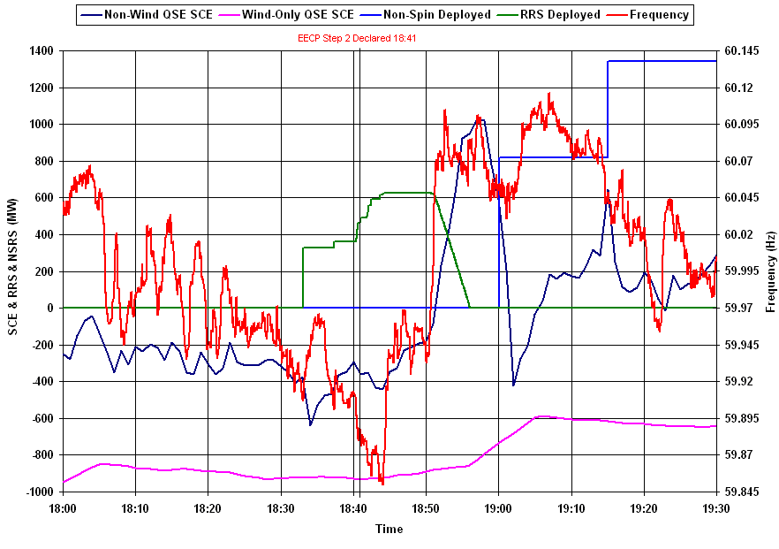

A non-spin deployment was issued at 18:28 due to the depletion of UBES stack and Up Regulation. Responsive Reserve was deployed five minutes later due to frequency dropping below 59.91 Hz.

Note the large negative Schedule Control Error (SCE) in wind-only QSE’s and lesser negative SCE of non-wind QSE’s around 18:30. (SCE performance after deployment of Responsive Reserve – as shown in green, should probably not be considered because responsive reserve deployment does not honor QSE’s ramp rates) Responsive reserve deployment at 18:33 briefly assisted frequency, but failed to restore it to 60 Hertz.
02/26/08 16:00 – 20:00 1-HOUR-AVERAGE REAL-TIME ONLINE CAPACITY AND
1-HOUR-AVERAGE DAY-AHEAD ONLINE CAPACITY
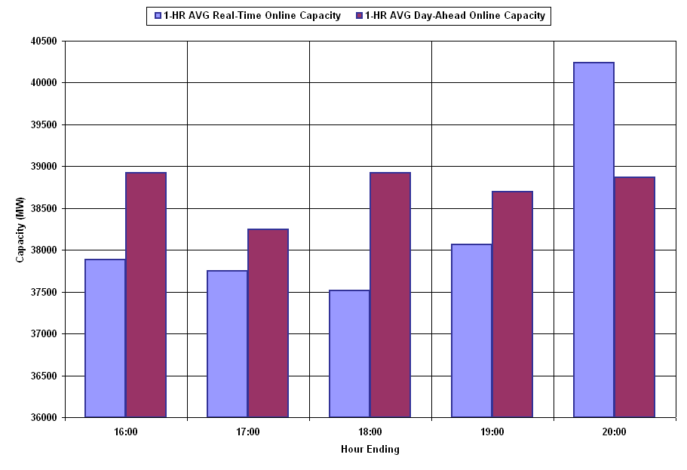
 | 1-HR AVG Real-Time Online Capacity | 1-HR AVG Day-Ahead Online Capacity
16:00 | 37885 | 38923
17:00 | 37746 | 38249
18:00 | 37514 | 38924
19:00 | 38062 | 38693
20:00 | 40237 | 38864

Day – Ahead Replacement Reserve

The RPRS market study for the Operating Day of February 26th, 2008 procured no units for congestion and capacity for the evening hours. The total hourly average on-line capacity at HE 19:00 in the RPRS market study was 38,693 MW; the actual hourly average on-line system capacity in real-time was 38,062 MW, less than the day-ahead resource plan capacity by 631 MW. There was an additional 600 MW of energy exported across the DC Tie that was not scheduled Day Ahead. For HE 19:00 in the Day- Ahead Resource Plan wind generation was scheduled to generate 1294 MW, real-time wind generation was approximately 335 MW when EECP was declared.
02/26/08 18:30 – 19:30 LaaR RRS DEPLOYMENT

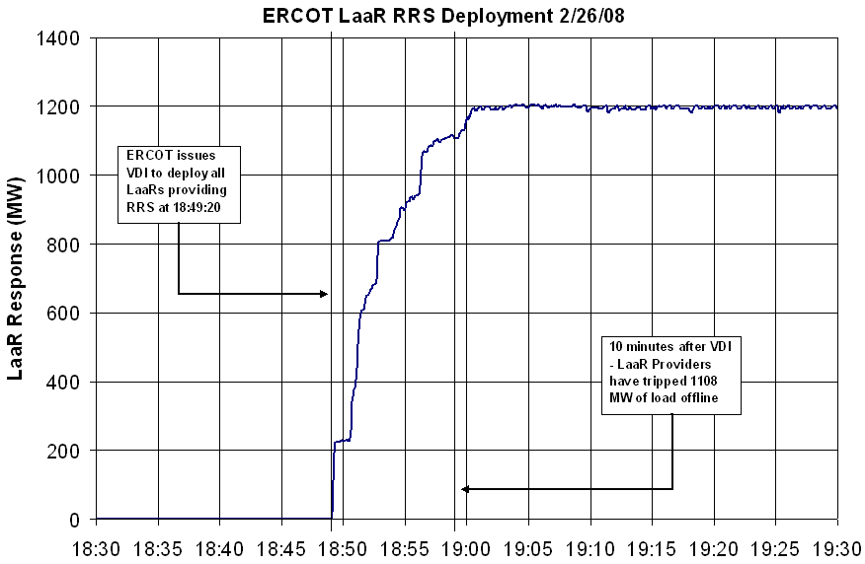

The response of LaaRs to deployment was generally good. Only two failed to deploy within 10 minutes. It appears to be the deployment of LaaRs which halted frequency decline and restored ERCOT to stable operation.

Action Items

ERCOT shall determine requirements for early integration of the Nodal Wind generation forecast into the current Zonal operating system to incorporate the forecast in the short term planning applications in place of the Resource Plan values for wind. With earlier detection of approaching deficits, additional capacity can be procured so it is available when needed.

