Posting LMPs and Settlement Point Prices

The nodal protocols require ERCOT to post LMPs and other pricing information to the MIS on each execution of SCED and on completion of the DAM.

From the protocols:
6.3.2 Activities for Real Time Operations, ERCOT Activities:

Distribute by ICCP, and post to the MIS Public Area, the LMPs created by each SCED process for each Resource Node, and the Settlement Point Price at each Hub and Load Zone immediately on deployment of Base Points from SCED with the time stamp the prices are effective.

4.5.3 Communicating DAM Results
(2) As soon as practicable, but no later than 1330, ERCOT shall post on the MIS Public Area the hourly: (a) Day-Ahead MCPC for each type of Ancillary Service for each hour of the Operating Day; (b) Day-Ahead Settlement Point Prices for each Settlement Point for each hour of the Operating Day; (c) Day-Ahead hourly LMPs for each Electrical Bus for each hour of the Operating Day;

The number of LMPs and settlement points is expected to be on the order of six to seven hundred. The current MIS design has the ability for a Market Participant to build a custom view of selected LMPs, as shown in the diagram below, but does not give an overall view all LMPs.

Viewing this large amount of data in a report form is cumbersome. It is difficult,at best, to determine points on the ERCOT Grid that have differences in prices due to transmission constraints. The intent of the posting LMPs to not only to inform Market Participants of prices, but also to seek relief of congested areas of the transmission system by voluntary commitment of off-line generation at points on the grid with high prices. To better facilitate communication of LMPs, posting a map of the ERCOT System with graphical colors showing areas of differences in LMPs would indicate where transmission constraints are active either in the DAM or in Real-Time SCED. ERCOT currently uses a graphical posting of LMPs using a existing licensed product form Power World when describing the effects of planned construction of new transmission lines.

The following is an example that shows the differences between LMPs by noting in orange area where LMPs that are higher that the average of all LMPs and blue LMP for LMPs that are lower than the average. This graph has a sensitivity setting of +/- $5.00 as the threshold on price differences.

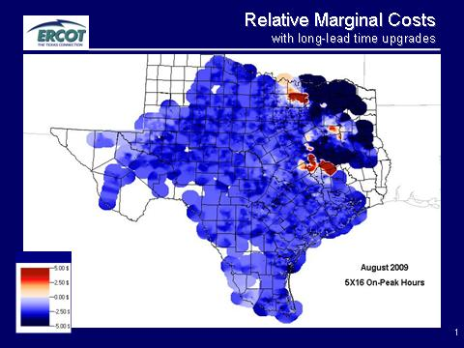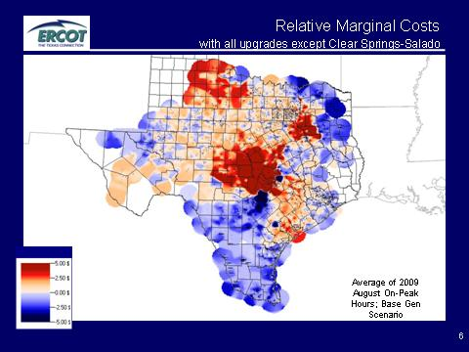

It is proposed that capabilities to graphically represent LMPs from both real time and DAM be provided to Market Participants on the MIS. ERCOT management could also view similar system data using the MIS on their office desktops. These graphical representations of LMPs are also valuable to ERCOT operations to show areas of the transmission system where congestion is occurring and for operators to be aware of developing transmission limitations that potentially could have serious effects on system reliability. Also, the graphical availability of pricing information would allow operators to quickly assess the accuracy of prices being used in SCED and DAM to manage transmission security by noting the binding constraints that are causing the differences in prices across the grid. This could lead to operators correcting incorrect transmission constraints to limit the effect of errors on the market.

It is proposed that the LMPs produced by DAM and SCED be graphically presented to both ERCOT operators on the MMS or EMS systems and to Market Participants on the MIS public area. The LMPs would be received form MMS and formatted in a system to produce graphical maps of the ERCOT System for the DAM and Real-Time SCED LMPs using four ranges of differences in LMPs allowing user selection of which range to view. Similar maps would also be available to show the Settlement Prices as of the last 15 minute interval.

The following mock up shows the desired user portal.

The default would show today’s latest LMPs or SPPs (indicated next to map).
Users could select DAM SPPs for each hour for the day-ahead forecast for today’s SPPs, calculated yesterday or tomorrow’s SPPs, calculated today. The DAM - for tomorrow would become available after 10:30. Additionally, users could view by the following ranges: -$1 to +$1, -$5 to +$5, -$10 to +$10 and -$20 to +$20.

[in the graph above is “today” meant to be from the last SCED? If so I would change this to Latest SCED run. We also wanted a graph of the latest Settlement SPP (every 15 minutes) from Real Time so I think we need a different button to look at that.

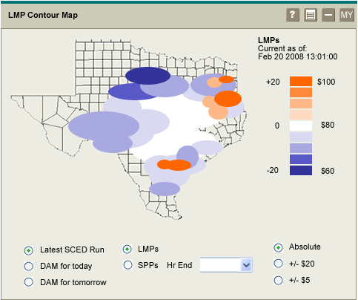

The default view is the LMPs from the latest SCED run with the absolute range selected.

Values for Hr End are: Select one (default) and 00 through 23.
Values for Range are: Absolute (default), +/- $20, +/- $5

Users can also select to view DAM for today or DAM for tomorrow:
- DAM for today – users must select an hour ending, SPP is the only option, the range may be any of the three values
- DAM for tomorrow – users must select an hour ending, but this information is only available after 10:30 a.m., SPP is the only option, the range may be any of the three values
- Invalid choices will be disabled, i.e., clicking on DAM for tomorrow when the current time is earlier than 10:30.

Users can view either LMPs or SPPs for the Latest SCED run.

