Day to Day Issues – Usage/Billing Issues

Required fields for Usage/Billing Issues
A CR or a TDSP can submit this sub type.

 | Assignee | ESI ID | Original Tran ID | Tran Type | Gaining/ Losing Rep | TXN Date | GS Number | Comments
Usage/Billing Issues | Req | Req | Req | Opt | N/A | Opt | N/A | Opt

Examples of Usage/Billing Issues

- Questions pertaining to point-to-point transactions (such as 810s) with TDSPs, excluding the 867 Contingency Plan
- If a CR is missing an 867_03 usage transaction
- If a CR is missing an 867_03 Final transaction
- If a CR is missing an 810 transaction
- If a CR is missing an 867_03 and an 810 transaction
- If a CR is missing an 867_04 transaction
- If a CR has a billing issue

Examples of Usage/Billing Issues (CR to TDSP)
- The CR selects the Submit tab (Fig 10.8a)
- From the Submit Tree, select Usage/Billing

Fig 10.8a
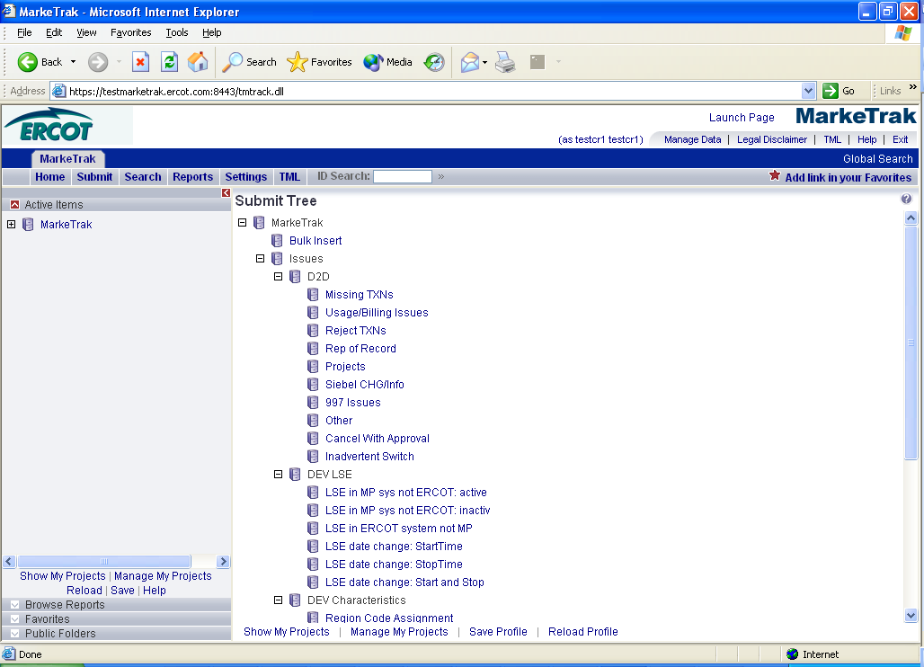

- The following fields must be populated for successful submission of Day to Day issue sub type Usage/Billing Issues:
(For this example, the submitter selects the TDSP.)
Assignee
ESIID
Original Tran ID
NOTE: The Comments field is optional. Please include any additional information in this box.

To expedite request please provide - Start and Stop dates of the usage associated with time period in question.
- Select OK. (Fig 10.8b)
Fig 10.8b
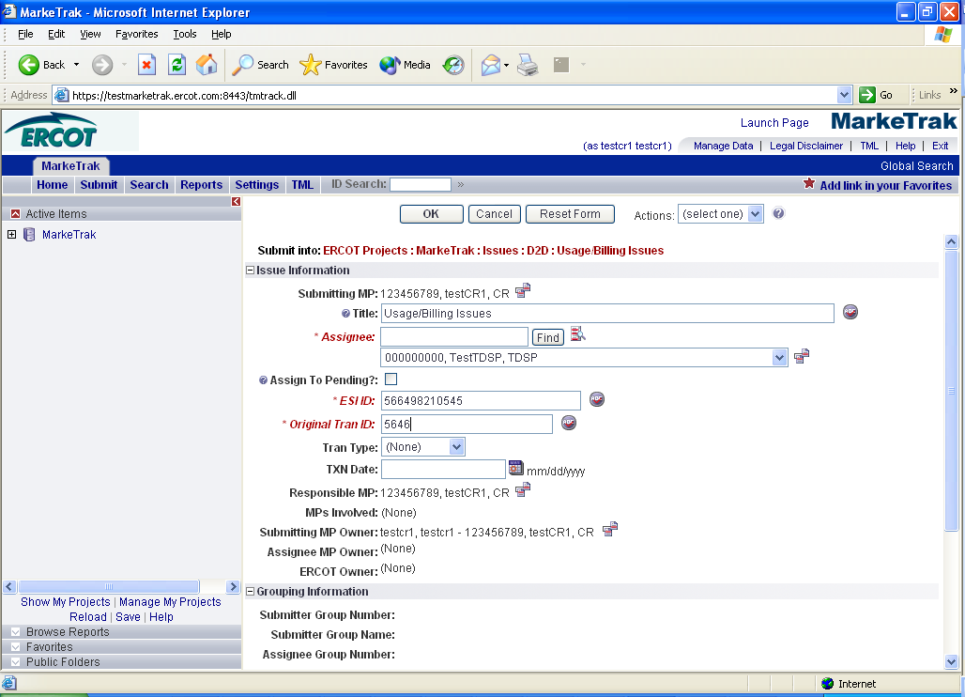

- The issue enters TDSP queue in a state of New and is visible only by the Submitting CR and TDSP.
- The Submitting CR can Withdraw the issue at this point.
- The TDSP selects Begin Working and the issue is transitioned in a new state of In Progress-Assignee. (Fig 10.8c)
Fig 10.8c
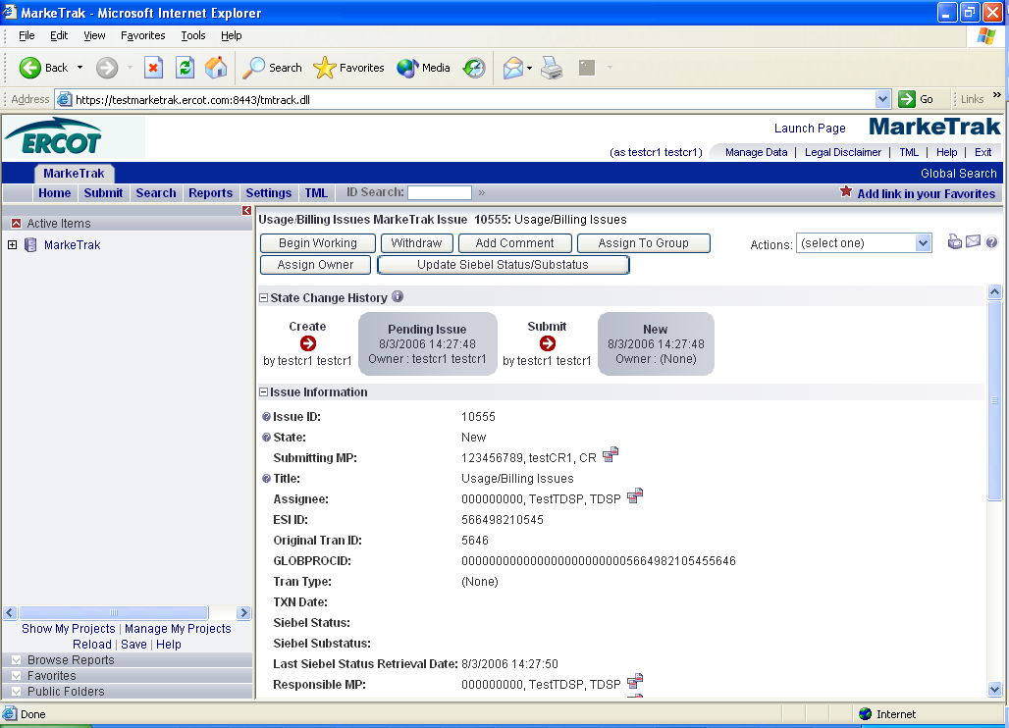

- At this point, the Submitting CR can no longer Withdraw the issue.
- TDSP reviews the issue and has the options:
  - Unexecutable, which results in state Unexecutable- Pending Complete
  - Return to Submitter, which requires comments and then the issue is transitioned back to the Submitter for additional information
  - Complete, which transitions to a state of Pending Complete. The Submitter has the option to close the issue by selecting Accept or the issue will be auto closed in 14 calendar days. (Fig 10.8d)

Fig 10.8d
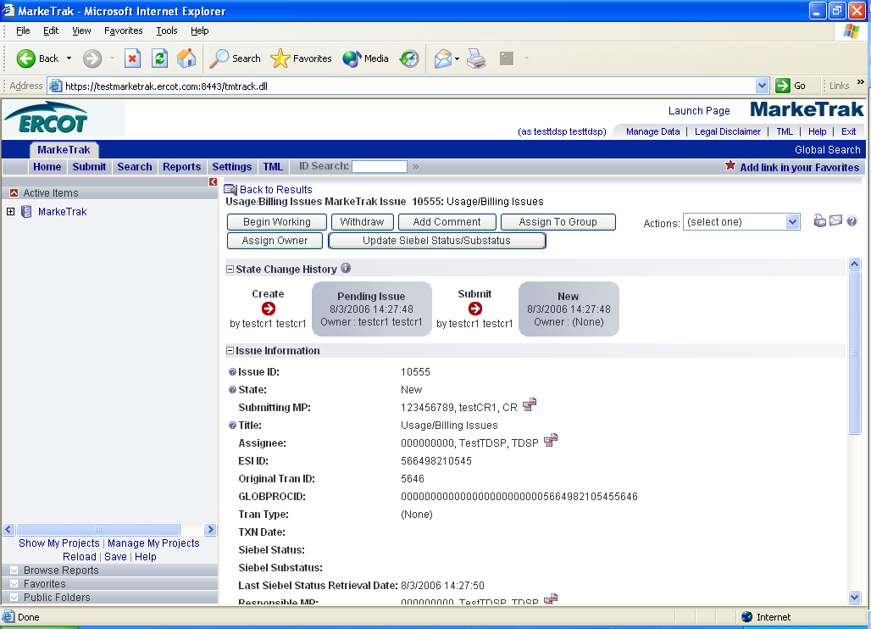

- In this example, if after researching, the TDSP found the missing transaction was sent to ERCOT, the TDSP would select Unexecutable; add comments and the issue would be transitioned back to the Submitter. The Submitter would select Re-assign and add ERCOT as the Assignee. The issue is transitioned as New in ERCOT queue. (Fig 10.8e)
Fig 10.8e
