Day to Day Issues – Missing Transactions

Required fields for Missing Transactions

 | Assignee | ESI ID | Original Tran ID | Tran Type | Gaining/ Losing Rep | TXN Date | GS Number | Comments
Missing TXNS | Req | Req | Req | Req | N/A | Opt | N/A | Opt

Examples of Missing Transactions
Examples of missing transactions are if a CR is missing an 814, 867_04 or 867_03 final.

Submitting a Missing Transactions

Example of a Submitting a Missing Transactions (CR to TDSP)
Before Submitting a D2D issue, MPs must validate the issue against the market reports and market resources:
- Service order Full Extract Report
- Located on the Texas Market Link (TML)
- ERCOT TML ESIID Look-Up/Transaction Look-Up
- ERCOT Market Participant (MP) Transaction Report
- Located in the FTP Reports Mailbox for each Market Participant

- The CR selects the Submit tab (Fig 10.7a)
- From the Submit Tree, select Missing TXNs
Fig 10.7a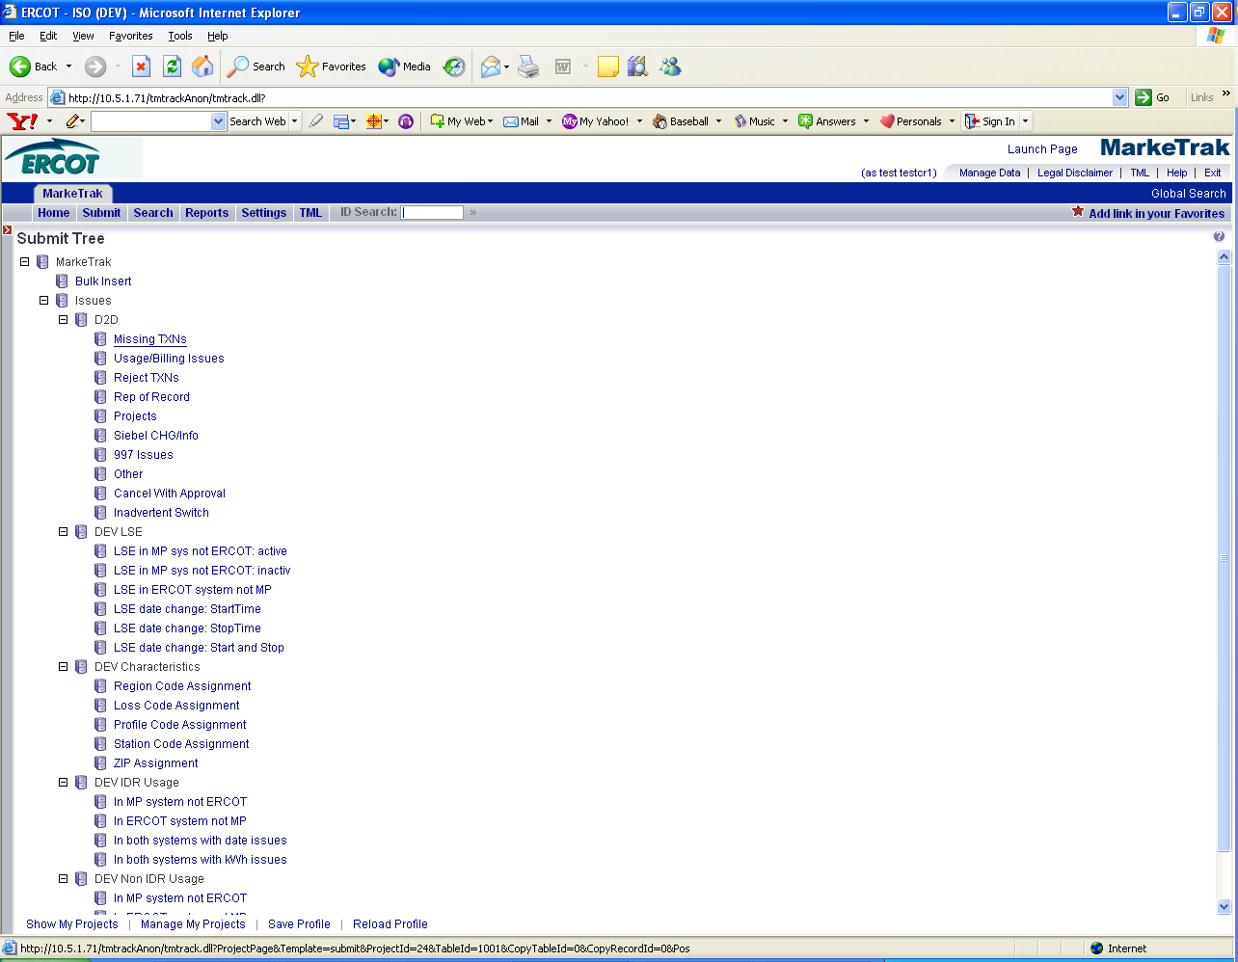

- The following fields must be populated for successful submission of Day to Day issue sub type Missing TXNs: (Fig 10.7b)

(For this example, the submitter selects TDSP)
Assignee
ESI ID
Original Tran ID
Tran Type

NOTE: The Comments field is optional. Please include any additional information in this box.
- Select OK.
Fig 10.7b
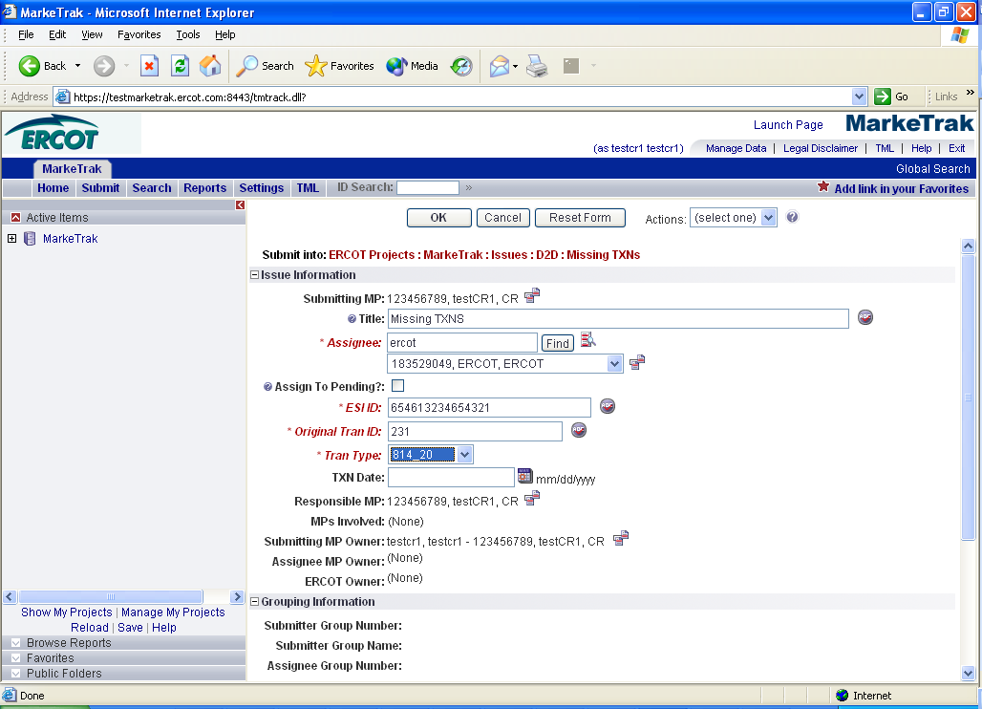

The issue enters the TDSP’S queue in a state of New-Assignee and is visible only by the Submitting CR and TDSP. (Fig 10.7c)

Fig 10.7c
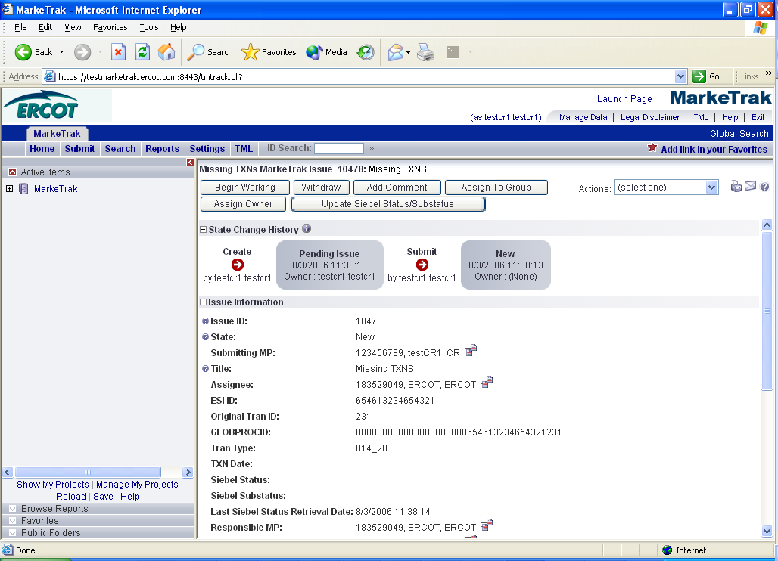

- The Submitting CR can Withdraw the issue at this point.
- TDSP selects Begin Working and the issue is transitioned in a new state of In Progress-Assignee. (Fig 10.7d)
Fig 10.7d
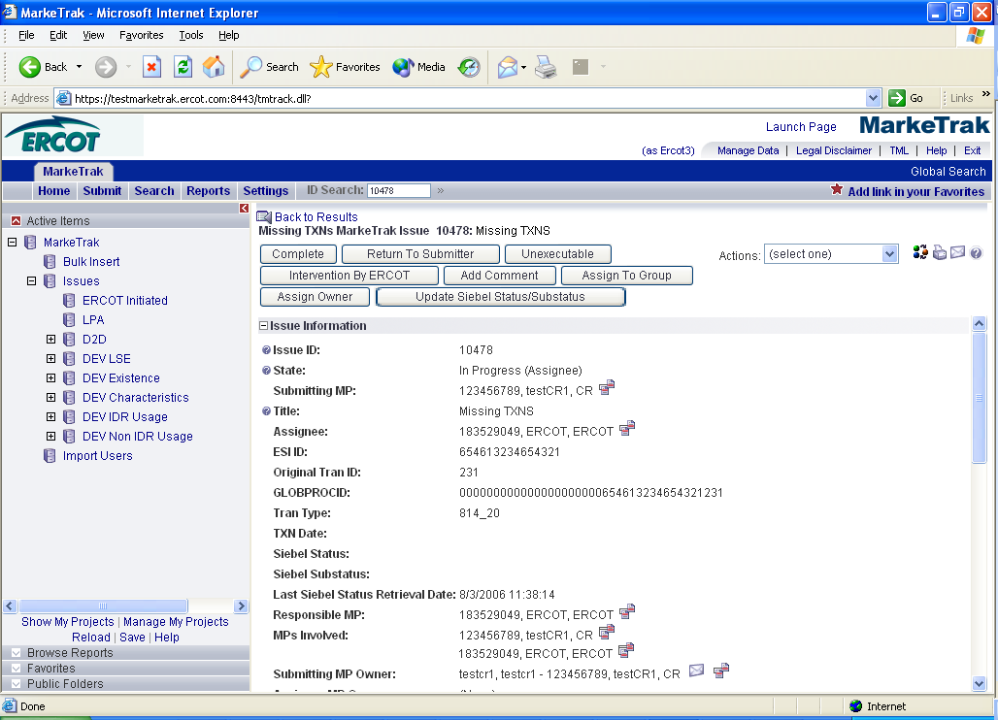

- At this point, the Submitting CR can no longer Withdraw the issue.
- TDSP reviews the issue and has the options:
- Unexecutable, which results in state Unexecutable- Pending Complete
- Return to Submitter, which requires comments and then the issue is transitioned back to the Submitter for additional comments
- Complete, which transitions to a state of Pending Complete.

The Submitter has the option to close the issue by selecting Complete or the issue will be auto closed in 14 calendar days.

- In this example, if after researching, the TDSP found the missing transaction was received at ERCOT, then the TDSP would select Unexecutable; add comments and the issue would be transitioned back to the Submitter. The Submitter selects Re-assign and adds ERCOT as the Assignee. The issue then would be transitioned as New in ERCOT’s queue.

