2705 West Lake Drive
Taylor, Texas 76574
(512) 248-6800
HTTP://WWW.ERCOT.COM

IDA003 White Paper

Combined-Cycle Unit Modeling in the Nodal Design
v1.210

Bill Blevins
03-26-07

Revision History

Revision | Comments | Date | Author
V1.0 | Initial document approved by TPTF. | 06-25-07 | Bill Blevins
V1.1 | Provided edits that change the language describing the Registration of Configurations and benchmarking. These changes were added in anticipation of being reviewed at the 1-21-08 TPTF meeting. | 01-18-08 | ERCOT
V1.2 | Incorporated clarifications on “how power augmentation information is to be provided”. | 02-01-08 | ERCOT

Table of Contents

Table of Contents 3
Executive summary 4
Background: 11
Discussion of alternative models of Combined Cycle plants 12
Aggregate CCP Modeling 12
Configuration-Based Modeling 12
Physical unit-based modeling 13
IDA Recommendations 13
High Level Approach: 14
Registration: 14
Metering: 15
NMMS: 15
EMS: 15
CRR: 16
MMS: 16
Outage schedules and Derating: 16
Power Augmentation: 16
Data Requirements: 17
SCED: 17
Deployments: 18
Settlements: 19
Appendix A 21
Appendix B 26

 | Combined-Cycle Plant modeling
 | 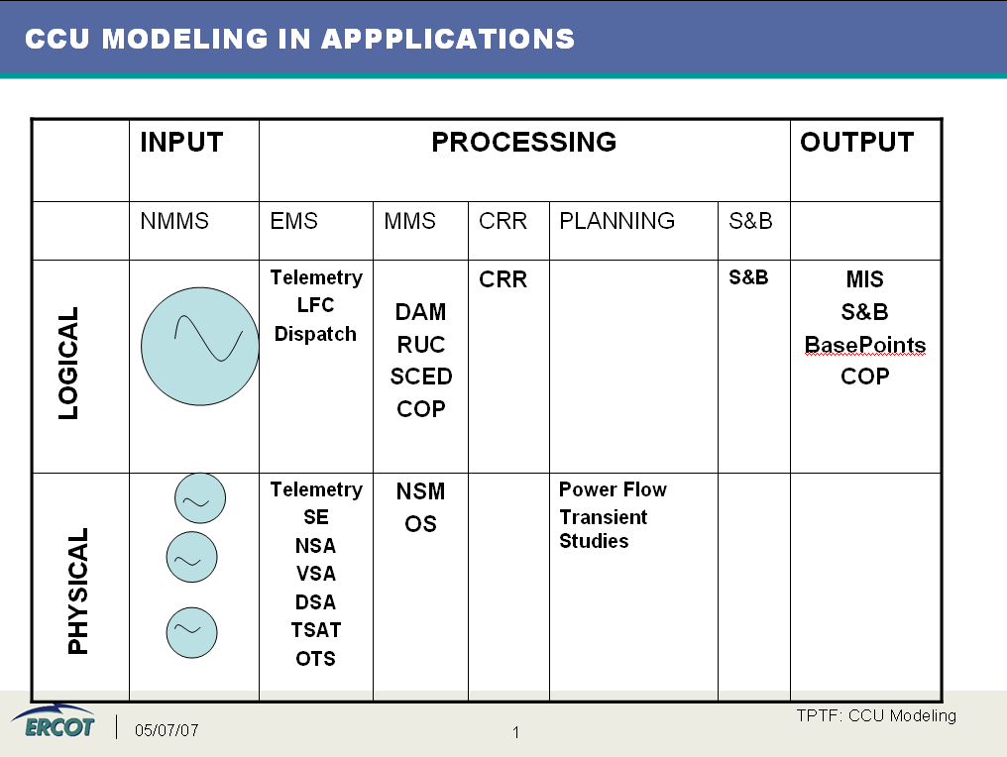
5/25/2007 | Executive summary
Nodal Market systems (DAM, SASM, RUC, SCED and LFC) shall support modeling of each configuration for a power block of Combined-Cycle Resources as considered as a single Resource unless multiple generators are connected to the ERCOT Transmission Grid at different voltage levels (Nodal protocol 6.5.5.2 (8) (a)). Each QSE shall provide ERCOT with the elements comprising each Combined-Cycle Configuration for a Resource through the Registration system, through Real-Time telemetry, and by appropriate entries in the COP. The configuration based model is provided to MMS and EMS by the NMMS system and includes attributes and interdependencies to represent the configurations available from the Combined-Cycle Resource.
Physical modeling of the individual generators within Combined-Cycle facility is important in the Network Security Analysis related to contingencies, transient/dynamic stability and voltage collapse. In addition to telemetry of Combined-Cycle facility, according to Nodal protocol 6.5.5.2 (8) (c), each QSE shall provide individual telemetered generator output (MW and Mvar). This telemetry is used by the State Estimator as input to the Network Security Analysis system.

Day Ahead|ONE
The DAM uses all three parts of the Three-Part Supply Offer or uses Only Energy Offer Curves submitted without a Startup Offer and without a Minimum-Energy Offer. The Three-Part Supply Offer and Only Energy Offer Curves can be submitted for each configuration of Combined Cycle plant. Additionally, the transition array is provided as well to specify allowed transitions from one configuration to another. DAM will solve for the configuration schedules using the available configuration information and provided Three Part Offers. Exclusivity shall be incorporated to ensure that only one configuration at a time can be procured from the Combined-Cycle configuration and transition array. DAM energy settlements use DAM Settlement Point Prices that are calculated for Resource Nodes, Load Zones, and Hubs for a one-hour Settlement Interval using the LMPs from DAM. In contrast, the Real-Time energy settlements use Real-Time Settlement Point Prices that are calculated for Resource Nodes, Load Zones, and Hubs for a 15-minute Settlement Interval.

DAM will allow an energy and Ancillary Service offer for each logical configuration.

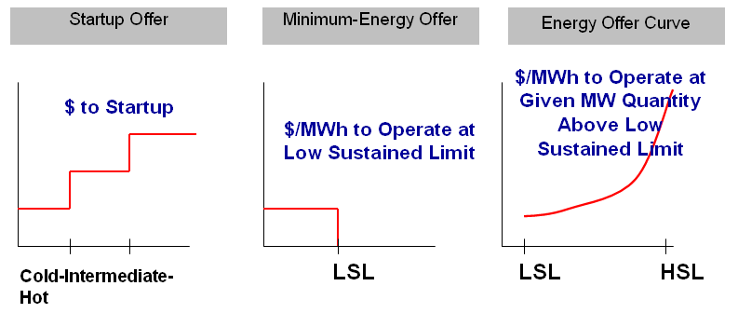
Figure 1: Configuration 1 offer

Figure 2: Configuration 2 offer
Figure 3: Configuration 3 offer

Nodal Protocol 4.4.9.2.1 Startup Offer and Minimum-Energy Offer Criteria (1) (d) and (4) specifies the Resource’s hot, intermediate, and cold Startup Offer in dollars; equal to or less than the Resource Category Generic Minimum-Energy Cost for that type of Resource listed in Section 4.4.9.2.3, Startup Offer and Minimum-Energy Offer Generic Caps, unless ERCOT has approved verifiable Resource-specific minimum-energy costs for that Resource, under Section 4.4.9.2.4.
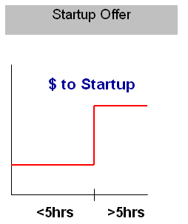

Figure 4 Generic Startup Offer

- Combined-Cycle greater than 90 MW with 5+ HRS offline 6,810
- Combined-Cycle greater than 90 MW with less than 5 HRS off line 5,310
- Combined-Cycle less than or equal to 90 MW with 5+ HRS off line`6,810
- Combined-Cycle less than or equal to 90 MW with less than 5 HRS off line`5,310

Nodal Protocol 4.4.9.2.1 Startup Offer and Minimum-Energy Offer Criteria (1) (d) and (4) specifies the Resource’s Minimum-Energy Offer in dollars per MWh; equal to or less than the Resource Category Generic Startup Cost for that type of Resource listed in Section 4.4.9.2.3, Startup Offer and Minimum-Energy Offer Generic Caps, unless ERCOT has approved verifiable Resource-specific startup costs for that Resource.

- Combined-Cycle greater than 90 MW = 10 MMBtu/MWh * FIP or FOP, as specified in Minimum-Energy Offer;
- Combined-Cycle less than or equal to 90 MW = 10 MMBtu/MWh * FIP or FOP, as specified in Minimum-Energy Offer;

Nodal Protocol 4.4.9.3.1 Energy Offer Curve Criteria specifies each Energy Offer Curve must be reported by a QSE and must be a monotonically increasing offer curve for both price (in $/MWh) and quantity (in MW) with no more than 10 price/quantity pair. This curve should be provided for each configuration offered in the DAM.

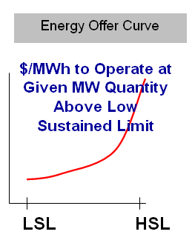

Figure 5 Typical Energy Offer Curve

Reliability Unit commitment|Two

The Three-Part Energy Offers along with transition array are submitted for each configuration of Combined Cycle facility. The RUC uses the Startup Offer and the Minimum-Energy Offer components for determining RUC commitments and Proxy Energy Offer Curves derived from DAM Energy Offer Curves to schedule capacities.

The Energy Offer Curve may be used in settlement to claw back some or all of a RUC-committed Resource’s energy payments.

A QSE that submits an Energy Offer Curve without also submitting a Startup Offer and a Minimum-Energy Offer is considered not to be offering the Resource into the RUC, but that does not prevent the Resource from being committed in the RUC process like any other Resource that does not submit an offer in the RUC.
RUC will solve for the configuration schedules using the available configuration information and provided the Startup Offer and the Minimum-Energy Offers. Exclusivity shall be incorporated to ensure that only one configuration at a time can be procured from the Combined-Cycle configuration and transition array.

Real-time|Three

In the real time QSEs representing a Combined-Cycle Resources will telemeter the Combined-Cycle Resource’s current configuration to ERCOT over ICCP. This will be passed to SCED by the EMS SCADA so that SCED will select the correct Energy Offer Curve for the current configuration. SCED will then calculate the new base point for the Combined-Cycle Resource. Note: SCED will be using only the current telemtered configuration and will not be considering any additional configurations for a particular Combined-Cycle Resource when it computes the new base point. SCED uses HDL and LDL of Combined-Cycle Resource dispatch range calculated by Resource Limit Calculator to compute the Base Point for Combined-Cycle Resource. The Combined-Cycle Resource Base Points will then be passed to the EMS SCADA and Generation Subsystem LFC for distribution to the QSE.

Figure 6 Current Configuration Energy Offer Curve

LFC will send Updated Desired Base Point for Combined-Cycle Resource. Each time LFC detects new SCED base points for Combined-Cycle Resource are available, it will begin to ramp the Combined-Cycle facility to the Updated Desired Base Point. Calculation of the Updated Desired Base Point will be by linear interpolation from the current Output MW to the new target base point over a four (?) minute period. LFC will continuously monitor the system frequency deviation against a pre-set ERCOT Operator-entered threshold. Whenever the magnitude of the system frequency deviation is above this threshold, LFC will temporary suspend ramping of the Updated Desired Base Points if that ramping is in a direction that will worsen ACE. During emergency (EECP is in effect or Operator initiated emergency because of SCED failure), the Updated Desired Base Points are immediately set equal to the LFC calculated emergency Base Point values ignoring the ramping.
The Desired Base Point for Combined-Cycle Resource is sent to QSE. The plant operator will distribute the Desired Base Point to currently available generating units within Combined-Cycle facility.
Regulation is deployed to the QSE and the QSE distributes the Regulation to its Resources including Combined-Cycle facilities according to Regulation Participation factors. LFC will deploy
Responsive reserve and the QSE will divide up the resulting responsive reserve deployment signal among the Resources providing responsive reserve, accounting for the amount of Responsive Reserve Ancillary Service Responsibility for each Resource. The QSE will telemeter back via ICCP the Responsive Reserve Ancillary Service Responsibility and the Responsive Reserve Ancillary Service Schedule for each Resource. The difference between the Responsive Reserve Ancillary Service Responsibility and the Responsive Reserve Ancillary Service Schedule is the amount of Responsive Reserve deployed for each Resource.
Non-Spin deployments are made by the operator using the MMS displays. For all Resources affected by the Non-Spin deployment, LFC will monitor that the Non-Spin Ancillary Service Schedule is updated to zero to reflect the 100% deployment of the Non-Spin Ancillary Service Responsibility within a specified time after the deployment.

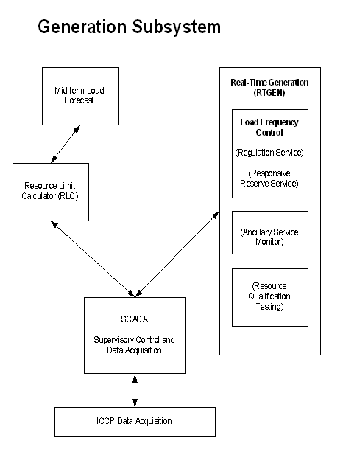
Figure 7 Generation Subsystem

Physical modeling|Four

3.10.7.2 Modeling of Resources and Transmission Loads (1) Each Resource Entity shall provide ERCOT and TSPs with information describing each of its Generation Resources and Load Resources connected to the transmission system. All Resources greater than 10 MW, Generation Resources less than 10 MW but providing Ancillary Service, Split Generation Resources, DC Tie Resources, and the non-TSP owned step-up transformers greater than 10 MVA, must be modeled to provide equivalent generation injections to the ERCOT Transmission Grid. ERCOT shall coordinate the modeling of Generation Resources, DC Tie Resources and Load Resources with their owners to ensure consistency between TSP models and ERCOT models.

6.5.5.2 Operational Data Requirements (2) A QSE representing a Generation Resource connected to Transmission Facilities or distribution facilities shall provide the following Real-Time data to ERCOT for each Generation Resource.
(a) Net real power (in MW);
(b) Net Reactive Power (in Mvar);
(c) Power to standby transformers serving Plant auxiliary Load;
(d) Status of switching devices in the plant switchyard not monitored by the TSP or DSP affecting flows on the ERCOT Transmission Grid;
(e) Any data mutually agreed to by ERCOT and the QSE to adequately manage system reliability;
(f) Generation Resource breaker and switch status;
(g) High Sustained Limit;
(h) High Emergency Limit, under Section 6.5.9.2, Failure of the SCED Process;
(i) Low Emergency Limit, under Section 6.5.9.2, Failure of the SCED Process;
(j) Low Sustained Limit;
(k) Ancillary Service Schedule for each quantity of Responsive Reserve and Non-Spin; and
(l) Reg-Up, Reg-Down and Responsive Reserve Services participation factors that represent how a QSE is deploying the Ancillary Service energy on a percentage basis to specific qualified Resource.

The results of the State Estimator (SE), an estimate of the state of the ERCOT network, are used as the input to all other Network Security Analysis programs including Contingency analysis, Security Enhancement, and Dynamic Stability Analysis (DSA): Voltage (VSAT) and Transient Stability Analysis (TSAT). These applications run hourly as part of the Real-Time Sequence and require generator specific information.
VSAT uses a specialized powerflow solver designed to handle large complex systems and it requires:
- Resource AGC
- Governor Response options for contingency solution
TSAT model for conventional transient and extended term dynamic simulations includes:
- Two-axis generator models of up to 6th order
- Standard IEEE models for generator excitation
- Standard IEEE models for generator speed controls
Generic constraints – protect the ERCOT Transmission Grid against transient instability, dynamic instability or voltage collapse. The constraints are considered in the DAM, RUC and SCED through TCM.

In order for ERCOT to comply with Nodal Protocol 6.5.7.1.11(1) the Dynamic Stability Analysis must be accurate which requires telemetry from each generator to properly model the physics of the system and thus derive correct solutions to stability issues.

Note: This is an updated version of the original whitepaper on Combined Cycle modeling. This version reflects discussions between ERCOT, the MMS vendor ABB and the various stakeholders with CC assets in the ERCOT Market.

Combined-Cycle Unit Modeling in the Nodal Design |Five

Background:

A Combined Cycle generating station consists of one or more combustion turbines (CT), each with a heat recovery steam generator (HRSG). Steam produced by each HRSG is used to drive steam turbines (ST). Each steam turbine and each combustion turbine have an electrical generator that produces electric power (CTG and STG). Typical configurations (Appendix A Figure 1-Figure 7) contain one, two, or three combustion turbines each with a HRSG and a single steam turbine. Because of high thermal efficiency, low initial cost, high reliability, relatively low gas prices and low air emissions, combined-cycle gas turbines have been the new resource of choice for bulk power generation for well over a decade.

ERCOT relies on a diverse mix of generation resources to meet the demand needs of the electrical system in Texas and approximately 20% of ERCOT’s total generation capability comes from Combined-Cycle Plants (CCPs). ). There is a variety of CCPs in ERCOT, the most complex consists of four CT and two ST generating units. Some of CCPs are capable of power augmentation. The CCPs create unique challenges for ERCOT because they can operate in a number of different configurations. For example, a “2x1” power block (2 combustion turbines with 1 steam turbine) may have as many as three individual configurations in normal operation.The stations thermal operating and electrical generating characteristics differ from one state to another and the transition from one state to another has own operational limits and costs. ERCOT and the stakeholders must provide mechanisms to solve modeling issues surrounding the flexible configurations and operation of Combined Cycle facilities.

The Market Management System (MMS) requires this information to produce optimum DAM, RUC and SCED solutions and provide dispatch instructions that are operationally feasible; therefore, each operational configuration should be used as inputs into the unit commitment and economic dispatch software.

While attempting to provide an optimal solution for the ERCOT market is important, ERCOT has the responsibility to perform real time and planning horizon power flow and transmission security studies which require input from a network model with each generation unit modeled. This paper addresses the issue of modeling combined-cycle plants so that all static and dynamic characteristics of the plant and cost are adequately represented in the NMMS, EMS, MMS and CRR.

Discussion of alternative models of Combined Cycle plants

In this section we present, in increasing order of complexity, three alternative models of CCPs within the EMS and MMS. For each model we would discuss some advantages and disadvantages as it relates to ERCOT operations and Market Participants. The first is an aggregated modeling of CCP units, the second is a configuration-based modeling and the last on is a physical modeling of each unit within EMS and MMS.

Aggregate CCP Modeling

The simplest way of modeling the Combined Cycle plant within the EMS and MMS is by aggregating all physical units into a single one (Appendix A Figure7). This single unit is then treated much the same way as a thermal unit, i.e., the decision made in each period of the planning/operation horizon is to switch on/off the unit with no regard to the configuration state the unit will be operating in. As of December 2005, this is the modeling approach in use at ISO NE, NYISO, MISO and PJM .

As the CCP components are hidden from the market operator, the determination of the CCP configuration is left with the plant operator. This is problematic since unit technical constraints cannot be correctly captured using this aggregate model. Limits based upon configurations are severely restricted as the only limits available are based upon the aggregate operation of all units. Also, importantly the aggregate representation of the CCP does not adequately capture the dynamic model of the CCP. As such, the reliability of results from applications such as the Dynamic Stability Analysis and the Operator Training Simulator will be suspect or maybe even inaccurate.

Configuration-Based Modeling

Based on possible CT and ST combinations, a CCP can operate in multiple configuration modes. For a 2 CT – 1 ST, for example, the possible configurations are 0 CT – 0 ST, 1 CT – 0 ST, 1 CT – 1 ST, 2 CT – 0 ST, and 2 CT – 1 ST. Each configuration is associated a number (0, 1, 2 …) and is characterized by, for example, minimum up and down times, minimum and maximum production levels, ramp rate as well as correct representation of startup and shutdown costs. No physical CCP components are modeled. (Appendix A Figure 8). In all realistic cases, the number of configurations, i.e. logical generating units to be optimized is very high.

The modeling will include a representation of transitions that are allowed from one configuration to another. These transitions, as well as forbidden ones, are represented in the mathematical model through a set of constraints. A state-space diagram can be constructed representing the modes and allowed transitions. The state space must be set according to the operations rules for individual configurations, as well as to those constraining the transition between the configurations. Configuration based modeling is limited to transitions representing a strict and reversible order of configurations.

This model is adequate for market applications but not the EMS, the OTS and other applications requiring dynamic models for the generating units. Also it is not applicable if physical units are connected to different network busses.

Physical unit-based modeling

A physical unit-based model for a CCP is where, instead of representing the possible unit modes, each physical component of the plant is fully represented having all the standard unit parameters, i.e., each CT and ST will have its own startup cost, minimum up/down time, cost curve, and dynamic characteristics. (Appendix A Figure 9). Note that number of physical units to be optimized much lower than number of CCP configurations to be optimized if configuration based model is used.

The transitions between configurations can be specified as simply explainable constraints (like at least one CT must be online for ST to be online) to represent complete state transition diagram without limitations. Note that for all types of CCPs the number of physical units to be optimized is significantly smaller than the number of configurations to be optimized.

This model is appropriate for the EMS, OTS and stability applications but currently not for the market applications. No vendor supplied solution for bidding Combined Cycle units on the physical level has been developed yet. Some vendors are working to solve this but there is not a solution currently that ERCOT has been presented with to address the market bidding of each physical unit at a Combined Cycle facility. Also the configuration bidding has some advantages in flexibility in that while the each unit may be bid or scheduled to run at a specific output the flexibility to move the generation around and maintain a required net output is all that is required. Based on this the settlement should be handled based upon the total output.

IDA Recommendations

IDA recommendation is to use the combination of the configuration-based model and the physical unit-based model in the representation of combined-cycle plants. The following sub-sections discuss how the models are handled.

To satisfy both the network security requirements and the market optimization issues associated with combined-cycle plants it is ERCOT’s recommendation that different modeling be used for the MMS and EMS (Network Security Analysis functions). The EMS and NMMS will continue to use what is referred to in this paper as the unit/physical approach (Appendix A Figure 9) while the MMS optimization tools will use a Combined Cycle configuration/logical approach (CCP Block) (Appendix A Figure 8). For the DAM market, RUC and SCED application the configuration based model (MMS) will be used, while in the EMS, State Estimator and Network Security Analysis processes the physical model (EMS) will be used due to operation reliability issues.

The Appendix B Table 1 shows a breakdown of the recommended approach for each of the sub-systems impacted within the MMS and EMS.

Based on industry wise ongoing activities it is expected that physical unit models will be used widely as soon as appropriate optimization tools are available. For MIP technology physical models are more suitable than configuration based models giving a practical opportunity to improve reliability and operational feasibility of provided solutions of unit commitment problems.

IDA Mitigation recommendation:
Nodal protocols require modeling of combined cycle plants as logical configurations. This introduces some risk because the number of configurations for combined cycle plants is unknown. Protocols do not specify the number of configurations to be supported. To mitigate performance risk it is recommended that ERCOT restrict the number of configurations that are offered in the DAM and the number of configurations shown as offline and available (and seen by the RUC process). There should not be a restriction on the number of configurations that can be registered through the Resource Asset Registration Form (RARF). Until benchmarking of the performance is completed, for each CCP, the number of configurations offered into the DAM shall be no more than the number of physical units in the power block. This shall be a self imposed limit executed by the QSE. Also, until benchmarking of the performance is completed, for each CCP, the number of configurations shown as offline and available (for the RUC process) shall be no more than the number of physical units in the power block for a rolling 36 hour study period. This limit to the number of configurations shown as offline and available to the RUC process shall also be a self imposed limit executed by the QSE. Benchmarking the performance of the Market system should be performed during the EDS testing phase. Based upon this benchmarking, a limit to the number of logical configurations for DAM and RUC should be considered by the vendor and the restriction on the number of configurations for the DAM and RUC should be adjusted accordingly. Power augmentation configurations will not be supported as separate configurations. For completeness the whitepaper addresses the maximum possible number of configurations but the practical limit based upon the rule of limiting the number of configurations to the number of physical units of a power block allows the minimum number of configurations while supporting the practical operation of the plant to the maximum extent. The power augmentation is able to be offered using the existing configuration limit.

If a split generation resource is also a combined cycle power plant it should be modeled as a combined cycle plant and not as a SGR. This will also limit risk of performance issues based upon additional complexity of modeling an SGR-Combined Cycle plant.

High Level Approach:

Registration:
Upon registering a Resource with ERCOT its Combined Cycle facility status will be identified and the applicable physical and configuration information will be stored in the Registration system. The Registration system will need to be expanded to accommodate physical unit-based information for applicable systems such as EMS and NMMS, and configuration-based information for MMS applications. The data will need to be stored in a manner similar enough to group the data together by facility, but unique enough to provide for exclusivity among the individual units and configurations. It has not been determined if the Transition Array described in Appendix 2, Table 5 will be stored in the Registration system detailing the allowable transitional paths from configuration to configuration.

Metering:
Some combined cycle facilities have multiple EPS metering points to measure the energy flows. If these facilities register as a single combined cycle Resource there will be more than one EPS metering point associated to the registered generation unit. To treat the multiple units as a single unit, settlements will need to aggregate EPS metering points for combined cycle facilities when more than one meter is used to measure the energy flows for the plant generation. For price calculation in MMS, the location of the resource node could be different than the location of the EPS metering points for such locations.

NMMS:

Registration will provide information to NMMS for each combined-cycle component physical unit along with their static and dynamic parameters. In addition a Combined Cycle configuration SCADA point (CCU mode) will be defined for any Combined Cycle facility within NMMS. The EMS will use the physical component parameters to supply network modeling information for EMS databases. Physical parameters will be used in Network Security Applications. The CCU mode is associated with a configuration number. The NMMS will store each configurations distinct set of operating parameters, physical constraints to be used by MMS in order to optimize the market solution for a particular configuration.

EMS:

In Real-Time, SCADA will receive and process current data for each physical unit within a combine-cycle plant. These will include breaker (or connectivity) statuses, MW and MVAR outputs of each unit within the plant. The status will be used in SCADA to derive the configuration mode of the plant, be it 0 CT – 0 ST, 1 CT – 0 ST, 1 CT – 1 ST, 2 CT – 0 ST, and 2 CT – 1 ST, for example, and consequently determine the configuration number. The system should alarm the system operator if the telemetered configuration differs from the derived number. LFC deployment will be done on a plant configuration basis based upon the telemetered CCU mode in which case limits and ramp information used are those associated with the CCP configuration. The Resource Limit Calculator calculates Resource limits and ramp rates that are used as inputs for both LFC and SCED. All the limit calculations are based solely on the telemetered values from QSEs, including each Resource’s Ancillary Service Schedule, Ancillary Service Resource Responsibility, HSL and LSL. The rest of the EMS applications use the physical unit models, i.e., SE, RTCA, VSA/DSA all use physical unit models.

The physical unit based approach recommended for the EMS and NMMS requires little change from the modeling approach in use today. Each generating unit is modeled as a separate unit generator and all the real time requirements are met at the unit level. From a combined-cycle perspective this means that each combustion turbine (CT) and steam turbine (ST) associated with a Combined Cycle facility is modeled along with the associated operational data and telemetry.

CRR:

Within NMMS the yearly and monthly CRR Network Models exists. CRR Network Model is managed within NMMS. The CRR Network Model is based upon the Network Operations Model using the “aggregate facility model” for Combined Cycle plants. The CRR DC Network Model is Bus branch model that will be used for representing the ERCOT system in the CRR calculations. The CRR System models injections and withdrawals via sources and sinks. Therefore, use of the aggregate facility model for Combined Cycle facilities is sufficient for CRR calculations.

MMS:

In the Market systems applications, configuration-based modeling is employed throughout. The CCP Block approach takes into account each possible operational configuration of the combined-cycle plant where each configuration is modeled as a separate resource in the optimization software. Each configuration will be required to have its own distinct set of operating parameters, physical constraints, and energy offer curves. ERCOT’s resource registration system will need to be expanded to allow for the additional parameters needed to accommodate the CCP Block approach. It should be expected that a QSE pre-register each operational configuration for the combined-cycle power block prior to system implementation. (Additional data requirements listed in Appendix B Table 4)

As per the Protocol Section 3.9.1, a QSE is required to show the status and limits for each operating configuration of its combined-cycle resources in the Current Operating Plan (COP). In real time QSEs are also required to report the current configuration of each combined-cycle resource that it represents to ERCOT (Protocol Section 6.5.5.2 (8)). ERCOT shall use the telemetered (CCU mode) Combined Cycle configuration to optimize the solutions for SCED. Both DRUC and HRUC will need to use the planned configuration information provided by COP along with the registered resource parameters to solve for the unit commitment and configuration schedules. DAM will solve for the unit commitment and configuration schedules using the available configuration information (from the Registration data which is stored in NMMS for each valid configuration) and QSE provided Three Part Offers. Exclusivity shall be incorporated to ensure that only one configuration at a time can be procured from the Combined Cycle configuration and capability array. This Combined Cycle array shall consist of each possible configuration registered by the QSE an example of this array is shown below in Appendix B Table 3.

- The CCP Block approach results in block dispatch schedules being generated by the MMS SCUC and SCED programs.

Outage schedules and Derating:
Outage schedule information is expected to be captured on the physical unit level. MMS will need to compare physical unit outages to the configuration matrix to determine which configurations are impacted. The Resource Entity or its designee must enter material deratings that are expected to last more than 48 hours in the ERCOT Outage Scheduler. This will also be reflected in the COP. Each QSE that represents a Resource shall update its COP reflecting changes in availability of any Resource as soon as reasonably practicable, but in no event later than 60 minutes after the event that caused the change. Deratings therefore will be treated similarly for Combined Cycle and non-Combined Cycle Resources.

Power Augmentation:

It is also a requirement of Section 6.5.5.2 (9) of the Protocol that the ERCOT system support power augmentation methods such as combustion turbine inlet air cooling (CTIAC), duct firing, and other methods for increasing the output of typical combined-cycle configuration. Power augmentation is the ability of a Combined Cycle facility to operate at a higher output rating than would normally be possible under one of the typical operating configurations. Two more commonly used methods of power augmentation are combustion turbine inlet air cooling (CTIAC) and duct firing. Power augmentation in the ERCOT Nodal Design will be treated as part of one of the traditional configurations.

These array elements would be communicated from the QSEs to the ISO system on a regular basis to indicate the configuration of each power block within the fleet. The QSE would also signal the ISO each configuration's HSL and LSL, and, based on the QSE's AS commitments, the ISO would send back to the QSE the calculated parameters to be used as a check against the QSE's calculations.

Note that the limits listed in Appendix B Table 3 are for presentation purposes only and are not representative of any actual facility.

Since augmentation options are to be represented within one of the existing traditional configurations, the higher output ratings would be reflected in the offers and resource parameters for that configuration. Appendix B Table 3 is an example of all traditional and power augmentation configurations for a 3x1 Combined Cycle facility with Duct Firing and CTIAC. Configurations B, D, F, H, J, and L would not be registered configurations in ERCOT and the higher output ratings would be reflected for one of the existing traditional configurations that is registered.

Data Requirements:

Appendix B Table 4 is a list of additional data requirements for Combined Cycle facilities. This list is in addition to the requirements currently noted in the nodal protocols for generation resources and will require some additional discussion if the data should be provided as additional resource parameters, COP information, or even telemetered real time.

SCED:

In SCED the current configuration will be determined from telemetered CCU mode. This will be compared to breaker statuses and MW output for validation purposes. The Generation Subsystem (Resource Limit Calculator component) provides SCED with Resource limits (Dispatch limits, HDL and LDL, in addition to High and Low Ancillary Service Limits).The Energy Offer Curve will be submitted by QSEs at CCP configuration level. The CCP total energy costs will be part of SCED objective function. The base point limits can be specified in two ways:

Consider whole CCP as a single unit and enforce CCP limits (that are equal to the sum of physical unit limits). MMS shall disaggregate the single Base Point of the Combined Cycle Resource determined by SCED to the various Resources consisting of the configuration in proportion to their telemetered MW values with the remainder sent to the last unit and send these disaggregated Resource-level Base Points to EMS/LFC. Note: This disaggregating is not necessary for LFC. LFC will send dispatch signals to the configuration as a whole and therefore it is not necessary for SCED to develop Base points for each unit only for the configuration. The Combined Cycle Resource will be configuration based so its limits change according to the configuration CCU mode. The protocols require the QSEs to provide actual deployment participation factors to be telemetered indicating the current deployment allocation among Resources for Reg-up, Reg-down, and Responsive Reserve. For Regulation the regulation signal will be sent to the QSE and distributed according to the QSE’s Participation Factor for each unit.

A concern for Combined Cycle facilities in the SCED process is the consideration of the potential financial impact of deviating from their dispatch instructions while transitioning between configurations. The change from one configuration to another may have been initiated through the DRUC or HRUC process. During the transition period the Combined Cycle facility may be operating outside its planned limits and there is concern that this could lead to unavoidable base point deviation charges. As per Section 6.6.5 of the Protocols, Generation Base-Point Deviation Charge, the Base-Point deviation charge does not apply to Generation Resources between breaker close and the time at which the telemetered HSL becomes greater than LSL”. This statement is somewhat confusing but ERCOT has interpreted this to mean that the charge will only apply if the breaker is closed (facility synchronized to the ERCOT grid) and the telemetered output of the Combined Cycle configuration is equal to or greater than the LSL but not greater than the HSL during the entire settlement interval. Therefore if a Combined Cycle facility is transitioning between configurations and the output has not reached the LSL of the new configuration, the Base-Point deviation charge will not apply. This should resolve the concern if a Combined Cycle facility is transitioning to a configuration of increased output but the protocols are silent of movements in the opposite direction in reducing output to shut down. A Combined Cycle will also be considered to be transitioning when going from one configuration to another which would reduce the capability of the facility. This would allow for the Combined Cycle to telemeter the LSL and HSL for the configuration equal to the output of the current configuration during such transitions.

Deployments:
SCED will create Base Points for Combined Cycle facilities at the plant level. It is also expected that these Base Points will be passed to LFC for deployment. Regarding Unit trips for configuration based Combined Cycle configurations. It is expected that the CCU mode value telemetered by the QSE will change to reflect the new configuration. These CCU mode values are verified as described in the EMS section of this document and alarmed if the value is improperly being telemetered by the QSE. The EMS FOD process should be used to determine if the Resources status has changed unexpectedly i.e. tripped. The QSE should telemeter the new mode and the Resource parameters for SCED to deploy new base points.

Settlements:
As defined in the ERCOT Nodal Protocols, all settlement calculations (except for procured Ancillary Service capacity) will be performed at the Resource level. Also per the ERCOT Nodal Protocols Section 6.5.5.2.(8) (a),”each configuration for a power block of Combined Cycle Resources is considered as a single Resource unless multiple generators are connected to the ERCOT Transmission Grid at different voltage levels”. ERCOT will perform all those settlement calculations at the configuration level and not the individual unit level. That also means that LSL and HSL will need to be provided at the configuration level. For DAM and RUC, ERCOT will use the limits provided in the COP for each configuration. As for SCED, ERCOT will use the Resource Limit Calculator limits which are based on the telemetered limits from the EMS.

Settlements will need the Energy Offer Curve data associated with the configuration during the DAM-commitment hour and the Energy Offer Curve data associated with the Real-Time configuration for the RUC make-whole settlements. Settlements shall use the telemetered configuration data for determining whether a combined cycle Resource operated in a particular configuration during a settlement interval.

The DAM uses all three parts of the Three-Part Supply Offer and RUC uses the Startup Offer and Minimum Energy Offer to commit units. A Resource that has a Three-Part Supply Offer cleared in the DAM may be eligible for make whole payment of the Startup Offer and Minimum Energy Offer submitted by the QSE representing the Resource under Section 4.6, DAM Settlement. Likewise for a Resource that is committed in the RUC process Make-Whole Payments are based on the Startup Offers and Minimum-Energy Offers for the Resource, limited by caps. Therefore Settlements needs to know whether or not the DAM or RUC committed configuration was delivered. This is accomplished according to Nodal Protocol “4.6.2.3Day-Ahead Make-Whole Settlements” through breaker status indications. Since Combined Cycle configurations involve multiple breakers the telemetered configuration number should be used in place of breaker status. This telemetered value is confirmed in the Real-Time by the EMS and alarmed to the ERCOT operator if a bad telemtered value is delivered by the QSE. Therefore the configuration number should indicate the composite status of the facility. Settlements also will need to know whether or not the DAM or RUC process committed multiple configurations with transitioning from one configuration to another. Settlements need to know the configuration that the DAM or RUC process has asked the combined-cycle power plant to be on in order to determine the correct cost to apply. If a resource has not submitted a verifiable cost then the settlements system will use generic cost. MMS will provide the startup instruction and startup cost to settlements and settlements will use the Resource status telemetry to determine if the startup occurred. The Resource Category Generic Costs will be used when no verifiable cost is available and those costs are set intentionally low to motivate Resources to file verifiable cost. A combined Cycle Resource that has the ability to run in Simple Cycle Mode would use Generic Cost applied as a Simple Cycle in instances where the Resource started and Ran in Simple Cycle mode. Each configuration should have a submitted Verifiable Cost in accordance with Protocol 5.6.1..

Appendix A

Figure 8 :
1 x 1 Plant Physical Layout

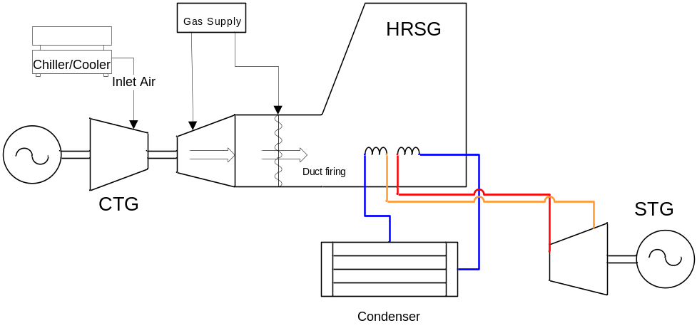

Figure 9 :
1 x 1 Plant Electrical Layout

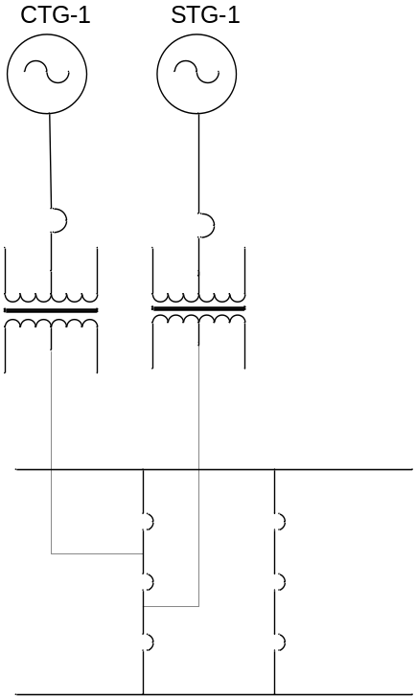

Figure 10 :
2 x 1 Plant Physical Layout

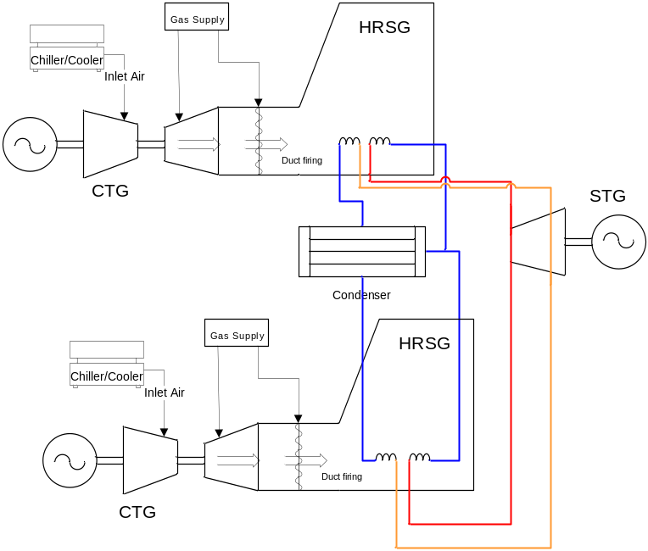

Figure 11 :
2 x 1 Plant Electrical Layout

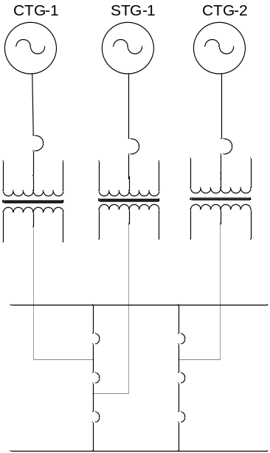

Figure 12 :
3 x 1 Plant Physical Layout

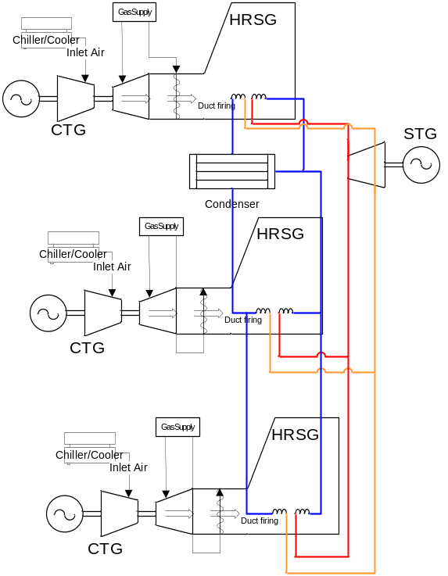

Figure 13 :
3 x 1 Plant Electrical Layout

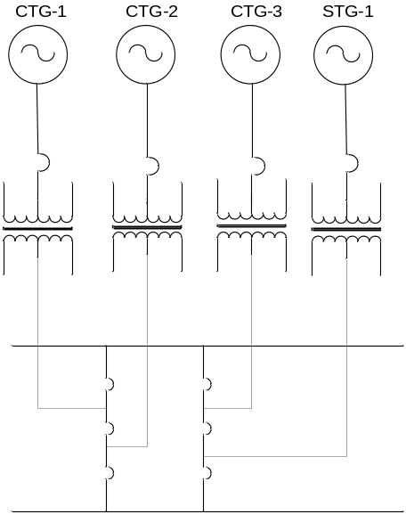

Figure 14 :
Aggregate modeling Example for any number of CTG and STGs for Combined Cycle plant
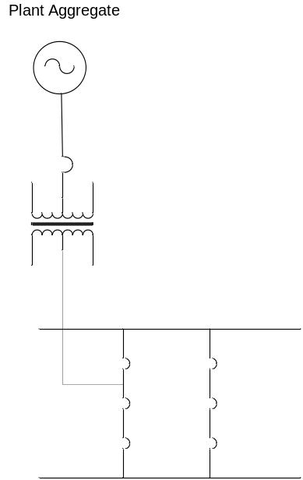

Figure 15 :
1x1; 2x1; and 3x1 simplified example based on logical or block modeling approach
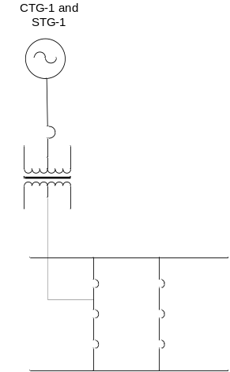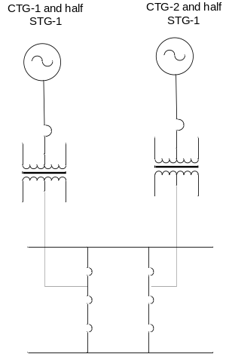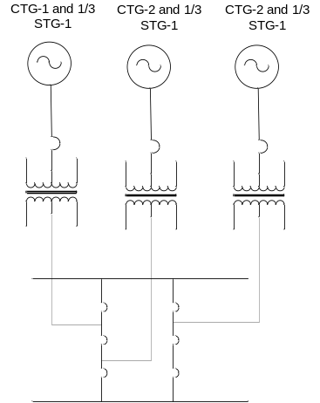

Figure 16 :
Physical unit-based modeling 3 CTG and 1 STG example

Appendix B

Table 1

Table 2

2x1 Combined-Cycle Configuration & Capability Array
 | A | B | C | D | E | F | G | H | I | J | K | L
CTG-1 | X | X |  |  | X | X |  |  | X | X | X | X
CTG-2 |  |  | X | X |  |  | X | X | X | X | X | X
STG-1 |  |  |  |  | X | X | X | X |  |  | X | X
PAUG-1 |  | X |  | X |  | X |  | X |  | X |  | X
HEL | 192 | 210 | 192 | 210 | 282 | 300 | 282 | 300 | 384 | 395 | 543 | 573
HSL | 172 | 190 | 172 | 190 | 262 | 290 | 262 | 290 | 344 | 355 | 523 | 553
HASL
HDL
LDL
LASL | 90 | 100 | 90 | 100 | 140 | 150 | 140 | 150 | 180 | 190 | 310 | 310
LSL | 90 | 100 | 90 | 100 | 140 | 150 | 140 | 150 | 180 | 190 | 310 | 310
Minimum online Time (Mins.) in this config. | 60 | 60 | 60 | 60 | 60 | 60 | 60 | 60 | 60 | 60 | 60 | 60
Maximum online time in this configuration. | 15 | 15 | 15 | 15 | 15 | 15 | 15 | 15 | 15 | 15 | 15 | 15
Minimum online Time (Mins.) per CC Unit | 25 | 25 | 25 | 25 | 25 | 25 | 25 | 25 | 25 | 25 | 25 | 25
Maximum online time in this per CC Unit | 360 | 360 | 360 | 360 | 360 | 360 | 360 | 360 | 360 | 360 | 360 | 360
Minimum offline time per CC Facility | 120 | 120 | 120 | 120 | 120 | 120 | 120 | 120 | 120 | 120 | 120 | 120
Hot Start-Up Time (Mins.) to Gen.Breaker Close ¹
Warm Start-Up Time (Mins.) to Gen.Breaker Close ²
Cold Start-Up Time (Mins.) to Gen.Breaker Close ³

Table 3

3X1 Combined-Cycle Configuration & Capability Array
 | A | B | C | D | E | F | G | H | I | J | K | L | M | N | O | P | Q | R | S | T | U | V | W | X | Y |  | Z
CTG-1 | X | X |  |  |  |  | X | X |  |  |  |  | X | X | X | X |  |  | X | X | X | X |  |  | X |  | X
CTG-2 |  |  | X | X |  |  |  |  | X | X |  |  | X | X |  |  | X | X | X | X |  |  | X | X | X |  | X
CTG-3 |  |  |  |  | X | X |  |  |  |  | X | X |  |  | X | X | X | X |  |  | X | X | X | X | X |  | X
STG-1 |  |  |  |  |  |  | X | X | X | X | X | X |  |  |  |  |  |  | X | X | X | X | X | X | X |  | X
PAUG-1 |  | X |  | X |  | X |  | X |  | X |  | X |  | X |  | X |  | X |  | X |  | X |  | X |  |  | X
HEL | 192 | 210 | 192 | 210 | 192 | 210 | 282 | 300 | 282 | 300 | 282 | 300 | 384 | 395 | 384 | 395 | 384 | 395 | 543 | 573 | 543 | 573 | 543 | 573 | 865 |  | 1000
HSL | 172 | 190 | 172 | 190 | 172 | 190 | 262 | 290 | 262 | 290 | 262 | 290 | 344 | 355 | 344 | 355 | 344 | 355 | 523 | 553 | 523 | 553 | 523 | 553 | 830 |  | 840
HASL
HDL
LDL
LASL | 90 | 100 | 90 | 100 | 90 | 100 | 140 | 150 | 140 | 150 | 140 | 150 | 180 | 190 | 180 | 190 | 180 | 190 | 310 | 310 | 310 | 310 | 310 | 310 | 400 |  | 400
LSL | 90 | 100 | 90 | 100 | 90 | 100 | 140 | 150 | 140 | 150 | 140 | 150 | 180 | 190 | 180 | 190 | 180 | 190 | 310 | 310 | 310 | 310 | 310 | 310 | 390 |  | 390
Minimum online Time (Mins.) in this config. | 60 | 60 | 60 | 60 | 60 | 60 | 60 | 60 | 60 | 60 | 60 | 60 | 60 | 60 | 60 | 60 | 60 | 60 | 60 | 60 | 60 | 60 | 60 | 60 | 60 |  | 60
Maximum online time in this configuration. | 15 | 15 | 15 | 15 | 15 | 15 | 15 | 15 | 15 | 15 | 15 | 15 | 15 | 15 | 15 | 15 | 15 | 15 | 15 | 15 | 15 | 15 | 15 | 15 | 15 |  | 15
Minimum online Time (Mins.) per CC Unit | 25 | 25 | 25 | 25 | 25 | 25 | 25 | 25 | 25 | 25 | 25 | 25 | 25 | 25 | 25 | 25 | 25 | 25 | 25 | 25 | 25 | 25 | 25 | 25 | 25 |  | 25
Maximum online time in this per CC Unit | 360 | 360 | 360 | 360 | 360 | 360 | 360 | 360 | 360 | 360 | 360 | 360 | 360 | 360 | 360 | 360 | 360 | 360 | 360 | 360 | 360 | 360 | 360 | 360 | 360 |  | 360
Minimum offline time per CC Facility | 120 | 120 | 120 | 120 | 120 | 120 | 120 | 120 | 120 | 120 | 120 | 120 | 120 | 120 | 120 | 120 | 120 | 120 | 120 | 120 | 120 | 120 | 120 | 120 | 120 |  | 120
Hot Start-Up Time (Mins.) to Gen.Breaker Close ¹
Warm Start-Up Time (Mins.) to Gen.Breaker Close ²
Cold Start-Up Time (Mins.) to Gen.Breaker Close ³

Table 4

Data Requirement | EMS | MMS | NMMS | COMS | Other

Configuration Array (Mapping from configuration to generators, Table B)
Startup transition flag
Shutdown transition flag
Limits noted in Table B
Minimum online Time (Mins.) in this config.
Maximum online time in this configuration.
Minimum online Time (Mins.) per CC Unit
Maximum online time in this per CC Unit
Minimum offline time per CC Facility
Hot Start-Up Time (Mins.) to Gen.Breaker Close
Warm Start-Up Time (Mins.) to Gen.Breaker Close
Cold Start-Up Time (Mins.) to Gen.Breaker Close

Notes:
⁽¹⁾ The min time in configuration is the minimum time the Combined Cycle can operate in that configuration before being dispatched to a lower operating configuration.

Transition Array

The transition array will be provided to ERCOT to be used in the DAM and RUC processes. The ERCOT software will only consider transitioning a Combined Cycle facility to configurations noted in the array. An example of the transition array is provided below in Table 5 and Table 6.

Table 5

2X1 Config. | A | B | C | D | E | F | G | H | I | J | K | L
( From > To)
A |  | X |  |  | X | X |  |  | X | X | X | X
B |  |  |  |  | X | X |  |  | X | X | X | X
C |  |  |  | X |  |  | X | X | X | X | X | X
D |  |  | X |  |  |  | X | X | X | X | X | X
E | X | X |  |  |  | X |  |  | X | X | X | X
F | X | X |  |  | X |  |  |  | X | X | X | X
G |  |  | X | X |  |  |  | X | X | X | X | X
H |  |  | X | X |  |  | X |  | X | X | X | X
I | X | X | X | X |  |  |  |  |  | X | X | X
J | X | X | X | X |  |  |  |  | X |  | X | X
K | X | X | X | X | X | X | X | X | X | X |  | X
L | X | X | X | X | X | X | X | X | X | X | X

Table 6
3X1 Config. | A | B | C | D | E | F | G | H | I | J | K | L | M | N | O | P | Q | R | S | T | U | V | W | X | Y | Z
( From > To)
A |  | X |  |  |  |  | X | X |  |  |  |  | X | X | X | X |  |  | X | X | X | X |  |  | X | X
B | X |  |  |  |  |  | X | X |  |  |  |  | X | X | X | X |  |  | X | X | X | X |  |  | X | X
C |  |  |  | X |  |  |  |  | X | X |  |  | X | X |  |  | X | X | X | X |  |  | X | X | X | X
D |  |  | X |  |  |  |  |  | X | X |  |  | X | X |  |  | X | X | X | X |  |  | X | X | X | X
E |  |  |  |  |  | X |  |  |  |  | X | X |  |  | X | X | X | X |  |  | X | X | X | X | X | X
F |  |  |  |  | X |  |  |  |  |  | X | X |  |  | X | X | X | X |  |  | X | X | X | X | X | X
G | X | X |  |  |  |  |  | X |  |  |  |  | X | X | X | X |  |  | X | X | X | X |  |  | X | X
H | X | X |  |  |  |  | X |  |  |  |  |  | X | X | X | X |  |  | X | X | X | X |  |  | X | X
I |  |  | X | X |  |  |  |  |  | X |  |  | X | X |  |  | X | X | X | X |  |  | X | X | X | X
J |  |  | X | X |  |  |  |  | X |  |  |  | X | X |  |  | X | X | X | X |  |  | X | X | X | X
K |  |  |  |  | X | X |  |  |  |  |  | X |  |  | X | X | X | X |  |  | X | X | X | X | X | X
L |  |  |  |  | X | X |  |  |  |  | X |  |  |  | X | X | X | X |  |  | X | X | X | X | X | X
M | X | X | X | X |  |  | X | X | X | X |  |  |  | X | X | X | X | X | X | X | X | X | X | X | X | X
N | X | X | X | X |  |  | X | X | X | X |  |  | X |  | X | X | X | X | X | X | X | X | X | X | X | X
O | X | X |  |  | X | X | X | X |  |  | X | X | X | X |  | X |  |  | X | X | X | X | X | X | X | X
P | X | X |  |  | X | X | X | X |  |  | X | X | X | X | X |  |  |  | X | X | X | X | X | X | X | X
Q |  |  | X | X | X | X |  |  | X | X | X | X | X | X | X | X |  | X | X | X | X | X | X | X | X | X
R |  |  | X | X | X | X |  |  | X | X | X | X | X | X | X | X | X |  | X | X | X | X | X | X | X | X
S | X | X | X | X |  |  | X | X | X | X |  |  | X | X | X | X | X | X |  | X | X | X | X | X | X | X
T | X | X | X | X |  |  | X | X | X | X |  |  | X | X | X | X | X | X | X |  | X | X | X | X | X | X
U | X | X |  |  | X | X | X | X |  |  | X | X | X | X | X | X | X | X | X | X |  | X | X | X | X | X
V | X | X |  |  | X | X | X | X |  |  | X | X | X | X | X | X | X | X | X | X | X |  | X | X | X | X
W |  |  | X | X | X | X |  |  | X | X | X | X | X | X | X | X | X | X | X | X | X | X |  | X | X | X
X |  |  | X | X | X | X |  |  | X | X | X | X | X | X | X | X | X | X | X | X | X | X | X |  | X | X
Y | X | X | X | X | X | X | X | X | X | X | X | X | X | X | X | X | X | X | X | X | X | X | X | X |  | X
Z | X | X | X | X | X | X | X | X | X | X | X | X | X | X | X | X | X | X | X | X | X | X | X | X | X

G. Anders (Principal Investigator), “Commitment Techniques for Combine Cycle Generating units”, Prepared by Kinectrics In, Toronto Canada, Sponsored by ISO NE and NY ISO, December 2005.

