
CDR
Conceptual System Design
v0.20
January 31, 2008

Document Revisions
Date | Version | Description | Author(s)
21-Dec-07 | 0.10 | First draft | Ganesh Narayan
24-Dec-07 | 0.11 | Changes incorporated as per Michael D’s suggestion | Ganesh Narayan
04-Jan-08 | 0.12 | Incorporated changes suggested by Sanjay | Ganesh Narayan
07-Jan-08 | 0.13 | Incorporated changes suggested by EA | Ganesh Narayan
08-Jan-08 | 0.14 | Added Data flow view | Ganesh Narayan
08-Jan-08 | 0.15 | Updated Figure 2 | Ganesh Narayan
09-Jan-08 | 0.16 | Cosmetic changes | Ganesh Narayan
10-Jan-08 | 0.17 | Grammatical and format changes only | Amy Apodaca
11-Jan-08 | 0.18 | Accepted Amy’s changes | Ganesh Narayan
14-Jan-08 | 0.19 | Formatting changes | Ganesh Narayan
31-Jan-08 | 0.20 | Changes to reflect TPTF comments | Ganesh Narayan
Document Approvals
Date | Approved By | Approval Documented In (select)
 | Brian Cook  Enterprise Architecture | ___ Approval email on file  ___ Signature

Table of Contents
1. Introduction 4
1.1. Purpose 4
1.2. Scope 4
1.3. Assumptions 4
1.4. Definitions, Acronyms, and Abbreviations 4
1.5. References 5
2. Overview 6
2.1. Design Goals 6
2.2. Design Approach 6
2.2.1 System Functional Capabilities 6
2.2.2 CDR White Box View 8
2.2.3 CDR Black Box View 9
3. Functional Specification 11
3.1. Function: Data Retrieval / Data Aggregation 11
3.1.1 Traceability to Requirements 11
3.1.2 Introduction 11
3.1.3 Inputs and Sources 11
3.1.4 Processing 11
3.1.5 Outputs and Targets 11
3.2. Function: Report Generation 11
3.2.1 Traceability to Requirements 11
3.2.2 Introduction 12
3.2.3 Inputs and Sources 12
3.2.4 Processing 12
3.2.5 Outputs and Targets 12
3.3. Function: Publish Reports 12
3.3.1 Traceability to the Requirements 12
3.3.2 Introduction 12
3.3.3 Inputs and Sources 12
3.3.4 Processing 12
3.3.5 Outputs and Targets 13
3.4. Function: Retrieve Reports 13
3.4.1 Traceability to Requirements 13
3.4.2 Introduction 13
3.4.3 Inputs and Sources 13
3.4.4 Processing 13
3.4.5 Outputs and Targets 13
4. System Dependencies and Design Constraints 13
4.1. Hardware 13
4.2. Software Interfaces 13
4.3. Services Interfaces 14
4.4. Database Interfaces 14
4.5. Licensing Requirements 14
5. Architectural View 15
6. Data Flow View 16
7. Supplementary Specifications 17
7.1. Performance 17
7.2. Legal and Regulatory 18
7.3. System and Communication 18
7.4. System Security 18
7.5. Data Confidentiality 18
7.6. Back up and Recovery 18
7.7. Availability and Redundancy 18
7.8. Maintainability 19
7.9. Usability 19

Introduction
The Real Time Reporting (CDR) Conceptual System Design (CSD) document is intended to explain how NODAL real time data reports will be delivered to Market Participants, as required by the NODAL protocols. As stated in the project charter, real time reports are defined as Market Information System (MIS) Content Inventory items with a latency, frequency, and/or performance requirements that cannot be met by the Enterprise Data Warehouse (EDW) environment. Market Participants will utilize the MIS portal application or Web Services to access these reports.
This project will also deliver a NODAL report content management solution that supports report archival needs of the real time reporting project. This solution will be separate from the existing Zonal report content management implementation.
The requirements for the real time reports originate from the Texas NODAL Protocols.

Purpose
The purpose of this Conceptual System Design document is to provide a conceptual overview of the high level architecture that will be in place to support NODAL CDR deliverables.

Scope
This document is limited to CDR requirements including real-time and graphical views of ERCOT market data. Replication of source system data to the EDW ODS and RSS systems is out of scope for this project and will be covered by the EDW CSD. The generation of dashboard portlets is out of scope for the CDR project. Alerts and Notifications are out of scope. The enhancements to MID/MIR to support CDR are a part of the scope of this project.
The reports delivered by CDR are either in the form of pre-defined, scheduled reports or reports that are generated on-demand and as data end points to External Web Services (EWS.) These deliverables have been identified via the NODAL Data Services Master List (NDSML) and have been mapped directly to specific NODAL Protocol sections.

Assumptions
The CDR project follows these assumptions
- Replication of source systems of record are out of scope for CDR project, it is in scope of the EDW project
- Dashboard portlets are out of scope for CDR, it is in scope of MIS
- Ad-Hoc and on-demand reports will be entire sets of data. These sets of data will not be filtered (Need to reword to say basic filter like datetimestamps but not fields like zones or hubs).
- CDR will go against the source system staging tables for real time data and the source staging table RSS in case of source system staging table outages or load balancing.

Definitions, Acronyms, and Abbreviations
In order to clarify the acronyms associated with the ERCOT Enterprise Information Services (EIS) environment, the conceptual definition for the systems and tools used in the development and deployment of NODAL CDR deliverables are described below. These definitions and acronyms are specific to ERCOT and may not reflect industry definitions for the same conceptual components.

Enterprise Data Warehouse (EDW) – Data warehouse solution for the replication of enterprise information from a variety of source systems to ensure all dimensional data conforms to a single set of enterprise-approved characteristics. EDW data will be used for Business Intelligence purposes.
Market Information Repository (MIR) – The report content management database containing all reports and data extracts generated to be available to Market Participants. Market Participants retrieve reports from MIR via MIS.
Market Information System (MIS) – The primary NODAL Market Participant interface providing both GUI and web service interfaces. The MIS is presented here only as the means by which Market Participants access reports generated by CDR or EDW. MIS is a separate project outside the scope of the CDR and EDW projects.
NODAL Data Services Master List (NDSML) – Identifies reports and extracts specified by the protocol, specifies the source system, and the system responsible for producing the report or extract.
Operational Data Store (ODS) – Provides point-in-time selectivity (PITS) history of each source system allowing for accurate historical reporting of source system data.
Replication – Technology that copies data from one data source to another whenever data is inserted, updated, or deleted. Depending on the needs, systems may be replicated in a master-slave (one-way) or master-master (bi-directional) manner. Please refer to EDW CSD for more details
Replicated Source System (RSS) – Standby database configured to match a given source system with high-speed replication (master-slave). Independent of the ISM (The central EIS database consisting of the ODS and the CDW) database, used to reduce risk to certain source systems sensitive to performance degradation.
Real Time Reporting (CDR) – The CDR system, rather than EDW, will handle real-time or near-real-time reports not produced by source systems. CDR will utilize EDW interfaces and other shared EIS features. CDR is a project separate from EDW.
Source System (Source System of Record) – One of the live systems making up the Texas NODAL Program. This may also include the source systems RSS and its replicated ODS. Source systems include EMS, MMS, NMMS, CRR, and COMS.

References
The following sources provided input to this conceptual design document.
Artifact | Definition
NDSM_ext_5.4.xls | The NODAL Data Services Master List
edw_conceptual_system_design_v0_14.doc | Texas NODAL EDW Conceptual System Design document
Mis_conceptual_system_design.doc | Texas MIS Portal Conceptual System Design document

Overview
The design goals and approach of the NODAL CDR project encompass leveraging existing infrastructure, with required enhancements, efficiently using tools and best practices to generate real time reports.

Design Goals
The design of CDR leverages the use of existing ERCOT implementations and develops new technologies to supplement them to meet and maintain report latencies as per the NODAL protocols.
The primary design goal of CDR development responsibility is to design a reporting system that generates market reports for the MIS Portal, Content Repository, and External Web Services in near real time per the NODAL protocols. The scope of the CDR project includes the design and implementation of the changes to the existing MID/MIR Solution.
Additional CDR design goals are:
- Conform to ERCOT corporate policies, including security and regulatory constraints.
- Conform to Enterprise architecture standards, such as technology standards.
- Coexist with current state and planned systems within which the Texas NODAL Systems operates.

Design Approach
The most important feature of a real time reporting engine is the ability to produce reports almost in near real time without adversely affecting the source system databases. The product also allows reusable components to plug-in to its architecture to account for any business logic or functional calculations. The generated data must also be wrapped in the required delivery file format. All these functionalities must happen without violating the report service level agreement. To reduce the overhead of time, a reporting engine can go directly against the source database, but this might affect the performance of the source system. A reporting engine can also be handled in a typical Extract Transform and Load basis, but this technology is better suited for batch runs or scheduled data synchronization, as performing ETL on a very short time frame (e.g., five minutes) can consume high resources. The CDR solution has been designed for meeting stringent report timelines by using source staging databases, calculation engine, and a light weight reporting engine.
The NODAL CDR design approach is to utilize existing enhanced NODAL source system staging tables. CDR will also develop loosely coupled systems in the form of an aggregation engine and reporting engine and incorporate additional systems where necessary. The design will meet all time latency periods, delivery formats, and archiving requirements dictated by MIR repository standards and NODAL protocol requirements

2.2.1 System Functional Capabilities
The basic functionality of the CDR project is to provide reports to the market participants according to the Service Level Agreements (SLA) described by the NODAL Protocols. This is achieved by performing the following four methods:
- Data Retrieval and Data Aggregation – data will be retrieved by issuing a query against the corresponding source system of record and can be further aggregated for reporting purposes.
- Generate Report – the engine can perform calculations and computations and generate outputs as defined by report templates.
- Publish Report – the engine will be able to post the report to MIR via the MID web services as well as make available the same data for graphs in User Interfaces and for External Web Services.
- Retrieve Report – will have the ability to fetch ad-hoc reports generated by the Source System.
In addition, the CDR project will also be functionally responsible for:
- MID/MIR enhancements to create reports
- Reports conforming to the ILM (Information Lifecycle Management) specified in the individual report spec
- Reproduction of reports at a future point in time

Figure 1 CDR White-Box

2.2.2 CDR White Box View
- Source Systems of Record (Staging tables of Source systems, RSS and ODS):
The Source Systems of record are the Staging tables of the operational systems or RSS or ODS based on the time criticality, latency, and load specified in the individual Report Specification.

- Market Information Repository (MIR):
Reports are published to MIR for the sake of retrieval by Market Participants and External Web Services. The Information Lifecycle Management (ILM) for each report will be determined as per the individual report specification (e.g., CDR and EDW.) Note: CDR and EDW do not present reports directly to users but place produced documents into MIR; user accesses MIR via the MIS web portal or a web service.

- Market Information Distribution (MID)
Set of services required to drop reports and extracts into the MIR, as well as retrieve them on demand. These are exposed as web services internal to ERCOT.

- Real Time Reporting (CDR)
Data aggregation, business logic, computational logic, and report meta-data are processed to turn data from the Source Staging tables into information in the form of reports useful for decision making and planning.

- External Web Services (EWS)

The external web services are machine to machine interfaces used by the Market Participants to retrieve reports programmatically.

- Market Information Systems (MIS)

The web portal that allows the Market Participants to view and download the reports from the various NODAL source systems. The MIS Portal is responsible for authentication and authorization of the Market Participants. Entry to the MIS Portal is through a valid digital certificate.

- ERCOT.COM

Web site of ERCOT for Market Participants to access public data and reports.

2.2.3 CDR Black Box View
CDR interfaces with the following external systems or entities:
- Source System(s) of Record
- MIS Portal for Market Participants
- External Web Services
- EDW
- MIR
Figure 2 CDR Black Box View

For the NODAL Market, the MIS portal will be the standard interface for distributing CDR reports to Market Participants via the portal and via External Web Services. Market Participants can retrieve data from MIS and External Web Services using digital certificate authentication for products not available to the general public. For more information regarding accessing data and information using MIS or External Web Services, please refer to the NODAL MIS Conceptual System Design document or the EIP conceptual design document. CDR will have the ability to retrieve data from the Source Systems of Record as per the individual report specification, aggregate data perform business logic on the data and format the output as per the individual report specification. The generated report will be published to the Content Repository and made available via Market Information Distribution Web Services. The ILM for each individual report will conform to the individual report specification.

The data retrieved for dashboard reports can also be presented by MIS as graphs and dynamic images in its portlets for display. The data for some reports can also be accessed by Market Participants using the External Web Services. Market Participants can download the reports from MIR using the MIS web portal. For archived reports, the market participant can use the MIS portal to query the MIR for dated or filtered reports.

Functional Specification
This section describes each element of the solution individually, detailing each function involved.

Function: Data Retrieval / Data Aggregation

3.1.1 Traceability to Requirements
Refer to MIS - Nodal Data Services Master List v5.7: 01/25/2008.

3.1.2 Introduction
All data required for the real time reports resides on the Source Systems of Record. The source of this data can be the Originating System source staging tables or its RSS and the ODS. The CDR will connect to these sources based on the specified latency of time for each report. For archived reports or ad-hoc reports, CDR will connect to the ODS for retrieving data from the replicated source system tables. Data aggregation required for the reports is based on the reports specification. The data retrieval can be from more than one Source Systems of Record and aggregated as per individual report specification. The CDR engine will only connect to the relevant tables as needed for a specific report. Most of the CDR output reports are from the MMS/EMS system; hence a major input source for CDR will be the EMS and MMS staging databases. The CDR however will also connect to other staging tables on an as needed basis.

3.1.3 Inputs and Sources
Inputs to this function will be from the Source Systems of Record.

3.1.4 Processing
The CDR engine will connect to the Source Systems of Record as dictated by the report specification. Data retrieved can then be aggregated, if necessary, if the report specifications warrant any rules for aggregation. This aggregation logic will be stored in the CDR Business Rules engine.

3.1.5 Outputs and Targets
Outputs from the Data Retrieval / Data Aggregation function will be posted to the Report Generation function.

Function: Report Generation

3.2.1 Traceability to Requirements
Refer to MIS - Nodal Data Services Master List v5.7: 01/25/2008.

3.2.2 Introduction
After retrieving and aggregating all data required for the report per the report specification, the data is formatted based on the templates.

3.2.3 Inputs and Sources
Inputs to this function will be from the Data Retrieval and Data Aggregation function.

3.2.4 Processing
The data for each report will be retrieved and aggregated per report specifications and published to the Report Generation function. This function will then format the data into a report based on the templates created as a part of the report specification. Any computational logic will also be executed by this function. This function will then generate the resultant report.

3.2.5 Outputs and Targets
The output from this function will be published to the Publish Reports function.

Function: Publish Reports

3.3.1 Traceability to the Requirements
Refer to MIS - Nodal Data Services Master List v5.7: 01/25/2008.

3.3.2 Introduction
This function will publish the generated reports to the Content Repository. Based on the requirements of the dashboard data for MIS and the external Web Services specification, reports are also published as dynamic images, graphs, and data for services fulfilling the external web services.

3.3.3 Inputs and Sources
The input for this function will be from the Report Generation function.

3.3.4 Processing
The Publish Reports function will post the generated report in the report format specified. These formats can be one of these:
PDF
DOC
XLS
XML
CSV
ZIP
The Publish Reports function will also generate the data required for the dashboard data. The reports data will also be made available to the external web services. Authentication and authorization is not in scope of CDR; security information classified by the source system will be duplicated in the reports and passed as metadata to MIR for its classification. It is assumed market participants will be authenticated and authorized from the MIS portal to view these reports

3.3.5 Outputs and Targets
The output of this function will be posted to the EIS Market Information Repository. This function will also generate dynamic images and graphs for the MIS Portal as well as data for the external web services.

Function: Retrieve Reports

3.4.1 Traceability to Requirements
Refer to MIS - Nodal Data Services Master List v5.7: 01/25/2008.

3.4.2 Introduction
This function will gather the report parameters from the Market Participant’s request to retrieve data on an on-demand basis. Data will be gathered from the RSS/ODS for data that is past the latency time for the Source System Staging tables. This will result in a request to data retrieval / data aggregation function.

3.4.3 Inputs and Sources
The input for this function will be on-demand parameters from the MP and the Data Retrieval / Data Aggregation function will fulfill the report generation based on the input parameters.

3.4.4 Processing
The Retrieve Reports function will retrieve data for the on-demand reports requested from the Market Participant. The MP will request for reports based on parameters and the report will be generated from the ODS for data past the latency time for the Source System Staging tables. The data will then go into the loop of Data Retrieval / Data Aggregation function and the Report Generation and then the Publish Reports function. The generated report will be only posted to MIR.

3.4.5 Outputs and Targets
The output of this function will be a report that is posted to the MIR Content Repository.

System Dependencies and Design Constraints

Hardware
The CDR system will run on the ERCOT standard hardware.

Software Interfaces
The software interfaces between CDR and MIR is the MID, which is also used by the MIS Portal as the interface to MIR. CDR also exposes an interface for MIS Portal to display the data for some reports in a visual format. CDR also makes available the data as a service endpoint for Enterprise Web Services to consume.

Services Interfaces
Interfaces to Market Participants are through the MIS Web Portal and the Enterprise Web Services using digital certificates.

Database Interfaces
Source Systems of Record interfaces required by the CDR will be controlled by the business and IT owners of the individual source systems. The standard interface to each source system staging database is satisfied by using read only connections. Interfaces to the MIR database are regulated by the MID services. To maintain the consistency of the Source Systems of Record data, no data will be stored or persisted as a part of the CDR project. All data needed to generate will reside only on the Source Systems of Record.

Licensing Requirements
This will be available in the detailed design document.

Architectural View
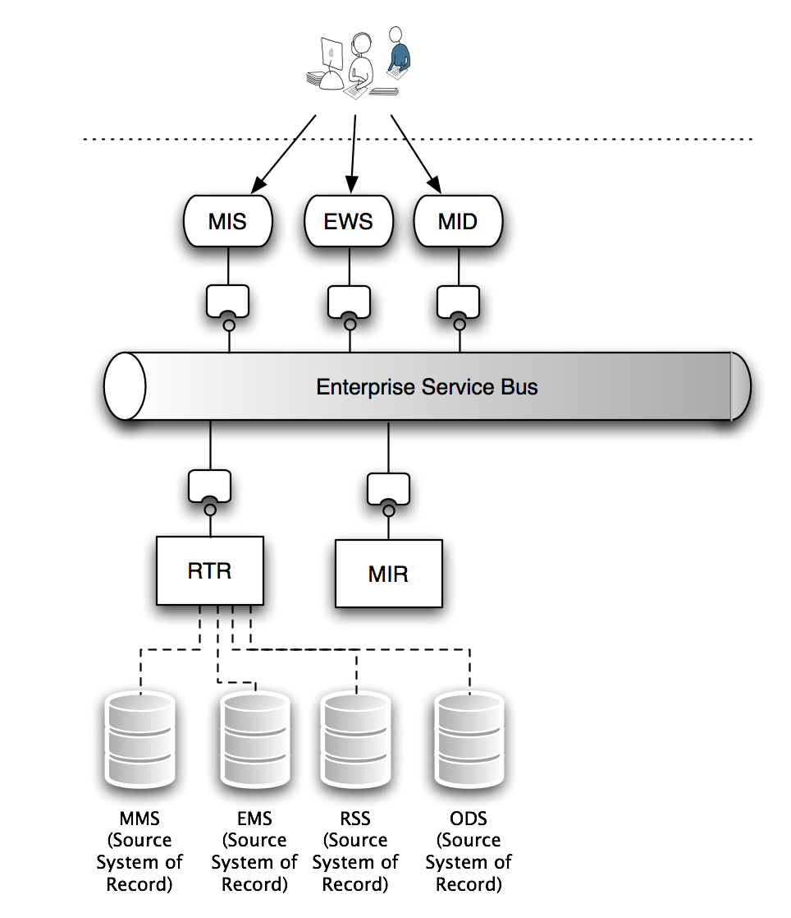

The CDR project will use the ERCOT NODAL Enterprise Service Bus (ESB) as the transport layer to pass data between the CDR engine and the content repository MIR, MIS Portal and Enterprise Web Services. The CDR project will interface through adapters or brokers to the ERCOT ESB. The ERCOT ESB will then handle the transport of data to and from the respective end points such as the MIR using the MID interface. The CDR also will make use of the services offered by the ESB such as exception handling, error processing and audit trailing.

Data Flow View

Data flow diagram for the CDR Project
Like EMS, MMS has its own staging tables where data is sourced from the originating source database. This is to minimize load on the source system itself. Each Source system staging table is also replicated into a RSS. The validity of the RSS tables is the same as the Source Staging tables and these tables act as load balancing or outage failover systems to the Source System tables. CDR will be configured in such a way to switch between the Source System staging tables or the RSS based on the load on the databases, At the end of the period for validity of the RSS data, data is then replicated to the ODS for archival. For ILM of ODS, please refer to the EDW Conceptual Design document.
The basic flow of CDR is as follows:
- The source system generates data for one of the CDR reports.
- CDR Engine is designed to retrieve the same data as per the latency time of the report as specified in the report specification. The data could be retrieved from more than one Source Systems of Record
- CDR Engine connects to the right data source based on the load. If there is heavy load on the Source staging tables or an outage on the same, the CDR engine connects to the Source System’s RSS.
- CDR engine then checks the report definitions to evaluate the need of any aggregation. If there is any, data is then aggregated for that report
- CDR engine then checks the report definitions to evaluate the need of any computations or calculations. If there is any, data is then computed for the report.
- The data is then transformed to a report based on the report specification. This could be a PDF, XLS, XML, DOC, ZIP or CSV.
- The generated report is then provisioned into the Market Information Repository database.
- The report data is also transformed to dashboard data or dynamic images based on the report specification and definitions.
- The report data is also enabled to be consumed by the External Web Services, if it is listed in the report specification.
- Market Participants get these reports delivered to them in the MIS Portal or ERCOT.COM for public reports in the form of downloadable reports or visual displays.
- Market Participants also get these reports in the form of web service methods for their machine to machine interfaces.

Supplementary Specifications

Performance
Performance requirements will be documented in the report specification document. There is a discovery process at ERCOT by the CDR business analysts to finalize the service level agreements for each and every CDR output. The report specifications will be published in the detailed design document.

Apart from maintaining the right SLA latency for the specific report, the CDR engine also needs to address these critical performance factors:
- Constant monitoring, with routines and scripts in place to identify and correct performance issues.
- Load balanced architecture designed for failover and disaster recovery with minimal recovery time.
- Enhanced framework for exception handling, logging and audit trails as well as quick feedbacks to helpdesk for customer support and outage notifications.
- Automated intervention procedures to step in when performance issues create inaccessibility of data.

Legal and Regulatory
Data products and services provided by CDR system will conform to the collection, handling, verification, and retention guidelines outlined in:
- Baseline 1 and Baseline 2
- ERCOT NODAL Protocols

System and Communication
CDR will be housed in a highly scalable, highly available network environment with load balancing abilities. CDR will present the market participants data in the form of reports and dashboard graphs.

System Security
System security will be compliant with the ERCOT and PUCT standards. The ERCOT security standards are specified in CS7.6 Information Classification Corporate Standard. Systems will be located within the internal network of ERCOT protected by Firewall and interfaces to the market participants will be via the MIS proxy server in the ERCOT DMZ

Data Confidentiality
Data Confidentiality will be originated by the source systems and will be included in the reports as a part of the meta-data classification for MIR. Similarly data needed to generate dashboard portlets will be included in the header variables for MIS. CDR packages the confidential information to determined intelligent targets to display the same data in these formats:
- Public
- Secure
- Certified
CDR does not validate any user directories for verification. For more information of MIRs security classification and MIS security interfaces and the External Web Services Security, please read the EDW, MIS Conceptual System Design document and the External Web Services Security document.

Back up and Recovery
Disaster recovery will be implemented on the production systems. The CDR system will adhere to standard practices of ERCOT business in regards to backup and recovery. These include:
- Tape backups
- Automatic failover routines and process to a secondary site
- Constant system monitoring for emergency recovery procedures

Availability and Redundancy
The production environment is designated as a high-availability, high-scalability system, and will utilize hardware and software features of the ERCOT NODAL architecture supporting availability, and both local and site failover.

Maintainability
The CDR system will conform to the following accepted standards ensuring maintainability:
- Design patterns and standards and naming standards will be followed to develop code and databases with adequate documentation.
- Version control software is used to maintain the code base. All releases and sub releases are labeled so that the correct code base can be reached when needed;
- Deployment scripts and Migration Control Documents adhering to the ERCOT standards will be strictly followed to deploy new versions of data descriptions and databases into the multiple environments
- Design documentation is provided to assist with maintenance, failover, and enhancement

Usability
Specific usability requirements access data is through the MIS Portal. The reports generated will strictly adhere to ERCOT User Experience standards. Data formats for reports are:
.doc (Microsoft Word)
.xls (Microsoft Excel)
.PDF (Adobe Acrobat)
.xml (w3c)
.zip (WinZip)

Extract formats are:
.CSV (comma delimited)
.xml (w3c)

For internal communications, CDR will pass all data in the form of XML for easy formatting and graph displays.

