
Texas Nodal:
Congestion Revenue Rights System
Market User Interface
User Manual
Version 1.0
December 18, 2007

Revision History

Date | Version | Description | Author
4/23/07 | 0.1 | Initial version | Energy Solutions, Nexant
5/31/07 | 0.2 | Update with new modules, features and functionalities | Energy Solutions, Nexant
8/01/07 | 0.3 | Include CRR Available Credit Limit Functionality | Energy Solutions, Nexant
8/22/07 | 0.4 | Include Counter-Party CRR Available Credit Limit Functionality, Update the document accordingly | Energy Solutions, Nexant
8/28/07 | 0.5 | Review and update document | Energy Solutions, Nexant
10/08/07 | 0.6 | Update document to reflect all ERCOT customization | Energy Solutions, Nexant
10/20/07 | 0.62 | Update bilateral market and credit managers | Energy Solutions, Nexant
11/30/07 | 0.99 | Update based on ERCOT feedback | Software and Information Systems, Nexant
12/13/07 | 1.0 | Final version | Software and Information Systems, Nexant
12/18/07 | 1.0 | Updated the footer & the header | Software and Information Systems, Nexant

Table of Contents

1. Introduction 1
1.1. General 1
1.2. Organization of This Document 1
1.3. Target Audience 1
2. ERCOT CRR System Overview 3
2.1. Overview 3
2.2. CRR System Components 3
2.3. CRR Allocation and Auction Time Lines 4
2.4. ERCOT Portal Web Site 6
2.4.a. Portal Access and Navigation 6
2.5. Overview of Account Holder User Interface Functions 7
3. Auction Portfolio Manager: Managing Auction Portfolios 9
3.1. Auction Portfolio Flow 9
3.2. Auction Portfolio List Page 9
3.2.a. Functionality 10
3.2.b. Auction Portfolio List Data Fields 11
3.2.c. Usage 11
3.3. Auction Portfolio Editor Page 13
3.3.a. Functionality 14
3.3.b. Auction Portfolio Editor Data Fields 14
3.3.c. Usage 16
4. Nominations Manager: Managing Nominations 18
4.1. Nominations Flow 18
4.2. Nomination General Tab 19
4.2.a. Functionality 19
4.2.b. Nomination General Page Data Fields 20
4.3. Capacity and Refund Tab 21
4.3.a. Functionality 21
4.3.b. Capacity and Refund Page Data Fields 23
4.3.c. Usage 23
4.4. Baseloads Tab 25
4.4.a. Functionality 26
4.4.b. Baseloads Page Data Fields 27
4.4.c. Usage 28
4.5. Results Page 30
4.5.a. Functionality 30
4.5.b. Results Page Data Fields 31
4.5.c. Usage 32
5. Messages Manager 34
5.1. Messages Manager Flow 34
5.2. Message Board Page 34
5.2.a. Functionality 35
5.2.b. Messages Board Data Fields 36
5.2.c. Usage 36
6. Downloads Manager: Managing Downloads 37
6.1. Downloads Manager Flow 37
6.2. Downloads Page 38
6.2.a. Data Fields 39
6.3. Private General Tab 39
6.3.a. Functionality 39
6.4. Private Market Results Tab 41
6.4.a. Functionality 41
6.5. Common General Tab 43
6.5.a. Functionality 43
6.6. Common Network Tab 44
6.6.a. Functionality 45
6.7. Common Market Tab 50
6.7.a. Functionality 51
6.8. Common Market Result Tab 53
6.8.a. Functionality 54
7. Credit Limit Manager 60
7.1.a. Functionality 60
7.1.b. Credit Limit Editor Data Fields 61
7.1.c. Usage 61
8. Bilateral Market 63
8.1. Introduction 63
8.2. Bilateral Market Action and Events Flow 64
8.3. Bilateral Market Manager 65
8.3.a. Functionality 65
8.3.b. Data Fields 66
8.4. Bilateral Market Manager – My Trades 67
8.4.a. Functionality 67
8.4.b. Private CRR page Data Fields 67
8.4.c. Usage 69
9. Counter-Party Credit Limit Manager 78
9.1.a. Functionality 78
9.1.b. Credit Limit Editor Data Fields 79
9.1.c. Usage 79

COPYRIGHT NOTICE
This document contains confidential and proprietary information of Nexant, Inc., and ERCOT, Inc. The contents are also protected as unpublished copyrighted works, Copyright, Nexant, Inc., 2002-2007 & ERCOT Inc., 2007. All rights reserved.

Introduction

General
The intent of this ERCOT CRR Market User Interface – User’s Manual is to provide ERCOT CRR Market Participants, i.e., Account Holders (AHs) and Counter-parties (CPs), with an introduction to ERCOT CRR System and its user interfaces, namely the Market User Interface (MUI). The Market User Interface (MUI) subsystem is a web-based system and allows ERCOT account holders to manage all of their ERCOT CRR market activities, including but not limited to their nominations for allocations and bids for auctions, submitting their portfolios for ERCOT allocations and auctions, following the market activities and results, as well downloading market results and market related data files. This manual also describes the user interface capabilities and functional features of the Bilateral Market for the registration of buy/sell of CRR in the bilateral market. Finally, it describes the Counter-Party CRR credit limit editor. As such, this user manual is not intended to be a complete reference source of information about the ERCOT CRR System, or its interfaces, or any of its other component subsystems, nor is this user manual intended to provide any guidance with respect to nomination and bidding strategies in the ERCOT CRR allocations and auctions respectively.

Organization of This Document
This User’s Manual is organized into chapters, which cover the following topics:
- Chapter 2 gives an overview of the ERCOT CRR System Market User Interface (MUI).
- Chapter 3 explains in detail how the Account Holders manage their auction portfolios.
- Chapter 4 explains in detail how the Account Holders manage their allocation nominations.
- Chapter 5 introduces the functionalities of the Messages Manager.
- Chapter 6 covers the functionalities under the Downloads Manager.
- Chapter 7 explains the Account Holder CRR Available Credit Limit (ACL) Editor and its functionalities.
- Chapter 8 explains ERCOT’s Bilateral Market features and how to use them to trade CRRs bilaterally using ERCOT’s Bilateral Market.
- Chapter 9 explains the Counter-Party CRR Available Credit Limit (ACL) Editor and its functionalities.

Target Audience
This User’s Manual is intended for use by ERCOT CRR System Account Holders and Counter-parties to aid them in performing the following tasks:
- Viewing and downloading the files that contain common information related to current allocations and auctions
- Viewing common messages
- Viewing and downloading private information such as Account Holder specific CRR buy bids, sell offers, and auction results
- Viewing private messages
- Managing their allocation nominations and auction bids
- Utilizing the Bilateral Market for the registration of buy/sell of CRR in the bilateral market
- Managing the CRR available credit limit
The Account Holders and Counter-parties are assumed to be familiar with the concepts of CRRs and CRR modeling. For more information on CRRs, the Account Holders and Counter-parties are also encouraged to refer to ERCOT’s documentation on Congestion Revenue Rights at ERCOT website.
Please note that private and common pages and data referred to in this document relate to functionalities and features of the ERCOT CRR System and are different from the Public, Secure and Certified areas of the ERCOT MIS as defined in the nodal Protocols.

ERCOT CRR System Overview

Overview
The ERCOT CRR System was designed to allow ERCOT Account Holders (AHs) to participate ERCOT’s CRR allocations and auctions, and ERCOT’s CRR Bilateral Market (BM). Account Holders use the web-based CRR system to nominate on allocations, bid on auctions, or register CRR ownership changes. ERCOT will conduct both annual and monthly allocations and auctions. Counter-parties (CPs) can only access the Counter-Party CRR Available Credit Limit Editor page.

CRR System Components
The CRR System has the following key components, shown in Figure 2.1:
- Market User Interface (MUI) Subsystem – The MUI CRR interface are state-the-art web-based market interface subsystems that will allow
  - Account holders to view and download common data, common allocation/auction results, and associated common announcements and messages.
  - Account holders to view and download private data, private allocation/auction results and to view private messages.
  - Account holders to manage and submit their CRR bids to an upcoming allocation and auction
  - Account holders to register ownership changes resulting from private bilateral trades of CRRs.
- Market Operator Interface (MOI) Subsystem – The MOI subsystem is a web-based system through which ERCOT personnel will operate and manage the CRR System. This interface is not available to Account holders.
- CRR Database Subsystem – The Database subsystem manages all access to both common and private data in the CRR System. All bid data submitted by Account holders are stored in this database.
- CRR Data Interface Subsystem – The Data Interface subsystem manages all the data exchange from and to other ERCOT Systems. This data typically include registration and credit information, network and network related data, CRR ownership, inventory, etc.
- CRR Calculation Subsystem – This subsystem is based on Nexant's HEDGE© software. HEDGE© is a versatile multi-function product that includes contingency constrained optimal power flow for CRR auction and allocation calculations, as well as simultaneous feasibility analysis.
Although, the ERCOT CRR System utilizes all the subsystems briefly mentioned above for successful and viable operations of ERCOT’s CRRs market, Account holders are exposed to the MUI only. Therefore, this manual is primarily focused on the MUI Subsystem features and functionalities. The functionalities of all other subsystems are transparent to the account holders and counter-parties.
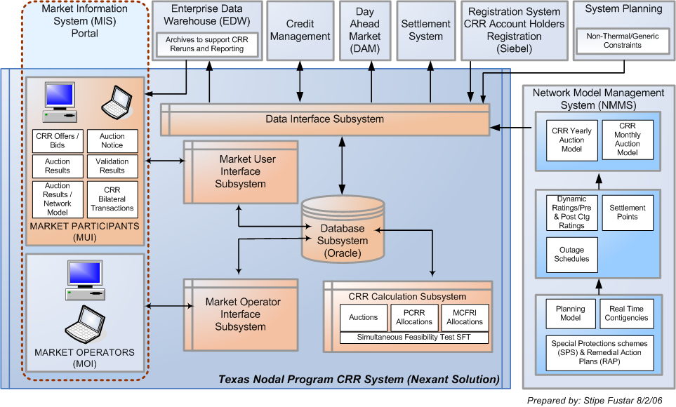
Figure 2.1: CRR System, its Components & Interfaces with other ERCOT Systems

CRR Allocation and Auction Time Lines
ERCOT will initiate, direct and oversee the CRR allocations and auctions. The timeline will incorporate the following steps:
- A defined time-period, wherein Account Holders submit MW nominations for allocations and bids for auctions.
- ERCOT market operators conduct the allocation or auction.
- Results are posted at the conclusion of the allocation or auction runs.
A typical timeline for the annual markets is shown below in Figure 2.2.
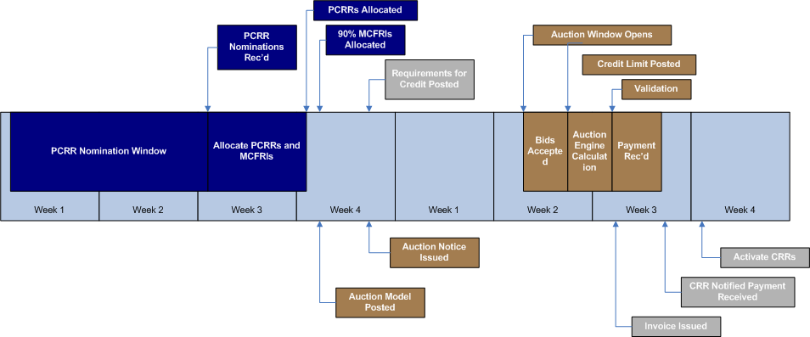
Figure 2.2: Typical Annual CRR Allocation and Auction Markets’ Timeline
Furthermore, Figure 2.2 shows typical monthly activities in October for the annual allocations and auctions for the following year. These include, but are not limited to:
- Market Operators set up the allocation market – 45 days in advance of 1st of month for monthly, during PCRR nomination window for annual
- Account Holders nominate PCRR over a two week submission period – Completed 15 business days prior to monthly auction (25 days prior to annual auction)
  - Monthly true-up nominations are determined by the CRR System automatically
- Market Operators run the allocation market – PCRRs and MCFRIs completed 10 business days in advance of monthly auction
- Market Operators post the auction model – 10 business days in advance of monthly, 20 business days in advance of annual
- Market Operators set up the auction market – 10 business days in advance of monthly, 20 business days in advance of annual
- Market Operators post the auction notice – 10 days in advance of monthly, 20 days in advance of annual
- Account holders submit bids and offers – 3 days for monthly auction (2nd Tuesday), 2 days for annual (1st Tuesday of Nov)
- CRR System receives the adjusted available auction credit limits from CMM
- Counter-parties adjust the CRR Available Credit Limits for the Account Holders they represent
- Market Operators run the auction market and validate results – 5 business days
- Market Operators post the results
  - CRR System notifies the account holders
  - CRR System notifies Settlements and Credit
- Activate CRRs in system for trading after payment notifications are received

ERCOT Portal Web Site
Account Holders interface with the ERCOT CRR System via the ERCOT portal. The portal is accessed via the Internet, using the following web browsers:
- Microsoft Internet Explorer Version 6 or above
The Sun’s Java Runtime Environment (JRE version 1.5.0) plug-ins are required to display applets on the CRR System portion of the ERCOT portal. The CRR System does not require any additional proprietary software to be installed on account holders’ or counter-parties’ computers.

Portal Access and Navigation
The ERCOT portal is the single point of entry for Account Holders and Counter-parties to access the ERCOT market systems.
The ERCOT CRR System will be navigated mainly by using links and drop-down menus available in the ERCOT Market Information System (MIS) portal system web pages, control tabs and buttons within these web pages, or through use of the Forward/Back controls of the web browser.
The CRR System registration for Account Holders will be managed by the ERCOT Registration System. Client side digital certificates will be required to be installed in account holders’ and counter-parties’ browsers. These digital certificates will be generated at the user level and will be used to access all ERCOT market systems that a user has the right to.

Overview of Account Holder User Interface Functions
The Market User Interface (MUI) for the Account Holders has six main menu headings. These six menu headings allow AHs to access all the functionalities to allow them to participate in ERCOT’s CRR market. The six main menu headings that the CRR AH will see are:
- Auction Portfolio
- Nomination
- Messages
- Downloads
- Credit Limit
- Bilateral Market
The main menu headings of the Market User Interface are shown in Figure 2.4.
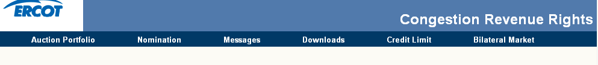
Figure 2.4: MUI Account Holder Menu Headings
Each menu heading contains links to various managers or displays:
- Auction Portfolio – The CRR AH will enter their respective auction portfolios through this tab, to be attached to a specific market or set up as a template. In addition, the CRR AH can download and update previously created portfolios, as long as they have not been submitted to a particular auction market.
- Nomination – The CRR AH will place their allocation nominations by using this tab. The allocation portfolio can be attached to an allocation market or saved as a template.
- Messages – This tab will display all common and private messages sent by the ERCOT CRR Operator to the AHs.
- Downloads – Using this tab, the AH will be able to download and view various types of market and network related data.
- Credit Limit – Using this tab, the AH will be able to input, change and view the CRR credit limit they assign to each CRR auction market.
- Bilateral Market – This tab allows the AH to access the Bilateral Market functionality of the CRR System. The CRR AH can post buy or sell requests of Bilateral Market transactions.
Please note that each of these functionalities will be explained further in the following chapters. Figure 2.5 shows the navigational structure under each main tab, and gives functional details for each link.

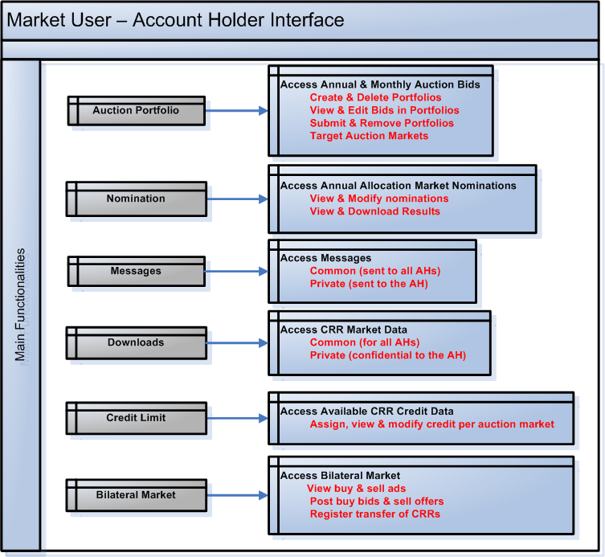
Figure 2.5: Main Account Holder User Interface Tabs and Functionalities

Auction Portfolio Manager: Managing Auction Portfolios
One of the important functions of the CRR Market User Interface is to manage auction CRR portfolios. A CRR auction portfolio is an efficient and effective package to manage CRR bids. Each valid CRR portfolio consists of a set of valid CRR bids – point-to-point CRR or Flowgate Rights (FGRs) buy bids, or sell offers. This section explains the functionalities available to manage the auction portfolios.

Auction Portfolio Flow
Figure 3.1 shows the general flow of events/actions in the Auction Portfolio manager.
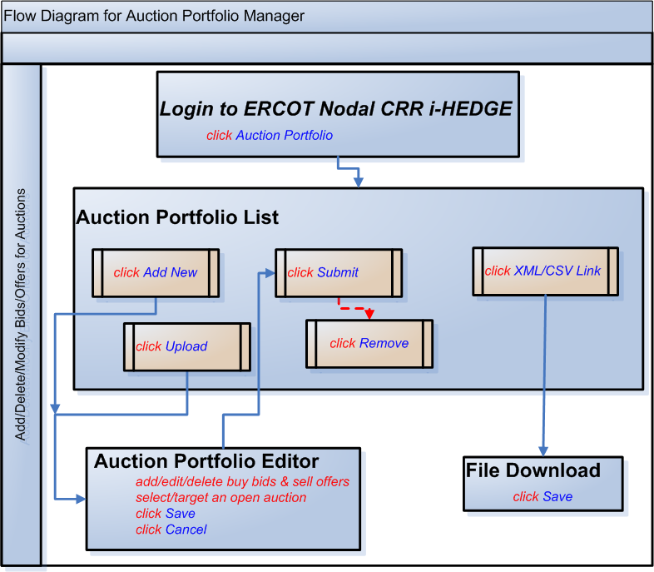
Figure 3.2: Auction Portfolio Flow

Auction Portfolio List Page
The Auction Portfolio link takes the user to Auction Portfolio List page shown in Figure 3.2.
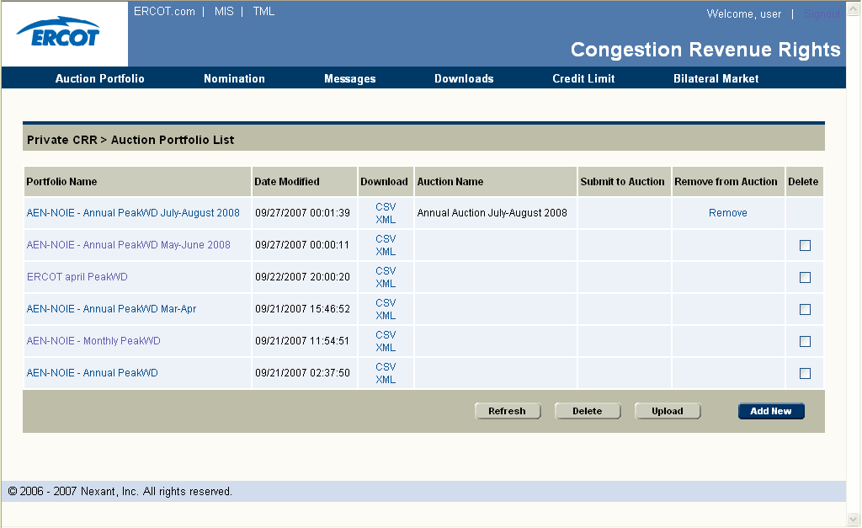
Figure 3.2: Auction Portfolio List Page

Functionality
The user would use this page to:
- View the user’s list for existing portfolios for CRR auctions (default display)
- Add a new portfolio for CRR auctions by using the CRR Auction Portfolio Editor (click on Add New)
- Upload a portfolio for CRR auctions (click on Upload)
- Edit an existing portfolio (click on the portfolio name link)
- Download an existing portfolio (click on the XML or CSV link for the corresponding portfolio)
- Submit a portfolio to an auction or remove it from one (click Submit or Remove links for the corresponding portfolio)
  - The portfolio needs to be already targeted to a specific auction
  - The user will not be able to edit any bids or offers in a submitted portfolio, but just only view them
  - If the user wants to modify the portfolio, one has to remove it and then click on the portfolio name link
- Delete portfolio(s) (check delete flag(s) box and click on the Delete)
It is important to Remove a previously submitted portfolio first, and Save to Template, before Delete. Otherwise, Delete before Remove would only delete the template data, not the previously submitted data. The next submission of data will then add on to the data previously submitted.
- Refresh the list (click on Refresh) to see any updated status

Figure 3.3 summarizes the functionalities on this page.
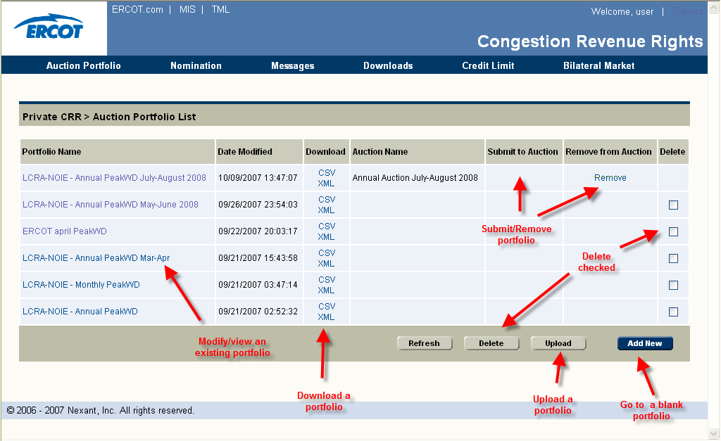
Figure 3.3: Auction Portfolio List Page Functionality Summary

Auction Portfolio List Data Fields
The data fields on this page are:
- Portfolio Name – Name of the portfolio
- Date Modified - Date when the portfolio was last modified
- Download – Click on the hyperlink to download the portfolio
- Auction Name – Name of the auction if the portfolio has been targeted towards a particular auction (Auction market name)
- Submit to Auction – Click on the hyperlink to submit the portfolio to the specified auction
- Remove from Auction – Click on the hyperlink to remove the portfolio from the specified auction
- Delete – Check the box to mark the portfolio to be deleted

Usage
If upload functionality is used for creating a new portfolio, then
- The user is prompted for a file name and location on the user’s computer
- Once the user clicks on the Submit button, the portfolio is loaded
- Once the file is loaded, the system automatically opens the Auction Portfolio Editor to allow the user make any necessary changes and save the portfolio in the database by clicking the Save command button. The user is then taken back to this page that should list the newly created portfolio as well.
The user can create one or more portfolios for an upcoming CRR auction as templates. The portfolios can be only submitted when bidding period is still open. After this open bidding period closes, portfolios cannot be submitted.
The user can remove the user’s portfolios only when bidding period is still open. After this open bidding period closes, portfolios cannot be removed. Please note that this action does not remove the portfolio from the user’s portfolio list. In fact, those submitted portfolios become templates again once the submission period closes.
Error messages will be generated under the following conditions while uploading a portfolio:
- If upload size file is bigger than 4 MB, the error message: “The upload portfolio file size is over 4MB”
- If the upload file is not an XML or CSV file , the error message: “The upload file type is not valid”
- If there is no file to upload, the error message: “There is no XML or CSV file to upload”
- If there are no bids in the upload file, the error message: “No auction portfolio bids found in the upload file”
- If there are no valid bids in the XML or CSV file, the error message: “No valid bids to upload!”
- If there is an input/output (IO) exception that is not covered above, the error message: “System file input/output exception occurs”
- If the uploaded XML or CSV file format do not match the XSD file format, the error message: “XML parsing exception occurs!”
Figures 3.4.a and 3.4.b. show the contents and layout of a valid portfolio (in CSV and XML formats) that can be uploaded to ERCOT i-HEDGE.
Please note that the users are highly encouraged to create a small portfolio by using ADD New functionality and downloading this portfolio for valid content and format.
Start Date and End Date are optional, can be blank. Bid ID should be left blank. The user needs to use valid flowgate, source and sink names, time-of-use, buy/sell, and hedge type identifiers. Please note that any invalid data field or record will be rejected either during upload or save step.
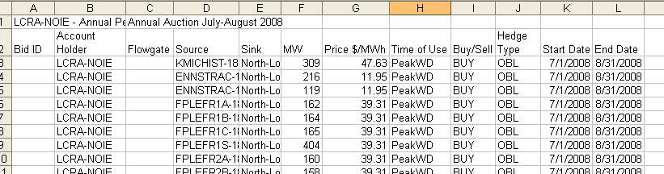
Figure 3.4.a: Sample Auction Portfolio in CSV Format
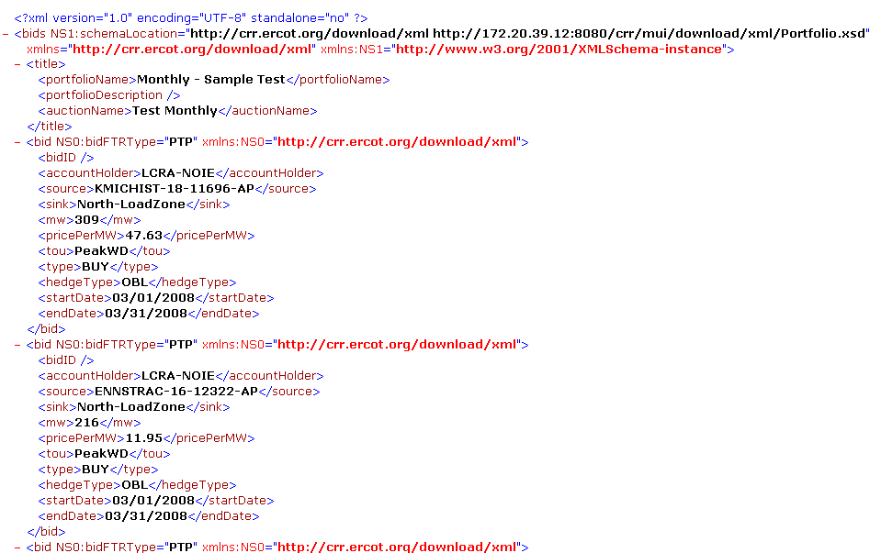
Figure 3.4.b: Sample Auction Portfolio in XML Format

Auction Portfolio Editor Page
The Add New button from Auction Portfolio List page takes the user to Auction Portfolio Editor page shown in Figure 3.5.

Functionality
The user would use this page to:
- Create a new portfolio for CRR auctions by interactively using the CRR Auction Portfolio Editor
- Add buy bids for CRRs for FGRs
- Add sell offers for CRRs or FGRs owned by the account holder
- Delete existing bids (highlight the record(s) and click on Delete)
- Cancel any changes made to the portfolio (click on Cancel). This returns the user to the Auction Portfolio List page
- Select and move to one of the existing portfolios from (Select a portfolio from the drop-down menu under Select Another Portfolio header
  - Note that the user would lose all the modifications made to the current portfolio
- Target a portfolio to a particular auction (select from the drop-down menu under the Select Auction header). The user performs this function by clicking on Save. The user can save one’s portfolio to a template for the time being instead of to an auction market.
- Search for valid sources and sinks (Enter the first few letter of a name and click Search)
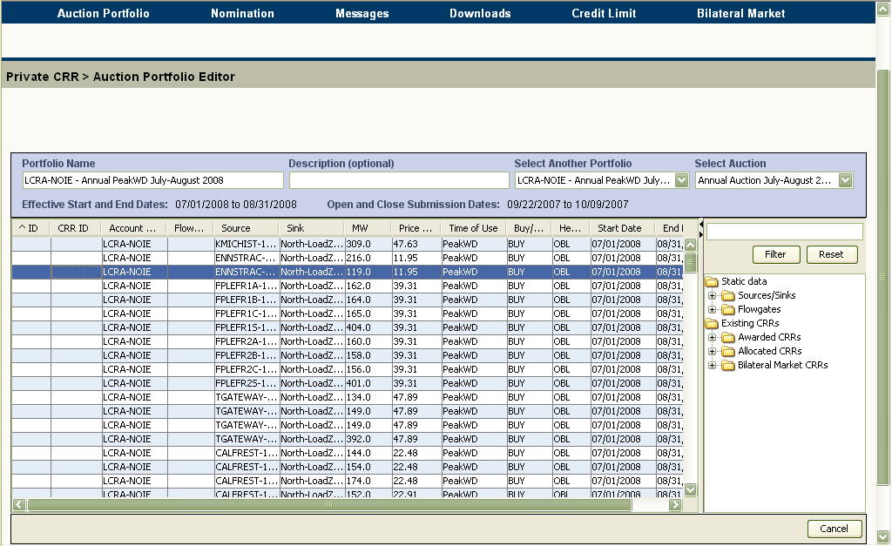
Figure 3.5: Auction Portfolio Editor Page
Figure 3.6 summarizes the functionalities on this page.

Auction Portfolio Editor Data Fields
The data fields in the upper pane are:
- Portfolio Name – A text box to which to view or input the name of the portfolio currently being managed. Note that a portfolio must have a name to be saved (Required field)
- Description – A text box to view or input the description for the current portfolio. Note that this field is optional
- Select Another Portfolio – A list box with all existing portfolios listed for selection. If selected, that portfolio is shown
- Select Auction – A list box with all the existing auctions for the user to target the portfolio. Please note that the user can select a portfolio to be a template. A template portfolio is a generic portfolio that the user has not targeted to a specific auction
Note that the panes on this page are shown in Figure 3.6.
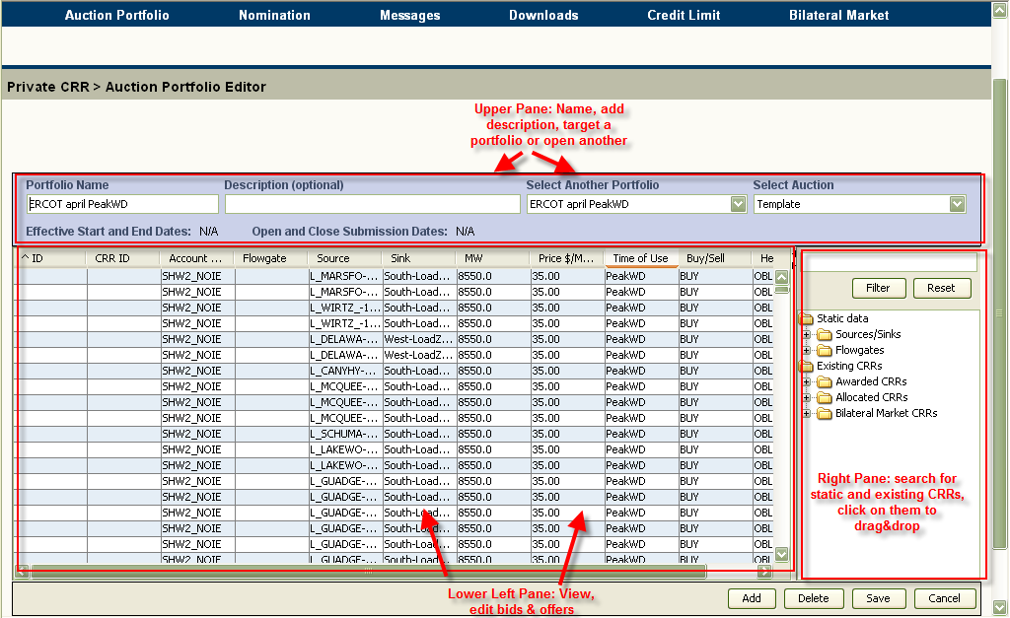
Figure 3.6: Auction Portfolio Editor Page Panes
The data fields in the lower left pane are:
- ID – Bid ID (not editable)
- CRR ID – ID of the CRR (not editable)
- Account Holder – The name the Account Holder who wishes to buy or sell CRRs (not editable)
- Flowgate – The name of the Flowgate (can be modified by using valid flowgates from under Static data/Flowgates folder only)
- Source – The name of the source for a CRR (can be modified by using valid source/sink names from under Static data/Sources/Sinks folder only)
- Sink – The name of the sink for a CRR (can be modified by using valid source/sink names from under Static data/Sources/Sinks folder only)
- MW – the MW associated with the Source/Sink pair or Flowgate (editable)
- Price – Bid price for CRR (editable)
- TOU – Time-of-use (editable)
- Buy/Sell – Buy bid or sell offer flag (editable as explained in usage section below)
- Hedge Type - Option (OPT) or obligation (OBL) for a CRR (editable)
The data fields in the right pane are:
- Static Data
  - Sources/Sinks – The folder contains all valid names of CRR sources and sinks
  - Flowgates – This folder contains all valid names of flowgates
- Existing CRRs
  - Awarded CRRs – The account holders existing CRRs that were awarded in prior auctions
  - Allocated CRRs – The account holders existing CRRs that were allocated in prior allocation
  - Bilateral Market CRRs – The account holders existing CRRs that were acquired and registered through the bilateral market

Usage
The user can add a new buy bid by
- Clicking the Add button under the CRR Editor
  - System will respond by adding a new row to the bid table for a data record
- Filling all the Account Holder, Sink and Source, or Flowgate data fields by dragging the appropriate item under the appropriate folder from the lower right pane
- Entering the bid price data by the required price
- Entering the MW amount
- Choosing the time-of-use from the drop-down menu
- Choosing the Hedge Type from the drop-down menu
The user can add a new sell offer by
- Clicking the Add button under the CRR Editor
  - System will respond by adding a new row to the bid table for a data record
- Clicking and dragging a CRR or an FGR from one of the folders under the Existing CRRs in the right pane
- Entering the offer price
- Entering the MW amount
Note that the auction editor enforces strict rules for data to ensure data integrity. Where applicable, only drag-and-drop or pull-down editing are allowed. In addition, the portfolio editor enforces the following rules for the user editable fields:
- Portfolio Name
  - Alphanumeric
  - Min Length: 1 Character
  - Max Length: 100 Characters
- Description
  - Alphanumeric
  - Min Length: 0 Characters
  - Max Length: 100 Characters
- MW
  - Real Number with 1 decimal point
  - Valid range is greater than 0
- Price $/MWHr
  - Real Number with 2 decimal points
i-HEDGE portfolio editor validates the data while the user saves them as templates or targeted portfolios. Validation rules are stricter for targeted portfolios as they encompass making sure that sources/sinks and flowgates used in a targeted portfolio are valid for the calendar periods in the target auction market.

Nominations Manager: Managing Nominations
Another important function of the CRR Market User Interface is to manage the nominations of annual PCCRs. Nominations manager allows the account holders to manipulate the “candidate” PCCRs before the annual allocation markets are run. This section explains the functionalities available to manage the candidate PCCRs.
Please note that McFRI allocation nominations and monthly allocation true-up are carried out by the ERCOT CRR market operators, and as such, account holders do not need to nominate any PCCRs for those markets. Account holders will receive information regarding those markets prior to and after they are run, and will be able to check the results using the Downloads manager.

Nominations Flow
Figure 4.1 shows the general flow of events/actions in the Nominations manager.
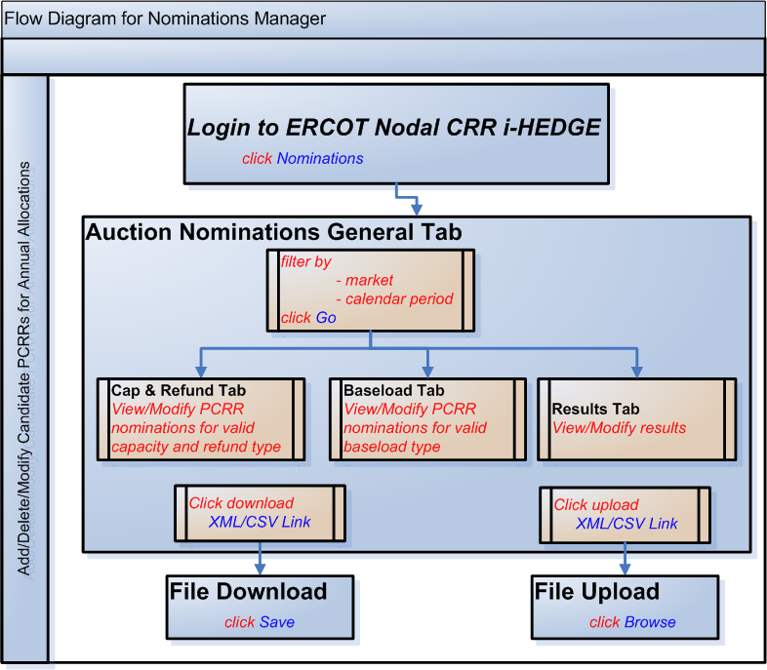
Figure 4.1: Nomination General Tab

Nomination General Tab
The Nomination link takes the user to the Nominations General page shown in Figure 4.2.
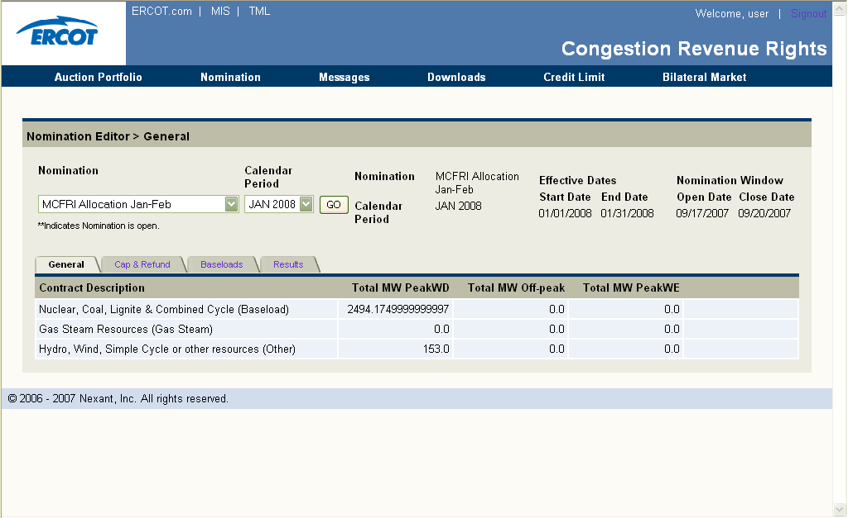
Figure 4.2: Nomination General Page

Functionality
The user would use this tab to:
- View a summary of the account holder’s eligible nominations amount by allocation eligibility type for each annual PCRR allocation market
- Navigate to the Capacity &Refund tab for each annual PCRR allocation market whose submission period is open (indicated by ** in the drop down list)
  - To view and modify the account holder’s list of candidate PCCRs of Capacity and Refund type
  - Use the filters by
    - Nomination market (select from drop down list)
    - Calendar period (select from drop down list)
  - Click on Go
- Navigate to the Baseload tab for each annual PCRR allocation market whose submission period is open (indicated by ** in the drop down list)
  - To view and modify the account holder’s list of candidate PCCRs of baseload
  - Use the filters by
    - Nomination market (select from drop down list)
    - Calendar period (select from drop down list)
  - Click on Go
- Navigate to the Results tab for each annual PCRR allocation market
  - To view the results for the account holder’s nominations
  - Use the filters by
    - Nomination market (select from drop down list)
    - Calendar period (select from drop down list)
  - Click on Go
These functionalities are summarized in Figure 4.3.
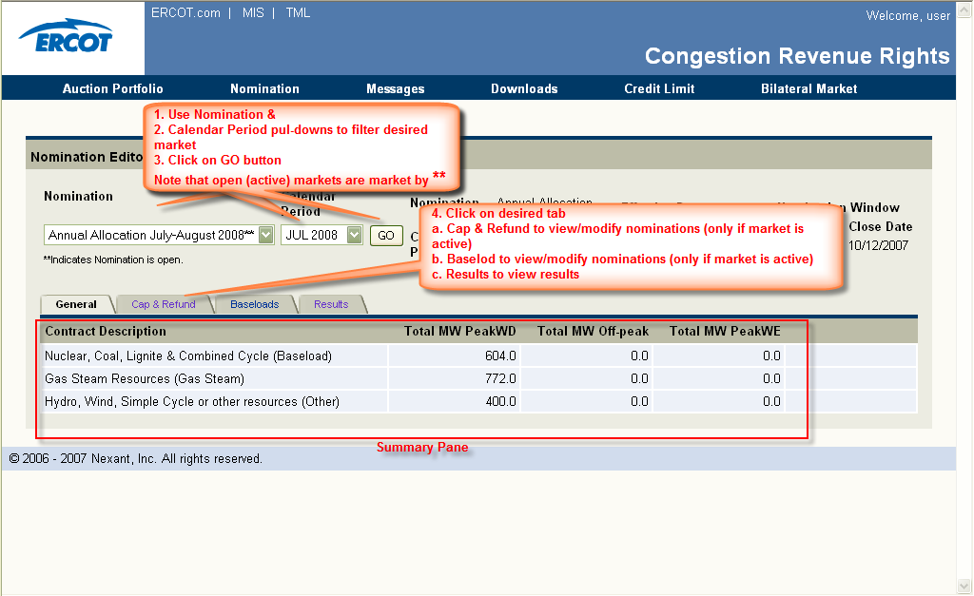
Figure 4.3: Nomination General Page Functionalities

Nomination General Page Data Fields
The data fields are:
- Nomination Case – Name of the allocation and time period
- Effective Start and End Dates – Dates for which a filtered allocation market is effective
- Nomination Window, Open and Close Dates – Open and close dates for the period during which an account holder can view, modify one’s candidate PCCRs
- A summary of account holder’s contracts for the filtered allocation market that has the following information:
  - Total MW, Peak Weekday
  - Total MW, Off-Peak
  - Total MW, Peak Weekend

Capacity and Refund Tab
The Cap&Refund tab from the Nomination General page takes the user to the Cap&Refund page as shown in Figure 4.4.
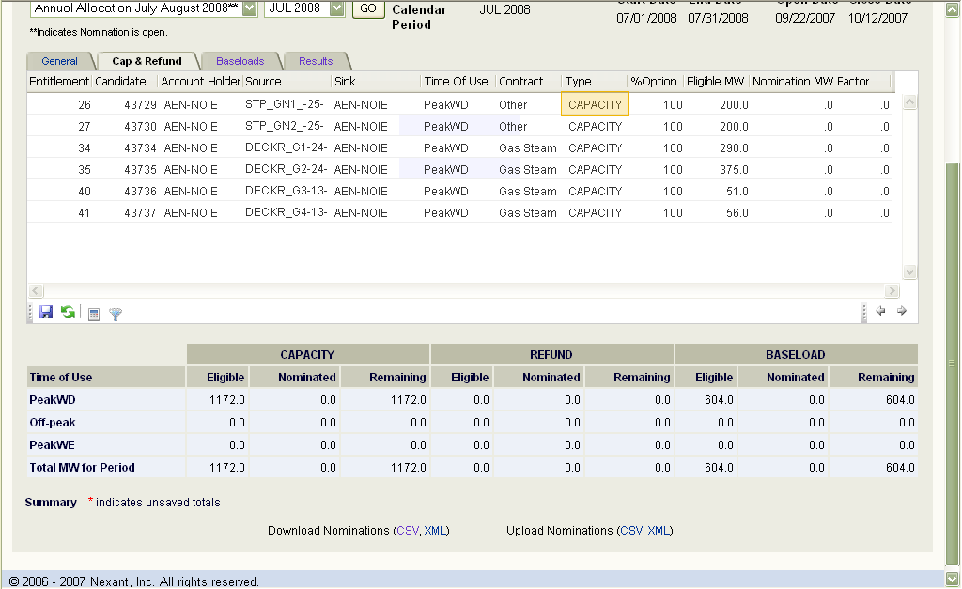
Figure 4.4: Cap & Refund Page

Functionality
The user would use this page to:
- Download nominations for CRR allocation (click on the file type to upload CSV or XML)
  - Note the downloaded file will have all of the candidates for the account holder’s for that particular calendar period specified in the pull-down menu (including the baseload types)
- Upload nominations for CRR allocation (click on the file type to upload CSV or XML)
  - Note the uploaded file may have all of the candidates for the account holder’s for that particular calendar period specified in the pull-down menu (including the baseload types)
  - Saving the nominations will save all of the candidate nominations (including the baseload types)
- Modify candidate nominations by
  - Toggling the type between capacity and refund
    - Note that if the account holder modifies the type from either CAPACITY to REFUND, or vice versa, the type of that particular candidate is automatically modified across all other calendar periods in the annual allocation
  - Modifying the option percentage
  - Editing the nomination MW
- Save the candidate nominations (click on Save icon)
- Refresh the page (click on Refresh icon)
  - Note that the modifications will be lost if the account holder has not already saved them
- Recalculate the capacity factors (click on Calculate icon)
  - Note that the modified Nominated and Remaining summaries at the bottom of page are not saved until the user clicks on Save button.
  - This temporary phase of the editing process is indicate by the red asterisks (*) sign in the summary table.
- Search for particular candidates (click on Filter icon)
The functionalities on the page are shown in Figure 4.5.
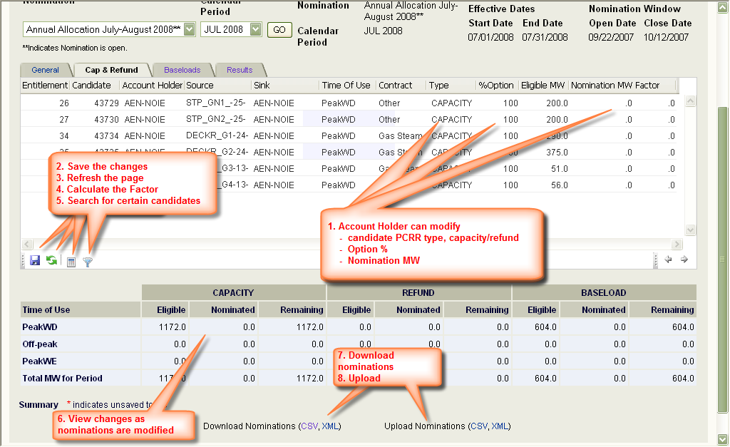
2
3
4
5
Figure 4.5: Cap & Refund Page Functionalities

Capacity and Refund Page Data Fields
The data fields are:
- Nomination Case – Name of the allocation and time period
- Effective Start and End Dates – Dates for which a filtered allocation market is effective
- Nomination Window, Open and Close Dates – Open and close dates for the period during which an account holder can view, modify one’s candidate PCCRs
- For each candidate PCCR:
  - Allocation eligibility ID – Allocation eligibility ID as entered by the ERCOT CRR Market Operators (not editable)
  - Candidate ID – Candidate PCRR ID created by ERCOT i-HEDGE (not editable)
  - Account Holder Name – Account holder name as entered by the ERCOT CRR Market Operators (not editable)
  - Source Name – Source name as entered by the ERCOT CRR Market Operators (not editable)
  - Sink Name – Sink name as entered by the ERCOT CRR Market Operators (not editable)
  - Time-of-use – Time-of-use of the corresponding contract(not editable)
  - Type (Capacity, Refund) (editable by toggling between Capacity and Refund)
  - % Option – Hedge Type (editable)
  - Eligible MW – Maximum eligible amount for a particular contract (not editable)
  - Nomination MW – Nominated MW (editable)
  - Factor – Calculated by i-HEDGE for candidates of type Capacity
- A summary of account holder’s eligible and nominated candidate MW amounts for contracts of Capacity, Refund and Baseloads types for the filtered allocation market that has the following information:
  - Total MW, Peak Weekday
  - Total MW, Off-Peak
  - Total MW, Peak Weekend

Usage
The account holder can use the download and upload functionalities to use a more powerful editor (such as MS Excel) to modify one’s candidate PCCRs. Download and upload functionalities follow standard Windows rules.
The user can modify and upload nominations for an upcoming CRR allocation only when the nomination period for a particular annual PCRR allocation is still open. After this nomination period closes, nominations cannot be modified.
Figure 4.6.a and 4.6.b show the contents and layout of a valid candidate PCRRs file (in CSV and XML formats) that can be uploaded to i-HEDGE.
Please note that the users are highly encouraged to download the candidates using the download functionality and manipulate this file for valid content and format.
The user should NOT change Allocation eligibility ID, Candidate ID, Account Holder, Source, Sink Time-of-use, Contract, Eligible MW and Factor fields. User can modify Type, %Option and Nomination MW fields. Please note that any invalid data field or record will be rejected either during upload or save step.
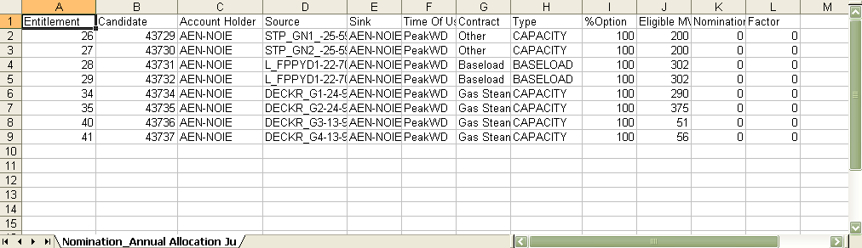
Figure 4.6.a: Sample Candidate PCCRs File in CSV Format
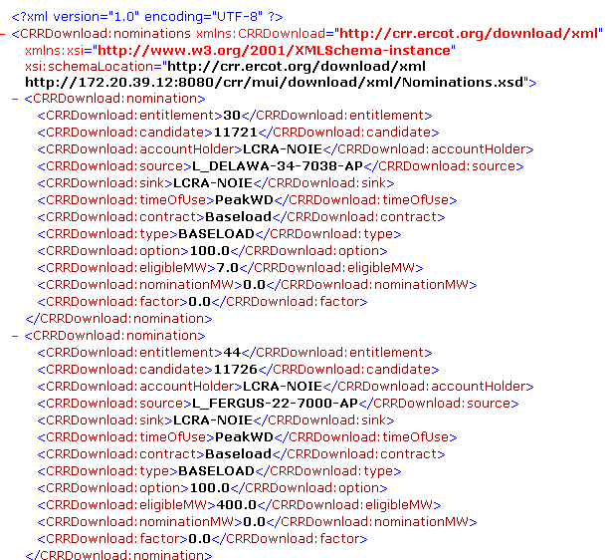
Figure 4.6.b: Sample Candidate PCCRs File in XML Format
As noted above, if the account holder modifies the type from either CAPACITY to REFUND, or vice versa, the type of that particular candidate is automatically modified across all other calendar periods in the annual allocation
For example, if the account holder changes the type to REFUND for the allocation eligibility #xyz for February for annual allocation 2020, the type for all candidate PCRRs corresponding to allocation eligibility #xyz is automatically changed to REFUND for calendar periods Jan., March through December.
When modifying the option percentage, note that
- 100% corresponds to a nomination that is all option
- 0% corresponds to a nomination that is all obligation
- Any value in between, say xyz%, corresponds to (xyz * nominated value)/100 MW of option, and [(100 - .xyz) * nominated value/100] MW of obligation.
For example, for a 100 MW nomination of 65% option, the system would automatically create one candidate of 65 MW of option type, and 35MW of obligation type for the same path (contract).
Also, note that the account holder can not nominate a MW amount larger than the eligible amount for the refund type candidates. The Nodal protocols and CRR Requirements Specification also require that “the CRR System shall also impose limits on each resource to affect a capacity factor limit of 40% for resources eligible for PCRRs marked with the “capacity option””. Therefore, if the account holder toggles the candidate type to capacity, the maximum amount allowed for a particular calendar period will depend on the amount that was nominated for the other particular periods.
- Cap&Refund page will automatically calculate the factor percentage through all calendar periods, based on the amounts nominated.
- Background validations will ensure that the capacity factor is not greater than 40% for a particular contract if capacity type is chosen.
- Validations will also ensure that nominations are not larger than the eligible amount if refund type is chosen.
- If they are, the candidate will be highlighted in yellow, and the nominations will not be saved.
Note that the nomination editor enforces strict rules for data to ensure data integrity. Where applicable, only pull-down editing are allowed. In addition, the nomination editor enforces the following rules for the user editable fields:
- % Option
  - Real Number with 0 decimal point
  - Valid range is greater than 0 and less than 1
- Nomination MW
  - Real Number with 1 decimal point
  - Valid range is greater than or equal 0

Baseloads Tab
The Baseloads tab from the Nomination General page takes the user to the Baseloads page as shown in Figure 4.7.
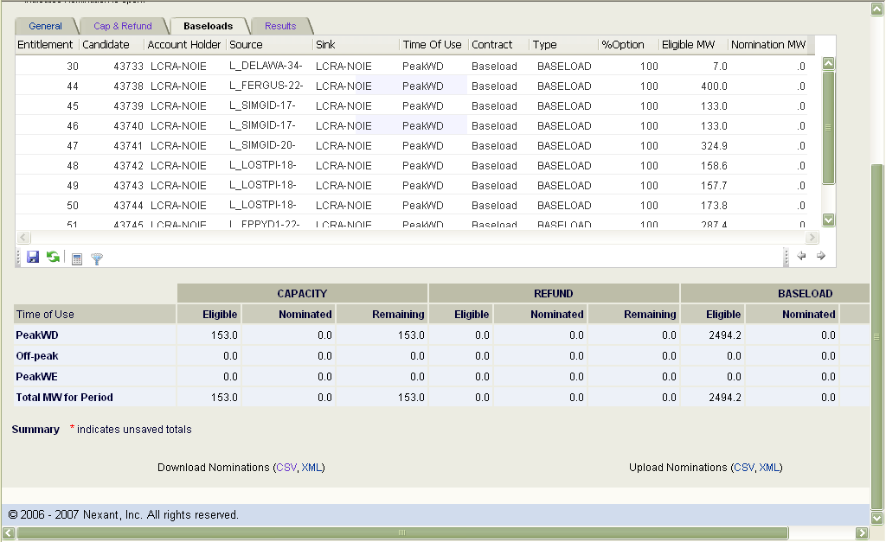
Figure 4.7: Baseleoads Page

Functionality
The user would use this page to:
- Download nominations for CRR allocation (click on the file type to upload CSV or XML)
  - Note the downloaded file will have all of the candidates for the account holder’s for that particular calendar period specified in the pull-down menu (including the capacity and refund types)
- Upload nominations for CRR allocation (click on the file type to upload CSV or XML)
  - Note the uploaded file may have all of the candidates for the account holder’s for that particular calendar period specified in the pull-down menu (including the capacity and refund types)
  - Saving the nominations will save all of the candidate nominations (including the capacity and refund types)
- Modify candidate nominations by
  - Modifying the option percentage
  - Editing the nomination MW
- Save the candidate nominations (click on Save icon)
- Refresh the page (click on Refresh icon)
  - Note that the modifications will be lost if the account holder has not already saved them
- Recalculate the capacity factors (click on Calculate icon)
  - Note that the modified Nominated and Remaining summaries at the bottom of page are not saved until the user clicks on Save button.
  - This temporary phase of the editing process is indicate by the red asterisks (*) sign in the summary table.
- Search for particular candidates (click on Filter icon)
The functionalities on the page are shown in Figure 4.58
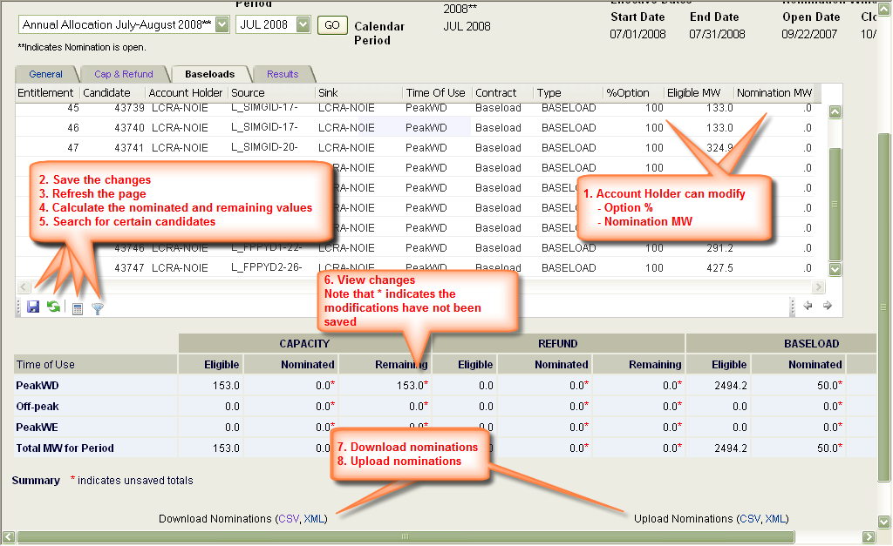
Figure 4.8: Baseloads Page Functionalities

Baseloads Page Data Fields
The data fields are:
- Nomination Case – Name of the allocation and time period
- Effective Start and End Dates – Dates for which a filtered allocation market is effective
- Nomination Window, Open and Close Dates – Open and close dates for the period during which an account holder can view, modify one’s candidate PCCRs
- For each candidate PCCR:
  - Allocation eligibility ID – Allocation eligibility ID as entered by the ERCOT CRR Market Operators (not editable)
  - Candidate ID – Candidate PCRR ID created by ERCOT i-HEDGE (not editable)
  - Account Holder Name – Account holder name as entered by the ERCOT CRR Market Operators (not editable)
  - Source Name – Source name as entered by the ERCOT CRR Market Operators (not editable)
  - Sink Name – Sink name as entered by the ERCOT CRR Market Operators (not editable)
  - Time-of-use – Time-of-use of the corresponding contract(not editable)
  - % Option – Hedge Type (editable)
  - Eligible MW – Maximum eligible amount for a particular contract (not editable)
  - Nomination MW – Nominated MW (editable)
- A summary of account holder’s eligible and nominated candidate MW amounts for contracts of Capacity Refund and Baseloads types for the filtered allocation market that has the following information:
  - Total MW, Peak Weekday
  - Total MW, Off-Peak
  - Total MW, Peak Weekend

Usage
The account holder can use the download and upload functionalities to use a more powerful editor (such as MS Excel) to modify one’s candidate PCCRs. Download and upload functionalities follow standard Windows rules.
The user can modify and upload nominations for an upcoming CRR allocation only when the nomination period for a particular annual PCRR allocation is still open. After this nomination period closes, nominations cannot be modified.
Figure 4.9.a and 4.9.b. show the contents and layout of a valid candidate PCRRs file (in CSV and XML formats) that can be uploaded to i-HEDGE.
Please note that the users are highly encouraged to download the candidates using the download functionality and manipulate this file for valid content and format.
The user should NOT change Allocation eligibility ID, Candidate ID, Account Holder, Source, Sink Time-of-use, Contract, Eligible MW and Factor fields. User can modify Type, %Option and Nomination MW fields. Please note that any invalid data field or record will be rejected either during upload or save step.
Figure 4.9.a: Sample Candidate PCCRs File in CSV Format
Figure 4.9.b: Sample Candidate PCCRs File in XML Format
When modifying the option percentage, note that
- 100% corresponds to a nomination that is all option
- 0% corresponds to a nomination that is all obligation
- Any value in between, say xyz%, corresponds to (xyz * nominated value)/100 MW of option, and [(100 - .xyz) * nominated value/100] MW of obligation.
For example, for a 100 MW nomination of 65% option, the system would automatically create one candidate of 65 MW of option type, and 35MW of obligation type for the same path (contract).
Also, note that the account holder can not nominate a MW amount larger than the eligible amount for the baseload type candidates. Background validations will ensure that the nominated amount is not greater than the eligible amount for a particular contract. If it is, the candidate will be highlighted in yellow, and the nominations will not be saved.
Note that the nomination editor enforces strict rules for data to ensure data integrity. Where applicable, only pull-down editing are allowed. In addition, the nomination editor enforces the following rules for the user editable fields:
- % Option
  - Real Number with 0 decimal point
  - Valid range is greater than 0 and less than 1
- Nomination MW
  - Real Number with 1 decimal point
  - Valid range is greater than or equal 0

Results Page
The Results tab from Nomination page takes the user to Results page shown in Figure 4.10.
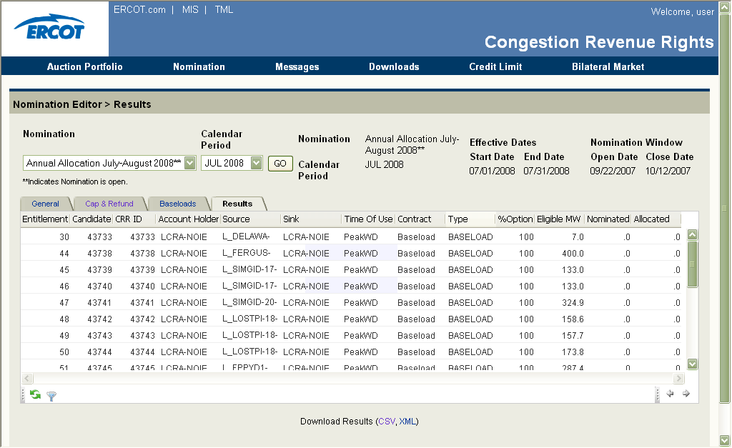
Figure 4.10 Results Page

Functionality
The user would use this page to:
- View and download the user’s results for annual PCCR allocation markets whose results are available.
  - To navigate to such a market, use the filters by
    - Nomination market (select from drop down list)
    - Calendar period (select from drop down list)
  - Click on Go
- Download results for PCRR Allocation (click on the file type to upload CSV or XML)
- Filter a view of available results (click on Filter icon)
- Navigate to the Cap& Refund page
- Navigate to the Baseloads page
- Navigate to the General page
These functionalities are summarized in Figure 4.11.
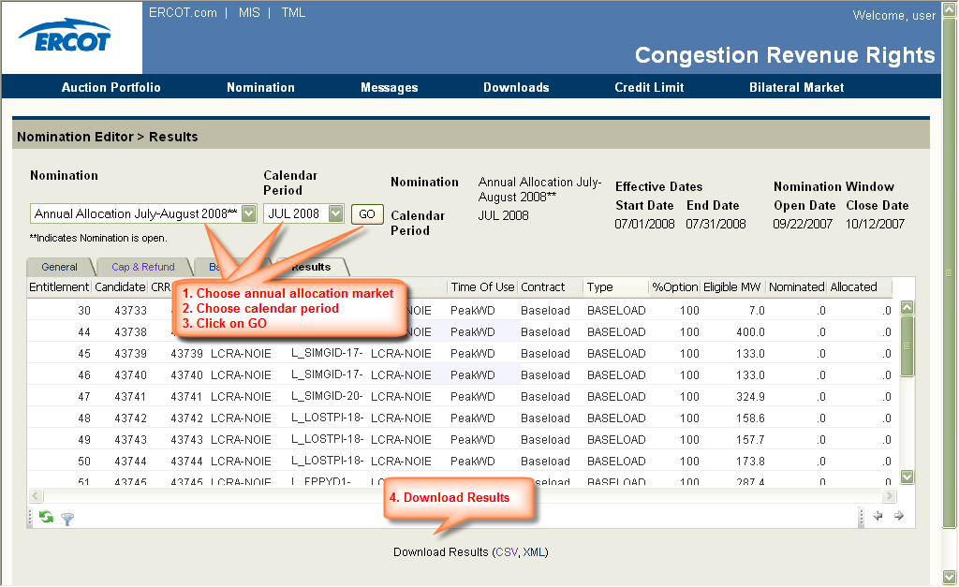
Figure 4.11 Results Page Functionalities

Results Page Data Fields
- Nomination Case – Name of the allocation and time period
- Effective Start and End Dates – Dates for which a filtered allocation market is effective
- Nomination Window, Open and Close Dates – Open and close dates for the period during which an account holder can view, modify one’s candidate PCCRs
- For each nomination:
- Resource ID
- Candidate ID
- CRR ID
- Owner
- Source
- Sink
- Flowgate (for Flowgate Nominations)
- Time-of-use
- Start Date
- End Date
- Contract
- Type (Capacity or Refund)
- Hedge Type (%age Option)
- Eligible MW
- Nomination MW
- Allocation MW
The data fields are:
- For each allocated PCCR:
  - Allocation eligibility ID – Allocation eligibility ID as entered by the ERCOT CRR Market Operators (not editable)
  - Candidate ID – Candidate PCRR ID created by ERCOT i-HEDGE (not editable)
  - CRR ID – Unique CRR ID created by ERCOT i-HEDGE (not editable)
  - Account Holder Name – Account holder name as entered by the ERCOT CRR Market Operators (not editable)
  - Source Name – Source name as entered by the ERCOT CRR Market Operators (not editable)
  - Sink Name – Sink name as entered by the ERCOT CRR Market Operators (not editable)
  - Time-of-use – Time-of-use of the corresponding contract (not editable)
  - Contract Type (not editable)
  - % Option – Hedge Type (not editable)
  - Eligible MW – Maximum eligible amount for a particular contract (not editable)
  - Nominated MW – Nominated MW (not editable)
  - Allocated MW – Allocated amount in MWs (not editable)

Usage
The account holder can use the download functionality to download and archive an annual PCRR market results. Download functionality follows standard Windows rules.
Figure 4.12.a and 4.12.b show the contents and layout of a valid candidate PCRRs file (in CSV and XML formats).
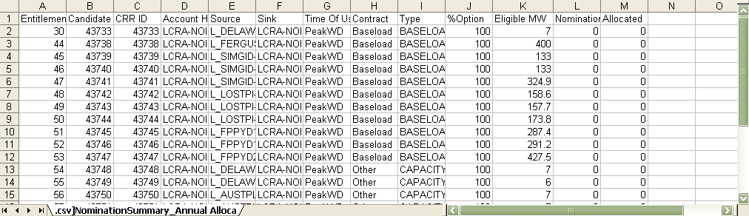
Figure 4.12.a: Sample Allocation Results File in CSV Format
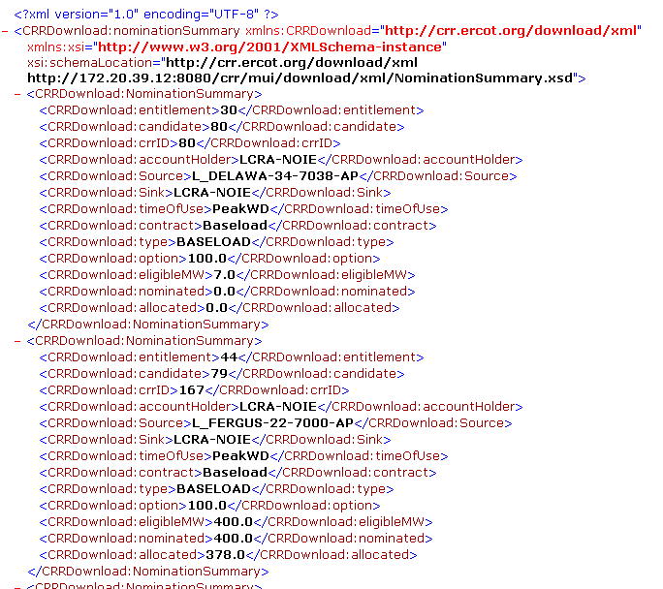
Figure 4.12.a: Sample Allocation Results File in XML Format

Messages Manager
ERCOT i-HEDGE allows ERCOT CRR Market operators to send private and common messages (with attachments) to ERCOT CRR market participants, namely the account holders. The account holders are encouraged to check the Messages page on a regular basis.

Messages Manager Flow
Figure 5.1 shows the general flow of events/actions in the Messages manager.
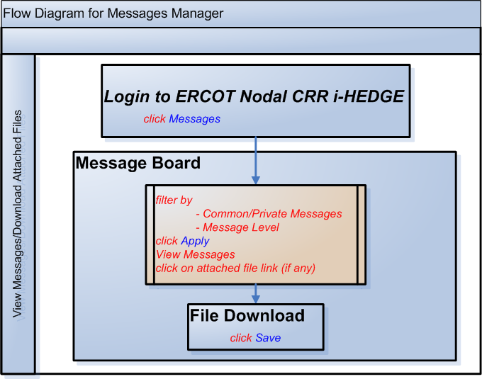
Figure 5.1: Flow Diagram for Messages Manager

Message Board Page
The Messages link takes the account holder to the Message Board page shown in Figure 5.2.
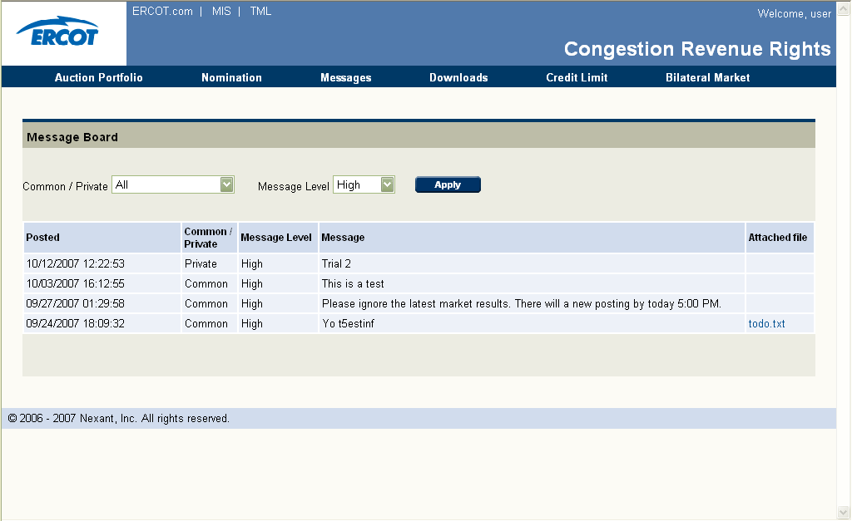
Figure 5.2: Message Board Page

Functionality
The user would use this page to:
- View current messages broadcasted by the ERCOT CRR market operators.
  - To navigate to a particular type of message, use the filters by
    - Common/Private messages type (select from drop down list)
      - Private messages – confidential message sent to a particular account holder (default)
      - Common messages – common message sent to all CRR Market account holders
      - All
    - Message Level (select from drop down list)
      - High (default)
      - Medium
      - Low
      - Info
  - Click on Apply
  - Download any desired attached file (if there is any)
These functionalities are shown in Figure 5.2.
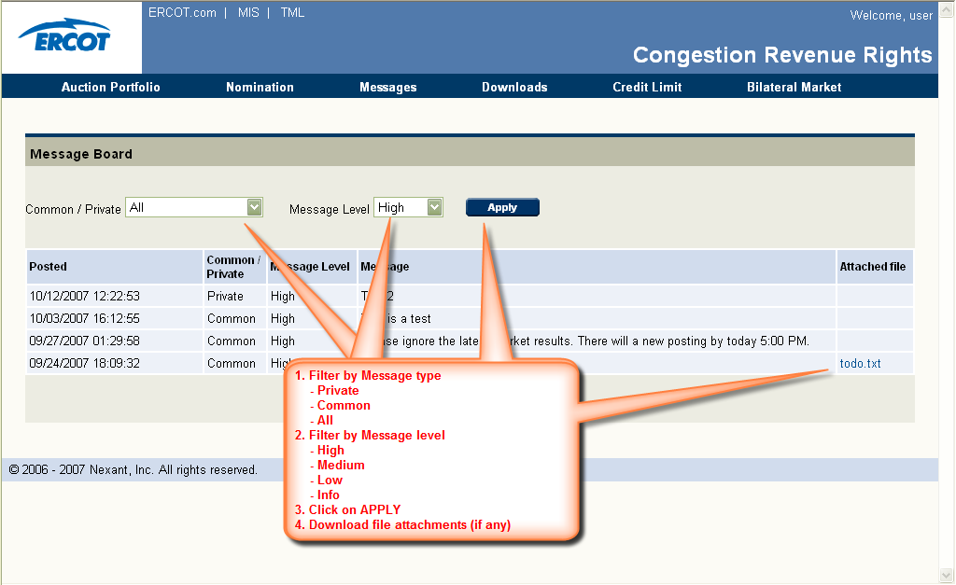
Figure 5.2: Message Board Page Functionalities

Messages Board Data Fields
- Posted – Time stamp of when the message was posted
- Common/Private – Indicates if the message is confidential or common
- Message Level – Indicates the priority of the message
- Message – Content of the message
- Attached File – Filename of attachment. This is a hyperlink where the user can click to download the file

Usage
Currently, ERCOT i-HEDGE does not issue any notice when a message is posted. Therefore, the account holders are encouraged to check the Messages Board Page on a regular basis.

Downloads Manager: Managing Downloads
In this chapter, Downloads Manager functionalities, data fields and controls are explained.

Downloads Manager Flow
Figure 6.1 shows the general flow of events/actions in the Downloads manager.
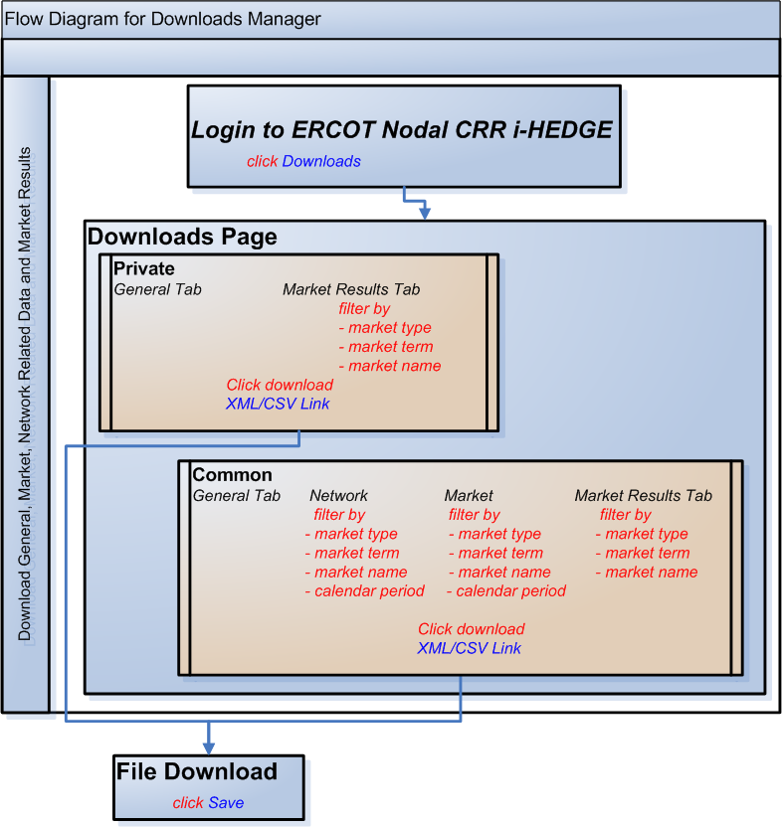
Figure 6.1: Flow Diagram for Downloads Manager

Downloads Page
The Downloads manager link takes the user to Downloads page shown in Figure 6.2.
This page has the following tabs available to the user
- Under private (confidential information and data regarding the account holder only)
  - General – Existing CRRs Tab – Account holder’s valid existing CRRs
  - Market Results – Account holder’s Allocation and Auction Results
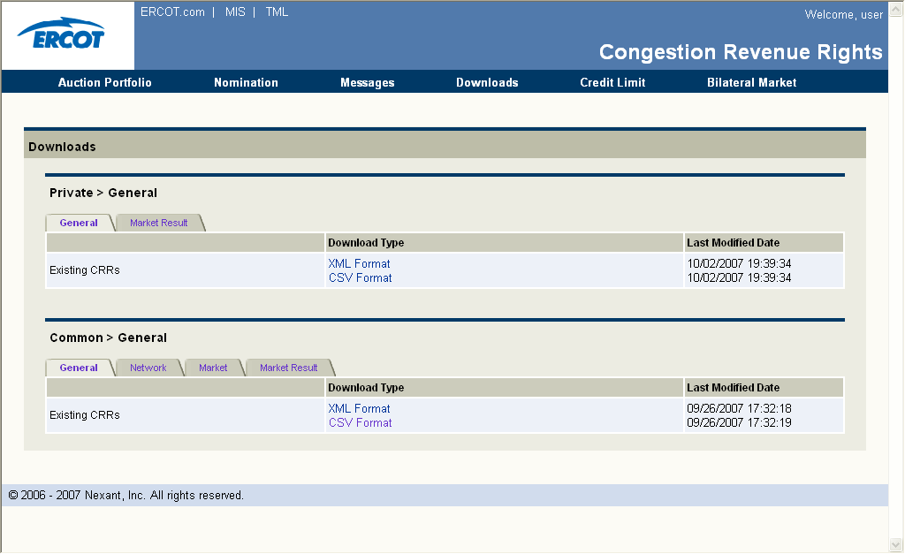
Figure 6.2: Downloads Manager Page
- Under common (common information and data available to all ERCOT CRR market account holders)
  - General – Existing CRRs Tab – All valid existing CRRs
  - Network Tab – Network related Data
    - Network Model
    - Contingencies
    - Monitored Lines & Transformers
    - Non-thermal Constraints
    - Flowgates
  - Market Tab
    - Source & Sinks
    - Base loading CRRs
  - Market Results – All Results for Allocations and Auctions
Please note that some of these data files become available prior to running allocation and auction markets, and some become available after as outlined in the nodal protocols and updated in the ERCOT CRR Market Business Process Manual.

Data Fields
Data fields in all tabs are the same and are as the following
- Name of the file – Name of the downloadable file
- Download Type –XML and CSV format. Hyperlinks to download the files
- Last Modified Date – Day and time when the file was posted

Private General Tab
The functionalities of the private General tab are shown in Figure 6.3.
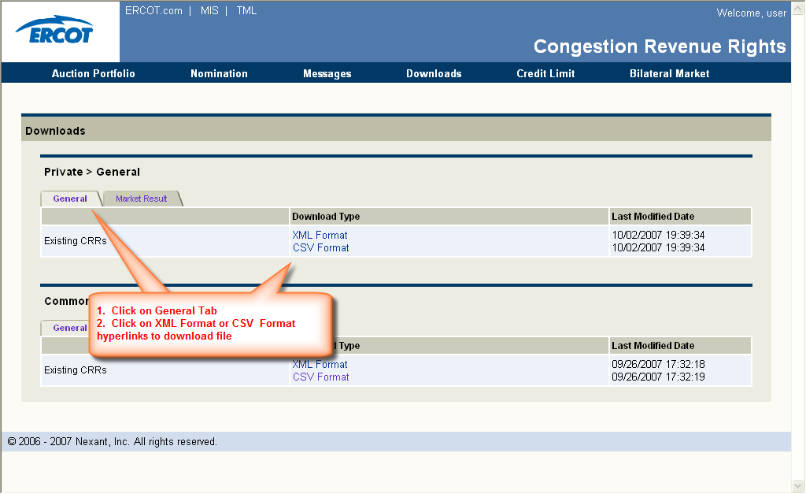
Figure 6.3: Private General Tab Functionalities

Functionality
The account holder would use this tab to:
- Download all currently available and valid CRRs owned by the account holder (click on the XML Format or CSV Format link under Download Type). This is the field where the user can click to download the file (default display). This download will be available once a market is run, and will be kept current after that. Please check the ERCOT CRR Market Business Process Manual for further details.
- Navigate to other tabs (for other downloads – click on the desired tab)
Following is a summary of all the data fields in the downloadable file:
- Existing CRRs – A list of valid current CRRs for that particular user with relevant information such as CRR ID, Segment ID, Account Holder, Category, Hedge Type, CRR Type, Source Name, Sink Name, Flowgate Name, Start Date, End Date, Time-of-use, MW
Sample files in CSV and XML formats are shown in Figure 6.4.a and 6.4.b.
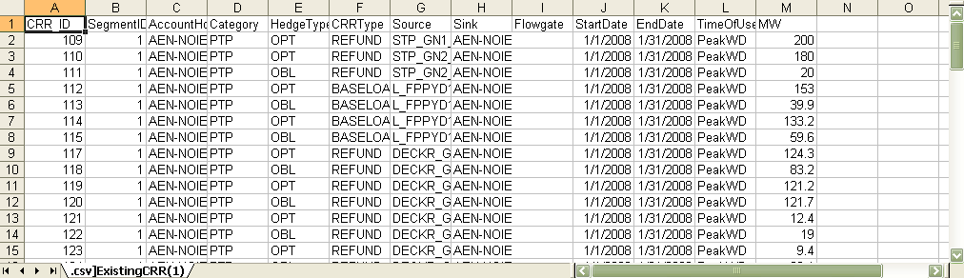
Figure 6.4.a: Sample Private Existing CRRs File in CSV Format
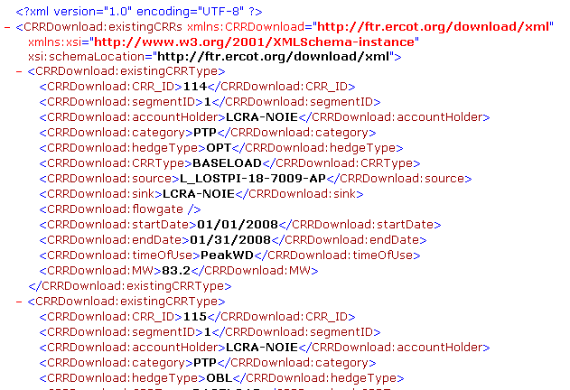
Figure 6.4.b: Sample Private Existing CRRs File in XML Forma

Private Market Results Tab
The functionalities of the private Market Results tab are shown in Figure 6.5.

Functionality
The account holder would use this tab to:
- Download the CRR results that are confidential to that particular market participant (click on the XML or CSV Format link under Download Type) that corresponds to user’s selection on
  - either auction or allocation by selecting Auction or Allocation from the Market Type drop down menu
  - either monthly or annual by selecting the Monthly or Annual from the Market Term drop down menu
  - A particular available auction or allocation market by using the Market pull-down menu
This download will be available once a market is run, and will be updated after each market results are posted. Please check the ERCOT CRR Market Business Process Manual for further details.
- Navigate to other tabs (for other downloads – click on the desired tab)
Following is a summary of all the data fields in the downloadable file:
- CRR Results – Corresponding list of CRR results for that particular market and the account holder, including Nomination/Bid ID, CRR ID, Account Holder, Category, Hedge Type, CRR Type, Source Name, Sink Name, Flowgate Name, Start Date, End Date, Time-of-Use, Nominated/ Bid Amount, Allocated/Awarded MW Amount, Allocation eligibility MW Amount (only for allocations), Clearing Price, Price Factor/Bid Price
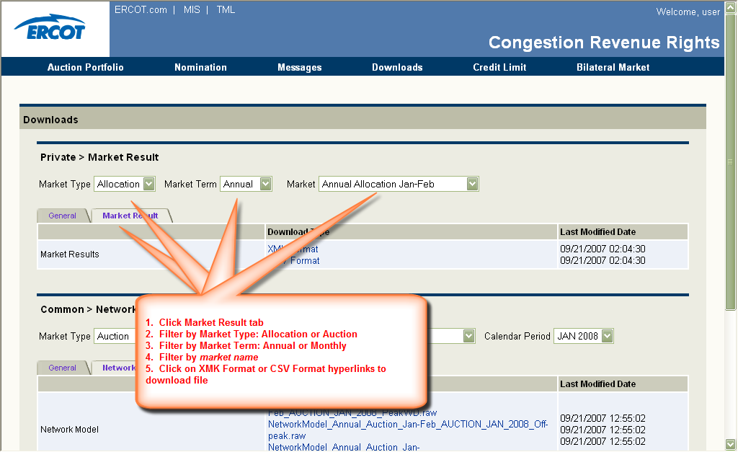
Figure 6.5: Private Market Results Tab Functionalities
Sample files in CSV and XML formats are shown in Figure 6.6.a and 6.6.b.
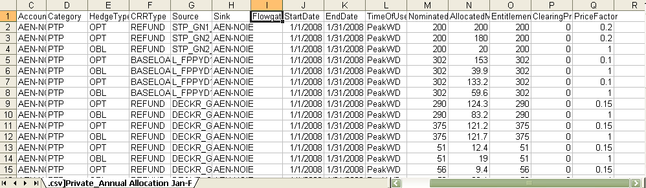
Figure 6.6.a: Sample Private Market Results File in CSV Format
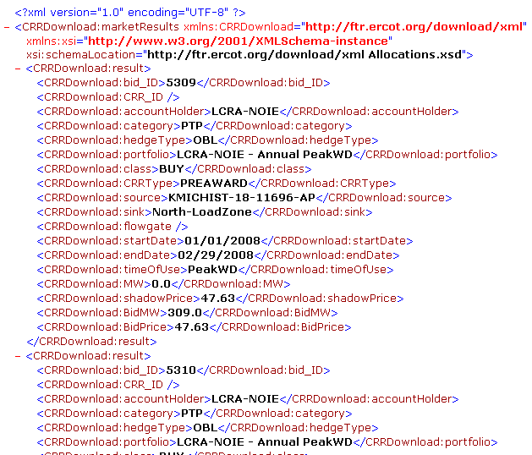
Figure 6.6.b: Sample Private Market Results File in XML Format

Common General Tab
The functionalities of the common General tab are shown in Figure 6.7.

Functionality
The account holders would use this tab to:
- Download all valid existing CRRs for all market participants (click on the XML or CSV Format link under Download Type). This download will be available once a market is run, and will be kept current after that. Please check the ERCOT CRR Market Business Process Manual for further details.
- Navigate to other tabs (for other downloads – click on the desired tab)
Following is a summary of all the data fields in the downloadable file:
- Existing CRRs – A list of valid current CRRs for that particular user with relevant information such as CRR ID, Segment ID, Account Holder, Category, Hedge Type, CRR Type, Source Name, Sink Name, Flowgate Name, Start Date, End Date, Time-of-use, MW
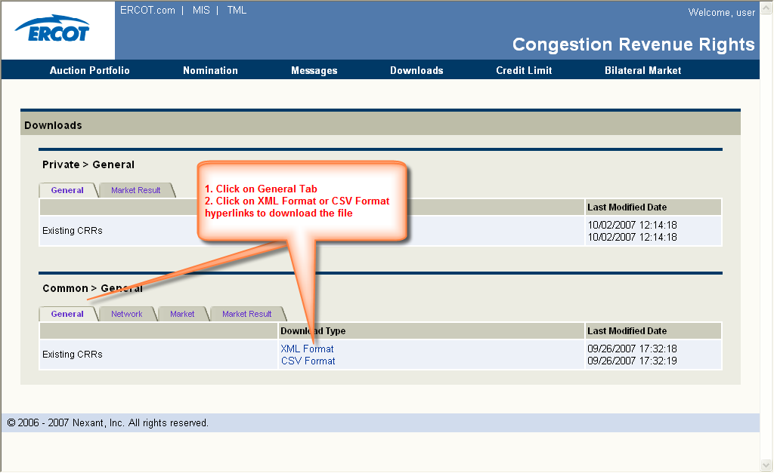
Figure 6.7: Common General Tab Functionalities
Sample files in CSV and XML formats are shown in Figure 6.8.a and 6.8.b..
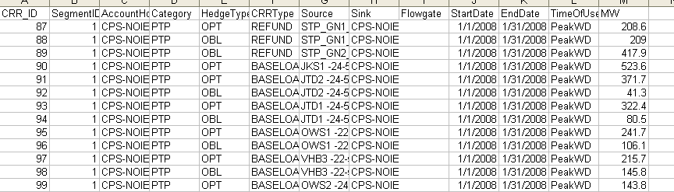
Figure 6.8.a: Sample Existing CRR Results File in CSV Format
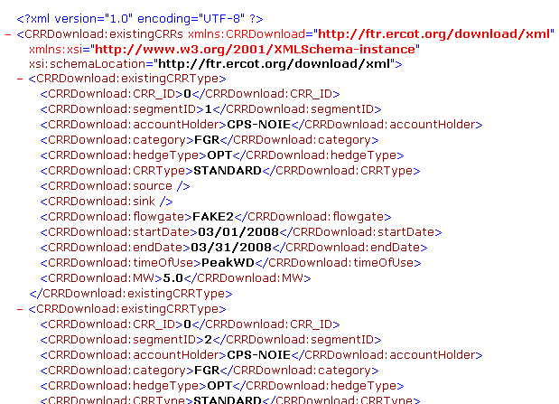
Figure 6.8.b: Sample Existing CRR Results File in XML Format

Common Network Tab
The common Network tab shown in Figure 6.9 is used to download and view all network related data for a particular market.
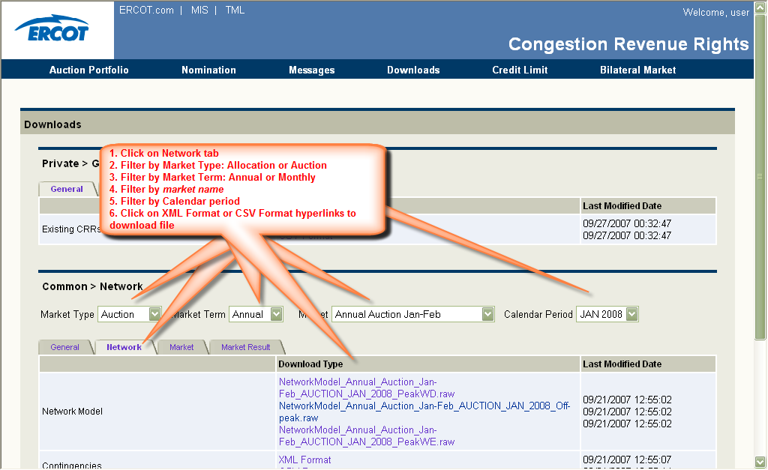
Figure 6.9: Common Network Tab Functionalities

Functionality
Account holders use this tab to:
- By selecting the desired market by using the following filters
  - either auction or allocation by selecting either Auction or Allocation from the Market Type drop down menu
  - A market term (Annually or Monthly) by selecting from the Market Term drop down menu
  - A market (e.g., Long-term Auction) by selecting from the Market drop down menu
  - A calendar period by selecting from the Calendar Period drop down menu
These downloads will be available prior to a market run for account holders’ information. Please check the ERCOT CRR Market Business Process Manual for further details.
- Download the Network Model data file (click on the .RAW Format link under Download Type) that corresponds to user’s selection on
- Download the corresponding Contingencies data file (click on the XML or CSV Format link under Download Type)
- Download the Monitored Line Transformers data file (click on the XML or CSV Format link under Download Type)
- Download the Non-thermal Constraint data file (click on the XML or CSV Format link under Download Type)
- Download the Flowgates data file (click on the XML or CSV Format link under Download Type)
- Navigate to other tabs (for other downloads – click on the desired tab)
Following is a summary of all the data fields in each downloadable file:
- Network Model – Corresponding network data in the PSS/E, version 30, raw data file format. The data contained in this file is augmented with an ERCOT supplied Device Name that is included in comment form at the end of each PSS/E data record.
The beginning of a sample network file is shown in Figure 6.10.
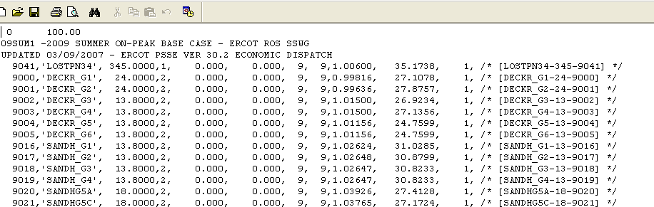
Figure 6.10: Sample Network File
- Contingencies – Corresponding list of contingencies that includes Contingency Name, Device Name, Device Type, Contingency Type (inage, outage).
Sample files in CSV and XML formats are shown in Figure 6.11.a and 6.11.b.
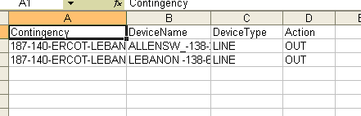
Figure 6.11.a: Sample Contingencies File in CSV Format
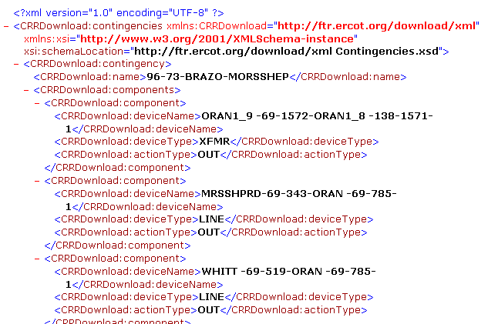
Figure 6.11.b: Sample Contingencies File in XML Format
- Monitored Lines and transformers -- Corresponding list of lines and transformers that includes Device Name, Device Type, Basecase Rating, Emergency Rating and Time-of-Use. Note that this list would include the ratings of lines and transformers that would overwrite the ratings in the PSS/E raw file.
Sample files in CSV and XML formats are shown in Figure 6.12.a and 6.12.b.
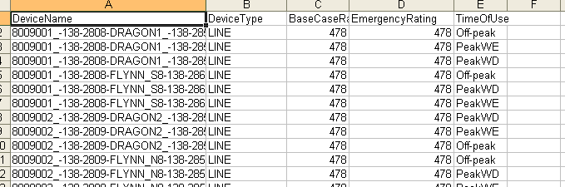
Figure 6.12.a: Sample Monitored Lines and Transformers File in CSV Format
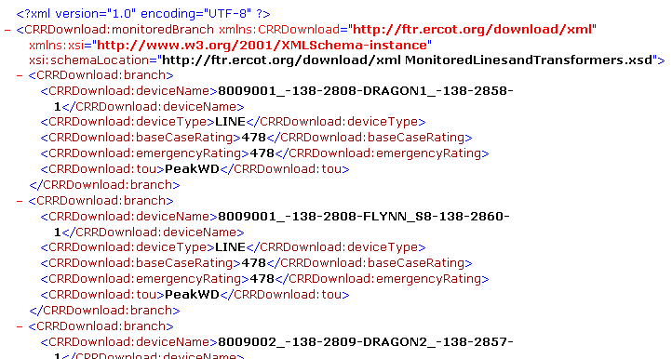
Figure 6.12.b: Sample Monitored Lines and Transformers File in XML Format
- Non Thermal Constraints – Corresponding list of interfaces that include Non-thermal Constraint Name, Limit, Device Name, Device Type, Flow Direction, Factor
Sample files in CSV and XML formats are shown in Figure 6.13.a and 6.13.b.
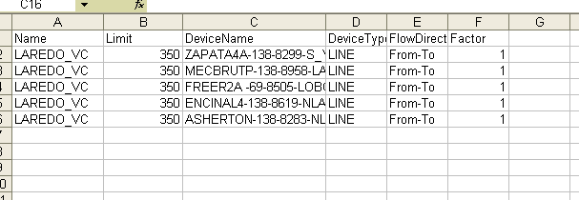
Figure 6.13.a: Sample Non-thermal File in CSV Format
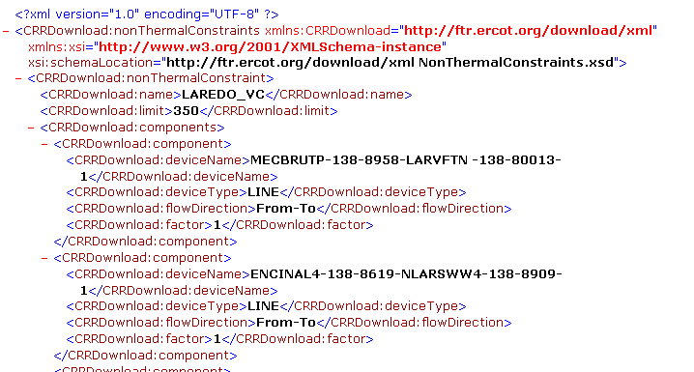
Figure 6.13.b: Sample Non-thermal File in XML Format
- Flowgates – Corresponding list of flowgates that include the Flowgate Name, Limit, Device Name, Device Type and Flow Direction
Sample files in CSV and XML formats are shown in Figure 6.14.a and 6.14.b.
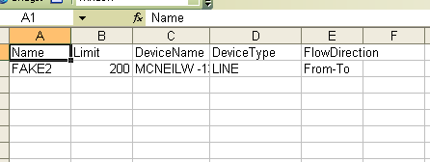
Figure 6.14.a: Sample Flowgates File in CSV Format
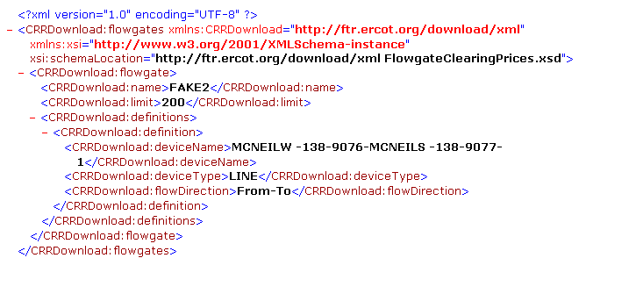
Figure 6.14.b: Sample Flowgates File in XML Format

Common Market Tab
The Market tab on Downloads page takes the user to the page shown in Figure 6.15.
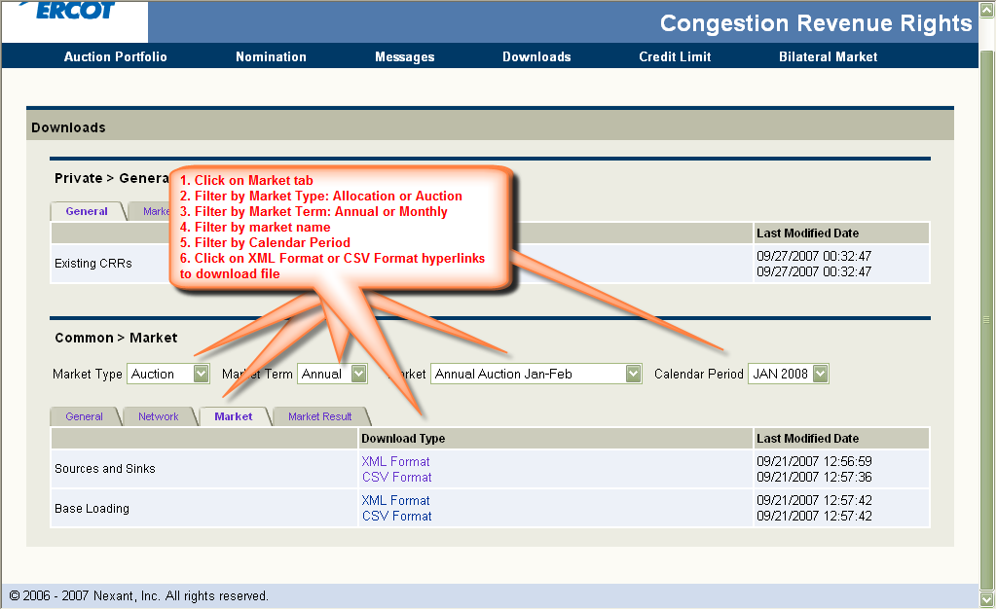
Figure 6.15: Sample Common Market Tab

Functionality
The account holders would use this tab to:
- By selecting the desired market by using the following filters
  - either auction or allocation by selecting either Auction or Allocation from the Market Type drop down menu
  - A market term (Annually or Monthly) by selecting from the Market Term drop down menu
  - A market (e.g., Long-term Auction) by selecting from the Market drop down menu
  - A calendar period by selecting from the Calendar Period drop down menu
These downloads will be available prior to a market run for account holders’ information. Please check the ERCOT CRR Market Business Process Manual for further details.
- Download the Source/Sink file (click on the XML or CSV Format link under Download Type) that corresponds to user’s selection on
- Download the corresponding Base Loading data file (click on the XML or CSV Format link under Download Type)
- Navigate to other tabs (for other downloads – click on the desired tab)
Following is a summary of all the data fields in each downloadable file:
- Source Sink Data – Corresponding list of sources and sinks that includes Source or Sink Name, Price Node Name, Bus Name and participation factor, Time-of-use
Sample files in CSV and XML formats are shown in Figure 6.16.a and 6.16.b.
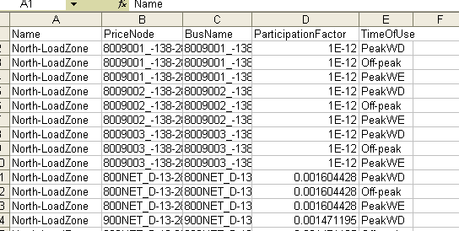
Figure 6.16.a: Sample Source/Sink File in CSV Format
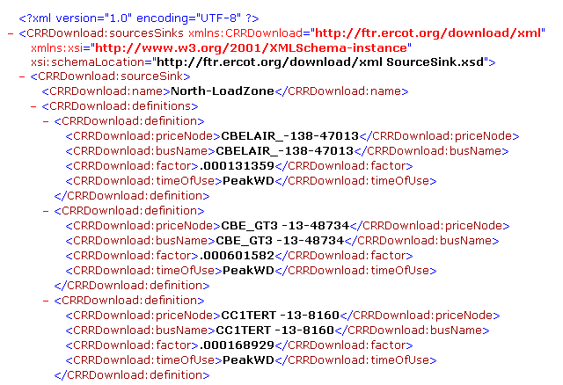
Figure 6.16.b: Sample Source/Sink File in XML Format
- Base Loading CRRs – Corresponding list of existing CRRs that form the base loading for a particular market, including CRR ID, Category, Account Holder’ Name, Source Name, Sink Name, Start Date, End Date, Flowgate Name, Hedge Type (Option or Obligation), Time-of-use, MW amount
Sample files in CSV and XML formats are shown in Figure 6.17.a and 6.17.b.
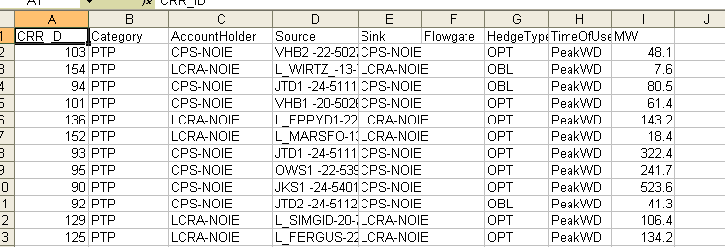
Figure 6.17.a: Sample Base Loading CRRs File in CSV Format

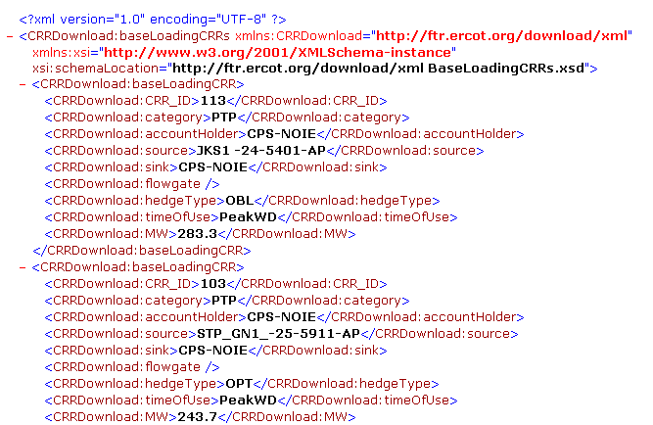Figure 6.17.b: Sample Base Loading CRRs File in XML Format

Common Market Result Tab
The common Market Result tab has the functionalities shown in Figure 6.18.

Functionality
The account holders would use this tab to:
- By selecting the desired market by using the following filters
  - either auction or allocation by selecting either Auction or Allocation from the Market Type drop down menu
  - A market term (Annually or Monthly) by selecting from the Market Term drop down menu
  - A market (e.g., Long-term Auction) by selecting from the Market drop down menu
These downloads will be available after a market is run for account holders’ information. Please check the ERCOT CRR Market Business Process Manual for further details.
- Download the corresponding Market Results data file (click on the XML or CSV format link under Download Type)
- Download the corresponding Flowgate Shadow Prices data file (click on the XML or CSV Format link under Download Type)
- Download the corresponding Source/Sink Shadow prices data file (click on the XML or CSV Format link under Download Type)
- Download the Auction Bids/Offers results data file (click on either the XML or the CSV Format link under Download Type) that corresponds to user’s selection on
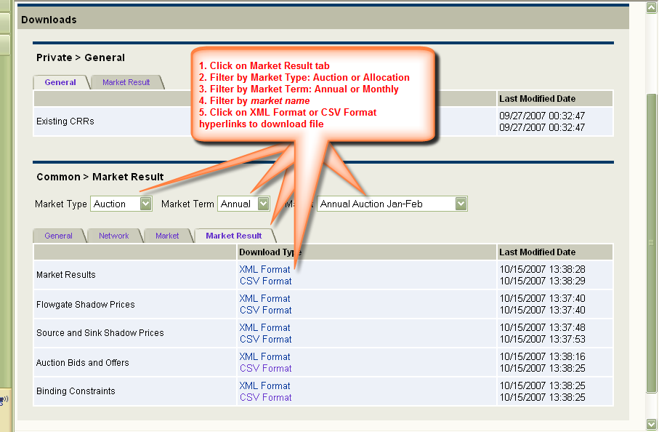
Figure 6.18: Common Market Results Tab Functionalities
- Download the corresponding Binding Constraints data file (click on the XML or CSV Format link under Download Type)
- Navigate to other tabs (for other downloads – click on the desired tab)
Following is a summary of all the data fields in each of the downloadable files:
- Market Results – Corresponding list of CRR results for that particular market and the account holder, including CRR ID, Account Holder, Category, Hedge Type, Class, Source Name, Sink Name, Flowgate Name, Start Date, End Date, Time-of-Use, MW Amount, Clearing Price
Sample files in CSV and XML formats are shown in Figure 6.19.a and 6.19.b.
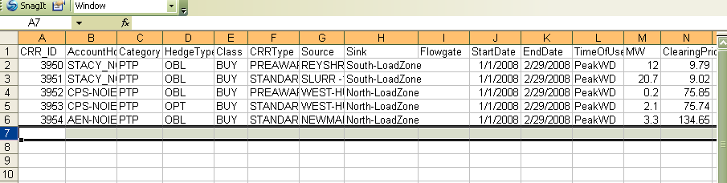
Figure 6.19.a: Sample Market Results File in CSV Format
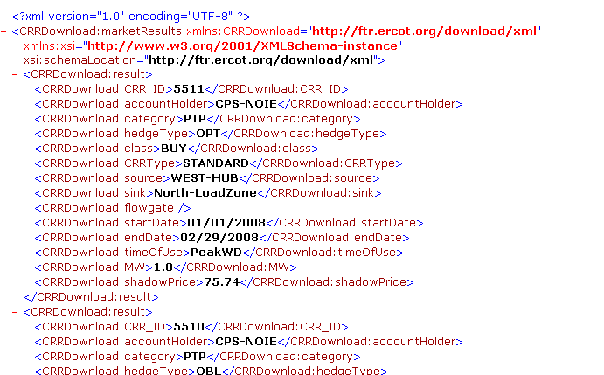
Figure 6.19.b: Sample Market Results File in XML Format
- Flowgate Shadow Prices (only for auction) – Corresponding list of flowgate clearing prices that include Flowgate Name, Calendar Period, Time-of-use, Clearing Price
Sample files in CSV and XML formats are shown in Figure 6.20.a and 6.20.b.
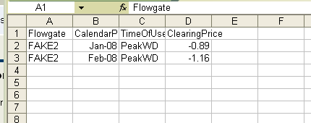
Figure 6.20.a: Sample Flowgate Shadow Prices File in CSV Format
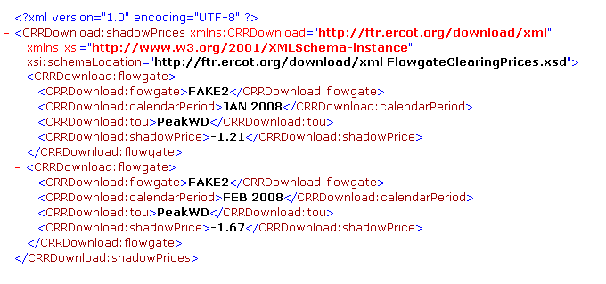
Figure 6.20.b: Sample Flowgate Shadow Prices File in XML Format
- Source/Sink Shadow Prices (only for auction) – Corresponding list of source/sink clearing prices that include Source/Sink Name, Calendar Period, Time-of-use, Clearing Price
Sample files in CSV and XML formats are shown in Figure 6.21.a and 6.21.b.
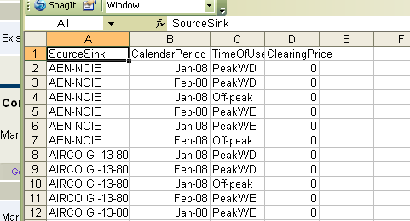
Figure 6.21.a: Sample Source/Sink Shadow Prices File in CSV Format
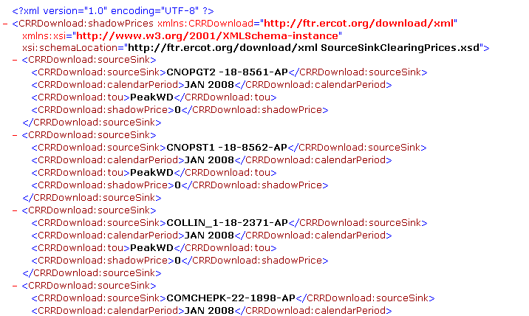
Figure 6.21.b: Sample Source/Sink Shadow Prices File in CSV Format
- Auction Bids/Offers (only for auction) – Corresponding list of CRR bids and offers for that particular market, including Category, Source Name, Sink Name, Flowgate Name, Bid Type, Start Data, End Date, Hedge Type, Time-of-Use, MW amount of bid, Bid Price
Sample files in CSV and XML formats are shown in Figure 6.22.a and 6.22.b.
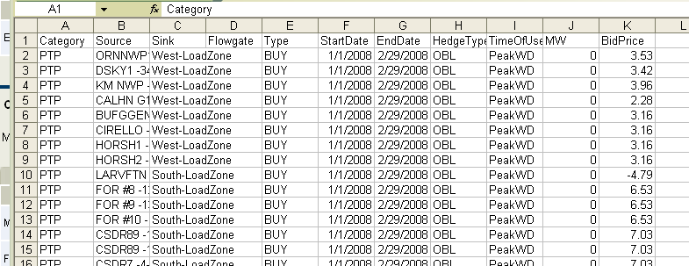
Figure 6.22.a: Sample Auction Bids/Offers File in CSV Format
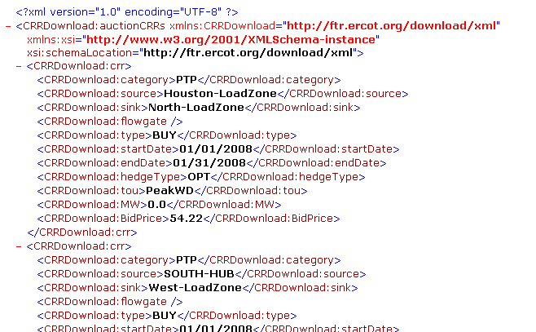
Figure 6.22.b: Sample Auction Bids/Offers File in XML Format
- Binding Constraints – Corresponding list of binding constraints that include Device Name, Device Type, Direction, Limit, Description, Contingency Case Name, Calendar Period, Time-of-use, Shadow price
Sample files in CSV and XML formats are shown in Figure 6.23.a and 6.23.b.
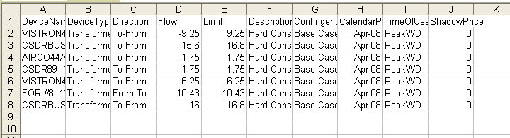
Figure 6.23.a: Sample Binding Constraints File in CSV Format
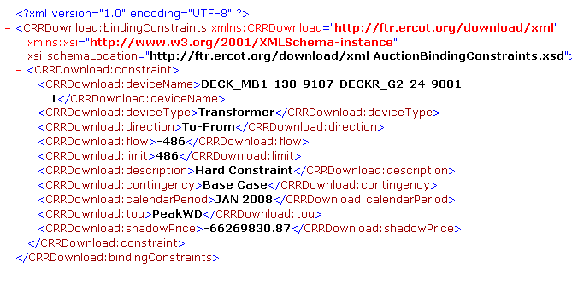
Figure 6.23.b: Sample Binding Constraints File in CSV Format

Credit Limit Manager
As a part of the auction process, account holders will have to specify a credit limit for each auction market. This chapter explains the functionalities available to manage the Account Holder’s credit limit editor page.
The Credit Limit link takes the user to Account Holder Available Credit Limit Editor page shown in Figure 7.1.
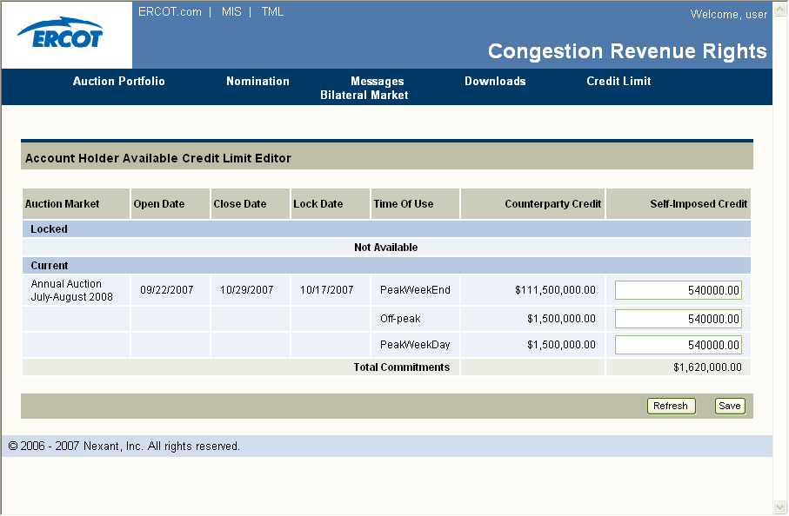
Figure 7.1: Credit Limit Editor Page

Functionality
The user would use this page to:
- Set or update credit limits for current auctions
- View the credits assigned to each market by their counter-parties
- Refresh display (click on Refresh tab)
- Save changes in credit limit (click on Save tab)
These functionalities are shown in Figure 7.2.
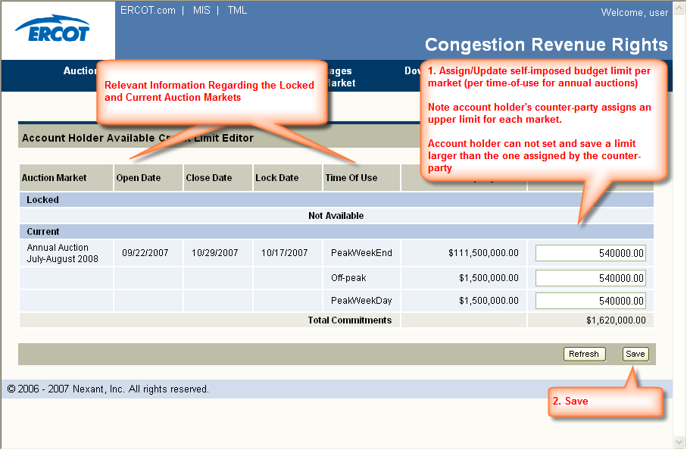
Figure 7.2: Credit Limit Editor Page Functionalities

Credit Limit Editor Data Fields
The Credit Limit Editor has the following data fields for Locked and Current markets:
- Auction Market – Name of the market
- Open Date – The date when the submission period opens for the market
- Close Date – The date when the submission period closes for the market
- Lock Date – The date after which an account holder can not modify one’s credit limits
- Time-of-use – Time-of-use for a particular market
- Counter-Party Credit Limit – The credit limit assigned by the account holder’s Counter-Party. The account holder can not enter a credit limit greater than this limit
- Self-imposed Credit Limit – The credit limit that he account holder assigned to a particular market

Usage
The credit limit is also known as the self-imposed budget constraint. The credit limit editor allows the account holder to set a limit to the amount of portion of the available CRR credit limit the account holder wants to allocate to a certain specific auction market.
Note that the credit limits set by the account holder using this manager applies to auction markets only.
There are three credit limits to be assigned for annual auctions one per each of time-of-use, since the multi calendar period, i.e., 12 months, auctions for the annual term are run separately. On the other hand, there is only one credit limit for the monthly auctions.
The Total Commitment field is calculated as the sum of the locked markets plus the current markets for the self-imposed values.
Figure 7.3 demonstrates all the dates that are related to an auction market.
Notice Date
Open Date
Close Date
Lock Date
Market is current: credit is editable for market
Market
is fully posted
End of grace period
Market is locked: credit is locked for market
Figure 6.5: Credit Limit Editor Page
Notice Date is when (download) data relevant to a particular becomes available. In other words, it represent the day when an auction market becomes visible to the ERCOT CRR market participants. Open and Close Dates represent the beginning and the end of the portfolio submission period. Lock date can be set between the open and close dates of a submission period, and represents the cut-off date after when the account holders (and their counter-parties) can not change their CRR credit limits. A market is considered “current” from its notice date until the lock date, with the understanding that multiple markets (e.g. Fall 2009 and Winter 2010) may be in the “current” state at the same time. A market is considered “locked” from its lock date until the end of the grace period. The grace period is calculated as “n” days after the Settlement date of the auction. All these dates are set by the ERCOT CRR market operators. More detail can be found on these in the ERCOT CRR Market Business Procedure Manual.
Finally, if a Counter-Party fails to set the budget constraint(s) for an auction market, that translates to none of that Counter-Party’s associated CRR account holders being able to participate in that particular market. If, on the other hand, an account holder does not enter a value for a given market, the only credit constraint they will be bound by would be the limit assigned by their Counter-Party.
For example, if Counter-Party, CP1, has three account holders AH1, AH2, and AH3, and CP1 does not assign a credit limit for an auction market, MKT1, then, AH1, AH2 and AH3 have all of their self-imposed budgets set to zero, and they can not participate in MKT1.
On the other hand, if CP1 has allocated $10M to MKT1, then the AHs can set their own limits up-to $10M. Assuming AH1 has set a self-imposed limit of $5M, AH2 of $2M for MKT1, and AH3 hasn’t set an SI limit, then self-imposed limits of $5M for AH1, $2M for AH2 of and $10M for AH3 are sent to the optimization process for MKT1.

Bilateral Market

Introduction
The ERCOT CRR bilateral market is a bilateral trading system that facilitates the registration of trading of existing CRRs between Account Holders using a bulletin board system, which is resident in the ERCOT CRR system. For CRR registration of trades made through the bulletin board, ERCOT automatically transfers ownership and adjusts each market participant’s settlement statements accordingly, provided that the credit check for the transfer is cleared and the transaction is approved by ERCOT.
The Bilateral Market allows registration of trading of existing CRRs only. A CRR as originally defined or a portion of the CRR can be traded, as long as the total MW amount of the CRR as well as the original CRR time spans are maintained. With these restrictions, trading in the bilateral market has no impact on the simultaneous feasibility of the existing outstanding CRRs and no impact on the market-clearing prices in the CRR auctions. In particular, there is no need for ERCOT to perform simultaneous feasibility tests for trades in the Bilateral Market.
Please note: when a CRR is traded, the associated firm transmission capability is not reassigned, just the financial allocation eligibilities. The Bilateral Market is a market system designed to facilitate the registration of trading of CRRs by Account Holders. It operates on a “classified advertisement” principle, where CRR buy bids and sell offers are posted for other Account Holders to peruse. Upon viewing a posting that interests a market participant, the market participant communicates with the entity that posted the item and negotiates the terms of the CRR sale. The money is exchanged outside the purview of the CRR System and only the transfer of ownership of the CRR is conducted through the CRR System.
The following steps are required to register a trade of CRR in the Bilateral Market:
- An account holder posts a buy bid or sell offer.
- Another Account Holder accepts this posting and confirms the trade.

Bilateral Market Action and Events Flow
Figure 8.1 shows the general flow of events/actions related to a sample ERCOT Bilateral Market transaction.
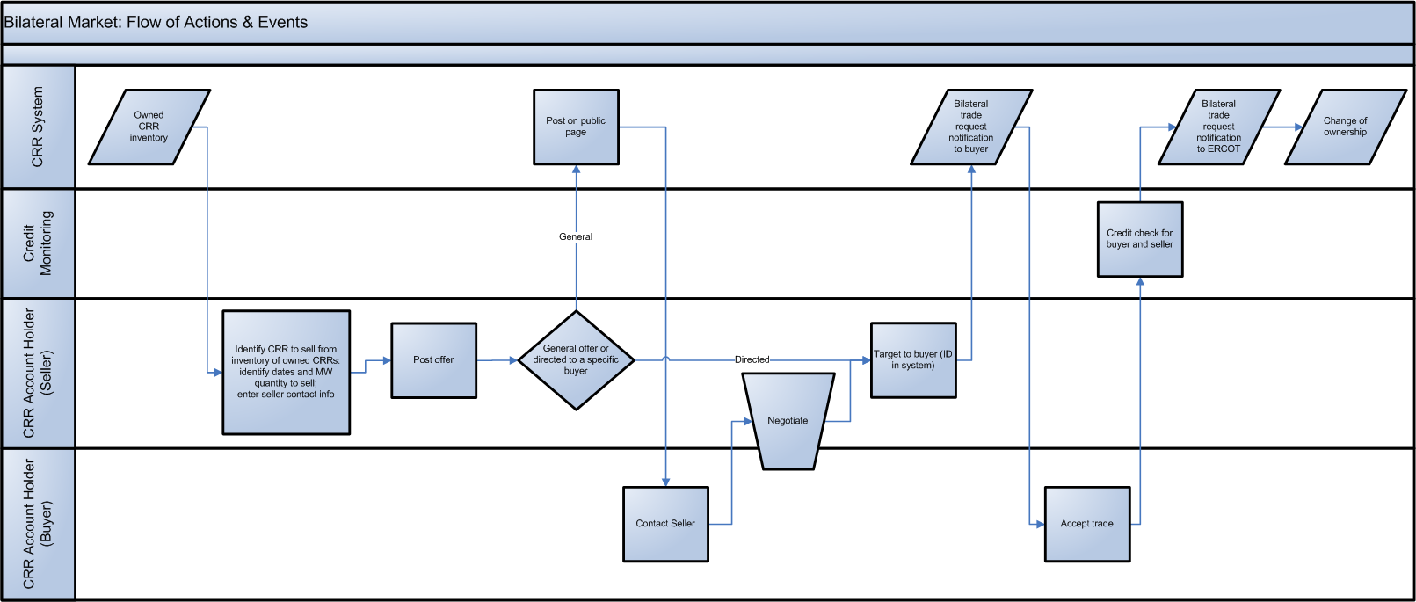
Figure 8.1: Bilateral Market Actions & Events Flow

Bilateral Market Manager
The Bilateral Market manager link takes the user to Bilateral Market page shown in Figure 8.2.
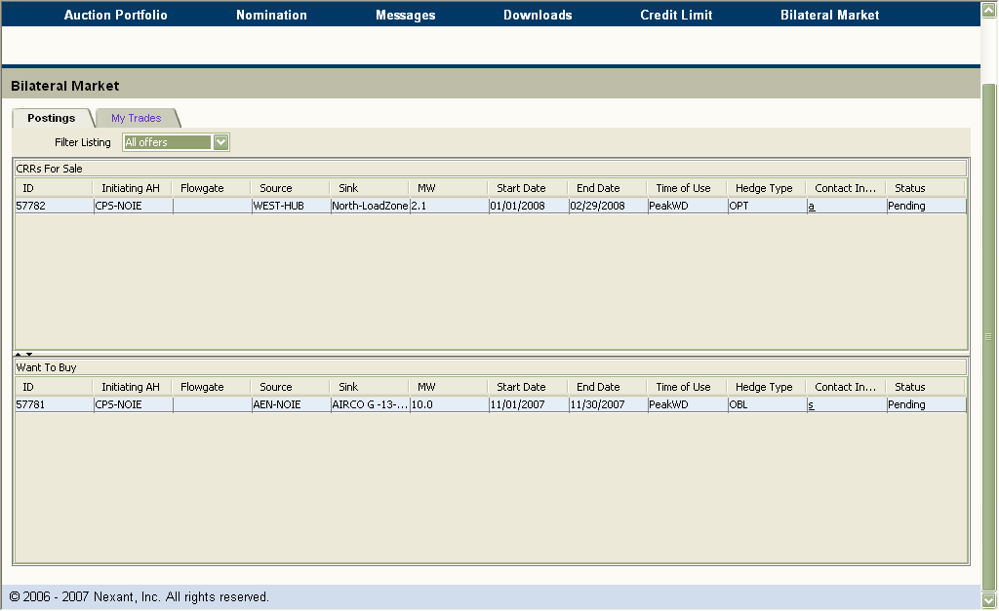
Figure 8.2: Bilateral Market Page

Functionality
The user would use this page to:
- View existing CRR sell offers and buy bids (default display)
- Filter the existing offers (by using the drop-down menu). The filter options are: All Offers, My Offers and Exclude My Offers.
- Navigate to My Trades page (click on My Trades tab)
These functionalities are shown in Figure 8.3.
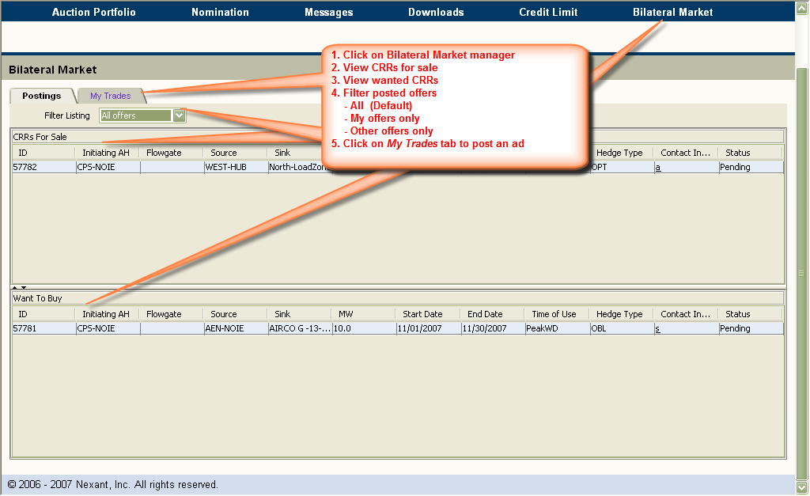
Figure 8.3: Bilateral Market Postings Tab Functionalities

Data Fields
The Postings tab for the bilateral market shown in Figures 8.2 and 8.3 contain two panes: an upper pane and a lower pane.
The upper pane, CRR Offers for Sale, lists the CRRs currently listed for sale with the following data fields:
- ID – the unique id of the transaction for the sell of the CRR.
- Initiating AH – The name of the selling Account Holder
- Flowgate – the name of the flowgate for the posted Flowgate sell offer
- Source – The name of the source for the posted CRR sell offer
- Sink – The name of the sink for the posted CRR sell offer
- MW – The MW amount of the sell offer.
- Start Date – The effective starting date of the posted CRR for sell
- End Date – The effective expiration date of the posted CRR for sell
- Time of Use – Peak Weekday (PeakWD), Off-peak (Off-peak), Peak Weekend (PeakWE) etc. for the posted CRR for sell
- Hedge Type – Option (OPT) or obligation (OBL) type of the posted CRR for sell
- Contact Information – Hyperlinks to the name, address, phone number, email address of the designated person regarding this transaction for the sale of the CRR. It is assumed that this person is authorized to conduct this transaction on behalf of the initiating Account Holder.
- Status – Status such as Posted, Closed, Pending, etc.
The lower pane, Want to Buy, lists the CRRs the Account Holders currently wishes to buy with the following data fields:
- ID – the unique id of the transaction for the buying of the CRR.
- Initiating AH – The name of the initiating Account Holder who wants to buy the CRR
- Flowgate – The name of the flowgate for the posted Flowgate bid to Buy
- Source – The name of the source for the posted CRR buy bid
- Sink – The name of the sink for the posted CRR buy bid
- MW – The MW amount of the CRR buy bid.
- Start Date – The effective starting date of the posted CRR for buying
- End Date – The effective expiration date of the posted CRR for buying
- Time of Use – Peak Weekday (PeakWD), Off-peak (Off-peak), Peak Weekend (PeakWE) etc. for the posted CRR for buying.
- Hedge Type – Option (OPT) or obligation (OBL) type of the posted CRR for sale
- Contact Information – Hyperlinks to the name, address, phone number, email address of the designated person regarding this transaction for the buying of the CRR. It is assumed that this person is authorized to conduct this transaction on behalf of the initiating Account Holder.
- Status – Status such as Posted, Closed, Pending, etc.

Bilateral Market Manager – My Trades
The My Trades tab from the Bilateral Market page takes the user to My Trades page shown in Figure 8.4.

Functionality
The user would use this page to:
- Post CRR sell offers and buy bids
- Navigate to Postings page (click on Postings tab)

Private CRR page Data Fields
This page is divided into three panes, an upper pane titled “My Offer Listings”, a lower right pane and a lower left pane titled “My Offer Details”. If the AH has any pending buy/sell offers, these would be listed in the pane titled “My Offer Listings”. New buy and sell offers are handled using “My Offer Details” and the lower right panes.
- The upper pane, “My Offer Listings,” has the following data fields:
  - ID – the unique id of the transaction for the buy/sell of the CRR
  - Public/Private designation
  - Initiating AH – The name of the Account Holder who initiates the Buy Bid or Sell Offer.
  - Buy/Sell – Buy/Sell flag indicating whether it is ‘Wants to Buy’ or ‘Wants to Sell’
  - Responding AH – The name of the Account Holder who responds to the Buy Bid or Sell Offer.
  - My Account Holder – The name of the account holder who is associated with the Initiating AH.
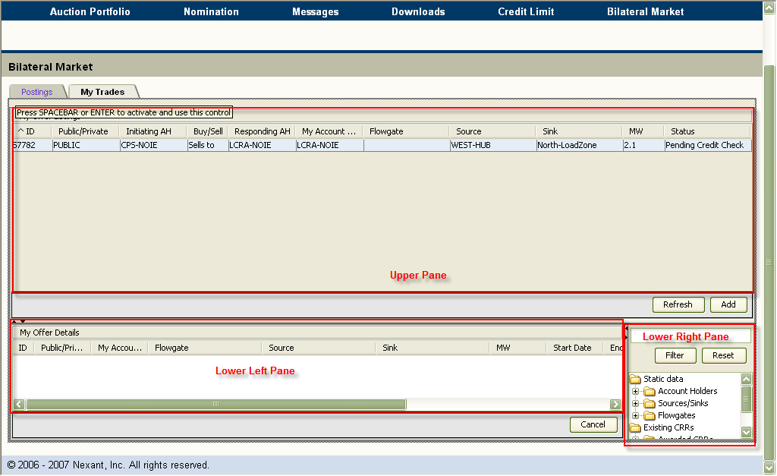
Figure 8.4: Bilateral Market My Trades Tab
  - Flowgate – the name of the Flowgate for the posted CRR transaction.
  - Source – The name of the source for the posted CRR transaction.
  - Sink – The name of the sink for the posted CRR transaction.
  - MW – The MW amount of the CRR transaction.
  - ID – the unique id of the transaction for the buy/sell of the CRR
  - Public/Private designation
  - Initiating AH – The name of the Account Holder who initiates the Buy Bid or Sell Offer.
  - Buy/Sell – Buy/Sell flag indicating whether it is ‘Wants to Buy’ or ‘Wants to Sell’
  - Responding AH – The name of the Account Holder who responds to the Buy Bid or Sell Offer.
  - My Account Holder – The name of the account holder who is associated with the Initiating AH.
  - Flowgate – the name of the Flowgate for the posted CRR transaction.
  - Source – The name of the source for the posted CRR transaction.
  - Sink – The name of the sink for the posted CRR transaction.
  - MW – The MW amount of the CRR transaction.
  - Status – Information regarding the status of the offer:
    - Posted – Posting of the buy bid/sell offer was successful
    - Accepted – Buy bid/sell offer process has been processed and finalized
    - Waiting for other – An action is requested by the responding party for the process to continue
    - Waiting for own – An action is requested by the initiating (posting) party for the process to continue
The lower left pane, “My Offer Details,” has the following data fields: This also a working window for the record selected in the upper pane.
- ID – the unique id of the transaction for the buy/sell of the CRR
- Public/Private designation – Pull-down menu to select if the add will be private or public
- My Account Holder – Name of the Account Holder who is associated with the initiating AH
- Flowgate – Flowgate Name
- Source – Source Name
- Sink – Sink Name
- MW – MW Amount
- Start Date – Effective start date of the CRR. The user can click this field to bring up the calendar
- End Date – Effective stop date of the CRR. The user can click this field to bring up the calendar
- Time-of-use – Time-of-use for the CRR. The user can select the data from the drop down menu
- Hedge Type - Hedge Type for the CRR. The user can select the data from the drop down menu
- Type – CRR type (STANDARD). The user can select the data from the drop down menu
- Contact Information – Name, Address, Phone Number, and Email of the initiating AH
The following fields are entered into the working window by the market participant to put together the CRR sell offer or buy bid for posting. This is done by using the data provided in the data groups in the lower right pane. The lower right pane has the following data fields:
- Static Data – The following common data
  - Account Holders – A folder containing all valid ERCOT CRR Account Holders names
  - Sources/Sinks – A folder containing the names of the sources and sinks that can be used to construct a CRR buy bid for the Bilateral Market
  - Flowgates – A folder containing the names of the flowgates that can be used to construct a Flowgate buy bid in the Bilateral Market
- Existing CRRs – The following private data for the account holder
  - Awarded CRRs – A folder containing the previously awarded CRRs which may be offered for selling in the Bilateral Market
  - Allocated CRRs – A folder containing the allocated CRRs, which may be offered for selling in the Bilateral Market
  - Bilateral Market CRRs – A folder containing all the CRRs that were obtained from the Bilateral Market, which can be offered for sale

Usage
The three panes shown in Figure 8.4 provide an interactive environment for the market participant to post a sell offer or a buy bid. Please note that “My Offer Details” pane is a working window which is used for both the buy and the sell offers. The data fields selected from the upper right corner and dropped in “My Offer Details” basically defines if the offer will be a buy or a sell. If an existing CRR is selected from the “Existing CRRs” data group in the upper corner and dropped in “My Offer Details”, then the offer is automatically set to “Wants to Sell”. If a source or a sink name is picked up from the “Sources/Sinks” data group, the offer is set to “Wants to Buy”.

Flow of Posting and Fulfilling a Buy Bid Actions
The following steps describe the flow of actions and event that take place during a buy bid ad posting and fulfillment. The steps and actions performed by the initiating AH who posts a buy bid are shown in blue. The actions of the responding AH are shown in red.
- Click the Add button found at the bottom of the “My Offer Listings”
System responds by creating a blank data entry record in the “My Offer Details”
- Specify Public or Private
  - If Public is chosen, all ERCOT CRR Market account holders will be able to see the ad
  - If Private is chosen, only the account holder to which the ad is targeted will be able to see it the ad
- Fill in the Source and Sink fields by dragging the desired ones from the lower right hand pane data structure Sources/Sinks into the appropriate fields of the “My Offer Details” screen and dropping it
  - Note: One can use the filter functionality to look for the desired sources/sinks
    - Type in the desired source/sink name or a part of it
    - Click Filter
    - Click the Source/Sinks folder to open and view the matches for the letter typed in
- Type in desired MW
- Select Start Date and End Date by clicking the data field to get to the pop-up calendars
- Select Time of Use from drop-down menu by clicking the data field, and selecting the Time-of-use
These steps are shown in Figure 8.5.a.
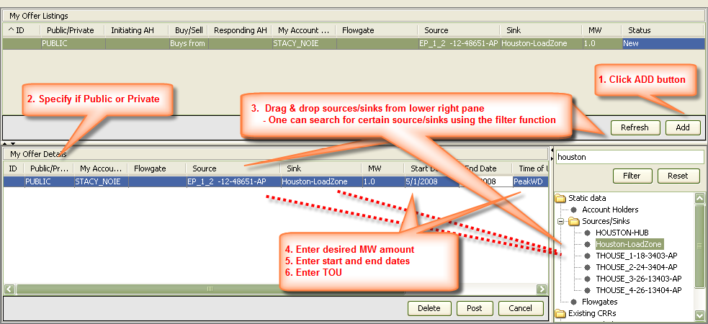
Figure 8.5.a: Posting a Buy Bid
- Select Hedge Type from drop-down menu by clicking the data field, and selecting the Hedge Type
- Select Type from drop-down menu by clicking the data field, and selecting the Type
- To fill in the Contact information, click on “Click to Add” hyperlink
System responds by a pop-up window
  - Enter the relevant contact information, name, address, phone number and e-mail address of the initiating AH.
  - Click Save to save the information, Cancel to close without saving; Add New to add more contacts or Delete to eliminate a contact
Please note that if a row is left empty, the system will not save the contact information
These steps are shown in Figure 8.5.b.
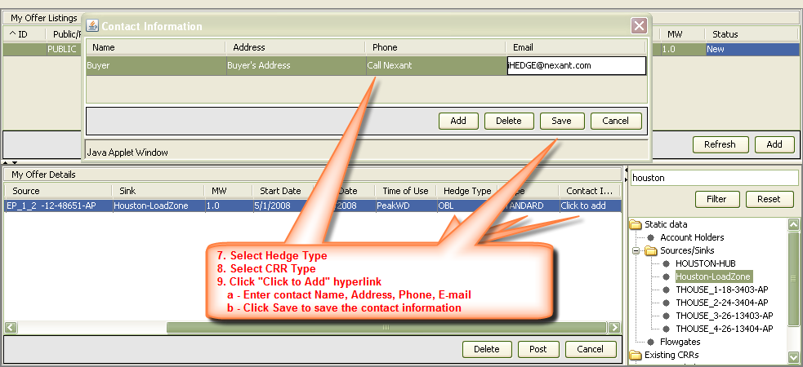
Figure 8.5.b: Posting a Buy Bid
- To post the offer, click on the Post button
System responds by adding the offer to the list shown in “My Offer Listings” pane and changing its status to “Posted”.
  - After the transaction is posted, a Retract tab shows up. At this point, the initiating AH can still back out from this posted transaction by clinking the Retract button
  - To see the updated Postings display, click on Postings tab. The Postings, now, should include the buy bid in the bulleting board
  - Account holders monitor the Bilateral Market, Postings page’s Want to Buy pane
  - A market participant who has a CRR that matches the ad and is interested in selling it will obtain the initiating AH’s contact information from the “Contact Information” field
    - Then negotiates the terms of the transaction
These steps are shown in Figure 8.5.c.
Figure 8.5.c: Posting a Buy Bid
- If the buyer or initiating AH agrees to the sale, the buyer assigns the seller to the CRR offer by performing the following steps:
  - Navigating to one’s My Trades page
  - Selecting the offer from the “My Offer Listings” pane
System responds by presenting the offer details to the “My Offer Details” pane
  - The initiating AH assigns the selling market participant to the offer by dragging and dropping the AH’s name into the “Other Party” field
- Clicking the Accept command button at the bottom right of the “My Offer Details” pane
System responds by changing the status from “Posted” to “Waiting for other party” in the “My Offer Listings” pane
These steps are shown in Figure 8.5.d.
- Selling market participant (Other Party) confirms the CRR purchase by
  - Signing into the system and going to the My Trades display
  - Selecting the CRR posting from “My Offer Listings” the AH wishes to fulfill
  - Selecting the CRR(s) from any of the folders “Awarded CRRs”, “Allocated CRRs” or “Bilateral Market CRRs” required to fulfill the buy bid by using the drag and drop method. Please note that the bid must be dropped on the buy bid box in the “My Offer Details” and the seller needs to match the MW amount that the buyer asked for
- Clicking the Accept command button on the bottom right side of the “My Offer Details” pane
System responds by changing the bid buy status to “Pending Credit Check” if the MW matches exactly the Buy bid. If not, a “Buy Accept Invalid” message will show up indicating that there is insufficient MW from the seller to match the Buy
System will change the status to “Accepted” when it receives the credit check confirmation through i-HEDGE.
These steps are shown in Figure 8.5.e.
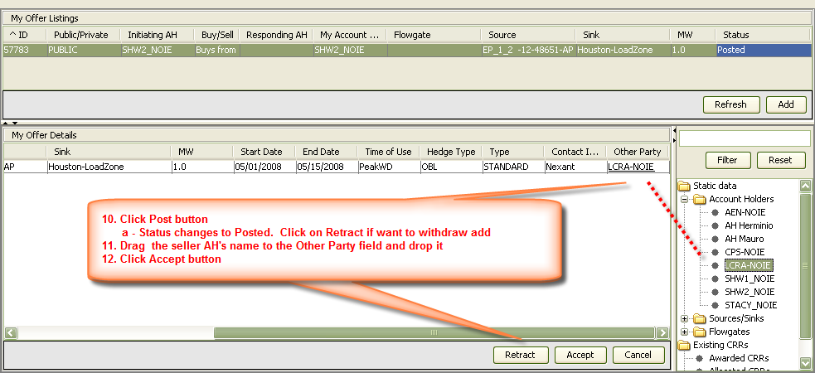
Figure 8.5.d: Posting a Buy Bid

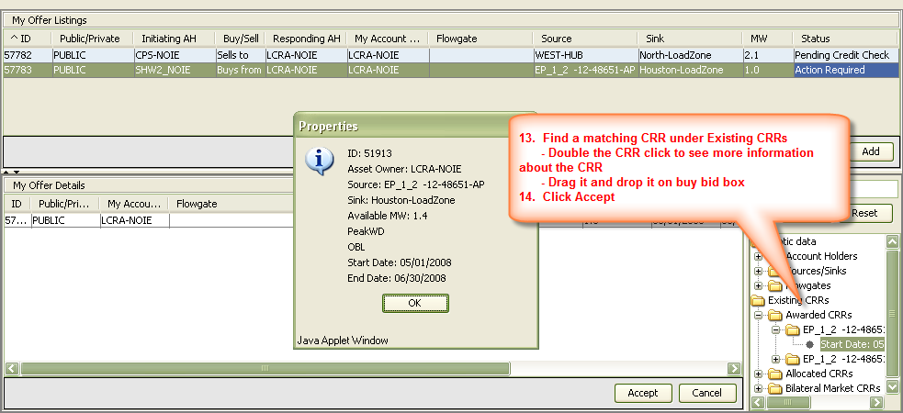
Figure 8.5.e: Responding to a Buy Bid

Flow of Posting and Fulfilling a Sell Offer Actions
The following steps describe the flow of actions and event that take place during a sell offer ad posting and fulfillment. The steps and actions performed by the initiating AH who posts a sell offer are shown in blue. The actions of the responding AH are shown in red.
- Click the Add button found at the bottom of the “My Offer Listings”
System responds by creating a blank data entry area in the “My Offer Details”
- Specify a certain CRR by dragging it from the lower right hand pane under Existing CRRs data structure into the blank record in “My Offer Details”
  - User can pick a CRR from
    - Awarded CRRs
    - Allocated CRRs
    - Bilateral Market CRRs
Please note that the user can get more information by double clicking on the individual CRR entries under these data structures (ID, Account Holder, Source, Sink, Available MW, Time of Use, Hedge Type, Start Date, End Date).
- Modify the offered MW (if desired)
- Modify the Start Date and the End Date by clicking the data field to get to the pop-up calendars (if desired)
- To fill in the Contact information, click on “Click to Add” hyperlink
System responds by a pop-up window
  - Enter the relevant contact information, name, address, phone number and e-mail address of the initiating AH
  - Click Save to save the information, Cancel to close without saving; Add New to add more contacts or Delete to eliminate a contact
Please note that if a row is left empty, the system will not save the contact information
These steps are shown in Figure 8.6.a.
- To post the offer, click on the Post button
System responds by adding the offer to the list shown in “My Offer Listings” pane and changing its status to “Posted”.
  - After the transaction is posted, a Retract button and an Accept button show up. At this point, the initiating AH can still back out from this posted transaction by clinking the Retract button
  - To see the updated Postings display, click on Postings tab. The Postings, now, should include the sell CRR offer in the bulleting board
  - Account Holders monitor the Bilateral Market Postings board
  - The market participant who is interested in purchasing a sell CRR offer obtain the initiating AH’s contact information from the “Contact” field
    - Then negotiates the terms of the sale

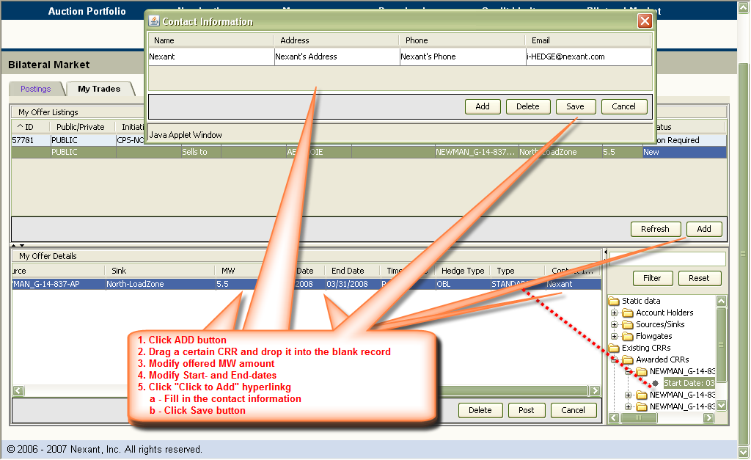
Figure 8.6.a: Posting a Sell Offer
- If the seller (initiating AH) agrees to the sale, the seller assigns the buyer to the CRR bid by
  - Navigating to the My Trades page
  - Selecting the offer from the “My Offer Listings” pane
System responds by presenting the offer details to the “My Offer Details” pane
  - Assigning the buying Account Holder to the offer by dragging and dropping the buying AH’s name into the “Other Party” field
- Click the Accept command button at the bottom right of the “My Offer Details” pane
These steps are shown in Figure 8.6.b.
System responds by changing the status from “Posted” to “Waiting for other party” in the “My Offer Listings” pane.
- The buying market participant (Other Party) confirms the CRR purchase by
  - Signing into the system and going to the My Trades display
  - Selecting the CRR posting from “My Offer Listings” the AH wishes to fulfill
- Clicking the Accept command button on the bottom right side of the “My Offer Details” pane
System responds by changing the bid buy status to “Pending Credit Check”.
System will change the status to “Accepted” when it receives the credit check confirmation through CRR Market Operator.
These steps are shown in Figure 8.6.c.
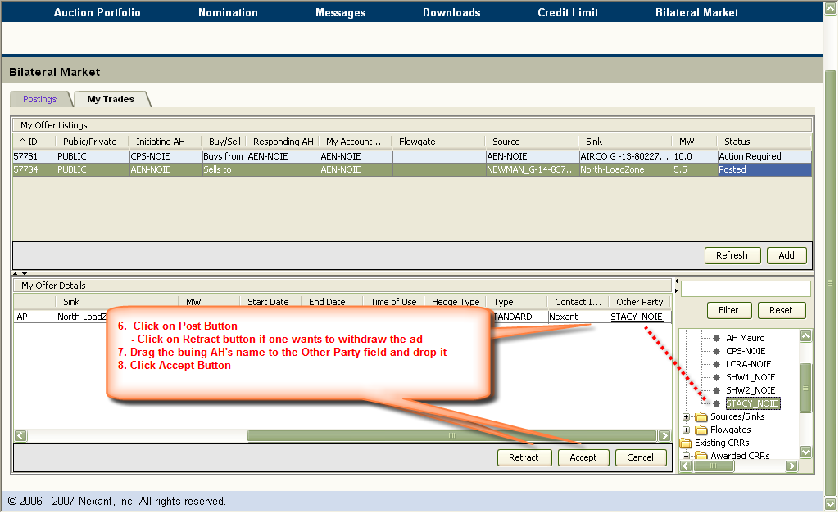
Figure 8.6.b: Posting a Sell Offer
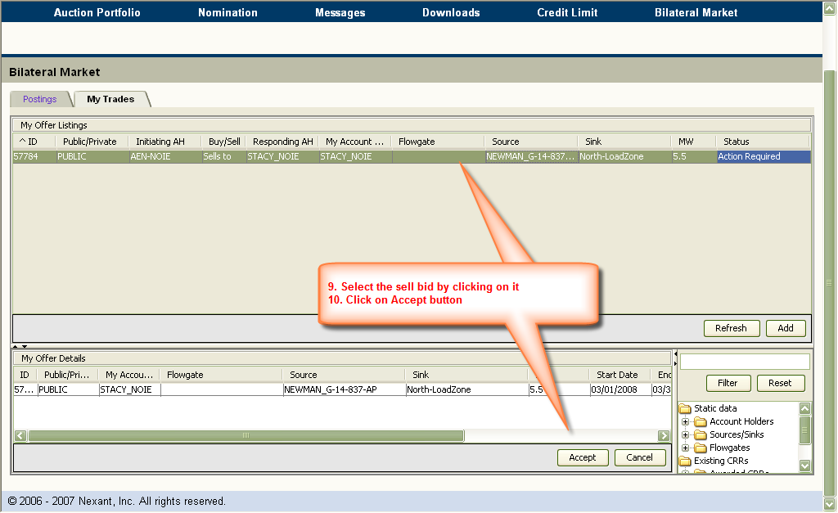
Figure 8.6.c: Responding to a Sell Offer

As shown in Figures 8.7.a and 8.7.b, these transactions will be pending until credit check of the responding AHs approved through i-HEDGE.
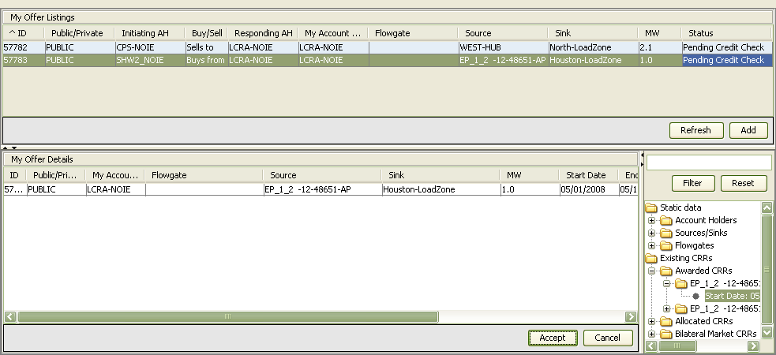
Figure 8.7.a: A Pending Transaction on My Trades Tab
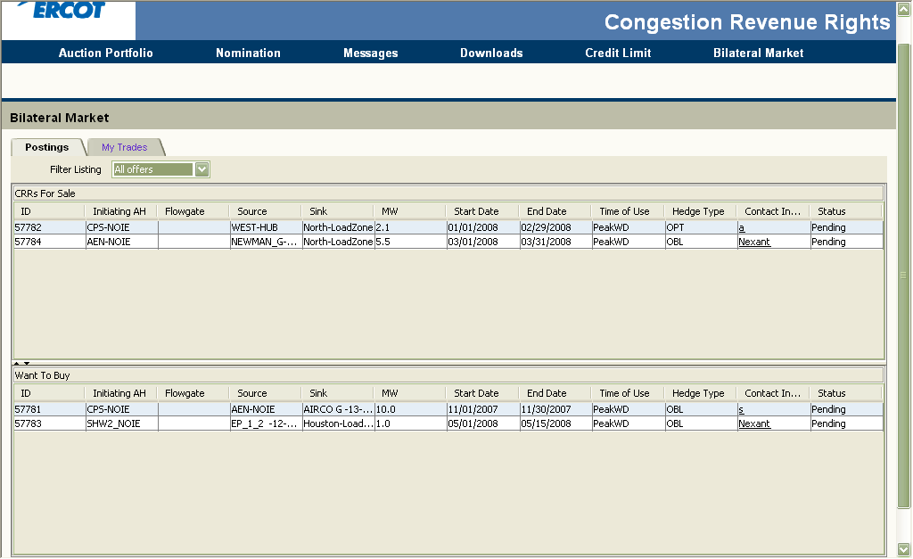
Figure 8.7.b: A Pending Transaction on My Postings Tab

Counter-Party Credit Limit Manager
ERCOT i-HEDGE allows counter-parties to login to the ERCOT CRR System and to specify a credit limit for each auction market for the account holders one Counter-Party represents. This chapter explains the functionalities available to manage the Counter-Party’s credit limit editor page.
The CRR System registration for CRR Market counter-parties will be managed by the ERCOT Registration System. Client side digital certificates will be required to be installed in counter-parties’ browsers. These digital certificates will be generated at the user level and will be used to access all ERCOT market systems that a user has the right to. When a Counter-Party logins to ERCOT i-HEDGE, a single manager, namely the Counter-Party Credit Limit Manager shown in Figure 9.1, will be available to the Counter-Party.
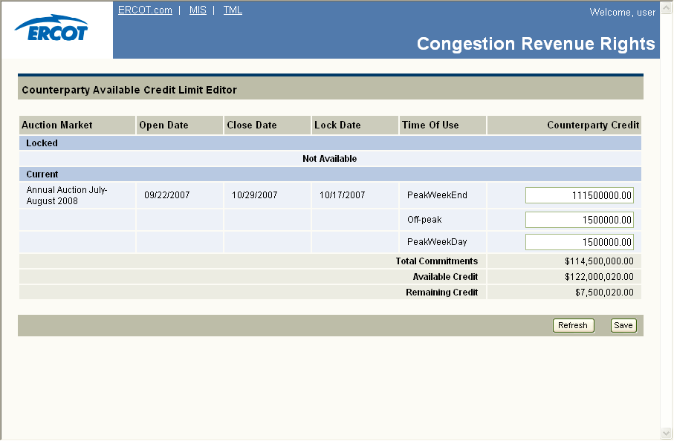
Figure 9.1: Credit Limit Editor Page

Functionality
The user would use this page to:
- Set, view or update credit limits for current auctions
- Refresh display (click on Refresh tab)
- Save changes in credit limit (click on Save tab)
These functionalities are shown in Figure 9.2.
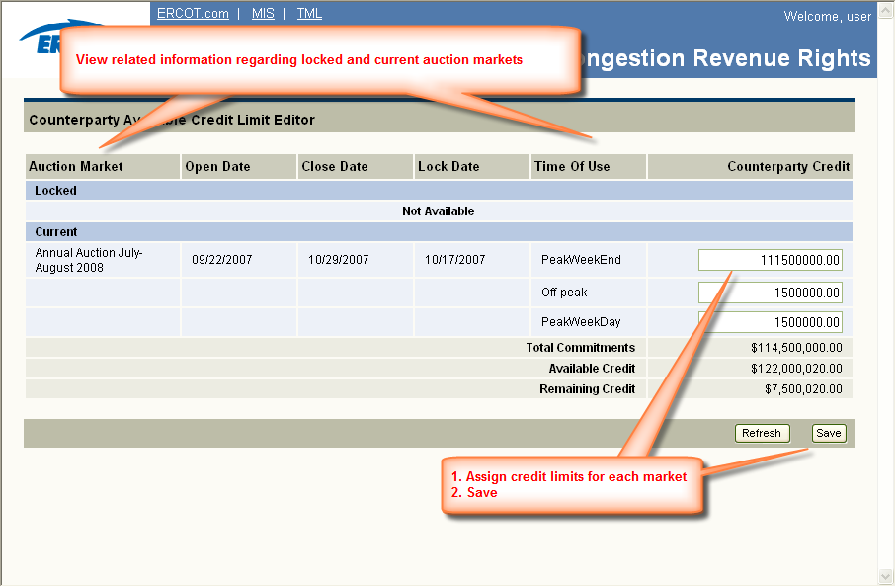
Figure 9.2: Counter-Party Credit Limit Editor Page Functionalities

Credit Limit Editor Data Fields
The Credit Limit Editor has the following data fields for Locked and Current markets:
- Auction Market – Name of the market
- Open Date – The date when the submission period opens for the market
- Close Date – The date when the submission period closes for the market
- Lock Date – The date after which an account holder can not modify one’s credit limits
- Time-of-use – Time-of-use for a particular market
- Counter-Party Credit Limit – The credit limit assigned by the account holder’s Counter-Party. The account holder can not enter a credit limit greater than this limit

Usage
The Counter-Party credit limit editor allows a Counter-Party to set a limit to the amount of portion of one’s available CRR credit limit the Counter-Party wants to allocate to a certain specific auction market.
Note that the credit limits set by the Counter-Party using this manager applies to auction markets only.
There are three credit limits to be assigned for annual auctions one per each of time-of-use, since the multi calendar period, i.e., 12 months, auctions for the annual term are run separately. On the other hand, there is only one credit limit for the monthly auctions.
The Total Commitment field is calculated as the sum of the locked markets plus the current markets for the Counter-Party credit values. The Total Commitment is provided to ERCOT i-HEDGE by Credit Monitoring and Management (CMM) every day. Please note that this number represents 90% of the maximum portion of the Counter-Party Available Credit Limit (ACL) that can be assigned to CRR. The Remaining Credit represents the difference between the available credit and the total commitment amount for both columns.
Figure 9.3 demonstrates all the dates that are related to an auction market.
Notice Date
Open Date
Close Date
Lock Date
Market is current: credit is editable for market
Market
is fully posted
End of grace period
Market is locked: credit is locked for market
Figure 9.3: Credit Limit Editor Page
Notice Date is when (download) data relevant to a particular becomes available. In other words, it represent the day when an auction market becomes visible to the ERCOT CRR market participants. Open and Close Dates represent the beginning and the end of the portfolio submission period. Lock date can be set between the open and close dates of a submission period, and represents the cut-off date after when the account holders (and their counter-parties) can not change their CRR credit limits. A market is considered “current” from its notice date until the lock date, with the understanding that multiple markets (e.g. Fall 2009 and Winter 2010) may be in the “current” state at the same time. A market is considered “locked” from its lock date until the end of the grace period. The grace period is calculated as “n” days after the Settlement date of the auction. All these dates are set by the ERCOT CRR market operators. More detail can be found on these in the ERCOT CRR Market Business Procedure Manual.
Finally, if a Counter-Party fails to set the budget constraint(s) for an auction market, that translates to none of that Counter-Party’s associated CRR account holders being able to participate in that particular market. If, on the other hand, an account holder does not enter a value for a given market, the only credit constraint they will be bound by would be the limit assigned by their Counter-Party.
For example, if Counter-Party CP1 has three account holders AH1, AH2, and AH3, and CP1 does not assign a credit limit for an auction market, MKT1, then, AH1, AH2 and AH3 have all of their self-imposed budgets set to zero, and they can not participate in MKT1.
On the other hand, if CP1 has allocated $10M to MKT1, then the AHs can set their own limits up-to $10M. Assuming AH1 has set a self-imposed limit of $5M, AH2 of $2M for MKT1, and AH3 hasn’t set an SI limit, then self-imposed limits of $5M for AH1, $2M for AH2 of and $10M for AH3 are sent to the optimization process for MKT1.

