

CRR:
Explanation of Market Submission/Retrieval Items
Version 0.12
January 15, 2008

Document Revisions
Date | Version | Description | Author(s)
11/05/07 | 0.08 | Initial draft | ERCOT CRR Team
11/30/07 | 0.09 | Updates:  - added details in ownership of record and baseload CRRs (based on TPTF clarification)  - moved xml samples to appendix (EDS team feedback)  - added xsds (TPTF feedback) | ERCOT CRR Team
1/3/2008 | 0.10 | Updated a few TBD items. | ERCOT CRR Team
1/15/2008 | 0.12 | Updates:  - addressed comments from Sid and Scott (TPTF)  - file name edits as agreed with MIS  - added existing CRR xsd | ERCOT CRR Team

Table of Contents

1 OVERVIEW 5
2 CRR Market Submission Items 6
2.1 CRR Account Holder Application 7
2.2 Allocation Eligibility Form 8
2.3 Counter Party Market Credit Limit 9
2.4 Self-Imposed Credit Limit 10
2.5 PCRR Nominations 11
2.6 CRR Auction Bids/Offers 12
2.7 CRR Bilateral Trades 14
2.8 Messages (Common/Private) 15
3 CRR Market Retrieval Items 16
3.1 CRR Auction Calendar 17
3.2 CRR Auction Notice 18
3.2.1 Base Loading CRRs 19
3.2.2 Flowgates 19
3.3 CRR Network Model 20
3.3.1 CRR Network Model 21
3.3.2 One Line Diagram 22
3.3.3 Outages 22
3.3.4 Contingencies 22
3.3.5 Monitored Lines and Transformers 22
3.3.6 Non-Thermal Constraints 23
3.3.7 Sources/Sinks 23
3.3.8 Dynamic Rating Inputs 23
3.3.9 Additional Assumptions or Inputs 23
3.4 CRR Auction Bids/Offers 24
3.5 Allocation Results 25
3.5.1 Market Results 26
3.5.2 Binding Constraints 27
3.6 CRR Auction Results – Private 28
3.7 CRR Auction Results – Public 29
3.7.1 Market Results 30
3.7.2 Flowgate Shadow Prices 31
3.7.3 Source/Sink Shadow Prices 31
3.7.4 Binding Constraints 31
3.7.5 Auction Bids and Offers 32
3.8 Existing CRRs 33
3.9 Messages (Common/Private) 34
4 Appendix A: xml samples 35
4.1 PCRR Nominations (Sample Upload file) 35
4.2 CRR Auction Bids/Offers (Sample Upload file) 37
4.3 Base Loading CRRs (Sample Download file) 39
4.4 Allocation Market Results (Sample Download file) 40
4.5 Allocation Binding Constraints (Sample Download file) 41
4.6 CRR Auction Market Results - Private (Sample Download file) 42
4.7 CRR Auction Market Results – Public (Sample Download file) 44
4.8 Flowgate Shadow Prices (Sample Download file) 45
4.9 Source/Sink Shadow Prices (Sample Download file) 46
4.10 Auction Binding Constraints (Sample Download file) 47
4.11 Auction Bids/Offers (Sample Download file) 48
4.12 Existing CRRs (Sample Download File) 49
5 APpendix B: Schema Definitions for XML Samples (XSD) 52
5.1 Allocation Market Results (XSD) 52
5.2 Auction Market Results – Private (XSD) 54
5.3 Auction Market Results – Public (XSD) 56
5.4 Existing CRRs (XSD) 58

OVERVIEW
This document describes data items relevant to the CRR market that are submitted or retrieved by CRR Account Holders and Market Participants.
This document is intended to allow interested parties to better understand CRR market-facing data interactions. There is a comprehensive user manual (separate from this document) that includes screen shots and elaborates on how to navigate around the CRR User Interface.
Information on each data item may include:
- Role of person submitting/retrieving the data (CRR Account Holder, NOIE, etc.)
- Attributes (Name, ID, MW Amount, Price, etc.)
- Format (CIM, XML, CSV, etc.)
- Method (download/upload, view, enter, etc.)
- Timing (when data is submitted/available to be retrieved)
- High-level explanation of purpose (and if applicable, how it is used in the system)
- Any additional details (special rules, etc)
- Samples* (csv tables, etc – xml samples are included in the appendix)
*Please note that these samples contain dummy information – the purpose of these samples is to enhance understanding of data formats; it does not reflect current or future intent.
** Also note that the XML/XSD samples included in the appendix may contain schemas/links that will later be modified.

Relevant reference documents:
- Nodal Protocols (in particular, Sections 3 and 7)
- CRR Market User Interface User Manual
- CRR Handbook (for EDS 3 Release 7)
- CRR Requirements

CRR Market Submission Items
A summary of submission data items relevant to CRR markets are listed below. Each is elaborated in following sub-sections.

Name | Time | Input Method | Format | MP
CRR Account Holder Application | One-time; x days before auction | Fax/email with attachment | DOC | CRR Account Holder
Allocation Eligibility Form | One-time; unless update needed | Fax/email with attachment | XLS, PDF, etc. | NOIE, McCamey WGR
Counter-Party Market Credit Limit | 3 BD before auction bid/offer submission window close | Enter only | N/A | Counter-Party
Self-Imposed Credit Limit | TBD – business process | Enter only | N/A | CRR Account Holder
PCRR Nominations | During nomination submission window | Enter and/or Upload | XML, CSV | NOIE
CRR Bid/Offer (incl. Portfolio) | During auction bid/offer submission window | Enter and/or Upload | XML, CSV | CRR Account Holder
CRR Bilateral Trade Buy/Offer | Anytime | Enter only | N/A | CRR Account Holder
Messages (Common/Private) | Anytime | Enter and/or upload attachment | Any file | CRR Account Holder

CRR Account Holder Application
The CRR Account Holder Application is submitted by anyone* wishing to participate in CRR market activities. Completion of this application process includes meeting ERCOT credit requirements.
*Parties who are not allowed to participate are Transmission and Distribution Service Providers (TSPs/DSPs), members of the PUCT staff, and members of the ERCOT staff.
This form is currently available on the Nodal website: http://www.ercot.com/services/rq/crr/index.html.

Allocation Eligibility Form
The Allocation Eligibility Form is submitted by eligible NOIEs wishing to participate in PCRR allocations. The purpose is to demonstrate proof of eligibility for PCRRs, as well as to establish NOIE’s eligible MW amount for PCRRs.
Eligible NOIEs also need to register as CRR Account Holders (submit the CRR Account Holder Application).
This form is currently available on the Nodal website: http://nodal.ercot.com/readiness/eds3/documents/index.html.

Counter Party Market Credit Limit
The Counter-Party Market Credit Limit is the credit limit each Counter-Party (CP) participating in any CRR auction (monthly or annual) would like to establish for that respective CRR auction. This limit restricts the total CRRs awarded to all CRR Account Holders represented by each CP, in that particular auction.
The CRR system will provide each CP with an overall credit limit, known as the Counter Party Available Credit Limit (CP ACL). No later than 3 business days prior to the close of the CRR bid submission window, the CP will submit the CP Market Credit Limit, a value equal to or less than the CP ACL, to restrict its credit for that particular CRR auction only. The Residual Credit Limit (CP ACL minus CP Market Credit Limit) becomes the available credit limit for Day-Ahead Market (DAM) activity and will be sent to the respective system.
Note: ERCOT also, on a daily basis, publishes a list of Available Credit Limits (ACL), by CP, on the Market Information System (MIS).
No samples are included as this is a value that is entered directly into the CRR application.

Self-Imposed Credit Limit
CRR Account Holders may choose to submit a self-imposed credit limit. If submitted, this credit limit is used in the auction optimization, in addition to the credit limit assigned by the Counter Party (CP).
The CP assigns a credit limit for each auction 3 business days before the auction bid/offer submission window closes (see Counter Party Market Credit Limit). The CRR Account Holder has an opportunity to view this credit limit assigned by the CP, and can then choose to enter a self-imposed credit limit that is equal or lower than the credit limit assigned by the CP.
No samples are included as this is a value that is entered directly into the CRR application.

PCRR Nominations
PCRR nominations are submitted by eligible CRR Account Holders who wish to be allocated Pre-Assigned Congestion Revenue Rights (PCRRs). Eligible CRR Account Holders are those that 1) meet PCRR qualifications (as per Nodal Protocol 7.4.1) 2) have registered as CRR Account Holders and 3) have submitted the Allocation Eligibility Form.
PCRR nominations consist of:
- Candidate ID : unique identifier of each eligible PCRR
- CRR Account Holder : name as registered
- Source : source name
- Sink : sink name
- Time Of Use : PeakWD, PeakWE, Off-peak
- Contract : Baseload, gas steam, other, etc.
- Type : Baseload, Capacity** or Refund
- Option : % as Options; remainder % as Obligations
- Eligible MW : as per Allocation Eligibility Form
- Nomination MW : desired MW (equal or less than eligible MW**)
- Factor : for capacity types, the calculated capacity factor**
For each annual allocation*, ERCOT will provide eligible CRR Account Holders with the MW amount that they are eligible for (per PCRR). The eligible CRR Account Holders can then: 1) enter/edit their desired nominated MW directly, or 2) download the eligible nominations, edit them locally, then upload their chosen nominations via CSV or XML.
These nominations are one of the inputs into the PCRR allocation optimization. If the nominated MW submitted to the annual allocation is not fully allocated, there will be a true-up allocation every month to allocate any remaining nomination MWs. These monthly true-up allocations do not involve any additional nominations or inputs from the eligible CRR Account Holder – they will be able to view any additional allocations received (see Allocation Market Results).
*During the first 6 monthly auctions, eligible CRR Account Holders submit nominations on a monthly basis. However, after the first multi-month or annual auction, nominations are submitted on an annual basis – every month, ERCOT will true-up any nominations that were not fully allocated during the annual allocation (but the eligible CRR Account Holder does not need to submit any additional nominations).
**For Capacity PCRRs, the total MWs nominated across the calendar year cannot exceed 40% capacity factor. When capacity nominations are entered/uploaded, the system calculates this capacity factor.
Sample CSV file:
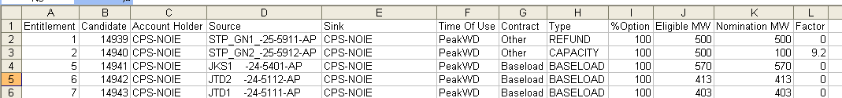

CRR Auction Bids/Offers

CRR auction bids/offers are submitted by CRR Account Holders who wish to buy PTP Options, PTP Obligations or MCFRIs during the auction submission window period (as specified in the CRR Auction Notice).
CRR offers are submitted by CRR Account Holders who wish to sell their owned PTP Options, PTP Obligations or MCFRIs during the auction submission window period. PTP Options/Obligations with Refund may not be offered into the auction. PCRRs that have been just allocated but not yet priced may be offered into the auction. PTP Option bids must have positive minimum reservation prices.
CRR bids/offers consist of the following:
- Bid ID : unique identifier for each bid and/or offer
- CRR Account Holder : name as in CRR Account Holder application
- Flowgate : if FGR bid/offer
- Source name : if PTP bid/offer
- Sink name : if PTP bid/offer
- MW : max MW amount (if offer), or min MW amount (if bid)
- Price ($/MWh) : not-to-exceed price, per MW per hour
- Time of Use : PeakWD, PeakWE, or Off-peak (or 24-Hours if applicable*)
- Buy/Sell : indication of whether this is an offer/bid
- Hedge Type : option/obligation
- Start Date : mm/dd/yyyy
- End Date : mm/dd/yyyy
*24-hour linked bids may be submitted to monthly auctions. 24-hour offers may NOT be submitted.
CRR bids/offers are managed by CRR Account Holders through portfolios. Each portfolio consists of a valid set of bids and/or offers, and is a “template” until the CRR Account Holder submits it to an auction. Submitting a portfolio to an auction includes choosing the available auction market and entering desired start/end dates (as allowed in protocols). After the auction, this submitted portfolio is defaulted back as a “template” and can be edited (if desired) and submitted to another auction.
CRR Account Holders can choose to:
- upload an XML or CSV file containing bids and/or offers as a portfolio
- create a portfolio and then enter bids and/or offers in it
- edit/enter additional bids and/or offers in any existing portfolio
Note: the CRR system does not constrain submission of bids/offers by the CRR Account Holder’s credit limit. The credit limit constraint is applied during the auction optimization.
Please refer to NP 7.5.2 for additional market rules on bid/offer submission.
Sample CSV file:
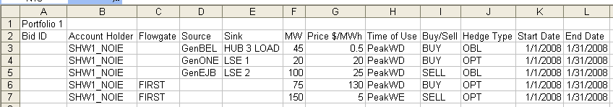

CRR Bilateral Trades
TBD – this is view-only.

Messages (Common/Private)
TBD

CRR Market Retrieval Items
A summary of retrieval data items relevant to CRR markets are listed below. Each will be elaborated in following sub-sections.

Data Name | Generating Frequency | Format | Intended Recipient
CRR Auction Calendar | Annually | Download (XLS) | Public
CRR Auction Notice  - Baseloading CRRs  - Flowgates  - McCamey Binding Constraints  - CRR Market User Interface User Manual | Monthly, Annually | Download (XLS, CSV)  Download (XLS, CSV)  TBD  Download (DOC)
McCamey Area One-Line Diagram | One time/update | Download (PDF) | Public
CRR Network Model  - CRR Network Model  - One Line Diagram  - Outages  - Contingencies  - Dynamic Rating Inputs  - Other Assumptions or Inputs | Monthly, Annually | Download (CIM-XML)  Download (PDF)  Download (TBD)  Download (XML, CSV)  Download (TBD)  Download (TBD) | MIS Secure users
CRR Auction Bids/Offers | Ad-hoc | View and/or download (XML, CSV) | Specific CRR Account Holder
CRR Allocation Results  - Market Results  - Binding Constraints | Monthly, Annually | Download (XML, CSV)  Download (XML, CSV) | All CRR Account Holders
CRR Auction Results - Private | Monthly, Annually | Download (XML, CSV) | Specific CRR Account Holder
CRR Auction Results – Public  - Market Results  - Auction Bids and Offers  - Binding Constraints | Monthly, Annually | Download (XML, CSV)  Download (XML, CSV)  Download (XML, CSV) | Public
Existing CRRs | Daily | Download (XML, CSV) | Public
CRR Bilateral Trades | Ad-hoc | View Only | All CRR Account Holders

CRR Auction Calendar
The CRR Auction Calendar is available on MIS Public. It contains key dates/deadlines relevant to CRR market activities, including auction notice dates, network model posting dates, bid/offer submission periods, nomination submission periods, and other relevant information.
This information is available in XLS format, and is updated annually.
For first CRR market go-live, the calendar will probably be available > 2 months in advance.
Sample/more details – TBD.

CRR Auction Notice
The CRR Auction Notice will be available on MIS Public 10 days before the monthly auction bid/offer submission window opens, and 20 days before the annual auction bid/offer submission window opens.
Information includes (as described in NP 7.5.3.1):
- Previously allocated/awarded CRRs (including PTP Options, Obligations and/or MCFRIs)
- McCamey Area flowgate limits and the affected Transmission Elements used to derive those limits
- Deadline for CRR Account Holders to satisfy financial requirements to participate in the auction;
- Date and time by which CRR Auction Bids and CRR Auction Offers in the CRR Auction must be submitted;
- Specifications for the equipment and interfaces necessary to participate in the CRR Auction;
- Bid and offer format; and
- Any other relevant information of commercial significance to CRR Account Holders.
Details of items 1 and 2 above are elaborated in the following sub-sections. Items 3-6 are included as part of the CRR Auction Calendar, the CRR user manual and this document. Item 7 is communicated to CRR Account Holders in the form of a Message.

Base Loading CRRs
“Base Loading CRRs” are the previously awarded/allocated CRRs that serve as an input into the auction. The network capacity will be reduced (or “base loaded”) by these CRRs.
This information is available in XML and/or CSV format.
Sample CSV file:
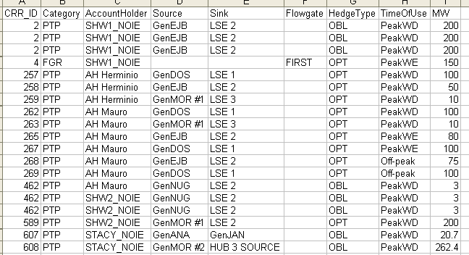

Flowgates
This information is available in XML and/or CSV format.
Sample CSV file:
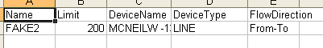

CRR Network Model
The CRR Network Model will be available on MIS Secure Area. It will be posted 20 Business Days before the annual CRR Auction window opens, and 10 Business Days before the CRR Auction window opens.
The CRR Network Model includes, as specified in NP 3.10.2(3):
- Network Model
- One-line diagram with all Settlement Points and including all Hub Buses used to calculate Hub prices (if applicable)
- Outages included in the Network Model, as per Nodal Operating Guides and NP 7.5.1(2)
- Contingency lists
- Data inputs used in the calculation of Dynamic Ratings
- Additional assumptions/inputs

Details of items that represent items 1-6 each are elaborated in the following sub-sections.

CRR Network Model
The CRR Network Model is available for download in both augmented PSS/E (via CRR application only) and/or CIM (via MIS Portal only) formats.
Both formats are generated by the ERCOT operator at the same time using the same system (NMMS).
The augmented PSS/E format includes corresponding network data in the PSS/E, version 30, raw data file format, and is augmented with an ERCOT supplied Device Name that is included in comment form at the end of each PSS/E data record. This format is used in the CRR system to run the CRR annual/monthly auction or allocation. 44
Sample CIM file:
TBD
Sample augmented PSS/E file:
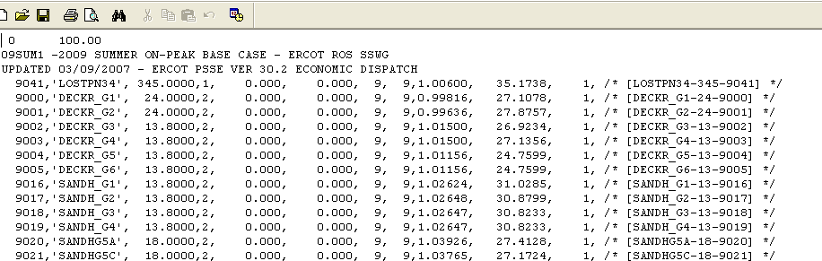

One Line Diagram
TBD

Outages
TBD

Contingencies
Available for download in both CSV and/or XML formats.
Sample CSV file:
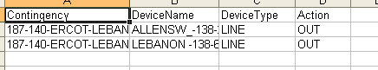

Monitored Lines and Transformers
Available for download in both CSV and/or XML formats.
Sample CSV file:
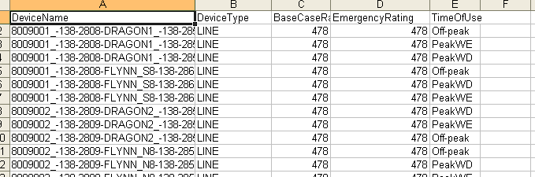

Non-Thermal Constraints
Available for download in both CSV and XML formats
Sample CSV file:
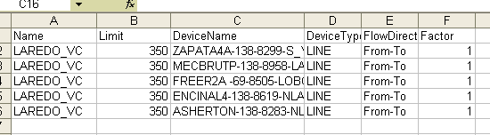

Sources/Sinks
Available for download in both CSV and XML formats
Sample CSV file:
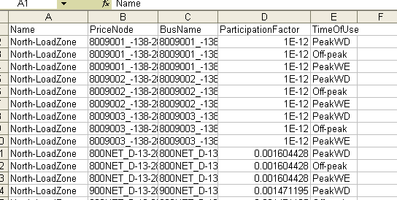

Dynamic Rating Inputs
TBD – temperature inputs to the calculation of Dynamic Ratings.

Additional Assumptions or Inputs
TBD - any additional assumptions and/or inputs into the CRR Network Model is retrieved as a Message.

CRR Auction Bids/Offers
CRR Account Holders who submitted valid CRR auction bids/offers to an auction may view and/or download these submitted* bids and/offers in either XML or CSV formats.
*Assuming auction bid/offer submission window is still open. If the window has closed (or if the CRR Account Holder has yet to submit the portfolio to the auction), the CRR Account Holder can still view and/or download the valid bids/offers in a portfolio “template” (see CRR Auction Bids/Offers)
Sample CSV file:
Note: First row displays the name of the portfolio and the name of monthly auction.
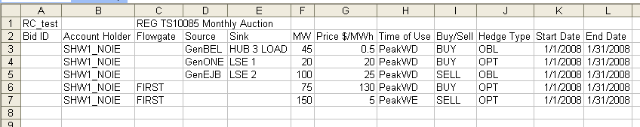
Sample XML file:
See CRR Auction Bids/Offers.

Allocation Results
Allocation Results are available to all CRR Account Holders (including those eligible CRR Account Holders who were allocated PCRRs/MCFRIs) after the PCRR and MCFRI allocation results 25 days prior to the annual auction or 10 business days prior to the monthly auction.
The Allocation Results consist of:
- market results
- binding constraints

Market Results
The Allocation Market Results include:
- CRR ID : unique identifier for each awarded/allocated CRR
- Account Holder : name as registered
- Category : PTP or FGR
- Hedge Type : Option or Obligation
- CRR Type : Baseload, Capacity or Refund*
- Source : source name
- Sink : sink name
- Flowgate : flowgate name (e.g. MCFRI)
- Start Date : mm/dd/yyyy
- End Date : mm/dd/yyyy
- Time of Use : PeakWD, PeakWE, Off-peak
- MW : MW amount allocated (MW per hour)
*Baseload and/or Capacity PCRR will change to Standard when its relevant CRR Invoice is paid in full.
Note: these results do not include the PCRR prices – this is because PCRRs are priced based on the subsequent auction clearing prices, according to NP 7.4.2(h).
CRR Account Holders that are eligible for PCRR allocations may also view their allocated MWs against their eligible and nominated MWs.
Available in both XML and CSV formats.
Sample CSV file:
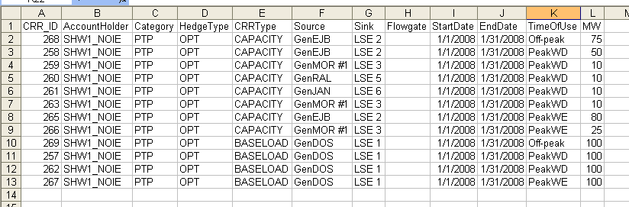

Binding Constraints
Available in both XML and CSV formats.
Sample CSV file:
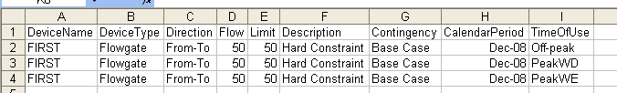

CRR Auction Results – Private
CRR auction results (private) are available only to the specific CRR Account Holder (only) after the auction optimization has been run. The date these auction results are posted is reflected in the CRR Auction Calendar or CRR Auction Notice – TBD.
The CRR auction results (private) include:
- Bid ID : unique identifier for each bid or offer
- CRR ID : unique identifier for each awarded/allocated CRR
- Account Holder : name as registered
- Category : PTP or FGR
- Hedge Type : Option or Obligation, if applicable
- Portfolio : name of the portfolio that contained the bid/offer
- Class : BUY represents a bid; SELL represents an offer
- CRR Type : PREAWARD or STANDARD*
- Source : source name
- Sink : sink name
- Flowgate : flowgate name, if applicable
- Start Date : mm/dd/yyyy
- End Date : mm/dd/yyyy
- Time of Use : PeakWD, PeakWE or Off-peak
- MW : MW amount awarded, per hour
- Clearing Price : auction clearing price (dollar per MW per hour)
- Bid MW : MW amount in bid/offer, per hour
- Bid Price : minimum reservation price in bid/offer, per MW per hour
*The CRR is considered a PREAWARD until its relevant CRR Invoice is paid in full – after which it will be considered STANDARD.
Available in both XML and CSV formats.
Sample CSV file:
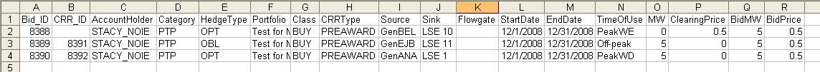

CRR Auction Results – Public
CRR auction results (public) are posted to MIS Public after the auction optimization has been run. The date these auction results are posted is reflected in the CRR Auction Calendar or CRR Auction Notice – TBD.
The CRR auction results (public) include, as per NP 7.5.3.1(2):
- PTP Options and PTP Options with Refund – the source and sink , and total MWs;
- PTP Obligations and PTP Obligations with Refund – the source and sink and total MWs;
- FGRs – the identity of each directional flowgate, and the magnitude of positive flow (MW) on each directional network element represented by each flowgate;
- The identities of the CRR Account Holders that were awarded or allocated CRRs in or before the CRR Auction;
- The clearing prices for each strip of CRR blocks awarded in the CRR Auction;
- The identity and post contingency flow of each binding directional element based on the CRR Network Model used in the CRR Auction; and
- All CRR Auction Bids and CRR Auction Offers, without identifying the name of the CRR Account Holder that submitted the bid or offer.

All items 1-7 above are available as data items as described in the following sub-subsections.

Market Results
The auction market results (public) include, as per NP 7.5.3.1:
- Awarded CRRs (including PTP Options/Obligations and FGRs)
- CRR Account Holders that were awarded/allocated CRRs (in or before the CRR Auction)
Specifically, the auction market results consist of:
- CRR ID : unique identifier for each awarded/allocated CRR per specified auction
- Account Holder : name as registered
- Category : PTP or FGR
- Hedge Type : Obligation or Option, if PTP
- Class : BUY represent a bid, SELL represents an offer
- CRR Type : PREAWARD or STANDARD*
- Source : source name
- Sink : sink name
- Flowgate : flowgate name, if applicable
- Start Date : mm/dd/yyyy
- End Date : mm/dd/yyyy
- Time of Use : PeakWD, PeakWE or Off-peak
- MW : MW amount awarded, per hour
- Clearing Price : auction clearing price (dollar per MW per hour)
*The CRR is considered a PREAWARD until its relevant CRR Invoice is paid in full – after which the CRR will be considered STANDARD.
Available in both XML and CSV formats.
Sample CSV file:
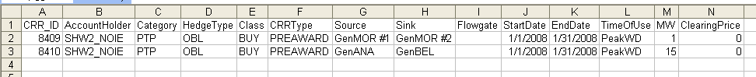

Flowgate Shadow Prices
Available in both XML and CSV formats.
Sample CSV file:
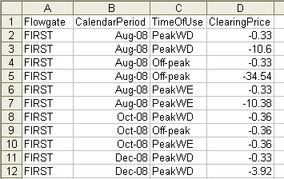

Source/Sink Shadow Prices
Available in both XML and CSV formats.
Sample CSV file:
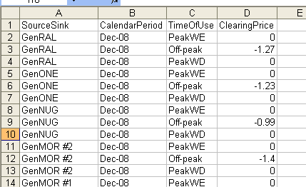\

Binding Constraints
Available in both XML and CSV formats.
Sample CSV file:
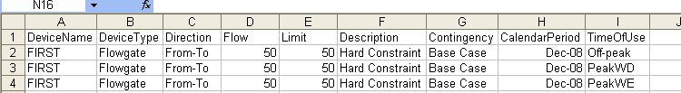

Auction Bids and Offers
This includes all valid bids and offers submitted to the auction are displayed, without revealing the CRR Account Holder that submitted it (as per NP 7.5.3.1). It also does not reveal whether or not the bid/offer was awarded in the auction.
These auction bids/offers include:
- Category : PTP or FGR
- Source : source name
- Sink : sink name
- Flowgate : flowgate name, if applicable
- Type : BUY represents a bid; SELL represents an offer
- Start Date : mm/dd/yyyy
- End Date : mm/dd/yyyy
- Hedge Type : Obligation or Option, if PTP
- Time of Use : PeakWD, PeakWE or Off-peak
- MW : MW amount in bid/offer, per hour
- Bid Price : not-to-exceed price (dollar per MW per hour)
Available in both XML and CSV formats.
Sample CSV file:
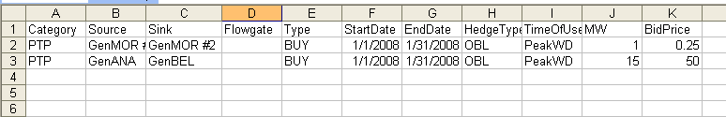

Existing CRRs
All existing CRRs are updated on MIS Public daily.
This consists of, consistent with NP 7.5.5.2:
- CRR ID : unique identifier for each awarded/allocated CRR
- Account Holder : name as registered
- Category : PTP or FGR
- Hedge Type : Obligation or Option, if PTP
- CRR Type : Standard or Refund
- Source : source name
- Sink : sink name
- Flowgate : flowgate name, if applicable
- Start Date : mm/dd/yyyy
- End Date : mm/dd/yyyy
- Time of Use : PeakWD, PeakWE or Off-Peak
- MW : MW amount awarded, per hour
Available in both CSV and XML formats.
Sample CSV file:
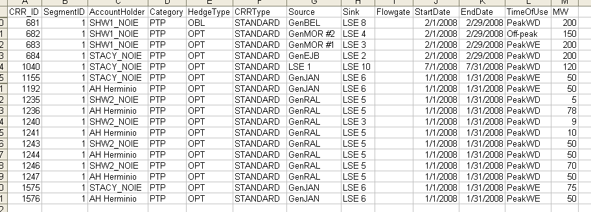

Messages (Common/Private)
See Messages (Common/Private).

Appendix A: xml samples

PCRR Nominations (Sample Upload file)

<?xml version="1.0" encoding="UTF-8" ?>
- <nominations xsi:schemaLocation="Nominations.xsd" xmlns:CRRDownload="http://crr.ercot.org/download/xml" xmlns="http://crr.ercot.org/download/xml" xmlns:xsi="http://www.w3.org/2001/XMLSchema-instance">
- <nomination>
<entitlement>501</entitlement>
<candidate>9178</candidate>
<accountHolder>SHW1_NOIE</accountHolder>
<source>GenDOS</source>
<sink>LSE 1</sink>
<timeOfUse>PeakWD</timeOfUse>
<contract>Baseload</contract>
<type>BASELOAD</type>
<option>100</option>
<eligibleMW>150</eligibleMW>
<nominationMW>0</nominationMW>
<factor>0</factor>
</nomination>
- <nomination>
<entitlement>502</entitlement>
<candidate>9158</candidate>
<accountHolder>SHW1_NOIE</accountHolder>
<source>GenEJB</source>
<sink>LSE 2</sink>
<timeOfUse>PeakWD</timeOfUse>
<contract>Gas Steam</contract>
<type>CAPACITY</type>
<option>100</option>
<eligibleMW>100</eligibleMW>
<nominationMW>0</nominationMW>
<factor>0</factor>
</nomination>
- <nomination>
<entitlement>609</entitlement>
<candidate>9186</candidate>
<accountHolder>SHW1_NOIE</accountHolder>
<source>GenMOR #1</source>
<sink>LSE 3</sink>
<timeOfUse>PeakWE</timeOfUse>
<contract>Other</contract>
<type>REFUND</type>
<option>0</option>
<eligibleMW>80</eligibleMW>
<nominationMW>0</nominationMW>
<factor>0</factor>
</nomination>
</nominations>

CRR Auction Bids/Offers (Sample Upload file)

<?xml version="1.0" encoding="UTF-8" ?>
- <CRRDownload:bids xmlns:CRRDownload="http://crr.ercot.org/download/xml" xmlns:xsi="http://www.w3.org/2001/XMLSchema-instance" xsi:schemaLocation="Portfolio.xsd">
- <CRRDownload:title>
<CRRDownload:portfolioName>RC_for TPTF upload download doc</CRRDownload:portfolioName>
<CRRDownload:portfolioDescription />
<CRRDownload:auctionName>REG TS10085 Monthly Auction</CRRDownload:auctionName>
</CRRDownload:title>
- <CRRDownload:bid CRRDownload:bidFTRType="PTP">
<CRRDownload:bidID />
<CRRDownload:accountHolder>SHW1_NOIE</CRRDownload:accountHolder>
<CRRDownload:source>GenBEL</CRRDownload:source>
<CRRDownload:sink>HUB 3 LOAD</CRRDownload:sink>
<CRRDownload:mw>45</CRRDownload:mw>
<CRRDownload:pricePerMW>0.5</CRRDownload:pricePerMW>
<CRRDownload:tou>PeakWD</CRRDownload:tou>
<CRRDownload:type>BUY</CRRDownload:type>
<CRRDownload:hedgeType>OBL</CRRDownload:hedgeType>
<CRRDownload:startDate>01/01/2008</CRRDownload:startDate>
<CRRDownload:endDate>01/31/2008</CRRDownload:endDate>
</CRRDownload:bid>
- <CRRDownload:bid CRRDownload:bidFTRType="PTP">
<CRRDownload:bidID />
<CRRDownload:accountHolder>SHW1_NOIE</CRRDownload:accountHolder>
<CRRDownload:source>GenONE</CRRDownload:source>
<CRRDownload:sink>LSE 1</CRRDownload:sink>
<CRRDownload:mw>20</CRRDownload:mw>
<CRRDownload:pricePerMW>20</CRRDownload:pricePerMW>
<CRRDownload:tou>PeakWD</CRRDownload:tou>
<CRRDownload:type>BUY</CRRDownload:type>
<CRRDownload:hedgeType>OPT</CRRDownload:hedgeType>
<CRRDownload:startDate>01/01/2008</CRRDownload:startDate>
<CRRDownload:endDate>01/31/2008</CRRDownload:endDate>
</CRRDownload:bid>
- <CRRDownload:bid CRRDownload:bidFTRType="PTP">
<CRRDownload:bidID />
<CRRDownload:accountHolder>SHW1_NOIE</CRRDownload:accountHolder>
<CRRDownload:source>GenEJB</CRRDownload:source>
<CRRDownload:sink>LSE 2</CRRDownload:sink>
<CRRDownload:mw>100</CRRDownload:mw>
<CRRDownload:pricePerMW>25</CRRDownload:pricePerMW>
<CRRDownload:tou>PeakWD</CRRDownload:tou>
<CRRDownload:type>SELL</CRRDownload:type>
<CRRDownload:hedgeType>OBL</CRRDownload:hedgeType>
<CRRDownload:startDate>01/01/2008</CRRDownload:startDate>
<CRRDownload:endDate>01/31/2008</CRRDownload:endDate>
</CRRDownload:bid>
- <CRRDownload:bid CRRDownload:bidFTRType="FGR">
<CRRDownload:bidID />
<CRRDownload:accountHolder>SHW1_NOIE</CRRDownload:accountHolder>
<CRRDownload:flowgate>FIRST</CRRDownload:flowgate>
<CRRDownload:mw>75</CRRDownload:mw>
<CRRDownload:pricePerMW>130</CRRDownload:pricePerMW>
<CRRDownload:tou>PeakWD</CRRDownload:tou>
<CRRDownload:type>BUY</CRRDownload:type>
<CRRDownload:hedgeType>OPT</CRRDownload:hedgeType>
<CRRDownload:startDate>01/01/2008</CRRDownload:startDate>
<CRRDownload:endDate>01/31/2008</CRRDownload:endDate>
</CRRDownload:bid>
- <CRRDownload:bid CRRDownload:bidFTRType="FGR">
<CRRDownload:bidID />
<CRRDownload:accountHolder>SHW1_NOIE</CRRDownload:accountHolder>
<CRRDownload:flowgate>FIRST</CRRDownload:flowgate>
<CRRDownload:mw>150</CRRDownload:mw>
<CRRDownload:pricePerMW>5</CRRDownload:pricePerMW>
<CRRDownload:tou>PeakWE</CRRDownload:tou>
<CRRDownload:type>SELL</CRRDownload:type>
<CRRDownload:hedgeType>OPT</CRRDownload:hedgeType>
<CRRDownload:startDate>01/01/2008</CRRDownload:startDate>
<CRRDownload:endDate>01/31/2008</CRRDownload:endDate>
</CRRDownload:bid>
</CRRDownload:bids>

Base Loading CRRs (Sample Download file)

<?xml version="1.0" encoding="UTF-8" ?>
- <CRRDownload:baseLoadingCRRs xmlns:CRRDownload="http://ftr.ercot.org/download/xml" xmlns:xsi="http://www.w3.org/2001/XMLSchema-instance" xsi:schemaLocation="http://ftr.ercot.org/download/xml BaseLoadingCRRs.xsd">
- <CRRDownload:baseLoadingCRR>
<CRRDownload:CRR_ID>265</CRRDownload:CRR_ID>
<CRRDownload:category>PTP</CRRDownload:category>
<CRRDownload:accountHolder>SHW1_NOIE</CRRDownload:accountHolder>
<CRRDownload:source>GenEJB</CRRDownload:source>
<CRRDownload:sink>LSE 2</CRRDownload:sink>
<CRRDownload:flowgate />
<CRRDownload:hedgeType>OPT</CRRDownload:hedgeType>
<CRRDownload:timeOfUse>PeakWE</CRRDownload:timeOfUse>
<CRRDownload:MW>80.0</CRRDownload:MW>
</CRRDownload:baseLoadingCRR>
- <CRRDownload:baseLoadingCRR>
<CRRDownload:CRR_ID>269</CRRDownload:CRR_ID>
<CRRDownload:category>PTP</CRRDownload:category>
<CRRDownload:accountHolder>SHW1_NOIE</CRRDownload:accountHolder>
<CRRDownload:source>GenDOS</CRRDownload:source>
<CRRDownload:sink>LSE 1</CRRDownload:sink>
<CRRDownload:flowgate />
<CRRDownload:hedgeType>OPT</CRRDownload:hedgeType>
<CRRDownload:timeOfUse>Off-peak</CRRDownload:timeOfUse>
<CRRDownload:MW>100.0</CRRDownload:MW>
</CRRDownload:baseLoadingCRR>
- <CRRDownload:baseLoadingCRR>
<CRRDownload:CRR_ID>2</CRRDownload:CRR_ID>
<CRRDownload:category>PTP</CRRDownload:category>
<CRRDownload:accountHolder>SHW1_NOIE</CRRDownload:accountHolder>
<CRRDownload:source>GenEJB</CRRDownload:source>
<CRRDownload:sink>LSE 2</CRRDownload:sink>
<CRRDownload:flowgate />
<CRRDownload:hedgeType>OBL</CRRDownload:hedgeType>
<CRRDownload:timeOfUse>PeakWD</CRRDownload:timeOfUse>
<CRRDownload:MW>200.0</CRRDownload:MW>
</CRRDownload:baseLoadingCRR>
</CRRDownload:baseLoadingCRRs>

Allocation Market Results (Sample Download file)

<?xml version="1.0" encoding="UTF-8" ?>
- <CRRDownload:marketResults xmlns:CRRDownload="http://ftr.ercot.org/download/xml" xmlns:xsi="http://www.w3.org/2001/XMLSchema-instance" xsi:schemaLocation="http://ftr.ercot.org/download/xml">
- <CRRDownload:result>
<CRRDownload:CRR_ID>268</CRRDownload:CRR_ID>
<CRRDownload:accountHolder>SHW1_NOIE</CRRDownload:accountHolder>
<CRRDownload:category>PTP</CRRDownload:category>
<CRRDownload:hedgeType>OPT</CRRDownload:hedgeType>
<CRRDownload:CRRType>CAPACITY</CRRDownload:CRRType>
<CRRDownload:source>GenEJB</CRRDownload:source>
<CRRDownload:sink>LSE 2</CRRDownload:sink>
<CRRDownload:flowgate />
<CRRDownload:startDate>01/01/2008</CRRDownload:startDate>
<CRRDownload:endDate>01/31/2008</CRRDownload:endDate>
<CRRDownload:timeOfUse>Off-peak</CRRDownload:timeOfUse>
<CRRDownload:MW>75.0</CRRDownload:MW>
</CRRDownload:result>
- <CRRDownload:result>
<CRRDownload:CRR_ID>269</CRRDownload:CRR_ID>
<CRRDownload:accountHolder>SHW1_NOIE</CRRDownload:accountHolder>
<CRRDownload:category>PTP</CRRDownload:category>
<CRRDownload:hedgeType>OPT</CRRDownload:hedgeType>
<CRRDownload:CRRType>BASELOAD</CRRDownload:CRRType>
<CRRDownload:source>GenDOS</CRRDownload:source>
<CRRDownload:sink>LSE 1</CRRDownload:sink>
<CRRDownload:flowgate />
<CRRDownload:startDate>01/01/2008</CRRDownload:startDate>
<CRRDownload:endDate>01/31/2008</CRRDownload:endDate>
<CRRDownload:timeOfUse>Off-peak</CRRDownload:timeOfUse>
<CRRDownload:MW>100.0</CRRDownload:MW>
</CRRDownload:result>
</CRRDownload:marketResults>

Allocation Binding Constraints (Sample Download file)

<?xml version="1.0" encoding="UTF-8" ?>
- <CRRDownload:bindingConstraints xmlns:CRRDownload="http://ftr.ercot.org/download/xml" xmlns:xsi="http://www.w3.org/2001/XMLSchema-instance" xsi:schemaLocation="http://ftr.ercot.org/download/xml AllocationBindingConstraints.xsd">
- <CRRDownload:constraint>
<CRRDownload:deviceName>FIRST</CRRDownload:deviceName>
<CRRDownload:deviceType>Flowgate</CRRDownload:deviceType>
<CRRDownload:direction>From-To</CRRDownload:direction>
<CRRDownload:flow>50</CRRDownload:flow>
<CRRDownload:limit>50</CRRDownload:limit>
<CRRDownload:description>Hard Constraint</CRRDownload:description>
<CRRDownload:contingency>Base Case</CRRDownload:contingency>
<CRRDownload:calendarPeriod>DEC 2008</CRRDownload:calendarPeriod>
<CRRDownload:tou>Off-peak</CRRDownload:tou>
</CRRDownload:constraint>
- <CRRDownload:constraint>
<CRRDownload:deviceName>FIRST</CRRDownload:deviceName>
<CRRDownload:deviceType>Flowgate</CRRDownload:deviceType>
<CRRDownload:direction>From-To</CRRDownload:direction>
<CRRDownload:flow>50</CRRDownload:flow>
<CRRDownload:limit>50</CRRDownload:limit>
<CRRDownload:description>Hard Constraint</CRRDownload:description>
<CRRDownload:contingency>Base Case</CRRDownload:contingency>
<CRRDownload:calendarPeriod>DEC 2008</CRRDownload:calendarPeriod>
<CRRDownload:tou>PeakWE</CRRDownload:tou>
</CRRDownload:constraint>
</CRRDownload:bindingConstraints>

CRR Auction Market Results - Private (Sample Download file)

<?xml version="1.0" encoding="UTF-8" standalone="yes"?>
<ns1:auctionCRRs xmlns:ns1="http://crr.ercot.org/download/xml">
<ns1:crr>
<ns1:bidID>8388</ns1:bidID>
<ns1:portfolio>Test for Macro - JAN09 Auction Portfolio</ns1:portfolio>
<ns1:assetOwner>STACY_NOIE</ns1:assetOwner>
<ns1:category>PTP</ns1:category>
<ns1:source>GenBEL</ns1:source>
<ns1:sink>LSE 10</ns1:sink>
<ns1:startDate>12/01/2008</ns1:startDate>
<ns1:endDate>12/31/2008</ns1:endDate>
<ns1:hedgeType>OPT</ns1:hedgeType>
<ns1:type>BUY</ns1:type>
<ns1:tou>PeakWE</ns1:tou>
<ns1:awardedMW>0</ns1:awardedMW>
<ns1:clearingPrice>0.5</ns1:clearingPrice>
<ns1:bidCurves>
<ns1:bidPoint>
<ns1:mw>5</ns1:mw>
<ns1:pricePerMW>0.5</ns1:pricePerMW>
</ns1:bidPoint>
</ns1:bidCurves>
</ns1:crr>
<ns1:crr>
<ns1:bidID>8389</ns1:bidID>
<ns1:crrID>8391<ns1:crrID/>
<ns1:portfolio>Test for Macro - JAN09 Auction Portfolio</ns1:portfolio>
<ns1:assetOwner>STACY_NOIE</ns1:assetOwner>
<ns1:category>PTP</ns1:category>
<ns1:source>GenEJB</ns1:source>
<ns1:sink>LSE 11</ns1:sink>
<ns1:startDate>12/01/2008</ns1:startDate>
<ns1:endDate>12/31/2008</ns1:endDate>
<ns1:hedgeType>OBL</ns1:hedgeType>
<ns1:type>BUY</ns1:type>
<ns1:tou>Off-peak</ns1:tou>
<ns1:awardedMW>5</ns1:awardedMW>
<ns1:clearingPrice>0.0</ns1:clearingPrice>
<ns1:bidCurves>
<ns1:bidPoint>
<ns1:mw>5</ns1:mw>
<ns1:pricePerMW>0.5</ns1:pricePerMW>
</ns1:bidPoint>
</ns1:bidCurves>
</ns1:crr>
<ns1:crr>
<ns1:bidID>8390</ns1:bidID>
<ns1:crrID>8392<ns1:crrID/>
<ns1:portfolio>Test for Macro - JAN09 Auction Portfolio</ns1:portfolio>
<ns1:assetOwner>STACY_NOIE</ns1:assetOwner>
<ns1:category>PTP</ns1:category>
<ns1:source>GenANA</ns1:source>
<ns1:sink>LSE 1</ns1:sink>
<ns1:startDate>12/01/2008</ns1:startDate>
<ns1:endDate>12/31/2008</ns1:endDate>
<ns1:hedgeType>OPT</ns1:hedgeType>
<ns1:type>BUY</ns1:type>
<ns1:tou>PeakWD</ns1:tou>
<ns1:awardedMW>5</ns1:awardedMW>
<ns1:clearingPrice>0.0</ns1:clearingPrice>
<ns1:bidCurves>
<ns1:bidPoint>
<ns1:mw>5</ns1:mw>
<ns1:pricePerMW>0.5</ns1:pricePerMW>
</ns1:bidPoint>
</ns1:bidCurves>
</ns1:crr>
</ns1:auctionCRRs>

CRR Auction Market Results – Public (Sample Download file)

<?xml version="1.0" encoding="UTF-8" ?>
- <CRRDownload:marketResults xmlns:CRRDownload="http://ftr.ercot.org/download/xml" xmlns:xsi="http://www.w3.org/2001/XMLSchema-instance" xsi:schemaLocation="http://ftr.ercot.org/download/xml">
- <CRRDownload:result>
<CRRDownload:CRR_ID>8484</CRRDownload:CRR_ID>
<CRRDownload:accountHolder>SHW2_NOIE</CRRDownload:accountHolder>
<CRRDownload:category>PTP</CRRDownload:category>
<CRRDownload:hedgeType>OBL</CRRDownload:hedgeType>
<CRRDownload:class>BUY</CRRDownload:class>
<CRRDownload:CRRType>PREAWARD</CRRDownload:CRRType>
<CRRDownload:source>LSE 1</CRRDownload:source>
<CRRDownload:sink>LSE 10</CRRDownload:sink>
<CRRDownload:flowgate />
<CRRDownload:startDate>01/01/2008</CRRDownload:startDate>
<CRRDownload:endDate>01/31/2008</CRRDownload:endDate>
<CRRDownload:timeOfUse>PeakWD</CRRDownload:timeOfUse>
<CRRDownload:MW>1.0</CRRDownload:MW>
<CRRDownload:ClearingPrice>75</CRRDownload:ClearingPrice>
</CRRDownload:result>
</CRRDownload:marketResults>

Flowgate Shadow Prices (Sample Download file)

<?xml version="1.0" encoding="UTF-8" ?>
- <CRRDownload:clearingPrices xmlns:CRRDownload="http://ftr.ercot.org/download/xml" xmlns:xsi="http://www.w3.org/2001/XMLSchema-instance" xsi:schemaLocation="http://ftr.ercot.org/download/xml FlowgateClearingPrices.xsd">
- <CRRDownload:flowgate>
<CRRDownload:flowgate>FIRST</CRRDownload:flowgate>
<CRRDownload:calendarPeriod>AUG 2008</CRRDownload:calendarPeriod>
<CRRDownload:tou>PeakWD</CRRDownload:tou>
<CRRDownload:clearingPrice>-.33</CRRDownload:clearingPrice>
</CRRDownload:flowgate>
- <CRRDownload:flowgate>
<CRRDownload:flowgate>FIRST</CRRDownload:flowgate>
<CRRDownload:calendarPeriod>AUG 2008</CRRDownload:calendarPeriod>
<CRRDownload:tou>PeakWD</CRRDownload:tou>
<CRRDownload:clearingPrice>-10.6</CRRDownload:clearingPrice>
</CRRDownload:flowgate>
- <CRRDownload:flowgate>
<CRRDownload:flowgate>FIRST</CRRDownload:flowgate>
<CRRDownload:calendarPeriod>AUG 2008</CRRDownload:calendarPeriod>
<CRRDownload:tou>Off-peak</CRRDownload:tou>
<CRRDownload:clearingPrice>-.33</CRRDownload:clearingPrice>
</CRRDownload:flowgate>
</CRRDownload:clearingPrices>

Source/Sink Shadow Prices (Sample Download file)

<?xml version="1.0" encoding="UTF-8" ?>
- <CRRDownload:clearingPrices xmlns:CRRDownload="http://ftr.ercot.org/download/xml" xmlns:xsi="http://www.w3.org/2001/XMLSchema-instance" xsi:schemaLocation="http://ftr.ercot.org/download/xml SourceSinkClearingPrices.xsd">
- <CRRDownload:sourceSink>
<CRRDownload:sourceSink>GenRAL</CRRDownload:sourceSink>
<CRRDownload:calendarPeriod>DEC 2008</CRRDownload:calendarPeriod>
<CRRDownload:tou>PeakWE</CRRDownload:tou>
<CRRDownload:clearingPrice>0</CRRDownload:clearingPrice>
</CRRDownload:sourceSink>
- <CRRDownload:sourceSink>
<CRRDownload:sourceSink>GenRAL</CRRDownload:sourceSink>
<CRRDownload:calendarPeriod>DEC 2008</CRRDownload:calendarPeriod>
<CRRDownload:tou>Off-peak</CRRDownload:tou>
<CRRDownload:clearingPrice>-1.27</CRRDownload:clearingPrice>
</CRRDownload:sourceSink>
- <CRRDownload:sourceSink>
<CRRDownload:sourceSink>GenRAL</CRRDownload:sourceSink>
<CRRDownload:calendarPeriod>DEC 2008</CRRDownload:calendarPeriod>
<CRRDownload:tou>PeakWD</CRRDownload:tou>
<CRRDownload:clearingPrice>0</CRRDownload:clearingPrice>
</CRRDownload:sourceSink>
</CRRDownload:clearingPrices>

Auction Binding Constraints (Sample Download file)

<?xml version="1.0" encoding="UTF-8" ?>
- <CRRDownload:bindingConstraints xmlns:CRRDownload="http://ftr.ercot.org/download/xml" xmlns:xsi="http://www.w3.org/2001/XMLSchema-instance" xsi:schemaLocation="http://ftr.ercot.org/download/xml AllocationBindingConstraints.xsd">
- <CRRDownload:constraint>
<CRRDownload:deviceName>FIRST</CRRDownload:deviceName>
<CRRDownload:deviceType>Flowgate</CRRDownload:deviceType>
<CRRDownload:direction>From-To</CRRDownload:direction>
<CRRDownload:flow>50</CRRDownload:flow>
<CRRDownload:limit>50</CRRDownload:limit>
<CRRDownload:description>Hard Constraint</CRRDownload:description>
<CRRDownload:contingency>Base Case</CRRDownload:contingency>
<CRRDownload:calendarPeriod>DEC 2008</CRRDownload:calendarPeriod>
<CRRDownload:tou>Off-peak</CRRDownload:tou>
</CRRDownload:constraint>
- <CRRDownload:constraint>
<CRRDownload:deviceName>FIRST</CRRDownload:deviceName>
<CRRDownload:deviceType>Flowgate</CRRDownload:deviceType>
<CRRDownload:direction>From-To</CRRDownload:direction>
<CRRDownload:flow>50</CRRDownload:flow>
<CRRDownload:limit>50</CRRDownload:limit>
<CRRDownload:description>Hard Constraint</CRRDownload:description>
<CRRDownload:contingency>Base Case</CRRDownload:contingency>
<CRRDownload:calendarPeriod>DEC 2008</CRRDownload:calendarPeriod>
<CRRDownload:tou>PeakWD</CRRDownload:tou>
</CRRDownload:constraint>
</CRRDownload:bindingConstraints>

Auction Bids/Offers (Sample Download file)

<?xml version="1.0" encoding="UTF-8" ?>
- <CRRDownload:auctionCRRs xmlns:CRRDownload="http://ftr.ercot.org/download/xml" xmlns:xsi="http://www.w3.org/2001/XMLSchema-instance" xsi:schemaLocation="http://ftr.ercot.org/download/xml">
- <CRRDownload:crr>
<CRRDownload:category>PTP</CRRDownload:category>
<CRRDownload:source>LSE 1</CRRDownload:source>
<CRRDownload:sink>LSE 10</CRRDownload:sink>
<CRRDownload:flowgate />
<CRRDownload:type>BUY</CRRDownload:type>
<CRRDownload:startDate>01/01/2008</CRRDownload:startDate>
<CRRDownload:endDate>01/31/2008</CRRDownload:endDate>
<CRRDownload:hedgeType>OBL</CRRDownload:hedgeType>
<CRRDownload:tou>PeakWD</CRRDownload:tou>
<CRRDownload:MW>1.0</CRRDownload:MW>
<CRRDownload:BidPrice>75</CRRDownload:BidPrice>
</CRRDownload:crr>
</CRRDownload:auctionCRRs>

Existing CRRs (Sample Download File)

<?xml version="1.0" encoding="UTF-8" ?>
- <CRRDownload:existingCRRs xmlns:CRRDownload="http://ftr.ercot.org/download/xml" xmlns:xsi="http://www.w3.org/2001/XMLSchema-instance" xsi:schemaLocation="http://ftr.ercot.org/download/xml">
- <CRRDownload:existingCRRType>
<CRRDownload:CRR_ID>3220</CRRDownload:CRR_ID>
<CRRDownload:segmentID>1</CRRDownload:segmentID>
<CRRDownload:accountHolder>STACY_NOIE</CRRDownload:accountHolder>
<CRRDownload:category>PTP</CRRDownload:category>
<CRRDownload:hedgeType>OPT</CRRDownload:hedgeType>
<CRRDownload:CRRType>BASELOAD</CRRDownload:CRRType>
<CRRDownload:source>GenJAN</CRRDownload:source>
<CRRDownload:sink>LSE 6</CRRDownload:sink>
<CRRDownload:flowgate />
<CRRDownload:startDate>04/01/2008</CRRDownload:startDate>
<CRRDownload:endDate>04/30/2008</CRRDownload:endDate>
<CRRDownload:timeOfUse>PeakWD</CRRDownload:timeOfUse>
<CRRDownload:MW>3.3</CRRDownload:MW>
</CRRDownload:existingCRRType>
- <CRRDownload:existingCRRType>
<CRRDownload:CRR_ID>3221</CRRDownload:CRR_ID>
<CRRDownload:segmentID>1</CRRDownload:segmentID>
<CRRDownload:accountHolder>STACY_NOIE</CRRDownload:accountHolder>
<CRRDownload:category>PTP</CRRDownload:category>
<CRRDownload:hedgeType>OPT</CRRDownload:hedgeType>
<CRRDownload:CRRType>CAPACITY</CRRDownload:CRRType>
<CRRDownload:source>GenRAL</CRRDownload:source>
<CRRDownload:sink>LSE 5</CRRDownload:sink>
<CRRDownload:flowgate />
<CRRDownload:startDate>05/01/2008</CRRDownload:startDate>
<CRRDownload:endDate>05/31/2008</CRRDownload:endDate>
<CRRDownload:timeOfUse>PeakWD</CRRDownload:timeOfUse>
<CRRDownload:MW>0.7</CRRDownload:MW>
</CRRDownload:existingCRRType>
- <CRRDownload:existingCRRType>
<CRRDownload:CRR_ID>3222</CRRDownload:CRR_ID>
<CRRDownload:segmentID>1</CRRDownload:segmentID>
<CRRDownload:accountHolder>STACY_NOIE</CRRDownload:accountHolder>
<CRRDownload:category>PTP</CRRDownload:category>
<CRRDownload:hedgeType>OPT</CRRDownload:hedgeType>
<CRRDownload:CRRType>REFUND</CRRDownload:CRRType>
<CRRDownload:source>GenONE</CRRDownload:source>
<CRRDownload:sink>LSE 10</CRRDownload:sink>
<CRRDownload:flowgate />
<CRRDownload:startDate>05/01/2008</CRRDownload:startDate>
<CRRDownload:endDate>05/31/2008</CRRDownload:endDate>
<CRRDownload:timeOfUse>PeakWD</CRRDownload:timeOfUse>
<CRRDownload:MW>2.8</CRRDownload:MW>
</CRRDownload:existingCRRType>
- <CRRDownload:existingCRRType>
<CRRDownload:CRR_ID>3481</CRRDownload:CRR_ID>
<CRRDownload:segmentID>1</CRRDownload:segmentID>
<CRRDownload:accountHolder>SHW1_NOIE</CRRDownload:accountHolder>
<CRRDownload:category>PTP</CRRDownload:category>
<CRRDownload:hedgeType>OPT</CRRDownload:hedgeType>
<CRRDownload:CRRType>CAPACITY</CRRDownload:CRRType>
<CRRDownload:source>GenMOR #1</CRRDownload:source>
<CRRDownload:sink>LSE 3</CRRDownload:sink>
<CRRDownload:flowgate />
<CRRDownload:startDate>06/01/2008</CRRDownload:startDate>
<CRRDownload:endDate>06/30/2008</CRRDownload:endDate>
<CRRDownload:timeOfUse>Off-peak</CRRDownload:timeOfUse>
<CRRDownload:MW>8.0</CRRDownload:MW>
</CRRDownload:existingCRRType>
- <CRRDownload:existingCRRType>
<CRRDownload:CRR_ID>3518</CRRDownload:CRR_ID>
<CRRDownload:segmentID>1</CRRDownload:segmentID>
<CRRDownload:accountHolder>SHW1_NOIE</CRRDownload:accountHolder>
<CRRDownload:category>FGR</CRRDownload:category>
<CRRDownload:hedgeType>OPT</CRRDownload:hedgeType>
<CRRDownload:CRRType>STANDARD</CRRDownload:CRRType>
<CRRDownload:source />
<CRRDownload:sink />
<CRRDownload:flowgate>FIRST</CRRDownload:flowgate>
<CRRDownload:startDate>12/01/2008</CRRDownload:startDate>
<CRRDownload:endDate>12/31/2008</CRRDownload:endDate>
<CRRDownload:timeOfUse>PeakWD</CRRDownload:timeOfUse>
<CRRDownload:MW>29.2</CRRDownload:MW>
</CRRDownload:existingCRRType>
</CRRDownload:existingCRRs>

APpendix B: Schema Definitions for XML Samples (XSD)

Allocation Market Results (XSD)

<?xml version="1.0" encoding="UTF-8" ?>
- <schema targetNamespace="http://ftr.ercot.org/download/xml" xmlns="http://www.w3.org/2001/XMLSchema" xmlns:CRRDownload="http://ftr.midwestiso.org/download/xml" attributeFormDefault="qualified" elementFormDefault="qualified">
- <element name="marketResults">
- <complexType>
- <sequence minOccurs="0">
- <element maxOccurs="unbounded" name="result">
- <complexType>
- <sequence>
<element name="CFTR_ID" type="long" />
<element name="candidateName" type="string" />
<element minOccurs="0" name="crrID" type="long" />
<element name="marketParticipant" type="string" />
<element name="source" type="string" />
<element name="sink" type="string" />
<element name="startDate" type="date" />
<element name="endDate" type="date" />
<element name="hedgeType" type="CRRDownload:hedgeDefType" />
<element name="tou" type="CRRDownload:classDefType" />
<element name="allocatedMW" type="double" />
<element name="gfaFlag" type="string" />
<element name="tier" type="string" />
</sequence>
</complexType>
</element>
</sequence>
</complexType>
</element>
- <simpleType name="hedgeDefType">
- <restriction base="string">
<enumeration value="OPT" />
<enumeration value="OBL" />
</restriction>
</simpleType>
- <simpleType name="classDefType">
- <restriction base="string">
<enumeration value="24-Hours" />
<enumeration value="PeakWE" />
<enumeration value="PeakWD" />
<enumeration value="Off-peak" />
</restriction>
</simpleType>
</schema>

Auction Market Results – Private (XSD)

<?xml version="1.0" encoding="UTF-8" ?>
- <schema targetNamespace="http://ftr.ercot.org/download/xml" xmlns="http://www.w3.org/2001/XMLSchema" xmlns:CRRDownload="http://ftr.midwestiso.org/download/xml" attributeFormDefault="qualified" elementFormDefault="qualified">
- <element name="allocatedCRRs">
- <complexType>
- <sequence minOccurs="0">
- <element maxOccurs="unbounded" name="crr">
- <complexType>
- <sequence>
<element name="candidateID" type="long" />
<element name="candidateName" type="string" />
<element minOccurs="0" name="crrID" type="long" />
<element name="assetOwner" type="string" />
<element name="source" type="string" />
<element name="sink" type="string" />
<element name="startDate" type="date" />
<element name="endDate" type="date" />
<element name="hedgeType" type="CRRDownload:hedgeDefType" />
<element name="tou" type="CRRDownload:classDefType" />
<element name="nominatedMW" type="double" />
<element name="allocatedMW" type="double" />
<element name="gfaFlag" type="string" />
<element name="tierLevel" type="string" />
</sequence>
</complexType>
</element>
</sequence>
</complexType>
</element>
- <simpleType name="classDefType">
- <restriction base="string">
<enumeration value="24-Hours" />
<enumeration value="PeakWE" />
<enumeration value="PeakWD" />
<enumeration value="Off-peak" />
</restriction>
</simpleType>
- <simpleType name="hedgeDefType">
- <restriction base="string">
<enumeration value="OPT" />
<enumeration value="OBL" />
</restriction>
</simpleType>
</schema>

Auction Market Results – Public (XSD)

<?xml version="1.0" encoding="UTF-8" ?>
- <schema targetNamespace="http://ftr.ercot.org/download/xml" xmlns="http://www.w3.org/2001/XMLSchema" xmlns:CRRDownload="http://ftr.ercot.org/download/xml" attributeFormDefault="qualified" elementFormDefault="qualified">
- <element name="marketResults">
- <complexType>
- <sequence minOccurs="0">
- <element maxOccurs="unbounded" name="result">
- <complexType>
- <sequence>
<element name="crrID" type="long" />
<element name="category" type="CRRDownload:categoryDefType" />
<element name="marketParticipant" type="string" />
<element name="source" type="string" />
<element name="sink" type="string" />
<element name="startDate" type="date" />
<element name="endDate" type="date" />
<element name="hedgeType" type="CRRDownload:hedgeDefType" />
<element name="type" type="CRRDownload:bidDefType" />
<element name="tou" type="CRRDownload:classDefType" />
<element name="mw" type="double" />
<element name="clearingPrice" type="double" />
</sequence>
</complexType>
</element>
</sequence>
</complexType>
</element>
- <simpleType name="categoryDefType">
- <restriction base="string">
<enumeration value="PTP" />
<enumeration value="NSR" />
<enumeration value="FGR" />
</restriction>
</simpleType>
- <simpleType name="hedgeDefType">
- <restriction base="string">
<enumeration value="OPT" />
<enumeration value="OBL" />
</restriction>
</simpleType>
- <simpleType name="classDefType">
- <restriction base="string">
<enumeration value="24-Hours" />
<enumeration value="PeakWE" />
<enumeration value="PeakWD" />
<enumeration value="Off-peak" />
</restriction>
</simpleType>
- <simpleType name="bidDefType">
- <restriction base="string">
<enumeration value="BUY" />
<enumeration value="SELL" />
</restriction>
</simpleType>
</schema>

Existing CRRs (XSD)

<?xml version="1.0" encoding="UTF-8"?>
<schema targetNamespace="http://ftr.ercot.org/download/xml"
xmlns="http://www.w3.org/2001/XMLSchema"
xmlns:CRRDownload="http://ftr.ercot.org/download/xml"
attributeFormDefault="qualified"
elementFormDefault="qualified">
<element name="existingCRRs">
<complexType>
<sequence>
<element maxOccurs="unbounded" name="crr">
<complexType>
<sequence>
<element name="CRR_ID" type="long" />
<element name="segmentID" type="int" />
<element minOccurs="0" name="accountHolder" type="string" />
<element name="category" type="CRRDownload:categoryDefType" />
<element minOccurs="0" name="source" type="string" />
<element minOccurs="0" name="sink" type="string" />
<element name="MW" type="double" />
<element minOccurs="0" name="flowgate" type="string" />
<element name="startDate" type="date" />
<element name="endDate" type="date" />
<element name="hedgeType" type="CRRDownload:hedgeDefType" />
<element name="timeOfuse" type="CRRDownload:classDefType" />
<element name="CRRType" type="CRRDownload:CRRType" />
</sequence>
</complexType>
</element>
</sequence>
</complexType>
</element>

<simpleType name="CRRType">
<restriction base="string">
<enumeration value="STANDARD"/>
<enumeration value="PREAWARD"/>
<enumeration value="BASELOAD"/>
<enumeration value="CAPACITY"/>
<enumeration value="REFUND"/>
</restriction>
</simpleType>

<simpleType name="categoryDefType">
<restriction base="string">
<enumeration value="PTP"/>
<enumeration value="FGR"/>
</restriction>
</simpleType>

<simpleType name="classDefType">
<restriction base="string">
<enumeration value="PeakWE" />
<enumeration value="PeakWD" />
<enumeration value="Off-peak" />
</restriction>
</simpleType>

<simpleType name="hedgeDefType">
<restriction base="string">
<enumeration value="OPT"/>
<enumeration value="OBL"/>
</restriction>
</simpleType>

</schema>

