§25.505. Resource Adequacy in the Electric Reliability Council of Texas Power Region

(f) Publication of resource and load information in ERCOT markets. To increase the transparency of the ERCOT-administered markets, ERCOT shall post at a publicly accessible location on its website, beginning no later than October 1, 2006, the information required pursuant to this subsection, unless a different date is specified by a paragraph of this subsection.
(1) The following information in aggregated form, for each settlement interval and for each area where available, shall be posted two calendar days after the day for which the information is accumulated.
(A) Quantities and prices of offers for energy and each type of ancillary capacity service, in the form of supply curves.

Real-time Energy Offers***********************

Three separate postings:

Generation Resources with Energy Offer curves (not including wind):
For each 15 minute settlement interval, ERCOT will post an aggregate energy supply curve based on all the Generation Resource offers (there are no virtual offers in real-time) for generation that are available to be dispatched by SCED. The aggregate offer curve will be calculated by ERCOT constraining each Resource dispatch between its Low Sustained Limit (LSL) and High Sustained Limit (HSL) and not considering transmission congestion or ramp rate limitations. The result will represent a supply curve of a simple economic dispatch of the Generation Resources with energy offer curves at various pricing points.

The first pricing point for each settlement interval will be that system price assuming the dispatch is at the sum of the Generation Resource’s LSLs. Disclose this information in 10 MW increments until the dispatch reaches the sum of HSLs.

Note that QSEs may submit offers for generation greater than their HSLs or less than their LSL but a dispatch outside of these limits is not feasible to SCED. If the QSE changes the HSL or the LSL or a generator changes on and off line status, the effect will be shown in the next full settlement interval. (see graphic below)

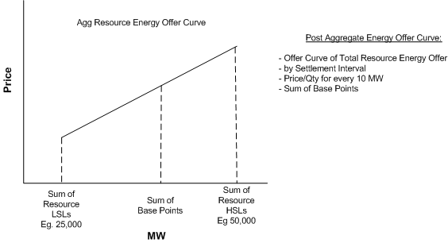

Wind Generation Resource Offer Curve-
Wind farms will be able to have Energy Offer Curves and be able to decrease energy.

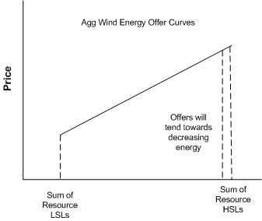

Generation Without Offer Curves (Output Schedules for DSR and non-DSR)-
ERCOT shall also post the sum of LSL and HSLs for all remaining generation without offer curves (O/S and DSRs should be posted) so that a user will know how much capacity SCED has to dispatch.

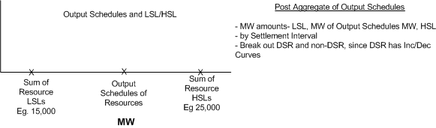

DAM Energy Offers********************************
For each hour settlement interval in the DAM, ERCOT will post an aggregate energy supply curve based on all the offers for energy (three-part supply offers and energy-only offers) that are available to the DAM. The aggregate DAM supply curve will be calculated by ERCOT in 10 MW increments until it reaches the total amount of energy offered in the DAM.
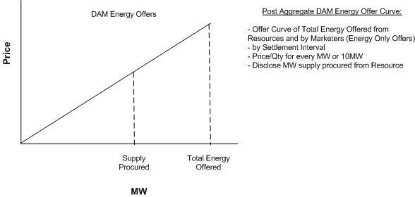

Ancillary Service Offers********************
For each hour, ERCOT will post an aggregate offer curve for each Ancillary Service offered in the DAM. The aggregate offer curve will not consider the effects of ramp rates, generation limitations, transmission congestion limits, trades that may occur subsequent to DAM, on or off line status of the Resource, or any SASM offers.

- Regulation
- Responsive- separate disclosure for each of the Gen/CLR/UFR offer stacks
- Non-Spin

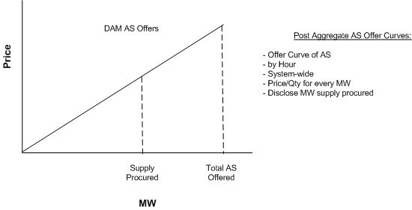

- Self-arranged energy and ancillary capacity services, for each type of service.
Post sum of the total amount of self-arranged ancillary services (AS) for each Service for each hour.

(C) Actual resource output.
This will be an aggregate total of all generators’ actual output for each 15 minute settlement period. (DC Tie resource would be included by definition).

(D) Load and resource output for all entities that dynamically schedule their resources.
Actual resource generation output associated with a DSR load, and the DSR load.

(E) During the operation of the market under a zonal market design, scheduled load and actual load. During the operation of the market under a nodal market design, firm scheduled load, scheduled load with “up to” limits on congestion charges, and actual load.
The nodal protocols do not define “firm scheduled load”, or “up to” limits –
Firm scheduled load- For discussion at TPTF
Up-to-limit- bids for PtP Obligations- and can put not to exceed. For further discussion at TPTF

- During the operation of the market under a nodal market design, the following day-ahead market information in aggregate form shall be posted two calendar days after the day for which the information is accumulated: load bids, including virtual loads, in the form of day-ahead bid curves, and cleared load.
Post total DAM Load bid curve.
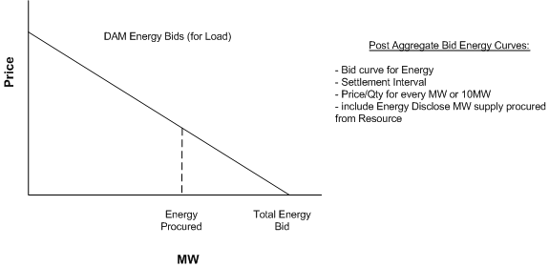

(3) The following information in entity-specific form, for each settlement interval, shall be posted as specified below.
(A) During the operation of the market under a zonal market design:
(i) Portfolio offer curves for balancing energy and for each type of ancillary service, for each area where available, shall be posted 60 days after the day for which the information is accumulated beginning September 1, 2007, except that, for the highest-priced offer selected or dispatched by ERCOT for each interval after January 12, 2007, ERCOT shall post the offer price and the name of the entity submitting the offer 48 hours after the day for which the information is accumulated. In the event of interzonal congestion, ERCOT shall post, separately for each zone, the offer price and the name of the entity submitting the highest-priced offer selected or dispatched.
(ii) If the market clearing price for energy (MCPE) or the market clearing price for capacity (MCPC) exceeds the event trigger during any interval, the portion of every market participant’s price-quantity offer pair for balancing energy service and each other ancillary service that is at or above the event trigger for that service and that interval shall be posted seven (7) days after the day for which the offer is submitted. ERCOT shall implement the requirements of this clause by September 1, 2007.
(iii) Other offer-specific information for each type of service and for each area where available shall be posted 90 days after the day for which the information is accumulated beginning March 1, 2007. Effective March 1, 2008, this information shall be posted 60 days after the day the information was accumulated. The information subject to this disclosure requirement is as follows:
(I) final energy schedules for each QSE;
(II) final ancillary services schedules for each QSE;
(III) resource plans for each QSE representing a resource;
(IV) actual output from each resource; and
(V) all dispatch instructions from ERCOT for balancing energy and ancillary services.
(iv) The information posted shall include the names of the resources in the portfolio that were committed, the name of the entity submitting the information, the name of the entity controlling each resource in the portfolio.

(B) Two months after the start of operation of the market under a nodal market design:

(i) Offer curves (prices and quantities) for each type of ancillary service and for energy at each settlement point in the real time market, shall be posted 60 days after the day for which the information is accumulated except that, for the highest-priced offer selected or dispatched for each interval on an ERCOT-wide basis, ERCOT shall post the offer price and the name of the entity submitting the offer 48 hours after the day for which the information is accumulated.
**************
48-hour posting - Two days after the Operating Day, ERCOT shall post the offer price and name of the entity or entities with energy offer curves for generation resources dispatched in SCED.

60-day posting - Sixty (60) days after the Operating Day, ERCOT shall post for each generation resource the energy offer curve used to dispatch the generation resource in SCED showing prices and quantity pairs between the generation resource’s LSL and HSL.

(ii) If the MCPE or the MCPC exceeds the event trigger during any interval, the portion of every market participant’s price-quantity offer pairs for balancing energy service and each other ancillary service that is at or above the event trigger for that service and that interval shall be posted seven (7) days after the day for which the offer is submitted.
When the LMP exceeds the event trigger, ERCOT will disclose all price and quantity offer pairs above 50 * FIP. Similar method will be applied to posting AS. If one LMP in the system is above the trigger, then disclose ALL system-wide offers above trigger (P-Q pairs above trigger).
§25.505(f)(3)(B)continued

- Other resource-specific information, as well as self-arranged energy and ancillary capacity services, and actual resource output, for each type of service and for each resource at each settlement point shall be posted 60 days after the day for which the information is accumulated.

Two tables will be created for each 15 minute settlement interval using a single snapshot during the first SCED execution in each 15 minute period:

The following Generation Resource data using a single snapshot during the first SCED execution in each Settlement Interval, Generation Resource name, Resource Status, HSL, HASL, LASL, HDL, LDL, LSL, any text reason entered for the HSL being greater than or less than the Resource’s Net Dependable Capability, telemetered Generation Resource net output used in SCED and the Ancillary Service Resource Responsibility for each Ancillary Service.

The following Load Resource data using a single snapshot during the first SCED execution in each Settlement Interval, Load Resource name, Resource Status, Maximum Power Consumption, Low Power Consumption, telemetered real power consumption, and Ancillary Service Resource Responsibility for each Ancillary Service.

(iv) The posted information shall be linked to the name of the resource (or identified as a virtual offer), the name of the entity submitting the information, and the name of the entity controlling the resource. If there are multiple offers for the resource, ERCOT shall post the specified information for each offer for the resource, including the name of the entity submitting the offer and the name of the entity controlling the resource.

Post for each Operating Day for each Resource, the Resource name, the names of the Entities providing information to ERCOT, and the names of the Entities controlling each Resource. ERCOT shall determine the Entity in control of each Resource in accordance with P.U.C. SUBST. R. 25.502(e), Pricing Safeguards in Markets Operated by the Electric Reliability Council of Texas.

(C) The load and generation resource output for each zone, for each entity that dynamically schedules its resources, shall be posted 90 days after the day for which the information is accumulated beginning March 1, 2007. Effective March 1, 2008, the information required by this subparagraph shall be posted 60 days after the day for which the information is accumulated.

A table similar to that required pursuant to item (B) (iii) above will be posted for all Generation Resources with a Resource Status of DSR showing the same information required above.

- ERCOT shall use §25.502(e) of this title (relating to Pricing Safeguards in Markets Operated by the Electric Reliability Council of Texas) as a basis for determining the control of a resource and shall include this information in its market operations data system.

ERCOT will register their Resources under the guidance of this section.

