Principles on Verifiable Cost Process and the existing issues for discussion

- Verifiable Start-up and Min Energy Costs are the most reasonable representations that can be verified by ERCOT for accuracy of a generator’s cost to cycle (start-up and shut down) and run the unit at minimum energy, using a Fuel Index.
  - Breaker Close vs. LSL- Resolution: Start Up Costs will include fuel costs from Start to LSL. The submitting entity will provide verifiable cost from Start to Breaker Close and from Breaker Close to LSL to ERCOT for the Start up calculation (Figure 1 attached to this document).
    - Will require NPRR to address “Breaker Close to LSL”
    - ERCOT will insert methodology into VC Manual
  - Inclusion of Shut-down in Start-up- Resolution: Shut-down fuel costs will be included in Start-up Costs.
    - Define Shut-down as Breaker Open to fuel off
    - Submit verifiable fuel burn between Breaker Open and time to shut-down (Figure 1)
    - NPRR is required to clarify Shut-down as a portion of Start-up
    - Update VC Manual
  - Start-up costs recovered when RUC is cancelled (Not part of the VC Manual)- Resolution: On an ERCOT cancelled RUC, Start-up costs incurred due to a RUC instruction subsequently cancelled by ERCOT are recoverable.
    - Cancelled by ERCOT
    - Rare, can be covered under dispute process
    - NPRR Clarification to address cancelled RUC
  - SPS considerations (Not part of the VC Manual)- Resolution: A resource brought on for a RUC instruction and subsequently brought offline due to SPS will be able to recover Start-up Costs.
    - Rare, can be covered under dispute process
    - NPRR Clarification to address SPS
  - Voluntary VC Process
  - Auxiliary Equipment- Resolution: Auxiliary equipment required for start will be included in Verifiable Costs for Start-up
    - Auxiliary O&M will require verifiable documentation in the Verifiable O&M portion of the process.
    - Fuel component submitted as in (a) above
  - Start up for holding at LSL to Dispatch (definition of RUC Commitment)
    - Table for possible further discussion could already be included in Start and Min Energy costs
  - Number of starts outside warranty
    - Should be included VC Process
    - Move to Section 3

- Verifiable Incremental Heat Rate is the most reasonable representation that can be verified by ERCOT for accuracy of a generator’s incremental cost to operate from LSL/LEL to HSL/HEL, using a Fuel Index.

  - How will ERCOT validate monotonically non-decreasing Incremental Heat Rate Curve- Resolution: ERCOT submitting entity will submit monotonically non-decreasing Incremental Heat Rate Curve as outlined in figure 1 attached.
  - Historical Data versus Test Data- Resolution: Average Incremental Heat Rate curves will be based on submitted test data or historical data
- Verifiable O&M costs are Average Incremental O&M Costs
  - 10-year requirement for data/evidence- Resolution: The submitting entity will provide 10-years of verifiable cost data to ERCOT. In the event the submitting entity does not have 10-years of data, the entity will submit whatever data is available.
  - Escalation rate (review figure 14 in VC manual)- Resolution: Handy-Whitman index in VC manual (and attached as Figure 2 in this document) is a reasonable means of calculating the escalation rate for historical costs. ERCOT will review the ability to include this information in the VC process as this is a subscribed service.
  - Types of acceptable documentation- set aside and moved to Other Items.

- There is a level of risk that Resource owners take in the recovery of Start-up and Minimum Energy costs

- The Verifiable Cost Process intends to make Generators whole and minimize costs to load

- FIP and FOP are defined by Protocols

  - Resolution: Discussions around exceptional events (principle 8) incorporate the issues below related to Fuel Index prices and additional fuel costs that are significant and create additional costs to resources over and above what may be verified. The discussions centered around events when fuel is purchased after the close of gas day and the spot price is significantly higher than index, as well as other costs to secure fuel may be significant. The resolution from the Sub-group is to exclude this from the Verifiable Cost process and begin discussions on a Cost Recovery process for Exceptional Events. The Sub-group will report on this issue to TPTF and seek direction to assign this task to the appropriate working group.
    - Additional Transportation Costs
    - Imbalance Fees
    - Swing Contracts
    - Spot Gas, Gas purchased at Close of Day Ahead (gas diverges from Index)
- Emissions Costs/Credits are an important part of verifiable O&M costs

  - Resolution: The submitting entity may submit verifiable incremental emissions costs in the form of a $/MWh calculated rate based on with incremental costs to include: (TBD)
    - SOX- Use Fuel Burn (mmbtu/start, mmbtu/MWh)
    - Start- (mmbtu/start)* (lbs/mmbtu)* ($/lb)
    - Min Energy- (mmbtu/MWh)* (lbs/mmbtu)* ($/lb)
    - NOX and other emissions can be handled as (a) above with verifiable incremental costs calculating a $/MWh rate
- Resource Owners should have a process to address exceptional events that create significant harm

  - List of exceptional events i.e. Fuel Curtailments, (See 6 above)

- Verifiable Costs Process is to be used prospectively.
- Other Items for discussion
- Inclusion of PPA information for VC Process
- Who provides VC information Resource Entity vs. QSE
- Combined Cycle Units
- Jointly Owned Units
- Documentation requirements

Figure 1: Data to support Verifiable Start-up
Time
Time
Time
MBTU/hr
MBTU/Kwh
Mw
Heat-Rate Over Time
Heat-Rate
KW over Time
Breaker Close
Breaker Open
LSL
Data to Support Verifiable Cost

Figure 2: Examples of creating monotonically non-decreasing Incremental Heat Rate Curves

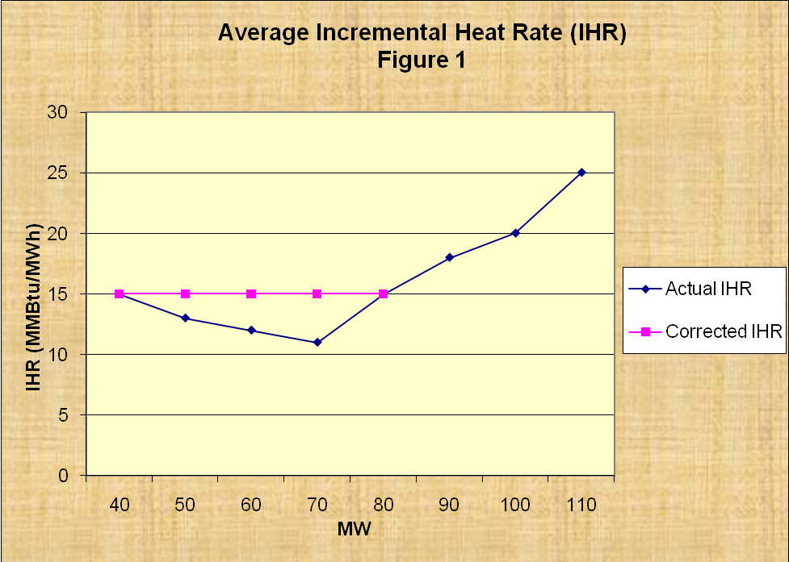

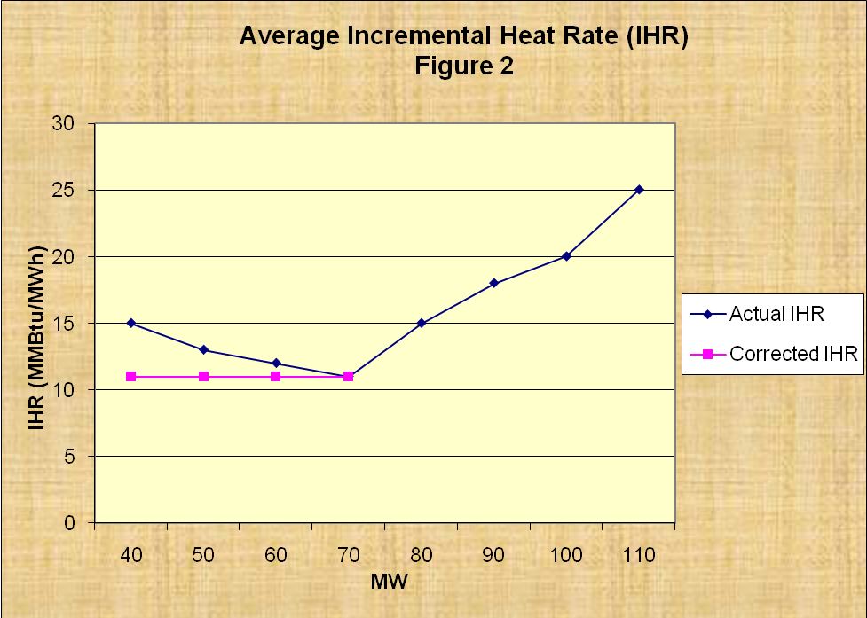
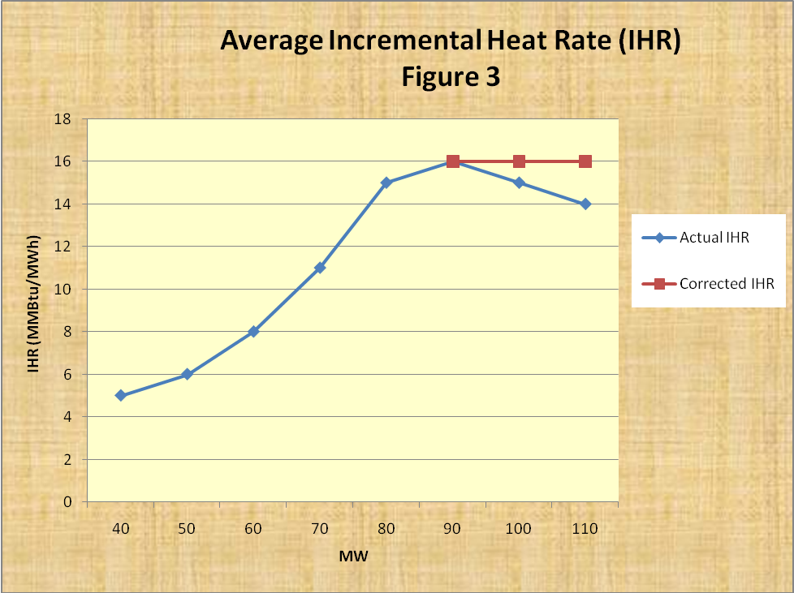

Figure 3: Handy-Whitman Index
