ERCOT Operations Report
December 2007 ROS & OWG
Frequency Control

Time | Freq (Hz) | Duration | Reason
12/1 0:06:40 | 60.102 | 4 s | Out of DRS during schedule change.
12/2 18:17:16 | 60.103 | 4 s | Server Failover. Steel Mill Load drop.
12/5 10:45:57 | 59.864 | 6 s | 450 MW unit trip
12/9 0:04:08 | 60.111 | 1 m 32 s | Out of DRS. Steel Mill Load drop.
12/9 0:09:32 | 60.116 | 1 m 21 s | Out of DRS. Steel Mill Load drop.
12/10 11:23:24 | 59.846 | 12 s | 565 MW unit trip
12/12 1:48:30 | 59.791 | 3 m 8 s | Near DCS event. 2 unit trips totaling 1021 MW.
12/12 1:58:18 | 60.161 | 6 m 7 s | LaaR Response
12/14 7:54:36 | 59.878 | 42 s | 350 MW unit trip
12/15 4:50:22 | 59.897 | 4 s | 265 MW DC Tie trip
12/15 18:04:04 | 60.104 | 10 s | Balancing Error due to incorrect load forecast.
12/19 8:51:38 | 59.828 | 1 m 6 s | 560 MW unit trip
12/26 2:02:46 | 60.134 | 6 m 6 s | SCE corrected 800 MW. Out of DRS.
12/27 5:47:02 | 60.109 | 2 m | Out of DRS. Wind Gen above schedule 400 MW.

Deployed Responsive (Reported Above)

Time of deployed | Stop Time | Duration | Max | Details
12/3 23:19:50 | 12/3 23:26:28 | 0:06:38 | 315.46 | Out of Up Reg
12/5 10:45:57 | 12/5 10:53:31 | 0:07:34 | 539.34
12/5 11:20:54 | 12/5 11:31:20 | 0:10:26 | 351.07 | Out of Up Reg
12/6 6:03:14 | 12/6 6:12:12 | 0:08:58 | 315.46 | Schedule Change
12/8 9:02:34 | 12/8 9:25:58 | 0:23:24 | 330.73 | 2 Units Trip
12/8 18:04:30 | 12/8 18:11:10 | 0:06:40 | 320.54 | Unit Trip
12/10 11:23:26 | 12/10 11:36:40 | 0:13:14 | 630.91
12/12 1:48:30 | 12/12 2:07:52 | 0:19:22 | 931.12
12/14 7:54:38 | 12/14 8:12:10 | 0:17:32 | 468.11
12/15 4:50:24 | 12/15 4:58:05 | 0:07:41 | 371.43
12/15 8:23:36 | 12/15 8:31:10 | 0:07:34 | 325.65 | SCE
12/18 0:00:21 | 12/18 0:12:24 | 0:12:03 | 315.46 | Schedule Change
12/19 8:51:36 | 12/19 9:07:50 | 0:16:14 | 722.51
12/21 21:03:16 | 12/21 21:23:26 | 0:20:10 | 310.37 | SCE
12/22 4:45:20 | 12/22 4:58:56 | 0:13:36 | 320.54 | Deployments held due to RTB failure
12/22 16:35:20 | 12/22 17:01:56 | 0:26:36 | 310.37 | SCE
12/22 17:22:46 | 12/22 18:07:44 | 0:44:58 | 340.9 | WIND SCE
12/22 21:26:14 | 12/22 21:41:16 | 0:15:02 | 325.65 | Unit Runback
12/27 23:33:16 | 12/27 23:40:04 | 0:06:48 | 325.65 | Schedule Change
12/30 23:00:00 | 12/30 23:10:08 | 0:10:08 | 320.54 | SCE

Day Ahead OOMC and RMR Capacity Purchases

Details | RMR | OOMC | RPRS S1 | RPRS S2 | Total
Austin | 0 | 1 | 4 | 5 | 10
Bryan Area | 0 | 0 | 0 | 0 | 0
Corpus | 0 | 0 | 0 | 0 | 0
DFW | 0 | 0 | 0 | 13 | 13
E RIO | 0 | 1 | 2 | 0 | 3
Houston | 0 | 0 | 0 | 8 | 8
Laredo | 47 | 0 | 0 | 0 | 47
North | 0 | 0 | 1 | 9 | 10
Northeast | 0 | 0 | 0 | 2 | 2
San Antonio | 0 | 0 | 0 | 3 | 3
South | 0 | 0 | 0 | 0 | 0
W RIO | 0 | 39 | 0 | 0 | 39
Western | 0 | 23 | 5 | 20 | 48
 | 47 | 64 | 12 | 60 | 183

Historical Totals | Dec-06 | Nov-07 | Dec-07
Austin | 11 | 45 | 10
Bryan Area | 0 | 1 | 0
Corpus | 0 | 0 | 0
DFW | 27 | 16 | 13
E RIO | 5 | 10 | 3
Houston | 1 | 44 | 8
Laredo | 90 | 71 | 47
North | 0 | 26 | 10
Northeast | 0 | 1 | 2
San Antonio | 1 | 18 | 3
South | 0 | 0 | 0
W RIO | 62 | 15 | 39
Western | 0 | 17 | 48
Total | 197 | 264 | 183

http://www.ercot.com/mktinfo/services/rprsdr/index.html

OOME and Congestion Management Activity
Congestion affected by outages
Remedial action plan has been developed for the element

Contingency | Overloaded Element | Days
Temple Pecan Creek - Tradinghouse & Temple Switch - Lake Creek 345 kV | Lorena - Waco West 69 kV | 5
Temple Pecan Creek - Tradinghouse & Temple Switch - Lake Creek 345 kV | Robertson - Watson Chapel 138 kV | 5
Martin Lake - Stryker Creek & Enterprise 345 kV | Elkton 345/138 kV Auto | 5
Temple Pecan Creek - Tradinghouse & Temple Switch - Lake Creek 345 kV | Lake Creek - Temple Pecan Creek 138 kV | 4
STP- Hillje & Whitepoint 345 kV | Blessing - Lolita 138 kV | 4
Odessa EHV - Morgan Creek SES & Quail Switch 345 kV | Big Springs Switch - Big Springs West 138 kV | 4
Menard - Gillespie 138 kV | Menard 138/69 kV Auto #1 | 4
Fort Mason 138/69 kV Auto #1 | Menard 138/69 kV Auto #1 | 3
Trinidad SES - Stryker Creek SES & Mt. Enterprise 345 kV | Athens - Athens North Switch 138 kV | 3
Odessa EHV Switch 345/138 kV Auto #2 | Rexene Nylon Tap - Olefin Switch 138 kV | 3
STP - Blessing 345 kV | Columbus - Stafford 69 kV | 3
Temple Pecan Creek - Tradinghouse & Temple Switch - Lake Creek 345 kV | Sonora - Friess Ranch 69 kV | 3
Baytown Energy Center - Chambers 345 kV | Baytown Auto #1 | 2
Midland East - Odessa EHV 345 kV | Odessa Switch - Moss Switch 138 kV | 2
Fisher Road - Oklaunion & Bowman 345 kV | Liberty REA - Lake Pauline 69 kV | 2
STP - Hillje 345 kV | Blessing - Lolita 138 kV | 2
STP - Whitepoint 345 kV | Blessing - Lane City 138 kV | 2
Lytton Spring - Zorn & Austrop 345 kV | Turnersville - Goforth 138 kV | 2
Austrop 345/138 kV Auto #1 | Austrop 345/138 kV Auto #2 | 2
Sandow - Temple Switch 345 kV | Killeen Fort Hood West - Killeen Clark Road POI 138 kV | 2
Comanche Peak - Decordova & Wolf Hollow - RockCreek 345 kV | Concord Auto | 1
Decker - McNeil & Dessau - Daffin 138 kV | Garfield - Hicross 138 kV | 1
Gillespie - Menard 138 kV | Gillespie - Phillips Mason 69 kV | 1
Lon Hill - Nelson Sharpe 345 kV | Robstown city - City of Robstown 69 kV | 1
Graham - Sweetwater Cogen & Graham - Long Creek 345 kV | Leon Switch - Putnam 138 kV | 1
Cedar Bayou - Chambers & Northbelt 345 kV | Greens Bayou 345/138 kV Auto #1 | 1
Midland East - Odessa EHV 345 kV | Odessa EHV - Rexene Nylon Tap 138 kV | 1
Odessa EHV - Morgan Creek SES & Quail Switch 345 kV | Morgan Creek - Cal Energy 345 kV | 1
Pawnee - Rayburn 138 kV | Rayburn 138/69 kV | 1
South Channel - Jefferson 138 kV | Jefferson - Crown 138 kV | 1
Temple Pecan Creek - Tradinghouse & Temple Switch - Lake Creek 345 kV | Waco West - Waco Woodway 138 kV | 1
Temple Pecan Creek - Tradinghouse & Temple Switch - Lake Creek 345 kV | Menard 138/69 kV Auto #1 | 1
Lytton Springs - Zorn & Austrop 345 kV | Killeen Fort Hood West - Killeen Clark Road POI 138 kV | 1
Blessing 345/138 kV Auto | Columbus - Stafford 69 kV | 1
Enterprise - Trinidad & Martin Lake - Stryker Creek 345 kV | Nacodoches 345/138 kV Auto | 1
Fisher Road - Oklaunion & Bowman 345 kV | Abilene - Potosi Tap 138 kV | 1
Hamilton - Sonora 138 kV | Campwood - Rocksprings 69 kV | 1
Austrop - Lostpines 345 kV | Fayetteville - Winchester 138 kV | 1
Dilley Switch - San Miguel Switch 138 kV | Derby - Pearsall 69 kV | 1
West - North Stability limit |  | 1

Zonal OC1

CSC | Days
North - West | 10
West - North | 7

New RAP

None

New Procedures/Forms/Operations Bulletins

Date | Subject | Bulletin No.
12/21/2007 | Day Ahead Desk, V3 Rev35 | 356
12/20/2007 | Frequency Control Desk - V3R61 | 357
12/19/2007 | Shift Supervisor Desk, V3 Rev42 | 355
12/05/2007 | Frequency Control Desk - V3R60 | 354

Blackout/Load Shed Incidences

None

EECP

None

Major System Voltage Problems

None

Major Computer Problems, Enhancements & Fixes

12/6 13:30 Market System failed to send Ancillary Service awards to Market Participants. Database issues.

12/11 10:45 Held Interval. Oracle issues.

12/13 04:15 Held Interval. Oracle issues.

12/13 18:15 Held Interval. Oracle issues.

12/15 05:30 Held Interval. Oracle issues.

12/22 04:26 Held Interval. Market Clearing Engine issues.

12/31 10:15 – 15:00 Ancillary Service Obligations re-published due to Responsive Reserve Obligation issues.

12/31 13:00 Procurement of Ancillary Services extended to 1500 due to Texas Market Link (TML) issues.

12/31 16:00 – 24:00 Day Ahead time line extended due to Replacement Reserve Service study failed to complete for 1/1/08.

1/1/08 00:00 – 02:00 Eight held consecutive intervals.
- Both issues related to zone changes.

Communication

None

ERCOT peak (Unofficial)

12/17 08:00 43,975 MW

Yearly MTLF Error Comparison

Yearly Mid-Term (Hourly) Load Forecast Error Comparison for the ERCOT Forecast
MAPE for MTLF at 16:00 Day-Ahead
2006 | 2006 | 2007
January | 4.79 | 4.55
February | 4.81 | 3.75
March | 4.95 | 2.70
April | 5.59 | 3.00
May | 3.59 | 3.22
June | 2.65 | 4.46
July | 2.62 | 4.29
August | 2.09 | 3.11
September | 4.03 | 3.78
October | 3.63 | 3.08
November | 3.28 | 2.95
December | 3.44 | 3.74
Annual Average | 3.79 | 3.55

OCN, Advisory, Alerts & Emergency Notices

Capacity
Date | Start | End | Event | Event
12/1 | 0:00 | 0:15 | Advisory | ARR below 3000 MW
12/1 | 11:15 | 24:00 | Advisory | ARR below 3000 MW
12/2 | 0:00 | 4:00 | Advisory | ARR below 3000 MW
12/2 | 20:55 | 24:00 | Advisory | ARR below 3000 MW
12/3 | 0:00 | 0:50 | Advisory | ARR below 3000 MW
12/3 | 3:50 | 13:00 | Advisory | ARR below 3000 MW
12/3 | 5:20 | 10:00 | Alert | ARR below 2500 MW.
12/3 | 17:30 | 23:45 | Advisory | ARR below 3000 MW
12/3 | 17:50 | 22:45 | Alert | ARR below 2500 MW.
12/4 | 17:47 | 22:26 | Advisory | ARR below 3000 MW
12/5 | 0:21 | 9:15 | Advisory | ARR below 3000 MW
12/5 | 17:38 | 22:17 | Advisory | ARR below 3000 MW
12/7 | 23:41 | 24:00 | Advisory | ARR below 3000 MW
12/8 | 0:15 | 24:00 | Advisory | ARR below 3000 MW
12/8 | 8:12 | 15:10 | Alert | ARR below 2500 MW.
12/8 | 18:01 | 19:35 | Alert | ARR below 2500 MW.
12/9 | 0:15 | 7:00 | Advisory | ARR below 3000 MW
12/9 | 9:10 | 24:00 | Advisory | ARR below 3000 MW
12/10 | 0:15 | 7:30 | Advisory | ARR below 3000 MW
12/10 | 11:29 | 24;00 | Advisory | ARR below 3000 MW
12/10 | 18:18 | 21:30 | Alert | ARR below 2500 MW.
12/11 | 0:15 | 5:10 | Advisory | ARR below 3000 MW
12/11 | 18:19 | 23:30 | Advisory | ARR below 3000 MW
12/12 | 2:15 | 5:25 | Alert | ARR below 2500 MW.
12/12 | 17:40 | 23:45 | Advisory | ARR below 3000 MW
12/13 | 18:00 | 23:30 | Advisory | ARR below 3000 MW
12/14 | 9:21 | 20:02 | Advisory | ARR below 3000 MW
12/15 | 17:56 | 23:00 | Advisory | ARR below 3000 MW
12/16 | 20:12 | 22:07 | Advisory | ARR below 3000 MW
12/17 | 7:19 | 7:40 | Advisory | ARR below 3000 MW
12/17 | 18:09 | 21:45 | Advisory | ARR below 3000 MW
12/19 | 3:07 | 6:01 | Advisory | ARR below 3000 MW
12/19 | 5:43 | 6:01 | Alert | ARR below 2500 MW.
12/22 | 17:37 | 24:00 | Advisory | ARR below 3000 MW
12/22 | 18:20 | 24:00 | Alert | ARR below 2500 MW.
12/23 | 0:15 | 10:11 | Advisory | ARR below 3000 MW
12/23 | 0:15 | 4:20 | Alert | ARR below 2500 MW.
12/24 | 1:22 | 11:10 | Advisory | ARR below 3000 MW
12/26 | 17:34 | 23:00 | Advisory | ARR below 3000 MW
12/26 | 17:54 | 21:31 | Alert | ARR below 2500 MW.
12/27 | 18:22 | 22:16 | Advisory | ARR below 3000 MW
12/29 | 4:30 | 12:20 | Advisory | ARR below 3000 MW
12/29 | 18:00 | 23:55 | Advisory | ARR below 3000 MW

Transmission

12/10 11:40 – 12:35 Transmission Alert issued for loss of Military Highway - LaPalma 138 kV overloads Military Highway Transformer #2.

Other
12/12 LaaR deployment due to 2 unit loss totaling 1021 MW.
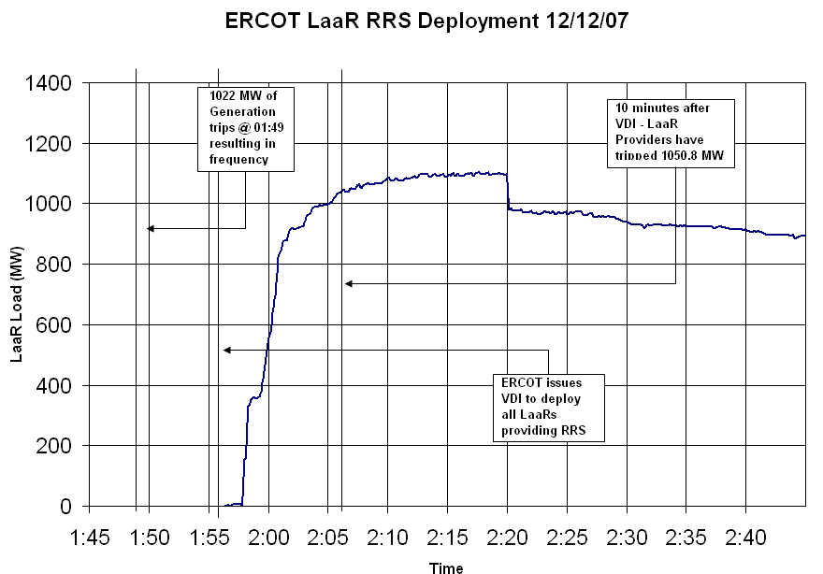

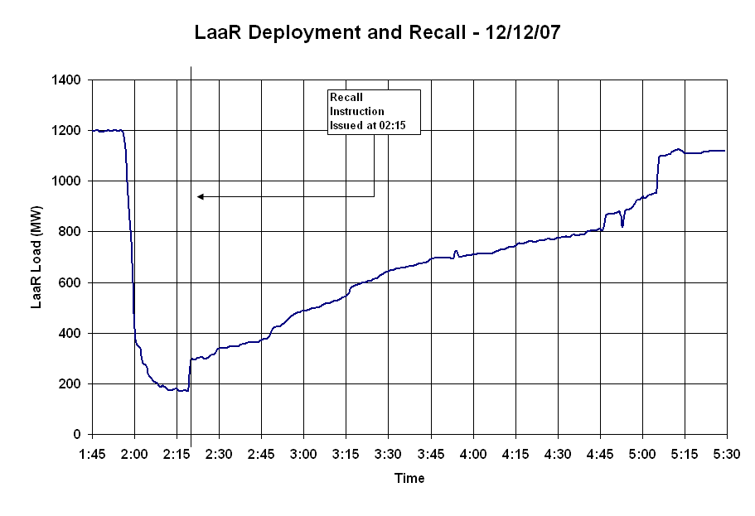
12/23 Opened an Adjustment Period Replacement Reserve Market for hours 19:00-24:00.

