December 10, 2007 TPTF VC Sub-Group meeting Minutes Regarding:
- Incremental Heat Rate Curves, and
- Emission Costs

The TPTF VC subgroup discussed the following two Principles of Verifiable Costs Process:

Principle Number 2:

Verifiable Incremental Heat Rate is the most reasonable representation that can be verified by ERCOT for accuracy of a generator’s incremental cost to operate from LSL/LEL to HSL/HEL, using a Fuel Index.

Principle Number 7:

Emissions Costs/Credits are an important part of verifiable O&M costs.

Notes regarding Principle Number 2

- ERCOT confirmed that QSEs may submit Incremental Heat Rate curves that range from the Low Emergency Limit (LEL) to the High Emergency Limit (HEL).

- A proposal was presented on a methodology for converting Monotonic decreasing IHR curves into Monotonic Non-Decreasing curves. It was suggested adding a straight line as shown in Figure 1 below to make the IHR Monotonic Non-Decreasing.

- It was proposed that ERCOT staff create CORRECTED IHR curves and divide these into 10 equal intervals to obtain the (IHR, MW) pairs used by SCED in Real Time Mitigation.

- Under the proposed approach, the corrected IHR curve would be the straight red line (zero slope) and including the portion of the curve from the 80MW point to the 110 MW point.

- QSEs may only submit one single average O&M value for the operating range between LSL(or LEL) and HSL (or HEL). This will allow ERCOT to choose the 10 individual points and add emission cost values at the specific points along the curve.

ERCOT Concerns and Proposals on Principle Number 2

- QSEs/Resources should calculate and submit CORRECTED IHR curves. ERCOT does not want to correct IHR curves that will be used by MMS to CAP Energy offer curves. ERCOT’s role is to verify that the submitted IHR curves meet the guidelines set forth in the Verifiable Cost Manual, not create curves that will affect QSEs financially.

- Monotonic decreasing IHR curves may be converted into Monotonic Non-Decreasing curves as shown in Figure 1. A horizontal line (zero slope) may be drawn from the (15, 40) point to the (15, 80) point. The corrected curve, line (15, 40) to (25, 110) is now a Monotonic Non-Decreasing curve.

- Another approach is presented in figure 2 for consideration. The difference between the corrected IHR curves shown figures 1 and 2 is that the IHR value used to CAP the Energy Offer under figure 1 is much greater than actual cost (decreasing slope line) when compared to that shown under figure 2. The error associated with correcting the actual IHR as shown in figure 1 appears to be greater than under figure 2 as the unit increases in loading. However, the error in terms of increase cost to the market is bounded by the amount of dispatch times the correction. That is, in the final analysis it may not matter much which option is chosen for correcting the actual IHR curve unless the unit is dispatched (by SCED) at a significant rate. Hence, ERCOT seeks clarification on the best approach to CORRECT Monotonic decreasing curves.

- Regardless of which option is chosen to CORRECT IHR curves, the point at (15, 80) in figure 1 or (15, 70) in figure 2, must be part of the data that are submitted to ERCOT when dividing the curve into equal intervals to obtain the (IHR, MW) pairs used by SCED in Real Time Mitigation.

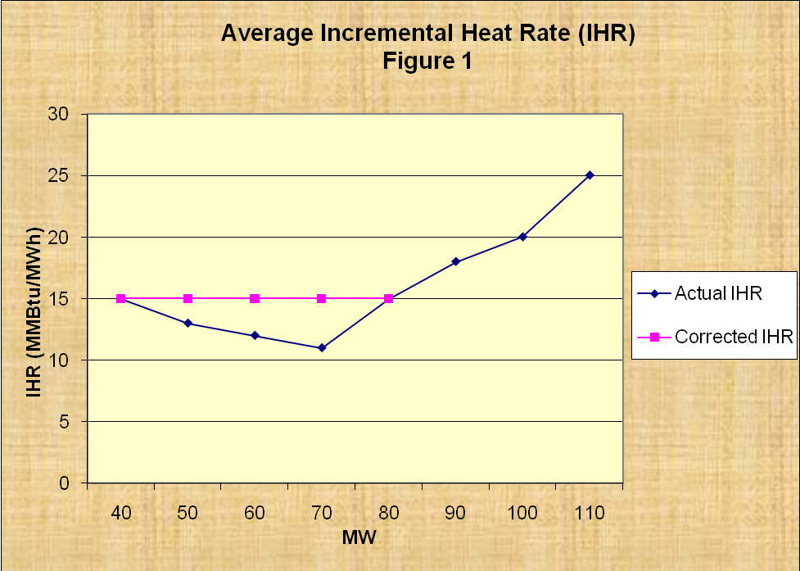

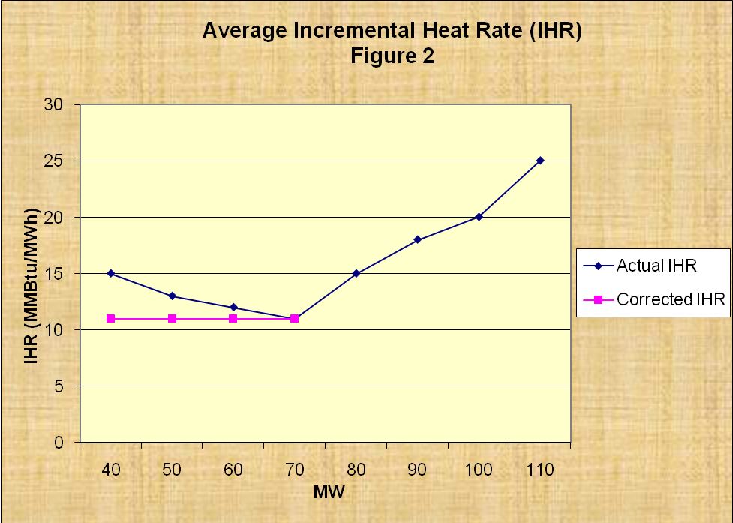

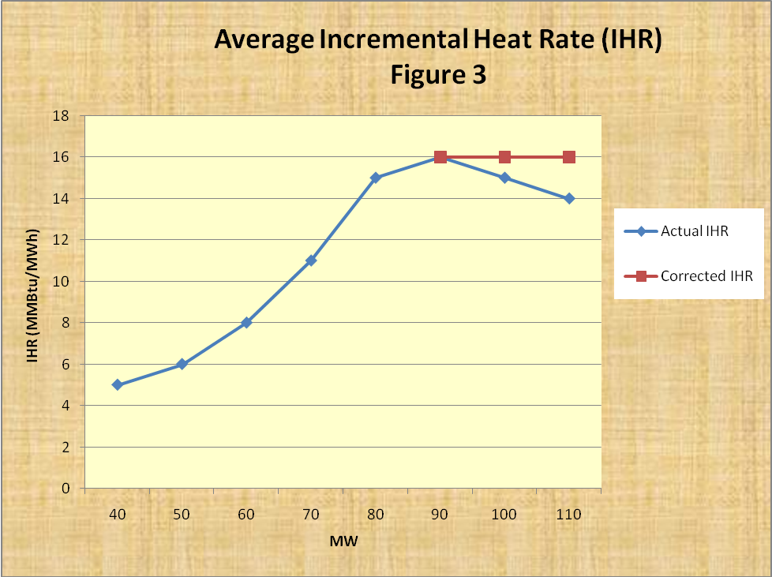

Notes regarding Principle Number 7

- A proposal was presented on a methodology for calculating emission costs to start and operate a resource at and above its LSL (or LEL).

- The proposal was to calculate emission costs (EC) as follow:

EC/start = MMBtu/start x lbs/MMBtu x $/lb

EC/MWh = MMBtu/MWh x lbs/MMBtu x $/lb

Where:

MMBtu/start = Fuel to start

MMBtu/MWh = Fuel to operate on a per MWh basis

lbs/MMBtu = Pounds of SOx allowances per fuel burned

$/lb = Price per pound of SOx allowances

- Proposal was for ERCOT to calculate the emission costs based on some index price for SOx allowances, at each point along the IHR curve, per start and LSL level.

ERCOT Concerns and Proposals on Principle Number 7

- Market needs to agree to an index price for SOx utilizing one of the currently available publications.

- Market needs to agree on the frequency ERCOT needs to calculate EC for the given SOx allowances. For example, should ERCOT calculate EC on a daily, weekly, monthly or annual basis?

- Is it the markets’ expectations that ERCOT build systems to allow MMS to calculate EC or are these calculations suppose to be done manually via the Verifiable Cost process? Daily calculations of EC would not be practical for manual applications and will require an interface with MMS to allow the submission of emission prices.

- How frequently do Resources purchase allowances?

- How frequently do Resources sell allowances?

- Will Resources provide to ERCOT copies of invoices showing the true price paid for allowances or should ERCOT use an index price?

