ERCOT OPERATIONS REPORT
ON THE
EECP EVENT
OF
NOVEMBER 29, 2007

Executive Summary.........................................................................................................................3
Time Line and Description of Significant Events............................................................................4
Observations/Data Review...............................................................................................................6
Load, ARR, & RRS 6
1-HR AVG Real-Time Load & 1-HR AVG Day-Ahead Load Forecast 7
1-HR AVG Real-Time & 1-HR AVG Day-Ahead Online Capacity 8
1-HR AVG Real-Time & 1-HR AVG Day-Ahead Wind Generation 9
Total SCE & Frequency 10
Regulation & Frequency 11
Lessons Learned.............................................................................................................................12
Executive Summary

ERCOT implemented Step One of its Emergency Electric Curtailment Plan (EECP) on
November 29, 2007. Factors that led to ERCOT implementing the EECP Step One:

Prior to the implementation of EECP Step 1, morning load pick up was rising at approximately 3600 MW/hour.

The hourly average day-ahead morning peak load predicted was 34,213 MW. The real-time hourly average load came to 34,836 MW, above the day-ahead forecast by 623 MW. ERCOT experienced an instantaneous peak load of 35,358 MW.

The RPRS study for the Operating Day of November 29th, 2007 procured one unit for local congestion and no units for capacity for the morning hours. The total on-line capacity at HE 07:00 in the RPRS market study was 36,687 MW; the actual on-line system capacity in real-time was 36,098 MW, less than the day-ahead resource plan capacity by 589 MW.

For HE 07:00 wind generation was predicted to generate 1000 MW in the day-ahead market, real-time wind generation was 380 MW, a difference of 620 MW. Between 04:00 to 08:00 real-time wind generation output dropped from 1478 MW to 192 MW, a 1286 MW difference.

At 06:24 ERCOT system recognized all deployable UBES bids were going to be used by hour ending 07:00. Non-Spin was then scheduled to deploy by interval 06:45.

An alert was issued at 06:28 for adjusted responsive reserve (ARR) below 2500 MW.

Unit A tripped at 06:36 at a total of 344 MW. Unit trip was due to a boiler feed water pump issue.

ARR dropped below 2300 MW at 06:34, at 06:48 was when EECP Step 1 was implemented. This was due to the delay in waiting for the initial deployment of Non-Spin at 06:45.

Quick start generation units were called for. Emergency power was not available on the North and East DC-Ties. Non-spin was deployed.

EECP Step 1 was terminated at 08:15.

Time Line and Description of Significant Events

11/29

- 04:05 ERCOT issued an Advisory for ARR below 3000 MW.

- 04:10 ERCOT performed a hotline call for Advisory issued at 04:05. ERCOT requested QSEs keep resource plans updated and notify ERCOT of any changes that will prevent from meeting the Responsive Reserve (RRS) Obligation.

- 05:08 QSE A schedules were not represented correctly. QSE A reported generation values for HE06 174 MW, HE07 242 MW, and HE08 146 MW.

- 05:11 QSE B notified to correct shortage of responsive by 60 MW as soon as possible. QSE B reported that units were being brought online.

- 05:40 QSE A notified to correct 35 MW short on RRS. QSE A reported unit coming up late will cover.

- 06:22 QSE A notified to correct 70 MW short on RRS. QSE A reported unit coming up late will cover.

- 06:24 Non-spin deployed for I.E. 07:00 due to using all “deployable UBES” for interval 06:45.

- 06:28 Alert issued due to ARR below 2500 MW.

- 06:30 Activated North to West at 102% of 390 limit. Deactivated North to West due to the alert and non-spinning coming in. North to West dropped below 100%.

- 06:34 ARR dropped to 2291 MW. Non-spin instructions sent and waiting on Non-spin to fully deploy before OOMC instructions are sent to bring on more generation.

- 06:36 Unit A tripped with 344 MW. Frequency dropped to 59.91 and responsive reserve deployed. Unit A trip was due to a boiler feed water pump issue. Unit is capable of a maximum resource plan capacity of 382 MW.

- 06:36 QSE B had bid schedules incorrect for Hour Ending 07 and 08.

- 06:45 1354 MW of Non-Spin was deployed.

- 06:48 Declared EECP Step 1 due to ARR below 2300 MW. QSEs notified, non-spin deployed for HE 07 and 08. Actual ARR was 1998 MW and ERCOT load was at 35,009 MW.

- 06:49 ERCOT notified SPP that ERCOT has gone into EEA 1.

- 06:54 OOMC to QSE B on Units B, C, D, and E.

- 06:55 Called QSE C and requested any generation available to be scheduled into ERCOT across the NORTH and EAST DC Ties. QSE C informed QSE C will look to see what is available and will call back.

- 06:58 ARR rose above 2300 MW. Actual ARR at 2378 MW.

- 07:08 OOMC to QSE D on Units F and G.

- 07:17 OOMC to QSE E on Units H and I. OOME and OOME VDI were sent out respecting 2 hour minimum run time.

- 07:20 Unit C tripped with 57 MW. Cause unknown at the time, however at 14:54 the same day it was reported Unit C LSL=HSL at 59 MW due to sticking water injection valve. Efforts to correct the problem are underway.

- 07:23 QSE C called and SPP will not authorize any emergency schedules across the NORTH and EAST DC Tie until ERCOT declares EEA Step 3.

- 07:44 Ended OOMC on Units B, C, D, and E for 0800.

- 08:15 Terminated EECP Step 1. ARR at 3280 MW.

- 09:00 Ended alert for ARR. ARR at 3590 MW.

Observations/Data Review

11/29/07 04:00 – 10:00 LOAD, ARR, AND RRS

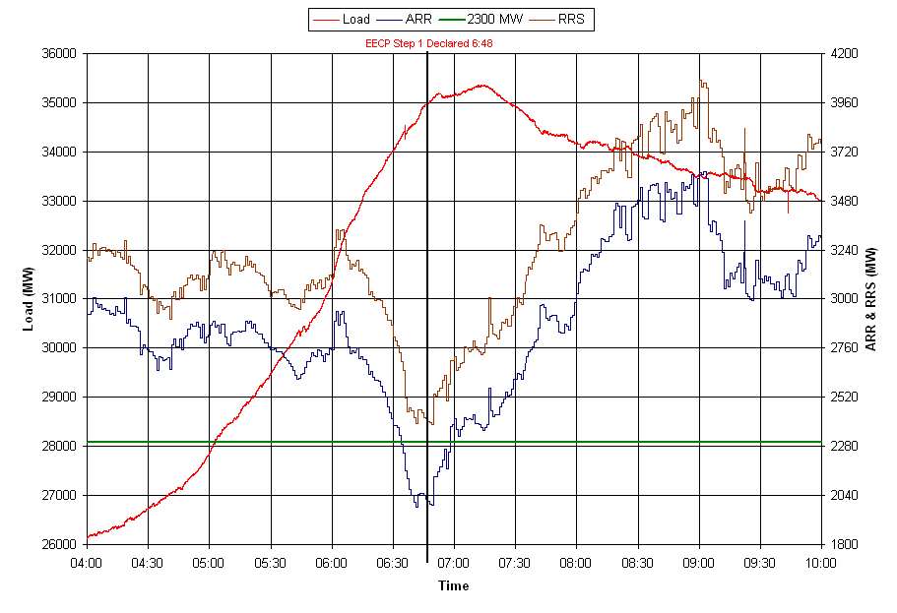
11/29/07 04:00 – 10:00 1-HOUR-AVERAGE REALTIME LOAD AND
1-HOUR-AVERAGE DAY-AHEAD LOAD FORECAST

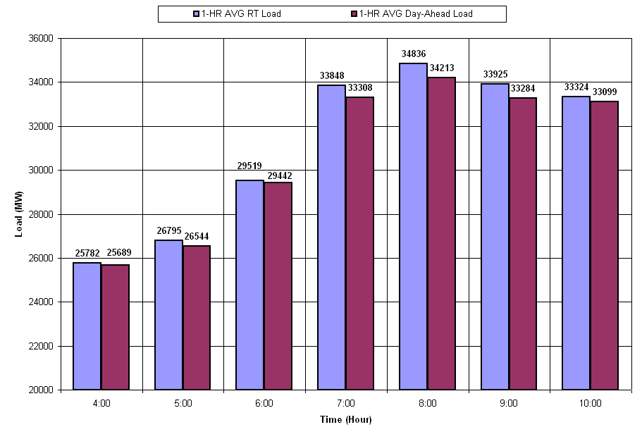
11/29/07 04:00 – 10:00 1-HOUR-AVERAGE REAL-TIME ONLINE CAPACITY AND
1-HOUR-AVERAGE DAY-AHEAD ONLINE CAPACITY

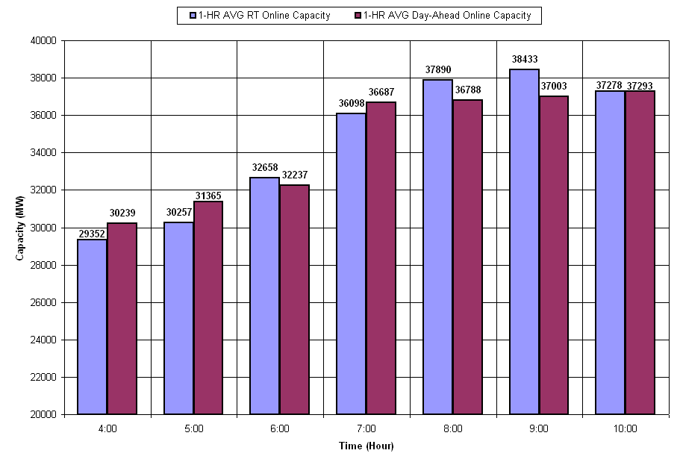

11/29/07 04:00 – 10:00 1-HOUR-AVERAGE REAL-TIME WIND GENERATION AND
1-HOUR-AVERAGE DAY-AHEAD WIND GENERATION

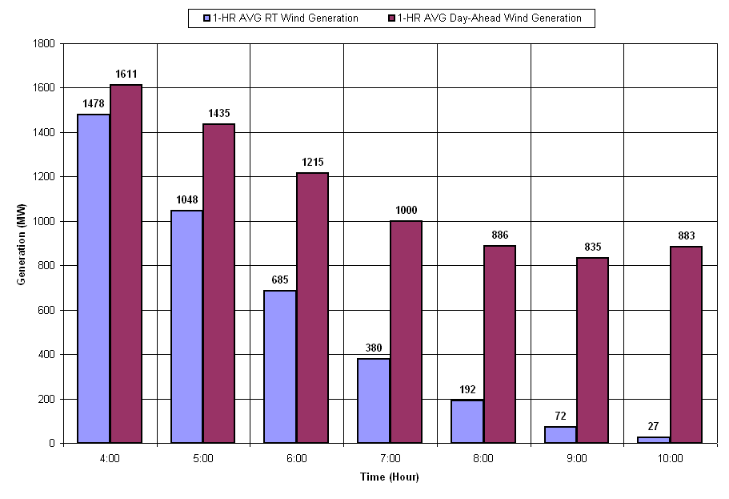
11/29/07 06:00 – 08:00 TOTAL SCE AND FREQUENCY

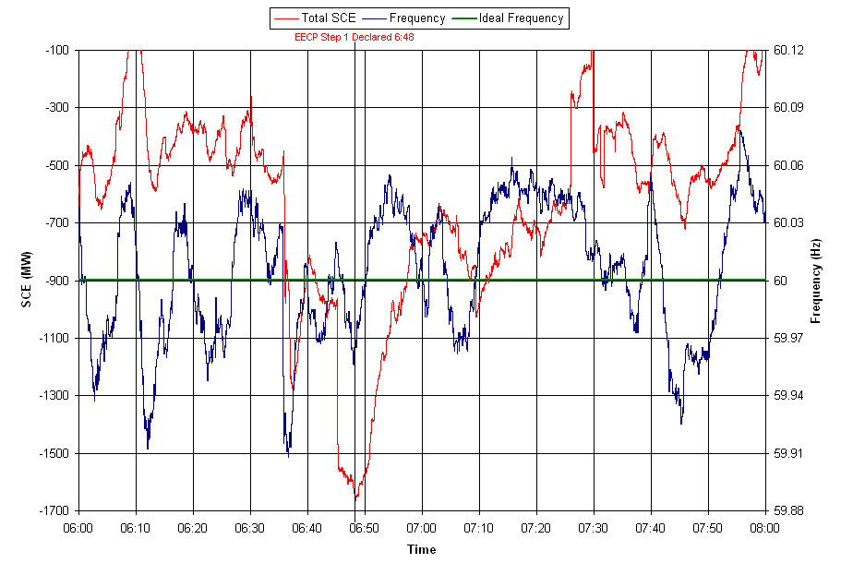
11/29/07 06:00 – 08:00 REGULATION AND FREQUENCY

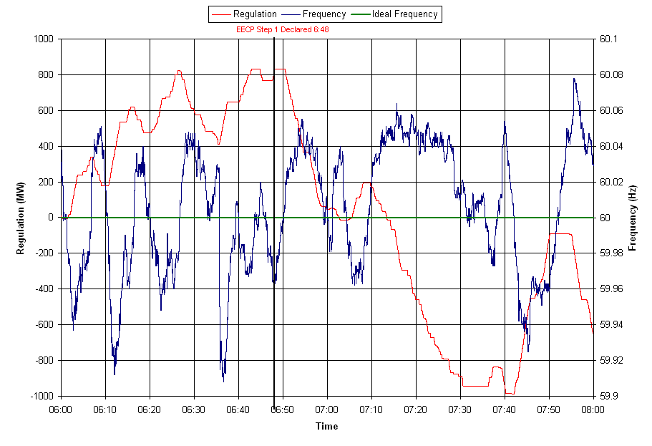

Lessons Learned

- ERCOT will be reviewing requirements of EEA Alert 1 and 2
  - Follow up with SPP for requirements of EEA Alert 1, 2 and 3.

- ERCOT will be reviewing the DC Tie procedures and include the CFE Ties.

