ERCOT OPERATIONS REPORT
ON THE
DCS AND EECP EVENT
SEPTEMBER 5, 2007
Revision 1

Executive Summary..............................................................................................................3
Time Line and Description of Significant Events.................................................................4
Subsequent Information Updated September 17, 2007.........................................................5
Observations/Data Review....................................................................................................6
LOAD, ARR, AND RRS 6
DISTURBANCE FREQUENCY AND RRS DEPLOYED 7
RAW SCADA LAAR PERFORMANCE 8
TOTAL SCE AND FREQUENCY 9
FREQUENCY AND REGULATION 10
Lessons Learned....................................................................................................................11

Executive Summary

ERCOT implemented Step One of its Emergency Electric Curtailment Plan (EECP) on
September 5, 2007. Factors that led to ERCOT implementing the EECP Step One:

Prior to the implementation of EECP, Units A and B tripped at a total of 1084 MW at 7:52 AM as well as the loss of two 345 kV circuits. This event qualified as a Disturbance Control Standard (DCS) event. Frequency recovered to 60 Hz in six minutes and eight seconds, not violating the DCS criteria.

Call for LaaR deployment was initiated at 7:57:57. 1169 MW deployed within the 10 minute mark. 1138 MW of LaaR was scheduled at that time and 95% of the scheduled LaaR deployed in 6 minutes and 20 seconds.

At 8:04 AM EECP was implemented due to Adjusted Responsive Reserve (ARR) dropping below 2300 MW. ARR initially dropped to 1932 MW and recovered to
2268 MW. Prior to disturbance load pick up was 1500 MW/hr.

Quick start generation units were called for until 11:00. Emergency power was not available during the event over the DC Ties. There were no requirements for procuring non-spin at the time.

EECP Step 1 was terminated at 9:33.

Subsequent Information Updated September 17, 2007

- North DC Tie trip at 08:10 was unrelated to the EECP event. The DC Tie tripped due to a bad power supply and was put back into service within 24 minutes with no problems.

- The following is based on the reports submitted by the transmission operators and generator owners:

The two 345 kV lines each received two faults, one single-phase fault and one three-phase fault. Both lines rode through the single phase fault and the breakers opened and reclosed. Line A received a three-phase fault 0.2 seconds after the single-phase fault and was isolated within 3 cycles. Line B received a three-phase fault 0.5 seconds after the single-phase fault and was isolated within 3 cycles.

A tornado in the area had caused two transmission towers supporting both 345 kV circuits to collapse. The line failures with the associated breaker opening and closure operations generated significant voltage and current swings. Units A and B sensed this and indicated this as momentary low generator output. The turbine controls detected a power load unbalance and this initiated an overspeed protection control response. Operation of multiple valves at once caused units’ system service pressure to drop thus sending a signal to the turbine control system and generated a shutdown trip. This action was designed to respond to a condition that may exist in which the unit loses electro-hydraulic fluid absent any external trip conditions.

The control system functioned as designed, and as intended. One of the goals of the control logic is to protect the unit systems in the event of severe load and frequency swings and imbalances. The control system tripped the units before damage could occur, and the units were restarted and returned to service the same day.

- LaaR deployment graph has been updated to reflect all LaaR that are currently in the system and that operated during the event.

Time Line and Description of Significant Events

- 1:00 Advisory issued ARR below 3000 MW. Actual at 2881 MW.

- 6:17 Frequency dropped 59.91 Hz due to heavy load pick up load. Actual load was
35,111 MW. Deployed 315 MW of responsive reserve (RRS). Load was rising at 1500 MW/hr.

- 7:52 Two 345 kV circuits tripped and Units A and B tripped at a total of 1084 MW.
Frequency dropped to 59.739 Hz. High winds and a possible tornado were reported in the area. Deployed 1162 MW of RRS.

- 7:52 High set LaaR deployed due to frequency below 59.8 Hz.

- 7:57 ERCOT issued LaaR deployment at 07:57:57 due to DCS event. 1169 MW
deployed within the 10 minute mark. 1138 MW of LaaR was scheduled at that time and 95% of the scheduled LaaR deployed in 6 minutes and 20 seconds.

- 08:00 Alert issued ARR below 2500 MW. Actual at 2368 MW.

- 08:04 Issued EECP Step 1 due to ARR below 2300 MW. ARR initially dropped to
1932 MW and recovered to 2268 MW.

- 08:10 QSE reports that North DC Tie tripped off line with 64 MW flowing out of
ERCOT. Trip was due to a bad power supply. DC Tie was back in service 24 minutes later.

- 08:15 OOME VDI Units C, D, E, F, G, H & I.

- 08:29 – 8:40
  - Requested emergency power from DC Ties. Emergency power was not available.

- 08:31 OOMC GTs J, K, L, M, N, O, P, & Q.

- 09:15 Started calling QSEs individually to restore LaaRs at 09:15 and finished
approximately 09:26 with request to fully restore LaaRs.

- 09:33 EECP Step 1 terminated. ARR is at 3395 MW.

- 09:34 Called SPP and informed them that ERCOT cancelled EECP Step 1.

- 11:00 Ended all OOMC/OOME quick start generation.

Observations/Data Review

09/05/07 07:00 – 10:00 LOAD, ARR, AND RRS

09/05/07 7:50 – 9:30 DISTURBANCE FREQUENCY AND RRS DEPLOYED
Pre-disturbance frequency = 60.003 Hz

09/05/07 7:37 – 8:37 RAW SCADA LAAR PERFORMANCE

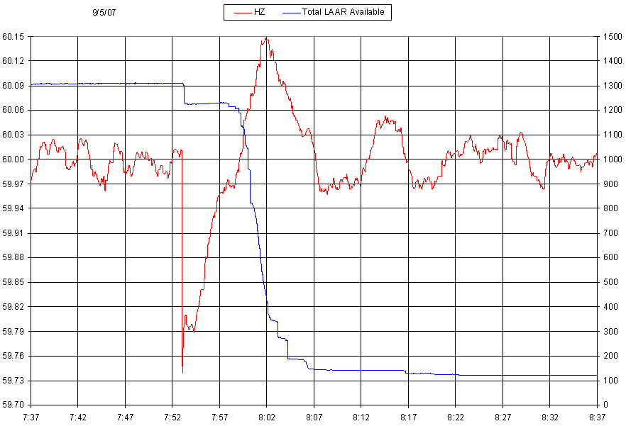
09/05/07 07:00 – 10:00 TOTAL SCE AND FREQUENCY

09/05/07 07:00 – 10:00 FREQUENCY AND REGULATION

Lessons Learned

- LaaR deployment and RRS deployment recovered frequency without violating the Disturbance Control Standards.

- NERC report EOP-004 was filed for the DCS Event.

