MIS and MMS
This prototype shows how the Day-Ahead Market landing page currently looks. In this example, each of the DAM results reports is displayed in its own portlet, with the most recent at the top. In this instance, there would be eight actual report portlets on the page – one for each report.
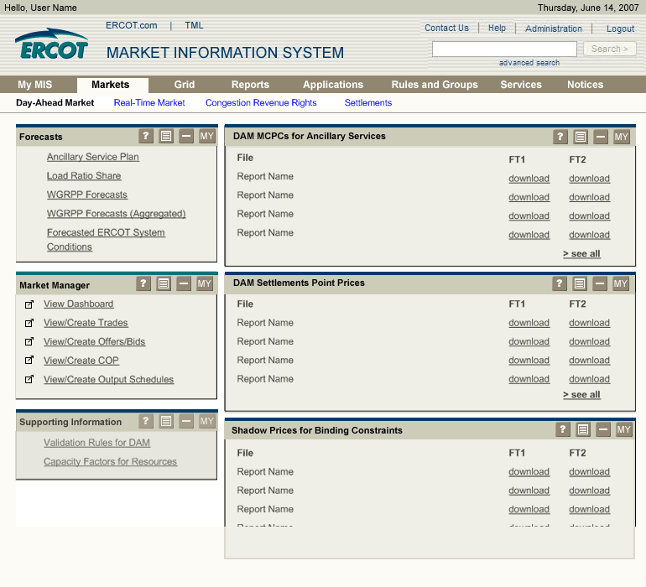
This prototype shows how the Day-Ahead Market landing page would look if all the DAM result reports appear in the same portlet. In this example, the portlet on the right would have all eight of the reports (only 3 shown here) that are the most current. To view older reports, you would click on archives. That would take you to a portlet that has all the previous days’ reports, similar to the report portlets shown on the previous page. This would reduce the number of portlets on this page.

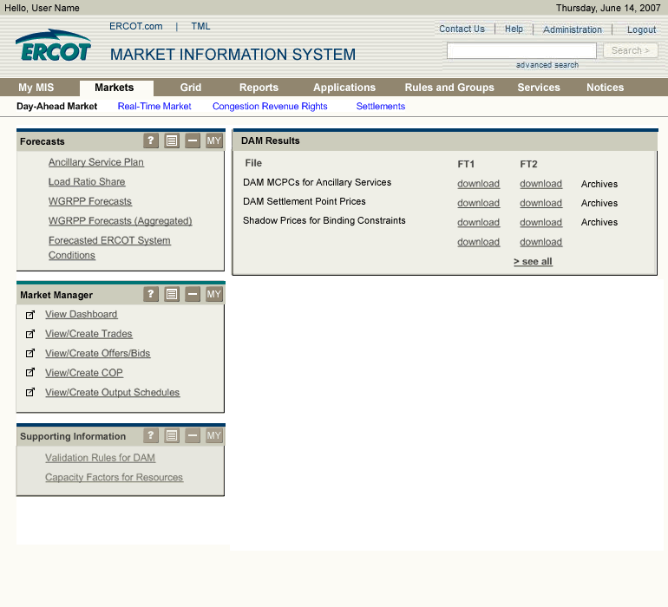
This prototype shows what you would see if you clicked on Create/View Trades, from the DAM landing page. By default, this application opens within the portal or inline. The “tearaway” icon allows you to open this application in its own window, shown in the next example

