2008 CSC Analysis

The Congestion Management Working Group (CMWG) met on August 3, 2007 to review the Commercially Significant Constraint (CSC) analysis provided by ERCOT on July 16 and 24, as a result of its review CMWG concluded that it would review two proposals and possibly a third proposal to be submitted by Mr. Mark Garrett at its August 13 meeting. On August 7, Mr. Garrett communicated to the CMWG via email that he would not be submitting a third proposal and would support the selection of Sandow - Temple as a bi-directional CSC for North to South and South toNorth. No other proposals were received by the close of business on August 7.

Proposal 1: ERCOT
Recommend four zones and designation of the following as the 2008 CSCs:
- S_N and N_S: Sandow-Temple 345kV
- N_H: Jewett to T.H. Wharton and Gibbons Creek to O’Brien 345kV
- W_N and N_W: Graham to Parker and Benbrook 345kV

In this clustering:
- STP clusters into the Houston zone.
- Colorado Bend and Texas Gulf cluster into the Houston zone.
- Reached maximum transfer in the South to Houston in VSAT, based on recent history
- 171.55 MWs of load moving zones

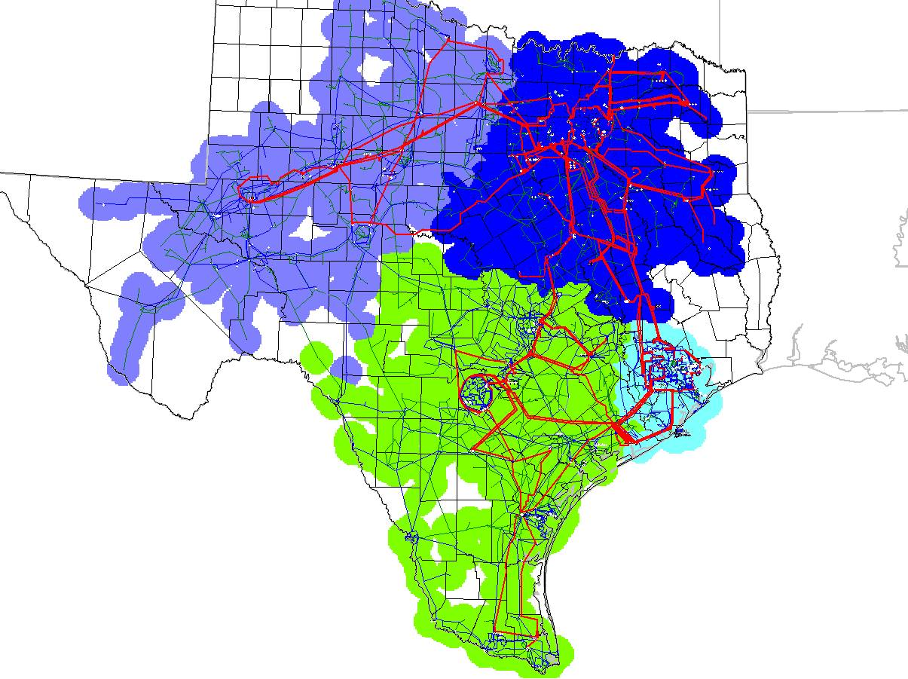

Proposal 2: Alternate
Recommend four zones and designation of the following as the 2008 CSCs:
- S_N and N_S: Sandow-Temple 345kV
- N_H: Jewett to T.H. Wharton and Gibbons Creek to O’Brien 345kV
- W_N and N_W: Graham to Parker and Benbrook 345kV
- S_H: STP – Dow 345kV

In this clustering:
- STP clusters into the South zone.
- Reached maximum transfer in the south to Houston in the August TCR calculation; no limit found, this assumes Hillje is in place.
- Reached maximum transfer in the south to Houston in VSAT, based on recent history
- 16.68 MWs of load moving zones

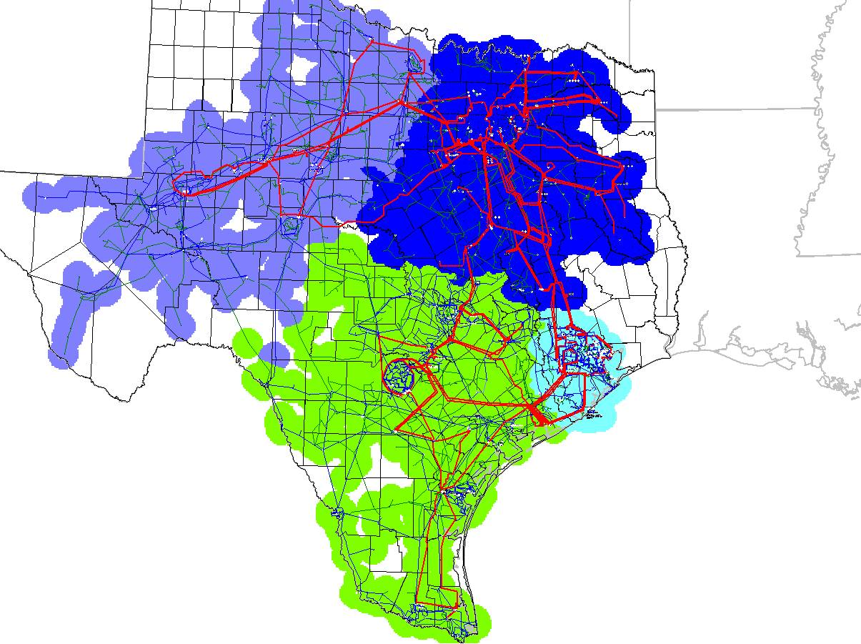

Other Data Requested

In addition to the clustering analysis for Proposal 2, CMWG requested the Zonal Shift Factors and the coefficient of determination (R²) as required by Protocols Section 7.2.2, Congestion Zone & Zonal Shift Factor Determination Methodology. This information is being provided for both proposals in these files:

Shift Factors and R²: 2008CSCanalysis_ShiftFactors.xls
Bus zone mappings: 2008BusCMZone_map20070809.xls

Total unavailable capacity in the South zone used in the volatage stability analysis of 2088 MWs, indicated that voltage was stable up to 3500 MWs with no additional generation available.

Estimated range of limits for the North to South CSC of 227-333 MW, these limits were calculated between July 20-24.

