NOGRR  Number | 007 | NOGRR Title | Nodal Operating Guides - Section 7, Telemetry and Communication
Date |  | August 9, 2007
Submitter’s Information
Name |  | Curtis Crews
E-mail Address |  | ccrews@ercot.com
Company |  | ERCOT
Phone Number |  | 512-248-3139
Cell Number
Market Segment

Overall Market Benefit
Overall Market Impact
Consumer Impact

Comments

ERCOT proposes revisions to clarify Telemetry and Communication requirements and additional administrative changes to Section 7 of the Nodal Operating Guides, Section 7.1.1, ERCOT Wide Area Network, including Figure 1, ERCOT Wide Area Network, Section 7.1.2 ERCOT’s Responsibilities, Section 7.1.3, QSE and TSP Responsibilities, and Section 7.1.4, Joint Responsibilities (Maintenance and Restoration). The author for this set of ERCOT comments is noted as “ERCOT – Additional Comments 2”.

Proposed Nodal Operating Guide Language Revision

ERCOT Nodal Operating Guides

Section 7: Telemetry and Communication

(Effective Upon Texas Nodal Market Implementation)

7 Telemetry and Communication 1
7.1 ERCOT Wide Area Network 1
7.1.1 ERCOT’s Responsibilities 2
7.1.2 QSE and TSP Responsibilities 3
7.1.3 Joint Responsibilities (Maintenance and Restoration) 4
7.2 ERCOT ICCP Interface 10
7.2.1 Quality Codes 10
7.2.2 Metric of Availability 13
7.3 Telemetry 14
7.3.1 Data from ERCOT to QSEs 15
7.3.2 Data from ERCOT to TSP 15
7.3.3 Data from QSEs and TSPs to ERCOT 16
7.3.3.1 Weather Zone Data 17
7.3.4 TSP and QSE Telemetry Restoration 17
7.3.5 General Telemetry Performance Criterion 18
7.4 Calibration and Testing of Telemetry Responsibilities 18

7 Telemetry and Communication

7.1 ERCOT Wide Area Network
(1) ERCOT interfaces with each Qualified Scheduling Entity (QSE) and Transmission Service Provider (TSP) over a Wide Area Network (WAN). ERCOT is responsible for the configuration, maintenance, and management of the communications hardware required to support WAN connectivity. The ERCOT WAN is a fully redundant, highly available network designed for Real Time data transport and is split in to two separate private networks; an Multiprotocol Label Switching (MPLS) network and a Point-to-Point network. See Figure 1, ERCOT Wide Area Network.
(2) The MPLS network is provisioned with a full T1 (1.544Mbps) to each WAN participant. The primary purpose of the MPLS network is to facilitate Transmission Control Protocol/Internet Protocol (TCP/IP) connectivity between ERCOT and the market for critical market data, most notably ICCP and applications programming interface (API) data.
(3) The Point-to-Point network is provisioned with adequate Digital Signal “zero” (DS0) channels to support specific Market Participant requirements. The Point-to-Point network’s main function is to provide voice communication to the Market Participant. Each Market Participant will be allocated the appropriate number of DS0s to support their particular configuration. The Point-to-Point network is also configured to provide redundancy to the MPLS network. In the event of an MPLS network failure, the Point-to-Point network is designed to route IP data traffic. Due to voice channelization associated with the Point-to-Point network, the maximum amount of data redundancy available is 1280Kbps.
(4) The ERCOT WAN provides communication for the following:
(a) Real Time telemetry data exchange for wholesale operations, frequency control, and transmission security;
(b) Operational voice communications for both normal and emergency use. The ERCOT WAN supports off-premise exchanges (OPX) with ERCOT’s control facilities and the ERCOT hotlines; and
(c) Data exchange to support API routines. These include power scheduling, operating plans, outage requests, dispatch instructions, posting of information and other applications.

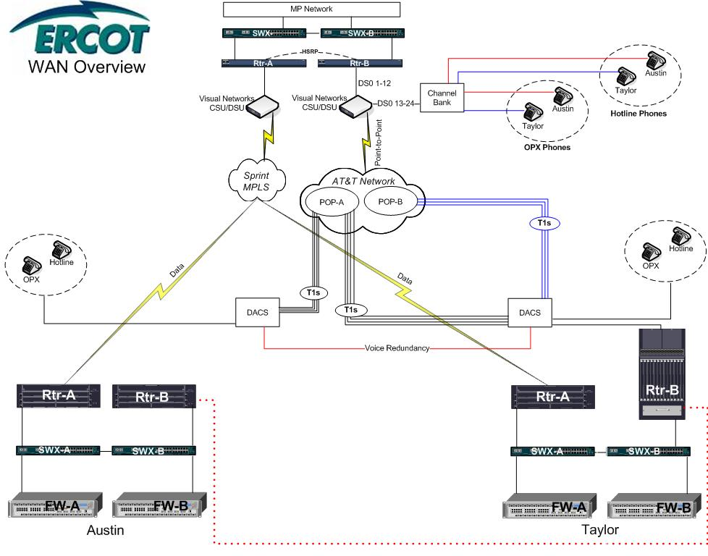
Figure 1 - ERCOT Wide Area Network

    - ERCOT’s Responsibilities
ERCOT’s responsibilities include the following:

(a) Supply Customer Premises Equipment (i.e. equipment at Market Participant facilities for the WAN) including routers, Channel Service Units/Data Service Units (CSU/DSUs), Local Area Network (LAN) switch/hub and all support equipment for management purposes;
(b) Order and provision of local loop, network access point and transport;
(c) Provide 24-hour network monitoring and management;
(d) Provide 24x7 maintenance, with 4-hour response, for all ERCOT equipment located at the Market Participant site; and
(e) The ERCOT Helpdesk will be the single point of contact for all network issues. The ERCOT Helpdesk will provide periodic updates to the Market Participant until the issue is resolved.
7.1.2 QSE and TSP Responsibilities
QSE and TSP Responsibilities include the following:

(a) TSPs and QSEs whose facilities connect to the ERCOT WAN are required to sign an agreement with ERCOT governing installation, operation and maintenance of the WAN hardware. Appropriate WAN documents can be obtained by contacting the ERCOT Account Manager.
(b) ERCOT WAN participants shall provide physical security systems compliant with the applicable Critical Infrastructure Protection (CIP) requirement of the North American Electric Reliability Corporation (NERC) Reliability Standards
(c) Any TSP or QSE facility, whether primary or back-up, will be required to connect directly to the ERCOT WAN; this includes connectivity to both the MPLS and Point-to-Point networks. The WAN connection will terminate at the Market Participant’s control center.
(d) Market Participants that serve both TSP and QSE functions at one location will only require one ERCOT WAN connection at that location.
(e) If a TSP and QSE share a centralized private branch exchange (PBX), separate off-premise exchange (OPX) circuits will be terminated for each function or participant.
(f) Market Participants shall not connect the ERCOT hotline voice system through their PBX system. For each Market Participant represented, a physical 500 set is required for connectivity to the Hotline system. This will ensure that ERCOT has uninterrupted voice communication to the Participant in the event the Participant’s PBX system fails.
(g) Each TSP and QSE must provide internal facilities and communications to collect and furnish data and voice signals to the ERCOT WAN as required by the ERCOT Protocols. For TSPs these include, but may not be limited to, voice communications, Inter-Control Center Communication Protocol (ICCP), and Supervisory Control And Data Acquisition (SCADA) for substations and other Transmission Facilities. For QSEs, these include, but may not be limited to, voice communications, ICCP, and SCADA for Resources.
(h) QSEs and TSPs shall supply, implement, and maintain all data and voice communication facilities required to fulfill the obligations set forth in these Operating Guides.

(i) ERCOT WAN participants shall provide adequate physical facilities to support the ERCOT WAN communications equipment. The physical facilities and communications equipment requirements include:
(i) Provide an analog business phone line or PBX analog extension for troubleshooting and maintenance of equipment;
(ii) Provide a height of 24” of rack space in a 19” wide rack;
(iii) Provide two separate UPS single-phase 115 VAC 20 amp circuits, each with 4 receptacles in the 19” rack listed above;
(iv) Provide building wiring from circuit termination to equipment rack;
(v) Within 24-hours notice, provide ERCOT employees or contractors access to the communication facility;
(vi) Within 1-hour notice, provide emergency access to the facility to ERCOT employees or contractors;
(vii) Provide on site personnel to escort ERCOT employees or contractors;
(viii) Provide a firewall or router, located at the Market Participant site, for the network address translation of internal Market Participant addresses to external addresses on the ERCOT LAN;
(ix) Provide connectivity from Market Participant firewall or router to ERCOT LAN located at Market Participant site. Market Participants are responsible for their own security through this connection;
(x) Provide a channel bank with at least one T1 interface and 4 FXS ports. Connect FXS (e.g. PBX, key system) to the appropriate equipment. On the digital T1 stream, levels for voice are zero dpm for transmit and receive;
(xi) Hotline must be a 500 set not attached to the Market Participant’s Phone System;
(xii) Dual cable entrances to Market Participant, connecting to different Telco Central Offices is highly recommended; and
(xiii) Provide ERCOT with internal IP addressing scheme as needed for network design. This will be kept confidential.
7.1.3 Joint Responsibilities (Maintenance and Restoration)
Joint responsibilities for ERCOT WAN-connected Market Participants and ERCOT include the following:

(a) Coordinate maintenance and restoration activities so reliability is not compromised;
(b) All primary and back-up circuits shall be tested annually or as otherwise requested by ERCOT for end-to-end performance;
(c) ERCOT will specify test procedures for hotline and any back-up or alternate path voice circuits;
(d) Test equipment to be used for the calibration or repair of communication equipment shall be certified to values of accuracy and precision. The standard used for testing shall be superior to the tested equipment calibration requirements; and
(e) Scheduled maintenance of any WAN hardware/software shall be coordinated between ERCOT and the affected Market Participant. The Market Participant shall provide reasonable outage windows for ERCOT support personnel to upgrade and repair equipment.

7.2 ERCOT ICCP Interface
The ICCP over the ERCOT WAN provides the Real-Time telemetry data from Market Participant computers, computer networks, or other devices. Market Participants providing the data using an ICCP link must format their data and coordinate installation according to the ERCOT WAN Agreement found in the ERCOT Nodal ICCP Communication Handbook. The ERCOT Nodal ICCP Communication Handbook provides additional details and shall be used in conjunction with the Protocols and Operating Guides to facilitate the communication needs of ERCOT and Market Participants to effectively manage system and market requirements. Updates to the ERCOT Nodal ICCP Communication Handbook shall be approved by the Technical Advisory Committee (TAC). The Protocols and Operating Guides have authoritative precedence over any discrepancy in the ERCOT Nodal ICCP Communication Handbook.

7.2.1 Quality Codes
Status and analog telemetry data provided to ERCOT shall have the associated quality codes and associated attributes found in the ERCOT Nodal ICCP Communication Handbook. ICCP quality codes to be provided to ERCOT by the Market Participant and to the Market Participants by ERCOT shall follow the standards set in the ERCOT Nodal ICCP Communication Handbook.

Table 1: ICCP Quality Codes from Market Participants to ERCOT
7.2.2.1.2 ICCP Quality Codes from ERCOT to Market Participants
The following Table 2: ICCP Quality Codes from ERCOT to Market Participants, describes the ICCP quality codes to be provided to the Market Participant by the ERCOT, the conditions under which each ICCP quality code is set, and the translation from the local ERCOT Real-Time database quality codes to the related ICCP quality code.

7.2.2 Metric of Availability
(1) ICCP links must achieve availability as prescribed by the TAC approved Telemetry Standards located on the ERCOT MIS Public Area. Availability metrics shall establish a process to coordinate downtime for ICCP links and database maintenance.
(2) ICCP links shall use fully redundant data communication from the QSE and TSP control systems to the ERCOT System as required by the Protocols

.
7.3 Telemetry
(1) QSE and TSP control centers required to supply Real-Time telemetry data to ERCOT shall use an ICCP interface through the ERCOT WAN. TSPs and QSEs shall also receive signals from ERCOT over the ICCP interface.

(2) Each QSE and/or TSP shall continuously provide to ERCOT the telemetry data quantities that they are responsible for in the format described in the ERCOT Nodal ICCP Communication Handbook. The frequency of updates, means of communication to ERCOT, and data format for each point provided by each Entity shall follow the specifications in the ERCOT ICCP Nodal Communications Handbook. At the frequency specified, each update cycle shall provide current operating data for all points being monitored. Design accuracy and availability of data points delivered to ERCOT shall satisfy the requirements of the Protocols and the TAC approved Telemetry Standards.
(3) QSEs, Resources and TSPs are required to provide power operation data to ERCOT according to the Protocols and the ERCOT ICCP Nodal Communications Handbook.

(4) The nomenclature format of data (i.e structure of the ICCP Object Name) shall follow the standards in the ERCOT Nodal ICCP Communication Handbook.
7.3.1 Data from ERCOT to QSEs
(1) ERCOT shall provide all required data and issue instructions to QSEs in accordance with the Protocols and the ERCOT Nodal ICCP Communications Handbook.
(2) ERCOT shall follow data requirements and standards described in the ERCOT Nodal ICCP Communication Handbook.
7.3.2 Data from ERCOT to TSP
(1) ERCOT shall provide operational data to the TSP in accordance with the Protocols and the ERCOT Nodal ICCP Communications Handbook.
(2) ERCOT is required to provide operational data to TSPs for the purpose of providing reliability information on current conditions. TSPs may request QSE supplied data as allowed by the Protocols.

(3) ERCOT will post notice to Market Participants of all available data.
7.3.3 Data from QSEs and TSPs to ERCOT
(1) Each TSP and QSE shall provide telemetered measurements on modeled Transmission Elements as required by the Protocols and the ERCOT Nodal ICCP Communications Handbook.
(2) QSEs and TSPs shall provide Real-Time monitoring of power system quantities to ERCOT as defined in the Protocols and the ERCOT Nodal ICCP Communications Handbook. ERCOT shall work with TSPs and QSEs to determine the required data using the methodology presented in the Protocols. Transmission Element status and analog measurements that the TSPs and QSEs define in the Network Operations Model shall, at a minimum, be provided to ERCOT. Ultimately, it is the responsibility of the TSPs and QSEs to provide all data requested by ERCOT.
(3) Real-Time telemetry data from QSEs used to supply power or Ancillary Services shall be integrated by ERCOT and checked against settlement meter values on a monthly basis.

(4) Each QSE and TSP shall notify ERCOT as soon as practicable when telemetry will not be available or is unreliable for operational purposes. When ERCOT receives notification, the associated points shall be removed from the TAC approved Telemetry Standard performance metrics calculations.
(5) Each QSE and TSP shall notify ERCOT as soon as practicable when telemetry is returned to normal state.
7.3.3.1 Weather Zone Data
(1) A TSP that is responsible for providing Weather Zone tie-line measurement data to ERCOT is required to establish a backup to the primary source.
(2) TSPs having an Energy Management System (EMS) with a native ICCP application capable of four second periodic data set transfers with minimum 300 points per data set, and hot standby backup ICCP servers with automatic fail-over capability, shall provide an additional ICCP association across the ERCOT WAN for the transfer of Weather Zone tie line measurements. ICCP nodes should exist at primary and backup facilities.
7.3.4 TSP and QSE Telemetry Restoration
Real-Time telemetry data shall be restored using criteria and procedures as established by the TAC approved Telemetry Standard.

7.3.5 General Telemetry Performance Criterion
All Real-Time telemetry as required by the Protocols shall meet the State Estimator Performance and the TAC approved Telemetry Standards.
7.4 Calibration and Testing of Telemetry Responsibilities

It is the responsibility of the owner of telemetry equipment to ensure that calibration, testing and other routine maintenance of equipment is performed consistently with the provisions of the Protocols, the TAC approved Telemetry Standards, and Good Utility Practice.

