2008 CSC Recommendation

The clustering analysis and bus locations provided were developed using the Steady State Working Group (SSWG) 2008 Summer Peak case, data set A.

Based on its analysis, ERCOT recommends four zones and designation of the following as the 2008 CSCs:
- S_N and N_S: Sandow-Temple 345kV
- N_H: Jewett to T.H. Wharton and Gibbons Creek to O’Brien 345kV
- W_N and N_W: Graham to Parker and Benbrook 345kV

This clustering represents ERCOT’s recommendation:
- STP clusters into the Houston zone.
- Colorado Bend clusters into the Houston zone.
- Texas Gulf clusters into the Houston zone.
- Reached maximum transfer in the south to Houston in the August TCR calculation; no limit found, this assumes Hillje is in place.
- Reached maximum transfer in the south to Houston in VSAT, based on recent history

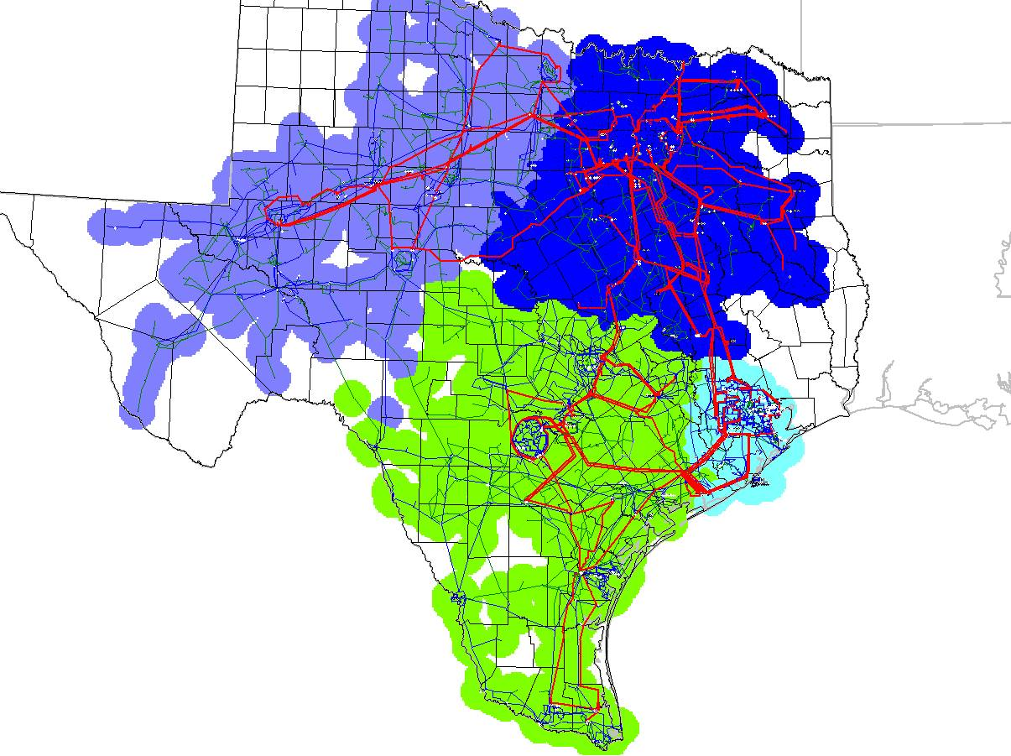

Load shifting zones

Bus Number | Bus Name | Nom kV | 2008 summer peak Load MW | 2008 CM Zone | 2007 CM Zone
616 | CARTER | 138 | 3.77 | West | North
631 | NEWPORT | 138 | 1.11 | West | North
1470 | NEWPRT_P8 | 138 |  | West | North
1471 | CARTR_P8 | 138 |  | West | North
5911 | STP_GN1___1 | 25 |  | Houston | South
5912 | STP_GN2___2 | 25 |  | Houston | South
5915 | SO_TEX__345A | 345 |  | Houston | South
6376 | CRM1TP2A | 69 |  | West | South
6377 | CRM12A | 69 | 3.77 | West | South
7063 | L_NARUNA8_1Y | 138 | 8.1 | North | South
7670 | L_SEAWAY8_1Y | 138 | 14.24 | South | Houston
8104 | LANCTYPM4A | 138 | 1.39 | Houston | South
8113 | BAY_CITY4A | 138 | 45.65 | Houston | South
8114 | CONOCO4A | 138 | 32.08 | Houston | South
8115 | WADSWORT4A | 138 | 5.49 | Houston | South
8116 | CELANEBC4A | 138 | 11.1 | Houston | South
8127 | LAN_CTY4A | 138 |  | Houston | South
8558 | STP_PTP4 | 138 |  | Houston | South
8559 | STP_CON4 | 138 |  | Houston | South
8563 | STP_PMP4 | 138 |  | Houston | South
44200 | HILLJE | 345 |  | Houston | South
44640 | SEALY___8020 | 138 | 42.77 | South | Houston
46220 | PETERS__138B | 138 |  | South | Houston
46230 | PETERS__69A | 69 | 2.08 | South | Houston

total load moving: 171.55

North → West: 4.88

South → Houston: 95.71

South → West: 3.77

South → North: 8.1

Houston → South: 59.09

