2008 CSC Analysis
ERCOT Planning

Background
At the initiation of this analysis the Steady State Working Group (SSWG) 2008 Summer Peak case, data set A was not yet available, therefore, all of the scenarios presented in this study were developed using the SSWG 2008 Summer Peak case, data set B last updated on May 25, 2007.

The UPLAN congestion analysis attached to this analysis is based on the 2007 5-year plan, 2008 case.

Recommendation
Based on this analysis ERCOT recommends four zones and that the following be designated as the 2008 CSCs:
- S_N and N_S: Sandow-Temple 345kV
- N_H: Jewett to T.H. Wharton and Gibbons Creek to O’Brien 345kV
- W_N and N_W: Graham to Parker and Benbrook 345kV

Discussion
Based on the MUST analysis performed, the S_N CSC should be the Austrop to Sandow 345kV line, however, if Sandow to Temple 345kV is selected as a two-way CSC for S_N and N_S then Austrop to Sandow 345kV and Tradinghouse to Temple Pecan Creek 345kV and Lake Creek to Temple Switch 345kV qualify to be designated as CREs.

With the increased transfer capability for south to Houston, ERCOT Staff believes that the S_H CSC is no longer needed. The August 2007 TCR calculation found no limit on the S_H CSC with the assumption that Hillje projects are in service. Additionally based on recent Real-Time VSAT results, ERCOT System Operations has found that in nearly all executions of VSAT, the maximum transfer across the S_H CSC was reached without voltage stability constrains. This supports the removal of the S_H CSC for 2008. At this time System Operations has not analyzed how voltage stability will be affected with the completion of the Hillje project, but believes that the completion of the Hilje project will only make things better in the area.

Other significant transmission projects scheduled to go in-service by the end of 2008 based on the Transmission Project and Information Tracking (TPIT) updated in May 2007 are:

- WA Parish-Hillje new 345-kV circuit (July 2007)
- Lingleville-Stephenville 138-kV line rebuild (December 2007)
- Leon-Lingleville 138-kV line rebuild (May 2008)
- Brownwood-Goldthwaite 138-kV line reconductor (May 2008)
- Temple Pecan Creek-Lake Creek 138-kV line rebuild (December 2008) *Not RPG approved yet

Generation projects scheduled to go in-service by the end of 2008 per SSWG are:
- Colorado Bend Phase 2 (May 2008)
- Quail Run Phase 2 (May 2008)
- 5112 MW total installed wind capacity in ERCOT by January 1, 2008
- 5471 MW total installed wind capacity in ERCOT by August 1, 2008
5. Holly 3 and 4 retire in late 2007
6. Morgan Creek 6 retires in late 2007

This information is posted on the ERCOT Operations and System Planning Data website at: http://oldercot.ercot.com/tmaps/login.cfm

Scenario 1: 2007 CSCs; 4 zones
Observations:
- Zones remain the same, no changes in generation location.
- Colorado Bend clusters in Houston zone same as 2007.
- Texas Gulf clusters in Houston zone same as 2007.

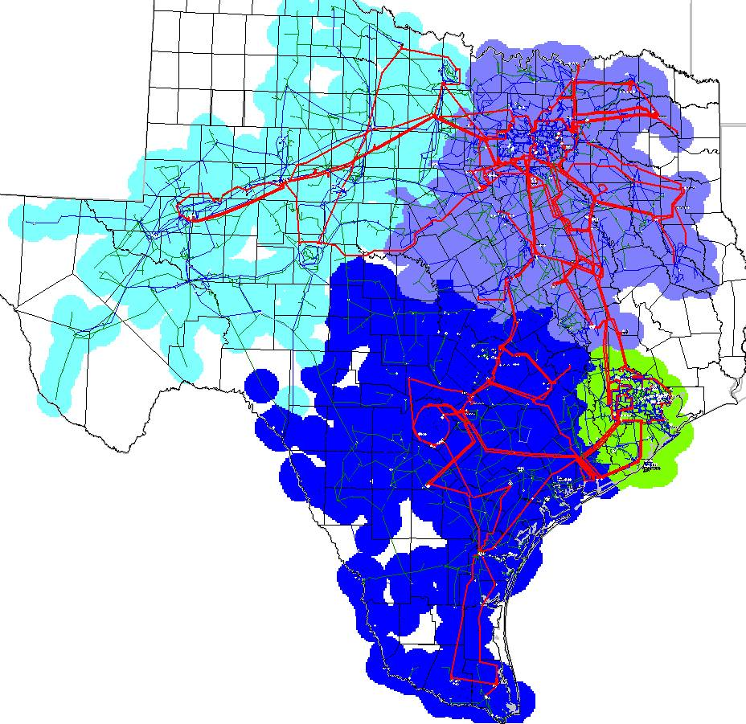

Scenario 2: 2007 CSCs; 3 zones
Observations:
- The Houston zone combines with North zone.
- Colorado Bend clusters into the South zone.
- Texas Gulf clusters into the South zone.

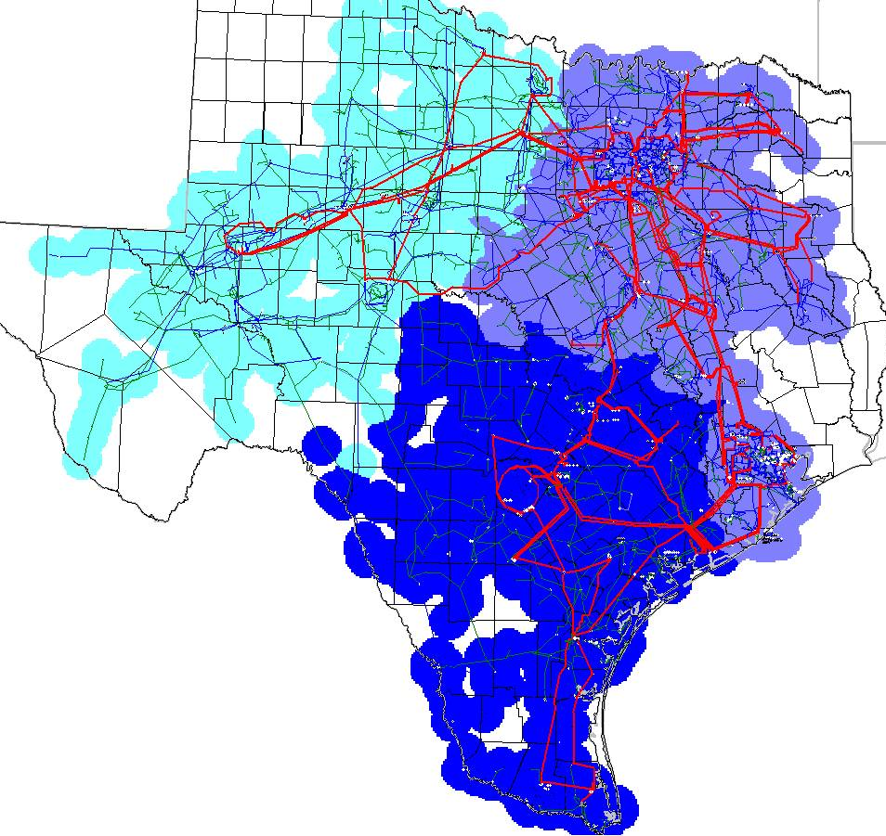

Scenario 3: 2007 CSCs; 5 zones
Observations:
- 5th zone is Dow.
- Colorado Bend clusters into the Houston zone.
- Texas Gulf clusters into the Houston zone.

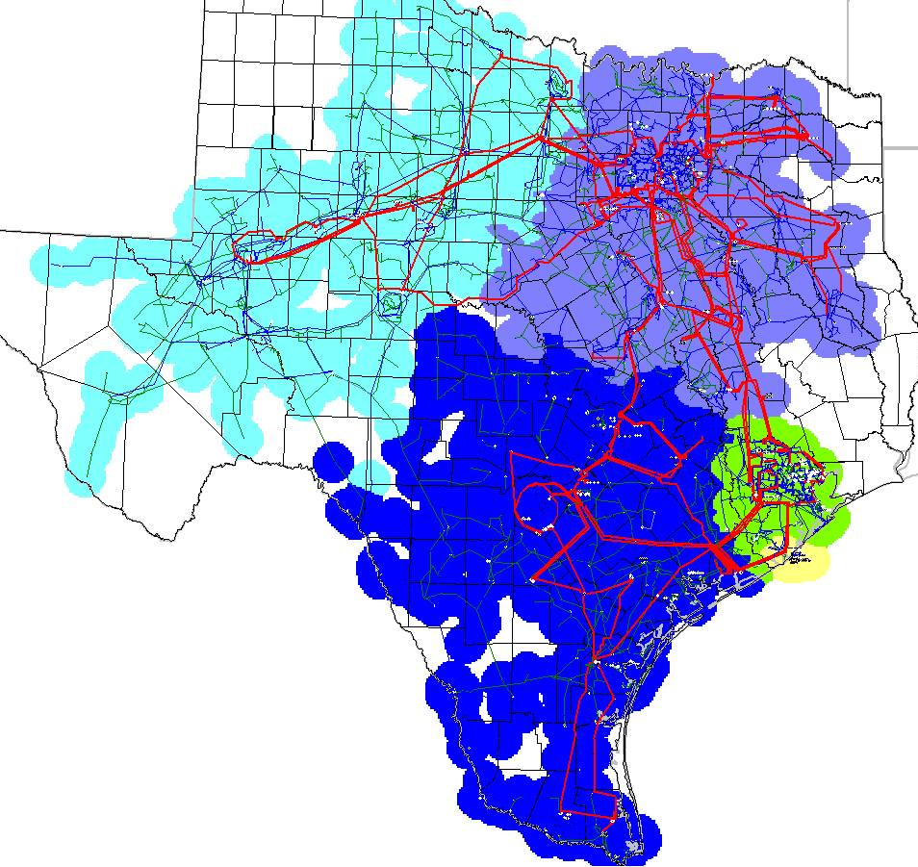

Scenario 4: 2007 CSCs minus South-Houston CSC; 4 zones
Observations:
- STP clusters into the Houston zone.
- Colorado Bend clusters into the Houston zone.
- Texas Gulf clusters into the Houston zone.
- Reached maximum transfer in the south to Houston in the August TCR calculation; no limit found, this assumes Hillje is in place.
- Reached maximum transfer in the south to Houston in VSAT, based on recent history

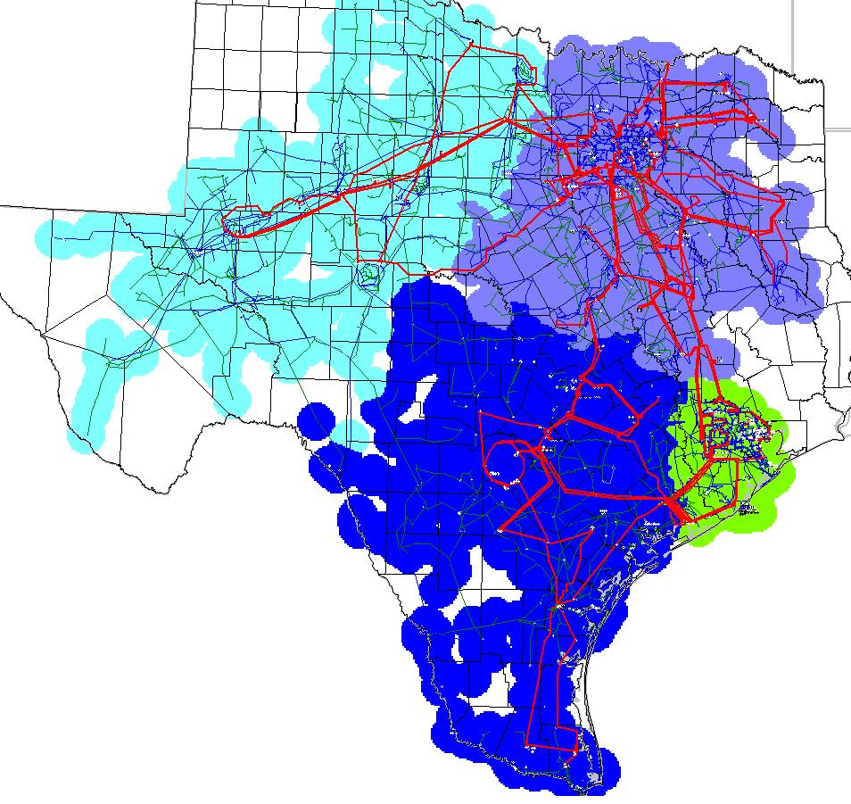

Scenario 5: 2007 CSCs minus South-North, add North-South (Tradinghouse-Temple PC/ Lake Creek-Temple 345-kV double circuit); 4 zones
Observations:
- No generators shift along North-South border.
- Colorado Bend clusters into the Houston zone.
- Texas Gulf clusters into the Houston zone.

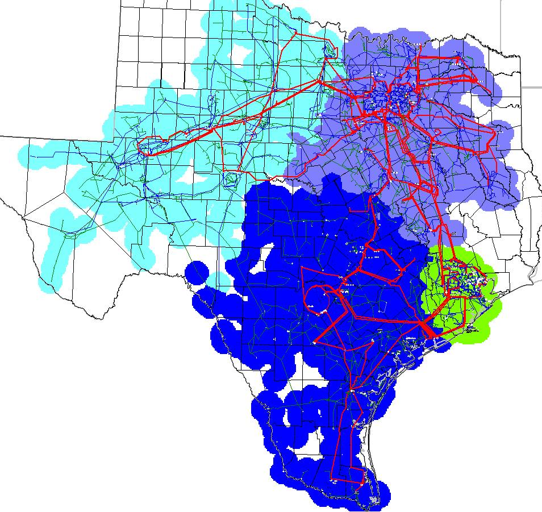

Scenario 6: 2007 CSCs minus South-Houston, minus South-North, add North-South (Tradinghouse-Temple PC/ Lake Creek-Temple 345kV double circuit); 4 zones
Observations:
- STP clusters into the Houston zone.
- Colorado Bend clusters into the Houston zone.
- Texas Gulf clusters into the Houston zone.
- No generators shift along the North to South border.

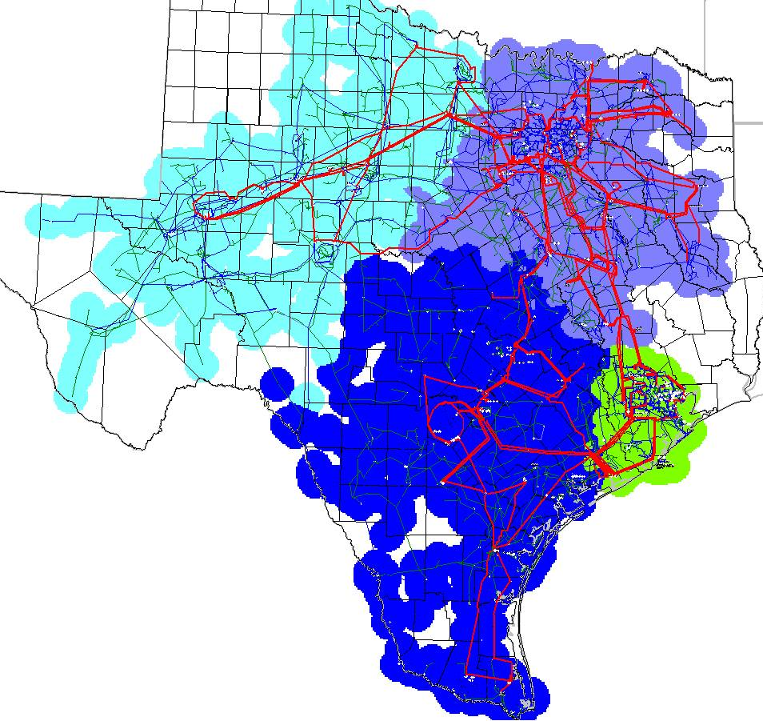

Attachments

MUST Transfer Analysis:

UPLAN Congestion Analysis:
2007 5-year plan, 2008 case

