
Conceptual System Design
Texas Nodal
Wind Power Forecasting
Version 1.0
11-June-07

Document Revisions
Date | Version | Description | Author(s)
9/7/06 | 0.01 | First draft | John Zack
03/17/07 | 0.02 | Added in ERCOT internal Comments. Updated diagram from AWST | Bill Blevins
03/27/07 | 0.03 | Reformatted the CSD to the current ERCOT Template and corrected typos and details based on ERCOT internal feedback and AWS Truewind feedback. | Bill Blevins
04/03/07 | 0.04 | Incorporated IDA comments from Bill Griffith and John Adams. Incorporated Internal EMS Comments. | Bill Blevins
05/04/07 | 0.05 | Incorporated comments from TPTF. | Bill Blevins
05/21/07 | 0.06 | Incorporated comments from meetings 05/14/07 Reliant and 05/15/07 FPLE. Incorporated ERCOT clarifications. | Bill Blevins
05/31/07 | 0.07 | Modified the requirement for meteorological tower height based upon TPTF comments. | Bill Blevins
06/11/07 | 1.0 | Incorporated TPTF comments on approved CSD. | Bill Blevins

Document Approvals
Date | Approved By | Approval Documented In (select)
 | <Name>  <Role> | ___ Approval email on file  ___ Signature

Table of Contents
1 Introduction 4
1.1 Purpose 4
1.2 Scope 4
1.3 Definitions, Acronyms, and Abbreviations 5
1.4 References 5
1.5 Overview 6
1.6 Program-level Standards 7
1.7 Deviations from Program-level Standards 8
2 Overview 9
2.1 Design Goals 9
2.2 Design Approach 9
2.3 Delivery Mechanism & Schedule 11
3 Functional Specification 12
3.1 ERCOT-WGR input data preparation 12
3.2 AWST-Regional Physics-Based Weather forecast 13
3.3 AWST-Statistical based forecast 14
3.4 AWST-WGR forecast 15
3.5 AWST-Error analysis 15
3.6 AWST & ERCOT- Displays 16
3.7 ERCOT- Post and Archive Wind Power Forecast data 17
3.8 ERCOT-LTWPF provided from WGR Entities 18
4 System Dependencies & Design Constraints 19
4.1 Hardware Interfaces 19
4.2 Software Interfaces 19
4.3 Services Interfaces 19
4.4 Database Interfaces 19
4.5 Licensing Requirements 19
5 Supplementary Specifications 20
5.1 Performance 20
5.2 Legal and Regulatory 20
5.3 System and Communication 20
5.4 System Security 20
5.5 Back up and Recovery 21
5.6 Availability and Redundancy 21
5.7 Maintainability 21
5.8 Usability 21
6 Appendix A: Subsystem Mapping to Nodal SoSA 22

Introduction
ERCOT’s current Zonal system does not include a Wind Power Forecasting (WPF) service and therefore forecasts are provided by the resources. The rapid growth of wind resources in the ERCOT grid have given rise to requirement for a more detailed forecast for short term operating and reliability studies. As ERCOT moves to the Nodal LMP market, an opportunity to improve the forecasting of Wind Power Generation Resource (WGR) was approved. ERCOT has contracted to AWS Truewind service to provide this short term forecast.
ERCOT will provide a WPF system to provide Short Term Wind Power Forecast (STWPF) for the next 48 hours. ERCOT will also provide a interface for WGRs to submit the Long Term Wind Power Forecast (LTWPF). The WPF system refers to the entire system used to provide the STWPF and the LTWPF. This Conceptual System Design will address the scope of the WPF system and provide a greater level of detail on how the integrated system will work together. The integrated system is a combination of ERCOT Nodal systems and a forecasting service from AWS Truewind.
The Functional Requirements (Section 3) are organized as follows:

- Section 3.1 addresses ERCOT requirements to provide input data to the AWST vendor for use in the short term forecast. Section 3.1.3 describes the telemetered information provided by WGRs to ERCOT via their QSEs SCADA.
- Section 3.2 through 3.5 addresses functions being performed by AWST to produce the short term forecast.
- Section 3.6 addresses both functions that ERCOT and AWST will perform.
- Section 3.7 and 3.8 addresses functions that ERCOT will develop and maintain for archiving and posting.
Note: The title of the functional requirement specifies which Entity ERCOT or AWST is providing a specific functional requirement.

Purpose
The purpose of the WPF system is to produce forecasts of Renewable Production Potential (RPP) for Wind Powered Generation Resources (WGR) to be used as an input into the Day-Ahead Reliability Unit Commitment (DRUC) and Hour-Ahead Reliability Unit Commitment (HRUC).The system shall provide forecasts for each WGR to the QSEs representing WGRs. The QSEs shall use the ERCOT provided forecasts for WGRs throughout the Day-Ahead and Operating Day for applicable markets and RUCs.Additionally the purpose is to allow WGRs to submit the LTWPF for their to ERCOT and their respective QSE.

Scope
This project is a subsystem of the Nodal EMS project. The scope of this subsystem is defined by the Texas Nodal EMS Wind Power Forecasting Requirements Specification which comprises requirements specified by Texas Nodal Protocols sections 3.13 and 4.2.2.

Definitions, Acronyms, and Abbreviations
Term | Definition
AWST | AWS Truewind is the vendor ERCOT has contracted to perform short term wind forecasting.
DMZ | The demilitarized zone (DMZ) or perimeter network is a network area (a subnetwork) that sits between an organization's internal network and an external network, usually the Internet
DSL | Digital Subscriber Line
EDW | EIS data services and products to support the nodal market, System designed to provide the appropriate access and toolsets and storage necessary for the IMM and PUCT oversight functions. Compised of Replicated Source System (RSS), Operational Data Store (ODS), Market Information Repository (MIR) and Conformed Data Warehouse (CDW).
FTP | File Transfer Protocol is used to transfer data from one computer to another over the Internet, or through a network.
GARF | Generation Asset Registration Form
HTTPS | https is a URI scheme used to indicate a secure HTTP connection.
LTWPF | Long-Term Wind Power Forecast: A facility operator produced forecast of power production, which is a “typical” energy profile for each day of a future month out to one year.
MIR | Market Information Repository The MIR system will be a database-centric system for file management of Market information.
MIS | (Market Information system) Web portal that provides a single point of access for Market Participants, PUCT, and ERCOT staff to Nodal market information and ERCOT market-facing applications.
MPIM | The Market participant Identity Management System is a component system of ERCOT that has no separate enterprise use cases but it does take part in each and every interaction between ERCOT’s guarded resources and Market participants.
QSE | Qualified Scheduling Entity
SCADA | Supervisory Control and Data Acquisition (SCADA) of the Energy Management System.
SSL | Secure Sockets Layer
STWPF | Short-Term Wind Power Forecast: An ERCOT produced hourly forecast of wind-power energy production potential for each WGR.
TLS | Transport Layer Security
WGR | Wind Power Generation Resource: A generation resource that is powered by wind.
WGRPP | Wind-Powered Generation Resource Production Potential: An ERCOT produced hourly forecast of wind-power energy production potential output with an 80% confidence level that the facility will exceed.
WPF | Wind Power Forecasting System including the internal and external systems that comprise Market Participant, ERCOT and Wind Forecasting vendor systems.

References
- ERCOT Nodal Protocols, January 1, 2007, http://nodal.ercot.com/protocols/2007/01/January%201%202007%20Nodal%20Protocols.zip
- Wind Power Forecasting Requirements Specification v1.0, 9 Mar 2007, http://nodal.ercot.com/docs/pd/ems/pd/wpforc/TN.EMS.61C01.WindPowForecastingReqSpec.doc

Overview

The ERCOT nodal WPF system requires information from many systems and subsystems of the ERCOT nodal system and from the WGRs and QSEs representing the WGRs. Outbound information will be information that ERCOT provides to the AWST forecasting service and inbound information will be data that is transferred from the AWST forecasting service to ERCOT. Outbound AWST will require information from the following ERCOT systems: SCADA subsystem, Outage Scheduler subsystem, Registration subsystem data, and EMS Oracle database. This is accomplished using an AWS Truewind communication’s server. On the outbound the WPF system will consolidate the required data from the ERCOT systems and then deliver this input information to the AWS True Wind server. AWST will then create a short term (48 hour) forecast. Inbound the AWST communication server will deliver the forecast to ERCOT. This information will be provided to the QSE via the Messaging System, posted on the Market Information System and archived in the EDW system. A QSE representing a Wind-Powered Generation Resource (WGR) must enter an HSL value that is less than or equal to the amount for that Resource from the most recent Wind-Powered Generation Resource Production Potential provided by ERCOT. AWST will deliver ERCOT the hourly STWPF and WGRPP forecast. Daily the AWST service will provide ERCOT the WPF performance analysis information and ERCOT will post and archive this information for market reporting purposes. The reader should understand that in reading this document the AWST vendor will be specifically performing the functions contained in Figure 1 (within the shaded area). ERCOT will manage the processes outside the shaded area. The LTWPF is required by protocol language to be submitted by WGR Entities to ERCOT and their QSEs. This is not being performed by the AWST forecasting system or ERCOT. The LTWPF interface will require the WGR to submit the LTWPF. ERCOT will provide a web service for the LTWPF submission.

The WPF system will provide a user interface to display the forecast and performance data. This ERCOT operator user interface will support large geographic displays as well as database-driven tabular displays used to monitor the process of preparing, transferring and receiving forecast information with AWST. File transfer failures will issue alarms to the EMS support teams.

Typically, the WPF system requires a high level of availability with no schedule downtime and is expected to be running 24 hours a day, 365 days a year. Section 5.6 of the Conceptual System Design document addresses the redundancy and availability of the servers at AWS Truewind.

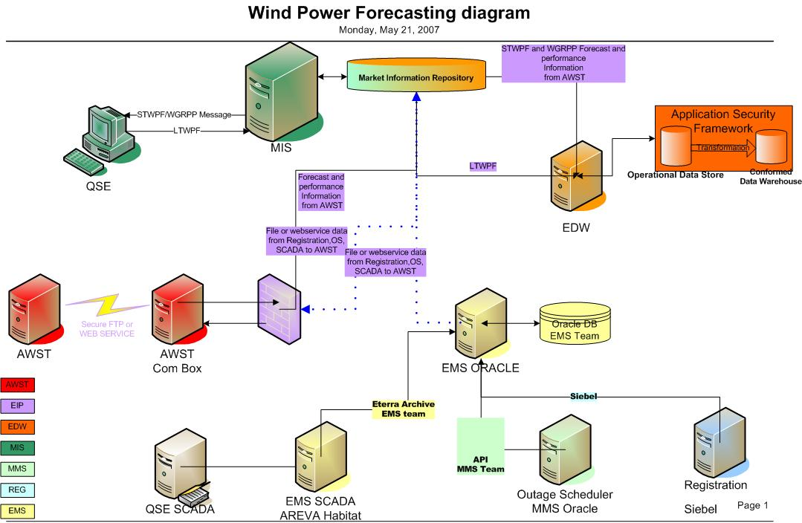

Figure 1 - Wind Power Physical Deployment View

Program-level Standards
Where applicable, the Nodal EMS conforms to official or de facto standards as much as possible. These include:
Official Standards:
- C++, C, and Fortran ANSI programming languages
- SQL for data exchange with RDBMS
- IEC 60870-5-101,-103,-104, DNP3 for serial and TCP/IP communication with RTUs
- IEC 61850 for communication with IEDs
- Modbus Serial and TCP/IP for communication with IEDs
- IEC 60870-6 TASE.2 (1996 & 2000), TASE.1 (ELCOM 90) for inter-control center communication, with optional secure protocol using X.509 certificates
- IEC 61970 part 301 CIM Model standard
Defacto Standards:
- Microsoft Windows 2003 32-bit, 64-bit for server applications
- Microsoft Windows XP for client applications
- Microsoft SQL Server (2005) for historical RDBMS
- Red Hat Linux Enterprise License 3.0 for server applications
- AIX 5L version 5.3
- Oracle RDBMS (10g) for historical RDBMS and market applications
- AREVA ISD Protocol for front-end communication with SCADA
Security Standards:
- North American Electric Reliability Council “DRAFT Critical Infrastructure Protection Standards 2-9 Cyber Security”, May 9, 2005”
- North American Electric Reliability Council “Urgent Action Standard 1200 – Cyber Security”, August 13, 2003
- Department of Energy “21 Steps to improve Cyber Security of SCADA Networks”
- US – Canada Power System Outage Task Force “Final Report on the August 14, 2003 Blackout in the United States and Canada: Causes and Recommendations”, April 2004

Deviations from Program-level Standards
This CSD is compliant with all Nodal program-level standards.

Overview

Design Goals
The objective of the forecasting service system is to create a forecast service which will provide ERCOT with the most accurate STWPF and WGRPP forecasts possible. The forecasts will be updated hourly and cover 1-48 hours from the forecast update time. The service will be developed to provide an extremely high level of reliability with over 99.8% of day ahead and hourly forecasts delivered on time. ERCOT has contracted to AWS Truewind for their forecasting service given their extensive experience in Wind Power Forecasting and research. Additionally, traditional forecasts from WGRs for LTWPF will be supported via web services. The LTWPF, STWPF and WGRPP will be integrated into a WPF system to address both Long-Term (one year) and Short-Term (48 hr) forecasts.

Design Approach
ERCOT will place all WGR Registration, EMS real-time and Outage Scheduler hourly data in an AWST communication server. The server will deliver the input data to AWS Truewind hourly. Currently AWST supports both CSV-FTP and web services. The detail design specification will specify the method ERCOT will use to communicate. Since the source system for registration data and outage scheduler data is an Oracle database, the WPF system will pull this data from the source database to the WPF staging database. EMS real-time SCADA data is stored in Areva’s proprietary database, Habitat. Therefore, Areva’s eTerra Archive software product will be used to extract the SCADA data from the proprietary format and transfer it to the WPF Oracle staging database. Once all of the data has been organized and consolidated, the WPF system will transfer this data to the AWST communication server for communication to the AWS Truewind servers. AWST will then create and provide a 48 hour rolling WGRPP and STWPF forecast to ERCOT before the next operating hour.

The AWST forecasting system consists of several elements. Each component of the system will have at least one backup. A physical weather model will be used to forecast conditions over the entire state of Texas for the 48 hour forecasting period. The model provides the capability to make a forecast even when ERCOT provided WGR data is unavailable. A second component of the AWST system will be a statistical model. The statistical model uses plant data to eliminate bias in the physical model forecast and to provide information about recent trends in the power production which are valuable predictors in the first few hours of the forecast period. The statistical model will be able to function with only historical data although current data will significantly improve the first few hours of the forecast. A delivery control system will be put in place to ensure that the forecast is sent from one of several redundant systems. The forecast will be delivered via the internet. To ensure reliability, two connections to the internet will be maintained (e.g., a T3 connection with a DSL connection as a backup). The forecast systems will be located behind a firewall in a server room monitored for unauthorized access and environmental conditions (temperature, humidity, liquid water etc.).

System functional capabilities
The WPF system functional capabilities include:
- Provide input to AWST for use in creating an hourly WPF forecast
- Provide a 48 hr STWPF for each WGR from AWST
- Provide a 48 hr STWPF for ERCOT from AWST
- Provide a 48 hr WGRPP for each WGR from AWST
- Provide a 48 hr WGRPP for ERCOT from AWST
- Provide Error Analysis for the STWPF and WGRPP from AWST
- Provide an LTWPF from WGR entities
- Post and archive all WPF information

Black Box View
Figure 1 depicts the physical computer servers that will realize the logical dataflow. Figure 2 depicts the conceptual view of the forecasting system. Figure 3 provides the conceptual view to show the logical data flow of the system including the input and output from ERCOT to AWS Truewind. Together, these diagrams provide a high-level view of the WPF system to be designed.
It is anticipated that the WGR data files sent from ERCOT to AWS Truewind will be on the order of 1 kb for each wind generator for each hour that data is to be sent. Forecast files received at ERCOT from AWS Truewind will be approximately 5 kb per wind generator.
All processing to create the forecast will be done at AWS Truewind facilities. Processing of the physics based model used in making the forecasts will occur separately from the running of the statistical models and other forecast processing as it will take substantially more processing time than other forecast system components. The physics based model will be updated 2 to 4 times per day and the other components of the system will use the most recent available physics based model data. It is anticipated that the forecast system will require 15 minutes or less to generate a forecast from the time new ERCOT data is received by AWS Truewind.

Figure 2 - eWind Conceptual View

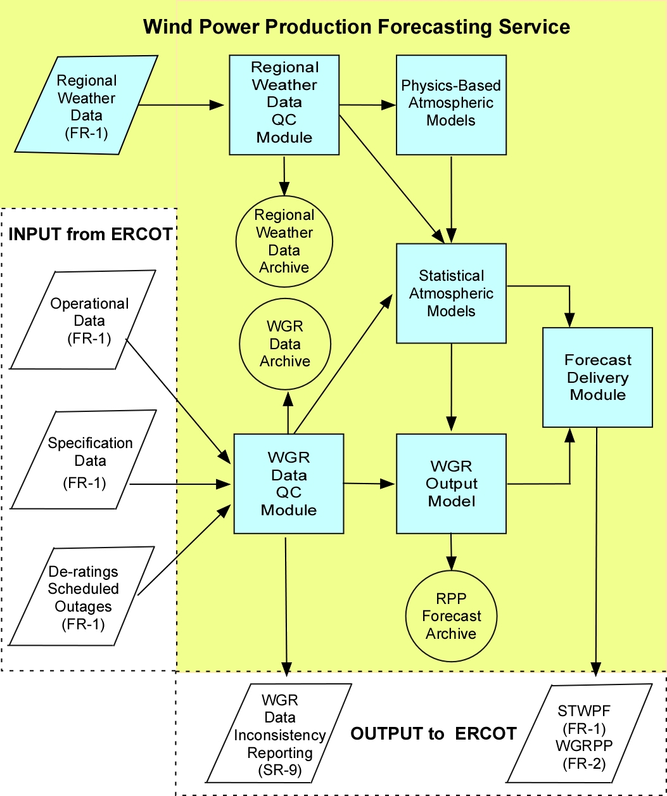

Figure 3 - Wind Power Data Flow

Delivery Mechanism & Schedule
All processing will be done at AWS Truewind facilities. ERCOT will provide a method of sending CSV flat file or web service information containing generator data to AWS Truewind and a method of receiving CSV flat file or web service information containing the forecast data from AWS Truewind. Transmission of the data will be via the Internet over a secure channel using digital certificates either as Secure FTP or Web Services over HTTPS.

AWST Truewind will deliver forecast data to ERCOT via the Internet over a secure channel as well. AWST Truewind will use Secure FTP or Web Services over HTTPS with the use of digital certificates. Forecasts will be available for delivery 15 minutes after AWS Truewind receives plant data from ERCOT. ERCOT will be free to determine the delivery time of the data to QSEs and the MIS System (and thus the forecast) so that scheduling time constraints may be met.

Functional Specification

ERCOT-WGR input data preparation

Traceability to Requirement(s)
RPP-FR1, RPP-SR8, RPP-SR9, RPP-SR11

Introduction
WGR entities must provide Registration, Outage Scheduler and Real-Time telemetry data to be used as an input to the AWST forecast Models. ERCOT will receive the SCADA information for the WGR from the WGRs QSE. The WPF system will receive the Registration and Outage Scheduling information as WGRs provide it to those new Nodal systems

Inputs & Sources
Input data consists of operational data, Registration data and outage data. All the operational input data will be telemetered via SCADA from the WGR to its QSE and then to ERCOT via ICCP. This data is then inserted into a database at ERCOT before being sent to the AWST forecasting service. This SCADA data will belong to current hour and any integration of wind speed or mw output will be done in the ERCOT SCADA system. Static-data will be sent to AWST when Registration changes are made via Market Participant Generation Asset Registration Forms (GARF) changes. The expectation is that current and new Wind Generation facilities will have the required meteorological data from meteorological towers located at the site. Wind Generation facilities meteorological tower height will be documented through Registration. Daily-data will be sent to AWST once per day. All other information will be sent to AWST hourly.
Registration data:
- Resource Name
- Resource-QSE mapping
- Resource Parameters Max and Min Reasonability limits (units MW)
- Location of wind farm latitude and longitude for the center point of wind farm (units decimal degrees)
- Location of the meteorological tower latitude and longitude (units decimal degrees)
- Type (manufacturer/model) and number of turbines
- Turbine hub height(s) above ground level with associated number of turbines (units Meters)
- Meteorological tower height
- Manufacturer’s power curve (capability curve)
- Resource Commercial Operation Date

Outage Scheduler data:
- Scheduled outages/derates of wind farms

SCADA data:
- Resource (wind farm) status on line/off line with date/time
- MW output of wind farm with date/time
- Wind speed (units MPH)
- Wind direction from one meteorological tower with date/time
- Temperature (units °C)
- Barometric pressure at 2 m above ground level on the meteorological tower (units hPa (mb))

Processing
The operational input data will be transferred through e-terra archive software from EMS real-time database to EMS relational database. The ERCOT SCADA system will integrate the WGR MW and Wind Speed values over the hour. The other SCADA values will be instantaneous snapshot values. SCADA information will be written to an Oracle database using e-Terra Archive systems that are delivered as part of the EMS. The Registration data and outage scheduler data will be transferred through data transfer procedures to EMS relational database. Registration data will be used so that AWST wind farm forecasted information can be accurately developed based upon physical specifications of the Wind Farm. Static Registration information will be sent to AWST. Also this information must be used when mapping forecast to specific QSEs. This is provided from the ERCOT Registration system. Outage Scheduler information will be provided as a file from Outage Scheduler listing all WGR outages for the next 48 hours. From EMS relational database, every hour data will be extracted and placed on the FTP server to be picked up by AWS Truewind for processing Wind Power Forecast. Before using this data by Statistical Atmospheric model, a quality code check process will be running by AWS Truewind for validity of input data. This is to ensure that the input information such as MW values are non-negative and within the maximum capability of each WGR and to confirm the information is not old, i.e. it changes from one hour to the next.

Outputs & Targets
ERCOT components of WPF will create a CSV flat file or web service data transfer containing the input data listed in 3.13 for use by AWS Truewind as input for the forecast.

AWST-Regional Physics-Based Weather forecast

Traceability to Requirement(s)
RPP-FR1, RPP-FR2

Introduction
The AWST uses regional physics-based models to create sets of forecast atmospheric data for the region around the resources to be forecast for. This data is used as an input to the statistical models. This physics based model is used by AWST to improve the forecasting accuracy.

Inputs & Sources
Input data consists of regional weather data (surface observations, Doppler radar wind data, and Rawinsonde) collected by the National Weather Service and data from larger-scale physics-based models run at government centers such as the National Center for Environmental Prediction obtained by AWS Truewind.

Processing
The regional physics-based models numerically solve a set of equations describing the atmosphere. Of the several models available to AWS Truewind, primarily AWST uses MASS and WRF. MASS is a model developed by Meso INC a partner in AWS Truewind. WRF is a community research and forecasting model developed cooperatively by several government agencies. Physics-based models output grids of atmospheric variables. The frequency of output is configurable. The models will be updated every six to 12 hours using the input regional weather data mentioned in 3.2.3.

Outputs & Targets
Grids of forecast meteorological variables are output by the models at user-specified intervals over the forecast time period for use by AWST forecast. Note: This weather grid is a list of weather variables and is used by AWST. This weather variable grid is not being provided to ERCOT.

AWST-Statistical based forecast

Traceability to Requirement(s)
RPP-FR1, RPP-FR2

Introduction
Statistical models are used to refine the forecast from the regional physics-based models by comparing model output to observed data from the plant and eliminating biases in the physics-based model output. Bias is systematic error in the output of the physical weather model. One example of a bias would be a forecast of winds which is too low on a narrow ridge because the physical model resolution does not allow the full height of the ridge to be captured. The statistical model compares observed data to the physical model output to eliminate such biases. The statistical models are also used to incorporate recent plant data into the forecasts.

Inputs & Sources
The statistical models will use historical model and plant data and current model and plant data. AWST will use off-site meteorological data when appropriate. ERCOT will own the private Market Participant data it provides to AWST and the forecasts produced under 2.2.1 and performance data that AWST provides to ERCOT. AWST owns the Regional weather data it subscribes to which will not be made available to ERCOT for posting but will be made available upon request by ERCOT for dispute resolution when necessary.

Processing
Several statistical models are available to choose from. AWS Truewind has experience with neural networks, support vector machines, multiple linear regression and others. The various models have different requirements for the amount of data to produce a reliable forecast and the length of time needed to run. AWS Truewind will select an appropriate model or models to run which function well within the run time available and makes maximum use of the available data.

Outputs & Targets
The statistical models will output a forecast of the wind speed at a meteorological tower or may directly output a forecast of plant generation. These variables are not being directly provided to ERCOT.

AWST-WGR forecast

Traceability to Requirement(s)
RPP-FR1, RPP-FR2, RPP-SR7

Introduction
The plant output model converts a forecast of wind speed at a plant to power output.

Inputs & Sources
The plant output model requires observed meteorological and generation data from the plant. It also uses forecast meteorological data.

Processing
When limited plant data is available the plant output model, will consist of a turbine manufacturer’s power curve. When adequate plant data is available a statistical facility-scale power curve will be constructed using the measured data. It is also possible that a statistical model such as an artificial neural network might be used to construct a more complex relationship between the meteorological data, the model data, and the observed generation.

Outputs & Targets
The plant output model creates a STWPF and WGRPP forecast of generation for each plant. AWST will provide these forecast to ERCOT through the AWST communication server.

AWST-Error analysis

Traceability to Requirement(s)
RPP-SR4, RPP-SR5, RPP-SR6

Introduction
AWS Truewind will run process to produce the error analysis for performance monitoring. Everyday along with 0600 hour’s Wind Power Forecast data, it will send the error analysis of the forecasted versus the actual WGR production data for last 24 hours through CSV flat file or web service AWS Truewind is also responsible for archiving and providing the data used to perform the STWPF upon request. This will require AWST to have the meter information from the WGR to calculate the forecast error.

Inputs & Sources
AWS Truewind will use the actual and Wind Power Forecast data to perform this process.

Processing
AWS Truewind will develop the process to generate the error analysis data for last 24 hours. After that data is available to ERCOT through CSV flat file or web service, it will be stored in EMS RELATIONAL database which process will be developed by ERCOT.AWST will provide the following Error analysis information.
- Forecast Availability for Day-Ahead Operations
- The WPF Process shall calculate statistics comparing the forecasts to the actual total ERCOT wind-power output and the output of wind farms.
- mean forecast WGRPP and STWPF (48 rolling forecast)
- actual
- WGRPP and STWPF mean error (bias)
- WGRPP and STWPF absolute mean error
- WGRPP and STWPF RMS error
- Measure of dispersion (standard deviation) for total ERCOT wind-power production for each hour-of-day by month
- Measure of dispersion (standard deviation) for each WGR for each hour-of-day by month
- STWPF Forecast Accuracy
- WGRPP Forecast Accuracy
- Wind Speed Forecast Accuracy

Outputs & Targets
AWST will provide the error statistics along with the Wind Generation metered output to allow ERCOT to easily relate the statistics to the WGR production for any particular time. The error analysis data and actual wind power production data for last 24 hours, which is used to perform STWPF error analysis are the required values necessary to relate the hourly forecast to the error. AWST will provide these error statistics to ERCOT through the AWST communication server.

AWST & ERCOT- Displays

Traceability to Requirement(s)
RPP-SR10

Introduction
AWS True wind will provide a web display which will be secure site that ERCOT operations may use to view the latest forecast and performance statistics with. MIS will provide ERCOT operations a view of the latest AWST provided forecast and performance statistics. Enterprise Integration will provide ERCOT operations with a view of the latest input information sent by ERCOT to AWS True Wind.

Inputs & Sources
AWS Truewind will provide digital certificate logins which ERCOT operations will use to login to the ERCOT AWST internet site. The MPIM identity manager will provide secure logins which ERCOT operations will use to view the latest ERCOT input file and the latest AWST provided STWPF, WGRPP and performance data.

Processing
AWST will develop a webpage for ERCOT Operations to display the 48 hour STWPF, WGRPP and performance data. Enterprise Integration will develop a mechanism for displaying to the ERCOT Operator the most recent ERCOT input file. MIS will provide a webpage for QSEs and ERCOT Operations to view the latest AWST provided 48 hour STWPF, WGRPP and performance data.

Outputs & Targets
- AWST forecast and performance WebPages.
- MIS Portal views of the most recent ERCOT input file and the latest AWST provided 48 hour STWPF, WGRPP and performance data.

ERCOT- Post and Archive Wind Power Forecast data

Traceability to Requirement(s)
RPP-FR4, RPP-FR5, RPP-FR6

Introduction
ERCOT will get the Wind Power Forecast data through a CSV flat file or web service from AWS Truewind every hour. ERCOT will load the data into EMS RELATIONAL database. From EMS RELATIONAL database the Wind Power Forecast data will be available to QSEs through MIS Portal and through the Messaging System. Also this data will be archived for 7 years retention in EDW.

Inputs & Sources
Wind Power Forecast and Wind Generation Resource Production Potential data of next 48 hours for each Wind Farm and the entire ERCOT system will be available through a CSV flat file or web service. Every hour AWST will create a STWPF and WGRPP forecast for the next 48 hours and provide the data to ERCOT..

Processing
WPF will develop a mechanism to read this data every hour from the CSV flat file or web service and load that into EMS RELATIONAL database. ERCOT will also store that data into EDW database for last 7 years retention.

Outputs & Targets
The Wind Power Forecast and Wind generation resource production potential data will be available to all QSEs through MIS Portal from the MIR. Enterprise integration will create a message containing the forecast and send it to the QSE once a new forecast is posted on MIS.
MIS data:
- Aggregated STWPF for ERCOT – (Secured Area)
- STWPF for each WGR (Certified Area)
- WGRPP for ERCOT – (Secured Area)
- WGRPP for each WGR (Certified Area)
The EMS relational database will make specific information available to EDW for archiving.

EDW data:
- Aggregated STWPF for ERCOT
- Aggregated WGRPP for ERCOT
- LTWPF for each WGR
- Metrics from System Requirements Specification For Wind Power Forecasting requirements SR4 and SR5 as specified in 3.5.4 above.
- Actual wind speed, temperature, barometric pressure, and power output from each WGR
- Each STWPF forecast and associated wind speeds with date/time forecasted, and date/time of forecast for each WGR.
- Each WGRPP forecast and associated wind speeds with date/time forecasted, and date/time of forecast and probability distribution table for each WGR
- Each LTWPF received with associated WGR, date/time of receipt, applicable month/year, and hourly wind forecast.

ERCOT-LTWPF provided from WGR Entities

Traceability to Requirement(s)
RPP-FR3

Introduction
ERCOT will get the LTWPF data through a web service from MIS portal. ERCOT will load the data into EMS RELATIONAL database. From EMS RELATIONAL database the LTWPF data will be available to all systems via the EMS relational Database. LTWPF data will be stored to Archive database.

Inputs & Sources
WGR Entities shall provide ERCOT and their respective QSEs with Long-Term Wind Power Forecast (LTWPF) profiles for each WGR having an aggregated rating larger than 10 MW at its point of interconnection with the transmission system. WGRs will submit LTWPF as a CSV file or by directly entering into the MIS portal the forecasted output for the WGR. The profiles must forecast the daily generation shape by hourly production of wind power Renewable Production Potential and the WGR Entities shall provide the profiles to ERCOT each month on a rolling 12 month basis.

Processing
ERCOT will develop a mechanism to read this data and load it into EMS RELATIONAL database. ERCOT will also store that data into Archive database through data replication process for last 7 years retention.

Outputs & Targets
The LTWPF will be available through MIS Portal from the EMS RELATIONAL database to the QSE registered with ERCOT and responsible for submitting market schedules and market information to ERCOT.

System Dependencies & Design Constraints

Hardware Interfaces
The WPF system will use an AWST communication server running Windows Server 2003 for staging data to and from AWS Truewind. Additionally, the WPF system will store relational database data on the existing EMS database server, running AIX 5.3. The AWST communication server will reside behind a firewall. All communications between the AWST server and ERCOT will be over the Internet. Authentication, integrity and confidentiality will be ensured with TLS (SSL).

Software Interfaces
The WPF system requires data from the Registration system, the Outage Scheduler system, the SCADA subsystem. The ERCOT components of the WPF system will consolidate this data before sending it to AWS Truewind for processing. AWS Truewind will process the data and send the processed data back to ERCOT. The ERCOT components of the WPF system will then post this data to the EDW and MIS Portal systems. Enterprise integration will create a message containing the forecast and send it to the QSE once a new forecast is posted on MIS. See Figure 1 for a diagram of the system interfaces.

Services Interfaces
The WPF system will require a secure communications channel to AWS Truewind. As such, it is anticipated that WPF will require authentication services from the Nodal Identity Management system. In addition, the WPF system will require an external facing server within ERCOT’s Demilitarized Zone (DMZ).

Database Interfaces
The WPF system will require a WPF Oracle schema within the EMS database server. This schema will house WPF data required for AWS Truewind processing. Additionally, the WPF system will require pulling EMS SCADA data from Habitat via eTerra Archive as well as pulling Oracle data from the registration database and the outage scheduler database. AWS Truewind will be communicating with the WPFs AWST communications server and thus will not be making direct database connections to any ERCOT systems.

Licensing Requirements
The WPF system will not require any software licenses as it will be developed in house with existing ERCOT systems. AWS Truewind does not require any software licenses. The AWS Truewind contract covers the cost of their service.

Supplementary Specifications

Performance
AWS Truewind will have the day ahead WGRPP available to ERCOT by 0600 of the day-ahead 99.8% of the time yearly. AWS Truewind will have the hourly WGRPP available to ERCOT 99.8% of the time yearly. This level of reliability will be achieved by the use of multiple backup forecast systems which will each be capable of generating and delivering a forecast to ERCOT. In the event of a primary forecast system failure, a backup AWST system will automatically provide the forecast. Additionally, AWS Truewind will maintain two independent Internet connections.

AWST will calculate forecast error statistics. The statistics will be calculated by an automated model as the actual output data from the wind plants becomes available. Statistics to be calculated will include: mean forecast, mean actual, mean error (bias), mean absolute error, RMS error, and the standard deviation for each WRG for each day of the month for all available lead times. Error statistics for agreed upon lead times requested by ERCOT will be provided to ERCOT.

AWST will monitor the forecast error statistics and maintain an active forecast research program to ensure that the error of the Day-Ahead STWPF is less than 18% of the maximum capacity of each WGR. AWST will monitor the WGRPP forecasts to ensure that the actual output of the WGR is less than the WGRPP at least 15% and not more than 25% of the hours over a six month period.

Legal and Regulatory
AWST will sign and comply with the terms of a non-disclosure agreement. Data will be stored in a physically-secure environment protected by a security system with access limited to necessary personnel and logged. The data will be hosted on secure servers isolated by a private subnet AWST has no legal or regulatory requirements for software licenses to be obtained by ERCOT as it will be providing this service using their internal systems. ERCOT will have a nondisclosure agreement in place to ensure the information provided by ERCOT will not be used for any purposes other than providing services to ERCOT.

System and Communication
AWST will be connecting to the ERCOT DMZ server using FTPS (i.e. FTP with TLS (SSL) authentication) or web services over HTTPS. Mutual authentication is required if public key transfer can be accommodated. AWST has a redundant connection to the Internet.

System Security
Authentication, integrity and confidentiality of data transfers will be ensured via TLS (SSL). On site, AWST servers are located in a secure room with biometric access. Only trusted persons have access to the server room and all accesses are logged (time and identity). The AWST servers hosting secure operations (e.g. ERCOT) will be protected by an internal VPN for traceability and auditing. Only trusted persons will have access to the VPN through trustworthy workstations located on-site. ERCOT trusted Certificate Authority will issue digital certificates to be used for secure channel encryption.

Back up and Recovery
AWS Truewind provides nightly backups of customer data to several offsite locations. AWS Truewind burns hard copies of customer data weekly which are also stored offsite. All backup transfers are across secure communication channels as well as redundant servers. Hard copies will be encrypted and written monthly to ensure having enough data to retrain given a major hardware failure. Once encrypted, the security is maintained on the disk and can be removed from the premises. ERCOT will use the existing back up and recovery capabilities of the MIS, EDW and EMS systems. No additional capability are required for the Wind Power Forecasting back up and recovery.

Availability and Redundancy
Redundancy of the AWST servers will be covered by 3 copies of the same system. Delivery from these systems will be ordered in a cascading manner such that failure of a primary machine, for any reason whatsoever, will cause the 2nd server to deliver the forecast on time and likewise the 3rd server will deliver in the event servers 1 & 2 have gone down. The use of this redundancy configuration has enabled AWST to provide forecasts on the specified delivery schedule more than 99.9% of the time in a similar application for the California ISO.

On the ERCOT side of the WPF system, ERCOT will provide two DMZ drop off points to provide redundancy.

Maintainability
Redundant AWST servers allow for flexible maintenance of the AWST system, while maintaining 99.8% system availability.AWST will maintain the servers located at AWST and ERCOT will maintain all servers located at ERCOT.

Usability
The main requirements for forecast usability will be on time delivery and delivery in the proper format to enable the forecast information to be assimilated by ERCOT’s Energy Management System. All displays will comply with ERCOT standards.

Appendix A: Subsystem Mapping to Nodal SoSA

SoSA Use Case & System Operation | Satisfied? (Y/N/?) | Subsystem | Subsystem Operation | Document Reference
S.UC3 – Plan System Operations | Y | Wind Power Forecasting | S.UC3.OP2 – Analyze Solution | Section 3.4  Section 3.5  Section 3.6  Section 3.7
S.UC4 – Plan the System (Long Term) | Y | Wind Power Forecasting | S.UC4.OP1.WB – Update Annual Planning Model | Section 3.9

See Figure 1 - Wind Power Physical Deployment View for the conceptual hardware design.

