

Electric Reliability Council of Texas

Retail Market IT Services

Summary:

Availability targets and related service information for the IT services provided by ERCOT that facilitate retail customer choice in the ERCOT market.

EFFECTIVE: TBD
Document Revisions
Date | Version | Description | Author(s)
March 23rd, 2006 | .9 | First draft | Aaron Smallwood
March 28th, 2006 | .91 | Revised draft | Aaron Smallwood
June 1st, 2006 | 1.0 | Final Version | Aaron Smallwood
June 15th, 2006 | 1.1 | Revised final version | Aaron Smallwood
May 1, 2007 | 2.0 | 2007 annual review revisions with ERCOT business and Market input | Aaron Smallwood

Table of Contents:

- Introduction
- Retail Market IT Services
  - Retail Transaction Processing
    - Service Scope
    - Service Availability
    - Service Availability and Market Notice Reporting
  - MarkeTrak
    - Service Scope
    - Service Availability
    - Service Availability and Market Notice Reporting
  - Texas Market Link (TML)
    - Service Scope
    - Service Availability
    - Service Availability and Market Notice Reporting
- Retail Market IT Services Reporting
- Service Availability Renegotiations and Change Control Process
- Annual Review Process
- Appendix A: Definitions
- Appendix B: System Architecture Diagram

Introduction

This document describes the service availability targets, operating hours and reporting mechanisms for several IT services provided by ERCOT to the Texas competitive retail electric market.

Where applicable, these availability targets build upon the requirements outlined in ERCOT Protocols Section 15 and the Retail Market Guide to provide additional guidance to Competitive Retailers and Transmission/Distribution Service Providers (TDSPs) regarding several IT services provided by ERCOT for the Texas competitive retail electric market.

In the event of a conflict between this document and the ERCOT Protocols, Retail Market Guide or PUCT Substantive Rules, the Protocols or PUC Substantive Rules take precedence over this document.

Retail Market IT Services

Retail Transaction Processing

Service Scope

Retail Transaction Processing Services is the flow of retail transactions between ERCOT and Market Participants. The service is provided by an integrated group of applications and includes the following components:

- NAESB Proxy Servers
- NAESB
- Electronic Data Interchange (EDI)
- Enterprise Application Integration (EAI)
- Customer Registration Database
- ERCOT maintained infrastructure supporting retail transaction processing

Refer to Appendix B for further application and system architecture information.

Excluded from the scope of the retail transaction processing service are the following systems that communicate with, but are not a primary component of, retail market transaction processing services:

- Enterprise Data Warehouse (EDW)
- Settlements & Billing Services (Lodestar)
- Web Services (e.g. TML, RMC, MarkeTrak, ERCOT.com)

Service Availability

ERCOT targets retail transaction processing services to be available at least 99.9% of the time outside of scheduled maintenance and release outage windows. Outages that are greater than 15 minutes in length will be counted against the retail transaction processing service availability metric.

ERCOT reserves the following times as maintenance and release outage windows:

Maintenance Windows:

- 1st, 3rd, and 4th Sunday of each month – 8:00am until 8:00pm (12 hours)

Release Window:

- 2nd weekend of each month – 12:00pm Saturday until 12:00am Monday (36 hours)

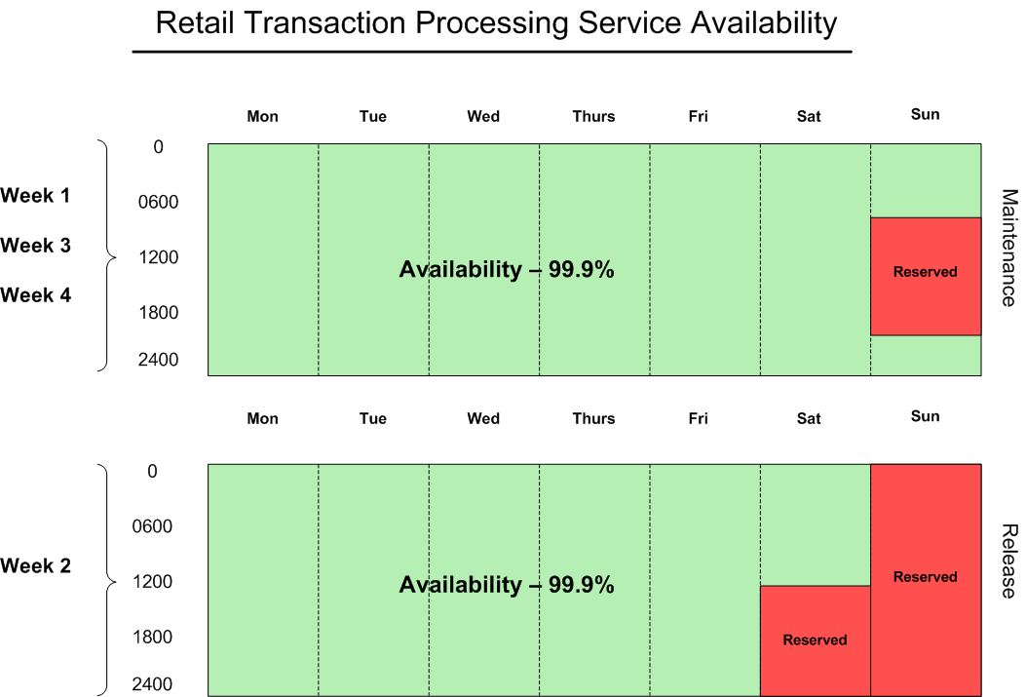

Exceptions:

Outages excluded from the availability metric which do not count as unplanned outage time include any market-wide releases requiring Market Participants and ERCOT to coordinate system outages for major upgrades, such as TX SET implementations. ERCOT will continue to coordinate such market-wide releases and outage expectations unique to each release will be communicated via the stakeholder process. Exceptions for extended maintenance and release windows will be requested by ERCOT at a Retail Market Subcommittee meeting prior to the extended outage.

Service Availability and Market Notice Reporting

ERCOT will measure and report monthly retail transaction processing service availability and track annual service availability for each calendar year. These results will be reported monthly through the ERCOT governance process that includes the Texas Data Transport Working Group, the Retail Market Subcommittee, the Technical Advisory Committee, and the ERCOT Board of Directors.

ERCOT will also maintain a log containing retail transaction processing market notices that will be updated monthly and made available on the Retail Market Subcommittee website. This log will also include service availability performance and detailed information regarding each notice related to retail transaction processing.

Availability Breakdown:

Service availability will be measured as a percentage of minutes that the service is available compared to the total number of minutes, excluding used maintenance and release outage window time.

Gross minutes per year = 525,600

Reserved maintenance outage minutes per year = 25,920

Reserved release outage minutes per year = 25,920

525,600 – 51,840 = 473,760 net availability minutes per year

99.9% availability = 474 unplanned outage minutes per year, or 7.9 hours (if all available maintenance and release windows are used)

Example Service Availability Calculation:

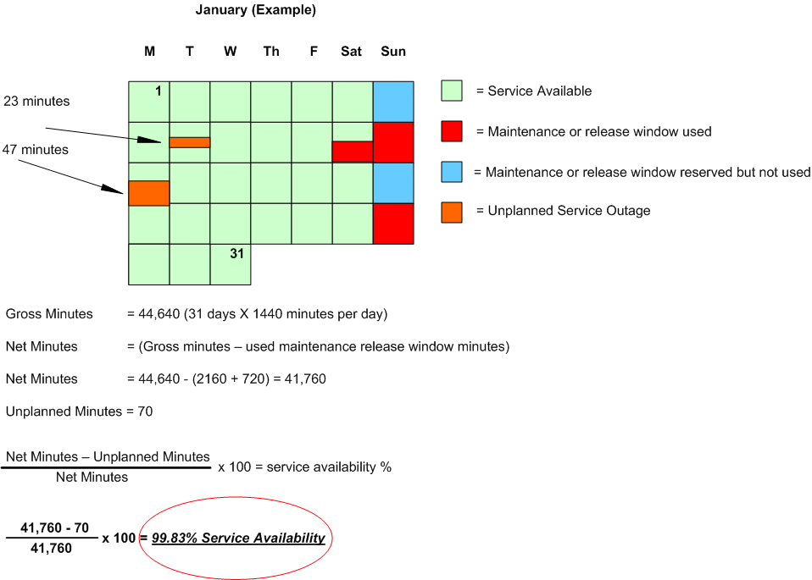

MarkeTrak

Service Scope

The MarkeTrak tool is a web based database application used to track, manage, and store data utilized by ERCOT and the Market Participants (MPs). This tool is the supported method to track ERCOT Retail market issue management and data discrepancies in the market.

Included in the scope of the MarkeTrak service are the user interfaces that MP’s use to create, contribute to, and resolve issues. These are the API (application programmatic interface) and the GUI (graphical user interface).

Service Availability

ERCOT targets MarkeTrak and its user interfaces, both the graphical user interface and application programmatic interface, to be available 98% of the time from 7:00am – 7:00pm during retail business days. ERCOT intends for MarkeTrak and its user interfaces to be available outside of retail business days, however this time will not be included in the service availability metric for MarkeTrak. Outages that are greater than 15 minutes in length will be counted against the MarkeTrak service availability metric.

Maintenance & Release Windows:

Maintenance and releases can be performed anytime outside of the availability timeframe (7:00am -7:00pm retail business days). Market notices will be sent prior to performing any planned maintenance.

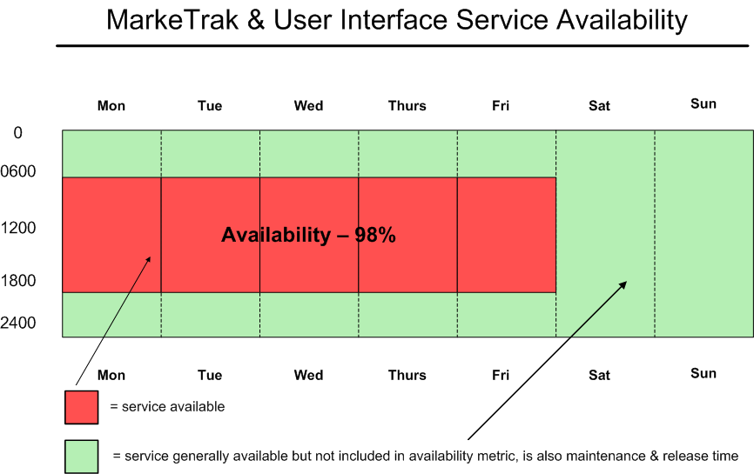

Service Availability and Market Notice Reporting

ERCOT will measure and report monthly MarkeTrak and user interface service availability and track annual service availability for each calendar year. These results will be reported monthly through the ERCOT governance process and includes the Texas Data Transport Working Group, the Retail Market Subcommittee, the Technical Advisory Committee, and the ERCOT Board of Directors.

ERCOT will also maintain a log containing details of market notices that will be updated monthly and made available on the Retail Market Subcommittee website. This log will also include service availability performance metrics and detailed information regarding each notice related to MarkeTrak performance.

Availability Breakdown:

Annual available minutes (7:00am – 7:00pm Retail Business Days) = 183,600

98% availability = 3,672 unplanned outage minutes per year, or 61 hours (if all available maintenance and release windows are used)

Texas Market Link (TML)

Service Scope

TML is the market information system that provides ERCOT market participants with a web based application for retrieving general market information, as well as secured access to market participant data.

Service Availability

ERCOT targets TML to be available 99% of the time outside of scheduled maintenance and release windows. TML maintenance and release windows are in line with retail transaction processing maintenance and release windows. Outages that are greater than 15 minutes in length will be counted against the TML service availability metric.

Maintenance Windows:

- 1st, 3rd, and 4th Sunday of each month – 8:00am until 8:00pm (12 hours)

Release Window:

- 2nd weekend of each month – 12:00pm Saturday until 12:00am Monday (36 hours)

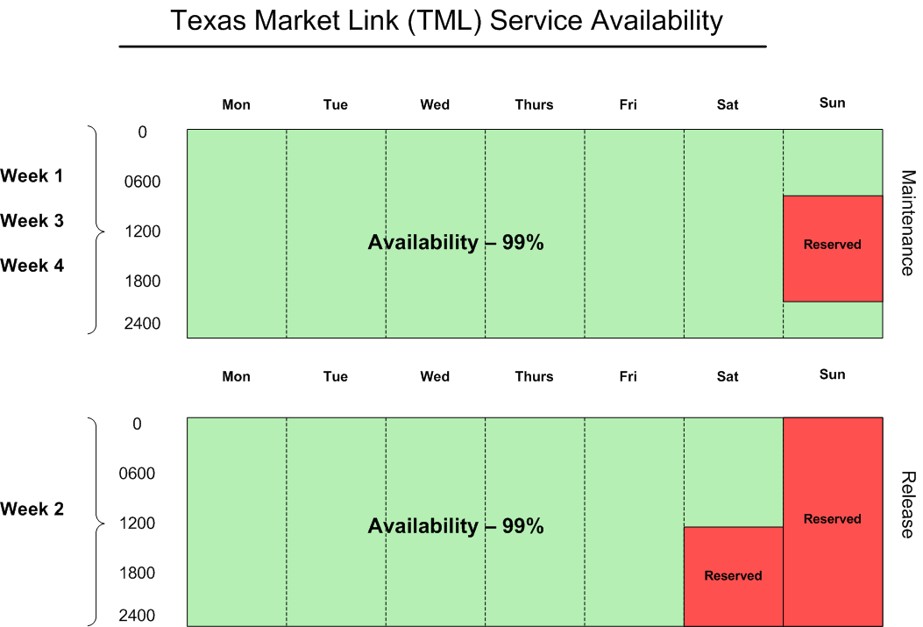

Exceptions:

Outages excluded from the availability metric which do not count as unplanned outage time include any market-wide releases requiring Market Participants and ERCOT to coordinate system outages for major upgrades, such as TX SET implementations. ERCOT will continue to coordinate such market-wide releases and outage expectations unique to each release will be communicated via the stakeholder process. Exceptions for extended maintenance and release windows will be requested by ERCOT at a Retail Market Subcommittee meeting prior to the extended outage.

Service Availability and Market Notice Reporting

ERCOT will measure and report each month’s TML availability and track annual service availability for each calendar year. These results will be reported monthly through the ERCOT governance process and includes the Texas Data Transport Working Group, the Retail Market Subcommittee, the Technical Advisory Committee, and the ERCOT Board of Directors.

ERCOT will also maintain a log containing details of market notices that will be updated monthly and made available on the Retail Market Subcommittee website. This log will also include service availability performance metrics and detailed information regarding each notice related to TML performance.

Availability Breakdown:

Service availability will be measured as a percentage of minutes that the service is available compared to the total number of minutes, excluding used maintenance and release outage window time.

Gross minutes per year = 525,600

Reserved maintenance outage minutes per year = 25,920

Reserved release outage minutes per year = 25,920

525,600 – 51,840 = 473,760 net availability minutes per year

99% availability = 4,738 unplanned outage minutes per year, or 79 hours (if all available maintenance and release windows are used)

Retail Market IT Services Reporting:

Service availability and impacting events related to the Retail Market IT services described in this document will be reported monthly to the Texas Data Transport Working Group, the Technical Advisory Committee and the Retail Market Subcommittee. The availability metrics and detailed market notice log will be updated monthly and posted to the Retail Market Subcommittee website on www.ercot.com.

Elements included in the report are:

- Outage/Incident date
- Date of initial Market Notice (if applicable)
- Market Notice ID tag (if applicable)
- Incident start and end times and duration
- Service(s) affected
- Issue description
- Incident type
- Identification method – the way that ERCOT learned of the incident (i.e.…monitoring, notification from market participant, etc…)
- Impact to the affected service
- Market impact – the impact of the incident to market participants and end use customers
- Resolution status
- Root cause when identified
- Date of any identified fix to be implemented
- Additional comments or notes

The report also summarizes the market notice data by type in monthly and annual breakdowns.

Service Availability Renegotiations and Change Control Process

Renegotiations of ERCOT retail market IT services can be initiated by either Market Participants or ERCOT management by making a request to the Retail Market Subcommittee.

Version control in the form of document version numbering will be maintained in this document as a means of providing a change control process.

Annual Review Process

ERCOT is committed to providing IT services to the competitive electric market in Texas. ERCOT intends that the IT services described in this document align with market participant requirements to the extent that is operationally feasible. To maintain alignment between the requirements of the market participants and the retail market IT services delivered by ERCOT, the service availability targets defined in this document will be reviewed at least annually in a workshop during the first quarter of each year.

Appendix A: Definitions

This section contains definitions of the systems referred to in this document and of the commonly used acronyms.

- Availability: The ability of a component or IT service to perform its required function over a stated period of time
- Planned Outage: A planned change in ERCOT IT systems that prevents users from being able to access the systems
- Unplanned Outage: An unplanned change in ERCOT IT systems that prevents users from being able to access the systems
- Incident: Any event that causes the agreed levels of service of ERCOT IT systems to be impacted
- Degradation: An event that causes the normal levels of ERCOT IT systems to be impacted while still allowing for minimal processing of or access to these systems
- NAESB: The North American Energy Standards Board (NAESB) serves as an industry forum for the development and promotion of standards which will lead to a seamless marketplace for wholesale and retail natural gas and electricity. The Texas electric market has implemented NAESB EDM v1.6 as the required data transport mechanism.
- EDI: Electronic Data Interchange – the transfer of data electronically
- PaperFree: The data validation and transformation engine utilized in ERCOT’s retail transaction processing system
- Integration: The creation of links between previously separate computer systems, applications, services or processes
- Retail Transactions:
  - 814 – Enrollment transaction used for registration in the retail market
  - 824 – Application advice transaction used for responding to errors on 867 usage transactions
  - 867 – Usage transaction used for reporting consumption or generation of electricity
  - 997 – Acknowledgement transaction
- Gross minutes - total minutes in a month
- Net minutes - gross minutes minus planned outage minutes
- Planned outage minutes - minutes used by ERCOT during the maintenance and release windows
- Unplanned outage minutes - minutes retail transaction processing services were not available that are outside of the planned use of the maintenance and release windows
- Exception outage minutes - minutes outside of the maintenance and release outage windows that have been granted exception from the availability metric (TX Set, etc.)
- Service availability percent - the percent of time that retail transaction processing services were available, not including planned outage minutes

Appendix B: Retail Market Systems Architecture Diagram

