
Demo Notes
MIS Portal
Prototype 3
Version 0.2
22-May-07

Table of Contents
1. Overview 4
2. Script 4
2.1. Login 4
2.2. Successful Login 4
2.3. Portal Framework Overview 4
2.3.1. Header 4
2.3.2. Footer 4
2.3.3. Top Level Navigation 4
2.3.4. Portlet Headers 4
2.3.5. Edit Button in the portlet header 4
2.4. MyPage 4
2.4.1. Add a portlet to MyPage 4
2.4.2. Remove a portlet to MyPage 4
2.4.3. Rearranging a portlet to MyPage 4
2.4.4. Undo an action on MyPage 4
2.5. Day Ahead Market 4
2.6. Grid 4
2.7. Reports 4
2.8. Notices 4

Overview
This document provides a high level overview of functionality provided by the MIS Portal in Prototype 3. It also contains instructions on how to navigate through the portal.

Script

Login
The Nodal Sandbox is only accessible to Market Participants who hold a currently approved digital certificate. Additionally, the MIS Portal is only accessible to authenticated users. This means that when Market Participants access the portal they will be required to login to the application.

Currently, we have a login screen (please see screenshot 1) where users can enter their credentials and have access to the portal. Eventually as the MPIM project goes live, users will be able to authenticate using the Digital Certificate on the browser, and no sign-in will be required. A valid digital certificate provides following information:

- DUNS ID
- EMPLOYEE ID

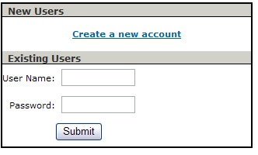
Screenshot 1

At present, login as

Username: MIStest
Password: password

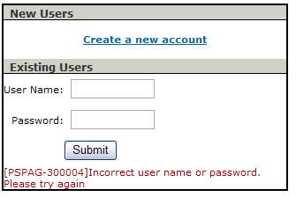

Screenshot 2

As shown in screenshot 2, unauthenticated users (who have incorrect username/password) will not be allowed to access portal.

Successful Login
After successful verification of user information (DUNS ID and EMPLOYEE ID), users will be provided access to the content and applications on the portal. They will only be able to see the content that is available to their user roles and filtered by DUNS ID. User roles will be stored in corporate LDAP (MPIM). These roles determine what information users have access to on the portal.

Portal Framework Overview

Header

As part of the standard portal functionality, the header will appear on all pages in the portal.

As seen in the screenshot 3 below, the header will contain a short welcome message, ‘Hello Firstname Lastname’. This is the name of the logged in user, dynamically picked up from the user profile.

On the right in the header, the portal will display the Date. This will be the DST date/time.

The header also contains some useful links in the header above search like ‘Contact Us’ and Logout. These are put in the header so that they are readily available to users from all screens.

Under the date is the ‘Search’ option. The user can enter a search term here and click ‘Search >’ button to return relevant results from the portal, ercot.com as well as MID/MIR reports. Please note that only the results that the logged in user has access to will be displayed on the portal. In case the user wants to add more filter criteria to the search, they can click on ‘Advanced Search’ where more filtering options are available like date range, document type etc.

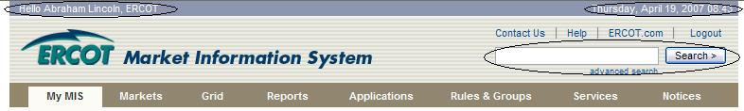

Screenshot 3

Footer

At the bottom of each page appears a footer note that contains the privacy and copyright statement and some other relevant information.

Screen Shot 4

Top Level Navigation
All pages in the portal also contain navigation below the header. This navigation will list the various sections of available content and information. Once the user does a mouse-over on a particular section in the navigation, the navigation will dropdown and allow selection of the relevant sub-section on the portal (Screenshot 5).

Again, the user only sees sections that they have access to.

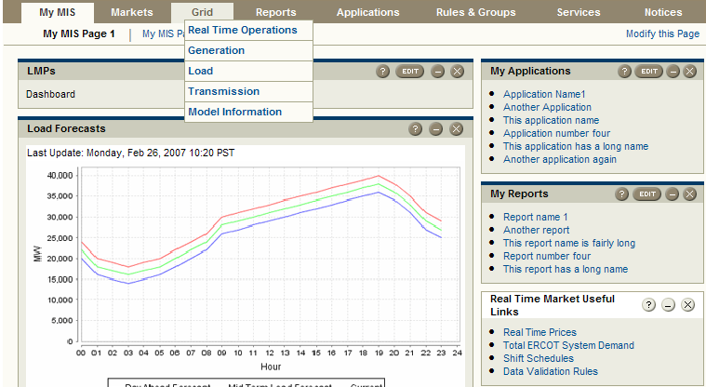

Screenshot 5

Portlet Headers

All the portlets in the portal have buttons in the header used to perform tasks as shown in the screenshot 6 below.

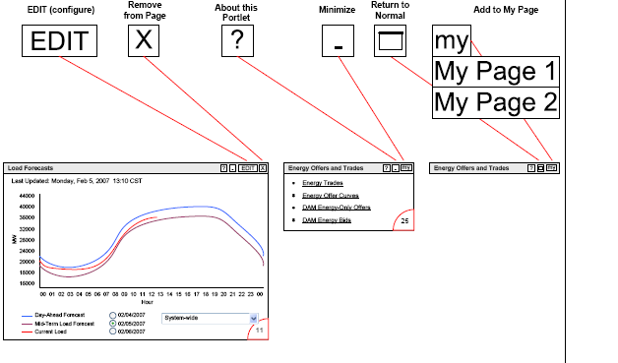
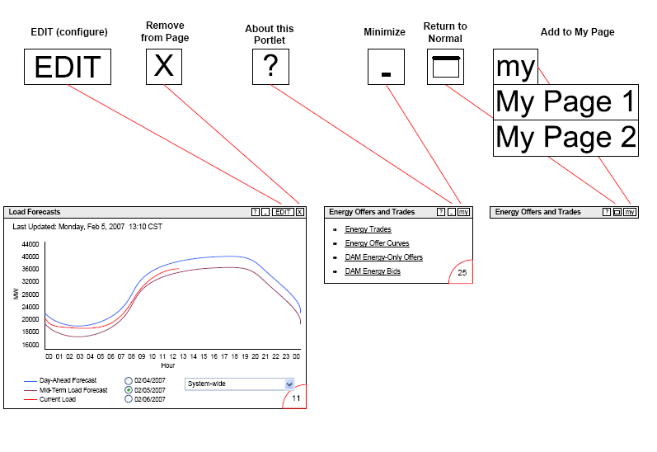
Screenshot 6

Not all buttons are displayed in all portlets. Depending on the state of the portlet and the functionality around the portlets, a button may or may not be available.

The button will remove a portlet from the page.

The button will display the help for that portlet.

The button can be used to minimize a certain portlet. This button is only visible if the portlet is in normal or maximized state.

The button can be used to return a minimized or maximized portlet back to its normal state.

The dropdown can be used to add a portlet to MyPage1 or MyPage2. (The concept and details around MyPage1 and MyPage2 are provided in the MyPage section).

The button can be used to enter ‘edit’ parameters for a specific portlet. (This is explained more in the next section.)

Edit Button in the portlet header

Certain customizable portlets will have an ‘edit’ button in the portlet header. This signifies that the user can enter certain parameters for this portlet to customize the view for the user’s preferences.

As shown below, see the portlet ‘My Reports’ on MyPage1. See screenshot 7. This portlet has an ‘edit button’ in the portlet.

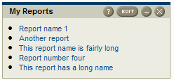

Screenshot 7

- Click on the edit button in the portlet header. This will change the portlet mode to ‘Edit’ as shown in screen shot 8. The user can enter the preference code and click Save. This will take the user back to the display mode as shown in screenshot 7.

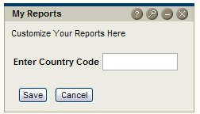

Screenshot 8

MyPage

The first page the user sees after successful login is MyPage1. Please see the screen shot 9 to see how the page might look. MyPage1 and MyPage2 are pages that can be personalized.

This means that they can add, remove or rearrange portlets n this page. User preferences are saved by the portal, which means that the next time users come to this portal page, their preferences on this page are saved.

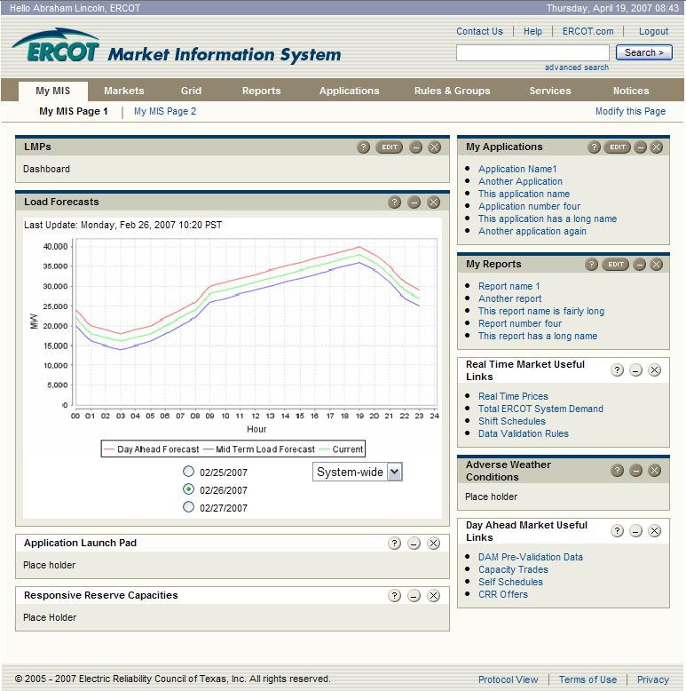

Screenshot 9

Add a portlet to MyPage

There are two ways to add a portlet to MyPage1:

- Users can click on the button in the portlet header for the portlets that they wish to see on the page, adding the portlet to MyPage1 in pane 1.

- Users can click on ‘Modify this page’ link on top right of the page. This will take them to a customize page (see screen shot 4). On this page users can click on any of the available portlets in the bottom section and click on ‘Add Subscription in Pane 1’ to add it to first pane. Similarly, to add to second pane, click on ‘Add Subscription in Pane 2’. To see this in action:
    - Check the box next to ‘Aggregated Ancillary Service Offer Curve’ and click ‘Add Subscription to Pane1’. This will add the portlet to pane 1. Click finish. This will take the user back to MyPage1 with the portlet added to pane 1 at the bottom.

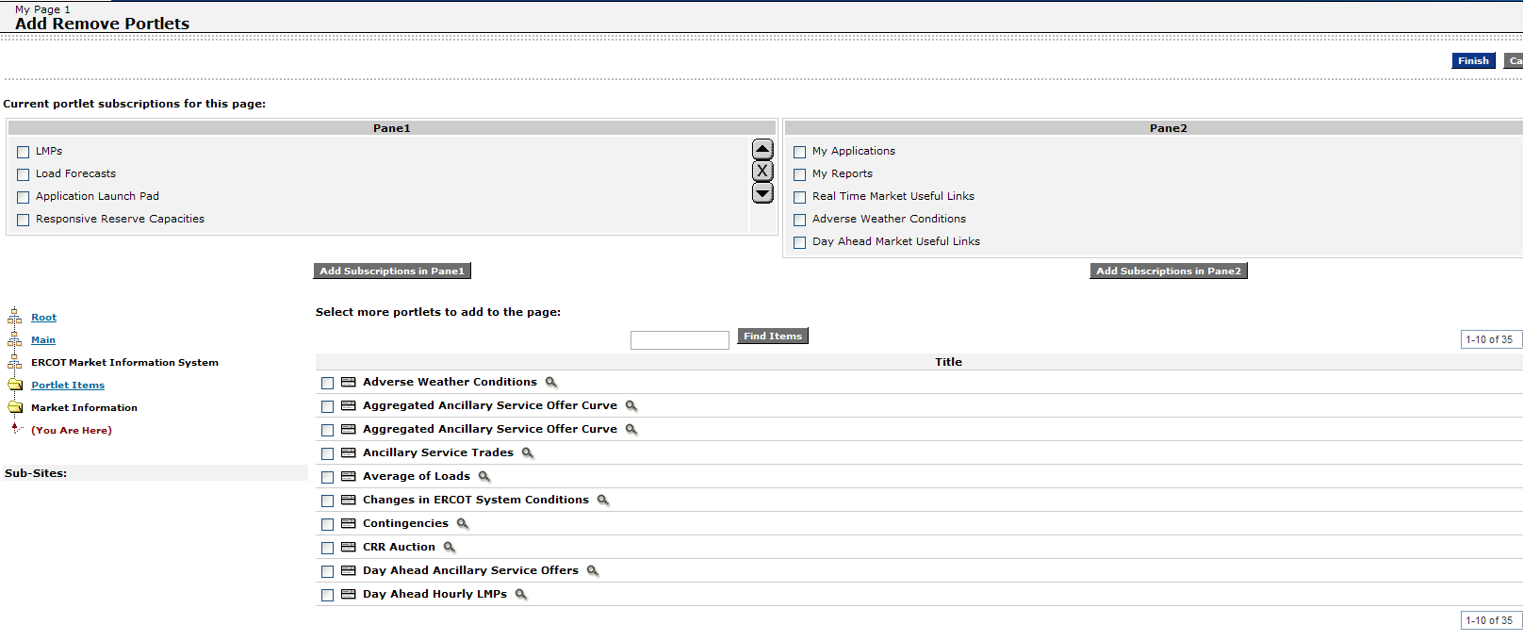

Screenshot 10

Remove a portlet from MyPage

There are two ways to remove a portlet from MyPage1.

- Users can click on the button in the portlet header on MyPage for the portlet that they wish to remove.

- Users can click on ‘Modify this page link’ on top right of the page. This will take them to a customize page (see screen shot 4). On this page users can select the portlet that they wish to remove, click on button in the panes and Click Finish. This will remove the portlets from the pane.

    - Check the box next to ‘Responsive Reserve Capacities’ and click ‘’. This will remove the portlet from pane 1. Click finish. This will take the user back to MyPage1 with the portlet removed from pane1.

Rearranging a portlet to MyPage
Users can click on the button to move a portlet up or button to move a portlet down.
- Check the box next to ‘Aggregated Ancillary Service Offer Curve’ and click ‘. This will move the portlet up in pane 1. Click Finish. You will notice that the portlet will show up higher in Pane1.

Undo an action on MyPage

There is no Undo button on the portal that will undo what you have done but based on the functionality provided by ‘Modify this Page’, users can reverse any action that they may wish to undo.

Day Ahead Market
This section has multiple reports that will be displayed in various portlets. For the landing view only a few reports per portlet that are displayed.
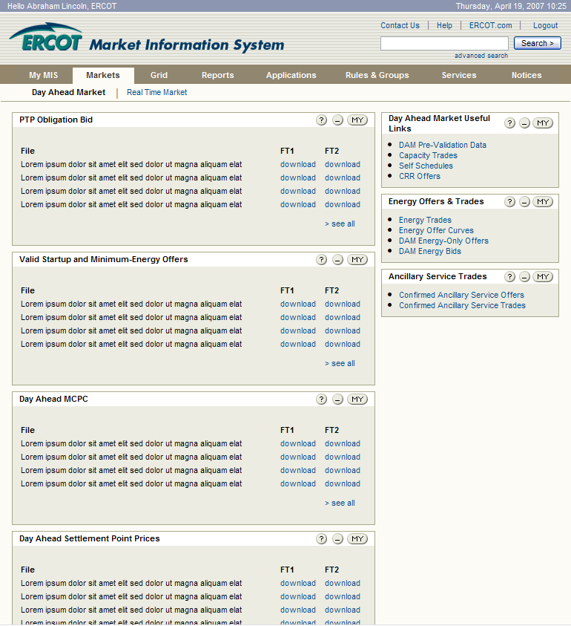

Screenshot 11

      - In the portlet ‘PTP Obligation Bid’ click on the link ‘> see all’ in the bottom of the portlet. This will maximize the portlet view (take over the entire page) and display all the reports inside that portlet as shown in screenshot 12. Clicking on ‘<Back’ takes the user back to the previous view (screenshot 11).

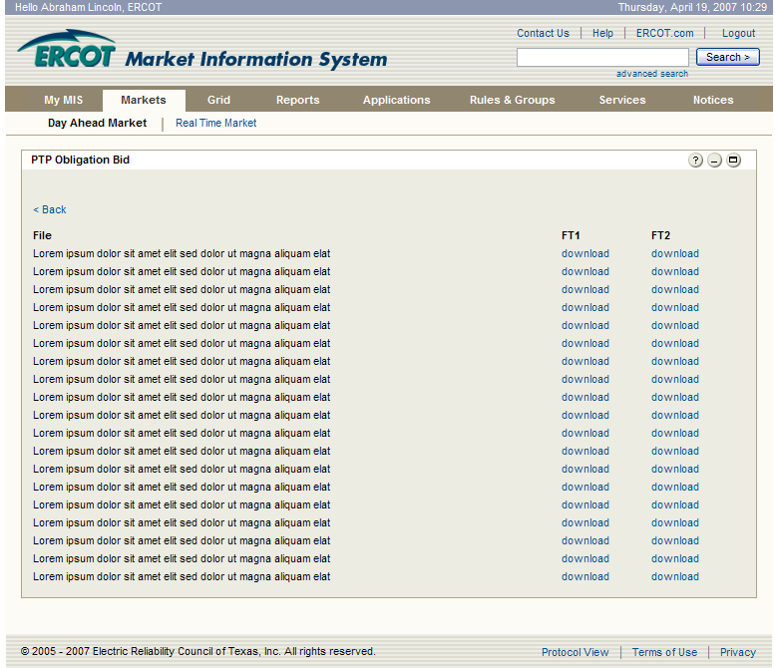

Screenshot 12

Grid
If a user clicks on the ‘Grid’ they are taken to a Grid landing page. The first portlet on the page is ‘IN THIS SECTION’ portlet. This is a portlet that is displayed on all the top level landing pages.

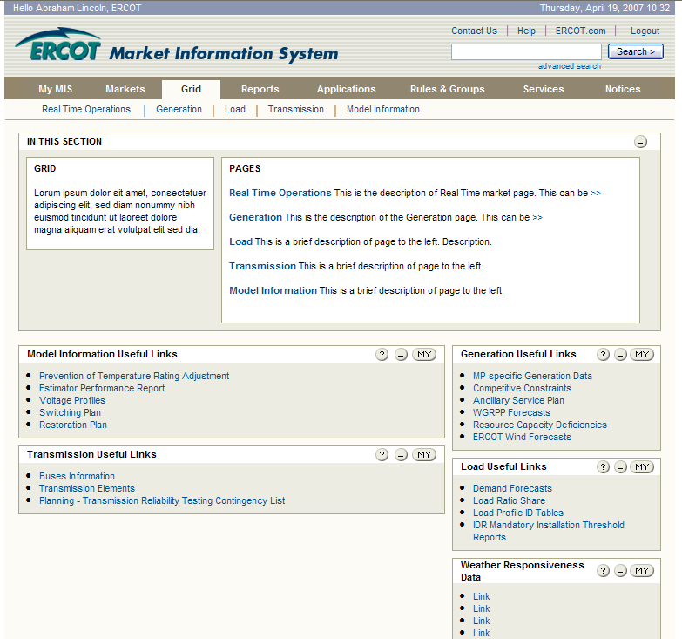
Screenshot 13

The purpose of this section is to give a brief summary of all the pages in that section.

    - Click on the ‘>>’ which is in the right side of this portlet, at the end of line ‘Real Time Operations’. This will open up a full description of this section without refreshing the page. The ‘<<’ will hide the description back to a single line. This is done to insure that long descriptions do not take over the entire page.
    - Click on the minimize button in the header. This will minimize the section. This is done so that once you are familiar with the sections on the portal and do not wish to see the descriptions anymore, they can be minimized in the interest of the real estate on the portal page.

Reports
This page contains the Report Explorer portlet. ‘Report Explorer’ portlet, displaying the MIR reports. Only the reports that the user has access to are displayed.

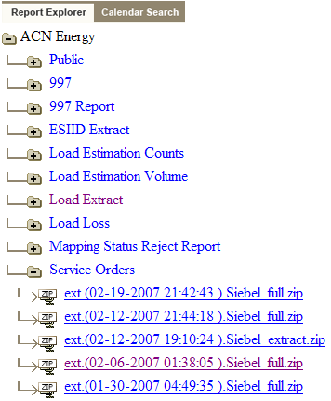

Screenshot 14

  - Click on the next to the ‘Services Orders’. The reports under this folder that the user has access to are displayed (Screenshot 14). The user can click on any of these reports and download them.

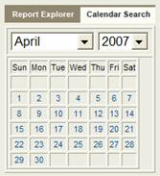

Screenshot 15

  - Click on the ‘Calendar’ Tab in the Report Explorer header. Select the date Feb, 19th, 2007. This should only bring back the filtered reports for that day in the report explorer view. The ‘Clear Date’ link on top of the ‘Reports’ will clear the date and take users back to the report explorer landing page.

Notices
This section on the portal will contain all the notices that the logged in user is allowed to see. The user will be able to filter the messages based on notice type, time frame and date range.

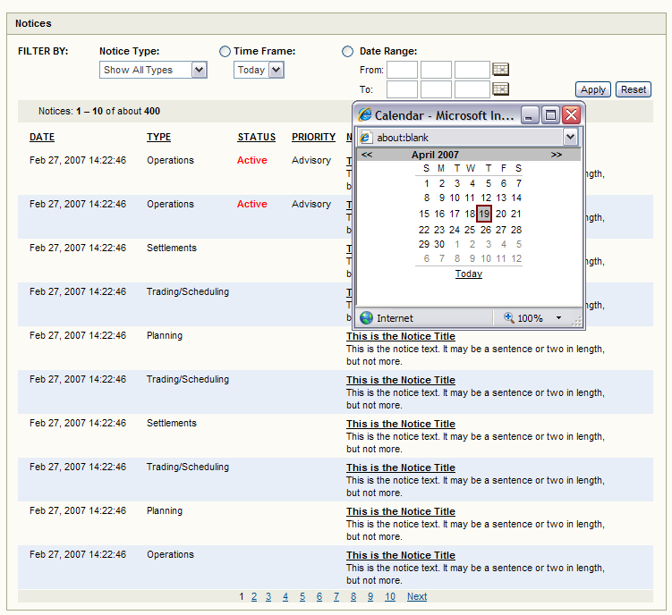

Screenshot 14

  - Click on the calendar icon next to the date range and it pops up a javascript calendar. If you select a date in this calendar, the results will be populated in the date field.

The results of the notices will be paginated. Users will be able to sort the messages for date, type, status and priority.

